UNITED STATES

SECURITIES AND EXCHANGE COMMISSION

Washington, D.C. 20549
FORM 8-K

CURRENT REPORT
PURSUANT TO SECTION 13 OR 15(D)

OF THE SECURITIES EXCHANGE ACT OF 1934

Date of Report (Date of earliest event reported): March 17, 2026

New Fortress Energy Inc.

(Exact name of registrant as specified in its charter)

Delaware

001-38790

83-1482060

(State or Other Jurisdiction of Incorporation)

(Commission File Number)

(IRS Employer Identification No.)

111 W. 19th Street, 8th Floor

New York, NY

10011

(Address of Principal Executive Offices)

Registrant’s Telephone Number, Including Area Code: (516) 268-7400

(Zip Code)

Check the appropriate box below if the Form 8-K filing is intended to simultaneously satisfy the filing obligation of the registrant under any of the following provisions:

- Written communications pursuant to Rule 425 under the Securities Act (17 CFR 230.425)

- Soliciting material pursuant to Rule 14a-12 under the Exchange Act (17 CFR 240.14a-12)

- Pre-commencement communications pursuant to Rule 14d-2(b) under the Exchange Act (17 CFR 240.14d-2(b))

- Pre-commencement communications pursuant to Rule 13e-4(c) under the Exchange Act (17 CFR 240.13e-4(c))

 |  |  | Securities registered pursuant to Section 12(b) of the Act:
 | Title of each class |  |  | Trading Symbol(s) |  | Name of each exchange on which registered
Class A Common Stock, par value $0.01 per share |  |  |  | “NFE” |  |  | Nasdaq Global Select Market

Indicate by check mark whether the registrant is an emerging growth company as defined in Rule 405 of the Securities Act of 1933 (§230.405 of this chapter) or Rule 12b-2 of the Securities Exchange Act of 1934 (§240.12b-2 of this chapter).

- Emerging growth company

If an emerging growth company, indicate by check mark if the registrant has elected not to use the extended transition period for complying with any new or revised financial accounting standards provided pursuant to Section 13(a) of the Exchange Act ☐

Item 1.01. Entry into a Material Definitive Agreement.

On March 17, 2026, New Fortress Energy Inc. and certain of its subsidiaries (collectively, “NFE” or the “Company”) entered into a restructuring support agreement (together with all exhibits, annexes, schedules, and appendices thereto, the “RSA”) with certain of its lenders and noteholders, including:

- certain members of an ad hoc group of holders (the “2029 New Notes Noteholder Group”) of the 12.000% Senior Secured Notes due 2029 (the “2029 New Notes”) pursuant to that certain Indenture, dated as of November 22, 2024, by and among NFE Financing LLC (the “2029 New Notes Issuer”), an indirect subsidiary of the Company, as the issuer, the guarantors from time to time party thereto and Wilmington Savings Fund Society, FSB, as trustee and collateral agent (as amended, restated, amended and restated, supplemented or otherwise modified from time to time, the “2029 New Notes Indenture”) (the “Supporting 2029 New Notes Holders”), which Supporting 2029 New Notes Holders, together with other Supporting Creditors (as defined herein), hold a majority of the aggregate principal amount of 2029 New Notes outstanding as of the date the RSA was executed (the “RSA Execution Date”);

- certain members of an ad hoc group of term lenders (the “Term Loan B Group”) under that certain Credit Agreement, dated as of October 30, 2023, by and among the Company, as the borrower, the guarantors from time to time party thereto, the lenders from time to time party thereto, and Morgan Stanley Senior Funding, Inc., as administrative agent and collateral agent (as amended, restated, amended and restated, supplemented or otherwise modified from time to time, the “Term Loan B Agreement”) (the “Supporting Term Loan B Lenders”), which Supporting Term Loan B Lenders, together with other Supporting Creditors, hold a majority of the loans outstanding under the Term Loan B Agreement as of the RSA Execution Date;

- certain holders of debt (the “Revolving Lender Group”) under that certain Credit Agreement, dated as of April 15, 2021, by and among the Company, as the borrower, the guarantors from time to time party thereto, the lenders and issuing banks from time to time party thereto, and MUFG Bank Ltd., as administrative agent and collateral agent (as amended, restated, amended and restated, supplemented or otherwise modified from time to time, the “Revolving Loan Agreement”) (the “Supporting Revolving Loan Lenders”), which Supporting Revolving Loan Lenders, together with other Supporting Creditors, hold a majority of the loans outstanding under the Revolving Loan Agreement as of the RSA Execution Date;

- certain members of an ad hoc group of term lenders (the “Term Loan A Group”) under that certain Credit Agreement, dated as of July 19, 2024, by and among the Company, as the borrower, the guarantors from time to time party thereto, the lenders from time to time party thereto, and Morgan Stanley Senior Funding, Inc., as administrative agent and collateral agent (as amended, restated, amended and restated, supplemented or otherwise modified from time to time, the “Term Loan A Agreement”) (the “Supporting Term Loan A Lenders”), which Supporting Term Loan A Lenders, together with other Supporting Creditors, hold a majority of the loans outstanding under the Term Loan A Agreement as of the RSA Execution Date; and

- a majority of the members of a group of creditors with recourse to the collateral assets in the Company’s core business, but not to the Company’s Fast LNG assets or Brazil business (the “Common Collateral Group”), including (1) holders of the 6.500% Senior Notes due 2026 (the “2026 Legacy Notes”) issued pursuant to that certain Indenture, dated as of April 12, 2021, by and among the Company, as issuer, the guarantors from time to time party thereto and U.S. Bank Trust Company, National Association (as successor in interest to U.S. Bank National Association), as trustee and collateral agent (the “Supporting 2026 Legacy Notes Holders”), (2) holders of the 8.750% Senior Secured Notes (the “2029 Legacy Notes”) issued pursuant to that certain Indenture, dated as of March 8, 2024, by and among the Company, as the issuer, the guarantors from time to time party thereto and U.S. Bank Trust Company, National Association, as trustee and collateral agent (as amended, supplemented or otherwise modified from time to time, the “2029 Legacy Notes Indenture”) (the “Supporting 2029 Legacy Notes Holders,” and together with the Supporting 2026 Legacy Notes Holders, the Supporting 2029 New Notes Holders, the Supporting Term Loan B Lenders, the Supporting Term Loan A Lenders, the Supporting Revolving Loan Lenders and creditors of the Series I Loan Debt and Series II Loan Debt, the “Supporting Creditors”) and (3) creditors of the Series I Loan Debt and Series II Loan Debt.

Kroll Issuer Services Limited, the Company’s information agent for purposes of the RSA and the Restructuring Plans (as defined below) (in such capacity, the “Information Agent”), is party to the RSA for certain limited purposes. A holder of or lender under the debt instruments described above that is not already party to the RSA may become an Additional Supporting Creditor (as defined in the RSA) by executing and delivering an Additional Supporting Creditor Joinder (as defined in the RSA) to the Information Agent in accordance with the terms of the RSA and as available on the Information Agent’s website: https://deals.is.kroll.com/nfe. Provided certain conditions are met (as set out in the RSA), the

Company will pay to holders of or lenders under the debt instruments described above that become Supporting Creditors on or before 5:00 p.m. New York City time on March 31, 2026 (the “Early Consent Deadline”), an early consent fee in an amount equal to 0.75% of the principal amount of such Supporting Creditors’ eligible applicable notes and loans (the “Early Consent Fee”). A Supporting Creditor’s entitlement to the Early Consent Fee will be determined by reference to the aggregate principal amount of notes and loans held by that Supporting Creditor as of the record date (the "Record Date") specified to creditors for voting under the Restructuring Plans. If holders of or lenders under the debt instruments become a Supporting Creditor after the Early Consent Deadline but acquires notes or loans that are eligible for the Early Consent Fee, its entitlement to the Early Consent Fee will be determined by reference to the aggregate principal amount of those acquired notes or loans by that Supporting Creditor as of the Record Date. Such early consent fee will be payable in kind in the form of the consideration to be afforded to such Supporting Creditors under the Restructuring Plans. Separately, the Company has agreed to pay each Revolving Loan Agreement lender that agrees to forbear from taking any enforcement action under the Revolving Loan Agreement and/or with respect to the Revolving Loan Agreement collateral a standstill fee (the "Standstill Fee") in an amount equal to 2.00% of the outstanding loans made by such forbearing Revolving Loan lender, provided that a simple majority of Revolving Loan Agreement lenders (constituting Required Lenders, under and as defined in the Revolving Loan Agreement) agree to forbear.

The RSA sets forth principal terms for a comprehensive restructuring of the Company’s principal funded debt obligations (the “Transaction”). Capitalized terms not defined herein will have the meanings ascribed to them in the RSA.

The RSA contemplates, among other things, the following:

- The Company will separate into two separate, independent companies: one generally comprising the Company’s businesses and assets in Brazil (“BrazilCo”), and the other generally comprising the Company’s other businesses and assets, which will be retained by NFE (“CoreCo”);

- Obligations under the 2026 Legacy Notes, the 2029 Legacy Notes, the Term Loan A Agreement, the Term Loan B Agreement, the Revolving Loan Agreement, the 2029 New Notes, and the Intercompany Credit Agreements will be exchanged (in each case on a ratable basis) for one or a combination of the following debt obligations and equity securities:

  - 100% of the common equity interests in BrazilCo;

  - up to $643 million (assuming full exercise of the elections provided for in the Restructuring Support Agreement allowing an exchange of a limited amount of CoreCo Convertible Preferred Stock (defined below) to debt thereby increasing the amount of New CoreCo Term Loans from $527.5 million) in senior secured term loans incurred by NFE, as borrower, and guaranteed by each subsidiary of NFE that will be part of CoreCo (subject to customary exclusions and other exclusions to be agreed and assuming all eligible participants exchange preferred equity for debt) (“New CoreCo Term Loans”);

  - convertible preferred stock of NFE with an aggregate liquidation preference of up to $2.5 billion (“CoreCo Convertible Preferred Stock”);

  - shares of NFE common stock representing 65% of NFE common stock as of the Transaction closing date (the “Closing Date”), before giving effect to an incentive plan for directors, officers and other employees of the Company or any conversion of the CoreCo Convertible Preferred Stock into NFE common stock;

  - corporate governance matters regarding CoreCo;

  - $400 million in non-recourse term loans (the “FLNG 2 Term Loans”) incurred or issued by the subsidiary that owns the Company’s Fast LNG 2 assets (“FLNG 2 Co”), payable in full on the third anniversary of the Closing Date, guaranteed by certain subsidiaries of FLNG 2 Co and secured by substantially all assets of FLNG 2 Co and such subsidiaries; and/or

  - $200 million in non-convertible, preferred equity (the “FLNG 2 Preferred Equity”) issued by FLNG 2 Co;

- Letters of credit issued under the Company’s existing letter of credit facility (the “Letter of Credit Facility”) or Revolving Loan Agreement will be backstopped or replaced by letters of credit issued under new fully committed letter of credit facilities for each of CoreCo and BrazilCo (or, in the case of CoreCo, may remain outstanding under the existing letter of credit facility, as amended, amended and restated, or otherwise modified);

- Certain other existing debt facilities and other liabilities will be refinanced, renegotiated, or compromised, or will remain outstanding in accordance with their existing terms;

- All shares of NFE common stock outstanding immediately prior to the consummation of the Transaction will remain outstanding and will represent 35% of NFE common stock issued and outstanding following the consummation of the Transaction but before giving effect to an incentive plan for directors, officers and other employees of the Company or any conversion of the CoreCo Convertible Preferred Stock into NFE common stock; and

- If required in order to meet a consolidated minimum liquidity threshold ($100 million) on the Closing Date, the Company will offer to all eligible creditors the opportunity to participate in a capital raise, pursuant to which the Company would raise up to $35 million in aggregate principal amount of additional New CoreCo Term Loans and, to the extent the consolidated minimum liquidity threshold would not be met after giving effect to the additional New CoreCo Term Loans, junior term loans secured by a second-priority lien in an amount so that the consolidated minimum liquidity threshold would be met.

Summary of the CoreCo Convertible Preferred Stock and FLNG 2 Preferred Equity

Pursuant to the terms of the RSA, the CoreCo Convertible Preferred Stock will mandatorily convert on the third anniversary of the Closing Date into shares of NFE common stock representing 87% of the fully diluted common stock of NFE as of the Closing Date (after giving effect to the shares of NFE common stock to be issued on the Closing Date and the incentive plan for directors, officers and other employees of the Company). The conversion rate of the CoreCo Convertible Preferred Stock will be subject to customary adjustments for stock splits, distributions, reorganizations and reclassifications, as well as to certain price-based anti-dilution adjustments for subsequent issuances of NFE common stock (or securities convertible into NFE common stock) made by the Company while the CoreCo Convertible Preferred Stock remains outstanding (subject to certain exempt issuances). CoreCo will have the right to redeem or repurchase the CoreCo Convertible Preferred Stock from time to time with certain sources of proceeds enumerated in the RSA. Holders of the CoreCo Convertible Preferred Stock will be entitled, in arrears, to a cumulative quarterly compounding dividend, which will accrue automatically via an increase to liquidation preference, with a cumulative per annum preferred return of 3.0%, 5.0% and 7.0% in each of the three years, respectively, prior to conversion. The CoreCo Convertible Preferred Stock will participate on an as-converted basis in any dividends and distributions on, and vote together with holders of, NFE common stock. The CoreCo Convertible Preferred Stock will be subordinated in right of payment to all existing and future indebtedness of CoreCo and senior in right of payment to all existing and future equity securities of CoreCo.

The FLNG 2 Preferred Equity will be issued by FLNG 2 Co at the Closing Date pursuant to the RSA and will reflect economic and structural features substantially similar to those of the CoreCo Convertible Preferred Stock, except as otherwise provided herein. CoreCo will have the right to redeem the FLNG 2 Preferred Equity from time to time with certain sources of proceeds enumerated in the RSA. The Company will not pay any dividends on the FLNG 2 Preferred Equity. The FLNG 2 Preferred Equity will be subordinated in right of payment to all existing and future indebtedness of FLNG 2 Co and senior in right of payment to all existing and future equity securities of FLNG 2 Co.

Summary of the New CoreCo Term Loans

NFE expects to use the proceeds of the New CoreCo Term Loans to refinance, on a cashless basis, certain of the loans and other obligations outstanding under NFE’s Revolving Loan Agreement and Term Loan B Agreement. If necessary, the cash proceeds of up to $35 million of additional New CoreCo Term Loans will be used to satisfy the consolidated minimum liquidity threshold required by the RSA. The New CoreCo Term Loans will mature five years after the Closing Date and will amortize at a rate of 1% per annum, paid quarterly. The New CoreCo Term Loans will be guaranteed, jointly and severally, on a senior secured basis by each subsidiary that is a guarantor under the Letter of Credit Facility on the Closing Date, and will be secured by substantially the same collateral as the collateral that currently secures the Letter of Credit Facility, subject to certain exceptions, including NFE’s FLNG 2 assets. To the extent the minimum liquidity threshold is not satisfied after giving effect to the funding of the New CoreCo Term Loans, the Company is permitted to incur additional indebtedness that will be guaranteed by the same guarantors guaranteeing the New CoreCo Term Loans and secured by a second-priority lien on all of the collateral securing the New CoreCore Term Loans.

The New CoreCo Term Loans may be voluntarily prepaid by the Company, in whole or in part, subject to prepayment premiums for optional prepayments equal to 102% of the aggregate principal amount of such term loan prepaid plus accrued and unpaid interest during the first year after the closing of the New CoreCo Credit Agreement, and at par plus accrued and unpaid interest thereafter. The Company will be required to prepay the New CoreCo Term Loans at par with the net proceeds of non-ordinary course asset sales, condemnations and certain other events enumerated in the RSA.

The Restructuring Plans; Holder Elections

Holders of R-2 Revolving Loan Agreement Debt and Term Loan A Debt may elect to receive (a) their pro rata share of $45 million in lieu of the BrazilCo Common Equity they would receive in exchange for their Debt and holders of Revolving Loan Agreement Debt may elect to receive (b) additional New CoreCo Term Loans in lieu of the CoreCo Preferred Stock they would receive in exchange for their claims, at a rate of 50% of the liquidation preference of the CoreCo Preferred Stock in aggregate principal amount of New CoreCo Term Loans.

In addition, one or more directors and officers of the Company and, potentially certain Supporting Creditors and/or third-party investors, as determined by such directors and officers, will offer to purchase from holders of Revolving Loan Agreement Debt and Term Loan A Debt a limited number of shares of CoreCo Convertible Preferred Stock allocated to such holders (subject to certain terms and conditions, including that the relevant holder timely elects to participate in such arrangements) for a cash purchase price of 25% of the liquidation preference of such shares of CoreCo Convertible Preferred Stock.

The following table summarizes the allocation of the debt obligations and equity securities to be incurred or issued pursuant to the Restructuring Plans (represents allocations prior to the Early Consent Fee and the Standstill
Fee):

($ in actuals) | 2029 New Notes | Term Loan B Agreement | Term Loan A Agreement | R-1 Revolving Loan Agreement | R-2 Revolving Loan Agreement | 2026 Legacy Notes | 2029 Legacy Notes | Total To Lenders | Existing Equity
Principal Claims | $2,730,126,770 | $1,266,077,800 | $294,999,563 | $100,000,000 | $560,400,000 | $510,879,463 | $236,728,231 | $5,699,211,827
BrazilCo
BrazilCo Common Equity (%) | 94.2977% | — | — | — | — | — | — | 94.2977%
RCF-2/TLA BrazilCo Equity
Pool (%) | — | — | 1.9719% | — | 3.7305% | — | — | 5.7023%
RCF-2/TLA BrazilCo Cash
Pool | — | — | — | — | — | — | — | —
CoreCo
New CoreCo Term Loans | — | $313,094,462 | $17,500,000 | $27,662,979 | $156,034,559 | — | — | $514,292,000
CoreCo Convertible Preferred
Stock (Initial) | $973,824,550 | $698,372,912 | $125,104,943 | $54,393,678 | $345,226,896 | $178,438,630 | $83,907,201 | $2,459,268,809
NFE Common Stock (%) | 25.7721% | 18.4046% | 3.3197% | 1.4337% | 9.1031% | 4.7390% | 2.2277% | 65.0000% | 35.0000%
FLNG 2 Term Loans | — | $228,666,187 | $53,087,321 | $17,813,329 | $100,433,163 | — | — | $400,000,000
FLNG 2 Preferred Equity | — | $114,333,093 | $26,543,660 | $8,906,665 | $50,216,582 | — | — | $200,000,000

The Company expects to complete the Transaction through restructuring plans promoted by each of two indirect subsidiaries of the Company (each, a “PlanCo”) under Part 26A of the UK Companies Act 2006 (for each PlanCo, the “Restructuring Plan”) and sanctioned by the High Court of Justice in England (the “High Court”). The PlanCos will seek recognition of the Restructuring Plans in the United States pursuant to chapter 15 of the U.S. Bankruptcy Code. The Restructuring Plans will bind all relevant creditors, and release the obligations of the Company and all guarantors, under the debt instruments addressed in the Restructuring Plans; however, neither the Company nor any of its subsidiaries other than the PlanCos anticipate being parties to the Restructuring Plans proceedings in the High Court, the chapter 15 recognition proceedings or any other restructuring, bankruptcy or insolvency proceeding in connection with the Transaction.

The RSA sets forth the commitments of the Company and the Supporting Creditors to, among other things, cooperate in good faith to negotiate the definitive documents necessary or advisable to effect the Transaction, use their commercially reasonable efforts to consummate the Transaction in accordance with such definitive documents, and refrain from taking any actions that would impede or would otherwise be inconsistent with the Transaction (including by supporting or consenting to any alternative transaction, subject, in the case of the Company, to a “fiduciary out”). In addition, the Supporting Creditors have agreed to forbear from exercising remedies (or directing or consenting to any such exercise of remedies) with respect to certain specified defaults and events of default under the applicable debt instruments while the RSA is in effect.

The parties’ obligations to consummate the Transaction are subject to the satisfaction of certain conditions, including the High Court’s entry of an order sanctioning the Restructuring Plans and the recognition of that order in the United States pursuant to chapter 15 of the U.S. Bankruptcy Code, completion of definitive documents acceptable to the parties in accordance with standards set forth in the RSA, approval of certain matters by the Company’s stockholders, receipt of required regulatory and third-party consents and approvals, and satisfaction of certain process “milestones.”

The RSA may be terminated by the Company and/or the Supporting Creditors, as applicable, upon the occurrence of specified events, including, without limitation, if (1) a material, uncured breach of certain parties’ representations, warranties, covenants, or obligations under the RSA occurs, (2) any of the conditions to the closing of the Transaction (including the timely satisfaction of any of the process “milestones” prescribed in the RSA) is not timely satisfied or waived, or (3) the Transaction has not closed by September 15, 2026 (which date may be automatically extended by up to 90 calendar days in certain circumstances and further extended with the consent of certain parties in accordance with the terms of the RSA through December 31, 2026). In addition, the Company may terminate the RSA if the Company’s board of directors determines, upon the advice of counsel, that the Company’s continued performance under the RSA would be inconsistent with the fiduciary duties of the Company’s directors.

The Company intends to submit certain proposals in connection with the Transaction to the Company’s stockholders at its 2026 Annual Meeting of Stockholders, including, among other things, an amendment to the Company’s Certificate of Incorporation (the “Certificate of Incorporation”) to increase the number of authorized shares of NFE common stock; approval for the potential issuance of common stock exceeding 20% of the current outstanding shares to comply with Nasdaq rules; an amendment to the Company’s 2019 Omnibus Incentive Plan to increase the number of shares available for grants; and an amendment to the Certificate of Incorporation to authorize a reverse stock split at a ratio to be determined by the Company’s board of directors (collectively, the “Stockholder Proposals”). The Transaction is conditioned upon approval of all of the Stockholder Proposals (collectively, the “Stockholder Approvals”).

Although the Company intends to pursue the Transaction in accordance with the terms set forth in the RSA, there can be no assurance that the Company will satisfy all of the conditions under the RSA and complete the Transaction as contemplated or at all. If the Company is unable to complete the Transaction or any other alternative transactions, the Company will be required or compelled to pursue additional restructuring initiatives to preserve value and optionality, including possible out-of-court restructurings, or in-court relief, in the UK or the U.S., which could have a material and adverse impact on stockholders.

The foregoing description of the RSA is a summary only and is subject to, and qualified in its entirety by, the full text of the RSA, a copy of which is attached as Exhibit 10.1 hereto and incorporated herein by reference.

Item 3.02. Unregistered Sale of Equity Securities

The information included in Item 1.01 is incorporated by reference into this Item 3.02. The offer and sale as part of the Transaction of the shares of NFE common stock, the CoreCo Convertible Preferred Stock and the FLNG 2 Preferred Equity are being made in reliance upon an exemption from registration under the Securities Act. Any shares of NFE common stock deliverable upon conversion of shares of the CoreCo Convertible Preferred Stock will be issued in reliance upon the exemption from registration in Section 3(a)(9) of the Securities Act.

In addition, in partial satisfaction for the assumption of certain of the Company’s existing liabilities by a counterparty on the three year anniversary of the Closing Date, the Company has agreed, at its option, to either (i) issue a number of shares of NFE common stock equal to 1.0% of NFE’s outstanding common stock (calculated as of the Closing Date, and giving effect to the issuance of NFE common stock pursuant to the Transaction) or (ii) make a payment of $10.0 million. Any shares of NFE common stock will be issued in reliance upon an exemption from registration under the Securities Act.

Item 8.01. Other Events

On March 17, 2026, the Company issued a press release announcing entry into the RSA. A copy of the press release is attached hereto as Exhibit 99.1 and incorporated herein by reference. On the same date, the Company posted on its investor relations website, located at https://ir.newfortressenergy.com/investor-relations, a PowerPoint presentation providing an overview of and update on the Transaction and related matters, which is attached hereto as Exhibit 99.2 and incorporated herein by reference.

On March 17, 2026, the Company issued a press release announcing the separation of its Brazilian operations as part of the Transaction. A copy of the press release is attached hereto as Exhibit 99.3 and incorporated herein by reference.

Cautionary Statement Regarding Forward Looking Statements

This Current Report on Form 8-K includes “forward-looking statements,” within the meaning of Section 27A of the Securities Act of 1933, as amended (the “Securities Act”) and Section 21E of the Securities Exchange Act of 1934, as amended (the “Exchange Act”), including, in particular, any statements about our plans, strategies, objectives, initiatives, roadmap and prospects. We generally use the words “may,” “will,” “could,” “expect,” “anticipate,” “believe,” “estimate,” “plan,” “intend,” “aim” and similar expressions in this Current Report on Form 8-K to identify forward-looking statements. We have based these forward-looking statements on our current views with respect to future events and financial performance. Actual results could differ materially from those projected in the forward-looking statements. These forward-looking statements include, but are not limited to, statements related to the Transaction described above, including the Company’s ability to complete the Transaction on the terms contemplated by the RSA, on the timeline contemplated or at all, and the Company’s ability to realize the intended benefits of the Transaction. The Company’s actual results may differ materially from those anticipated in these forward-looking statements as a result of certain risks and other factors. Additional risks that could cause future results to differ from those
expressed by any forward-looking statement are described in the Company’s reports filed with the U.S. Securities and Exchange Commission (the “SEC”), including in the section entitled “Risk Factors” in Part I, Item 1A of the Company’s Annual Report on Form 10-K for the fiscal year ended December 31, 2024 and the section entitled “Risk Factors” in Part II, Item 1A of the Company’s Quarterly Report on Form 10-Q for the quarter ended September 30, 2025. You should not put undue reliance on any forward-looking statements. You should understand that many important factors, including those identified herein, could cause our results to differ materially from those expressed or suggested in any forward-looking statement. Except as required by law, we do not undertake any obligation to update or revise these forward-looking statements to reflect new information or events or circumstances that occur after the date of the filing of this Current Report on Form 8-K or to reflect the occurrence of unanticipated events or otherwise.

No Offer or Solicitation

The information set forth in this Current Report on Form 8-K and the exhibits attached hereto are not an offer to sell or exchange, or solicitation of an offer to subscribe for or buy or an invitation to purchase or subscribe for, any securities, or the solicitation of a proxy, consent, or authorization in any jurisdiction or any vote or approval in any jurisdiction in connection with the Transaction, the Stockholder Approvals or otherwise, nor shall there be any sale, issuance or transfer of securities in any jurisdiction in contravention of applicable law. In particular, this communication is not an offer of securities for sale into the United States. No offer of securities shall be made in the United States absent registration under the Securities Act or pursuant to an exemption from, or in a transaction not subject to, such registration requirements.

Additional Information and Where to Find It

This communication may be deemed to be solicitation material in respect of the Transaction and the Stockholder Approvals. In connection with the Transaction and the Stockholder Approvals, the Company will file with the SEC a proxy statement (as amended or supplemented from time to time, the “proxy statement”). BEFORE MAKING ANY VOTING DECISION, THE COMPANY’S STOCKHOLDERS ARE URGED TO READ THE PROXY STATEMENT AND OTHER RELEVANT DOCUMENTS FILED OR TO BE FILED WITH THE SEC IN CONNECTION WITH THE TRANSACTION AND THE STOCKHOLDER APPROVALS OR INCORPORATED BY REFERENCE IN THE PROXY STATEMENT (IF ANY) CAREFULLY AND IN THEIR ENTIRETY WHEN THEY BECOME AVAILABLE BECAUSE THEY WILL CONTAIN IMPORTANT INFORMATION ABOUT THE TRANSACTION AND THE STOCKHOLDER APPROVALS AND THE PARTIES TO THE TRANSACTION. Copies of the proxy statement and other relevant materials and any other documents filed by the Company with the SEC may be obtained free of charge at the SEC’s website, at www.sec.gov. In addition, stockholders and investors may obtain free copies of the proxy statement and other relevant materials by directing a request to: New Fortress Energy Inc., 111 W. 19th Street, 8th Floor, New York, New York 10011, Attention: Investor Relations.

Participants in Proxy Solicitation

The Company and certain of its directors and executive officers and other members of management and employees may be deemed to be participants in the solicitation of proxies from the Company’s stockholders in respect of the Transaction and the Stockholder Approvals. Information about the directors and executive officers of the Company, including a description of their direct or indirect interests, by security holdings or otherwise, is set forth in the Company’s Annual Report on Form 10-K for the fiscal year ended December 31, 2024, filed with the SEC on March 10, 2025, and the Company’s Definitive Proxy Statement on Schedule 14A, filed with the SEC on April 29, 2025, including under the headings “Executive Compensation,” “Compensation Committee Report,” “Director Compensation” and “Security Ownership of Management and Certain Beneficial Owners.” To the extent holdings of NFE common stock by the directors and executive officers of NFE have changed from the amounts disclosed in such filings, such changes have been or will be

reflected on Initial Statements of Beneficial Ownership of Securities on Form 3, Statements of Changes in Beneficial Ownership on Form 4 or Annual Statements of Changes in Beneficial Ownership of Securities on Form 5, in each case filed with the SEC. Other information regarding the persons who may be deemed participants in the proxy solicitations in connection with the Transaction, and a description of any interests that they have in the Transaction, by security holdings or otherwise, will be contained in the proxy statement to be filed with the SEC regarding the Transaction and the Stockholder Approvals when they become available. Stockholders, potential investors, and other interested persons should read the proxy statement carefully before making any voting or investment decisions. You may obtain free copies of these documents from the sources indicated above.

Item 9.01. Financial Statements and Exhibits.

Exhibit No. |  | Description
10.1* |  | Restructuring Support Agreement, dated as of March 17, 2026, among the Company Parties (as defined therein), the Information Agent (as defined therein) and the Supporting Creditors.
99.1 |  | RSA Signing Press Release, dated as of March 17, 2026
99.2 |  | Transaction Update Presentation, in use beginning March 17, 2026
99.3 |  | BrazilCo Press Release, dated as of March 17, 2026
104 |  | Cover Page Interactive Data File (embedded within the Inline XBRL document)

*Certain schedules have been omitted pursuant to Item 601(a)(5) of Regulation S-K and will be provided on a supplemental basis to the SEC upon request.

SIGNATURES

Pursuant to the requirements of the Securities Exchange Act of 1934, the registrant has duly caused this report to be signed on its behalf by the undersigned, hereunto duly authorized.

 | NEW FORTRESS ENERGY INC.
Date: March 17, 2026 | By: | /s/ Christopher S. Guinta
 | Name: | Christopher S. Guinta
 | Title: | Chief Financial Officer

Execution Version

THIS RESTRUCTURING SUPPORT AGREEMENT IS NOT AN OFFER OR ACCEPTANCE WITH RESPECT TO ANY SECURITIES. ANY SUCH OFFER OR SOLICITATION WILL COMPLY WITH ALL APPLICABLE SECURITIES LAWS. UNTIL THE OCCURRENCE OF THE AGREEMENT EFFECTIVE DATE ON THE TERMS DESCRIBED HEREIN, NOTHING CONTAINED IN THIS RESTRUCTURING SUPPORT AGREEMENT SHALL BE AN ADMISSION OF FACT OR LIABILITY OR DEEMED BINDING ON ANY OF THE PARTIES HERETO.

THIS RESTRUCTURING SUPPORT AGREEMENT IS A SETTLEMENT PROPOSAL PROTECTED BY RULE 408 OF THE U.S. FEDERAL RULES OF EVIDENCE AND ANY OTHER APPLICABLE STATUTES OR DOCTRINES PROTECTING THE USE OR DISCLOSURE OF CONFIDENTIAL SETTLEMENT DISCUSSIONS.

THIS RESTRUCTURING SUPPORT AGREEMENT DOES NOT PURPORT TO SUMMARIZE ALL OF THE TERMS, CONDITIONS, REPRESENTATIONS, WARRANTIES, AND OTHER PROVISIONS WITH RESPECT TO THE RESTRUCTURING DESCRIBED HEREIN, WHICH RESTRUCTURING WILL BE SUBJECT TO THE COMPLETION OF DEFINITIVE DOCUMENTS INCORPORATING THE TERMS SET FORTH HEREIN AND THE CLOSING OF ANY RESTRUCTURING SHALL BE SUBJECT TO THE TERMS AND CONDITIONS SET FORTH IN SUCH DEFINITIVE DOCUMENTS AND THE APPROVAL RIGHTS OF THE PARTIES SET FORTH HEREIN AND IN SUCH DEFINITIVE DOCUMENTS, IN EACH CASE, SUBJECT TO THE TERMS HEREOF.

RESTRUCTURING SUPPORT AGREEMENT

This Restructuring Support Agreement (including the Restructuring Term Sheet and all other exhibits, annexes, and schedules attached hereto in accordance with Section 23, this “Agreement”), dated as of March 17, 2026, is entered into by and among:

- New Fortress Energy Inc., a Delaware corporation (the “Company,” and collectively with each of its directly and indirectly owned subsidiaries, the “Group”), NFE Financing LLC, a Delaware limited liability company (the “2029 New Notes Issuer”), NFE Brazil Investments LLC, a Delaware limited liability company (the “Brazil Parent”), NFE Global Holdings Limited, a private limited company incorporated in England and Wales (the “CoreCo PlanCo”), a subsidiary of the 2029 New Notes Issuer that will accede to this Agreement by executing and delivering a joinder substantially in the form of Schedule 4 (a “PlanCo Joinder”) in order to promote the Restructuring Plan (as defined below) (the “BrazilCo PlanCo” and, together with the CoreCo PlanCo, the “PlanCos”) and each other Obligor (as defined below) (together with the Company, the 2029 New Notes Issuer, the Brazil Parent and the PlanCos, the “Company Parties”);

- each of the undersigned holders or lenders of, or the investment advisors, sub-advisors or managers for the accounts of beneficial holders or beneficial holder(s), which such accounts of beneficial holders and such investment advisors, sub-advisors or managers have authority to bind or direct the beneficial holder(s) or lender(s) of, the Debt (as defined below) (and in such capacity having the power to direct the voting and disposition of the Debt (as

defined below) held by such holder(s) or lender(s)) (each such holder, lender, investment advisor, sub-advisor or manager for the account of a beneficial holder, a “Supporting Creditor” and, collectively, the “Supporting Creditors,” in each case, including those who execute and deliver an additional supporting creditor joinder substantially in the form of Schedule 8 (an “Additional Supporting Creditor Joinder,” those that execute and deliver an Additional Supporting Creditor Joinder being an “Additional Supporting Creditor”) to the Information Agent pursuant to Section 7 as an Additional Supporting Creditor); and

- solely with respect to Sections 7 and 17, Kroll Issuer Services Limited, a company incorporated under the laws of England and Wales, in its capacity as information agent (the “Information Agent”).

The Company Parties, the Supporting Creditors, the Information Agent (solely with respect to Sections 7 and 17) and any person that subsequently becomes a party hereto in accordance with the terms hereof are referred to herein as the “Parties.”

- WHEREAS, the Company has outstanding approximately $510,879,463 in aggregate principal amount of its 6.500% Senior Notes due 2026 (the “2026 Legacy Notes”) issued pursuant to that certain Indenture, dated as of April 12, 2021, by and among the Company, the guarantors from time to time party thereto and U.S. Bank Trust Company, National Association (as successor in interest to U.S. Bank National Association), as trustee and collateral agent (as amended, supplemented or otherwise modified from time to time, the “2026 Legacy Notes Indenture,” with all present and future moneys, debts and liabilities due, owing or incurred from time to time by any member of the Group to the holders of the 2026 Legacy Notes under or in connection with the 2026 Legacy Notes (in each case, whether alone or jointly, or jointly and severally, with any other person, whether actually or contingently, and whether as principal, surety or otherwise) being the “2026 Legacy Notes Debt,” and the 2026 Legacy Notes Debt held by holders of 2026 Legacy Notes that are Supporting Creditors being “Supporting 2026 Legacy Notes Debt”);

- WHEREAS, the Company has outstanding approximately $236,728,231 in aggregate principal amount of its 8.750% Senior Secured Notes due 2029 (the “2029 Legacy Notes”) issued pursuant to that certain Indenture, dated as of March 8, 2024, by and among the Company, the guarantors from time to time party thereto and U.S. Bank Trust Company, National Association, as trustee and collateral agent (as amended, supplemented or otherwise modified from time to time, the “2029 Legacy Notes Indenture,” with all present and future moneys, debts and liabilities due, owing or incurred from time to time by any member of the Group to the holders of the 2029 Legacy Notes under or in connection with the 2029 Legacy Notes (in each case, whether alone or jointly, or jointly and severally, with any other person, whether actually or contingently, and whether as principal, surety or otherwise) being the “2029 Legacy Notes Debt,” and the 2029 Legacy Notes Debt held by holders of the 2029 Legacy Notes that are Supporting Creditors being “Supporting 2029 Legacy Notes Debt”);

- WHEREAS, the 2029 New Notes Issuer has outstanding approximately

$2,730,126,765 in aggregate principal amount of its 12.000% Senior Notes due 2029 (the “2029 New Notes,” and together with the 2026 Legacy Notes and the 2029 Legacy Notes, the “Notes”) pursuant to that certain Indenture, dated as of November 22, 2024, by and among the 2029 New Notes Issuer, the guarantors from time to time

2

party thereto and Wilmington Savings Fund Society, FSB, as trustee and collateral agent (as amended, supplemented or otherwise

3

modified from time to time, the “2029 New Notes Indenture,” together with the 2026 Legacy Notes Indenture and the 2029 Legacy Notes Indenture, the “Indentures,” with all present and future moneys, debts and liabilities due, owing or incurred from time to time by any member of the Group to the holders of the 2029 New Notes under or in connection with the 2029 New Notes (in each case, whether alone or jointly, or jointly and severally, with any other person, whether actually or contingently, and whether as principal, surety or otherwise) being the “2029 New Notes Debt,” and together with the 2026 Legacy Notes Debt and the 2029 Legacy Notes Debt, the “Notes Debt,” and the 2029 New Notes Debt held by holders of the 2029 New Notes that are Supporting Creditors being “Supporting 2029 New Notes Debt”);

- WHEREAS, the Company has entered into that certain Credit Agreement, dated as of July 19, 2024, by and among the Company, the guarantors from time to time party thereto, the lenders from time to time party thereto and Morgan Stanley Senior Funding, Inc., as administrative agent and collateral agent (as amended, supplemented or otherwise modified from time to time, the “Term Loan A Agreement,” the loans and other extensions of credit made under the Term Loan A Agreement being the “Term Loan A,” with all present and future moneys, debts and liabilities due, owing or incurred from time to time by any member of the Group to the lenders of the Term Loan A under or in connection with the Term Loan A (in each case, whether alone or jointly, or jointly and severally, with any other person, whether actually or contingently, and whether as principal, surety or otherwise) being the “Term Loan A Debt,” and the Term Loan A Debt held by lenders of the Term Loan A that are Supporting Creditors being “Supporting Term Loan A Debt”);

- WHEREAS, the Company has entered into that certain Credit Agreement, dated as of October 30, 2023, by and among the Company, the guarantors from time to time party thereto, the lenders from time to time party thereto, and Morgan Stanley Senior Funding, Inc., as administrative agent and collateral agent (as amended, supplemented or otherwise modified from time to time, the “Term Loan B Agreement,” the loans and other extensions of credit made under the Term Loan B Agreement being the “Term Loan B,” with all present and future moneys, debts and liabilities due, owing or incurred from time to time by any member of the Group to the lenders of the Term Loan B under or in connection with the Term Loan B (in each case, whether alone or jointly, or jointly and severally, with any other person, whether actually or contingently, and whether as principal, surety or otherwise) being the “Term Loan B Debt,” and the Term Loan B Debt held by lenders of the Term Loan B that are Supporting Creditors being the “Supporting Term Loan B Debt”);

WHEREAS, the Company has entered into that certain Credit Agreement, dated as of April 15, 2021, by and among the Company, the guarantors from time to time party thereto, the lenders and issuing banks from time to time party thereto, and MUFG Bank Ltd., as administrative agent and collateral agent (as amended, supplemented or otherwise modified from time to time, the “Revolving Credit Facility Agreement,” the loans and other extensions of credit made under the Revolving Credit Facility Agreement being the “Revolving Credit Facility,” with all present and future moneys, debts and liabilities due, owing or incurred from time to time by any member of the Group to any agent, any issuing bank, any lender or any lender counterparty of the Revolving Credit Facility under or in connection with the Revolving Credit Facility (in each case, whether alone or jointly, or jointly and severally, with any other person, whether actually or contingently, and whether as

4

principal, surety or otherwise) being the “Revolving Credit Facility Debt,” and the Revolving Credit Facility Debt held by lenders of the Revolving Credit Facility that are Supporting Creditors being the “Supporting Revolving Credit Facility Debt”);

5

- WHEREAS, the Company has entered into that certain Letter of Credit and Reimbursement Agreement, dated as of July 16, 2021, by and between the Company, the guarantors from time to time party thereto, the lenders and issuing banks from time to time party thereto, and Natixis, New York Branch, as administrative agent and collateral agent (as amended, supplemented or otherwise modified from time to time, the “Letter of Credit Facility Agreement,” the letters of credit issued and reimbursement obligations and other extensions of credit made under the Letter of Credit Facility Agreement being the “Letter of Credit Facility,” with all present and future moneys, obligations, debts and liabilities, whether actual or contingent, direct or indirect, due, to become due, or that may become due, or otherwise incurred or outstanding from time to time by any member of the Group to any agent, any issuing bank, any lender or any lender counterparty of the Letter of Credit Facility under or in connection with the Letter of Credit Facility (in each case, whether alone or jointly, or jointly and severally, with any other person, and whether as principal, surety or otherwise) being the “Letter of Credit Facility Debt”);

- WHEREAS, the Brazil Parent has entered into that certain Credit Agreement, dated as of November 22, 2024, by and between the Brazil Parent, the guarantors from time to time party thereto, the 2029 New Notes Issuer, as lender, and Wilmington Savings Fund Society, FSB, as administrative agent and collateral agent (as amended, supplemented or otherwise modified from time to time, the “Brazil Parent Intercompany Loan Agreement,” the loans and other extensions of credit made under the Brazil Parent Intercompany Loan Agreement being the “Brazil Parent Intercompany Loan,” with all present and future moneys, debts and liabilities due, owing or incurred from time to time by any member of the Group to the lenders of the Brazil Parent Intercompany Loan under or in connection with the Brazil Parent Intercompany Loan (in each case, whether alone or jointly, or jointly and severally, with any other person, whether actually or contingently, and whether as principal, surety or otherwise) being the “Brazil Parent Intercompany Debt”);

- WHEREAS, the Company has entered into that certain Credit Agreement, dated as of November 22, 2024, by and between the Company, the guarantors from time to time party thereto, the Brazil Parent, as lender, and Wilmington Savings Fund Society, FSB, as administrative agent and collateral agent (as amended, supplemented or otherwise modified from time to time, the “Series I Loan Agreement,” the loans and other extensions of credit made under the Series I Loan Agreement being the “Series I Loan,” with all present and future moneys, debts and liabilities due, owing or incurred from time to time by any member of the Group to the lenders of the Series I Loan under or in connection with the Series I Loan (in each case, whether alone or jointly, or jointly and severally, with any other person, whether actually or contingently, and whether as principal, surety or otherwise) being the “Series I Loan Debt”);

WHEREAS, the Company has entered into that certain Credit Agreement, dated as of December 6, 2024, by and between the Company, the guarantors from time to time party thereto, the 2029 New Notes Issuer, as lender, and Wilmington Savings Fund Society, FSB, as administrative agent and collateral agent (as amended, supplemented or otherwise modified from time to time, the “Series II Loan Agreement,” the loans and other extensions of credit made under the Series II Loan Agreement being the “Series II Loan,” together with the Term Loan A Agreement, Term Loan B Agreement, Revolving Credit Facility Agreement, Letter of Credit Facility Agreement, Brazil Parent Intercompany Loan Agreement and the

6

Series I Loan Agreement being the “Credit Agreements,” and, for the avoidance of doubt, the loans and other extensions of credit made under the Credit Agreements being the “Loans,” and the Credit

7

Agreements together with the Indentures and any related security and ancillary documents being the “Debt Documents,” with all present and future moneys, debts and liabilities due, owing or incurred from time to time by any member of the Group to the lenders of the Series II Loan under or in connection with the Series II Loan (in each case, whether alone or jointly, or jointly and severally, with any other person, whether actually or contingently, and whether as principal, surety or otherwise) being the “Series II Loan Debt,” the Series II Loan Debt, together with the Term Loan A Debt, Term Loan B Debt, Revolving Credit Facility Debt, Letter of Credit Facility Debt, Brazil Parent Intercompany Debt and Series I Loan Debt being the “Loan Debt,” the Loan Debt together with the Notes Debt being the “Debt”);

- WHEREAS, as of the Agreement Effective Date, certain Specified Defaults (as defined below) have occurred under the Debt Documents, and the Group has informed the Supporting Creditors that it expects certain additional Specified Defaults to occur during the Forbearance Period (as defined below);

- WHEREAS, the Group and the Supporting Creditors have engaged in arm’s-length, good-faith negotiations regarding the terms of the Forbearance, which shall be effective during the Forbearance Period (as defined below);

- WHEREAS, the Group and the Supporting Creditors have engaged in arm’s-length, good-faith negotiations regarding the terms of a recapitalization of the Group’s indebtedness on the terms of and subject to the conditions set forth in this Agreement and as specified in that certain term sheet attached as Exhibit A hereto (together with the other exhibits, annexes and schedules attached thereto (including, but not limited to, the Term Sheets (as defined below)), and as may be modified in accordance with the terms thereof and Section 19 hereof, the “Restructuring Term Sheet”) and as will be further specified in the Term Sheets and the Definitive Documents (as defined below) (the “Restructuring”); and

- WHEREAS, the Restructuring shall be implemented through restructuring plans initiated by the PlanCos under Part 26A of the Companies Act 2006 in accordance with the terms of this Agreement, and in conjunction with these restructuring plans, it is intended that each PlanCo shall commence a case in the United States Bankruptcy Court for the Southern District of New York or other court of competent jurisdiction (the “Chapter 15 Court”) in order to seek, among other things, the entry of a recognition order under chapter 15 of title 11 of the United States Code, titled “Bankruptcy,” recognizing such restructuring plans (the “Chapter 15 Proceedings,” with all documents in relation to the Chapter 15 Proceedings being the “Chapter 15 Documents”).

NOW, THEREFORE, in consideration of the premises and mutual covenants and agreements set forth herein, and for other good and valuable consideration, the receipt and sufficiency of which are hereby acknowledged, the Parties hereby agree as follows:

Section 1. Interpretation.

- In this Agreement:

“2026 Legacy Notes” has the meaning given to it in Recital A; “2026 Legacy Notes Debt” has the meaning given to it in Recital A; “2026 Legacy Notes Indenture” has the meaning given to it in Recital A;

8

“2029 Legacy Notes” has the meaning given to it in Recital B; “2029 Legacy Notes Debt” has the meaning given to it in Recital B;

“2029 Legacy Notes Indenture” has the meaning given to it in Recital B; “2029 New Notes” has the meaning given to it in Recital C; “2029 New Notes Debt” has the meaning given to it in Recital C;

“2029 New Notes Forbearance Instruction” has the meaning given to it in Section 2(c)(2);

“2029 New Notes Indenture” has the meaning given to it in Recital C; “2029 New Notes Issuer” has the meaning given to it in the Preamble;

“2029 New Notes Rescission Notice” has the meaning given to it in Section 2(c)(3); “Accounts Payable” has the meaning given to it in Section 5(l);

“Action(s)” means any claim, investigation, litigation, action, suit, audit, examination, charge, complaint, investigation, inquiry or proceeding by or before any governmental authority, including any arbitrator, arbitration panel, mediator or mediation panel;

“Ad Hoc Groups” means, collectively, the Akin/Evercore AHG, the PW/PWP AHG and the Legacy Notes AHG;

“Additional Debt” has the meaning given to it in Section 7(d);

“Additional Supporting Creditor” has the meaning given to it in the Preamble;

“Additional Supporting Creditor Joinder” has the meaning given to it in the Preamble;

“Advisor Fee Letters” means, collectively, fee letters, engagement letters, and similar agreements between any Company Party and certain of the Advisors, pursuant to which the applicable Company Parties have agreed to pay certain fees and expenses incurred by such Advisors in connection with the Restructuring;

“Advisor Fees and Expenses” means the fees and expenses properly incurred and invoiced by an Advisor in connection with the negotiation, formulation, preparation, execution, delivery, implementation, consummation, and/or enforcement of this Agreement, the Restructuring, and/or any of the other Definitive Documents, or otherwise payable or reimbursable by the Company Parties pursuant to an Advisor Fee Letter or an existing Credit Agreement, as applicable;

“Advisors” means, collectively, the Akin/Evercore AHG Advisors, the PW/PWP AHG Advisors, the RCF Advisors, the TLA Advisors, the Legacy Notes Advisors, and any additional advisors or consultants engaged by any of the Ad Hoc Groups, the agent under the Revolving Credit Facility Agreement or the agent under the Term Loan A Agreement;

9

“Affiliate” means, with respect to a specified person or entity, any other person or entity directly or indirectly controlling, controlled by, or under direct or indirect common control with, such specified person or entity, including any Related Fund. For purposes of this definition, “control” (including, with correlative meanings, the terms “controlling,” “controlled by,” and “under common control with”) as used with respect to any person or entity shall mean the possession, directly or indirectly, of the right or power to direct or cause the direction of the management or policies of such person or entity, whether through the ownership of voting securities, by agreement, or otherwise; provided that Parties with investments managed by separate persons, entities, trading desks, fund(s), account(s), business groups or units therein shall not be deemed to be Affiliates of one another solely as a result of such persons, entities, trading desks, fund(s), account(s), business groups, or units therein being under common control, nor shall entities specified on the Party’s signature page hereto as excluded be deemed to be Affiliates of a Party and, in each case, shall be excluded hereunder;

“Agreed Form RP Documents” means the Final Practice Statement Letter and each other RP Document in the form agreed by the Majority Supporting Creditors pursuant to, and in accordance with, the terms of this Agreement;

“Agreement” has the meaning given to it in the Preamble;

“Agreement Effective Date” has the meaning given to it in Section 3(a);

“Akin/Evercore AHG” means the ad hoc group of certain unaffiliated holders of Term Loan B Debt represented by Akin Gump Strauss Hauer & Feld LLP and Evercore Group L.L.C., as counsel and financial advisor, respectively;

“Akin/Evercore AHG Advisors” means, collectively, Akin Gump Strauss Hauer & Feld LLP and Evercore Group L.L.C., as counsel and financial advisor, respectively, to the Akin/Evercore AHG, as well as other regulatory, local, foreign, and special counsel (in each case as notified to the Company), in their respective capacities as counsel to the Akin/Evercore AHG;

“Alternative Transaction” means any sale, disposition, new-money investment, merger, amalgamation, acquisition, consolidation, dissolution, winding-up, liquidation, reorganization, recapitalization, receivership, assignment for the benefit of creditors, tender offer, workout, share exchange, extension, merger, consolidation, business combination, joint venture, partnership, sale of all or substantially all assets of the Group or any members of the Group, financing (whether debt or equity) or restructuring of or involving the Group or all or any material portion of the assets, debt, or equity of any members of the Group, that, in each case, would, or would reasonably be expected to, preclude consummation of, or is an alternative to, the Restructuring;

“Alternative Transaction Proposal” means any oral or written proposal, indication of interest, offer, bid or term sheet with respect to an Alternative Transaction;

“Amendment” has the meaning given to it in Section 19(a);

“Anti-Corruption Laws” has the meaning given to it in Section 5(g)(1);

10

“Antitrust Approvals” means the consents, clearances, approvals, permissions, licenses, variances, exemptions, authorizations, acknowledgments, permits, non-actions, consents and waivers required to be obtained from, and all registrations, applications, notices and filings required to be made with or provided to, any supranational, domestic or foreign federal, state or local governmental, regulatory or administrative authority, department, court, agency, commission or official, with jurisdiction or responsibility for enforcing Antitrust Laws in connection with the implementation of the Restructuring, as set forth on Schedule 11;

“Antitrust Laws” means the Sherman Act of 1890, the Clayton Act of 1914, the Federal Trade Commission Act of 1914, the Hart-Scott-Rodino Antitrust Improvements Act of 1976 and any other applicable merger control laws (each as amended and together with the rules and regulations promulgated thereunder) and all other federal, state and foreign laws in effect from time to time that are designed or intended to prohibit, restrict or regulate actions having the purpose or effect of monopolization or restraint of trade or lessening of competition through merger or acquisition;

“Appeal Condition” means the expiry of the Appeal Period in respect of the Restructuring Plan;

“Appeal Period” means the period commencing on the date of the Convening Order or Sanction Order (as applicable) and ending on the earliest of: (a) the expiry of any period prescribed by applicable procedural or other rules (or such other period directed by any English Court) for the making of an application for permission to appeal in respect of the Restructuring Plan and/or Sanction Order (or any part thereof) having ended without permission to appeal having been sought; (b) where an application for permission to appeal has been sought, the date on which permission to appeal is finally refused (and the time limit for seeking any further permission to appeal has expired); or (c) where permission to appeal has been sought and granted, the date on which the appeal is disposed of (and there is no further right to appeal, or any time limit for exercising any further right to appeal has expired);

“Attribution Parties” means, with respect to any person or entity, any other person or entity acting as a “group” (as that term is used in Section 13(d) of the Exchange Act) together with such person or entity, and any other persons or entities, to the extent such persons’ or entities’ beneficial ownership (as defined in Rule 13d-3 under the Exchange Act) of the common stock of the Company would be aggregated with such person’s or entity’s for purposes of Section 13(d) of the Exchange Act;

“Authority” means any applicable stock exchange or governmental authority; “Automatic Termination Parties” has the meaning given to it in Section 13;

“Blocked Property” means property (as such term is defined by the relevant Sanctions): (a) that was or is owned, directly or indirectly, by a Restricted Person;

- that was or is due to or from a Restricted Person; (c) in which a Restricted Person held or holds any interest (as such term is defined by the relevant Sanctions); or (d) that was or is located in a Sanctioned Jurisdiction;

“Brazil Parent” has the meaning given to it in the Preamble;

11

“Brazil Parent Intercompany Debt” has the meaning given to it in Recital H; “Brazil Parent Intercompany Loan” has the meaning given to it in Recital H; “Brazil Parent Intercompany Loan Agreement” has the meaning given to it in Recital H;

“BrazilCo” has the meaning given to it in the Restructuring Term Sheet;

“BrazilCo Common Equity” means all common equity interests of New BrazilCo Parent from and after the Restructuring Effective Date;

“BrazilCo Common Equity Issuance Documents” means all documents that may be necessary or advisable to issue the BrazilCo Common Equity; “BrazilCo Entities” means, collectively, NFE Brazil Holdings Limited and each direct and indirect subsidiary thereof;

“BrazilCo Governance Document Modifications” means all necessary amendments, modifications, or supplements to all applicable organizational documents of each BrazilCo Entity to provide that, to the maximum extent possible under applicable law,
- the approval of the BrazilCo Independent Director (or, in the case of a BrazilCo entity that is a member-managed Delaware limited liability company, the sole member of such BrazilCo Entity, acting with the approval of the BrazilCo Independent Director of such member) shall be required in order to approve or commence any bankruptcy, insolvency or similar proceeding in any jurisdiction with respect to the applicable BrazilCo Entity, except in the event that any creditor (or representative of any such creditor) under any Local Brazilian Debt Facility validly and affirmatively
- accelerates or otherwise causes the obligations thereunder to become due and payable prior to the stated maturity thereof and (y) exercises secured-creditor remedies against any such BrazilCo Entity or its property to take possession or control of any such BrazilCo Entity or its property, (ii) the fiduciary duties of the BrazilCo Independent Director shall take into account all constituents including creditors (including the holders of 2029 New Notes) and not take into account the interests of equity holders other than in their economic capacity as equity holders and (iii) any circumvention of the foregoing provisions by any means, including any merger, recapitalization or similar transaction shall be void ab initio and ultra vires;

“BrazilCo Governance Milestone” has the meaning given to it in Section 11(j)(2);

“BrazilCo GSA” means a sale and purchase agreement for the purchase by CELBA-1 Centrais Electricas Barcarena S.A. from a third party of liquefied natural gas;

“BrazilCo Independent Director” means a new independent director selected by the Majority PW/PWP AHG Members to be appointed to the board of directors or similar body of each BrazilCo Entity that is not a member-managed Delaware limited liability company;

12

“BrazilCo MIP” has the meaning given to it in the Restructuring Term Sheet; “BrazilCo PlanCo” has the meaning given to it in the Preamble;

13

“BrazilCo Restructuring Plan” has the meaning given to it in Section 2(d)(6)(B); “BrazilCo Separation” has the meaning given to it in the Restructuring Term Sheet;

“BrazilCo Separation Documents” means all documents that may be necessary or advisable to implement the BrazilCo Separation, in each case other than the BrazilCo Common Equity Issuance Documents;

“BrazilCo Undertakings” means the undertakings of the Company Parties set forth in Paragraphs 25–30, collectively, of Schedule 3;

“Business Day” means a day other than a Saturday, Sunday, or other day on which commercial banks are authorized to close under the laws of, or are in fact closed in, the State of New York or in London, United Kingdom;

“Business Plan” means, as of any relevant date of determination, the business plan for CoreCo most recently delivered to the Advisors;

“Capital Raise” has the meaning given to it in the Restructuring Term Sheet; “Chapter 15 Court” has the meaning given to it in Recital N;

“Chapter 15 Documents” has the meaning given to it in Recital N; “Chapter 15 Proceedings” has the meaning given to it in Recital N; “Charter Amendment Agreement” has the meaning given to it in Section 2(b)(2);

“Claim Form” means the claim form to be issued under CPR Part 8, together with any accompanying listing note or information form (or equivalent), to commence the proceedings for the Restructuring Plan;

“Cleared Advisors” has the meaning given to it in Section 11(j)(3);

“Code” means the Internal Revenue Code of 1986, as amended from time to time;

“Collateral” means all property and assets that secure any portion of the obligations evidenced by or arising under one or more of the Debt Documents, including all proceeds, products, substitutions and replacements thereof;

“Company” has the meaning given to it in the Preamble; “Company Parties” has the meaning given to it in the Preamble; “Company RSA Termination Event” has the meaning given to it in Section 12;

“Consolidated Liquidity” means, as of any date of determination, an amount determined for CoreCo, on a consolidated basis, equal to the sum of: (x) unrestricted cash and cash equivalents, and (y) available committed capacity under the Exit LNG Facility;

14

“Convening Order” means an order of the English Court convening the meeting(s) of creditors and/or members in relation to the Restructuring Plan under section 901C of the Companies Act 2006;

“CoreCo” has the meaning given to it in the Restructuring Term Sheet;

“CoreCo–BrazilCo Transition Services Agreement” has the meaning given to it in the Restructuring Term Sheet;

“CoreCo Common Stock” means the common stock of the Company from and after the Restructuring Effective Date;

“CoreCo–FLNG 2 Management Agreement” has the meaning given to it in the Restructuring Term Sheet;

“CoreCo Governance Term Sheet” means the term sheet setting forth the material terms and conditions regarding the governance of CoreCo on and after the Restructuring Effective Date, including, but not limited to, the composition of the New CoreCo Board (as defined in the Restructuring Term Sheet);

“CoreCo Preferred Stock” means a series of convertible preferred stock of the Company from and after the Restructuring Effective Date, which shall have the terms set forth in the CoreCo Preferred Stock Term Sheet;

“CoreCo Preferred Stock Certificate of Designations” means a certificate of designations establishing the voting powers, designations, preferences, rights and qualifications, limitations and restrictions of the CoreCo Preferred Stock;

“CoreCo Preferred Stock Term Sheet” means the term sheet setting forth the material terms and conditions of the CoreCo Preferred Stock;

“CoreCo Registration Rights Agreement” means a registration rights agreement to be entered into on the Restructuring Effective Date among the Company, certain Supporting Creditors, and certain Existing NFE Stockholders, on the terms set forth in the CoreCo Governance Term Sheet;

“CoreCo Restructuring Plan” has the meaning given to it in Section 2(d)(6)(B);

“CoreCo Undertakings” means the undertakings of the Company Parties set forth in Paragraphs 1–8, 9 (to the extent relating to FLNG 3–5), and 10–24, collectively, of Schedule 3;

“Credit Agreements” has the meaning given to it in Recital J; “Creditors” means holders or lenders of Debt; “Debt” has the meaning given to it in Recital J;
“Debt Documents” has the meaning given to it in Recital J; “Definitive Documents” has the meaning given to it in Section 8(a);

15

“Diligence Requests” has the meaning given to it in Section 10(j);

“Early Consent Deadline” has the meaning given to it in the Restructuring Term Sheet;

“Early Consent Fee” has the meaning given to it in the Restructuring Term Sheet;

“Election Deadline” means March 17, 2026; provided that such deadline may be extended by not more than five (5) Business Days in the Company’s reasonable discretion, with any further extension requiring the consent of the Majority Supporting Creditors; provided, further, however, that no Equity-for-Debt Exchanging Creditor (as defined in the Restructuring Term Sheet) may exercise an Equity-for-Debt Exchange Election (as defined in the Restructuring Term Sheet) as to less than all of such Creditor’s right to receive shares of CoreCo Preferred Stock after the Election Deadline prevailing as of the Agreement Effective Date unless (a) such Creditor desires to make such partial election for bona fide regulatory or compliance purposes, or (b) the Company and the Majority Supporting Creditors consent to the later exercise of such partial election;

“English Court” means the High Court of Justice of England and Wales and any appellate court in England and Wales having jurisdiction in connection with the Restructuring (including the Court of Appeal and the Supreme Court);

“Ex-Im Laws” has the meaning given to it in Section 5(g)(4);

“Exchange Act” means the Securities Exchange Act of 1934, as amended, and the rules and regulations of the SEC promulgated thereunder;

“Exchange Consideration Chart” has the meaning given to it in the Restructuring Term Sheet;

“Existing Board” means the board of directors of the Company then serving as of the Agreement Effective Date;

“Existing Intermediation Facility” means that certain Master LNG Sale and Purchase Agreement, dated as of June 11, 2025 (as amended, amended and restated, supplemented or otherwise modified from time to time), by and between the intermediation facility provider referred to therein and NFE North Trading LLC;

“Existing LC Commitments” means “LC Commitments” as that term is defined under the Letter of Credit Facility Agreement; “Existing LC Obligations” means “LC Obligations” as that term is defined under the Letter of Credit Facility Agreement; “Existing NFE Stockholders” has the meaning given to it in the Restructuring Term Sheet;
“Exit LNG Facility” has the meaning given to it in Schedule 3;

16

“Expert Witness” means a partner, officer or employee of Alvarez & Marsal Europe LLP;

17

“Explanatory Statement” means the explanatory statement required to be provided to all creditors who will be affected by the Restructuring Plan (together with the Restructuring Plan Document) in accordance with section 901D of the Companies Act 2006, including any appendices, schedules or other documents attached thereto and any supplemental, revised or replacement explanatory statement issued in connection with the Restructuring Plan;

“Final Practice Statement Letter” has the meaning given to it in Section 11(j)(7)(D);

“Final Relevant Alternative Report” has the meaning given to it in Section 11(j)(7)(E);

“Financial Statements” means the Company’s annual report for the period ended December 31, 2024 and quarterly report for the period ended September 30, 2025, in each case, filed by the Company with the SEC;

“FLNG 1” means the FLNG1 Assets and FLNG1 Subsidiaries (each as defined in the Term Loan B Agreement) which comprise the natural gas liquefaction facility referred to by the Group as “FLNG 1”;

“FLNG 2” means the FLNG2 Assets and FLNG2 Subsidiaries (each as defined in the Term Loan B Agreement) which comprise the natural gas liquefaction facility referred to by the Group as “FLNG 2”;

“FLNG 2 Documents” has the meaning given to it in Section 8(b);

“FLNG 2 MIP” has the meaning given to it in the Restructuring Term Sheet; “FLNG 2 Parent” means NFE FLNG 2 LLC, a Delaware limited liability company;

“FLNG 2 Parent Operating Agreement” means the amended and restated limited liability company agreement of FLNG 2 Parent from and after the Restructuring Effective Date, which shall, among other things, establish the terms of the FLNG 2 Preferred Equity;

“FLNG 2 Preferred Equity” means all preferred equity interests of FLNG 2 Parent from and after the Restructuring Effective Date, which shall have the terms set forth in the FLNG 2 Preferred Equity Term Sheet;

“FLNG 2 Preferred Equity Term Sheet” means the term sheet setting forth the material terms and conditions of the FLNG 2 Preferred Equity; “FLNG 2 Sale Proceeds” has the meaning given to it in the Restructuring Term Sheet;

“FLNG 2 Term Loan Agreement” means the credit agreement governing the FLNG 2 Term Loan Facility, to be entered into on the Restructuring Effective Date among the FLNG 2 Parent, the guarantors party thereto, the lenders party thereto, and the administrative agent for such lenders, on the terms set forth in the FLNG 2 Term Loan Term Sheet;

18

“FLNG 2 Term Loan Facility” has the meaning given to it in the FLNG 2 Term Loan Term Sheet;

19

“FLNG 2 Term Loan Term Sheet” means the term sheet setting forth the material terms and conditions of the FLNG 2 Term Loans; “FLNG 2 Term Loans” has the meaning given to it in the FLNG 2 Term Loan Term sheet;
“FLNG 2 Term Sheets” means the FLNG 2 Preferred Equity Term Sheet and the FLNG 2 Term Loan Term Sheet;

“FLNG 2 Undertakings” means the undertakings of the Company Parties set forth in Paragraph 9 of Schedule 3 solely insofar as such undertakings relate to FLNG 2; “Forbearance” has the meaning given to it in Section 2(b)(1);

“Forbearance Period” means the period beginning on the Agreement Effective Date and ending on the RSA Termination Date;

“Foreign Investment Approvals” means the consents, clearances, approvals, permissions, licenses, variances, exemptions, authorizations, acknowledgments, permits, non-actions, consents and waivers required to be obtained from, and all registrations, applications, notices and filings required to be made with or provided to, relevant supranational, domestic or foreign federal, state or local governmental, regulatory or administrative authority, department, court, agency, commission or official, with jurisdiction or responsibility for enforcing relevant applicable foreign investment laws (each as amended and together with the rules and regulations promulgated thereunder) that are designed or intended to prohibit, restrict or regulate foreign investment activities requiring approval, in connection with the implementation of the Restructuring, as set forth on Schedule 11; provided that any notices required after the Restructuring Effective Date will not need to be filed in advance of the Restructuring Effective Date;

“GAAP” means generally accepted accounting principles in the United States of America, as in effect from time to time;

“Group” has the meaning given to it in the Preamble;

“Increase / Decrease Notice” means a notice substantially in the form set out in Schedule 6;

“Indentures” has the meaning given to it in Recital C; “Information Agent” has the meaning given to it in the Preamble;

“Intercompany Credit Agreements” means, collectively, the Series I Loan Agreement, Series II Loan Agreement, and the Brazil Parent Intercompany Loan Agreement;

“Launch Date” has the meaning given to it in Section 11(j)(8);

“Legacy Notes” means, collectively, the 2026 Legacy Notes and the 2029 Legacy Notes;

20

“Legacy Notes Advisors” means Paul Hastings LLP, as counsel to the Legacy Notes AHG;

“Legacy Notes AHG” means the ad hoc group of certain unaffiliated holders of Legacy Notes represented by Paul Hastings LLP as counsel; “Legacy Notes Debt” means, collectively, the 2026 Legacy Notes Debt and the 2029 Legacy Notes Debt; “Letter of Credit Facility” has the meaning given to it in Recital G;

“Letter of Credit Facility Agreement” has the meaning given to it in Recital G; “Letter of Credit Facility Debt” has the meaning given to it in Recital G; “Loan Debt” has the

meaning given to it in Recital J;

“Loaned Debt” means any Debt that is, on the Agreement Effective Date, loaned or transferred to any third party on a temporary basis pursuant to any loan or repurchase agreement;

“Loans” has the meaning given to it in Recital J;

“Local Brazilian Debt Facilities” has the meaning given to it in the Restructuring Term Sheet;

“Long-Stop Date” means September 15, 2026; provided that the Long-Stop Date will be automatically extended (without need for further action by the Company Parties or any Supporting Creditors) by up to an additional 90 calendar days if (i) regulatory approvals necessary to consummate the Restructuring have not yet been obtained by the Company Parties or any one or more Supporting Creditors, as applicable, or (ii) an appeal of the Convening Order or the Sanction Order is pending in the Court of Appeals, in each case solely to the extent that all other conditions to the occurrence of the Restructuring Effective Date (including the Restructuring Condition Precedents) have been satisfied or waived except those conditions that by their nature are to be satisfied on the Restructuring Effective Date; provided, further, that the Long-Stop Date may be further extended by the consent of the Majority Supporting Creditors up to December 31, 2026;

“Majority Akin/Evercore AHG Members” means, as of any relevant time, members of the Akin/Evercore AHG that are Supporting Creditors holding, in the aggregate, greater than 50.0% of the aggregate outstanding principal amount of Term Loan B Debt then held by the members of the Akin/Evercore AHG that are Supporting Creditors;

“Majority Legacy Notes Supporting Creditors” means, as of any relevant time, Supporting Creditors holding, in the aggregate, greater than 50.0% of the aggregate outstanding principal amount of the Legacy Notes then held by the Supporting Creditors;

21

“Majority PW/PWP AHG Members” means, as of any relevant time, members of the PW/PWP AHG that are Supporting Creditors holding, in the aggregate, greater than

22

50.0% of the aggregate outstanding principal amount of 2029 New Notes Debt then held by the members of the PW/PWP AHG that are Supporting Creditors;

“Majority RCF Supporting Creditors” means, as of any relevant time, holders of Revolving Credit Facility Debt that are Supporting Creditors holding, in the aggregate, greater than 50.0% of the aggregate outstanding principal amount of Revolving Credit Facility Debt then held by holders of Revolving Credit Facility Debt that are Supporting Creditors;

“Majority Supporting Creditors” means, collectively, as of any relevant time, the

- Majority Akin/Evercore AHG Members, (ii) the Majority PW/PWP AHG Members,

- the Majority RCF Supporting Creditors, (iv) solely with respect to any matter that

- materially and adversely alters (1) the treatment of the 2026 Legacy Notes Debt or the 2029 Legacy Notes Debt, as applicable, under the Restructuring or (2) the rights or obligations of the holders of Supporting 2026 Legacy Notes Debt or Supporting 2029 Legacy Notes Debt, as applicable, under this Agreement, or (y) disproportionately alters the allocation of consideration to the holders of the 2026 Legacy Notes Debt or the 2029 Legacy Notes Debt as set forth on the Exchange Consideration Chart, whether by decreasing the consideration allocated to holders of 2026 Legacy Notes Debt or the 2029 Legacy Notes Debt or increasing (including in the form of additional fees) the consideration allocated to holders of other Debt, and (v) solely with respect to any matter that (x) materially and adversely alters (1) the treatment of the Term Loan A Debt under the Restructuring or (2) the rights or obligations of the holders of Supporting Term Loan A Debt under this Agreement, or (y) disproportionately alters the allocation of consideration to the holders of the Term Loan A Debt as set forth on the Exchange Consideration Chart, whether by decreasing the consideration allocated to holders of Term Loan A Debt or increasing (including in the form of additional fees) the consideration allocated to holders of other Debt;

“Majority Supporting FLNG 2 Creditors” means, collectively, as of any relevant time, (i) the Majority Akin/Evercore AHG Members, (ii) the Majority RCF Supporting Creditors, and

- solely with respect to any matter that materially and adversely alters

- the treatment of the Term Loan A Debt under the Restructuring Plan or (y) the rights or obligations of the holders of Supporting Term Loan A Debt under this Agreement, and only to the extent the Supporting Creditors holding Term Loan A Debt would be affected in a manner that is disproportionately adverse in any material respect from the effect such matter would have on the holders of Supporting Term Loan B Debt or holders of Supporting Revolving Credit Facility Debt, the Majority TLA Supporting Creditors;

“Majority TLA Supporting Creditors” means, as of any relevant time, holders of Term Loan A Debt that are Supporting Creditors holding, in the aggregate, greater than 50.0% of the aggregate outstanding principal amount of Term Loan A Debt then held by such holders of Term Loan A Debt that are Supporting Creditors;

“Management Investors” has the meaning given to it in the Credit Agreements;

23

“Minimum Liquidity Condition” means the Restructuring Condition Precedent set forth in Section 10(k); “Money Laundering Laws” has the meaning given to it in Section 5(g)(2);

24

“Net BrazilCo–CoreCo Intercompany Claim” has the meaning given to it in the Restructuring Term Sheet; “New BrazilCo” means New BrazilCo Parent and its direct and indirect subsidiaries;
“New BrazilCo Credit Facility” has the meaning given to it in the Restructuring Term Sheet;

“New BrazilCo Financing Arrangements” has the meaning given to it in the Restructuring Term Sheet;

“New BrazilCo Financing Documents” means any and all agreements, documents, and instruments (including any amendments, restatements, supplements, or modifications of any of the foregoing) delivered or executed in connection with, or otherwise governing, the New BrazilCo Financing Arrangements, including the New BrazilCo Credit Facility (if applicable), and any other materials distributed in connection with the consummation of the New BrazilCo Financing Arrangements;

“New BrazilCo Governance Documents” means any document that may be necessary or appropriate with respect to the governance of New BrazilCo following the consummation of the Restructuring, and any certificates of formation, charters, certificates or articles of incorporation, bylaws, operating agreements, limited liability company agreements, or other applicable organizational documents or charter documents or amendments thereto, including the New BrazilCo Parent Operating Agreement;

“New BrazilCo LC Facility” has the meaning given to it in the Restructuring Term Sheet;

“New BrazilCo LC Facility Agreement” means the agreement governing the New BrazilCo LC Facility, to be entered into on the Restructuring Effective Date among New BrazilCo Parent, the guarantors party thereto, the lenders party thereto, and the administrative agent for such lenders;

“New BrazilCo Parent” means NFE Brazil Holdings Limited, or a newly formed parent entity thereof, from and after the Restructuring Effective Date;

“New BrazilCo Parent Operating Agreement” means the amended and restated limited liability company agreement or other analogous organizational document or documents of New BrazilCo Parent from and after the Restructuring Effective Date;

“New CoreCo Credit Agreement” means the credit agreement governing the New CoreCo Credit Facility, to be entered into on the Restructuring Effective Date among the Company, the guarantors party thereto, the lenders party thereto, and the administrative agent for such lenders, on the terms set forth in the New CoreCo Credit Facility Term Sheet;

“New CoreCo Credit Facility” has the meaning given to it in the Restructuring Term Sheet;

“New CoreCo Credit Facility Term Sheet” means the term sheet setting forth the material terms and conditions of the New CoreCo Credit Facility;

25

“New CoreCo Governance Documents” means any document that may be necessary or appropriate with respect to the governance of CoreCo following the consummation of the Restructuring, and any certificates of formation, charters, certificates or articles of incorporation, bylaws, operating agreements, limited liability company agreements, or other applicable organizational documents or charter documents or amendments thereto, including the CoreCo Registration Rights Agreement and the CoreCo Preferred Stock Certificate of Designations, which documents shall be on the terms set forth in the CoreCo Governance Term Sheet;

“New CoreCo LC Facility” has the meaning given to it in the Restructuring Term Sheet;

“New CoreCo LC Facility Agreement” means the agreement governing the New CoreCo LC Facility, to be entered into on the Restructuring Effective Date among the Company, the guarantors party thereto, the lenders party thereto, and the administrative agent for such lenders;

“New CoreCo Term Loans” has the meaning given to it in the Restructuring Term Sheet;

“Notes” has the meaning given to it in Recital C; “Notes Debt” has the meaning given to it in Recital C;

“Notes Intercreditor Agreements” means, collectively, (i) the Equal Priority Intercreditor Agreement, dated as of November 22, 2024, among the collateral agent under the 2029 New Notes Indenture, in its capacity as collateral agent, and MUFG Bank, Ltd., in its applicable capacities thereunder, and (ii) the Junior Priority Intercreditor Agreement, dated as of November 22, 2024, among the collateral agent under the 2029 New Notes Indenture, as Senior Notes Collateral Trustee and Designated Senior Lien Representative, and MUFG Bank, Ltd., as Senior Common Collateral Agent and Junior Common Collateral Agent;

“Obligors” means the obligors under the Debt, other than the Company, the 2029 New Notes Issuer and the Brazil Parent, including those Obligors listed in Schedule 1; “Other Business Units” has the meaning given to it in Section 6(d);
“Participant’s Letter” means a document substantially in the form set out in Schedule 7;

“Parties” has the meaning given to it in the Preamble;

“Permitted Transferee” means each transferee of Debt who meets the requirements of Section 7(a);

“PlanCo Accession” has the meaning given to it in Section 2(a)(2); “PlanCo Joinder” has the meaning given to it in the Preamble; “PlanCos” has the meaning given to it in the Preamble;

26

“Practice Statement Letter” means the letter prepared in accordance with the Chancery Division of the High Court Practice Statement issued on September 18, 2025, to be sent to all creditors affected by the Restructuring Plan informing them of the proposed Restructuring Plan and the proposed Restructuring Plan convening hearing;

“Private-Side Supporting RCF Creditor” has the meaning given to it in Schedule 3;

“Proof of Holding” means a statement from a Supporting Creditor or its custodian, trustee, prime broker, or similar party confirming all or part of that Supporting Creditor’s holding of Debt, in form and substance satisfactory to the Information Agent (acting reasonably);

“PW/PWP AHG” means the ad hoc group of certain unaffiliated holders of 2029 New Notes Debt represented by Paul, Weiss, Rifkind, Wharton & Garrison LLP and Perella Weinberg Partners LP, as counsel and financial advisor, respectively;

“PW/PWP AHG Advisors” means, collectively, Paul, Weiss, Rifkind, Wharton & Garrison LLP and Perella Weinberg Partners LP, as counsel and financial advisor, respectively, to the PW/PWP AHG, as well as other regulatory, local, foreign, and special counsel (in each case as notified to the Company), in their respective capacities as counsel to the PW/PWP AHG;

“PW/PWP AHG Documents” has the meaning given to it in Section 8(b);

“Qualified Marketmaker” means an entity that (i) holds itself out to the public or the applicable private markets as standing ready in the ordinary course of business to purchase from customers, and sell to customers, Debt (or enter with customers into long and/or short positions in Debt), in its capacity as a dealer or marketmaker in Debt and
(ii) is, in fact, regularly in the business of making a market in claims against issuers or borrowers (including debt securities or other debt);

“R-1 Revolving Credit Facility Debt” means Revolving Credit Facility Debt held by R-1 Lenders (as defined in the Revolving Credit Facility Agreement);

“R-2 Revolving Credit Facility Debt” means Revolving Credit Facility Debt held by R-2 Lenders (as defined in the Revolving Credit Facility Agreement);

“RCF Advisors” means Sidley Austin LLP, as counsel, and FTI Consulting, Inc. and Moelis & Company, as financial advisors, to the agent under the Revolving Credit Facility and any other advisors retained consistent with the Revolving Credit Facility Agreement;

“RCF Commitments” means “Commitments” as that term is defined under the Revolving Credit Facility Agreement;

“RCF-2 / TLA BrazilCo Cash Pool” means $45 million of cash, which cash pool shall be funded with proceeds of the New BrazilCo Financing Arrangements;

27

“RCF-2 / TLA BrazilCo Equity Pool” means a number of shares of BrazilCo Common Equity equal to 5.8% of the aggregate amount of BrazilCo Common Equity to be distributed to holders of 2029 New Notes, R-2 Revolving Credit Facility Debt, and holders of Term Loan A Debt pursuant to the Restructuring on the Restructuring

28

Effective Date. For the avoidance of doubt, the BrazilCo Common Equity that comprises the RCF-2 / TLA BrazilCo Equity Pool is subject to dilution by the BrazilCo MIP; “Record Date” means the date specified as the “record date” for voting under a Restructuring Plan as notified to Creditors; “Related Definitive Documents” has the meaning given to it in Section 8(a)(30);
“Related Fund” means, with respect to any person or entity, a fund, account or investment vehicle which is (i) controlled, managed or advised by such person or entity or (ii) if such fund, account or investment vehicle is managed by a different investment manager or investment adviser, a fund, account or investment vehicle whose investment manager or investment adviser is an Affiliate of the investment manager or investment adviser of the specified fund, account or investment vehicle;

“Related Parties” means: (i) with respect to an entity, such entity’s Affiliates and its and its Affiliates’ current and former directors, officers, employees, shareholders and equity holders, and each of their respective direct or indirect affiliated investment funds or investment vehicles, predecessors, successors, assigns (whether by operation of law or otherwise), managed or advised entities, partners, limited partners, general partners, principals, members, management companies, fund advisors, managers, trustees and agents; and (ii) with respect to individuals, such individual’s current and former spouses and their respective parents and lineal descendants and, with respect to any of the foregoing in this clause (ii), the respective heirs, executors and estates of each of the foregoing, in each case solely in their capacity as such;

“Relevant Alternative” means the most likely outcome to occur in relation to the PlanCos if the Restructuring Plan were not sanctioned;

“Relevant Alternative Report” means the report of the Expert Witness as independent expert instructed by the PlanCos to be submitted in respect of the Restructuring Plan which (i) estimates for the purposes of Condition A in section 901G(3) of the Companies Act 2006, that none of the holders of the Term Loan A Debt, Term Loan B Debt, Revolving Credit Facility Debt, Series I Loan Debt and Series II Loan Debt, Legacy Notes Debt or 2029 New Notes Debt would be worse off under the Restructuring Plan than they would be in the Relevant Alternative, and (ii) sets out the estimated recoveries under the Relevant Alternative and the proposed allocation of the benefits of the Restructuring Plan;

“Relevant Representative” means any agent, facility agent, administrative agent, security agent, collateral agent or indenture trustee under the Debt Documents;

“Reporting Business Units” has the meaning given to it in Section 6(d); “Restricted Persons” has the meaning given to it in Section 5(g)(4); “Restructuring” has the meaning

given to it in Recital M;

“Restructuring Condition Precedent” means each and any of the conditions precedent set out in Section 10;

29

“Restructuring Effective Date” means the date on which each of the Restructuring Conditions Precedent is satisfied or duly waived and the Restructuring has been fully implemented; “Restructuring Milestones” has the meaning given to it in Section 11(j);
“Restructuring Plan” means the CoreCo Restructuring Plan and the BrazilCo Restructuring Plan;

“Restructuring Plan Document” means the document setting out the terms of the Restructuring Plan, which is to be voted on by creditors affected by the Restructuring Plan;

“Restructuring Term Sheet” has the meaning given to it in Recital M; “Revolving Credit Facility” has the meaning given to it in Recital F;

“Revolving Credit Facility Agreement” has the meaning given to it in Recital F; “Revolving Credit Facility Debt” has the meaning given to it in Recital F;

“RP Documents” means the Claim Form, the Practice Statement Letter, the Convening Order, the Explanatory Statement, the Restructuring Plan Document, the Sanction Order, and all other documents which are necessary or desirable to implement the Restructuring Plan (including, without limitation, all skeleton arguments and written submissions, and all witness statements, affidavits, exhibits and other evidence to be filed or relied upon by the PlanCos in connection with the Restructuring Plan), together with any amendments, supplements or updates to any of the foregoing;

“RSA Termination Date” has the meaning given to it in Section 3(b); “RSA Termination Event” has the meaning given to it in Section 11; “RSA Termination Notice”

has the meaning given to it in Section 11;

“Rules” means Rule 501(a)(1), (2), (3), (7), (8), (9), (12) and (13) of the Securities Act;

“Sanction Order” means an order of the English Court sanctioning the Restructuring Plan under section 901F of the Companies Act;

“Sanctioned Jurisdictions” has the meaning given to it in Section 5(g)(4); “Sanctions” has the meaning given to it in Section 5(g)(4); “SEC” means the U.S. Securities and Exchange Commission;

“Securities Act” means the Securities Act of 1933, as amended, and the rules and regulations of the SEC promulgated thereunder; “Series I Loan” has the meaning given to it in Recital I;

30

“Series I Loan Agreement” has the meaning given to it in Recital I;

31

“Series I Loan Debt” has the meaning given to it in Recital I; “Series II Loan” has the meaning given to it in Recital J;

“Series II Loan Agreement” has the meaning given to it in Recital J; “Series II Loan Debt” has the meaning given to it in Recital J; “Skadden” means Skadden, Arps, Slate, Meagher & Flom LLP, as counsel to the Company Parties;

“Solicitation Materials” means, as applicable, any documents, forms, ballots, notices, and other materials provided in connection with the solicitation of votes on the Restructuring Plan, as applicable;

“Specified Defaults” has the meaning given to it in Section 2(b)(1);

“Specified Material Contract” has the meaning given to it in the Restructuring Term Sheet;

“Standstill Debt” means any Debt or other debts, costs, expenses and indebtedness of every kind and nature whatsoever, whether known or unknown, suspected or unsuspected, fixed or contingent, direct or indirect, arising out of or relating to any and all amounts owing or which may be owing to the Supporting Creditor (in its capacity as creditor in respect of such Debt) by any member of the Group as of any applicable date of determination during the Forbearance Period, including (without limitation) all principal, interest, fees, costs and expenses;

“Stonebriar Loan Agreement” means that certain Loan Agreement, dated as of May 31, 2024, by and between the Company, as the borrower, and Stonebriar Commercial Finance LLC, as the lender;

“Supporting 2026 Legacy Notes Debt” has the meaning given to it in Recital A; “Supporting 2029 Legacy Notes Debt” has the meaning given to it in Recital B; “Supporting 2029 New Notes Debt” has the meaning given to it in Recital C; “Supporting Creditor” has the meaning given to it in the Preamble;

“Supporting Revolving Credit Facility Debt” has the meaning given to it in Recital F; “Supporting Term Loan A Debt” has the meaning given to it in Recital D; “Supporting Term Loan B Debt” has the meaning given to it in Recital E;

“Tax Returns” means any return, declaration, report, election, notice, claim for refund, form, information return or other document or statement filed or required to be filed by the applicable Company Party or BrazilCo Entity with respect to Taxes (including any related or supporting schedules, statements or attachment thereto, and any amendments thereof), and including, where permitted or required, combined,

32

consolidated or unitary returns for any group of entities that includes any Company Party;

33

“Taxes” means all United States federal, state, local, foreign and other income, gross receipts, sales, use, production, ad valorem, transfer, franchise, registration, profits, license, lease, service, service use, withholding, payroll, employment, unemployment, estimated, excise, severance, environmental, stamp, occupation, premium, property (real or personal), real property gains, windfall profits, customs, duties or other taxes, assessments or charges of any kind whatsoever imposed by a governmental authority, together with any interest, additions or penalties with respect thereto and any interest in respect of such additions or penalties;

“Term Loan A” has the meaning given to it in Recital D;

“Term Loan A Agreement” has the meaning given to it in Recital D; “Term Loan A Debt” has the meaning given to it in Recital D; “Term Loan A Obligations” means “Obligations” as that term is defined under the Term Loan A Agreement;

“Term Loan B” has the meaning given to it in Recital E;

“Term Loan B Agreement” has the meaning given to it in Recital E; “Term Loan B Debt” has the meaning given to it in Recital E; “Term Loan B Obligations” means “Obligations” as that term is defined under the Term Loan B Agreement;

“Term Sheet Milestone” has the meaning given to it in Section 11(j)(1);

“Term Sheets” means the CoreCo Governance Term Sheet, FLNG 2 Preferred Equity Term Sheet, FLNG 2 Term Loan Term Sheet, New CoreCo Credit Facility Term Sheet, and CoreCo Preferred Stock Term Sheet;

“Terminating Group” has the meaning given to it in Section 11;

“TLA Advisors” means Cahill Gordon & Reindel LLP, as counsel to the agent under the Term Loan A Agreement;

“Transaction Steps Memorandum” means a memorandum describing the various transactions and steps to be carried out to effectuate the Restructuring, including the sequencing thereof;

“Transfer” means the sale, resale, reallocation, use, pledge, assignment, transfer, loan, grant, hypothecation, participation, donation or encumbrance or disposal of, directly or indirectly (including through derivatives, options, swaps, pledges, forward sales or other transactions) of any Debt;

“Transfer Notice” means a notice substantially in the form set out in Schedule 5; “Transition Committee” has the meaning given to it in the Restructuring Term Sheet;

34

“Transition Committee Call” has the meaning given to it in the Restructuring Term Sheet;

“Transition Committee Charter” has the meaning given to it in the Restructuring Term Sheet;

“Turbine and Intermediation Facility Term Sheet” has the meaning given to it in Section 2(b)(2); “Units” has the meaning given to it in Section 6(d);

“Weekly Calls” has the meaning given to it in Schedule 3; and “ZeroParks Term Sheet” has the meaning given to it in Section 2(b)(2).

- in the appropriate context, each term, whether stated in the singular or the plural, shall include both the singular and the plural, and pronouns stated in the masculine, feminine, or neuter gender shall include the masculine, feminine, and the neuter gender;

- unless otherwise specified, any reference herein to an existing document, schedule, or exhibit shall mean such document, schedule, or exhibit, as it may have been or may be amended, restated, supplemented, or otherwise modified from time to time prior; provided that any capitalized terms herein which are defined with reference to another agreement, are defined with reference to such other agreement as of the Agreement Effective Date, without giving effect to any termination of such other agreement or amendments to such capitalized terms in any such other agreement following the Agreement Effective Date;

- unless otherwise specified, all references herein to “Sections,” “Schedules,” or “Exhibits,” respectively, are references to Sections, Schedules or Exhibits of or to this Agreement (as amended, modified, supplemented, or otherwise restated from time to time pursuant to the terms of this Agreement) which form part of this Agreement and have the same force as if set out in the body of this Agreement;

- the words “herein,” “hereof,” and “hereto” refer to this Agreement in its entirety rather than to any particular portion of this Agreement;

- captions and headings to Sections are inserted for convenience of reference only and are not intended to be a part of or to affect the interpretation of this Agreement;

- references to “shareholders,” “directors,” and/or “officers” shall also include “members” and/or “managers,” as applicable, as such terms are defined under the applicable limited liability company laws;

- the use of “include” or “including” is without limitation, whether stated

or not;

- unless otherwise specified, when calculating the period of time before

35

which, within which, or following which any act is to be done or step taken pursuant to this Agreement, the date that is the reference date in calculating such period shall be excluded and, if the last day of such period is not a Business Day, the period in question shall end on the next succeeding Business Day;

36

- all references herein to “Restructuring Plan” are references to both the CoreCo Restructuring Plan and BrazilCo Restructuring Plan, such that (without limitation) any undertaking, milestone or termination right set out herein that relates to (x) the Restructuring Plan is an undertaking, milestone or termination right that applies to each of the CoreCo Restructuring Plan and the BrazilCo Restructuring Plan, and (y) any document included in the definition of “RP Documents” is an undertaking, milestone or termination right that applies to that document for each of the CoreCo Restructuring Plan and the BrazilCo Restructuring Plan;

- where a Term Sheet or Definitive Document is not executed or in a form attached to this Agreement as of the Agreement Effective Date, upon such Term Sheet or Definitive Document being in a form agreed for the purposes of, and in accordance with, this Agreement, all references to that Term Sheet or Definitive Document in or under this Agreement shall thereafter be construed as references to that agreed form of that Term Sheet or Definitive Document; and

- upon the date that a Definitive Document that is the subject of a Term Sheet is in a form agreed for the purposes of, and in accordance with this Agreement, the terms of such Definitive Document shall control over the terms of the applicable Term Sheet.

Section 2. Commitments.

- Parties’ Commitments. From the Agreement Effective Date until the RSA Termination Date, (i) each Supporting Creditor, severally (and neither jointly nor jointly and severally) and (ii) each Company Party, jointly and severally, in each case, agrees and covenants, to the extent permitted by law and subject to the other terms hereof, to:

  - use commercially reasonable efforts to promptly take all actions which it is able to take and which are reasonably necessary to support, facilitate, implement, consummate or otherwise give effect to this Agreement and the Restructuring on the terms and subject to the conditions set forth in this Agreement, the Restructuring Term Sheet and the Definitive Documents as soon as reasonably practicable;

  - to the extent it is legally entitled to do so, (i) vote (or cause the relevant person or entity to vote, to the extent it is legally entitled to cause that person or entity to vote), exercise any powers or rights available to it, and provide any consent, approval, waiver or instruction to any Relevant Representative, in each case, in favor of (A) the Restructuring Plan, and (B) any matter requiring approval under the Debt Documents for the purpose of implementing the Restructuring in accordance with this Agreement, including (without limitation) to provide the Forbearance with respect to the Specified Defaults subject to receipt of and in accordance with the Solicitation Materials, and (ii) consent to the formation of BrazilCo PlanCo and the accession of the BrazilCo PlanCo to the 2029 New Notes Indenture as an additional guarantor thereunder (the “PlanCo Accession”);

- negotiate in good faith with a view to implementing the Restructuring and use commercially reasonable efforts to complete the preparation, as soon as practicable after the Agreement Effective Date, of each of the Term Sheets and Definitive Documents for which it is responsible, (B) provide each of such Term

37

Sheets and Definitive Documents to, and afford reasonable opportunity for comment and review of each of such Term Sheets and Definitive Documents by, the other Parties

38

hereto (and Advisors, as applicable) that have consent rights with respect to such documents pursuant to Section 8 (including providing the applicable Advisors, to the extent practicable, at least five (5) Business Days to review such Term Sheets and Definitive Documents in advance of any filing, execution, distribution, or use (as applicable) thereof), and (C) in accordance with Section 8, obtain the written consent (with email from counsel being sufficient) of the applicable Parties to the form and substance of each of such Term Sheets and Definitive Documents to which such Parties have a right of approval pursuant to Section 8;

- execute, file and/or deliver all Definitive Documents to which it is to be party and all instructions, proxies, directions, consents, notices and other similar things which are necessary or reasonably desirable to support, facilitate, implement, consummate or otherwise give effect to the Restructuring;

- to the extent any legal or structural impediment arises that would prevent, hinder or delay the consummation of the Restructuring contemplated herein and in the Restructuring Term Sheet, (A) use commercially reasonable efforts to take all steps reasonably necessary and reasonably desirable to address any such impediment and (B) negotiate with the other Parties, subject to applicable laws and regulations, in good faith appropriate additional or alternative provisions to eliminate any such impediment;

- refrain from (A) taking any action, whether directly or indirectly, a substantial purpose of which is to object to or interfere with, impede, obstruct, hinder or materially delay the implementation of the Restructuring or otherwise materially adversely affect the implementation of the Restructuring, the Definitive Documents or the consummation of the transactions contemplated thereby, (B) encouraging any person or entity (including (without limitation) the Relevant Representatives) to do any of the foregoing and (C) executing or filing any agreement, instrument or other document that is intended to implement or effectuate this Agreement or the transactions contemplated hereby that is not consistent in all material respects with this Agreement, the Restructuring Term Sheet or the Definitive Documents, or waiving, amending or modifying any of the Definitive Documents in a manner inconsistent with this Agreement or the consent rights of any of the Majority Supporting Creditors;

- on a timely basis (and, in the case of a Supporting Creditor, only if requested by the Company or PlanCos), to instruct its legal advisers to provide such assistance or information as may be reasonably necessary to support petitions or applications to the English Court (or any other court or administrative regulatory body in respect of any application for recognition of the Restructuring Plan) which are reasonably necessary or desirable to support, facilitate, implement, consummate or otherwise give effect to the Restructuring Plan, in each case, within any reasonably requested timeframe and if and to the extent applicable; provided that no Supporting Creditor nor any advisor to any Supporting Creditor (including, for the avoidance of doubt, the Advisors) shall be obligated absent its explicit consent to provide a witness statement, affidavit, expert report or other evidential material, or to give oral evidence to the English Court (or any other court, tribunal or other authority) in connection with the Restructuring Plan or any related petition, application or proceeding;

39

with respect to the Supporting Creditors only, inform Skadden of the amount of equity securities of the Company (including or through any options or

40

other derivatives) beneficially owned (as defined in Rule 13d-3 under the Exchange Act) by such Supporting Creditor and its Attribution Parties as of the Agreement Effective Date and of any changes in such ownership as promptly as possible (and in any event not later than three (3) Business Days following the date of such change). Each Supporting Creditor covenants and agrees that during the Forbearance Period, neither it nor any of its Attribution Parties shall acquire, directly or indirectly, including through any derivative, or through the exercise of any conversion right, beneficial ownership of any such equity securities of the Company to the extent such acquisition would result, to such Supporting Creditor’s knowledge, exercising commercially reasonable efforts, in the Supporting Creditors and their Attribution Parties (excluding, for the avoidance of doubt, the Automatic Termination Parties and their Attribution Parties), collectively, beneficially owning an aggregate amount of 3.99% or more of the outstanding Class A common stock of the Company;

- with respect to the Automatic Termination Parties only, not to enter into any arrangement or understanding, directly or indirectly, with any of its Attribution Parties, the effect of which is to result in the termination of this Agreement with respect thereto pursuant to the second sentence of Section 13;

- use commercially reasonable efforts to obtain any and all regulatory, governmental, and third-party approvals that are necessary or advisable to effectuate and consummate the Restructuring, which include (A) using commercially reasonable efforts to obtain as promptly as practicable each consent, permit, and order of any governmental authority, and requisite clearances, approvals, or expiration of any waiting period, that may be, or become, necessary for the consummation of the Restructuring, including those set forth on Schedule 11 hereto, (B) filing, as promptly as practicable following the Agreement Effective Date, applicable notifications with the necessary governmental authorities, and (C) furnishing all information and documents required by or advisable under applicable law in connection with regulatory, governmental, and third-party approvals as promptly as practicable; provided, however, that to the extent a Supporting Creditor has notified the Company on or in advance of its execution of this Agreement or its Additional Supporting Creditor Joinder, as applicable, that, as a condition to such execution, the terms of this proviso shall apply, and the Company has consented to such application (which such notice and consent may be by email from counsel), then notwithstanding anything to the contrary in this Agreement, nothing in this Section 2(a)(10) (or otherwise in this Agreement) shall require a Supporting Creditor or any of its Related Parties to (A) furnish any information or documents to any governmental authority or other person except to the extent such information or documents are already included in the Definitive Documents or are otherwise in the public domain, or (B) to execute any documents or other instruments containing, or otherwise become subject to, any terms and conditions, that in the good faith determination of such Supporting Creditor are reasonably likely to cause or otherwise result in the imposition of any burdensome terms or conditions on such Supporting Creditor or any of its Related Parties;

in connection with, and without limiting Section 2(a)(10), use commercially reasonable efforts to (A) promptly furnish to each other applicable Party such necessary information and reasonable assistance as another Party may request in connection with its preparation of any filing or submission that is necessary to obtain

41

any regulatory, governmental, and third-party approvals (except where such material is

42

redacted for privilege or where such material is confidential or proprietary), (B) permit each other relevant Party to review any filing or submission prior to submitting to the applicable governmental authorities (except where such material is confidential to a Party, in which case it will be provided (subject to applicable law) to the other Party’ s counsel on an “external counsel” basis), (C) promptly keep each other apprised of the status of any communications with, and any inquiries or requests for additional information from, any governmental authorities, and comply as promptly as practicable with any such inquiry or request, and (D) agree not to participate in any substantive meeting or discussion, either in person or by telephone or videoconference, with any governmental authority in connection with the Restructuring, unless (i) to the extent permitted by any such governmental authority, it consults with each other relevant Party in advance and (ii) to the extent permitted by any such governmental authority, gives

the other Party reasonable opportunity to attend and participate thereat, in each case, to the extent practicable;

  - without limiting the foregoing, use commercially reasonable efforts to take promptly any and all steps necessary to satisfy the conditions set forth in Section 10; provided, however, that with respect to Sections 2(a)(10) and 2(a)(11), no Supporting Creditor nor any of their respective Affiliates shall be required to or be required to agree to: (i) sell, divest or dispose of, any assets, products, businesses, equity or interests; (ii) any conditions relating to, or changes or restrictions in, any such assets, products, businesses, equity or interests; (iii) any modification or waiver of the terms and conditions of this Agreement or any Definitive Document; or (iv) any other condition that requires a Supporting Creditor or any of its Affiliates to take any action or that limits the freedom of action with respect to any assets, products, businesses, equity or interests of such Supporting Creditor or its Affiliates; and

  - shall respond to all Diligence Requests within five (5) Business Days of receipt; provided, further, that all diligence requests received prior to the Agreement Effective Date must be responded to by March 23, 2026.

- Forbearance. From the Agreement Effective Date until the RSA Termination Date, each Supporting Creditor, severally (and neither jointly nor jointly and severally), further

agrees and covenants:

with respect to all Standstill Debt held by or beneficially owned by such Supporting Creditor, that such Supporting Creditor shall (A) forbear and refrain from exercising any of its rights or remedies, including with respect to any acceleration, under the applicable Debt Documents or applicable law with respect to any Defaults or Events of Default (howsoever described in the relevant Debt Documents) listed in Schedule 2 (the “Specified Defaults”), as such schedule may be amended, supplemented, or otherwise modified from time to time to include additional Defaults or Events of Default as Specified Defaults by written agreement between the Company and Supporting Creditors holding the requisite amount of Debt under the applicable Debt Documents necessary to forbear from the exercise of rights or remedies with respect to such Defaults or Events of Default (which may be provided by email from counsel) and (B) instruct any Relevant Representative to forbear from (and not consent to its) exercising its rights and remedies under the applicable Debt Documents or applicable law with respect to the Specified Defaults; and, in the event

43

that any such Relevant Representative or any lender or holder (or group thereof) takes any action that

44

results in an acceleration or other exercise of remedies with respect to the Specified Defaults, such Supporting Creditor shall, as soon as reasonably practicable after becoming aware of the occurrence of such action, deliver written notice to the Relevant Representative to rescind such acceleration and its consequences and take all other commercially reasonable action in its power to cause such acceleration to be rescinded and annulled, and such Supporting Creditor shall provide any and all instructions, proxies, directions, consents, notices and other similar actions reasonably necessary to give effect to such forbearance, in each case solely with respect to any Standstill Debt (the “Forbearance”); and

    - that, notwithstanding anything herein or in any Loan Document (as defined in any Credit Agreement) or Note Document (as defined in any Indenture) to the contrary

- (w) each of the transactions contemplated by that certain document titled “Indicative Terms and Conditions for Operating Equipment Lease”, dated as of March 4, 2026 (the “Turbine and Intermediation Facility Term Sheet”), (x) each of the transactions contemplated by that certain document titled “Term Sheet Summary of Principal Terms and Conditions,” dated as of March 15, 2026, relating to the loans under that certain EB-5 Loan Agreement, dated as of July 21, 2023 between ZeroPark I LLC and the lender referred to therein (the “ZeroParks Term Sheet”), (y) each of the transactions contemplated by that certain NFE Restructuring Support Agreement, dated as of March 8, 2026, by and between the charter entities and their affiliates party thereto, and the Company and certain of its affiliates party thereto, (the “Charter Amendment Agreement”), and (z) any extension of the maturity date under the Letter of Credit Facility so long as such extensions do not involve economic consideration (other than customary payments of out-of-pocket fees and expenses), are permitted in all respects, and (ii) each Supporting Creditor shall, in each case, subject to compliance with the consent rights set forth in Section 8 hereof, execute and deliver, or cause to be executed and delivered, such additional instruments, certificates or documents, and take such actions, as the Company may reasonably request in connection with the consent described in this Section 2(b)(2) for the purposes of giving full effect to such arrangement (including, as applicable, directing their Relevant Representative to execute and deliver, or cause the execution and delivery of, all applications, certifications, instruments and other documents and papers that the Company may be reasonably required to obtain from the Relevant Representative or any Creditor) and, in furtherance of the foregoing, the provisions of this Section 2(b)(2) shall be deemed to constitute a Loan Document (or the equivalent term) with respect to each of the Debt Documents.

  - Additional Commitments of the Supporting 2029 New Notes Debt Holders. Each holder of Supporting 2029 New Notes Debt, collectively constituting “Majority Holders” under the 2029 New Notes Indenture and the “Required Holders” under each of the Intercompany Credit Agreements, hereby:

    - directs Wilmington Savings Fund Society, FSB, in its capacity as trustee under the 2029 New Notes Indenture, pursuant to Section 7.01(e) of the 2029 New Notes

Indenture, to:

in its capacity as the Controlling Authorized Representative, and pursuant to Section 2.02(a) and Section 2.03 of the Equal Priority Intercreditor

45

Agreement, direct MUFG Bank, Ltd., in its capacity as a Non-Controlling Authorized Representative, during the Forbearance Period

46

only, to forbear and refrain from taking, causing, or joining in any enforcement, foreclosure, possession, exercise of remedies, or other action with respect to any Shared Collateral (as defined in the 2029 New Notes Indenture), and not to interfere with, object to, or seek to compel any action or inaction of the Controlling Authorized Representative with respect to such Shared Collateral;

  - in its capacity as the Designated Senior Lien Representative, and pursuant to Section 3.01(a) and Section 3.02 of the Junior Priority Intercreditor Agreement, to direct MUFG Bank, Ltd., in its capacity as Junior Lien Representative, during the Forbearance Period only, to forbear and refrain from taking, causing, or joining in any enforcement, foreclosure, possession, exercise of remedies, or other action with respect to any Senior Lien Collateral (as defined in the Junior Priority Intercreditor Agreement), and further not to interfere with, object to, or seek to compel any action or inaction of the Designated Senior Lien Representative with respect to such Senior Lien Collateral;

- instructs (A) Wilmington Savings Fund Society, FSB, in its respective capacities as administrative agent and collateral agent under each respective Intercompany Credit Agreement and (B) each lender party to each Intercompany Credit Agreement to, during the Forbearance Period, forbear from exercising any of their rights and remedies, including with respect to an acceleration, under the applicable Intercompany Credit Agreement or applicable law with respect to any of the Specified Defaults (the “2029 New Notes Forbearance Instruction”); and

- in the event that any lender takes any action to declare all outstanding loans and other obligations to be due and payable immediately upon occurrence of a Specified Default, as applicable, under any Intercompany Credit Agreement during the Forbearance Period, agrees to, and shall promptly after the occurrence of such action, deliver written notice to the applicable lender to rescind such acceleration and its consequences and take all other action in their power to cause such acceleration to be rescinded and annulled (the “2029 New Notes Rescission Notice”); provided that the Forbearance with respect to the Specified Defaults, as applicable, shall remain in effect only during the Forbearance Period and the Supporting Creditors’ obligations hereunder with respect to the 2029 New Notes Forbearance Instruction and 2029 New Notes Rescission Notice shall apply only during the Forbearance Period. The foregoing instruction shall constitute a direction of the “Required Holders” for all purposes under each Intercompany Credit Agreement.

All capitalized terms used but not defined in this Section 2(c) shall have the meanings given to them in the applicable Notes Intercreditor Agreement.

- Company Parties’ Commitments to all Supporting Creditors. Each of the Company Parties further agrees and covenants, subject to its obligations under applicable law and

regulations, that:

it will comply in all respects with the obligations set forth in Schedule 3 and all obligations contained in the existing Credit Agreements except for, if

47

applicable, those obligations solely set forth in (x) forbearance agreements relating to any of the Debt and (y) amendments to the existing Credit Agreements solely to the extent that such amendments were related to the forbearance agreements referenced in

48

clause (x) or defaults referenced in such forbearance agreements or amendments that are contemplated under and relate to the same subject matter as such forbearance agreements, it being understood and agreed that such obligations set forth in clauses (x) and (y) shall be superseded and replaced by the corresponding provisions of Schedule 3; provided, for the avoidance of doubt, that during the Forbearance Period, the occurrence of any Specified Default or the termination of any forbearance agreement as a result of this Agreement shall not be deemed a breach of this Agreement during the Forbearance Period;

- it will comply in all respects with the obligations set forth in Section 9 hereof;

- it will not consummate the Restructuring unless each of the conditions to the consummation of such transactions set forth in this Agreement (including, for the avoidance of doubt, the Restructuring Conditions Precedent) and the Definitive Documents has been satisfied (or waived by the applicable parties as required herein or in the applicable Definitive Document);

- it will consider in good faith all actions necessary or reasonably requested by the Supporting Creditors to facilitate the solicitation and consummation of the

Restructuring;

- on a timely basis, it will prepare and file all filings and documentation as may be required by the rules and regulations of the SEC or Nasdaq;

- with respect to the Restructuring Plan:

  - on a timely basis, it will prepare and file for any legal process or proceedings, and supporting petitions or applications to (and where applicable, instruct counsel to support such petition or applications on its behalf before) any court, to support, facilitate, implement, consummate or otherwise give effect to the Restructuring Plan and the Chapter 15 Proceedings;

  - two parallel and inter-conditional restructuring plans will be proposed under Part 26A of the Companies Act 2006, with one restructuring plan to be proposed by each of: (1) BrazilCo PlanCo (the “BrazilCo Restructuring Plan”); and (2) CoreCo PlanCo (the “CoreCo Restructuring Plan”), and each PlanCo will propose its respective Restructuring Plan, and make all requisite court filings and applications (including any supporting petitions) in a manner consistent with the terms of this Agreement, the Restructuring Term Sheet, the Final Relevant Alternative Report, and the Agreed Form RP Documents;

  - it will procure that BrazilCo PlanCo accedes to this Agreement through its execution and delivery of a joinder substantially in the form of Schedule 4 as soon as reasonably practicable upon the incorporation of BrazilCo PlanCo, and in any event within five Business Days of incorporation;

49

it will inform the Advisors as soon as reasonably practicable (and in any event within forty-eight (48) hours of actual knowledge) after becoming aware of any and each instance of the following: (A) the occurrence, or failure to occur, of

50

any event of which any Company Party has knowledge, where the occurrence or failure to occur of any such event would be reasonably likely to permit any Party to terminate, or would result in the termination of, this Agreement, (B) receipt of any written notice from any third party alleging that the consent of such party is or may be required to effectuate (x) the Restructuring Plan or (y) the Restructuring, (C) receipt of any written notice from any governmental authority or regulatory body regarding any approval necessary to consummate the Restructuring, (D) any matter or circumstance which any Company Party has actual knowledge of that is reasonably likely to be a material impediment to the implementation or consummation of the Restructuring, (E) any proceeding being commenced, or, to the actual knowledge of the Company Parties, threatened against any of the Company Parties, relating to or involving or otherwise reasonably affecting in any material respect the Restructuring, (F) a breach of this Agreement by any Party (including a breach by any Company Party), (G) any representation or statement made by any Company Party under this Agreement which was or is proven to have been incorrect in any material respect when made, and (H) the occurrence or existence of any event that shall have made any of the Restructuring Conditions Precedent set forth in Section 10 herein incapable of being satisfied prior to the Long-Stop Date;

  - it will disclose this Agreement (including the Restructuring Term Sheet attached hereto) by publicly filing a Form 8-K or any periodic report required or permitted to be filed by the Company under the Exchange Act with the SEC or, if the SEC’s EDGAR filing system is not available, on a press release that results in prompt public dissemination of such information, in either case, on the first Business Day following the Agreement Effective Date; provided that no information relating to the names or identities of any Supporting Creditors, or their individual holdings of Debt, shall be included (but the aggregate of such holdings may be disclosed);

  - upon reasonable advance notice and to the extent such requests are related to the Restructuring, provide the Advisors upon request (email shall suffice)

- regular updates regarding the Restructuring; (B) reasonably requested and proportionate access to management of and advisors to any of the Company Parties for the purpose of evaluating the Group’s, or any member of the Group’s, finances and operations and participating in the planning process with respect to the Restructuring;

- timely updates regarding the status of obtaining any necessary authorizations (including any consents) from any competent judicial body, governmental authority, banking, taxation, supervisory, or regulatory body, if any, with respect to the Restructuring; and (D) any other information related to the Restructuring reasonably requested by the Advisors (it being acknowledged that email shall suffice for the discharge of any requests set forth under this sub-section); and

it will not (A) seek discovery in connection with, prepare, or commence any proceeding or other action that challenges (i) the amount, validity, allowance, character, enforceability, or priority of any Debt of any of the Supporting Creditors or (ii) the validity, enforceability, or perfection of any lien or other encumbrance securing any Debt of any of the Supporting Creditors, or (B) support any

51

person or entity in connection with any of the acts described in clause (A) of this Section 2(d)(10).

52

- Additional Provisions Regarding Commitments. Notwithstanding anything contained in this Agreement:

  - no Supporting Creditor has waived (regardless of any delay in exercising such rights and remedies) any default or Event of Default (as defined in the applicable Debt Document) that may be continuing on the Agreement Effective Date or any default or Event of Default that may occur after the Agreement Effective Date (whether the same or similar to the Specified Defaults), and no Supporting Creditor has agreed to forbear with respect to any of its rights or remedies concerning any default or Event of Default (other than, during the Forbearance Period, the Specified Defaults, and solely to the extent expressly set forth herein) that may have occurred or be continuing as of the Agreement Effective Date, or that may occur after the Agreement Effective Date;

  - except as limited by the Forbearance, each Supporting Creditor reserves all of its rights, powers, and remedies under each of the Debt Documents, as applicable, and

applicable law;

  - the execution, delivery and effectiveness of this Agreement shall not directly or indirectly constitute a course of dealing or other basis for altering the Debt Documents, or any other contract, agreement or instrument;

  - the Supporting Creditors’ agreement to forbear from exercising certain of their rights and remedies with respect to the Specified Defaults during the Forbearance Period does not in any manner whatsoever limit any Supporting Creditor’s right to insist upon strict compliance with each of the Debt Documents, as applicable;

  - nothing in this Agreement shall prohibit any Supporting Creditor from taking any action that it determines is required to comply with applicable law, including regulatory requirements or the order of any relevant court, administrative agency, or governmental body; provided that if such Supporting Creditor determines in accordance with this sub-paragraph (5) that it must take any action that would be otherwise materially inconsistent with this Agreement, such Supporting Creditor shall, to the extent permitted by applicable law and reasonably practicable, provide at least one (1) Business Day’s (and in no event less than 24 hours) prior written notice to the Company before taking such action; provided further, however, provisions of this sub-paragraph (5) shall not prejudice the Company’s termination rights under this Agreement;

nothing in this Agreement shall require any Supporting Creditor to take any action that is prohibited by applicable law, including regulatory requirements or the order of any relevant court or governmental body, or to waive or forgo any applicable legal privilege or to commence or become party to any litigation, court proceedings, arbitration or similar proceedings; provided, however, that if such Supporting Creditor determines that it must refrain from taking any action in a manner that would be otherwise materially inconsistent with this Agreement in order to comply with applicable law, including regulatory requirements or the order of any relevant court or governmental body, such Supporting Creditor shall, to the extent permitted by applicable law and reasonably practicable, provide at least one (1)

53

Business Day’s (and in no event less than 24 hours) prior written notice to the other Parties before taking

54

such action; provided further, however, provisions of this sub-paragraph (6) shall not prejudice the Company’s termination rights under this Agreement;

- from and after the RSA Termination Date with respect to a given Supporting Creditor (other than an RSA Termination Date as a result of the occurrence of the Restructuring Effective Date), nothing in this Agreement shall obligate such Supporting Creditor to deliver a vote or consent to support the Restructuring or prohibit such Supporting Creditor from withdrawing such vote or consent, and, except as set forth in Section 13, such Supporting Creditor shall have the opportunity to change its vote or consent;

- nothing in this Agreement shall require any Supporting Creditor to (A) incur, assume, become liable in respect of, or suffer to exist any expenses, liabilities, or other obligations, except with respect to costs and expenses that a Company Party has agreed to reimburse on terms satisfactory to such Supporting Creditor, (B) except as expressly set forth in this Agreement, agree to or become bound by any commitments, undertakings, concessions, indemnities, or other arrangements that could result in expenses, liabilities, or other obligations to such Supporting Creditor, except with respect to costs and expenses that a Company Party has agreed to reimburse on terms reasonably satisfactory to such Supporting Creditor or except as contemplated in the Term Sheets or Definitive Documents, or (C) provide any information that it reasonably determines to be sensitive or confidential, in each case, other than as expressly contemplated by the terms of this Agreement, the Term Sheets and/or the Definitive Documents;

- nothing in this Agreement shall affect the ability of any Supporting Creditor to consult with any other Party, person, entity, or the Company Parties, or their respective advisors, counsel, or other representatives, so long as any such consultation and any communication in connection therewith is not inconsistent with any terms of this Agreement or any applicable confidentiality agreement and is not for the purpose of delaying, interfering, or impeding, directly or indirectly, the Restructuring;

- nothing in this Agreement shall prevent any Supporting Creditor from taking any customary perfection step or other action as is necessary to preserve or defend the validity, existence, and priority of its Debt or any lien securing any such Debt;

- nothing in this Agreement shall constitute a termination or release of lien on, or any security interest in, any of the assets of the Group that secure obligations under any Debt Documents, except as expressly contemplated in the Term Sheets or Definitive Documents;

- nothing in this Agreement shall prohibit any Supporting Creditor from taking any action that is not inconsistent with this Agreement or the Restructuring;

nothing in this Agreement shall impair or prevent any Party from enforcing this Agreement or any Definitive Document or contesting whether any matter, fact or thing is a breach of, or is inconsistent with, this Agreement or any

55

Definitive Document, including (without limitation) by exercising its rights or remedies reserved herein or in the Definitive Documents; and

56

- nothing in this Agreement shall be construed to prevent the Parties from exercising any consent rights or rights or remedies specifically reserved herein, in the Term Sheets, or in the Definitive Documents.

Section 3. Effectiveness.

- Agreement Effective Date. This Agreement shall become effective and binding upon each of the Parties that has executed and delivered counterpart signature pages to this Agreement as of the time and date on which all of the following conditions have been satisfied or waived in accordance with this Agreement (the “Agreement Effective Date”); provided, that, notwithstanding anything in this Agreement to the contrary, the BrazilCo Governance Condition may be modified or waived solely by the Majority PW/PWP AHG Members:

  - each of the Company Parties shall have executed and delivered counterpart signature pages of this Agreement to counsel to each of the Parties as specified in Section

22;

  - the following Parties shall have executed and delivered counterpart signature pages of this Agreement to counsel to the Company or the Information Agent:

    - holders of the 2029 New Notes holding or beneficially owning in the aggregate greater than fifty percent (50%) of the aggregate outstanding principal amount of the 2029 New Notes Debt;

    - lenders under the Term Loan B Agreement holding or beneficially owning in the aggregate greater than fifty percent (50%) of the aggregate outstanding principal amount of the Term Loan B Debt;

    - lenders under the Revolving Credit Facility Agreement holding or beneficially owning in the aggregate greater than fifty percent (50%) of the aggregate outstanding principal amount of the Revolving Credit Facility Debt; and

    - lenders under the Term Loan A Agreement holding or beneficially owning in the aggregate greater than fifty percent (50%) of the aggregate outstanding principal amount of the Term Loan A Debt;

  - receipt by the PW/PWP AHG Advisors, Akin/Evercore AHG Advisors, TLA Advisors, and RCF Advisors of payment from the Company Parties for any Advisor Fees and Expenses for which the Company Parties have received an invoice at least two (2) Business Days prior to the date hereof;

  - appointment by the Existing Board of the Transition Committee and adoption of the Transition Committee Charter, in each case in accordance with the Restructuring

Term Sheet; and

the Company shall have given notice to the Supporting Creditors (which may be communicated by Skadden to the Advisors) in the manner set forth in

57

Section 22 hereof (by email) that the conditions to the Agreement Effective Date set forth in this Section 3 have occurred.

58

Notwithstanding the occurrence of the Agreement Effective Date, the provisions of this Agreement establishing consent rights of the Majority Legacy Notes Supporting Creditors (including clause (iv) of the definition of “Majority Supporting Creditors”) shall not be effective unless and until (x) members of the Legacy Notes AHG holding, in the aggregate, greater than 50.0% of the aggregate outstanding principal amount of the Legacy Notes then held by the members of the Legacy Notes AHG and (y) holders of the Legacy Notes holding in the aggregate greater than fifty percent (50%) of the aggregate outstanding principal amount of the Legacy Notes Debt become Supporting Creditors.

- RSA Termination Date. This Agreement shall be effective as of the Agreement Effective Date until validly terminated in accordance with the terms hereof (the date on which such termination occurs, the “RSA Termination Date”).

Section 4. Representations and Warranties of Each Party. Each of the Parties severally (and neither jointly nor jointly and severally) represents and warrants as to itself only to each of the other Parties hereto that the following statements are true and correct as of the Agreement Effective Date or, in the case of BrazilCo PlanCo or an Additional Supporting Creditor, the date of its accession to this Agreement:

  - Power and Authority. It has all requisite power and authority to enter into this Agreement and to carry out the transactions contemplated by, and perform its respective obligations under, this Agreement.

  - Authorization. The execution and delivery of this Agreement and the performance of its obligations hereunder have been duly authorized by all necessary action on its part.

  - No Conflicts. The execution, delivery and performance by it of this Agreement does not and shall not (1) violate any provision of law, rule or regulation applicable to it or its certificate of incorporation or bylaws (or other organizational documents) or

- conflict with, result in a breach of or constitute (with due notice or lapse of time or both) a default under any material contractual obligations to which it is a party.

  - Governmental Consents. The execution, delivery and performance by it of this Agreement does not and shall not require any registration or filing with, consent or approval of, or notice to, or other action to, with or by, any federal, state or other governmental authority or regulatory body, assuming the accuracy of the Parties’ representations in Section 6 hereof.

  - Binding Obligation. Upon the occurrence of the Agreement Effective Date, this Agreement is the legally valid and binding obligation of it, enforceable against it in accordance with its terms, except as enforcement may be limited by bankruptcy, insolvency, reorganization, moratorium or other similar laws relating to or limiting creditors’ rights generally or by equitable principles relating to enforceability.

  - Good Standing. It is validly existing and in good standing under the laws of the state or jurisdiction of its organization.

59

Section 5. Representations and Warranties of the Company Parties. Each of the Company Parties, jointly and severally, represents and warrants to each of the other Parties

60

hereto that the following statements are true and correct as of the Agreement Effective Date or, in the case of BrazilCo PlanCo, the date of its accession to this Agreement:

    - Validity and Enforceability of Agreements. Each of this Agreement and the Indentures and the Credit Agreements under which the Supporting Creditors hold Debt constitute valid and legally binding agreements, enforceable against the Company Parties, as applicable, in accordance with their terms, except as enforcement may be limited by bankruptcy, insolvency, reorganization, moratorium or other similar laws relating to or limiting creditors’ rights generally or by equitable principles relating to enforceability.

    - Due Authorization and Execution. Each of this Agreement and the Indentures and the Credit Agreements under which the Supporting Creditors hold Debt have been duly and validly authorized by the applicable Company Parties and has been duly executed and delivered by the Company Parties.

    - Group Assets. (1) Each Company Party and BrazilCo Entity owns and has full legal right, title and ownership in the assets used in connection with the operation of its respective business as conducted prior to and as of the Agreement Effective Date and
- such assets constitute all of the assets and rights used in or necessary for the conduct of its business as conducted prior to and as of the Agreement Effective Date.

    - Absence of Defaults (Other Than Specified Defaults). As of the Agreement Effective Date, except for the Specified Defaults, no Default or Event of Default (as defined in the applicable Debt Document) has occurred or is continuing under any of the Debt Documents.

    - Alternative Transaction Negotiations. Neither the Company Parties nor the BrazilCo Entities are party to, or in discussions regarding, any contract, agreement, commitment, understanding or other binding agreement or obligation (written or oral) with respect to any Alternative Transaction.

    - Fiduciary Duties. Each of the Company Parties believes that entry into this Agreement is consistent with the exercise of the fiduciary duties of such Company Party’s governing person or body.

    - Anti-Corruption, Money Laundering; Sanctions; Trade.

      - No Company Party nor any of their subsidiaries (including the BrazilCo Entities) nor any of their respective directors, managers, officers, employees, or, to the knowledge of any Company Party, agents nor any representatives or any other person or entity acting on behalf or at the direction of any Company Party or any of its subsidiaries (including the BrazilCo Entities), has, in the past six years (or with respect to Sanctions since April 24, 2019): (A) used any funds or assets of a Company Party or any of its subsidiaries (including the BrazilCo Entities) for any unlawful contribution, gift, entertainment or other unlawful expense, in each case, relating to political activity;

  - made, offered, promised or authorized or provided any payment or transfer of money or anything of value, directly or indirectly, to any foreign or domestic government official or employee, political party, political candidate or any other

61

person in violation of applicable law; (C) violated the U.S. Foreign Corrupt Practices Act of 1977, the UK Bribery Act, Brazil’s Clean Company Act and related regulations, Mexico’s General Law of Administrative Responsibilities (Ley General de

62

Responsabilidades Administrativas) and the National Anti-Corruption System framework, or any other applicable anti-corruption or anti-bribery laws (“Anti-Corruption Laws”); (D) made any bribe, rebate, payoff, influence payment, kickback, facilitation payment or other unlawful or improper payment; or (E) violated or is in violation of Sanctions or Ex-Im Laws.

  - The operations of each Company Party and their subsidiaries (including the BrazilCo Entities) are and have been at all times conducted in compliance with financial recordkeeping and reporting requirements of the U.S. Currency and Foreign Transactions Reporting Act of 1970, and all applicable U.S., U.K. and other applicable anti-money laundering and counter-terrorism finance laws of all jurisdictions in which they operate (and the rules and regulations promulgated thereunder) and any related or similar applicable laws (collectively, the “Money Laundering Laws”). To the knowledge of any Company Party, no part of the proceeds of any transaction involving any Company Party or any of its subsidiaries has been used, directly or indirectly, to facilitate or support any activity that would constitute a violation of Money Laundering Laws.

  - No legal proceeding, action, claim, dispute, cause of action, audit, inquiry, investigation, review or enforcement action by or before any governmental authority, regulator or arbitrator, involving any Company Party or any of their subsidiaries (including the BrazilCo Entities) or any of their current or former directors, managers, officers, employees, or, to the knowledge of any Company Party, agents, representatives, or other persons, relating to Money Laundering Laws, Anti-Corruption Laws, Ex-Im Laws or Sanctions is pending or threatened, and none of the Company Parties or their subsidiaries (including the BrazilCo Entities) has received any written notice, subpoena, request for information or other communication alleging or relating to any potential violation of Money Laundering Laws, Anti-Corruption Laws, Ex-Im Laws or Sanctions. The Company Parties have disclosed to the Supporting Creditors all allegations, complaints or reports received through any compliance, reporting or whistleblower mechanism maintained by any Company Party during the past five
- years (including any hotline submission, whistleblower complaint, anonymous report or other internal allegation) alleging any material actual or potential violation of Money Laundering Laws, Anti-Corruption Laws, Ex-Im Laws or Sanctions involving any Company Party or any of their subsidiaries (including the BrazilCo Entities). The Company Parties have also disclosed any material internal investigations, compliance reviews or, governmental inquiry relating to such matters, and have provided true and complete summaries of the findings and status thereof.

None of the Company Parties nor any of their subsidiaries (including the BrazilCo Entities) nor any of their respective current directors, managers, officers or employees nor any agent, representative or other person or entity acting on behalf or at the direction of any of the Company Parties or any of their subsidiaries (including the BrazilCo Entities), is, or is acting for, on behalf or at the direction of any person or entity that is, currently (A) the target of any economic, financial or trade sanctions administered or enforced by the United States (including the Office of Foreign Assets Control of the United States Treasury Department, the U.S. Department of State and the U.S. Department of Commerce), United Nations Security Council, United Kingdom (including His Majesty’s Treasury) or European Union or

63

its member states (“Sanctions”), (B) the target of any U.S. or any applicable export or import

64

control laws (including any administered by the U.S. Department of Commerce or U.S. Customs and Border Protection) (“Ex-Im Laws”), (C) located, organized or resident in a country or territory subject to comprehensive or sectoral Sanctions (currently being Cuba, Iran, North Korea, and Crimea, and those portions of the so-called Donetsk People’s Republic and the Luhansk People’s Republic, and the non-Ukrainian government controlled areas of Kherson and Zaporizhzhia regions of Ukraine, Russia, Belarus or Venezuela) (“Sanctioned Jurisdictions”) or (D) owned or controlled by any of the person(s) or entity(ies) described in clauses (A), (B) and/or (C) (as “owned” and “controlled” are defined or interpreted by the relevant Sanctions and Ex-Im Laws) (collectively (A)-(D), “Restricted Persons”). None of the Company Parties nor any of their subsidiaries (including the BrazilCo Entities) has historically or is currently engaged in any business, activities, transactions or dealings involving any Restricted Persons or Sanctioned Jurisdictions. The Company Parties reserve the right to, in the future, pursue business opportunities in Sanctioned Jurisdictions if: (w) Sanctions are lifted or modified; (x) the activity is not prohibited by Sanctions; (y) OFAC issues general license(s) permitting certain transactions in Sanctioned Jurisdictions (any such business to be consistent with the general license); or (z) the Company Parties apply for and receive a license from OFAC to conduct certain business in Sanctioned Jurisdictions; provided that with respect to clauses (x), (y) and/or (z), the business, activity, transaction or dealing in connection with such business opportunities is not prohibited by Sanctions and would not cause a violation of Sanctions by any person or entity, including the Supporting Creditors; provided, further, that the Company Parties shall not pursue any business opportunities in Sanctioned Jurisdictions during the Forbearance Period without obtaining the prior consent of the Majority Supporting Creditors. Further, no Restricted Person has or holds a property interest (as defined by the relevant Sanctions) in the Collateral.

- None of the Collateral was or is Blocked Property; and the granting or maintenance of the Collateral to or by any person, and the enforcement of the Collateral to or by any of the Relevant Representatives, has not violated and will not violate, and has not caused and will not cause a violation by any person (including any Supporting Creditor), of Sanctions.

- The Company Parties have implemented and maintain policies, procedures, and internal controls reasonably designed to ensure and monitor compliance by the Company Parties, their subsidiaries (including the BrazilCo Entities) and their respective directors, managers, officers, employees, agents, representatives and other persons or entities acting on behalf of or at the direction of any of the foregoing with Money Laundering Laws, Anti-Corruption Laws, Ex-Im Laws and Sanctions.

The Company Parties and their subsidiaries (including the BrazilCo Entities) maintain books, records and accounts which, in reasonable detail, accurately and fairly reflect the transactions and dispositions of the assets of the Company Parties and their subsidiaries. Such books and records are maintained in accordance with applicable law and are sufficient to permit the preparation of financial statements in accordance with GAAP (or other applicable accounting standards). None of the Company Parties nor any of their subsidiaries (including the BrazilCo Entities) maintains or has maintained any undisclosed or unrecorded funds, accounts or assets.

65

    - The Company Parties and their subsidiaries (including the BrazilCo Entities) will not, directly or indirectly, use the proceeds of the Debt, or lend, contribute or otherwise make available such proceeds to any subsidiary, joint venture partner or other person, (A) to fund any activities or business of or with any person that, at the time of such funding, is a Restricted Person, or in any country or territory, that, at the time of such funding, is a Sanctioned Jurisdiction, or (B) in any other manner that would result in a violation of Sanctions by any Supporting Creditor.

    - The representations and warranties set forth in Section 3.22 of the Revolving Credit Facility Agreement are true and correct in all material respects, except to the extent such representations and warranties specifically relate to an earlier date, in which case such representations and warranties shall have been true and correct in all material respects on and as of such earlier date; provided that, in each case, such materiality qualifier shall not be applicable to any representations and warranties that already are qualified or modified by materiality in the text hereof or thereof.

    - Notwithstanding anything else provided herein and for the avoidance of doubt, the representations under this Section 5(g) shall be made by each of the Company Parties for the benefit of each Supporting Creditor and shall be continuing representations deemed repeated on each date through the RSA Termination Date; provided that such Supporting Creditor shall not be entitled to the benefit of such representations to the extent they would, individually or in the aggregate, result in a violation of the Council Regulation (EC) NO. 2271/96 of 22 November 1996 as amended by Commission Delegated Regulation (EU) 2018/1100 of 6 June 2018, section 7 of the German Foreign Trade Ordinance (Außenwirtschaftsverordnung – AWV) or any other applicable anti-boycott or similar laws or regulations).

  - Litigation. Except as set forth on Schedule 14 or as disclosed in the Company’s quarterly report on Form 10-Q dated November 21, 2025, there are no Actions pending or, to the knowledge of any Company Party, threatened, in each case, which would

- materially impair or materially and adversely affect the ability to use, in any way, the licenses or permits held by any Company Party or any BrazilCo Entity necessary to operate its business in the ordinary course of business consistent with past practice, (2) materially and adversely affect the legality, validity or enforceability of this Agreement or any other Definitive Document to which such Company Party is or will be a party, (3) be material to the Company and its subsidiaries (other than the BrazilCo Entities), taken as a whole, or the BrazilCo Entities, taken as a whole, or (4) materially impair or materially delay the ability of any Company Party to consummate the Restructuring.

Related Party Agreements. Except for those agreements, contracts, arrangements, or understandings that are set forth on Schedule 9 (which schedule sets forth in further detail the categories of agreements, contracts, arrangements and understandings excluded from this representation) or that have been disclosed in the Company’s quarterly report on Form 10-Q dated November 21, 2025, there are no agreements, contracts, arrangements, or understandings in place between any Company Party or BrazilCo Entity, on the one hand, and any Related Party of any Company Party or BrazilCo Entity, on the other hand, and there are no agreements, contracts, arrangements, understandings, or commitments to enter into or put in place

66

any such agreements, contracts, arrangements, or understandings between the Agreement Effective Date and the Restructuring Effective Date.

67

  - No Undisclosed Liabilities. Except as set forth in the Financial Statements or on Schedule 15, the Company Parties and the BrazilCo Entities have no material liabilities or obligations, contingent or otherwise, other than (i) liabilities and obligations of a type or nature not required under GAAP to be reflected in the Financial Statements, and

- liabilities and obligations incurred after September 30, 2025 in the ordinary course of business and consistent with past practices, or pursuant to this Agreement.

- Tax Matters. Except as set forth on Schedule 12:

  - Each Company Party and each BrazilCo Entity has timely filed all material Tax Returns required to be filed by it and such Tax Returns are true, correct and complete in all material respects. All material Taxes due and owing by the Company Parties or the BrazilCo Entities (whether or not shown on any Tax Return) have been timely paid.

  - Each Company Party and each BrazilCo Entity has withheld and paid each material Tax required to have been withheld and paid in connection with material amounts paid or owning to any employee, independent contractor, creditor, customer, shareholder or other party, and materially complied with all information reporting and backup withholding provisions of applicable law.

  - To the knowledge of the Company, no claim has been made by any taxing authority in any jurisdiction where any Company Party or BrazilCo Entity does not file Tax Returns that it is, or may be, subject to Tax by that jurisdiction.

  - There are no material liens with respect to Taxes on any of the assets of the Group, other than liens for Taxes not yet due and payable and Taxes being contested in

good faith.

  - No audits, examinations, investigations, administrative or judicial proceedings, or other claims or assessments with respect to U.S. federal, state, local or non-U.S. Taxes are pending or, to the Company’s knowledge, threatened against any Company Party or BrazilCo Entity. No Company Party and no BrazilCo Entity has, to the Company’s knowledge, received from any U.S. federal, state, local or non-U.S. taxing authority any notice of deficiency or proposed adjustment for a material amount of Tax.

  - No Company Party and no BrazilCo Entity has agreed to or is the beneficiary of any waiver of any statute of limitations in respect of material Taxes that remains in effect or has agreed to, or is subject to, any extension of time with respect to a material Tax assessment or deficiency (other than in connection with an extension to file a Tax Return obtained in the ordinary course of business).

No Company Party and no BrazilCo Entity has been, during a taxable period for which the statute of limitations on Tax assessment has not expired, a member of an affiliated, combined, consolidated or unitary Tax group (other than the consolidated Tax group of which another member of the Group is the parent). No Company Party and no BrazilCo Entity has any liability for the Taxes of any person (other than another member of the Group) under Treasury Regulations Section

68

1.1502-6 (or any similar provision of state, local or foreign law), or as a transferee or successor.

69

      - No Company Party and no BrazilCo Entity (A) is a party to, or bound by, any Tax indemnity, Tax sharing or Tax allocation agreement (other than an agreement entered into by any Company Party the primary purpose of which is not related to Taxes), (B) has been, a party to a “listed transaction” within the meaning of Section 6707A(c)(2) of the Code and Treasury Regulations Section 1.6011-4(b)(2),
  - has entered into a gain recognition agreement pursuant to Treasury Regulation Section 1.367(a)-8, (D) has transferred an intangible the transfer of which would be subject to the rules of Section 367(d) of the Code, (E) is, nor has been during the applicable period specified in Section 897(c)(1)(A) of the Code, a United States real property holding corporation (as defined in Section 897(c)(2) of the Code), or (F) has requested, entered into or been issued any closing agreements, private letter rulings, technical advice memoranda or similar agreements or rulings relating to Taxes by any taxing authority.

    - Accounts Payable. Unless paid prior to the Agreement Effective Date, the accounts payable, including accrued expenses, owed by the Company Parties or the BrazilCo Entities (collectively, “Accounts Payable”) are current and payable liabilities net of the respective reserves shown on the Financial Statements as of the dates thereof and the accounting records of the applicable Company Party or BrazilCo Entity as of the date hereof. All Accounts Payable have been calculated and recorded in accordance with GAAP.

    - Specified Material Contracts. Except as set forth on Exhibit B to the Restructuring Term Sheet, (i) no Company Party, no BrazilCo Entity, and, to the knowledge of the Company Parties, no other party is in material breach of any Specified Material Contract set forth in Section (2) of Exhibit B to the Restructuring Term Sheet, and (ii) no Company Party and no BrazilCo Entity has delivered notice of cancellation of any Specified Material Contract, and, to the knowledge of the Company Parties, no other party to any Specified Material Contract has delivered written notice of cancellation of any Specified Material Contract, other than, in each case of (i) and (ii), any breach or notice of cancellation that is
- the subject of a bona fide dispute, or (y) identified on Exhibit B to the Restructuring Term Sheet.

    - Compliance with Laws. The Company Parties and the BrazilCo Entities are and have been in compliance, in all material respects, with all applicable (i) laws, statutes, ordinances, and regulations, whether federal, national, state, provincial or local,

- regulations, rules, codes, standards, requirements and criteria issued under any laws, ordinances or regulations, whether federal, national, state, provincial or local and

- judgments, in each case, whether domestic or foreign. No Company Party and no BrazilCo Entity has received any written or, to the knowledge of any Company Party, other notice, subpoena, request for information or other communication from any governmental authority alleging any material violation of, or material failure to comply with, any of the foregoing, and no investigation, inquiry, enforcement action or proceeding relating to any such violation is pending or threatened.

Section 6. Representations and Warranties of the Supporting Creditors. Each of the Supporting Creditors severally (and neither jointly nor jointly and severally) represents and warrants as to itself only to each of the other Parties hereto that the following statements are true and correct as of the Agreement Effective Date:

70

- Nature of Holding. Each Supporting Creditor acknowledges and agrees

that it:

71

    - is either (A) a “qualified institutional buyer” within the meaning of Rule 144A promulgated under the Securities Act, (B) for a Supporting Creditor located outside the United States, a “non-U.S. person” as defined in Regulation S promulgated under the Securities Act, and, to the extent it is located in the United Kingdom or otherwise subject to the UK financial promotion regime, it is a person to whom this Agreement and the transactions contemplated hereby may lawfully be communicated under the Financial Services and Markets Act 2000 and the Financial Services and Markets Act 2000 (Financial Promotion) Order 2005 or (C) an institutional “accredited investor” (within the meaning of the Rules);

    - is participating in, and has entered into this Agreement for the purpose of supporting and facilitating the Restructuring, in its capacity as the record holder and/or beneficial holder (or investment manager or advisor of the beneficial holder) of the relevant Debt, and not with a view to, or for sale in connection with, any distribution thereof in violation of the registration provisions of the Securities Act;

    - understands and acknowledges that certain securities, instruments, or other consideration that it may receive pursuant to the Restructuring (including any amendment, compromise, exchange, or replacement of its existing Debt) may constitute “restricted securities” under the federal securities laws, will not be registered under the Securities Act or any state securities or “blue sky” laws, and may not be sold except pursuant to an effective registration statement thereunder or an exemption from registration under the Securities Act and applicable state securities laws; and

    - has received adequate information concerning the business and affairs of the Company Parties to make an informed decision with respect to this Agreement and the Restructuring, and has independently and without reliance upon the Company Parties (other than reliance on the accuracy of the Company Parties’ representations and warranties set forth herein), and based upon such information as such Supporting Creditor has deemed appropriate, made its own analysis and decision to enter into this Agreement and to support the Restructuring.

  - Ownership of the Debt. Each Supporting Creditor severally (and neither jointly nor jointly and severally) represents and warrants that it beneficially owns and/or

- serves as the investment advisor, sub-advisor or manager for the beneficial holder(s) or lender(s) of such Debt having the power to vote and dispose of such holdings on behalf of such beneficial holder(s) or lenders (or, in the case of a participation where the Supporting Creditor is a lender of record, the relevant participant has delivered to the Information Agent a Participant’s Letter in respect of the relevant Debt) or (2) to the extent it has any Loaned Debt, it has recalled any Loaned Debt to the extent possible (and will use commercially reasonable efforts to ensure it beneficially owns any such Debt as of the Record Date), as of the Agreement Effective Date the aggregate principal amount of Debt as set forth on such Supporting Creditor’s signature page hereto and as indicated in Proof of Holding provided to the Information Agent as soon as reasonably practicable following the Agreement Effective Date, which represents all the Debt beneficially owned (or recalled or

72

managed as set forth above) by such Supporting Creditor as of the Agreement Effective Date, and such Debt, and any Additional Debt (as defined below) acquired by the Supporting Creditor following the Agreement Effective Date, in each case, shall be beneficially owned by the Supporting Creditor free and clear of any pledge, security interest, claim, lien or other encumbrance of any kind or,

73

with respect to any recalled Debt as set forth above, shall be so owned if such Debt is successfully recalled prior to the consummation of the Restructuring.

- Ownership of Class A Common Stock. Set forth on its signature page, hereto is the aggregate amount of Class A common stock of the Company (including, for the avoidance of doubt, through derivative securities, in each case, as noted therein) beneficially owned by such Supporting Creditor and its Attribution Parties in the aggregate.

- Reporting Business Units; Information Barriers. The Debt and Class A common stock reported on its signature page may reflect the Debt and Class A common stock beneficially owned, or deemed to be beneficially owned, by certain business units (collectively, the “Reporting Business Units”) of such Supporting Creditor and does not include Debt or Class A common stock, if any, beneficially owned by certain other business units of such Supporting Creditor (the “Other Business Units” and, together with the Reporting Business Units, the “Units”) for which voting and investment power are exercised independently of the Reporting Business Units. To the extent a Supporting Creditor delivers a signature page hereto on behalf of its Reporting Business Units, such Supporting Creditor hereby represents and warrants that (i) such Reporting Business Units, on the one hand, and such Supporting Creditor’s Other Business Units, on the other hand, are subject to written policies and procedures that are reasonably designed to prevent the flow of information between the Units and that comply with the requirements of “Amendments to Beneficial Ownership Reporting Requirements,” SEC Release No. 34-39538, 63 Fed. Reg. 2854 (January 16, 1998), (ii) such informational barriers have not been crossed with respect to the securities of the Company or the Company Parties, (iii) as a result of such informational barriers and the consistent enforcement of such policies, voting and investment power over the Debt and Class A common stock is exercised independently from the Other Business Units and therefore the Reporting Business Units’ beneficial ownership of securities, including any Debt or Class A common stock, is disaggregated from any beneficial ownership of securities by the Other Business Units, including any Debt or Class A common stock, and, therefore, no beneficial ownership of securities by the Other Business Units is required to be reported on such Supporting Creditor’s signature page hereto, and (iv) the Reporting Business Units are not a member of a Section 13(d) group with any other beneficial owner of Debt or Class A common stock whose beneficial ownership is not reported on its signature page hereto, and all beneficial ownership of Debt and Class A common stock that should be aggregated with the Reporting Business Units is set forth on its signature page hereto.

Automatic Termination Parties. Solely with respect to the Automatic Termination Parties, each Automatic Termination Party represents and warrants that its investment advisor has implemented internal processes and controls the effects of which are to prohibit the Automatic Termination Parties and their Attribution Parties from acquiring beneficial ownership of any equity securities of the Company to the extent such acquisition would result in the Automatic Termination Parties and their Attribution Parties, collectively, beneficially owning, in the aggregate, more than 1% of the outstanding Class A common stock of the Company during the Forbearance Period, provided, however, it is understood and agreed that the representations and warranties (whether set forth in Section 4 above or in this Section 6) made by a Supporting Creditor that is an investment manager, advisor, or subadvisor of a beneficial owner of Debt are made with respect to, and on behalf of, such beneficial owner and not such investment manager, advisor or subadvisor, and, if applicable, are

74

made severally (and neither jointly nor jointly and severally) with respect to the investment funds, accounts and other investment vehicles managed by such investment manager, advisor or subadvisor;

75

provided, further, that, solely for purposes of this Section 6 and for the avoidance of doubt, “Supporting Creditor” shall mean and be reference to the desk, team, fund(s), account(s), group(s), or unit(s) therein of such Supporting Creditor identified in such Supporting Creditor’s signature page hereto or in any Additional Supporting Creditor Joinder, Transfer Notice and Increase/Decrease Notice and only the Debt of such desk, team, fund(s), account(s), group(s), or unit(s) thereof set forth or identified in such signature page or Additional Supporting Creditor Joinder, Transfer Notice and Increase/Decrease Notice so long as any other desk, team, fund(s), account(s), group(s), or unit(s) therein of such Supporting Creditor is not acting at the direction of such Supporting Creditor.

Section 7. Transfer Restrictions; Additional Supporting Creditor Joinder. Each Supporting Creditor severally (and neither jointly nor jointly and severally) covenants that from the Agreement Effective Date until the RSA Termination Date, such Supporting Creditor shall be bound by the following transfer restrictions provisions set forth in this Section 7 (including with respect to any Additional Debt acquired by the Supporting Creditor following the Agreement Effective Date):

- No Supporting Creditor shall Transfer any ownership (including any beneficial ownership as defined in the Rule 13d-3 under the Exchange Act) in any Debt to any affiliated or unaffiliated party, including any party in which it may hold a direct or indirect beneficial interest, unless either (1) to the extent not already a Supporting Creditor, the transferee executes and delivers to the Information Agent, at or before the time of the proposed Transfer, an Additional Supporting Creditor Joinder, substantially in the form attached hereto as Schedule 8 providing, among other things, that such person signatory thereto shall be bound by the terms of this Agreement, and following such execution, shall be a “Party” under this Agreement, (2) the transferee is a Supporting Creditor or an Affiliate or a Related Fund thereof that has executed an Additional Supporting Creditor Joinder at or before the time of the proposed Transfer, or (3) such Transfer is in connection with the bona fide liquidation, dissolution, reorganization or wind-down of a collateralized loan obligation, collateralized debt obligation or similar investment vehicle for which the underlying Debt serves as collateral and the transferee in connection therewith has executed an Additional Supporting Creditor Joinder at or before the time of the proposed Transfer.

- Further, no Supporting Creditor shall transfer any ownership (including any beneficial ownership as defined in the Rule 13d-3 under the Exchange Act) in any Debt to any affiliated or unaffiliated party, including any party in which it may hold a direct or indirect beneficial interest, unless the transferor and the transferee provide notice of such Transfer (including the amount and type of Debt Transferred) to the Information Agent within three (3) Business Days after the time of the Transfer by delivering a Transfer Notice, substantially in the form of Schedule 5 and an Increase/Decrease Notice, substantially in the form of Schedule 6.

Upon compliance with the requirements of Section 7(a) above, the transferee shall be deemed a Supporting Creditor and a Party under this Agreement and the transferor shall be deemed to relinquish its rights (and be released from its obligations) under this Agreement to the extent of the rights and obligations in respect of such transferred Debt. Any Transfer in violation of Section 7(a) above shall be void ab initio and of no force or effect until an Additional Supporting Creditor Joinder is executed and delivered in accordance with Section 7(a).

76

- Except as expressly provided in this Section 7(d), this Agreement shall in no way be construed to preclude the Supporting Creditors from acquiring additional Debt (“Additional Debt”); provided, however, that (i) such additional Debt shall automatically and immediately upon acquisition by a Supporting Creditor be deemed subject to the terms of this Agreement (regardless of when or whether notice of such acquisition is given to counsel to the Company), and (ii) such Supporting Creditors must provide notice of such acquisition (including the amount and type of Debt acquired) to the Information Agent within five (5) Business Days of such acquisition by delivering an Increase/Decrease Notice, substantially in the form of Schedule 6, including providing the Information Agent with Proof of Holding in respect of such Debt acquired as soon as reasonably practicable following such acquisition. For the avoidance of doubt, and notwithstanding anything to the contrary set forth herein, all Transfers of Notes shall remain subject to the terms of the applicable Indenture and Transfers of Loans shall remain subject to the terms of the applicable Credit Agreement.

- In respect of Debt, notwithstanding Section 7(a), any Qualified Marketmaker that acquires any Debt with the purpose and intent of acting as a Qualified Marketmaker for such Debt shall not be required to execute and deliver an Additional Supporting Creditor Joinder in respect of such Debt if (1) such Qualified Marketmaker subsequently transfers such Debt (by purchase, sale, assignment, participation or otherwise) within fifteen (15) Business Days of its acquisition (or at least one (1) Business Day before the Record Date, if earlier) to a transferee that is an entity that is not an Affiliate or Related Fund with a common investment advisor of the Qualified Marketmaker; (2) such transferee has executed an Additional Supporting Creditor Joinder at or before the time of the proposed Transfer or such transferee is a Supporting Creditor or an Affiliate thereof; and (3) the Transfer otherwise is permitted under Section 7(a). To the extent that a Supporting Creditor is acting in its capacity as a Qualified Marketmaker, it may Transfer (by purchase, sale, assignment, participation or otherwise) any right, title, or interests in Debt that the Qualified Marketmaker acquires from a holder of the Debt who is not a Supporting Creditor without the requirement that the transferee be a Permitted Transferee pursuant to Section 7(a). The Qualified Marketmaker must communicate to the Information Agent the details of any trades of Debt where the transferor is a Supporting Creditor, including the name and email address of the transferor and the transferee.

Each Company Party understands that each of the Supporting Creditors is engaged in a wide range of financial services and businesses, and, in furtherance of the foregoing, each Company Party acknowledges and agrees that, notwithstanding anything in this Agreement to the contrary, the obligations set forth in this Agreement shall only apply to the trading desk(s), fund(s), account(s), business group(s), and/or unit(s) of the Supporting Creditors that principally manage and/or supervise each Supporting Creditor’s investment in the Company or the Debt identified in the signature pages hereto for such Supporting Creditor or in any Additional Supporting Creditor Joinder or in its Proof of Holding, or the 2029 New Notes Issuer (as applicable) as set forth in the signature pages hereto, and shall not apply to any other trading desk or business group of each Supporting Creditor, so long as such other trading desk or business group is not acting at the direction or for the benefit of such Supporting Creditor or in connection with such Supporting Creditor’s investment in the Company or the 2029 New Notes Issuer (as applicable). For the avoidance of doubt and notwithstanding anything to the contrary in this Agreement, any person or any trading desk(s), fund(s), account(s), business group(s), and/or unit(s) therein of, or

77

advised by the same investment advisor of, a Supporting Creditor shall not be a Supporting Creditor nor deemed an Affiliate or

78

Related Fund of a Supporting Creditor, including, without limitation, to the extent expressly excluded on a Supporting Creditor’s signature page to this Agreement.

- Further, notwithstanding anything in this Agreement to the contrary, the Parties agree that, in connection with the delivery of signature pages to this Agreement by a Supporting Creditor that is a Qualified Marketmaker before the occurrence of the Agreement Effective Date, such Supporting Creditor shall be a Supporting Creditor hereunder solely with respect to the Debt listed on such signature pages and shall not be required to comply with this Agreement for any other Debt it may hold from time to time in its role as a Qualified Marketmaker.

- No Supporting Creditor shall participate any of its rights in respect of its Debt to the extent that such participation would result in the Supporting Creditor’s voting rights (or rights to direct voting) in respect of such Debt being assumed by the participant:

  - except as otherwise permitted under the relevant Debt Documents; and

  - in the case of a proposed participant who is not a Supporting Creditor, unless and until the Supporting Creditor delivers a duly completed and signed Participant’s Letter to the Information Agent confirming the amount of that Supporting Creditor’s Debt that is subject to the participation agreement with the proposed participant.

- Notwithstanding anything to the contrary in this Section 7, the restrictions on Transfer set forth in this Section 7 shall not apply to the grant of any liens or encumbrances on any Debt in favor of a bank or broker-dealer holding custody of such Debt in the ordinary course of business and which lien or encumbrance is released upon the Transfer of such Debt.

- Any holder of Debt may become an Additional Supporting Creditor and therefore a Party to this Agreement as a Supporting Creditor by executing and delivering an Additional Supporting Creditor Joinder to the Information Agent pursuant to Section 7 hereof. Notwithstanding the foregoing, no person or entity may become a Party to this Agreement to the extent that the equity securities beneficially owned by such person or entity and its Attribution Parties, when aggregated with the equity securities owned by the Supporting Creditors already a party hereto and their respective Attribution parties, would equal 5.0% or more of the Class A common stock of the Company. Any Additional Supporting Creditor Joinder entered into by any such person or entity that does not comply with the terms and procedures set forth herein, including this Section 7(j), shall be deemed void ab initio, and each other Party shall have the right to enforce the voiding of such Additional Supporting Creditor Joinder.

Notwithstanding anything herein to the contrary, no Transfer shall be permitted hereunder to any transferee, and no transferee shall be a Permitted Transferee or become a Party hereunder, to the extent that the equity securities beneficially owned by such transferee and its Attribution Parties, when aggregated with the equity securities owned by the Supporting Creditors already a party hereto prior to such Transfer and their respective Attribution Parties, would equal 5% or more of the outstanding Class A common stock of the Company.

79

Section 8. Term Sheets and Definitive Documents.

- The “Definitive Documents” governing the Restructuring shall include:

  - the RP Documents;

  - the Chapter 15 Documents;

  - the Transaction Steps Memorandum;

  - the New CoreCo Credit Agreement and the New CoreCo LC Facility Agreement;

  - the New CoreCo Governance Documents;

  - the FLNG 2 Parent Operating Agreement;

  - the FLNG 2 Term Loan Agreement;

  - the FLNG 2 MIP;

  - the CoreCo-FLNG 2 Management Agreement;

  - the BrazilCo Governance Document Modifications;

  - the New BrazilCo Governance Documents;

  - the BrazilCo Common Equity Issuance Documents;

  - the New BrazilCo Financing Documents and the New BrazilCo LC Facility Agreement;

  - the BrazilCo MIP;

  - the BrazilCo GSA;

  - the BrazilCo Separation Documents;

  - the CoreCo–BrazilCo Transition Services Agreement;

  - the Solicitation Materials;

  - all BrazilCo PlanCo organizational documents;

  - the documents necessary for the PlanCo Accession;

  - any Term Sheet that by its terms is binding and executed by the parties contemplated to be a party thereto;

all definitive transaction documents with respect to (a) the Exit LNG Facility, (b) effecting the transactions contemplated by the ZeroParks Term Sheet, and (c) the Charter Amendment Agreement (which shall be consistent, in each case,

80

with the terms and conditions of the Turbine and Intermediation Facility Term Sheet and the ZeroParks Term Sheet, as applicable);

- any termination agreements or other forms of termination with respect to any intercompany obligations, as set forth in “Other Intercompany Obligations” in the Restructuring Term Sheet;

- any amendments or modifications to the Specified Material Contracts, as set forth in “Specified Material Contracts” in the Restructuring Term Sheet, other than (x) amendments or modifications made in the ordinary course of business and consistent with past practice and (y) expirations of any such Specified Material Contract in accordance with its terms and in the ordinary course of business;

- all regulatory filings required to implement the Restructuring (other than ministerial filings or ancillary documents);

- any other restructuring support agreement, voting agreement or similar agreement entered into by a Company Party with respect to implementing the Restructuring;

- the Transition Committee Charter;

- the documents related to the Capital Raise;

- the restructuring implementation deed;

- a plan creditor letter, that would include customary provisions, including, among others, the ability to designate or direct consideration; and

- all other documents (including all exhibits, schedules, supplements, appendices, annexes, instructions and attachments thereto) that are, in any material respect, related to any of the foregoing (collectively, the “Related Definitive Documents”) or that may be necessary or advisable to implement the Restructuring, in each case other than the documents set forth in the foregoing clauses (1) through (30).

Each of the Term Sheets and Definitive Documents not executed or in a form attached to this Agreement as of the Agreement Effective Date remains subject to negotiation and completion. Upon completion of such Term Sheet or Definitive Document, as applicable, such Term Sheet or Definitive Document and every other document, deed, agreement, filing, notification, letter, or instrument related to the Restructuring shall each contain terms, conditions, representations, warranties, and covenants consistent with the terms of this Agreement, including the Restructuring Term Sheet, as it may be modified, amended, amended and restated, or supplemented in accordance with Section 19. Further, the Term Sheets and Definitive Documents not executed or in a form attached to this Agreement as of the Agreement Effective Date shall otherwise be in form and substance acceptable to the Company Parties and the Majority Supporting Creditors; provided that (w) the documents listed in Section 8(a)(6), Section 8(a)(7), and Section 8(a)(8), as well as any Related Definitive Documents relating solely thereto and the FLNG 2 Term Sheets (collectively, the “FLNG 2 Documents”), shall be in form and substance acceptable to the Company

81

Parties and the Majority Supporting FLNG 2 Creditors; (x) the documents listed in Section 8(a)(5), as well as any Related Definitive Documents relating solely thereto shall be in form and substance

82

acceptable to the Company Parties, the Majority Akin/Evercore AHG Members, the Majority PW/PWP AHG Members, and the Majority RCF Supporting Creditors; (y) the documents listed in Section 8(a)(10) and Section 8(a)(15), as well as any Related Definitive Documents relating solely thereto (collectively, the “Specified BrazilCo Documents”), shall be in form and substance acceptable to the Company Parties and the Majority PW/PWP AHG Members; and (z) the documents listed in Section 8(a)(11), Section 8(a)(12), Section 8(a)(13), and Section 8(a)(14), as well as any Related Definitive Documents relating solely thereto (collectively, the “PW/PWP AHG Documents”), shall be in form and substance acceptable solely to the Majority PW/PWP AHG Members.

Section 9. Exclusivity.

  - Each Company Party will not and will direct their Affiliates, representatives and agents not to, directly or indirectly, (i) continue, initiate, facilitate or cooperate with any Alternative Transaction Proposal; (ii) participate in any discussions or negotiations (or continue discussions) with any third party regarding any Alternative Transaction or potential Alternative Transaction; or (iii) enter into any agreement, arrangement or understanding regarding any Alternative Transaction or potential Alternative Transaction. The Company Parties further agree to, and shall direct their representatives to, immediately cease existing discussions or negotiations with any person or entity regarding any Alternative Transaction. The Company Parties shall notify the Advisors of the receipt of any Alternative Transaction Proposal within forty-eight (48) hours of such receipt, with such notice to include a copy of such proposed Alternative Transaction or, to the extent such proposal is delivered orally, a summary of the material terms of such Alternative Transaction (in each case, including the identity of the proposing party).

  - Notwithstanding anything to the contrary in this Section 9 or elsewhere in this Agreement, the Company Parties and their respective boards of directors (or equivalent governing bodies) may take any action (including furnishing information to, entering into discussions or negotiations with, or implementing an unsolicited Alternative Transaction with any person or entity) if the board of directors or equivalent governing body of a Company Party determines in good faith, after consultation with its outside legal advisors, that (i) the failure to take such action would be inconsistent with its fiduciary duties under applicable law, and

- such Alternative Transaction is (A) more favorable to the Company Parties and their stakeholders, than the Restructuring, and (B) reasonably capable of being consummated, taking into account all legal, financial, regulatory, and other relevant considerations, including the identity and financial condition of the person or entity making such proposal or offer, the terms and conditions of such proposal or offer, and the likelihood of completion. The Company Parties will use commercially reasonable efforts not to enter into any confidentiality agreement or nondisclosure agreement with respect to an Alternative Transaction Proposal to the extent such agreement restricts its ability to notify the Ad Hoc Groups or the Advisors as required hereby with respect to an Alternative Transaction Proposal. The Company Parties shall notify the Advisors of any determination to take any action or to refrain from taking any action pursuant to this Section 9 within forty-eight (48) hours following such determination. Notwithstanding anything to the contrary herein, each Supporting Creditor reserves its rights to challenge any action taken or not taken based on such determination.

83

Section 10. Conditions Precedent to the Restructuring. The obligations of the Parties to consummate or otherwise give effect to the Restructuring, and the effectiveness of the Definitive Documents, shall be subject to satisfaction (or written waiver by the Company and the Majority Supporting Creditors, each acting reasonably) of the following conditions

84

precedent (each, a “Restructuring Condition Precedent” and collectively, the “Restructuring Conditions Precedent”):

- RSA Effectiveness. The Agreement Effective Date shall have occurred, and this Agreement shall remain in full force and effect.

- Definitive Documents. Each of the Definitive Documents shall have been negotiated in good faith and finalized, consistent with this Agreement (including the consent rights set forth in Section 8), consistent with any Term Sheet applicable to such Definitive Document and not inconsistent in any material respect with any other Term Sheet, and, where applicable, duly executed and delivered by the relevant Parties thereto.

- Corporate Approvals. All necessary corporate, board, and shareholder authorizations of the Parties approving the execution, delivery, and performance of the Definitive Documents shall have been obtained and remain in full force and effect.

- Stockholder Approval. If the Restructuring is implemented through a Restructuring Plan, the Existing NFE Stockholders shall have approved the matters described under the heading “Restructuring Plan Considerations” in the Restructuring Term Sheet.

- Regulatory and Third-Party Consents. All regulatory (including self-regulatory), governmental, stock exchange, and third-party approvals set forth on Schedule 11, including all Antitrust Approvals and Foreign Investment Approvals, and any other approvals required to implement or consummate any part of the Restructuring, as agreed in good faith between the Company Parties and Majority Supporting Creditors, shall have been obtained or made, shall not be subject to unfulfilled conditions, shall remain in full force and effect, and all applicable waiting periods shall have expired without any action being taken by any competent authority that would restrain, prevent, or otherwise impose materially adverse conditions on the Restructuring.

- Implementation Documents. All other actions, documents, and agreements necessary or advisable to implement and consummate the Restructuring shall have been duly executed and delivered by the parties required to be party thereto and shall remain in full force and effect.

- Financing and Funding. All new money, exit financing, or backstop commitments required under the Restructuring Term Sheet shall have been duly executed and (subject to satisfaction of customary draw conditions) shall be available to be funded on or prior to the Restructuring Effective Date.

- Restructuring Milestones. Each of the Restructuring Milestones shall have been achieved by the applicable dates set forth therein (as such dates may be extended by written agreement between the Company and the Majority Supporting Creditors).

Accuracy of Representations and Warranties. The representations and warranties of the Company Parties set forth in Section 5 shall be true and correct (without giving effect to any “materiality,” “material adverse effect,” or similar qualifiers contained therein) in all material respects as of the Agreement Effective Date and as of the Restructuring Effective Date (or as of such other date expressly set forth in such representation or warranty).

85

- Diligence. No later than five (5) Business Days prior to the Restructuring Effective Date, the Company Parties shall have provided all diligence materials and sufficiently detailed information (to the satisfaction of the Advisors) reasonably requested by any of the Advisors, which such requests are made within forty-five (45) days of the Agreement Effective Date, relating to the representations and warranties set forth in Section 5(g) and Section 5(h) (“Diligence Requests”); provided, that nothing herein shall prejudice or waive the Advisors’ right or ability to make additional or supplemental diligence requests.

- Minimum Liquidity. CoreCo shall have (i) Consolidated Liquidity of not less than $100 million on the Restructuring Effective Date (pro forma for the Restructuring) and (ii) projected Consolidated Liquidity of not less than $100 million as of the end of each monthly period projected by the Business Plan; provided that such Business Plan must be reasonably acceptable to the Majority Supporting Creditors.

- Certain Liabilities Subject to Compromise. Each agreement set forth on Schedule 13 shall be in full force and effect and neither the applicable Group member nor other party thereto shall be in material breach or have delivered a notice of cancellation thereof, in each case, except as otherwise provided on such Schedule 13.

- No Insolvency Proceedings. No insolvency, winding-up, administration, receivership, or similar proceedings shall have been commenced by or against any of the Company Parties, other than as expressly contemplated by the Restructuring Term Sheet or the Definitive Documents.

- Payment of Advisor Fees. The Advisors shall have received payment in full from the Company Parties for all accrued and unpaid Advisor Fees and Expenses on or prior to the Restructuring Effective Date (inclusive of any reasonable estimate of Advisor Fees and Expenses through and including the Restructuring Effective Date).

- Sanction Orders. The Sanction Orders have been entered (which remain in full force and effect) in respect of the Restructuring Plan (which has not been overturned, modified, amended, varied, invalidated or returned to any lower court for further consideration or determination), and the Appeal Condition has been satisfied.

- No Draw on Certain Letters of Credit. From the Agreement Effective Date through the RSA Termination Date, no letter of credit issued under the Revolving Credit Facility Agreement shall have been drawn upon.

- Other Agreed Conditions. Such other conditions as may be mutually agreed in writing between the Company and the Majority Supporting Creditors.

The Company shall deliver to the Majority Supporting Creditors (through their counsel) a certificate executed by a duly authorized officer of the Company confirming satisfaction (or waiver) of the Restructuring Conditions Precedent prior to the Restructuring Effective Date.

Section 11. Termination of Obligations by Supporting Creditors. Upon the occurrence of an RSA Termination Event (as defined below), this Agreement may be terminated (a) with respect to the Supporting Creditors that are members of the Akin/Evercore AHG, by the Majority Akin/Evercore AHG Members, (b) with respect to the

86

Supporting Creditors that are members of the PW/PWP AHG, by the Majority PW/PWP AHG Members,

87

- with respect to the Supporting Creditors that are holders of Supporting Revolving Credit Facility Debt, by the Majority RCF Supporting Creditors, (d) with respect to Supporting Creditors that are holders of Term Loan A Debt, by the Majority TLA Supporting Creditors, and (e) with respect to the Supporting Creditors that are holders of Legacy Notes, by the Majority Legacy Notes Supporting Creditors (each, as applicable, a “Terminating Group”), and such termination shall be effective upon, delivery of a written notice (an “RSA Termination Notice”) executed by such Terminating Group. Such RSA Termination Notice shall be delivered in accordance with Section 22 hereof to the other Parties, and the obligations of the Terminating Group (and each Supporting Creditor within such Terminating Group) hereunder shall thereupon terminate and be of no further force or effect solely with respect to such Terminating Group; for the avoidance of doubt, the obligations of all other Parties shall continue in full force and effect and this Agreement shall remain operative as to all Parties other than the Terminating Group. “RSA Termination Event” means that:

  - a Company Party shall have publicly announced its intention to terminate the pursuit of consummation of the Restructuring;

  - the Restructuring Effective Date has not occurred on or before the Long-

Stop Date;

- a governmental or regulatory body or court of competent jurisdiction has

issued a final, non-appealable ruling, judgment, decision, determination or order that (i) enjoins the consummation of a material portion of the Restructuring or renders the Restructuring illegal or impossible or declaring this Agreement to be unenforceable and (ii) remains in effect for thirty (30) Business Days after any Terminating Group transmits a written notice in accordance with Section 22 detailing any such issuance; provided that this termination right shall not apply to or be exercised by a Terminating Group or any individual Supporting Creditor if such Party sought, requested or supported such ruling, judgment, decision, determination, or order in contravention of any obligation or restriction set out in this Agreement;

  - any governmental or regulatory body terminates or refuses to renew any authorization required for the Group to conduct its business, trade, and ordinary activities, and, in each case, such termination or refusal to renew has a material adverse effect;

  - the termination of this Agreement in accordance with its terms by the Majority Akin/Evercore AHG Members, the Majority PW/PWP AHG Members, or the Majority RCF

Supporting Creditors;

  - any Company Party breaches (other than in an immaterial respect) any of the representations, warranties, or covenants of such Company Party set forth in this Agreement solely in the event that such breach, to the extent curable, remains uncured for five

- Business Days after written notice in accordance with Section 22 detailing any such breach; provided, that (x) with respect to any breach of the FLNG 2 Undertakings, this termination right shall solely be exercisable by Majority Supporting

88

FLNG 2 Creditors, (y) with respect to any breach of the BrazilCo Undertakings, this termination right shall solely be exercisable by Majority PW/PWP AHG Members, and (z) this termination right otherwise shall solely be exercisable by the Majority Akin/Evercore AHG Members, the Majority PW/PWP AHG Members, the Majority RCF Supporting Creditors, the Majority TLA Supporting Creditors, and the Majority Legacy Notes Supporting Creditors;

89

  - one or more Supporting Creditors holding or controlling in excess of fifty percent (50%) of the aggregate principal amount of the 2029 New Notes Debt, fifty percent (50%) of the aggregate principal amount of the Term Loan B Debt, or fifty percent (50%) of the aggregate principal amount of the Revolving Credit Facility Debt breach (other than in an immaterial respect) the terms of this Agreement, which breach, to the extent curable, remains uncured for five (5) Business Days after written notice in accordance with Section 22 detailing any such breach; provided, that neither a breaching Supporting Creditor nor an Affiliate or a Party acting in concert with a breaching Supporting Creditor can exercise the termination right under this Section 11(g);

  - any Company Party or one or more Supporting Creditors holding or controlling in excess of fifty percent (50%) of the aggregate principal amount of the 2029 New Notes Debt, fifty percent (50%) of the aggregate principal amount of the Term Loan B Debt, or fifty percent (50%) of the aggregate principal amount of the Revolving Credit Facility Debt amends or modifies any of (or consents to any amendment or modification of any of) the Definitive Documents other than, in each case, in a non-material or ministerial respect, unless such amendment or modification otherwise complies with the consent rights set forth in Section 8;

  - other than as expressly contemplated by the terms of this Agreement, without the prior consent of the Majority Supporting Creditors, any Company Party

- voluntarily commences any case or files any petition seeking bankruptcy, winding up, dissolution, liquidation, administration, moratorium, reorganization or other relief under any federal, state, or foreign bankruptcy, insolvency, administrative receivership or similar law now or hereafter in effect except as expressly permitted under this Agreement, (2) consents to the institution of, or fails to contest in a timely and appropriate manner, any involuntary proceeding or petition described above, (3) makes a general assignment or arrangement for the benefit of creditors, or (4) takes any corporate action for the purpose of authorizing any of the foregoing;

  - any of the following milestones (together with any milestones set forth in any Term Sheet, as applicable, the “Restructuring Milestones” and each, a “Restructuring Milestone”) is not satisfied by the applicable date set forth below, as such dates may be extended or waived by the Majority Supporting Creditors (which may be provided by email from counsel to each Ad Hoc Group) or as otherwise set forth herein or in any Term Sheet; provided that the BrazilCo Governance Milestone may be extended or waived solely by the Majority PW/PWP AHG Members (which may be provided by email from counsel to the PW/PWP AHG):

    - on or before the date that is ten (10) Business Days after the Agreement Effective Date, the Company Parties shall have delivered to the Advisors those Term Sheets not attached to the Restructuring Term Sheet as of the Agreement Effective Date, which Term Sheets shall be in agreed form consistent with this Agreement (including the consent rights set forth in Section 8) (the Restructuring Milestone set forth in this Section 11(j)(1), the “Term Sheet Milestone”);

on or before the date that is (x) with respect to each BrazilCo Entity organized under the laws of any jurisdiction outside of Brazil, three (3) Business Days after the Agreement Effective Date, and (y) with respect to each BrazilCo entity organized under the laws of any jurisdiction within Brazil, twenty-five (25) Business

90

Days after the Agreement Effective Date, the Company Parties shall have caused the board of directors or similar body of each such BrazilCo Entity to (A) effectuate the

91

BrazilCo Governance Document Modifications with respect to all applicable organizational documents of such BrazilCo Entity and (B) with respect to each BrazilCo Entity that is not a member-managed Delaware limited liability company, to appoint the BrazilCo Independent Director to the board of directors or similar body of each such BrazilCo Entity (the Restructuring Milestone set forth in this Section 11(j)(2), the “BrazilCo Governance Milestone”);

- on or before the date that is ten (10) Business Days after the Agreement Effective Date and, in any event, ten (10) Business Days before the Launch Date, the Company Parties shall provide those Advisors who have signed binding non-reliance letters with, and in a form satisfactory to, the Expert Witness (the “Cleared Advisors”), with a detailed summary of the Relevant Alternative Report;

- on or before the date that is five (5) Business Days after the Agreement Effective Date, the Claim Form for the CoreCo Restructuring Plan shall have been filed with

the English Court;

- on or before the date that is ten (10) Business Days before the Launch Date, the Company Parties shall provide the Advisors with an advanced draft of the Practice Statement Letter for the Restructuring Plan;

- on or before the date that is five (5) Business Days before the Launch Date, the Company Parties shall provide the Cleared Advisors with the Relevant Alternative Report in final or near-final form;

- on or before the Launch Date:

(A)the Claim Form for the BrazilCo Restructuring Plan shall have been filed with the English Court;

(B)holders of the 2029 New Notes holding or beneficially owning in the aggregate greater than seventy five percent (75%) of the aggregate outstanding principal amount of the 2029 New Notes Debt shall have become a Party to this Agreement;

(C)holders of the Debt (other than the 2029 New Notes) holding or beneficially owning in the aggregate greater than seventy five percent (75%) of the aggregate outstanding principal amount of the debt classified in at least one of the creditor classes for the purpose of voting on the CoreCo Restructuring Plan shall have become a Party to this Agreement;

the Practice Statement Letter shall be in form and substance satisfactory to the Majority Supporting Creditors (such form being the “Final Practice Statement Letter”) (which may be confirmed by email from the Advisor to each relevant Ad Hoc Group); and

92

(D)the Majority Supporting Creditors shall be satisfied that the Relevant Alternative Report will provide adequate independent expert evidence on the Relevant Alternative for the purpose of implementing the Restructuring Plan (such form being the “Final Relevant Alternative Report”) (which may be confirmed by email from the Advisor to each relevant Ad Hoc Group).

  - on or before the date falling thirty (30) Business Days after the Agreement Effective Date, the Practice Statement Letter(s) shall have been sent to all Creditors who will be affected by the Restructuring Plan (the date on which the Practice Statement Letter is sent being, the “Launch Date”);

  - each RP Document that is to be filed with the Court as part of the Restructuring Plan proceeding is an Agreed Form RP Document before it is filed;

  - on or before the date falling thirty-five (35) days after the date in

- above, the English Court shall (i) have held the convening hearing in respect of the Restructuring Plan, and (ii) granted an order to convene meetings for each class of creditor in a manner consistent with the Agreed Form RP Documents;

  - on or before the date falling thirty (30) days after the date in (10) above, the meetings of the relevant creditor classes in respect of the Restructuring Plan shall have been convened and held pursuant to the convening order;

  - on or before the date falling twenty (20) days after the date in

- above, the English Court shall have entered the Sanction Orders, and the PlanCos shall have delivered a copy of the Sanction Orders to the registrar of companies for England and Wales; and

  - on or before the date falling forty-five (45) days after entry of the Sanction Orders, an order approving the recognition of the Sanction Orders shall have been made in the Chapter 15 Proceedings;

provided that this termination right shall not be available to any Supporting Creditor within such Terminating Group to the extent that the non-satisfaction of the relevant Restructuring Milestone is solely attributable to (i) the unavailability of the English Court, in which case the Restructuring Milestone shall automatically be extended to the date immediately following such court’s availability or (ii) any action or inaction in breach of this Agreement by, or on behalf of, such Supporting Creditor; provided, further, that this termination right arising from any Company Party’s failure to satisfy the BrazilCo Governance Milestone shall only be available to the Supporting Creditors that are members of the PW/PWP AHG; provided, further, that this termination right arising from any Company Party’s failure to satisfy the Term Sheet Milestone with respect to the FLNG 2 Term Sheet shall only be available to the Majority Supporting FLNG 2 Creditors;

except for the Specified Defaults (including, for the avoidance of doubt, any Specified Defaults added to Schedule 2 in accordance with Section 2(b)),

93

any Event of Default (as defined in the applicable Debt Document) occurs and is continuing under such Debt Document; provided that such Event of Default shall give rise to a termination right only for

94

the Majority Akin/Evercore AHG Members if the Term Loan B Agreement is the subject of such Event of Default, the Majority PW/PWP AHG Members if the 2029 New Notes Indenture is the subject of such Event of Default, the Majority RCF Supporting Creditors if the Revolving Credit Facility Agreement is the subject of such Event of Default, the Majority Legacy Notes Supporting Creditors if the 2026 Legacy Notes Indenture or the 2029 Legacy Notes Indenture is the subject of such Event of Default, or the Majority TLA Supporting Creditors if the Term Loan A Agreement is the subject of such Event of Default;

- any of the Restructuring Conditions Precedent set forth in Section 10 is not satisfied on or before the Long-Stop Date; provided that this termination right shall not be available to any Supporting Creditor within such Terminating Group to the extent that the non-satisfaction of a Restructuring Milestone is attributable to any action or inaction in breach of this Agreement by, or on behalf of, such Supporting Creditor (or any other Supporting Creditor within such Terminating Group purporting to terminate this Agreement);

- any Company Party terminates or materially breaches any Advisor Fee Letter or otherwise fails to pay Advisor Fees and Expenses as required under any Advisor Fee Letter or hereunder and such breach remains uncured for five (5) Business Days; provided that any such termination right shall be exercisable only by a Terminating Group if such failure relates to such Terminating Group’s Advisors;

- any Company Party terminates or purports to terminate this Agreement in accordance with Section 12;

- any Company Party (i) consummates, enters into a binding agreement to consummate or otherwise affirmatively takes steps to implement an Alternative Transaction, or (ii) provides notice or fails to provide notice as required under Section 9(b) of its determination to pursue an Alternative Transaction;

  - any Company Party or member of the Group, without the consent of the Majority Supporting Creditors, (A) consents to the appointment of, or taking possession by, a receiver, administrator, liquidator, assignee, custodian, trustee, or sequestrator (or similar official) of any Company Party or member of the Group, (B) seeks any arrangement, adjustment, protection, or relief of its debtors, or (C) makes any general assignment for the benefit of its creditors, in each case, other than with a view to implement the Restructuring as agreed and pursuant to the express terms of this Agreement or (2) the commencement of an involuntary case against any Company Party or member of the Group or the filing of an involuntary petition or application seeking bankruptcy, insolvency, winding up, dissolution, liquidation, administration, administrative dissolution without liquidation, moratorium, reorganization, corporate reorganization, judicial reorganization, reorganization by amicable agreement, any stay of enforcement and/or proceedings, or other relief in respect of any Company Party or member of the Group, or its debts, or of a substantial part of its assets, under any federal, state, provincial, or other foreign bankruptcy, insolvency, corporate restructuring, administrative receivership, or similar law nor or hereafter in effect (provided that such involuntary proceeding is not dismissed within a period of thirty (30) days after the filing thereof) or if any court grants the relief sought in such involuntary proceeding; provided that this termination right may not be exercised by any Supporting Creditor if such Supporting Creditor directly or indirectly commenced,

95

filed, or supported such case or proceeding, with respect to clause (2) of this Section 11(p);

96

- the Restructuring Plan proposed, or any court filing, application or supporting petition made in connection with the Restructuring Plan, is not consistent with this Agreement, the Restructuring Term Sheet, the Final Relevant Alternative Report, and the Agreed Form RP Documents;

- the English Court refuses to sanction the Restructuring Plan at the applicable sanction hearing(s) (or any adjournment thereof) and no Sanction Order is made or indicates that it will sanction the Restructuring Plan but only subject to modifications, conditions or directions that are unacceptable to the Majority Supporting Creditors (acting reasonably);

- an appeal of the Convening Order or Sanction Order results in any set aside, amendment, variation, or invalidation of the Convening Order or Sanction Order, in whole or in part, that is not approved in writing by the Majority Supporting Creditors;

- any Company Party changes, amends, or modifies the composition of the Transition Committee, the Transition Committee Charter, or the authority granted by the Existing Board to the Transition Committee as of the Agreement Effective Date absent the prior written consent (with email from counsel being sufficient) of the Majority Supporting Creditors; or

- any letter of credit issued under the Revolving Credit Facility Agreement shall have been drawn upon from the Agreement Effective Date through the RSA Termination

Date.

Notwithstanding anything to the contrary herein, any termination pursuant to this Section 11 shall not be effective with respect to the liabilities and obligations of a given Supporting Creditor within the Terminating Group whose failure to perform or comply in all material respects with the terms and conditions of this Agreement, caused, or resulted in, the occurrence of the RSA Termination Event giving rise to such termination.

Section 12. Termination of Obligations by the Company. Upon the occurrence of a Company RSA Termination Event (as defined below), this Agreement may be terminated by delivery of a written notice in accordance with Section 22 below by the Company to the other Parties and subject to Section 16, the obligations of each of the Parties hereunder shall thereupon terminate and be of no further force or effect with respect to each Party. “Company RSA Termination Event” means:

  - a governmental or regulatory body or court of competent jurisdiction has issued a final, non-appealable ruling, judgment, decision, determination or order that

- enjoins the consummation of a material portion of the Restructuring or renders the Restructuring illegal or impossible and (2) remains in effect for thirty (30) Business Days after any Company Party transmits a written notice in accordance with Section 22 detailing any such issuance; provided that this termination right shall not apply to or be exercised by any Company Party that sought, requested or supported such ruling, judgment, decision, determination, or order in contravention of any obligation or restriction set out in this Agreement;

97

  - any Supporting Creditor breaches in any material respect any of the representations, warranties, or covenants of the Supporting Creditors set forth in this Agreement solely in the event that such breach to the extent curable, remains uncured for five

- Business Days after the Company transmits a written notice in accordance with Section 22

98

detailing any such breach; provided, however, that, so long as the non-breaching Supporting Creditors hold (1) greater than fifty percent (50%) of the aggregate principal amount of the 2029 New Notes Debt, (2) greater than fifty percent (50%) of the aggregate principal amount of the Term Loan B Debt and (3) greater than fifty percent (50%) of the aggregate principal amount of the Revolving Credit Facility Debt, the Company’s termination of this Agreement pursuant to this Section 12(b) shall be effective only as to the breaching Supporting Creditor; or

- any of the Restructuring Conditions Precedent set forth in Section 10 are not satisfied (or waived by the Company and the Majority Supporting Creditors) on or before the Long-Stop Date; provided that this termination right shall not be available to the Company to the extent that the non-satisfaction of the relevant Restructuring Condition Precedent is attributable to any action or inaction in breach of this Agreement by, or on behalf of, the Company.

For the avoidance of doubt, subject to Section 9, the Company and its respective board of directors (or equivalent governing bodies) may terminate this Agreement if the board of directors (or equivalent governing body) of the Company determines in good faith, after consultation with its outside legal advisors, that the failure to take such action would be inconsistent with its fiduciary duties under applicable law.

Section 13. Automatic Termination. This Agreement shall, except as expressly provided herein, automatically terminate without any further required action or notice upon the Restructuring Effective Date, and subject to Section 16, the obligations of each of the Parties hereunder shall thereupon terminate and be of no further force or effect with respect to each Party. In addition, with respect to the Supporting Creditors named in Schedule 10 (the “Automatic Termination Parties”), to the extent that the taking of any action by any person or entity, whether or not a Party, or the occurrence of any event (including the passage of time), would, assuming such action is taken or such event occurred, result in the Supporting Creditors and their Attribution Parties, collectively, beneficially owning, or being deemed to beneficially own, an aggregate amount of 5% or more of the outstanding Class A common stock of the Company, this Agreement shall be automatically, and without the need for any action by, notice to, or knowledge of any Party, terminated solely with respect to the Automatic Termination Parties as of immediately prior to such action or event and, to the extent this Agreement terminates with respect to Automatic Termination Parties pursuant to this Section 13, such Automatic Termination Parties shall have no further obligations or commitments under this Agreement effective as of such time; provided, however, that the existing votes of such Automatic Termination Parties shall remain valid and not be subject to voiding ab initio under Section 16.

Section 14. Termination by Mutual Consent. This Agreement may be terminated at any time prior to the consummation of the Restructuring by mutual written consent of the Company and the Majority Supporting Creditors.

Section 15. Individual Termination. Any Supporting Creditor may terminate this Agreement as to itself only, upon written notice to the Company Parties and the other Supporting Creditors on or after December 31, 2026.

Section 16. Effect of Termination. Except as set forth herein, upon the occurrence of the RSA Termination Date as to a Party, this Agreement shall be of no further force

99

and effect as to such Party and each Party subject to such termination shall be released from its

100

commitments, undertakings and agreements under or related to this Agreement and shall have the rights and remedies that it would have had, had it not entered into this Agreement, and shall be entitled to take all actions, whether with respect to the Restructuring or otherwise, that it would have been entitled to take had it not entered into this Agreement, including with respect to any and all claims; provided, however, that in no event shall any such termination (a) relieve any Party from liability for its breach or non-performance of its obligations under this Agreement prior to the RSA Termination Date, or (b) affect obligations under this Agreement which by their terms expressly survive termination of this Agreement. Upon the occurrence of the RSA Termination Date, any consents given by the Parties subject to such termination with respect to the Restructuring, in each case before the RSA Termination Date, shall be deemed, for all purposes, to be null and void from the first instance and shall not be considered or otherwise used in any manner by the Parties in connection with the Restructuring, this Agreement, or otherwise (without the need to seek an order of a court of competent jurisdiction or consent from the Company or any other applicable Party allowing such change). Nothing in this Agreement shall be construed as prohibiting the Company or any of the Supporting Creditors from contesting whether any such termination is in accordance with its terms or to seek enforcement of any rights under this Agreement that arose or existed before the RSA Termination Date. Except as expressly provided in this Agreement, nothing herein is intended to, or does, in any manner waive, limit, impair, or restrict any right of any Supporting Creditor, or the ability of any Supporting Creditor, to protect and preserve its rights (including rights under this Agreement), remedies, and interests, including its claims against any other Party. For the avoidance of doubt, no purported termination of this Agreement shall be effective if the Party seeking to terminate this Agreement is in material breach of this Agreement.

Section 17. Information Agent.

- The Company has appointed the Information Agent, and the Information Agent shall be responsible for, among other things:

  - receipt and processing of Additional Supporting Creditor Joinders, Transfer Notices and Increase/Decrease Notices, Participant’s Letters and other related

documents;

  - calculating the positions of the Supporting Creditors and percentages of Debt for the purposes of satisfying certain of the conditions to the occurrence of the Agreement Effective Date;

  - calculating the positions of the Supporting Creditors to establish whether requisite majorities required pursuant to this Agreement have been achieved, and the decision of the Information Agent in relation to such reconciliations and calculations (as applicable) shall be final (in the absence of manifest error) and may not be disputed by any Supporting Creditor and each Supporting Creditor hereby unconditionally and irrevocably waives and releases any claims which may arise against the Information Agent after the date of this Agreement (save in the case of willful misconduct, fraud or gross negligence), in each case, in relation to the Information Agent’s performance of its role in connection with the Restructuring; and

reconciling the positions of the Supporting Creditors and entitlements of such Supporting Creditors to any fee payable under this Agreement.

101

- The Information Agent shall provide any Supporting Creditor with such information relating to the calculations and reconciliations referred to above as that Supporting Creditor may reasonably request for the purposes of evaluating and checking such calculations and reconciliations; provided that the Information Agent shall not, in any case, identify any other Supporting Creditor or its individual holdings of Debt and agrees to keep such information confidential. The Information Agent shall, no later than five (5) Business Days prior to the anticipated Restructuring Effective Date, provide each Supporting Creditor with details of its expected consideration.

- In undertaking such reconciliation and calculation, the Information Agent and/or the Company Parties may request, and the relevant Supporting Creditor shall deliver, such evidence as may reasonably be required by the Information Agent and/or the Company Parties proving (to the reasonable satisfaction of the Information Agent and/or the Company Parties (as applicable)) that it is the beneficial owner of the relevant Debt in relation to this Agreement.

- Each Party agrees that for the purposes of any reconciliation and calculation, including for the purpose of assessing whether any requisite majorities required pursuant to this Agreement have been achieved or the performance of any other duty or function by the Information Agent under this Agreement, the Information Agent may:

  - rely upon the principal amount of Debt shown opposite the Supporting Creditor’s name in the relevant part of such Supporting Creditor’s signature page to this Agreement or Additional Supporting Creditor Joinder, Transfer Notice and Increase/Decrease Notice (as applicable) duly completed and executed by the Supporting Creditor under this Agreement and assume that the principal amount(s) of Debt set out therein represents the total principal amount of Debt held by, or owed to, that Supporting Creditor;

  - assume that each Supporting Creditor which has provided information in relation to its Debt and has purported to enter into and deliver this Agreement or an Additional Supporting Creditor Joinder, Transfer Notice and Increase/Decrease Notice (as applicable) has authority to execute and has executed such documents;

102

- rely upon any confirmation of Debt provided to it by the

Advisors; and

- base all calculations and confirmations on the principal amount

of the relevant Debt.

- The Information Agent, in consultation with the Company and the Advisors, shall calculate the amount of Early Consent Fee that each eligible Supporting Creditor is entitled to under, and in accordance with, the Restructuring Term Sheet on the basis of the Solicitation Materials in connection with the Restructuring Plan, subject to satisfactory Proof of Holding being delivered in respect of its Debt.

Section 18. Specific Performance; Damages. Each Party hereto recognizes and acknowledges that a breach by it of any covenants or agreements contained in this Agreement may cause the other Parties to sustain damages for which such Parties may not have an adequate remedy at law for money damages, and therefore each Party hereto agrees that in the event of

103

any such breach the other Parties shall be entitled to seek the remedy of specific performance of such covenants and agreements and injunctive and other equitable relief in addition to any other remedy to which such Parties may be entitled, at law or in equity. Notwithstanding anything to the contrary in this Agreement, no Party or its representatives will be liable to any other Party for any punitive, incidental, consequential, special, or indirect damages, including the loss of future revenue or income or opportunity, relating to a breach or alleged breach of this Agreement. Notwithstanding anything to the contrary in this Agreement and for the avoidance of doubt, no Party shall be precluded from seeking actual damages arising out of or relating to any breach or alleged breach of this Agreement.

Section 19. Amendments.

- Except to the extent set forth herein or any Definitive Document, this Agreement and the Restructuring Term Sheet (including as to the content of any Term Sheet or Definitive Document in a form attached to this Agreement as of the Agreement Effective Date, including, for the avoidance of doubt, with respect to the Early Consent Fee) may not be modified, amended, waived or supplemented, and compliance with any provision may not be waived (each of the foregoing, an “Amendment”), except in writing signed by the Company and the Majority Supporting Creditors (which may be provided, in each case, by counsel on behalf of the relevant Supporting Creditors, including by email); provided, however, that:

  - if the proposed modification, amendment, waiver or supplement materially and adversely affects any of the Supporting Creditors in a manner that is disproportionately adverse in any material respect from the effect such modification, amendment, supplement or waiver has on the other Supporting Creditors, other than in proportion to the amount of such Debt held by such Supporting Creditor, then the consent of each such disproportionately affected Supporting Creditor shall also be required to effectuate such modification, amendment, waiver or supplement;

  - any Amendment to Section 15 shall not be binding on any Supporting Creditor that has not provided its prior written consent to such amendment;

  - any modification or amendment to the definition of “Majority Akin/Evercore AHG Members” and any other defined term whose definition affects the population covered by “Majority Akin/Evercore AHG Members” shall solely require the consent of all members of the Akin/Evercore AHG and the Company;

  - any modification or amendment to the definition of “Majority PW/PWP AHG Members” and any other defined term whose definition affects the population covered by “Majority PW/PWP AHG Members” shall solely require the consent of all members of the PW/PWP AHG and the Company;

  - any modification or amendment to the definition of “Majority RCF Supporting Creditors” and any other defined term whose definition affects the population covered by “Majority RCF Supporting Creditors” shall solely require the consent of all holders of Revolving Credit Facility Debt that are Supporting Creditors and the Company;

104

any modification or amendment to the definition of “Majority TLA Supporting Creditors” and any other defined term whose definition affects the population covered by “Majority TLA Supporting Creditors” shall solely require the

105

consent of all holders of Term Loan A Debt that are Supporting Creditors and the Company;

- any modification or amendment to the definition of “Majority Legacy Notes Supporting Creditors” and any other defined term whose definition affects a population covered by “Majority Legacy Notes Supporting Creditors” shall solely require the consent of all members of the Legacy Notes AHG and the Company;

- any modification or amendment to the definition of “Majority Supporting Creditors” and any other defined term whose definition affects the population covered by “Majority Supporting Creditors” shall require the consent of all Supporting Creditors and the Company;

- any Amendment of the Specified BrazilCo Documents shall solely require the consent of the Majority PW/PWP AHG Members and the Company;

- any Amendment of the PW/PWP AHG Documents shall solely require the consent of the Majority PW/PWP AHG Members;

- any Amendment of the FLNG 2 Documents shall solely require the consent of the Majority Supporting FLNG 2 Creditors and the Company;

- any Amendment of the BrazilCo Undertakings shall solely require the consent of the Majority PW/PWP AHG Members and the Company; and

- any modification or amendment to this Section 19 shall require the consent of all Supporting Creditors and the Company.

- Any Amendment to this Agreement that does not comply with this Section 19 shall be ineffective and void ab initio.

Section 20. No Waiver. The failure of any Party hereto to exercise any right, power or remedy provided under this Agreement or otherwise available in respect hereof at law or in equity, or to insist upon compliance by any other Party hereto with its obligations hereunder, and any custom or practice of the Parties at variance with the terms hereof, shall not constitute a waiver by such Party of its right to exercise any such or other right, power or remedy or to demand such compliance. The waiver by any Party of a breach of any provision of this Agreement shall not operate or be construed as a further or continuing waiver of such breach or as a waiver of any other or subsequent breach.

Section 21. Governing Law; Jurisdiction. This Agreement and any non-contractual obligations arising out of or in connection with it (other than matters arising from the Restructuring Plan, which shall be governed by, and construed in accordance with, English law) shall be governed by, and construed in accordance with, New York law. By its execution and delivery of this Agreement, each Party irrevocably and unconditionally agrees for itself that any legal action, suit or proceeding against it with respect to any matter arising under or arising out of or in connection with this Agreement or for recognition or enforcement of any judgment rendered in any such action, suit or proceeding, may be brought in the state and federal courts in New York County, New York (other than matters arising in connection with the Restructuring

106

Plan, which shall be brought in the courts of England), and by execution and delivery of this Agreement, each of the Parties irrevocably accepts and submits itself to the

107

exclusive jurisdiction of such court, generally and unconditionally, with respect to any such action, suit or proceeding.

Section 22. Notices. All demands, notices, requests, consents, and communications hereunder shall be in writing and shall be deemed given if delivered personally, transmitted by email, mailed by registered or certified mail with postage prepaid and return receipt requested, or sent by commercial overnight courier, courier fees prepaid (if available; otherwise, by the next best class of service available), to the parties at the following addresses, or such other addresses as may be furnished hereafter by notice in writing, to the following parties:

- if to the Company, to:

New Fortress Energy Inc. 111 W. 19th Street, 8th Floor New York, New York 10011
Attention: Kevin Sullivan; Matthew Reinhard Email: kesullivan@newfortressenergy.com; mreinhard@newfortressenergy.com;

with copies (which shall not constitute notice) to:

Skadden, Arps, Slate, Meagher & Flom LLP One Manhattan West

New York, New York 10001 Telephone: (212) 735-3694

Attention: Michael J. Schwartz; Ron Meisler; Peter Newman; Christopher Dressel

Email: Michael.Schwartz@Skadden.com; Ron.Meisler@Skadden.com; Peter.Newman@Skadden.com; Christopher.Dressel@skadden.com; and DLPLady@Skadden.com;

- if to the CoreCo PlanCo:

NFE Global Holdings Limited Suite 1, 7th Floor, 50 Broadway London

SW1H 0BL

United Kingdom

Attention: Kevin Sullivan; Matthew Reinhard Email: NFEGlobalUK@newfortressenergy.com;

with copies (which shall not constitute notice) to:

Skadden, Arps, Slate, Meagher & Flom (UK) LLP 22 Bishopsgate, London EC2N 4BQ

Attention: Michael J. Schwartz; Ron Meisler; Peter Newman; Christopher Dressel

108

Email: Michael.Schwartz@Skadden.com; Ron.Meisler@Skadden.com; Peter.Newman@Skadden.com; Christopher.Dressel@skadden.com; and DLPLady@Skadden.com;

109

- if to any member of the Akin/Evercore AHG, to the address shown for such Supporting Creditor on the applicable signature page hereto or in the Additional Supporting Creditor Joinder executed and delivered by it or to the attention of the person who has signed this Agreement or Additional Supporting Creditor Joinder on behalf of such Supporting Creditor;

with copies (which shall not constitute notice) to:

Akin Gump Strauss Hauer & Feld LLP One Bryant Park

New York, New York 10036 Attention: Michael Stamer Email: mstamer@akingump.com

and

Akin Gump Strauss Hauer & Feld LLP 2001 K Street, NW

Washington, DC 20006

Attention: James Savin; Iain Wood

Email: jsavin@akingump.com; iwood@akingump.com

- if to any member of the PW/PWP AHG, to the address shown for such Supporting Creditor on the applicable signature page hereto or in the Additional Supporting Creditor Joinder executed and delivered by it or to the attention of the person who has signed this Agreement or Additional Supporting Creditor Joinder on behalf of such Supporting Creditor;

with copies (which shall not constitute notice) to:

Paul, Weiss, Rifkind, Wharton & Garrison LLP 1285 Avenue of the Americas

New York, New York 10019

Attention: Andrew Rosenberg; Sung Pak; Kyle R. Satterfield Email: arosenberg@paulweiss.com; spak@paulweiss.com; ksatterfield@paulweiss.com

- if to any member of the Legacy Notes AHG, to the address shown for such Supporting Creditor on the applicable signature page hereto or in the Additional Supporting Creditor Joinder executed and delivered by it or to the attention of the person who has signed this Agreement or Additional Supporting Creditor Joinder on behalf of such Supporting Creditor;

with copies (which shall not constitute notice) to: Paul Hastings LLP

200 Park Avenue

New York, NY 10166

110

Attention: Sayan Bhattacharyya and Matthew Friedrick

111

Email: sayanbhattacharyya@paulhastings.com; matthewfriedrick@paulhastings.com

- if to any member of the holders of Supporting Revolving Credit Facility Debt to the address shown for such Supporting Creditor on the applicable signature page hereto or in the Additional Supporting Creditor Joinder executed and delivered by it or to the attention of the person who has signed this Agreement or Additional Supporting Creditor Joinder on behalf of such Supporting Creditor;

with copies (which shall not constitute notice) to: Sidley Austin LLP

1000 Louisiana Street

Suite 5900

Houston, TX 77002

Attention: Duston K. McFaul; Brian E. Minyard; Maegan Quejada Email: dmcfaul@sidley.com; bminyard@sidley.com; mquejada@sidley.com

and

Sidley Austin LLP One South Dearborn Chicago, IL 60603

Attention: Matthew A. Clemente Email: mclemente@sidley.com

- if to any member of the holders of Supporting Term Loan A Debt to the address shown for such Supporting Creditor on the applicable signature page hereto or in the Additional Supporting Creditor Joinder executed and delivered by it or to the attention of the person who has signed this Agreement or Additional Supporting Creditor Joinder on behalf of such Supporting Creditor;

with copies (which shall not constitute notice) to: Cahill Gordon & Reindel LLP

32 Old Slip

New York, NY 10005

Attention: Matthew E. Rosenthal; Joel Moss; Ariel Goldman

Email: mrosenthal@cahill.com; JMoss@cahill.com; AGoldman@cahill.com

- if to the Information Agent, to: Attention: Alessandro Zorza Email: nfe@is.kroll.com

112

Section 23. Entire Agreement; Conflicts. This Agreement (together with the Restructuring Term Sheet and all exhibits, schedules, annexes, appendices and other documents attached thereto or incorporated therein, and together with all exhibits, schedules, annexes, appendices and other documents attached hereto) constitutes the entire understanding and agreement among the Parties with regard to the subject matter hereof, and supersedes all prior agreements with respect thereto. In the event of any inconsistency between this Agreement (without reference to the Restructuring Term Sheet or the other exhibits, annexes, and schedules hereto) and the exhibits, annexes, and schedules hereto, the exhibits, annexes, and schedules hereto (including the Restructuring Term Sheet) shall govern; provided that in the event of any inconsistency between the Restructuring Term Sheet or any Term Sheet, on the one hand, and any of the Definitive Documents, on the other hand, the applicable Definitive Document shall govern.

Section 24. Headings. The section headings of this Agreement are for convenience of reference only and shall not, for any purpose, be deemed a part of this Agreement.

Section 25. Successors and Assigns. This Agreement is intended to bind and inure to the benefit of each of the Parties and their respective successors, assigns, heirs, executors, administrators and representatives.

Section 26. Several, Not Joint, Obligations. Except where otherwise specified, the agreements, representations, warranties, obligations, and rights of the Supporting Creditors under this Agreement are, in all respects, several and neither joint nor joint and several.

Section 27. Remedies Cumulative. All rights, powers and remedies provided under this Agreement or otherwise available in respect hereof at law or in equity shall be cumulative and not alternative, and the exercise of any right, power or remedy thereof by any Party shall not preclude the simultaneous or later exercise of any other such right, power or remedy by such Party.

Section 28. Costs and Expenses. The Company Parties shall promptly pay all Advisor Fees and Expenses as the same become due and payable in accordance with the terms and subject to the standards and conditions of the applicable Advisor Fee Letter or existing Credit Agreement and this Agreement, as applicable.

Section 29. Survival. Notwithstanding (a) any Transfer of any Debt in accordance with this Agreement or (b) the termination of this Agreement in accordance with its terms, the agreements and obligations of the Parties in Sections 7 (solely with respect to clause (a) of this Section 29), and 16-38, and any defined terms needed for the interpretation of any such Sections shall survive such Transfer and/or termination and shall continue in full force and effect for the benefit of the Parties in accordance with the terms hereof and thereof.

Section 30. Counterparts. This Agreement may be executed in one or more counterparts, each of which shall be deemed an original and all of which shall constitute one and the same Agreement. Delivery of an executed signature page of this Agreement by email shall be effective as delivery of a manually executed signature page of this Agreement. The words “execution,” “signed,” “signature,” and words of like import in this Agreement or any Additional Supporting Creditor Joinder hereto shall be deemed to include electronic signatures or the keeping of records in electronic form, each of which shall be of the same legal effect, validity or enforceability as a

113

manually executed signature or the use of a paper-based recordkeeping system, as the case may be, to the extent and as provided for in any applicable

114

law, including the Federal Electronic Signatures in Global and National Commerce Act, the New York State Electronic Signatures and Records Act, or any other similar state laws based on the Uniform Electronic Transactions Act.

Section 31. No Third-Party Beneficiaries. Unless expressly stated herein, this Agreement shall be solely for the benefit of the Parties hereto, and no other person or entity shall be a third-party beneficiary hereof or have any rights under the Contracts (Rights of Third Parties) Act 1999 to enforce or to enjoy the benefit of any term of this Agreement. Notwithstanding anything herein to the contrary, this Agreement may be terminated and any term of this Agreement may be amended or waived without the consent of any person who is not a Party.

Section 32. Severability. Any provision of this Agreement which is prohibited or unenforceable in any jurisdiction shall, as to such jurisdiction, be ineffective to the extent of such prohibition or unenforceability without invalidating the remaining provisions hereof or affecting the validity or enforceability of such provision in any other jurisdiction.

Section 33. Public Disclosure. Each of the Supporting Creditors hereby consents to the disclosure of the entry into this Agreement to the extent required by law or regulation, including in any so-required filings by the Company with the SEC; provided that it is expressly understood by the Parties that none of the Supporting Creditors consent to any disclosure of their identities or individual holdings of the Debt (including, for the avoidance of doubt, to any other Supporting Creditor) and the Company hereby agrees to keep such information confidential, unless such disclosure is required by applicable law or regulations of any Authority, in which case, the Company shall (a) provide each of the Supporting Creditors whose information is required to be disclosed with notice of the intent to disclose and provide such Supporting Creditors with the reasonable opportunity to review and comment on the proposed disclosure to be provided by the Company in advance of such disclosure (if permitted by the applicable Authority), (b) take all reasonable measures to limit such disclosure to the extent permitted by applicable law and only disclose such information as is required to be disclosed by the applicable Authority and (c) to the extent this Agreement will be filed publicly with the SEC by the Company, the Company shall file with the SEC a form of this Agreement that does not include the identities and individual holdings of the Supporting Creditors in lieu of filing an executed version. The Company further agrees that such information shall be redacted from “closing sets” or other representations of the fully executed Agreement. For the avoidance of doubt, the Company will not disclose any Supporting Creditor’s name publicly (other than solely by virtue of the inclusion of such Supporting Creditor as a consenting signatory to any applicable Definitive Document as required by applicable law), including in any press release, without such Supporting Creditor’s consent. The Company shall submit drafts to counsel to the Ad Hoc Groups of any press releases and/or public filings announcing or related to this Agreement, the Restructuring and the Definitive Documents at least two (2) Business Days prior to making any such disclosure or publicizing any such press release, and shall afford them a reasonable opportunity under the circumstances to review and comment on such documents and disclosures and shall incorporate any such reasonable comments in good faith; provided that no such press releases or public filings shall disclose the individual holdings, any backstop commitments or the identity of any Supporting Creditor.

Section 34. Interpretation. This Agreement is the product of negotiations among the Parties, and the enforcement or interpretation of this Agreement shall be conducted in

115

a neutral manner, and any presumption with regard to interpretation for or against any Party by reason

116

of that Party having drafted or caused to be drafted this Agreement or any portion of this Agreement shall not be effective in regard to the interpretation of this Agreement.

Section 35. Relationship Among Parties. It is understood and agreed that no Supporting Creditor owes any fiduciary duty or duty of trust or confidence of any kind or form to any other Party. In this regard, it is understood and agreed that any Supporting Creditor may trade in Debt without the consent of the Company or any other Supporting Creditor, subject to applicable securities laws, the terms of this Agreement and the terms of the applicable Debt Documents. No prior history, pattern or practice of sharing confidences among or between the Parties shall in any way affect or negate this understanding and agreement. The Parties acknowledge and agree that this Agreement is entered into by the Supporting Creditors solely in the capacity of creditors of the Company Parties, and that the rights and obligations set forth herein relate exclusively to the Debt held by the Supporting Creditors. The Parties have no agreement, arrangement or understanding with respect to acting together for the purpose of acquiring, holding, voting or disposing of any securities (including the Debt) of any of the Company Parties and do not constitute a “group” within the meaning of Section 13(d)(3) of the Exchange Act or Rule 13d-5 promulgated thereunder. Notwithstanding any other provision of this Agreement to the contrary, nothing in this Agreement shall be construed or deemed to grant any Supporting Creditor or any of its Attribution Parties beneficial ownership (as defined in Rule 13d-3 under the Exchange Act) of any equity securities of the Company. All rights under this Agreement are separately granted to each Supporting Creditor by the Company Parties and vice versa, and the use of a single document is for the convenience of the Company Parties. The decision to commit to enter into the Restructuring contemplated by this Agreement and the other Definitive Documents has been made independently.

Section 36. FRE 408. Pursuant to Federal Rule of Evidence 408, the “without prejudice” rule as applied in England and Wales and any other applicable rules of evidence in any applicable jurisdiction, this Agreement and all negotiations relating hereto shall not be admissible into evidence in any proceeding other than a proceeding to enforce its terms.

Section 37. Email Consents. Notwithstanding anything to the contrary herein, where a written consent, acceptance, approval, notice or waiver is required pursuant to or contemplated by this Agreement, including a written approval by any Party, such written consent, acceptance, approval or waiver shall be deemed to have occurred if, by agreement between counsel identified in Section 22 to the applicable Parties submitting and receiving such consent, acceptance, approval or waiver, it is conveyed in writing (including electronic mail) between each such counsel.

Section 38. No Solicitation. Each Party acknowledges that this Agreement is not, and is not intended to be, an offer for the purchase, sale, exchange, hypothecation or other transfer of securities for purposes of any federal or local securities laws.

[Remainder of Page Intentionally Left Blank]

117

IN WITNESS WHEREOF, the parties hereto have caused this Agreement to be executed as of the date set forth above.

COMPANY PARTIES:

NEW FORTRESS ENERGY INC.

By: |  | Name: Christopher S. Guinta
 | Title: |  | Chief Financial Officer
NFE FINANCING LLC
By: |  | Name: Christopher S. Guinta
 | Title: |  | Chief Financial Officer

NFE BRAZIL INVESTMENTS LLC

By: |  | Name: Christopher S. Guinta
 | Title: Chief Financial Officer

AMERICAN ENERGY LOGISTICS SOLUTIONS LLC

ATLANTIC ENERGY HOLDINGS LLC

BRADFORD COUNTY DEVELOPMENT HOLDINGS LLC BRADFORD COUNTY GPF HOLDINGS LLC BRADFORD COUNTY GPF PARTNERS LLC BRADFORD COUNTY POWER HOLDINGS LLC BRADFORD COUNTY POWER PARTNERS LLC BRADFORD COUNTY REAL ESTATE PARTNERS LLC BRADFORD COUNTY TRANSPORT HOLDINGS LLC BRADFORD COUNTY TRANSPORT PARTNERS LLC ISLAND LNG LLC LA DEVELOPMENT HOLDINGS LLC

LA REAL ESTATE HOLDINGS LLC LA REAL ESTATE PARTNERS LLC LNG HOLDINGS LLC NFE FLNG 2 LLC

NEW FORTRESS ENERGY MARKETING LLC NEW FORTRESS ENERGY HOLDINGS LLC NEW FORTRESS INTERMEDIATE LLC NFE ANDROMEDA CHARTERING LLC NFE ANGOLA HOLDINGS LLC

NFE ATLANTIC HOLDINGS LLC NFE BCS HOLDINGS (A) LLC NFE BCS HOLDINGS (B) LLC

NFE EQUIPMENT HOLDINGS LLC NFE EQUIPMENT PARTNERS LLC NFE GHANA HOLDINGS LLC NFE GHANA PARTNERS LLC NFE GLOBAL SHIPPING LLC NFE GRAND SHIPPING LLC

NFE HONDURAS HOLDINGS LLC NFE INTERNATIONAL LLC

NFE INTERNATIONAL SHIPPING LLC NFE ISO HOLDINGS LLC

NFE ISO PARTNERS LLC NFE JAMAICA GP LLC

NFE LOGISTICS HOLDINGS LLC NFE MANAGEMENT LLC

NFE NICARAGUA DEVELOPMENT PARTNERS LLC

By: |  | Name: Christopher S. Guinta
 | Title: Chief Financial Officer

NFE NORTH TRADING LLC NFE PIONEER 1 LLC

NFE PIONEER 2 LLC NFE PIONEER 3 LLC

NFE PLANT DEVELOPMENT HOLDINGS LLC NFE FLNG 1 ISSUER LLC NFE SOUTH POWER HOLDINGS LLC NFE SUB LLC

NFE TRANSPORT HOLDINGS LLC NFE TRANSPORT PARTNERS LLC NFE US HOLDINGS LLC

PA DEVELOPMENT HOLDINGS LLC PA REAL ESTATE HOLDINGS LLC PA REAL ESTATE PARTNERS LLC TICO DEVELOPMENT PARTNERS HOLDINGS LLC

TICO DEVELOPMENT PARTNERS LLC

By: |  | Name: Christopher S. Guinta
 | Title: Chief Financial Officer

ATLANTIC PIPELINE HOLDINGS SRL

By: |  | Name: Christopher S. Guinta
 | Title: | Manager

NFE BERMUDA HOLDINGS LIMITED

NFE INTERNATIONAL HOLDINGS LIMITED

By: |  | Name: | Christopher S. Guinta
 | Title: | Director
NFE NICARAGUA HOLDINGS LLC
By: |  | Name: | Christopher S. Guinta
 | Title: | Chief Financial Officer

NFE SHANNON HOLDINGS LIMITED

By: |  | Name: Christopher S. Guinta
 | Title: | Director

NFE SOUTH POWER TRADING LIMITED

By: |  | Name: Christopher S. Guinta
 | Title: | Director

AMAUNET, S. DE R.L. DE C.V. NFENERGIA MEXICO, S. DE R.L. DE C.V.

NFENERGIA GN DE BCS, S. DE R.L. DE C.V. NFE PACIFICO LAP, S. DE R.L. DE C.V.

NFE BCS MEXICO HOLDINGS, S. DE R.L. DE C.V. NFE ALTAMIRA ONSHORE, S. DE R.L. DE C.V. MEXICO FLNG ONSHORE, S. DE R.L. DE C.V.

By: |  | Name: Christopher S. Guinta
 | Title: | Legal Representative

NFENERGÍA LLC

SOLUCIONES DE ENERGIA LIMPIA PR LLC NFE POWER PR LLC ENCANTO EAST LLC ENCANTO WEST LLC ENCANTO POWER WEST LLC

By: |  | Name: Christopher S. Guinta
 | Title: | Chief Financial Officer

NFE NICARAGUA DEVELOPMENT PARTNERS LLC, SUCURSAL NICARAGUA

By: |  | Name: Christopher S. Guinta
 | Title: | Chief Financial Officer

NFE MEXICO HOLDINGS S.À R.L.

A Luxembourg private limited liability company (société à responsabilité limitée), with registered office located at 12F, rue Guillaume Kroll, L-1882

Luxembourg, Grand Duchy of Luxembourg and registered with the Luxembourg trade and companies register (Registre de Commerce et des Sociétés,

Luxembourg) under number B267469, duly represented by:

By: |  | Name: Christopher S. Guinta
 | Title: | Manager

NFE MEXICO HOLDINGS PARENT S.À R.L.

A Luxembourg private limited liability company (société à responsabilité limitée), with registered office located at 12F, rue Guillaume Kroll, L-1882

Luxembourg, Grand Duchy of Luxembourg and registered with the Luxembourg trade and companies register (Registre de Commerce et des Sociétés,

Luxembourg) under number B267494, duly represented by:

By: |  | Name: Christopher S. Guinta
 | Title: | Manager

NFE GLOBAL HOLDINGS LIMITED

By: |  | Name: | Christopher S. Guinta
 | Title: | Director
NFE INTERNATIONAL HOLDINGS
By: |  | Name: | Christopher S. Guinta
 | Title: | Director

NFE MEXICO POWER HOLDINGS LIMITED

By: |  | Name: Christopher S. Guinta
 | Title: | Director

NFE MEXICO TERMINAL HOLDINGS LIMITED

By: |  | Name: | Christopher S. Guinta
 | Title: | Director
NFE UK HOLDINGS LIMITED
By: |  | Name: | Christopher S. Guinta
 | Title: | Director
NFE GP LLC
By: |  | Name: | Christopher S. Guinta
 | Title: | Chief Financial Officer

NFE INTERNATIONAL HOLDINGS 1 LIMITED

By: |  | Name: Christopher S. Guinta
 | Title: | Director

NFE INTERNATIONAL HOLDINGS 2 LIMITED

By: |  | Name: Christopher S. Guinta
 | Title: | Director

INFORMATION AGENT:

(solely with respect to Section 7 and Section 17)

KROLL ISSUER SERVICES LIMITED

By: Name:

Title:

[Supporting Creditor Signature Pages on file with Company]

Exhibit A Restructuring Term Sheet

[See attached]

Execution Version

RESTRUCTURING TERM SHEET

for

NEW FORTRESS ENERGY INC.

This term sheet (including all exhibits, annexes, schedules and appendices attached hereto, this “Restructuring Term Sheet”), dated as of March 17, 2026, sets forth certain material terms of restructuring transactions for New Fortress Energy Inc., a Delaware corporation (“NFE”), certain subsidiaries of NFE identified on the signature pages to the Restructuring Support Agreement to which this Restructuring Term Sheet is attached (the “Agreement”), including the PlanCos (each of NFE, the PlanCos, the 2029 New Notes Issuer, the Brazil Parent and the Obligors, each, a “Company Party” and, collectively, the “Company Parties”). The exhibits, annexes, schedules and appendices attached hereto constitute part of this Restructuring Term Sheet and the Agreement. All capitalized terms used but not defined herein will have the meanings ascribed to such terms in the Agreement.

This Restructuring Term Sheet does not constitute (nor will it be construed as) an offer to sell, or a solicitation of an offer to buy, any securities or a solicitation of acceptances of a chapter 11 plan within the meaning of sections 1125 and 1126 of title 11 of the United States Code, it being understood that any such offer or solicitation will be made only in compliance with applicable provisions of securities and other applicable laws. This Restructuring Term Sheet does not purport to summarize all of the terms, conditions, representations, warranties, and other provisions with respect to the transactions described herein, which transactions will be subject to the completion of fully and properly executed Definitive Documents incorporating the terms set forth herein. The closing of any transaction will occur on the terms and subject to the conditions set forth in such Definitive Documents. This Restructuring Term Sheet does not constitute an admission of liability or a waiver of any rights of the Parties. Until the occurrence of the Agreement Effective Date on the terms described herein and in the Agreement, nothing contained in this Restructuring Term Sheet shall be deemed binding on any of the Parties.

THIS RESTRUCTURING TERM SHEET IS IN FURTHERANCE OF SETTLEMENT DISCUSSIONS. ACCORDINGLY, THIS RESTRUCTURING TERM SHEET IS ENTITLED TO THE PROTECTIONS OF RULE 408 OF THE FEDERAL RULES OF EVIDENCE AND ANY OTHER APPLICABLE STATUTES OR DOCTRINES PROTECTING THE USE OR DISCLOSURE OF CONFIDENTIAL INFORMATION AND INFORMATION EXCHANGED IN THE CONTEXT OF SETTLEMENT DISCUSSIONS. FURTHER, NOTHING IN THIS RESTRUCTURING TERM SHEET SHALL BE AN ADMISSION OF FACT OR LIABILITY OR DEEMED BINDING ON THE PARTIES HERETO OR THEIR RESPECTIVE AFFILIATES.

Overview and Implementation

Transaction Overview The principal elements of the Restructuring include the following:

- The Group will separate into two separate, independent companies:

  - A company comprising New BrazilCo Parent and its direct and indirect subsidiaries set forth on Exhibit C-1 hereto (collectively, “BrazilCo”), securities in respect of which shall be issued in accordance with the New BrazilCo Governance Documents; and

  - A company comprising NFE and its direct and indirect subsidiaries other than BrazilCo set forth on Exhibit C-2 hereto (collectively, “CoreCo”), securities in respect of which shall be issued in accordance with the CoreCo Governance Term Sheet attached as Exhibit D hereto;

- Obligations under the 2026 Legacy Notes, 2029 Legacy Notes, Term Loan A Agreement, Term Loan B Agreement, Revolving Credit Facility Agreement, 2029 New Notes, and Intercompany Credit Agreements will be exchanged (in each case on a ratable basis), as applicable, for BrazilCo Common Equity, New CoreCo Term Loans, CoreCo Preferred Stock, CoreCo Common Stock, the FLNG 2 Term Loans, and/or the FLNG 2 Preferred Equity, in each case, as set forth in the Restructuring Effective Date Exchange Consideration Chart in Exhibit A attached hereto (the “Exchange Consideration Chart”) and as more particularly described in Part II below; provided that eligible Supporting Creditors shall be entitled to the consideration specified in the Exchange Consideration Chart as an Early Consent Fee as further described under “Early Consent Fee” below; provided, further, that the eligible Supporting Creditor may designate an Affiliate to be the recipient of the consideration set forth herein, in accordance with the plan creditor letter referred to in Section 8(a)(30) of the Agreement. For the avoidance of doubt, the allocations of BrazilCo Common Equity, CoreCo Preferred Stock, and

83

CoreCo Common Stock are expressed immediately prior to giving effect to the BrazilCo MIP and CoreCo MIP, as applicable, or any conversion of the CoreCo Preferred Stock into CoreCo Common Stock;

- NFE, as borrower, and each other CoreCo entity, as a guarantor (subject to customary exclusions and other exclusions reasonably acceptable to the Company and Majority Supporting Creditors), shall enter into a senior secured, first-priority term loan credit facility for CoreCo in accordance with the New CoreCo Credit Facility Term Sheet attached as Exhibit E hereto;

- All letters of credit issued under the existing Letter of Credit Facility or Revolving Credit Facility will be backstopped or replaced by letters of credit issued under separate new fully committed letter of credit facilities for each of CoreCo and BrazilCo (or, in the case of CoreCo, remain outstanding under an amended, amended and restated, or otherwise modified Letter of Credit Facility Agreement), in each case on terms and conditions acceptable to (x) the Company and the Majority Supporting Creditors and (y) the Majority PW/PWP AHG Members, respectively;

- BrazilCo shall enter into one or more financing arrangements to provide liquidity for New BrazilCo and fund the RCF-2 / TLA BrazilCo Cash Pool on the Restructuring Effective Date (the “New BrazilCo Financing Arrangements”);

- Local Brazilian Debt Facilities shall, at the election of the Company Parties and with the consent of the Majority PW/PWP AHG Members, be refinanced in full or remain outstanding on their existing terms (subject to the elimination of the NFE corporate guarantee and any other obligations tied to CoreCo);

- Certain other existing debt facilities and other liabilities shall be refinanced, renegotiated, or compromised, or will remain outstanding in accordance with their existing terms, as set forth in more detail in Part II hereof;

- Existing NFE Stockholders shall retain shares of NFE’s common stock representing 35% of the CoreCo Common Stock issued and outstanding as of the Restructuring Effective Date, immediately before giving effect to the CoreCo MIP or

84

Transaction Implementation

Restructuring Plan Considerations

BrazilCo Separation

85

any conversion of the CoreCo Preferred Stock into CoreCo Common Stock;

- To the extent required to satisfy the Minimum Liquidity Condition on the Restructuring Effective Date, the Company will raise capital from eligible Creditors that elect to participate in the form of (x) up to $35 million in aggregate principal amount of Capital Raise New CoreCo Term Loans and (y) to the extent further capital is necessary to satisfy the Minimum Liquidity Test on the Restructuring Effective Date, Capital Raise New CoreCo Junior Term Loans, in each case, in accordance with the terms set forth under “Capital Raise”;

in each case on the terms and subject to the conditions of the Agreement, including this Restructuring Term Sheet and the exhibits and appendices hereto.

The Restructuring shall be implemented pursuant to the Restructuring Plan in accordance with the Agreement (including, without limitation, the Agreed Form RP Documents, each of the Restructuring Milestones set forth in Section 11(j) of the Agreement, and each of the Restructuring Conditions Precedent) and in a manner consistent with the Final Relevant Alternative Report, and the PlanCos will seek recognition of the Restructuring Plan in the United States by commencing the Chapter 15 Proceedings.

The Company shall, in accordance with the Restructuring Milestones and the other provisions of the Agreement, obtain the approval of holders of a majority of its existing common stock to, among such other matters as the Company and the Majority Supporting Creditors may determine advisable, (a) issue greater than 20% of its existing common stock, (b) amend its organizational documents to, among other things, authorize additional shares of common stock, (c) grant NFE’s board of directors authority to effect a reverse stock split, and

(d) approve the issuance of shares in respect of the CoreCo MIP, in each case, as required by applicable securities laws and exchange rules.

On or prior to the Restructuring Effective Date, the Company Parties shall effect the separation of BrazilCo from CoreCo, such that BrazilCo will operate on a stand-alone basis (the “BrazilCo Separation”). As part of the BrazilCo Separation, on or prior to the Restructuring Effective Date, BrazilCo will (a) secure new long-term

 | dedicated vessel and (b) cause the BrazilCo GSA to become effective. CoreCo and BrazilCo shall enter into the CoreCo–BrazilCo
 | Transition Services Agreement, as described more particularly in Part III below.
Post–Restructuring Effective Date CoreCo | Following the BrazilCo Separation, and as of the Restructuring Effective Date, CoreCo shall retain ownership of all assets and liabilities
 | (other than BrazilCo and those assets and liabilities (including taxes) of BrazilCo’s business, including tax and ICMS liabilities of BrazilCo,
 | which shall in each case remain assets and liabilities of BrazilCo), including, without limitation, retaining FLNG 1, FLNG 2, the assets and
 | liabilities relating to the Group’s businesses in Puerto Rico, Mexico and Nicaragua, the turbines, the Company Parties’ claims against
 | FEMA, and certain other non-core assets.
 | FLNG 2 Parent and its subsidiaries will remain wholly owned subsidiaries of CoreCo but shall operate on an arm’s-length basis vis-à-vis
 | CoreCo. On the Restructuring Effective Date, FLNG 2 Parent shall incur $400 million of FLNG 2 Term Loans and issue $200 million of
 | FLNG 2 Preferred Equity as set forth in the Exchange Consideration Chart.
New CoreCo Credit Facilities | On the Restructuring Effective Date, NFE, as borrower, and each other CoreCo entity, as a guarantor (subject to customary exclusions and
 | other exclusions reasonably acceptable to the Company and the Majority Supporting Creditors), shall enter into the following credit
 | facilities:
 | (a) A secured term loan credit facility, secured by first-priority liens (except that such liens shall rank junior to the liens securing the
 | New CoreCo LC Facility and such other indebtedness as may be permitted to be secured by a first-priority lien) on substantially all
 | assets of CoreCo (subject to certain exclusions as agreed to in the New CoreCo Credit Agreement, which shall be subject to the
 | consent rights set forth in Section 8 of the Agreement) in accordance with the New CoreCo Credit Facility Term Sheet (the “New
 | CoreCo Credit Facility” and the loans thereunder, the “New CoreCo Term Loans”), consisting of the following (which New
 | CoreCo Term Loans shall be a single tranche of debt, fully fungible, and issued under the same CUSIP):
New CoreCo Term Loans in an aggregate principal amount equal to the sum of (w) up to $475 million,

86

    - the aggregate principal amount of FEMA Make Whole Incremental New CoreCo Term Loans incurred in accordance with the terms hereof, (y) the aggregate principal amount of Incremental Equity-for-Debt Exchange Election New CoreCo Term Loans, and
    - solely to the extent necessary to meet the Minimum Liquidity Condition on the Restructuring Effective Date, up to $35 million in aggregate

principal amount of Capital Raise New CoreCo Term Loans, the proceeds of which shall be applied to refinance, on a cashless basis, certain of the loans and other obligations outstanding under the Revolving Credit Facility, Agreement, the Term Loan B Agreement, and the Term Loan A Agreement, as described more particularly in Part II below; and

  - To the extent required to satisfy the Minimum Liquidity Condition on the Restructuring Effective Date, Capital Raise New CoreCo Term Loans in an aggregate principal amount of up to $35 million in accordance with the terms set forth under “Capital Raise”;

- A fully committed letter of credit facility (or an amendment, amendment and restatement, or other modification to the Letter of Credit Facility Agreement) on terms and subject to conditions acceptable to the Majority Supporting Creditors (the “New CoreCo LC Facility”). The New CoreCo LC Facility shall have the same guarantors as the New CoreCo Term Loans. For the avoidance of doubt, there will be no sharing of collateral or guarantors between the New CoreCo LC Facility and New BrazilCo LC Facility or any credit facility constituting part of the New BrazilCo Financing Arrangements.

In addition, on the Restructuring Effective Date, FLNG 2 Parent, as borrower, shall enter into a non-recourse term loan facility in the aggregate principal amount of $400 million (the “FLNG 2 Term Loan Facility,” and the loans made thereunder, the “FLNG 2 Term Loans”), the proceeds of which shall be applied to refinance, on a cashless basis, certain of the loans and other obligations outstanding under the Revolving Credit Facility, the Term Loan A Agreement, and

87

the Term Loan B Agreement, in accordance with the FLNG 2 Term Loans Term Sheet attached as Exhibit F hereto, and as described more particularly in Part II below.

88

New BrazilCo Financing | On the Restructuring Effective Date, or as promptly as practicable thereafter (provided that the RCF-2 / TLA Cash Pool is funded on the
Arrangements | Restructuring Effective Date), BrazilCo shall enter into:
 | (a) | the New BrazilCo Financing Arrangements, which may include a “new money” secured debt facility (the “New BrazilCo Credit
 |  | Facility”); and
 | (b) | a fully committed, unsecured letter of credit facility on terms and conditions acceptable to the Majority PW/PWP AHG Members
 |  | (the “New BrazilCo LC Facility”).
BrazilCo Liquidity Arrangements | Prior to the Restructuring Effective Date, BrazilCo may enter into one or more financing arrangements with members of the PW/PWP AHG or
 | third parties to provide liquidity for BrazilCo, in each case on terms and conditions and definitive documentation acceptable to the relevant
 | BrazilCo Entities and the Majority PW/PWP AHG Members.
 |  | Treatment of Existing Facilities and Securities
Revolving Credit Facility Obligations | On the Restructuring Effective Date:
 | (a) | The Revolving Credit Facility Agreement and all RCF Commitments shall terminate;
 | (b) | All letters of credit currently outstanding under the Revolving Credit Facility Agreement will be backstopped or replaced under the
 |  | New CoreCo LC Facility or the New BrazilCo LC Facility, as applicable (including by rolling over any such existing letter of credit
 |  | as if issued under the New CoreCo LC Facility or the New BrazilCo LC Facility (in the event such lender is a lender under the New
 |  | BrazilCo LC Facility), as the case may be);
 | (c) | Each holder of R-1 Revolving Credit Facility Debt will exchange its R-1 Revolving Credit Facility Debt for its pro rata share (relative
 |  | to the aggregate amount of all Revolving Credit Facility Debt held by R-1 Lenders as of the Determination Date) of the New CoreCo
 |  | Term Loans, CoreCo Preferred Stock, CoreCo Common Stock, FLNG 2 Term Loans, and
89
FLNG 2 Preferred Equity to be distributed to holders of R-1 Revolving Credit Facility Debt, in each case, as set forth the Exchange Consideration Chart; and

- Each holder of R-2 Revolving Credit Facility Debt will exchange its R-2 Revolving Credit Facility Debt for:

  - its pro rata share (relative to the aggregate amount of all Revolving Credit Facility Debt held by R-2 Lenders as of March 31, 2026 (the

“Determination Date”)) of the New CoreCo Term Loans, CoreCo Preferred Stock, CoreCo Common Stock, FLNG 2 Term Loans, and FLNG 2 Preferred Equity to be distributed to holders of R-2 Revolving Credit Facility Debt, in each case, as set forth on the Exchange Consideration Chart; and

  - its pro rata share (relative to the aggregate amount of all Revolving Credit Facility Debt held by R-2 Lenders and all Term Loan A Debt) of the RCF-2 / TLA BrazilCo Equity Pool;

- Each holder of Revolving Credit Facility Debt shall be entitled to receive its pro rata share (relative to the aggregate amount of all Revolving Credit Facility Debt as of the Determination Date) of incremental New CoreCo Term Loans in an aggregate principal amount of $35 million (such incremental New CoreCo Term Loans, together with any incremental New CoreCo Term Loans incurred pursuant to clause (c) of the second paragraph under “Term Loan A Obligations”, the “FEMA Make Whole Incremental New CoreCo Term Loans”);

Further, independent of any applicable participations or fund allocations of any such holder of Revolving Credit Facility Debt, as applicable, on or before the

Election Deadline:

- Each holder of R-2 Revolving Credit Facility Debt may elect to receive its pro rata share (relative to the aggregate amount of all Revolving Credit Facility Debt held by R-2 Lenders and all Term Loan A Debt as of the Restructuring Effective Date) of the RCF-2 / TLA BrazilCo Cash Pool in lieu of its pro rata share of the RCF-2 / TLA BrazilCo Equity Pool;

- Each holder of Revolving Credit Facility Debt may elect to exchange all or a portion of its right to receive shares of

90

91

CoreCo Preferred Stock for the right to receive incremental New CoreCo Term Loans, in each case subject to the terms of the Agreement, at a rate of 50% of the liquidation preference of the CoreCo Preferred Stock in aggregate principal amount of New CoreCo Term Loans per share of CoreCo Preferred Stock (the “Equity-for-Debt Exchange Election,” holders of Revolving Credit Facility Debt in their capacities as such that validly exercise the Equity-for-Debt Exchange Election, the “Equity-for-Debt Exchanging Creditors,” any shares of CoreCo Preferred Stock in respect of which Equity-for-Debt Exchange Elections are validly exercised, the “Equity-for-Debt Exchanged Preferred Shares,” and any incremental New CoreCo Term Loans incurred on the Restructuring Effective Date in respect of valid exercises of such Equity-for-Debt Exchange Elections, the “Incremental Equity-for-Debt Exchange Election New CoreCo Term Loans”); provided, however, that no such holder shall be entitled to exchange more than (x) in the case of a holder of R-1 Revolving Credit Facility Debt, its pro rata share (relative to the aggregate amount of all R-1 Revolving Credit Facility Debt as of the Determination Date) of 31,500 shares of CoreCo Preferred Stock (and a proportional number of shares of CoreCo Common Stock) and

(y) in the case of a holder of R-2 Revolving Credit Facility

Debt, its pro rata share (relative to the aggregate amount of all R-2 Revolving Credit Facility Debt as of the Determination Date), of 200,000 shares of CoreCo Preferred Stock (and a proportional number of shares of CoreCo Common Stock) pursuant to the Equity-for-Debt Exchange Election (the “Equity-for-Debt Exchange Election Pool”); and

- Each holder of Revolving Credit Facility Debt may elect to participate in the CoreCo Preferred Stock Cash Purchase Election as set forth under “CoreCo Preferred Stock Cash Purchase Election” below.

Each Creditor shall exercise its election rights described herein and the election rights described in “Term Loan A Obligations” and “CoreCo Preferred Stock Cash Purchase Election” in accordance with the policies and procedures to be agreed between the Company Parties and the Majority Supporting Creditors. All election rights duly exercised in accordance with such policies and procedures will be binding and irrevocable on such Creditor.

92

For the avoidance of doubt, in no circumstance shall the number of Equity-for-Debt Exchanged Preferred Shares exceed 231,500 in the aggregate. Additional terms, conditions, and procedures with respect to the Equity-for-Debt Exchange Election shall be set forth in the Definitive Documents.

Letter of Credit Facility | On the Restructuring Effective Date:
 | (a) | The Letter of Credit Facility Agreement and all Existing LC Commitments and Existing LC Obligations thereunder shall terminate
 |  | unless the New CoreCo LC Facility is effectuated by an amendment, amendment and restatement, or other modification to the Letter of
 |  | Credit Facility Agreement; and
 |  | All letters of credit currently outstanding under the Revolving Credit Facility Agreement will be backstopped or replaced under the New
 | CoreCo LC Facility or the New BrazilCo LC Facility, as applicable (including by rolling over any such existing letter of credit as if issued under
 | the New CoreCo LC Facility or the New BrazilCo LC Facility (in the event such lender is a lender under the New BrazilCo LC Facility), as the
 | case may be).
Term Loan A Obligations | On the Restructuring Effective Date, the Term Loan A Agreement and all Term Loan A Obligations will be terminated, and each holder of Term
 | Loan A Debt will exchange its outstanding Term Loan A Debt for:
 | (a) | Its pro rata share (relative to the aggregate amount of all Term Loan A Debt outstanding as of the Determination Date), of CoreCo
 |  | Preferred Stock, CoreCo Common Stock, FLNG 2 Term Loans, and FLNG 2 Preferred Equity to be distributed to holders of Term Loan
 |  | A Debt, in each case, as set forth on the Exchange Consideration Chart;
 | (b) | Its pro rata share (relative to the aggregate amount of all Revolving Credit Facility Debt held by R-2 Lenders and all Term Loan A
 |  | Debt) of the RCF-2 / TLA BrazilCo Equity Pool; and
 | (c) | Its pro rata share (relative to the aggregate amount of all Term Loan A Debt as of the Determination Date) of FEMA Make Whole
 |  | Incremental New CoreCo Term Loans in an aggregate principal amount of $17.5 million.
93

Term Loan B Obligations

2026 Legacy Notes

and 2029 Legacy

Notes

2029 New Notes

94

Further, each holder of Term Loan A Debt, on or before the Election Deadline:

- May elect to receive its pro rata share (relative to the aggregate amount of all Revolving Credit Facility Debt held by R-2 Lenders and all Term Loan A Debt) of the RCF-2 / TLA BrazilCo Cash Pool in lieu of its pro rata share of the RCF-2 / TLA BrazilCo Equity Pool (the election described in this clause (a) and the election described in clause (a) of the second paragraph under “Revolving Credit Facility Obligations” above, together, the “BrazilCo Cash Pool Election”); and

- May elect to participate in the CoreCo Preferred Stock Cash Purchase Election as set forth under “CoreCo Preferred Stock Cash Purchase Election” below.

On the Restructuring Effective Date, the Term Loan B Agreement and all Term Loan B Obligations will be terminated, and each holder of Term Loan B Debt will exchange its outstanding Term Loan B Debt for its pro rata share (relative to the aggregate amount of all Term Loan B Debt outstanding as of the Determination Date) of New CoreCo Term Loans, CoreCo Preferred Stock, CoreCo Common Stock, FLNG 2 Term Loans, and FLNG 2 Preferred Equity to be distributed to holders of Term Loan B Debt, in each case, as set forth on the Exchange Consideration Chart.

On the Restructuring Effective Date, all 2026 Legacy Notes and 2029 Legacy Notes will be exchanged on a pro rata basis (relative to the aggregate amount of all 2026 Legacy Notes and 2029 Legacy Notes outstanding as of the Determination Date, taken together) for CoreCo Preferred Stock and CoreCo Common Stock to be distributed to holders of the 2026 Legacy Notes Debt and the 2029 Legacy Notes Debt, in each case, as set forth on the Exchange Consideration Chart.

On the Restructuring Effective Date, all 2029 New Notes will be exchanged on a pro rata basis (relative to the aggregate amount of all 2029 New Notes outstanding as of the Determination Date) for BrazilCo Common Equity, as set forth on the Exchange Consideration Chart.

In addition, as set forth below under “BrazilCo–CoreCo Intercompany Credit Agreements,” in exchange for their secured interests in the Brazil Parent Loan Agreement, Series I Loan Agreement, and Series II Loan Agreement, the holders of the 2029 New Notes shall receive

 | their pro rata share (relative to the aggregate amount of all 2029 New Notes outstanding as of the Determination Date) of the CoreCo
 | Preferred Stock and CoreCo Common Stock to be distributed on account of the Series I Loan Debt, Series II Loan Debt, and Brazil Parent
 | Intercompany Debt, as set forth on the Exchange Consideration Chart.
Equity-for-Debt Exchanged Preferred | Each Creditor that, in each case, is (i) neither an Equity-for-Debt Exchanging Creditor nor a CoreCo Preferred Stock Cash Purchase Selling
Shares Reallocation | Party (as defined below) with respect to the applicable Debt and (ii) is entitled to receive CoreCo Preferred Stock pursuant to the
 | Restructuring on account of such applicable Debt (each, an “Eligible Non-Exchanging Creditor”) shall be entitled to receive its pro rata
 | share (based on the aggregate amount of CoreCo Preferred Stock allocated to Creditors in accordance with the following paragraph) of an
 | incremental number of shares of CoreCo Preferred Stock equal to one-half the aggregate number of Equity-for-Debt Exchanged Preferred
 | Shares.
 | The reallocation of the CoreCo Preferred Stock shall be made based on each Eligible Non-Exchanging Creditor’s CoreCo Preferred Stock
 | holdings after taking into consideration pro forma adjustments for the Equity-for-Debt Exchange Election and CoreCo Preferred Stock Cash
 | Purchase Election.
 | All CoreCo Common Stock held by Creditors that make the Equity-for-Debt Exchange Election will be adjusted on a pro rata basis. For
 | the avoidance of doubt, the adjustment of such shares of CoreCo Common Stock will not result in an increase to the Existing NFE
 | Stockholders’ allocation of CoreCo Common Stock as set forth in “Existing NFE Common Stock” and reflected in the Exchange
 | Consideration Chart.
BrazilCo–CoreCo Intercompany Credit | On the Restructuring Effective Date, the Brazil Parent Loan Agreement, the Series I Loan Agreement and Series II Loan Agreement and the
Agreements | Brazil Parent Intercompany Debt, the Series I Loan Debt and Series II Loan Debt arising thereunder will be terminated in exchange for a
 | portion of the CoreCo Common Stock and CoreCo Preferred Stock, which shall be distributed to the holders of the 2029 New Notes as set
 | forth in “2029 New Notes” and reflected in the Exchange Consideration Chart.
95
Other BrazilCo–CoreCo Intercompany Claims On the Restructuring Effective Date, all valid net intercompany claims of CoreCo against BrazilCo (other than claims arising under the Intercompany Credit Agreements) (such claims, the “Net BrazilCo–CoreCo Intercompany Claim”) shall be replaced with a loan, promissory note, or other debt instrument in an aggregate principal amount equal to the Net BrazilCo–CoreCo Intercompany Claim, which shall bear interest at a rate of 8.00% per annum, payable quarterly in cash, shall mature on the Business Day immediately preceding the third anniversary of the Restructuring Effective Date, and otherwise shall be on terms and subject to conditions to be mutually agreed between the Company Parties and the Majority Supporting Creditors. The total amount of the Net BrazilCo–CoreCo Intercompany Claim shall exclude any interest on existing promissory notes that accrues through the Agreement Effective Date and shall exclude any interest on existing promissory notes that accrues after the Agreement Effective Date.

Other Intercompany Obligations | On the Restructuring Effective Date, all other intercompany obligations between any CoreCo entity, on the one hand, and any BrazilCo
 | entity, on the other hand, shall be terminated, including, but not limited to, those Specified Material Contracts (as defined below) between
 | any CoreCo entity, on the one hand, and any BrazilCo entity, on the other hand; provided that ordinary-course trade payables between any
 | CoreCo entity, on the one hand, and any BrazilCo entity, on the other hand, shall remain outstanding without modification and be paid in the
 | ordinary course of business on or after the Restructuring Effective Date.
 | On the Restructuring Effective Date, all other intercompany obligations between any CoreCo entity (other than FLNG 2 Parent and its direct
 | subsidiaries), on the one hand, and FLNG 2 Parent and its direct subsidiaries, on the other hand, shall be terminated; provided that ordinary-
 | course trade payables between any CoreCo entity (other than FLNG 2 Parent and its direct subsidiaries), on the one hand, and FLNG 2
 | Parent and its direct subsidiaries, on the other hand, shall remain outstanding without modification and be paid in the ordinary course of
 | business on or after the Restructuring Effective Date.
 | For the avoidance of doubt, from and after the Restructuring Effective Date, all transactions between any BrazilCo entity or FLNG 2 Parent
 | or its direct subsidiaries, on the one hand, and any CoreCo entity, on the other hand, shall be on arm’s-length terms.
96

Local Brazil Debt: Brazil Financing Notes | On the Restructuring Effective Date, NFE Brazil Financing Limited’s
 | $350,000,000 aggregate principal amount of 15.000% Senior Secured Notes due 2029 (the “Brazil Financing Notes”) will, at the election of
 | the Company Parties and with the consent of the Majority PW/PWP AHG Members, be refinanced in full or remain outstanding on their
 | existing terms; provided that any guarantees or obligations of NFE or other CoreCo entities thereunder will be terminated.
Local Brazil Debt: BNDES Term Loan | On the Restructuring Effective Date, that term loan made pursuant to that certain Credit Agreement, dated as of October 30, 2023, and as
 | amended, supplemented, or otherwise modified from time to time, by and between CELBA-2 Centrais Elétricas Barcarena S.A., the
 | guarantors from time to time party thereto, the lenders from time to time party thereto, and the Brazilian Development Bank (also known as
 | BNDES) (the “BNDES Term Loan”), will, at the election of the Company Parties and with the consent of the Majority PW/PWP AHG
 | Members, be refinanced in full or remain outstanding on its existing terms; provided that any guarantees or obligations of NFE or other
 | CoreCo entities thereunder will be terminated.
Local Brazil Debt: PortoCem Debentures | On the Restructuring Effective Date, PortoCem Geração de Energia S.A.’s R$4.5 billion aggregate principal amount of debentures due
 | September 2040 (the “PortoCem Debentures” and together with the Brazil Financing Notes and the BNDES Term Loan, the “Local
 | Brazilian Debt Facilities”) will, at the election of the Company Parties and with the consent of the Majority PW/PWP AHG Members, be
 | refinanced in full or remain outstanding on their existing terms; provided that any guarantees or obligations of NFE or other CoreCo entities
 | thereunder will be terminated.
Stonebriar Loan Agreement | To the extent obligations thereunder remain outstanding on the Restructuring Effective Date, the Stonebriar Loan Agreement shall remain
 | outstanding in accordance with its existing terms.
Existing Intermediation Facility | On or prior to the Restructuring Effective Date, the Existing Intermediation Facility shall be refinanced on terms and conditions acceptable to
 | the Majority Supporting Creditors, it being understood and agreed that the certain term sheet entitled Indicative Terms and Conditions for
 | Operating Equipment Lease, dated as of March 4, 2026, is acceptable to the Majority Supporting Creditors.
97

Specified Material Contracts | As a condition to the occurrence of the Restructuring Effective Date,
 | (a) each of the material contracts of the Company Parties attached as Exhibit B hereto (the “Specified Material Contracts”) shall be in full
 | force and effect and (b) those contracts set forth in Section B(2) of Exhibit B shall not subject to (1) any written notice of termination thereof
 | or (2) any material breach thereof by any member of the Group, other than a written notice of termination or material breach
 | (x) capable of being cured by the Restructuring Effective Date, (y) that is the subject of a bona fide dispute, or (z) that is identified on
 | Exhibit B hereto.
Existing NFE Common Stock | Holders of common stock of NFE as of the Determination Date (“Existing NFE Stockholders”) will retain their existing shares of NFE
 | common stock. Such existing shares will represent 35% of NFE’s common stock, on a fully diluted basis, after giving effect to the exchanges
 | contemplated hereby, but before giving effect to the CoreCo MIP, any conversion of the CoreCo Preferred Stock, or the cancellation,
 | termination, and/or settlement of any existing equity grants, restricted stock units, or similar awards or instruments.
Existing BrazilCo Equity Interests | On the Restructuring Effective Date, all existing equity interests in BrazilCo Parent shall be extinguished or distributed to the holders of the
 | 2029 New Notes Debt, holders of the R-2 Revolving Credit Facility Debt, and the holders of the Term Loan A Debt, such that 100% of the
 | BrazilCo Common Equity shall be distributed to the holders of the 2029 New Notes in partial exchange for the 2029 New Notes Debt subject
 | to dilution by (a) the issuance of the BrazilCo Common Equity to holders of the R-2 Revolving Credit Facility Debt and Term Loan A Debt
 | to the extent such holders elect to receive their pro rata share of the RCF-2 / TLA BrazilCo Equity Pool and (b) the BrazilCo MIP.

CoreCo Preferred Stock Cash Purchase Election

Certain Management Investors and such other investors as may be selected by the Management Investors (such parties, collectively, the

“CoreCo Preferred Stock Purchase Rightholders”) shall offer to purchase from holders of Revolving Credit Facility Debt and Term Loan A Debt the shares of CoreCo Preferred Stock allocated to such holders in their capacities as holders of Revolving Credit Facility Debt and/or Term Loan A Debt, as applicable, and not part of the Equity-for-Debt Exchange Election Pool (and a proportional number of shares of CoreCo Common Stock) for a cash purchase price of 25% of the liquidation preference of the CoreCo Preferred Stock (the “CoreCo

98

Preferred Stock Cash Purchase Election” and, such parties that elect to sell in the CoreCo Preferred Stock Cash Purchase Election, the “CoreCo Preferred Stock Cash Purchase Selling Parties” and such parties that elect to purchase CoreCo Preferred Stock pursuant to the CoreCo Preferred Stock Cash Purchase Election, the “CoreCo Preferred Stock Cash Purchase Purchaser Parties”). CoreCo Preferred Stock Cash Purchase Elections must be exercised on or before the Election Deadline. Additional terms and conditions with respect to the CoreCo Preferred Stock Cash Purchase Election shall be set forth in bilateral agreements between the applicable CoreCo Preferred Stock Cash Purchase Selling Parties and CoreCo Preferred Stock Cash Purchase Purchaser Parties. For the avoidance of doubt, no more than 301,444 shares of CoreCo Preferred Stock in the aggregate (and a proportional number of shares of CoreCo Common Stock in the aggregate) shall be eligible for the CoreCo Preferred Stock Cash Purchase Election.

Miscellaneous

CoreCo MIP Promptly, and in any event, not later than one hundred and twenty

- days after the Restructuring Effective Date, the new board of directors of CoreCo (the “New CoreCo Board”) shall adopt an equity incentive plan for directors, officers, and other employees of CoreCo (the “CoreCo MIP”) that provides for the issuance of equity and/or equity-based compensation. Ten percent (10%) of the CoreCo Common Stock on a fully diluted basis as of the Restructuring Effective Date (prior to giving effect to any conversion of the CoreCo Preferred Stock into CoreCo Common Stock) and seven percent (7%) of the CoreCo Preferred Stock outstanding as of the Restructuring Effective Date shall be reserved for issuance in connection with the CoreCo MIP. The participants of the CoreCo MIP, the allocations, the reservation for future issuances, the form of equity-based compensation to such participants (including the amount of allocations and the timing of the grant of the equity-based compensation), and the terms and conditions of such equity-based compensation (including vesting, exercise prices, base values, hurdles, forfeiture, repurchase rights and transferability) shall be determined by the New CoreCo Board.

99

FLNG 2 MIP

BrazilCo MIP

Transition Committee

100

To facilitate the prompt adoption of the CoreCo MIP as contemplated by the preceding paragraph, the anticipated New CoreCo Board shall, as soon as reasonably practicable following its selection, engage a compensation consultant (the fees and expenses of which shall be deemed Advisor Fees and Expenses) to assist the anticipated New CoreCo Board in evaluating and determining the terms and conditions of the equity-based compensation to be awarded under the CoreCo MIP.

After the Agreement Effective Date, the Company shall adopt a cash incentive plan for officers and other employees of CoreCo that are involved in the development of FLNG 2 (the “FLNG 2 MIP”). A cash participation pool will be established under the FLNG 2 MIP upon the occurrence of an FLNG 2 Sale, in an amount based on cash proceeds of such FLNG 2 Sale received by FLNG 2 Parent or its subsidiaries, determined before deducting any such cash proceeds applied, or required to be applied, to pay amounts owing to CoreCo under CoreCo–FLNG 2 Management Agreement or otherwise, but net of other transactions expenses and customary deductions (“FLNG 2 Sale Proceeds”), equal to the sum of: (i) 2.0% of every dollar of FLNG 2 Sale Proceeds up to and including $200,000,000; plus (ii) 3.0% of every dollar of FLNG 2 Sale Proceeds above $200,000,000 up to and including $400,000,000; plus (iii) 5% of every dollar of FLNG 2 Sale Proceeds above $400,000,000.

After the Restructuring Effective Date, the new board of directors of BrazilCo shall adopt an equity incentive plan for directors, officers, and employees of BrazilCo (the “BrazilCo MIP”).

On the Agreement Effective Date, the Existing Board shall appoint a two-person independent committee of the board (the “Transition Committee”) comprised of (i) Charles M. Sledge and (ii) Katherine E. Wanner. Mr. Sledge shall serve as the chairperson of the Transition Committee. Any change to the composition of the Transition Committee shall require the prior written consent (with email from counsel being sufficient) of the Majority Supporting Creditors.

The responsibilities and authority granted by the Existing Board to the Transition Committee pursuant to the Transition Committee’s charter, a form of which is attached hereto as Exhibit I (the “Transition Committee Charter”), shall not be amended or modified absent the

 | prior written consent (with email from counsel being sufficient) of the Majority Supporting Creditors.
 | The Transition Committee shall be dissolved on the Restructuring Effective Date.
CoreCo Governance | The terms and conditions with respect to the corporate governance of CoreCo as of the Restructuring Effective Date shall be in accordance
 | with the CoreCo Governance Term Sheet.
BrazilCo Governance | The terms and conditions with respect to the corporate governance of BrazilCo as of the Restructuring Effective Date shall be set forth in the
 | New BrazilCo Governance Documents.
CoreCo–BrazilCo Transition Services | On the Restructuring Effective Date, CoreCo and BrazilCo shall enter into a transition services agreement pursuant to which CoreCo will
Agreement | provide certain transition services to BrazilCo (the “CoreCo–BrazilCo Transition Services Agreement”).
CoreCo–FLNG 2 Management | On the Restructuring Effective Date, CoreCo and FLNG 2 shall enter into a management services agreement pursuant to which CoreCo will
Agreement | provide management services to FLNG 2 (the “CoreCo–FLNG 2 Management Agreement”).
FLNG 2 Sale | In the event that FLNG 2 is sold, transferred, or disposed (however such sale, transfer, or disposal is structured, including, without limitation,
 | any sale of the equity interests of New FLNG 2 Parent or any direct or indirect subsidiary thereof or any of its or their respective assets)
 | following the Restructuring Effective Date (an “FLNG 2 Sale”), CoreCo shall retain any proceeds from such sale, transfer, or disposal of
 | FLNG 2 in excess of the sum of (a) the outstanding obligations under the FLNG 2 Term Loan Facility and (b) the FLNG 2 Preferred Equity
 | amount, after giving effect to the FLNG 2 MIP.
Tax Matters | The Parties shall work together in good faith to structure the Restructuring in a manner that is tax efficient for the Supporting Creditors,
 | NFE, and its subsidiaries, including with respect to the respective tax status of each of the entities and any changes thereto.
Transaction Expenses | Notwithstanding Section 28 of the Agreement, BrazilCo shall be responsible for its pro rata share of transaction expenses, including
 | professional fees, as agreed by the Majority Supporting Creditors and the Company Parties.
101
Early Consent Fee

102

    - Subject to (b) below, the Company Parties shall pay or procure payment of the consideration as set forth in the Exchange Consideration Chart as an early consent fee payable to an eligible Supporting Creditor, being an amount equal to 0.75% of the principal amount of eligible Debt held by such Supporting Creditor (the “Early Consent Fee”) to:

      - each Supporting Creditor that is party to the Agreement as of the Agreement Effective Date, its entitlement to the Early Consent Fee determined by reference to the aggregate principal amount of Debt held by that Supporting Creditor as of the Record Date;

      - any Creditor that becomes a Supporting Creditor in accordance with Section 7 of the Agreement on or before 5:00 p.m. New York City time on March 31, 2026 (the “Early Consent Deadline”), its entitlement to the Early Consent Fee determined by reference to the aggregate principal amount of Debt held by that Supporting Creditor as of the Record Date; and

      - any Creditor that becomes a Supporting Creditor in accordance with Section 7 of the Agreement after the Early Consent Deadline to the extent that such Supporting Creditor acquires, in accordance with Section 7 of the Agreement, Debt that is eligible for the Early Consent Fee, its entitlement to the Early Consent Fee determined by reference to the aggregate principal amount of that acquired Debt held by that Supporting Creditor as of the Record Date.

    - Without prejudice to any other rights of the Company Parties under this Agreement or otherwise, a Supporting Creditor shall only be entitled to receive any Early Consent Fee if:

- such Supporting Creditor performs its obligations under the terms of this Agreement, including, without limitation, its obligations under Section 2(a)

  - of the Agreement;

- to the extent such Supporting Creditor is shown in the records of the clearing and settlement systems of DTC as a holder of Debt or holds Debt indirectly through Euroclear or Clearstream, such Supporting Creditor

Capital Raise

103

provides the required instructions to the relevant clearing system on or before the Early Consent Deadline; and

  - the Restructuring is implemented through the Restructuring Plan, the Restructuring Conditions Precedent are satisfied, and the Restructuring Effective Date occurs.

- The Information Agent, in consultation with the Company and the Advisors, shall calculate the amount of Early Consent Fee that each eligible Supporting Creditor is entitled to under, and in accordance with, the above on the basis of the Solicitation Materials in connection with the Restructuring Plan, subject to satisfactory Proof of Holding being delivered in respect of its Debt.

- To the extent required to satisfy the Minimum Liquidity Condition on the Restructuring Effective Date, the Company will offer to (x) raise up to $35 million in aggregate principal amount (after giving effect to any original issue discount) of additional New CoreCo Term Loans on the same terms and conditions set forth in the CoreCo Credit Facility Term Sheet (the “Existing CoreCo Terms”) (such New CoreCo Term Loans, the “Capital Raise New CoreCo Term Loans”) and

  - to the extent the Minimum Liquidity Condition would not be satisfied after giving effect to funding commitments in respect of the Capital Raise New CoreCo Term Loans provided to the Company in accordance with the following procedures, raise term loans that are
  - issued by the issuer of the New CoreCo Term Loans and shall be guaranteed by all of the same obligors guaranteeing the New CoreCo Term Loans, (ii) secured by a second priority lien on all of the collateral securing the obligations in respect of the New CoreCo Term Loans, in a principal amount, after giving effect to the application of proceeds from the Capital Raise New CoreCo Term Loans and any original issue discount, not to exceed that required to satisfy the Minimum Liquidity Condition on the Restructuring Effective Date and

  - on terms and conditions substantially similar to those under the CoreCo Credit Facility Term Sheet, adjusted as appropriate for the Initial Terms (as defined below) and similar second lien credit facilities of this

size, type and purpose (such junior term loans, the “Capital

Raise New CoreCo Junior Term Loans”) (such raise of Capital Raise New CoreCo Term Loans and/or Capital Raise New CoreCo Junior Term Loans, collectively, as applicable, the “Capital Raise”).

- Promptly following the Company’s final determination of the required amount of the Capital Raise, the Company shall (x) offer (i) to each creditor receiving New CoreCo Term Loans pursuant to the Restructuring Plan (each, a “Potential Pari Capital Raise Creditor”) an original issue discount for the Capital Raise New CoreCo Term Loans and (ii) to each Creditor (each, a “Potential Junior Capital Raise Creditor” and, together with the Potential Pari Capital Raise Creditors, the “Potential Capital Raise Creditors”) an original issue discount for the Capital Raise New CoreCo Junior Term Loans and an interest

rate for the Capital Raise New CoreCo Junior Term Loans, which interest rate and original discount shall be based on market terms (the “Initial Terms”) and

(y) notify the Potential Capital Raise Creditors of any other requirements and procedures for the Capital Raise not inconsistent with these provisions (the “Capital Raise Parameters”).

- The issuance of Capital Raise New CoreCo Junior Term Loans may be backstopped (the “Junior Term Loans Backstop”) by Potential Junior Capital Raise Creditors (the “Backstop Parties”) on market terms at the commencement of the Capital Raise, subject to paragraph (k) below. The Initial Terms for the Capital Raise New CoreCo Junior Term Loans shall be determined by reference to the interest rate and original issue discount applicable to any Junior Term Loans Backstop (to the extent applicable).

- The issuance of the Capital Raise New CoreCo Term Loans shall not be backstopped by any party.

- Each Potential Pari Capital Raise Creditor shall have the right, but not the obligation, to make an offer to the Company within the Capital Raise Parameters (and subject to paragraph (i) below) to subscribe for its pro rata share (relative to the aggregate principal amount of all New CoreCo Term Loans held by the Potential Pari Capital Raise Creditors) of the Capital Raise New CoreCo Term Loans on the Existing

CoreCo Terms (other than the amount of original issue

104

discount) (“Pro Rata Capital Raise New CoreCo Term Loan Subscriptions”).

- Each Potential Junior Capital Raise Creditor shall have the right, but not the obligation, to make an offer to the Company within the Capital Raise Parameters (and subject to paragraph
(i) below) to subscribe for its pro rata share (determined based on the aggregate number of shares of CoreCo Preferred Stock initially allocated to such Potential Junior Capital Raise Creditors relative to all the issued CoreCo Preferred Stock Potential Junior Capital Raise Creditors) of the Capital Raise New CoreCo Junior Term Loans on the Initial Terms, excluding any applicable backstop economics (“Pro Rata Capital Raise CoreCo Junior Term Loan Subscriptions”).

- Notwithstanding the foregoing, each Potential Capital Raise Creditor and any other person acceptable to the Company shall have the right, but not the obligation, to make an offer to the Company within the Capital Raise Parameters (and subject to paragraph (i) below) to subscribe for (x) Capital Raise New CoreCo Term Loans in excess of its pro rata share (if any), which may constitute all of the Capital Raise New CoreCo Term Loans, on the Existing CoreCo Terms (other than the amount of original issue discount) (“Incremental Capital Raise New CoreCo Term Loan Subscriptions”), and (y) Capital Raise New CoreCo Junior Term Loans in excess of its pro rata share (if any), which may constitute all of the Capital Raise New CoreCo Junior Term Loans, all of which shall be on economic terms specified by such Participating Capital Raise Creditor or other person, as applicable (“Incremental CoreCo Junior Term Loans Subscriptions”).

- Any Potential Capital Raise Creditor that does not provide binding written notice to the Company of its election to participate in the Capital Raise (within a reasonable period of time to be agreed by the Majority Supporting Creditors and the Company after notice of the Capital Raise) shall be deemed to have irrevocably declined to participate in the Capital Raise. Each Potential Pari Capital Raise Creditor that provides binding written notice to the Company of its election to participate in the Capital Raise with respect to the Capital Raise New CoreCo Term Loans shall be a “Participating Pari Capital Raise Creditor”, each Potential Junior Capital Raise

105

Creditor that provides binding written notice to the Company

106

of its election to participate in the Capital Raise with respect to the Capital Raise New CoreCo Junior Term Loans shall be a “Participating Junior Capital Raise Creditor”, and the Participating Pari Capital Raise Creditors and the Participating Junior Capital Raise Creditors shall collectively be the “Participating Capital Raise Creditors.”

- Subject to ratable treatment for subscriptions with the same priority level, the Company will allocate to the required amount of the Capital Raise all valid subscriptions from any person for Capital Raise New CoreCo Term Loan and Capital Raise New CoreCo Junior Term Loans made in compliance with the Capital Raise Parameters; provided that (v) subscriptions for a lower yield-to-maturity shall be allocated in full prior to any allocation of subscriptions for a higher yield-to-maturity, (w) Pro Rata Capital Raise New CoreCo Term Loan Subscriptions shall be allocated in full prior to any allocation of Incremental Capital Raise New CoreCo Term Loan Subscriptions, (x) Pro Rata Capital Raise New CoreCo Junior Term Loan Subscriptions shall be allocated in full prior to any allocation of Incremental Capital Raise New CoreCo Junior Term Loan Subscriptions on the Initial Terms, (y) all Incremental Capital Raise New CoreCo Term Loan Subscriptions provided by any person that is not a Participating Pari Capital Raise Creditor shall be subject to a customary right of last refusal (including customary notice and response periods), prior to allocation to any such person, of the Participating Pari Capital Raise Creditors on a pro rata basis, and (z) all Incremental Capital Raise New CoreCo Junior Term Loan Subscriptions provided by any person that is not a Participating Junior Capital Raise Creditor shall be subject to a customary right of last refusal (including customary notice and response periods), prior to allocation to any such person, of the Participating Junior Capital Raise Creditors on a pro rata basis.

- The aggregate principal amount of Capital Raise New CoreCo Term Loan subscriptions accepted by the Company shall not exceed $35 million after giving effect to any original issue discount. The aggregate principal amount of Capital Raise New CoreCo Junior Term Loan subscriptions accepted by the Company shall not exceed the minimum amount required to satisfy the Minimum Liquidity Condition on the Restructuring Effective Date after giving effect to any original issue discount.

107

108

- Additional terms, conditions, and procedures for the Capital Raise, including the terms of the Junior Term Loans Backstop and arrangements, if any, with respect to a backstop for the Capital Raise New CoreCo Term Loans, shall be determined by the Company in consultation with, and with the consent of, the Majority Supporting Creditors.

109

Exhibit A

Restructuring Effective Date Exchange Consideration

[See attached]
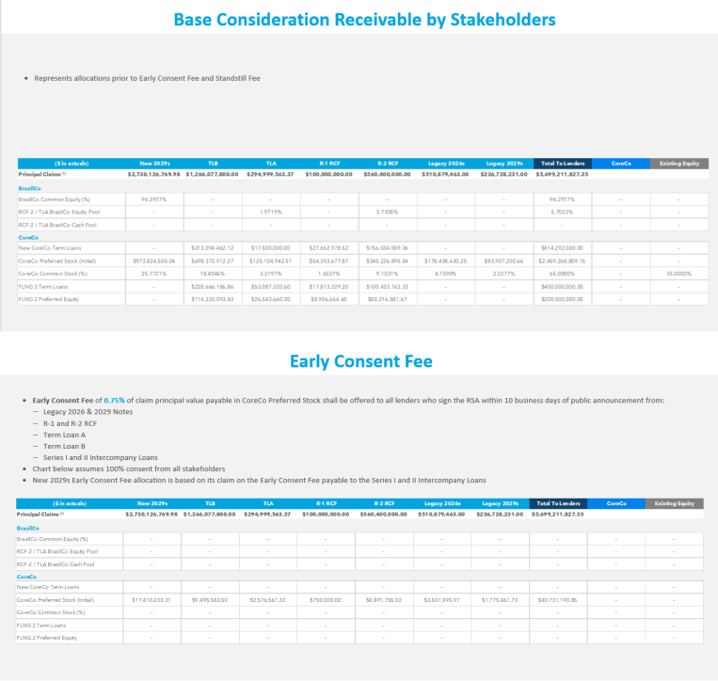

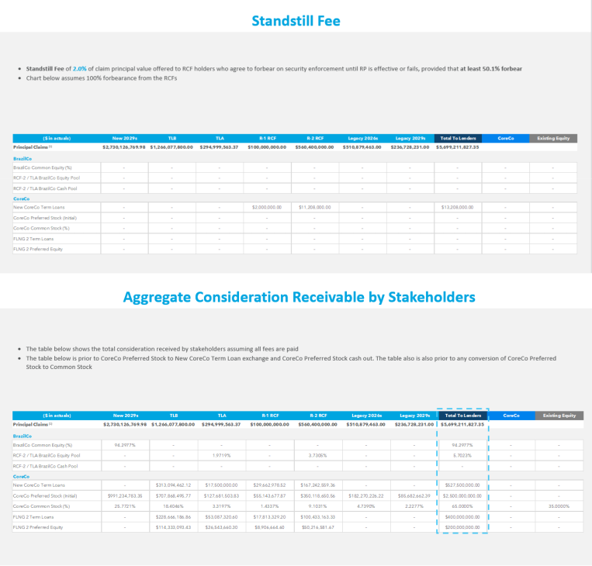

Exhibit B Specified Material Contracts

Omitted pursuant to Item 601(a)(5) of Regulation S-K

Exhibit C-1

New BrazilCo Parent Subsidiaries

- Barcarena Offshore Capital LLC

- CELBA – Centrais Elétricas Barcarena S.A.

- CELBA 2 – Centrais Elétricas Barcarena S.A.

- CH4 Energia Ltda

- Hygo Energy Transition Ltd.

- LNG Power Limited

- NFE Brazil Financing Limited

- NFE Brazil Holdings Limited

- NFE Brazil Holdings LLC

- NFE Power Brasil Participações S.A.

- NFE Power Comercializadora de Gás Natural Ltda.

- NFE Power Distribuidora de Gás Natural Ltda.

- NFE Power Latam Participações e Comércio Ltda.

- NFE Power SSLNG Participações Ltda.

- Portocem Geração de Energia S.A.

- Portocem Participações Ltda.

- Usina Teremeletrica de Lins S.A.

Exhibit C-2 CoreCo Subsidiaries

- Amaunet, S. de R.L. de C.V.

- American Energy Logistics Solutions LLC

- Atlantic Energy Holdings LLC

- Atlantic Pipeline Holdings SRL

- Bradford County Real Estate Holdings LLC

- Bradford County Development Holdings LLC

- Bradford County GPF Holdings LLC

- Bradford County GPF Partners LLC

- Bradford County LNG Marketing

- Bradford County Power Holdings LLC

- Bradford County Power Partners LLC

- Bradford County Real Estate Partners LLC

- Bradford County Transport Holdings LLC

- Bradford County Transport Partners LLC

- Clean Energy Services Limited

- Encanto East LLC

- Encanto Power West LLC

- Encanto West LLC

- Energy Transport Solutions LLC

- FLNG 1 Trading LLC

- FLNG 3 UK Holdings Limited

- FLNG Global Production Co. Limited

- FLNG Lakach GasCo Holdings Limited

- FLNG Lakach Upstream HoldCo Limited

- FLNG Lakach Upstream Parent Limited

- FLNG Lakach Upstream Topco Parent Limited

- Floating Infrastructure Holdings LLC

- Genera Management LLC

- Genera PR LLC

- Genera Services LLC

- Golar LNG Partners LP

- Golar Spirit Corporation

- Golar Winter Shipping Corp.

- Island LNG LLC

- KDI Wyalusing Holdings LLC

- KDI Wyalusing Power LLC

- Klondike Digital Infrastructure LLC

- LA Development Holdings LLC

- LA Real Estate Holdings LLC

- LA Real Estate Partners LLC

- LNG Holdings LLC

- Louisiana Development Holdings

- Mexico FLNG Onshore S. de R.L. de C.V.

- Mexico FLNG S. de R.L. de C.V.

- Naviera Ballena Azul S. de R.L. de C.V.

- New Fortress Energy Foundation Limited

- New Fortress Energy Holdings LLC

- New Fortress Energy Inc.

- New Fortress Energy Marketing LLC

- New Fortress Energy Servicios Mexico, S. de R.L. de C.V.

- New Fortress Intermediate LLC

- NFE Altamira FLNG S de RL de CV

- NFE Altamira Holdings LLC

- NFE Altamira Onshore S. de R.L. de C.V.

- NFE Altamira Pipeco S de RL de CV

- NFE Andromeda Chartering LLC

- NFE Angola Holdings LLC

- NFE Angola - Sociedade Unipessoal, Lda.

- NFE Atlantic Holdings LLC

- NFE BCS Holdings (A) LLC

- NFE BCS Holdings (B) LLC

- NFE BCS Mexico Holdings, S. de R.L. de C.V.

- NFE Bermuda Holdings Limited

- NFE BGE Consortium Project Company (Pty) Ltd

- NFE Brazil Funding LLC

- NFE Brazil Funding LP

- NFE Brazil Investments LLC

- NFE Equipment Holdings LLC

- NFE Equipment Partners LLC

- NFE Explorer LLC

- NFE Fast LNG Holdings LLC

- NFE Fast LNG Operations LLC

- NFE Financing LLC

- NFE FLNG 1 Issuer LLC

- NFE FLNG 2 LLC

- NFE FLNG 3 LLC

- NFE FLNG 4 LLC

- NFE FLNG 5 LLC

- NFE FLNG Management (Singapore) Pte. Ltd.

- NFE Frontier LLC

- NFE Gas Trading Limited

- NFE Ghana Holdings LLC

- NFE Ghana Partners LLC

- NFE Global Holdings Limited

- NFE Global Shipping LLC

- NFE GP LLC

- NFE Grand Shipping LLC

- NFE Honduras Holdings LLC

- NFE Innovation 1 LLC

- NFE Innovation 2 LLC

- NFE International Holdings

- NFE International Holdings 1 Limited

- NFE International Holdings 2 Limited

- NFE International Holdings Limited

- NFE International LLC

- NFE International Shipping LLC

- NFE Ireland Treasury Limited

- NFE ISO Holdings LLC

- NFE ISO Partners LLC

- NFE Jamaica GP LLC

- NFE Lakach Gasco FLNG S. de R.L. de C.V.

- NFE Liberty Shipping LLC

- NFE Logistics Holdings LLC

- NFE Management LLC

- NFE Marketing and Trading Limited

- NFE Mexico Holdings Parent S. à R.L.

- NFE Mexico Holdings S. à R.L.

- NFE Mexico Power Holdings Limited

- NFE Mexico Terminal Holdings Limited

- NFE Nicaragua Development Partners LLC

- NFE Nicaragua Development Partners LLC, Sucursal Nicaragua

- NFE Nicaragua Holdings LLC

- NFE North Infrastructure Limited

- NFE North Trading LLC

- NFE Pacifico LAP, S. de R.L. de C.V.

- NFE Patent Holdings LLC

- NFE Pathfinder LLC

- NFE Pioneer 1 LLC

- NFE Pioneer 2 LLC

- NFE Pioneer 3 LLC

- NFE Plant Development Holdings LLC

- NFE Power Mexico Soc. de Resp. Limitada de Capital Variable

- NFE Power PR LLC

- NFE PR Management LLC

- NFE SA Holdings (Pty) Ltd

- NFE SA Terminal (Pty) Ltd

- NFE Shannon Holdings Limited

- NFE South Power Buyback Holdings Limited

- NFE South Power Holdings LLC

- NFE South Power Trading Limited

- NFE Sub LLC

- NFE Transport Holdings LLC

- NFE Transport Partners LLC

- NFE UK Holdings Limited

- NFE Upstream Co., S. de R.L. de C.V.

- NFE US Holdings LLC

- NFE Vanguard LLC

- NFE Vessel Management LLC

- NFE Vessel Operations LLC

- NFEnergia GN de BCS, S. de R.L. de C.V.

- NFEnergia Honduras S de RL

- NFEnergía LLC

- NFEnergia Mexico, S. de R.L. de C.V.

- PA Development Holdings LLC

- PA Real Estate Holdings LLC

- PA Real Estate Partners LLC

- PATH Ltd

- Shannon LNG Energy Limited

- Shannon LNG Limited

- Soluciones de Energia Limpia PR LLC

- Tico Development Partners Holdings LLC

- Tico Development Partners LLC

- ZeroPark I LLC

- ZeroPark II LLC

- ZeroParks Holdings LLC

- ZeroParks Inc.

- ZeroParks Management LLC

- Zest Energia SCP

Exhibit D

CoreCo Governance Term Sheet

[See attached]

GOVERNANCE TERM SHEET FOR

NEW FORTRESS ENERGY INC. (“CORECO”)

March 17, 2026

The following term sheet (the “Term Sheet”) presents certain preliminary material terms in respect of the capital structure and corporate governance of New Fortress Energy Inc., a Delaware corporation (the “Company”), that would be reflected in the amended certificate of incorporation, amended bylaws and registration rights agreement, as applicable, (collectively, the “Organizational Documents”), of the Company to be amended or entered into and effective upon the consummation of the Restructuring (as defined in the RSA). Capitalized terms used and not defined herein shall have the meanings ascribed to them in the Restructuring Support Agreement (including the Restructuring Term Sheet attached thereto), dated as of March 17, 2026, by and among the Company and the other parties thereto (the “RSA”).

THIS TERM SHEET IS NOT LEGALLY BINDING OR AN EXHAUSTIVE LIST OF ALL THE TERMS AND CONDITIONS IN RESPECT OF THE STRUCTURE AND GOVERNANCE OF THE COMPANY NOR DOES IT CONSTITUTE AN OFFER TO SELL OR BUY, NOR THE SOLICITATION OF AN OFFER TO SELL OR BUY, ANY SECURITIES. ANY SUCH OFFER OR SOLICITATION SHALL ONLY BE MADE IN COMPLIANCE WITH ALL APPLICABLE LAWS. WITHOUT LIMITING THE GENERALITY OF THE FOREGOING, THIS TERM SHEET AND THE UNDERTAKINGS CONTEMPLATED HEREIN ARE SUBJECT IN ALL RESPECTS TO THE NEGOTIATION, EXECUTION AND DELIVERY OF DEFINITIVE DOCUMENTATION.

General:

Board of Directors:

The Company will remain a Delaware corporation managed by a board of directors (the “Board”), which will be responsible for overseeing the operation of the Company’s business. The Company will be managed on a day-to-day basis by its Chief Executive Officer and other senior executive officers with oversight from the Board.

The Board will be comprised of seven (7) directors, which shall initially be as follows as of the Restructuring Effective Date: (i) Wesley R. Edens; (ii) to the extent holders of Revolving Credit Facility Debt will receive at least seven percent (7%) of the voting equity of the Company in the Restructuring (pro forma for the Equity-for-Debt Exchange Election and CoreCo Preferred Stock Cash Purchase Election), one (1) director initially selected by holders of a majority of the outstanding Revolving Credit Facility Debt, which director (if any) must have knowledge of or experience in the industry and satisfy Nasdaq independence rules (it being understood that such director shall neither be an employee nor an Affiliate of any holder of Revolving Credit Facility

Debt); and (iii) the remaining five (5) directors (or (x) six

Common Stock:

Convertible Preferred Stock:

(6) directors if no director is selected pursuant to clause

- of this paragraph or (y) seven (7) directors if the size of the Board is increased to nine (9) directors pursuant to this paragraph) initially selected by holders of a majority of the outstanding Term Loan B Debt (the “Majority TLB Holders”) and holders of a majority of the outstanding 2029 New Notes Debt (the “Majority 2029 New Notes Holders”), the composition of which would satisfy Nasdaq independence rules (including committee composition) (it being understood that the directors appointed by the Majority TLB Holders and Majority 2029 Holders shall neither be employees nor Affiliates of any holder of Term Loan B Debt or 2029 New Notes Debt). Upon receiving the prior written consent (email from counsel being sufficient) from each of (i) the Majority TLB Holders, (ii) the Majority 2029 New Notes Holders and (iii) holders of a majority of the outstanding Revolving Credit Facility Debt, the size of the Board may be increased such that as of the Restructuring Effective Date the Board will be comprised of up to nine (9) directors. The members of the Board shall serve until the Company’s next annual meeting following the Restructuring Effective Date subject to a director’s earlier resignation, removal, death or incapacity (the “Initial Term”).

Following expiration of the Initial Term, the entire Board will be nominated/elected in accordance with standard public company board procedures (i.e. no ongoing right to serve; elected by majority vote of stockholders).

There shall be no cumulative voting for directors. The Board shall not be staggered or classified.

One class of voting common stock, par value $0.01 per share (each such share, a “Common Share” and each holder thereof, a “Common Holder”).

One class of voting preferred stock, par value $0.01 per share (each such share, a “Preferred Share” and each holder thereof, a “Preferred Holder” and, together with the Common Holders, the “Holders”), having such designations, preferences, limitations and relative rights, including preferences over the Common Shares with

respect to dividends and distributions, in each case, as

shall be set forth in the CoreCo Preferred Stock Term Sheet.

The Preferred Holders shall have the right to vote their Preferred Shares on an as-converted basis, and the Preferred Shares shall vote together with the Common Shares on all matters submitted to the Holders for approval.

Registration Rights: Each Supporting Creditor to have customary registration rights for any Common Shares and Preferred Shares (including the Common Shares underlying the Preferred Shares) to be provided for in a registration rights agreement (the “RRA”), including:

- S-1 Resale Shelf. The Company shall use commercially reasonable efforts to, on or as soon as reasonably practicable after the Restructuring Effective Date, but in no event greater than 10 business days after the Restructuring Effective Date:

- file a registration statement to register all of the Common Shares and Preferred Shares (including the Common Shares underlying the Preferred Shares) (such Common Shares and Preferred Shares (including the Common Shares underlying the Preferred Shares), together with any securities issued or issuable in respect of such shares by way of conversion, exchange, stock dividend, split or combination, recapitalization, merger, consolidation or otherwise, the “Registrable Securities”) on a shelf registration statement (the “S-1 Resale Shelf”) on Form S-1 or applicable successor form (“Form S-1”), and it shall use its commercially reasonable efforts to have the S-1 Resale Shelf declared effective as soon as practicable after the filing thereof, but no later than thirty (30) calendar days after the filing thereof (or ninety (90) calendar days after the filing

thereof if the SEC notifies the Company that it will “review” the S-1 Resale Shelf); provided that any Registrable Securities shall cease to be Registrable Securities on the first date that (i) all such securities shall have become freely tradable under Rule 144 or applicable successor rule (“Rule 144”) under the Securities Act of 1933, as amended (the “Securities Act”) without a holding period, current public information requirement, limitation on volume, manner of sale restrictions or notice requirements and (ii) any and all securities law restrictive legends or designations associated with such shares have been removed. The S-1 Resale Shelf shall provide for offerings on a delayed or continuous basis pursuant to Rule 415 under the Securities Act or applicable successor rule (“Rule 415”).

The Company shall use commercially reasonable efforts to prepare and file such amendments, post-effective amendments and supplements to the S-1 Resale Shelf as may be necessary to keep the S-1 Resale Shelf effective until the earlier of

  - the date that no Registrable Securities remain,

  - the date that all Registrable Securities have been sold pursuant to Rule 144 or a registration statement or (3) the date the S-3 Resale Shelf (as defined below) has become effective.

- S-3 Registration. Once the Company is eligible to file a shelf registration statement on Form S-3 (“Form S-3”), the Company shall use commercially reasonable efforts to, as promptly as practicable, file a registration statement under the Securities Act on Form S-3 (or similar or successor form) (“S-3 Resale Shelf”), covering the remaining Registrable Securities that have not been sold pursuant to Rule 144 or a registration statement. The Company shall use

commercially reasonable efforts to prepare and make all such filings as may be necessary to keep the S-3 Resale Shelf effective until the earlier of (1) the date that no Registrable Securities remain and (2) the date that all such Registrable Securities have been sold pursuant to Rule 144 or a registration statement. The applicable Holders shall have the right to request an unlimited number of registrations on Form S-3.

- Shelf Takedowns. If requested by holders of Registrable Securities representing at least 10% of the then-outstanding Registrable Securities, the Company shall conduct a shelf takedown off of the S-1 Resale Shelf or S-3 Resale Shelf, as applicable, covering Common Shares and, if applicable, Preferred Shares requested by such holders (a “Takedown Request”); provided that the Company shall not be obligated to have to undertake more than five shelf takedowns in the aggregate and no more than two shelf takedowns in any twelve-month period. Such holders may specify the type of offering to be covered by the Takedown Request, such as an underwritten offering or registered block trade.

- Piggyback Registration. Each Holder of Registrable Securities representing at least 5% of the then-outstanding Registrable Securities will have the right to include its Preferred Shares and Common Shares each time the Company proposes for any reason to register the Preferred Shares and/or Common Shares under the Securities Act. The rights to piggyback registration may be exercised an unlimited number of occasions. The rights to piggyback registration will be subject to usual and customary exceptions and limitations (including, without limitation, as to exceptions employee plan S-8 filings and acquisition transactions and as to limitations, selection of underwriters, priority and cutbacks).

DTC

Listing:

- Other Provisions. The RRA will also contain customary provisions relating to the registration procedures to be followed by the Company, indemnification obligations, delay and suspension rights, selection of underwriters, priority, cutbacks, lock-ups (to the extent requested by an applicable underwriter) and payment of expenses of registrations by the Company (including reasonable fees and disbursements of one counsel for the selling holders of Registrable Securities, but excluding underwriter discounts and commissions.

The Common Shares and Preferred Shares shall be DTC-Eligible and issued through DTC other than any Common Shares and Preferred Shares required to bear a “restricted” legend under applicable securities laws (which shall be issued through DTC under a restricted CUSIP if feasible and otherwise, in book entry form). The Company shall use commercially reasonable efforts to remove any such restricted legends when permitted under applicable securities laws, including obtaining any necessary legal opinions.

Following the occurrence of the Restructuring Effective Date, the Company will use its commercially reasonable efforts to continue as an SEC public reporting company.

The RRA will provide that, after the Restructuring Effective Date, if the Common Shares and Preferred Shares are not then listed on the Nasdaq Global Select Market or another National Securities Exchange (as defined below), the holders of a majority of the number of Preferred Shares outstanding on the Restructuring Effective Date can require the Company to use commercially reasonable efforts to cause the Common Shares and, after the Company satisfies applicable listing standards, the Preferred Shares, to be listed on a National Securities Exchange as promptly as reasonably practicable.

“National Securities Exchange” means The New York Stock Exchange, The Nasdaq Global Select Market or the Nasdaq Global Market.

Board Vacancies:

Chairperson of the Board:

Board Committees:

Board Observers:

Transfer Restrictions:

Amendments:

Upon the resignation, removal with or without cause, death or incapacity of a director, the vacancy resulting from such resignation, removal with or without cause, death or incapacity of a director shall be filled by the majority of directors then in office, in each case, to serve until the next annual meeting of stockholders.

The Chairperson of the Board shall be an independent director initially selected collectively by the Majority TLB Holders and Majority 2029 New Notes Holders. Thereafter, the Chairperson will be determined by a majority vote of the Board; provided, that (i) such Chairperson will not also serve as the Chief Executive Officer and (ii) the initial Chairperson shall be selected from the five (5) directors selected by the Majority TLB Holders and Majority 2029 New Notes (or (x) six (6) directors if no director is selected pursuant to clause (ii) of the first paragraph of Board of Directors above, or (y) seven (7) directors if the size of the Board is increased to nine (9) directors pursuant to the first paragraph of Board of Directors above) and at all times shall be an independent director in accordance with SEC and Nasdaq independence rules.

The composition of any committee of the Board will be subject to agreement by a majority of the Board, subject to compliance with SEC and Nasdaq independence requirements.

Initially, there shall be no Board observers.

The Common Shares and Preferred Shares shall be freely transferable following the Restructuring Effective Date, subject to compliance with applicable securities laws as determined by the Company with the consent of the Majority Supporting Creditors (not to be unreasonably withheld, conditioned or delayed). For the avoidance of doubt, the Common Shares and Preferred Shares shall not be subject to any ROFR/ROFO, preemptive rights, tag-along rights, drag-along rights or any similar restrictions.

The Organizational Documents will not be amended, modified or waived without the approval of a majority of the issued and outstanding equity on an as-converted basis, unless a greater percentage is required under applicable law or the rules and regulations of any National Securities Exchange or quotation system on which the Company’s securities are listed or
quoted for

trading. Amendments to the amending provisions in the

Holder Approvals:

Other Terms:

Organizational Documents shall require approval by two-thirds of the issued and outstanding equity on an as-converted basis.

Other Holder approvals only as required by Delaware law (i.e., mergers/sale of substantially all assets).

The Organizational Documents will also provide for other customary terms, including, without limitation, the time, place and manner of calling of regular and special meetings of Holders and the Board, actions may be taken by the Board or stockholders without a meeting by written consent, the titles and duties of officers of the Company and the manner of appointment, removal and replacement thereof, and indemnification and exculpation of directors, officers and other

appropriate

persons.

Exhibit E

New CoreCo Credit Facility Term Sheet

[See attached]

New CoreCo Credit Facility Term Sheet Summary of Principal Terms and Conditions Senior Secured Term Loan Facility

This summary constitutes the New CoreCo Credit Facility Term Sheet delivered pursuant to that certain Restructuring Support Agreement (the “RSA”), dated as of March 17, 2026, entered into by and among New Fortress Energy Inc., each of the other company parties party thereto, and each of the supporting creditors party thereto. Certain capitalized terms used and not defined herein are defined in the RSA.

Borrower:

Agent and Lenders:

Facility:

New Fortress Energy Inc., a Delaware corporation (the “Borrower”).

Wilmington Trust, National Association will act as sole administrative agent and collateral agent for the New CoreCo Credit Facility (in such capacities, the “Agent”) for a syndicate of banks, financial institutions and other institutional lenders as described in the RSA or otherwise reasonably acceptable to the Borrower (the “Lenders”, and, together with the Agent, the “Secured Parties”), subject to customary exclusions for disqualified lenders, and will perform the duties customarily associated with such roles.

A senior secured term loan facility (the “New CoreCo Credit Facility,” and the loans made thereunder, the “New CoreCo Term

Loans”), in an aggregate principal amount equal to the sum of (w) up to $475 million, (x) $52.5 million of FEMA Make Whole

Incremental New CoreCo Term Loans incurred, (y) the aggregate principal amount of the Incremental Equity-for-Debt Exchange

Election New CoreCo Term Loans and (z) solely to the extent necessary to meet the Minimum Liquidity Condition on the Restructuring Effective Date, up to $35 million of Capital Raise New CoreCo Term Loans.

New CoreCo Term Loans will be incurred by the Borrower on the Restructuring Effective Date (the “Take-Back Loans”) and applied to refinance, on a cashless basis, certain of the loans and other obligations outstanding under the Revolving Credit Facility Agreement and the Term Loan B Agreement.

Amounts borrowed under the New CoreCo Credit Facility that are repaid or prepaid may not be reborrowed.

Interest Rates: The New CoreCo Term Loans will bear interest at a fixed rate per annum equal to Term SOFR plus 6.125% (the “Cash Rate”).

At the Borrower’s option, during the period commencing on the Restructuring Effective Date and ending on the last day of the first full fiscal quarter ending after the 18-month anniversary of the Restructuring Effective Date (the “PIK Election Period”), the next scheduled interest payment may be paid in kind rather than in cash, which will be capitalized and added to the outstanding principal amount of the New CoreCo Term Loans, at a rate equal

to the Cash Rate plus 150 basis points, compounding at the end of

Mechanics for Interest Payments and

Computations:

Default Rate:

Maturity and Amortization:

Guarantees:

the applicable interest period (but at least quarterly) (the “PIK Option”). The PIK Option shall not be available if any Event of Default has occurred and is continuing.

The Borrower shall provide written notice to the Agent of its election to pay interest in kind at least five (5) Business Days prior to the applicable interest payment date.

All interest on the New CoreCo Term Loans, whether paid in cash or paid in kind, will be payable in arrears on the last day of each interest period (but at least quarterly) or, if such day is not a business day, the next succeeding business day. The Borrower shall have a customary base rate option and may otherwise select a customary SOFR interest period of 1, 3, or 6 months.

In accordance with the Documentation Principles.

All outstanding principal and accrued and unpaid interest and fees under, or in respect of, the New CoreCo Credit Facility, upon the occurrence and during the continuance of any event of default thereunder shall bear interest payable on demand at a rate that is 2.00% per annum in excess of the interest rate otherwise payable with respect to the New CoreCo Term Loans.

The Take-Back Loans shall be repaid in full on the date that is five

(5) years after the Restructuring Effective Date (the “Maturity Date”).

The Take-Back Loans will amortize at a rate of 1% per annum, paid quarterly.

The definitive documentation implementing the New CoreCo Credit Facility (the “Facility Documentation”) will contain customary “amend and extend” provisions consistent with the Documentation Principles pursuant to which Borrower, with the approval of consenting Lenders, may extend the loans of such consenting Lenders and, in connection therewith, amend the interest rates, yield, fees, amortization (so long as the maturity and weighted average life to maturity is not shortened) and prepayment provisions applicable to such extended loans. Such extensions shall not be subject to any financial tests or “most-favored nation pricing provisions.” The Facility Documentation may be amended with respect to such extended loans by the Borrower, the Agent and such consenting Lenders.

All obligations of the Borrower under the New CoreCo Credit Facility will be unconditionally guaranteed (the “Guarantees”) by each existing and subsequently acquired or organized, direct and indirect subsidiary of the Borrower (the “Guarantors”, and, together with the Borrower, the “CoreCo Loan Parties”), subject to the Documentation Principles and certain customary exclusions.

 |  | Notwithstanding the Documentation Principles or anything to the contrary, none of the following entities shall be required to be a Guarantor
 |  | on the Agreement Effective Date or the Restructuring Effective Date: (i) NFE FLNG2 LLC, a Delaware limited liability company, (ii)
 |  | Mexico FLNG Onshore S. de R.L. de C.V., a sociedad de responsabilidad limitada de capital variable organized under the laws of Mexico,
 |  | (iii) NFE Altamira Onshore, S. de R.L. de C.V., a sociedad de responsabilidad limitada de capital variable as organized under the laws of
 |  | Mexico, and (iv) NFE South Power Trading Limited, a Jamaican limited company and (v) each entity that is listed on Schedule 1 hereto
 |  | (each entity in this clause, a “Dissolving Entity”) as such Schedule is initially populated (if at all) and may be updated from time to time by
 |  | the Borrower, in each case, with the prior written consent of the Supporting Creditors holding greater than 50% of the aggregate principal
 |  | amount of all Debt held by the Supporting Creditors (such consent not to be unreasonably withheld, conditioned or delayed); provided that
 |  | each Dissolving Entity organized in the United States shall be dissolved or otherwise wound up on or prior to the date that is 30 days from
 |  | the Restructuring Effective Date and, each Dissolving Entity organized outside the United States shall be dissolved or otherwise wound up
 |  | or the paperwork to dissolve or wind up shall have been filed on or prior to the date that is 60 days from the Restructuring Effective Date
 |  | (each, respectively, a “Dissolution Deadline”). Any Dissolving Entity that is not dissolved, wound up or for which the paper work has not
 |  | been filed by the Dissolution Deadline shall become a Guarantor within 60 days thereafter in accordance with the guaranty and collateral
 |  | requirements set forth in the Facility Documentation. It is understood and agreed that any Dissolving Entity may be wound up prior to the
 |  | Restructuring Effective Date.
 |  | The Subsidiaries that are listed on Schedule 1 as initially populated (if at all) and identified as a “Migrating Entity” therein (as may be
 |  | updated from time to time by the Borrower, in each case, with the prior written consent of the Supporting Creditors holding greater than
 |  | 50% of the aggregate principal amount of all Debt held by the Supporting Creditors (such consent not to be unreasonably withheld,
 |  | conditioned or delayed)) may be migrated to, re-domiciled to or otherwise converted to an entity in any jurisdiction of organization of any
 |  | other Guarantor on or prior to the date that is 60 days after the Restructuring Effective Date. Each Migrating Entity shall become a
 |  | Guarantor within 60 days thereafter in accordance with the guaranty and collateral requirements set forth in the Facility Documentation.
Security: |  | The Borrower’s obligations under the New CoreCo Credit Facility, and the Guarantors’ Guarantees, will be secured by first-priority liens
 |  | (subject to the exception described below and liens securing
 |  | the New CoreCo LC Facility) on all of the assets of the Borrower

 |  |  |  |  |  |  | and the Guarantors, whether now or hereafter existing or acquired, other than any Excluded Assets (as defined below), subject to
 |  |  |  |  |  |  | the Documentation Principles and certain customary exceptions to be set forth in the Facility Documentation (the “Collateral”).
 |  |  |  |  |  |  | Notwithstanding the Documentation Principles or anything to the contrary, the Collateral shall not include (i) the FLNG2 Collateral
 |  |  |  |  |  |  | (as defined in the Term Loan B Agreement) to the extent such FLNG 2 Collateral constitutes “Collateral” under the FLNG 2 Term
 |  |  |  |  |  |  | Loan Facility and (ii) other assets to be agreed (collectively, the “Excluded Assets”).
 |  |  |  |  |  |  | Subject to the Documentation Principles, the obligations under the New CoreCo Credit Facility will be secured by the Collateral on
 |  |  |  |  |  |  | a junior basis to the liens securing the obligations under the New CoreCo LC Facility (as defined in the Restructuring Term Sheet).
 |  |  |  |  |  |  | The liens on the Collateral securing the New CoreCo Credit Facility will be first-priority liens, subject to the Documentation
 |  |  |  |  |  |  | Principles, permitted liens and certain customary exceptions to be set forth in the Facility Documentation, and will be subject to a
 |  |  |  |  |  |  | customary intercreditor agreement with respect to the liens securing the New CoreCo LC Facility (which liens shall be super
 |  |  |  |  |  |  | priority).
Mandatory Prepayments: |  |  |  |  |  |  | The Facility Documentation will contain provisions related to mandatory prepayments with the net cash proceeds of non-ordinary
 |  |  |  |  |  |  | course asset sales (other than any Specified Asset Sale, which carve-out shall only apply to proceeds from any Specified Asset Sale
 |  |  |  |  |  |  | up to an amount to be agreed by the Borrower and Lenders) and casualty and condemnation events and proceeds from FEMA
 |  |  |  |  |  |  | claims in excess of $140 million must be used to prepay New CoreCo Term Loans. The CoreCo Loan Parties shall have no
 |  |  |  |  |  |  | reinvestment rights. Mandatory prepayments will not be subject to any payment penalty or premium.
Optional Prepayments: |  |  |  |  |  |  | At any time at the option of the Borrower upon not less than three
 |  |  |  |  |  |  | (3) business days’ prior written notice, New CoreCo Term Loans may be prepaid in whole or in part, without premium or penalty
 |  |  |  |  |  |  | (except as set forth in the next sentence), in minimum amounts to be mutually agreed and subject to reimbursement of the Lenders’
 |  |  |  |  |  |  | redeployment costs in the case of a prepayment of prior to the last day of any relevant interest period.
Call Protection: |  |  |  |  |  |  | Soley with respect to any optional prepayment, 102 for the first year; par thereafter.
Application of Prepayments: |  |  |  |  |  |  | Optional prepayments to be applied at the election of the Borrower and otherwise usual and customary for facilities of this type and
 |  |  |  |  |  |  | consistent with the Documentation Principles.
Documentation Principles: |  |  |  |  |  |  | The Facility Documentation will be consistent with this Term
 |  |  |  |  |  |  | Sheet and, except as otherwise mutually agreed by Borrower and the Lenders, based on the Term Loan B Agreement (without
 |  |  |  |  |  |  | giving

 |  |  |  | effect to any forbearance agreements or other modifications after its initial effectiveness); provided that the Facility Documentation
 |  |  |  | shall reflect (a) the provisions of this Term Sheet, (b) in relation to any matter that is not or only partially dealt with in this Term Sheet
 |  |  |  | or the RSA, provisions that are generally consistent with the RSA and the corresponding provisions of the Term Loan B Agreement,
 |  |  |  | with changes (which may be significant) to reflect the technical aspects of the New CoreCo Credit Agreement, the financial position
 |  |  |  | and ratings of the Borrower as of the Restructuring Effective Date, any applicable changes in law, operational, administrative and
 |  |  |  | mechanical requirements, customary minority Lender protections (including with respect to liability management transactions and
 |  |  |  | other non-ratable transactions) and additional updates reasonably requested by the Lenders or required by the RSA, and (c) the
 |  |  |  | appropriate modification of any provision in the Term Loan B Agreement that expressly relates to any asset-specific treatment of
 |  |  |  | “FLNG1 Collateral”, “FLNG2 Collateral” or any component thereof.
 |  |  |  | Notwithstanding anything to the contrary contained herein, the Borrower and its subsidiaries shall be required to enter into all
 |  |  |  | definitive documentation (including the creation or perfection of any security interest) governed by the laws of a jurisdiction outside of
 |  |  |  | the United States by the date that is 90 days after the initial funding of any New CoreCo Term Loans (subject to any extensions as
 |  |  |  | agreed by the Agent in its sole discretion and exceptions as to scope of foreign security and perfection requirements as agreed by the
 |  |  |  | Agent in its reasonable discretion).
 |  |  |  | One or more intercreditor agreements (each, a “CoreCo Intercreditor Agreement”) will be substantially consistent with the terms of
 |  |  |  | the existing Equal Priority Intercreditor Agreement (as defined in the Term Loan B Agreement), with updates to reflect the super
 |  |  |  | priority nature of the New CoreCo LC Agreement, and if applicable, the junior priority nature of the Capital Raise New CoreCo Junior
 |  |  |  | Term Loans. With respect to routine administrative matters, collateral extensions and similar ministerial actions related to the shared
 |  |  |  | collateral subject to any CoreCo Intercreditor Agreement, any consent, approval or direction given by the administrative agent and/or
 |  |  |  | collateral agent under the New CoreCo LC Agreement shall be deemed to constitute the consent, approval or direction of the
 |  |  |  | Administrative Agent and/or Collateral, as applicable, for such purposes, without the need to obtain separate consent from the Agent.
 |  |  |  | The foregoing provisions are, collectively, the “Documentation Principles.”
Limited Condition Transactions: |  |  |  | The Facility Documentation will contain provisions related to Limited Condition Transactions solely for asset sales in
 |  |  |  | accordance with the Documentation Principles.

Representations and Warranties: |  |  |  |  |  |  | The Facility Documentation will contain customary representations and warranties for similar credit facilities of this size, type and
 |  |  |  |  |  |  | purpose applicable to the CoreCo Loan Parties, including, without limitation, the following (subject to customary qualifications and
 |  |  |  |  |  |  | exceptions to be agreed by the Lenders and Borrower):
 |  |  |  |  |  |  | Financial condition; No change;
 |  |  |  |  |  |  | Existence and compliance with law;
 |  |  |  |  |  |  | Power, authorization and enforceable obligations; No legal bar;
 |  |  |  |  |  |  | No material litigation; No default;
 |  |  |  |  |  |  | Ownership of property and liens; Intellectual property rights; Taxes;
 |  |  |  |  |  |  | Federal regulations; Labor matters; ERISA;
 |  |  |  |  |  |  | Investment Company Act; Subsidiaries;
 |  |  |  |  |  |  | Use of proceeds; Environmental matters; Accuracy of information, etc.; Security documents;
 |  |  |  |  |  |  | Solvency;
 |  |  |  |  |  |  | Anti-money laundering, anti-corruption laws and sanctions; and
 |  |  |  |  |  |  | Insurance.
Conditions Precedent to Borrowing: |  |  |  |  |  |  | The Facility Documentation will contain conditions precedent to the funding of New CoreCo Term Loans in accordance with the
 |  |  |  |  |  |  | RSA and shall include:
 |  |  |  |  |  |  | (a) the execution and delivery of definitive Facility Documentation evidencing the New CoreCo Credit Agreement;

 |  |  | (b) delivery of satisfactory legal opinions; corporate formation and authority documents; officers’ and secretaries’ certificates;
 |  |  | borrowing notices and other customary closing documents;
 |  |  | (c) the representations and warranties in the Facility Documentation being true and correct in all material respects;
 |  |  | (d) the Restructuring Conditions Precedent shall have occurred or shall occur substantially concurrently therewith; and
 |  |  | (e) the consummation or effectiveness of the Restructuring Plan and the Chapter 15 Proceedings.
Affirmative Covenants: |  |  | The Facility Documentation will contain customary affirmative covenants for similar credit facilities of this size, type and purpose
 |  |  | applicable to the CoreCo Loan Parties in accordance with the Documentation Principles, including, without limitation, the following
 |  |  | (subject to customary qualifications and exceptions to be agreed by the Lenders and Borrower):
 |  |  | Financial statements;
 |  |  | Certificates and other information; Payment of taxes;
 |  |  | Conduct of business, maintenance of existence and compliance with law;
 |  |  | Maintenance of property and insurance;
 |  |  | Inspection of property, books and records and discussions; Notices;
 |  |  | Environmental laws; Plan compliance;
 |  |  | Additional Guarantors, additional Collateral and Collateral limitations;
 |  |  | Further assurances;
 |  |  | Post-closing covenants; and Use of proceeds.
Negative Covenants: |  |  | The Facility Documentation will contain customary negative covenants for similar credit facilities of this size, type and purpose
 |  |  | applicable to the CoreCo Loan Parties in accordance with the Documentation Principles, including, without limitation, the following
 |  |  | (subject to (i) customary qualifications and exceptions to be agreed by the Lenders and Borrower and (ii) the elimination of the
 |  |  | baskets and carve outs set forth therein, other than general
 |  |  | de minimis baskets and other baskets and carve outs to be agreed by the Lenders and the Borrower that are necessary or advisable

for the CoreCo Loan Parties to run their business in the ordinary course of business:

Restricted payments; provided that there shall be a basket for (i) to the extent constituting a restricted payment, investments in NFE FLNG2 LLC consisting of obligations of NFE FLNG2 LLC owed to the CoreCo Loan Parties in respect of management services and payment of costs and expenses provided to NFE FLNG2 LLC and

- the declaration and payment of regular dividends or distributions to holders of the CoreCo Preferred Stock for so long as such preferred stock is outstanding and solely to the extent that the payment of such dividends is required by the terms of such CoreCo Preferred Stock, provided, further, that the amount of such dividends or distributions are not increased from the amounts of such dividends or distributions in effect or otherwise authorized on the Restructuring Effective Date;

Dividend and other payment restrictions affecting restricted subsidiaries;

Incurrence of indebtedness; provided that there shall be an exception for:

- indebtedness represented by the New CoreCo LC Agreement;

- the incurrence of indebtedness, disqualified stock or preferred stock owing to holders of the CoreCo Preferred Stock;

- the incurrence of indebtedness represented by the Capital Raise New CoreCo Junior Term Loans, to the extent additional capital is necessary to satisfy the Minimum Liquidity Condition on the Restructuring Effective Date; and

- purchase money indebtedness and finance leases in an aggregate principal amount not to exceed an amount to be agreed between the Borrower and Lenders.

- Asset sales;

- Transactions with affiliates; provided that there shall be an exception for any transactions for services provided by the Borrower or its subsidiaries to NFE FLNG2 LLC in accordance with the Definitive Documents;

- Liens; provided that there shall be an exception for:

- Liens incurred by the Borrower or its Restricted Subsidiaries to secure the New CoreCo LC Agreement;

- Liens securing permitted purchase money indebtedness or finance leases; and

- junior priority Liens securing the Capital Raise New CoreCo Junior Term Loans; provided that such Liens shall be subject to a customary intercreditor agreement.

Ratings Requirement:

Financial Maintenance Covenant:

Events of Default:

(g) Merger, consolidation or sale of all or substantially all assets.

The Facility Documentation shall permit the CoreCo MIP, the FLNG-2 MIP and the transactions contemplated by the CoreCo–FLNG 2 Management Agreement. The Facility Documentation shall permit all actions, matters and circumstances that exist as of the Restructuring Effective Date and have been declared to the Lenders prior to such time. The Facility Documentation shall permit (w) each of the transactions contemplated by that certain document titled “Term Sheet Summary of Principal Terms and Conditions,” dated as of March 17, 2026, relating to the loans under that certain EB-5 Loan Agreement, dated as of July 21, 2023, between ZeroPark I LLC and the lender referred to therein (the “ZeroParks Term Sheet”), including, for the avoidance of doubt, the incurrence of indebtedness further described therein in an aggregate amount not to exceed $22.5 million, (x) each of the transactions contemplated by that certain document titled “Indicative Terms and Conditions for Operating Equipment Lease”, dated as of March 4, 2026 (the “Turbine and Intermediation Facility Term Sheet”), including, for the avoidance of doubt, the increase in the aggregate amounts under the LNG Facility (as defined in the Turbine and Intermediation Facility Term Sheet) further described therein in an aggregate amount not to exceed $200 million and (y) the Borrower and its Subsidiaries to sell or finance (on a secured or unsecured basis) the instrument issued in respect of the Net BrazilCo—CoreCo Intercompany Claim (such transactions described in these clauses (w), (x) and (y), the “Specified Asset Sales”).

The Borrower shall use commercially reasonable efforts to obtain within 90 days following the Closing Date or as soon as reasonably practicable thereafter and maintain a public or private corporate credit rating (but not obtain or maintain a specific rating) of the New CoreCo Credit Facility from two of Moody’s, Fitch and S&P.

None.

The Facility Documentation will contain customary events of default for similar credit facilities of this size, type and purpose in accordance with the Documentation Principles, including, without limitation, the following (subject to customary qualifications and exceptions to be agreed by the Lenders and Borrower):

Failure to pay amounts when due; Incorrect representations or warranties;

Failure to perform or observe any covenants contained in the Facility Documentation;

Cross-acceleration under any instrument representing, issuing or securing material indebtedness or guarantees for borrowed money;

 |  |  | Failure to pay non-appealable material judgments; Bankruptcy, insolvency and winding up;
 |  |  | ERISA violations;
 |  |  | Failure to maintain perfected and enforceable liens; Failure to maintain enforceable guarantees;
 |  |  | Assertion of invalid of unenforceable security document; and
 |  |  | Change of control.
Unrestricted Subsidiaries: |  |  | The Facility Documentation will contain provisions governing designation of and transactions with unrestricted subsidiaries, in each
 |  |  | case, in accordance with the Documentation Principles. As of the Restructuring Effective Date, the Unrestricted Subsidiaries will
 |  |  | include:
 |  |  | NFE South Power Buyback Holdings Limited, a Jamaican limited company, and each of its subsidiaries;
 |  |  | NFE FLNG2 LLC, a Delaware limited liability company, and each of its subsidiaries; and
 |  |  | ZeroPark 1 LLC, a Delaware limited liability company
Voting: |  |  | The Facility Documentation will contain customary provisions governing amendments and waivers for similar credit facilities of
 |  |  | this size, type and purpose, including, without limitation, required consent of:
 |  |  | with respect to any amendment, modification or waiver of any provision of the application of proceeds, each Lender directly
 |  |  | affected by such amendment, modification or waiver;
 |  |  | with respect to the creation of (x) a new debt basket not to exceed
 |  |  | $350 million so long as the net cash proceeds thereof are applied to the amounts payable under the form contract for the supply of
 |  |  | natural gas to FLNG1 (the “FLNG1 Debt Basket”), (y) a new lien basket for senior Liens on FLNG1 Collateral securing the
 |  |  | FLNG1 Debt Basket or (z) a basket not to exceed an amount to be agreed between the Borrower and Majority Supporting Creditors
 |  |  | for bona fide business transactions (including the incurrence of Indebtedness and granting Liens) in relation to the Borrower’s and
 |  |  | any of its Subsidiaries’ operations in certain jurisdictions disclosed to the Majority Supporting Creditors prior to the Agreement
 |  |  | Effective Date (“Operations Basket”) (each of clauses (x), (y) and (z), a “Specified Basket”), the Super Majority Lenders (to be
 |  |  | defined as the Lenders holding more than 75% of the aggregate principal amount of all New CoreCo Term Loans);
 |  |  | with respect to the creation of any new debt basket or lien basket (other than any Specified Basket), the Super Majority Lenders;

 |  |  |  |  |  |  |  |  |  |  | with respect to any waiver of all affirmative and negative covenants, each Lender;
 |  |  |  |  |  |  |  |  |  |  | with respect to any amendment, modification or waiver of the provisions on releases of collateral and guarantees, to the extent such
 |  |  |  |  |  |  |  |  |  |  | amendment, modification or waiver would permit the release of all or substantially all of the Collateral, any Subsidiary from a
 |  |  |  |  |  |  |  |  |  |  | Guarantee (unless otherwise specifically permitted by the terms of the Facility Documentation) or all or substantially all of the
 |  |  |  |  |  |  |  |  |  |  | value of the Guarantees, each Lender;
 |  |  |  |  |  |  |  |  |  |  | other than any Specified Basket, with respect to any amendment, modification or waiver that (A) subordinates, or has the effect of
 |  |  |  |  |  |  |  |  |  |  | subordinating, the Obligations under the New CoreCo Credit Facility to any other Indebtedness, each Lender or (B) subordinates
 |  |  |  |  |  |  |  |  |  |  | the Lien of the Agent in all or substantially all of the Collateral in any transaction or series of related transactions, each Lender; and
 |  |  |  |  |  |  |  |  |  |  | with respect to any amendment, modification or waiver that (A) decreases any interest rates or fees, (B) changes final maturity, (C)
 |  |  |  |  |  |  |  |  |  |  | changes to the form of interest payment (e.g., cash or PIK) or (D) changes the definition of “Required Lenders” (or such correlative
 |  |  |  |  |  |  |  |  |  |  | term) or the terms of this section, in each case, each Lender.
Cost and Yield Protection: |  |  |  |  |  |  |  |  |  |  | In accordance with the Documentation Principles.
Assignments and Participations: |  |  |  |  |  |  |  |  |  |  | In accordance with the Documentation Principles.
Expenses and Indemnification: |  |  |  |  |  |  |  |  |  |  | In accordance with the Documentation Principles.
Governing Law and Forum: |  |  |  |  |  |  |  |  |  |  | New York

1.

Schedule 1

Omitted pursuant to Item 601(a)(5) of Regulation S-K

Exhibit F

FLNG 2 Term Loan Term Sheet

[See attached]

FLNG 2 Term Loan Term Sheet Summary of Principal Terms and Conditions

$400 Million Senior Secured Term Loan Facility

This summary constitutes the FLNG 2 Term Loan Term Sheet delivered pursuant to that certain Restructuring Support Agreement (the “RSA”), dated as of March 17, 2026, entered into by and among New Fortress Energy Inc. (“NFE”), each of the other company parties party thereto, and each of the supporting creditors party thereto. Certain capitalized terms used and not defined herein are defined in the RSA.

Borrower:

Agent and Lenders:

Facility:

Interest Rate:

Mechanics for Interest Payments and Computations:

Default Rate:

Maturity and Amortization:

Guarantees:

NFE FLNG 2 LLC, a Delaware limited liability company (the “Borrower”).

Wilmington Trust, National Association will act as sole administrative agent and collateral agent for the FLNG 2 Term Loan Facility (in such capacities, the “Agent”) for a syndicate of banks, financial institutions and other institutional lenders as described in the RSA or otherwise reasonably acceptable to the Borrower (the “Lenders”), subject to customary exclusions for disqualified lenders, and will perform the duties customarily associated with such roles.

A non-recourse senior secured term loan facility (the “FLNG 2 Term Loan Facility,” and the loans made thereunder, the “FLNG 2 Term Loans”), in an aggregate principal amount of $400 million.

The FLNG 2 Term Loans will be issued on the Restructuring Effective Date in connection with the RSA.

Amounts borrowed under the FLNG 2 Term Loan Facility that are repaid or prepaid may not be reborrowed.

The FLNG 2 Term Loans will bear interest at a fixed rate per annum equal to Term SOFR plus 3.00%, which will be payable in arrears on the last day of each interest period (but at least quarterly) and which may be paid in kind, compounding at the end of the applicable interest period. The Borrower shall have a customary base rate option and may otherwise select a customary SOFR interest period of 1, 3, or 6 months.

In accordance with the Documentation Principles.

None.

The FLNG 2 Term Loans shall be repaid in full on the date that is three

- years after the Restructuring Effective Date (the “Maturity Date”). The FLNG 2 Term Loans shall have no amortization.
All obligations of the Borrower under the FLNG 2 Term Loan Facility will be unconditionally guaranteed (the “Guarantees”) by each existing and subsequently acquired or organized, direct and indirect subsidiary of the Borrower (the “Guarantors”, and, together with the Borrower, the “FLNG Loan Parties”). For the avoidance of doubt,
neither NFE nor any subsidiary of NFE other than the Borrower and

 |  |  |  |  |  | its direct and indirect subsidiaries will guarantee the obligations of the Borrower under the FLNG 2 Term Loan Facility.
Security: |  |  |  |  |  | The Borrower’s obligations under the FLNG 2 Term Loan Facility, and the Guarantors’ Guarantees, will be secured by first-priority liens on
 |  |  |  |  |  | all of the assets of the Borrower and the Guarantors, whether now or hereafter existing or acquired, other than the Excluded Assets (as
 |  |  |  |  |  | defined below), subject to the Documentation Principles and certain customary exceptions to be set forth in the definitive documentation
 |  |  |  |  |  | implementing the FLNG 2 Term Loan Facility (the “Facility Documentation”) (collectively, the “Collateral”). The liens on the Collateral
 |  |  |  |  |  | securing the FLNG 2 Term Loan Facility will be first-priority liens, subject to the Documentation Principles and certain customary
 |  |  |  |  |  | exceptions to be set forth in the Facility Documentation.
 |  |  |  |  |  | The Collateral will not include such assets as may be agreed in the Facility Documentation (the “Excluded Assets”).
Mandatory Prepayments: |  |  |  |  |  | The Facility Documentation will contain provisions related to mandatory prepayments with the net cash proceeds (after payment in full of (i)
 |  |  |  |  |  | all obligations owing by any FLNG Loan Party in respect of permitted management services and payment of costs and expenses provided by
 |  |  |  |  |  | the “New CoreCo Loan Parties” and (ii) cash payments in respect of awards under the FLNG 2 MIP) of FLNG 2 asset sales and casualty
 |  |  |  |  |  | and condemnation events, subject to exceptions to be agreed in the Facility Documentation; provided that the FLNG Loan Parties shall have
 |  |  |  |  |  | no reinvestment rights.
Optional Prepayments: |  |  |  |  |  | At any time at the option of the Borrower upon not less than three (3) business days’ prior notice, FLNG 2 Term Loans may be prepaid in
 |  |  |  |  |  | whole or in part, without premium or penalty, except as noted below, in minimum amounts to be mutually agreed, and subject to
 |  |  |  |  |  | reimbursement of the Lenders’ redeployment costs in the case of a prepayment of prior to the last day of any relevant interest period.
Prepayment Premium: |  |  |  |  |  | Prepayment premium of 0% in year 1, 0% in year 2 and 3% in year 3.
Application of Prepayments: |  |  |  |  |  | Optional prepayments to be applied at the election of the Borrower and otherwise usual and customary for facilities of this type and
 |  |  |  |  |  | consistent with the Documentation Principles.
Documentation Principles: |  |  |  |  |  | The Facility Documentation will be consistent with this Term Sheet and, except as otherwise agreed by Borrower and the Lenders, based on
 |  |  |  |  |  | the Term Loan B Agreement (without giving effect to any forbearance agreements or other modifications after its initial effectiveness);
 |  |  |  |  |  | provided that the Facility Documentation shall reflect
 |  |  |  |  |  | (a) the provisions of this Term Sheet, (b) in relation to any matter that is not or only partially dealt with in this Term Sheet or the RSA,
 |  |  |  |  |  | provisions that are generally consistent with the RSA and the corresponding provisions of the Term Loan B Agreement, with changes (which
 |  |  |  |  |  | may be significant) to reflect the technical aspects of the FLNG 2 Term Loan Agreement, the financial position and ratings
 |  |  |  |  |  | of the Borrower as of the Restructuring Effective Date, any applicable

 |  |  |  |  |  |  | changes in law, operational, administrative and mechanical requirements, customary minority Lender protections (including with respect to
 |  |  |  |  |  |  | liability management transactions and other non-ratable transactions) and additional updates reasonably requested by the Lenders or required by
 |  |  |  |  |  |  | the RSA, and (c) the appropriate modification of any provision in the Term Loan B Agreement that expressly relates to any asset-specific
 |  |  |  |  |  |  | treatment of “FLNG1 Collateral”, “FLNG2 Collateral” or any component thereof.
 |  |  |  |  |  |  | Notwithstanding anything to the contrary contained herein, the Borrower and its subsidiaries shall be required to enter into all definitive
 |  |  |  |  |  |  | documentation (including the creation or perfection of any security interest) governed by the laws of a jurisdiction outside of the United States by
 |  |  |  |  |  |  | the date that is 90 days after the initial funding of any FLNG 2 Term Loans (subject to any extensions as agreed by the Agent in its sole
 |  |  |  |  |  |  | discretion and exceptions as to scope of foreign security and perfection requirements as agreed by the Agent in its reasonable discretion).
 |  |  |  |  |  |  | The foregoing provisions are, collectively, the “Documentation Principles.”
Limited Condition Transactions: |  |  |  |  |  |  | The Facility Documentation will contain provisions related to Limited Condition Transactions solely for asset sales in accordance with the
 |  |  |  |  |  |  | Documentation Principles.
Representations and Warranties: |  |  |  |  |  |  | The Facility Documentation will contain customary representations and warranties for similar credit facilities of this size, type and purpose
 |  |  |  |  |  |  | applicable to the FLNG Loan Parties, including, without limitation, the following (subject to customary qualifications and exceptions to be
 |  |  |  |  |  |  | agreed by the Lenders and Borrower):
 |  |  |  |  |  |  | Financial condition;
 |  |  |  |  |  |  | Existence and compliance with law;
 |  |  |  |  |  |  | Power, authorization and enforceable obligations; No legal bar;
 |  |  |  |  |  |  | No material litigation;
 |  |  |  |  |  |  | No default under the Facility Documentation; Ownership of property and liens;
 |  |  |  |  |  |  | Intellectual property rights; Taxes;
 |  |  |  |  |  |  | Federal regulations;
 |  |  |  |  |  |  | Labor matters; ERISA;

Conditions Precedent to Borrowing:

Affirmative Covenants:

Investment Company Act; Subsidiaries;

Use of proceeds; Environmental matters; Accuracy of information, etc.; Security documents;

Anti-money laundering, anti-corruption laws and sanctions; and

Insurance.

The Facility Documentation will contain conditions precedent to the funding of FLNG 2 Term Loans in accordance with the RSA and shall

include:

- the execution and delivery of definitive Facility Documentation evidencing the FLNG 2 Term Loan Agreement;

- delivery of satisfactory legal opinions; corporate formation and authority documents; officers’ and secretaries’ certificates; borrowing notices and other customary closing documents;

- the representations and warranties in the Facility Documentation being true and correct in all material respects;

- the Restructuring Conditions Precedent shall have occurred or shall occur substantially concurrently therewith; and

- the consummation or effectiveness of the Restructuring Plan and the Chapter 15 Proceedings.

The Facility Documentation will contain customary affirmative covenants for similar credit facilities of this size, type and purpose applicable to the FLNG2 Loan Parties in accordance with the Documentation Principles, including, without limitation, the following (subject to customary qualifications and exceptions to be agreed by the Lenders and Borrower):

Financial statements;

Certificates and other information; Payment of taxes;

Conduct of business, maintenance of existence and compliance with law;

Maintenance of property and insurance;

Inspection of property, books and records and discussions;

 |  | Notices; Environmental laws; Plan compliance;
 |  | Additional Guarantors, additional Collateral and Collateral limitations;
 |  | Further assurances;
 |  | Post-closing covenants; and Use of proceeds.
Negative Covenants: |  | The Facility Documentation will contain customary negative covenants for similar credit facilities of this size, type and purpose applicable to the
 |  | FLNG Loan Parties including, without limitation, the following (subject to (i) customary qualifications and exceptions to be agreed by the
 |  | Lenders and Borrower and (ii) the elimination of the baskets and carve-outs set forth therein, other than general de minimis baskets and other
 |  | baskets and carve outs to be agreed by the Lenders and Borrower that are necessary or advisable for the FLNG Loan Parties to run their business
 |  | in the ordinary course of business):
 |  | Restricted payments;
 |  | Dividend and other payment restrictions affecting restricted subsidiaries;

Incurrence of indebtedness; provided that, there shall be

- a basket permitting the incurrence of indebtedness, disqualified stock or preferred stock owing to holders of the FLNG 2 Preferred Equity and (ii) a basket permitting the incurrence of intercompany indebtedness between CoreCo and FLNG 2;

Asset sales;

Transactions with affiliates; provided that, there shall be an exception for permitted management services provided by the New

CoreCo Loan Parties in accordance with the Definitive Documents;

Liens; and

Merger, consolidation or sale of all or substantially all assets.

The Facility Documentation shall permit the FLNG-2 MIP and the transactions contemplated by the CoreCo–FLNG 2 Management Agreement, including payment of fees and reimbursement of expenses in accordance with the terms thereof. The Facility Documentation shall permit all actions, matters and circumstances that exist as of the

Restructuring Effective Date.

Ratings Requirement: |  |  |  |  |  | The Borrower shall use commercially reasonable efforts to obtain within 90 days following the Restructuring Effective Date or as soon as
 |  |  |  |  |  | reasonably practicable thereafter and maintain a public or private corporate credit rating (but not obtain or maintain a specific rating) of the
 |  |  |  |  |  | FLNG 2 Term Loan Facility from two of Moody’s, Fitch and S&P.
Financial Covenant: |  |  |  |  |  | None.
Events of Default: |  |  |  |  |  | The Facility Documentation will contain customary events of default for similar credit facilities of this size, type and purpose, including,
 |  |  |  |  |  | without limitation, the following (subject to customary qualifications and exceptions to be agreed by the Lenders and Borrower):
 |  |  |  |  |  | lure to pay amounts when due;
 |  |  |  |  |  | terially incorrect representations or warranties;
 |  |  |  |  |  | lure to perform or observe any covenants contained in the Facility cumentation;
 |  |  |  |  |  | oss-acceleration under any instrument representing, issuing or securing terial indebtedness or guarantees for borrowed money;
 |  |  |  |  |  | lure to pay non-appealable material judgments; nkruptcy, insolvency and winding up;
 |  |  |  |  |  | terial ERISA violations;
 |  |  |  |  |  | lure to maintain perfected and enforceable liens; lure to maintain enforceable guarantees; and
 |  |  |  |  |  | ange of control.
Unrestricted Subsidiaries: |  |  |  |  |  | The Facility Documentation will contain provisions governing designation of and transactions with unrestricted subsidiaries, in each case, in
 |  |  |  |  |  | accordance with the Documentation Principles.
Voting: |  |  |  |  |  | The Facility Documentation will contain customary provisions governing amendments and waivers for similar credit facilities of this size, type
 |  |  |  |  |  | and purpose, including, without limitation, required consent of:
 |  |  |  |  |  | with respect to any amendment, modification or waiver of any provision of the application of proceeds, each Lender directly affected
 |  |  |  |  |  | by such amendment, modification or waiver;
 |  |  |  |  |  | with respect to any waiver of all affirmative and negative covenants, each Lender;

with respect to any amendment, modification or waiver that

- subordinates, or has the effect of subordinating, the Obligations under the FLNG 2 Term Loan Credit Facility to any other Indebtedness, each Lender or (B) subordinates the
Lien of the Agent in all or substantially all of the Collateral

in any transaction or series of related transactions, each Lender; and

with respect to any amendment, modification or waiver that

(a) decreases any interest rates or fees, (b) changes final maturity, or (c) changes the definition of “Required Lenders” (or such correlative term) or the terms of this section, in each case, each Lender.

 |  |  |  |  |  | Notwithstanding the forgoing, the Facility Documentation will provide that the Borrower may sell all of the Collateral and any other assets,
 |  |  |  |  |  | and release related liens and guarantees, with the consent of the Required Lenders, provided that (i) such sale shall be for no less than fair
 |  |  |  |  |  | market value (as determined by the Borrower in good faith) of such Collateral at the time of such sale, (ii) the net cash proceeds from such
 |  |  |  |  |  | sale shall be used to repay outstanding FLNG 2 Term Loans in accordance with the mandatory prepayments section (including any
 |  |  |  |  |  | exceptions thereto) and (iii) to the extent the net cash proceeds from such sale is not sufficient to repay outstanding FLNG 2 Term Loans in
 |  |  |  |  |  | full, (x) the Borrower shall provide a customary fairness opinion related to such determination, (y) the remaining outstanding balance of
 |  |  |  |  |  | FLNG 2 Term Loans shall be cancelled and all obligations under the FLNG 2 Term Loan Facility shall be deemed paid in full and
 |  |  |  |  |  | terminated after giving effect to such sale and (z) more than 50% of the members of the board of the Borrower shall approve such
 |  |  |  |  |  | cancellation of FLNG 2 Term Loans.
Cost and Yield Protection: |  |  |  |  |  | In accordance with the Documentation Principles.
Assignments and Participations: |  |  |  |  |  | In accordance with the Documentation Principles.
Expenses and Indemnification: |  |  |  |  |  | In accordance with the Documentation Principles.
Governing Law and Forum: |  |  |  |  |  | New York

Exhibit G

FLNG 2 Preferred Equity Term Sheet

[See attached]

INDICATIVE TERM SHEET

This term sheet is for discussion purposes only and does not represent or constitute an agreement, arrangement, understanding or commitment with respect to any transaction referred to herein. This term sheet includes certain of the material terms and conditions related to the Preferred Units to be issued by NFE FLNG 2 LLC (the “Issuer”) and does not purport to include all of the terms and other provisions that would be contained in the definitive agreements contemplated hereby if entered into. There will be no agreement, arrangement, understanding or commitment among the parties regarding the issuance of the Preferred Units unless and until definitive agreements in respect thereof have been duly approved and executed by the respective parties to any such transaction. Capitalized terms used but not defined herein shall have the respective meanings ascribed to them in the Restructuring Term Sheet to which this term sheet is annexed.

Issuer | NFE FLNG 2 LLC
 | The Parties contemplated to receive Preferred Units (as defined below) pursuant to the Restructuring Term Sheet and the Exchange Consideration Chart
Recipients | attached thereto.
 | 200,000 units of a new series of nonconvertible non-voting perpetual preferred limited liability company membership interests of the Issuer (the “Preferred
Securities | Units”).
 | The Preferred Units shall be subordinated to all existing and future indebtedness of the Issuer (including the FLNG 2 Term Loans). The Preferred Units shall
Ranking | be, with respect to rights upon any Liquidation (as defined below), senior to all existing and future equity securities of the Issuer.
 | In the event of any (a) voluntary or involuntary liquidation, dissolution or winding up, (b) bankruptcy or insolvency event, (c) (i) merger, change of control,
 | or consolidation approved by the managing body of the Issuer or in which the Issuer issues equity securities, in each case, excluding, for the avoidance of
 | doubt, any internal merger, consolidation or reorganization or
 | (ii) entry by the Issuer into a stock purchase agreement or other combination pursuant to which a person acquires a majority of the outstanding voting
 | membership interests, or (d) sale, lease, transfer or other disposition of assets representing greater than 80% of the aggregate book value of the assets of the
 | Issuer and its subsidiaries taken as a whole (each event described in the foregoing clauses (a) through (d), a “Liquidation”), the holder of each Preferred Unit
 | will receive in preference to the holders of any other equity securities of the Issuer a per unit amount in cash equal to $1,000 per Preferred Unit (the
 | “Liquidation Preference”); provided that the holders of at least a majority of the Preferred Units may agree, on behalf of all holders of the Preferred Units,
 | that the price per Preferred Unit payable in connection with any such Liquidation be less than the Liquidation Preference per Preferred Unit.
Liquidation
 | The Issuer will have the right to redeem the outstanding Preferred Units in cash at any time and from time to time, in full or in part, at a redemption price
Redemption | equal to the Liquidation Preference.
 | Consent of the holders of a majority of the Preferred Units will be required with respect to certain actions of the Issuer and its subsidiaries including, but
Consent Rights | not limited to:

 | (a) amendments to the Issuer’s organizational documents that have a disproportionate and adverse effect on the Preferred Units;
 | (b) authorizations or issuances by the Issuer of equity securities that are senior to, or equal in priority with, the Preferred Units (other than as
 | contemplated by the FLNG 2 MIP);
 | (c) increases or decreases in the number of authorized Preferred Units; and
 | (d) redemptions of equity (other than Preferred Units and subject to exceptions for conversion into/exchange for junior equity, distributions upon
 | liquidation and repurchases in connection with cashless exercise of convertible/exchangeable securities and upon vesting of incentive interests).
Governing Law | Delaware.
Transfer Restrictions | Freely tradeable, subject to applicable securities laws.

Exhibit H

CoreCo Preferred Stock Term Sheet

[See attached]

INDICATIVE TERM SHEET

This term sheet is for discussion purposes only and does not represent or constitute an agreement, arrangement, understanding or commitment with respect to any transaction referred to herein. This term sheet includes certain of the material terms and conditions related to the Preferred Shares to be issued by New Fortress Energy Inc. (“NFE”) and does not purport to include all of the terms and other provisions that would be contained in the definitive agreements contemplated hereby if entered into. There will be no agreement, arrangement, understanding or commitment among the parties regarding the issuance of the Preferred Shares unless and until definitive agreements in respect thereof have been duly approved and executed by the respective parties to any such transaction. Capitalized terms used but not defined herein shall have the meanings assigned to them in the Restructuring Support Agreement to which this term sheet is attached.

Issuer | New Fortress Energy Inc.
 | The Parties contemplated to receive Preferred Shares (as defined below) pursuant to the Restructuring Term Sheet and the Exchange Consideration Chart
Recipients | attached thereto.
Securities | 2.5 million¹ shares of a new series of Mandatorily Convertible Preferred Stock of NFE, par value $0.01 (the “Preferred Shares”).
Conversion Shares | NFE’s Class A common stock, par value $0.01 per share (“Common Stock”).
Mandatory Conversion | Each outstanding Preferred Share will automatically convert into [•]² shares of Common Stock upon the 3-year anniversary of the issue date.
 | The Preferred Shares shall be subordinated to all existing and future indebtedness of NFE. The Preferred Shares shall be, with respect to rights to the
 | payment of dividends and the distribution of assets upon NFE’s liquidation, dissolution or winding up, senior to all existing and future equity securities of
Ranking | NFE.
 | In the event of any (a) voluntary or involuntary liquidation, dissolution or winding up, (b) bankruptcy or insolvency event, (c) (i) merger, change of control,
 | or consolidation approved by the board of directors of NFE or in which NFE issues shares of its capital stock, in each case, excluding, for the avoidance of
 | doubt, any internal merger, consolidation or reorganization or
 | (ii) entry by NFE into a stock purchase agreement or other combination pursuant to which a person acquires a majority of the outstanding voting stock, or
 | (d) sale, lease, transfer or other disposition of assets representing greater than 80% of the aggregate book value of the assets of NFE and its subsidiaries
 | taken as a whole, the holder of each Preferred Share will receive in preference to the holders of any other equity securities of NFE a per share amount in
 | cash equal to $1,000 per Preferred Share plus the amount of accrued but unpaid preferred dividends on such Preferred Share (the “Liquidation
Liquidation | Preference”).
Preferred Dividends | NFE will pay to the holders of Preferred Shares, in arrears, a cumulative quarterly compounding dividend (the “Quarterly Dividend”), which will

1 Subject to reduction to the extent of any Equity-for-Debt Exchange Elections (and subject to further reallocation).

2 A conversion factor to be determined after the number of Class A common stock is finalized; to be calculated such that the Preferred Shares, upon conversion, will convert into 87% of pro forma common equity, subject to pro ration for redemptions.

 | accrue automatically via an increase to the Liquidation Preference (pro-rated to account for any partial calendar quarters), with a cumulative per annum
 | preferred return of 3.0% in Year 1, 5.0% in Year 2 and 7.0% in Year 3.
 | Preferred Shares will participate on an as-converted basis in any dividends and distributions on the Common Stock.
 | The Quarterly Dividend shall be paid via an increase to the Liquidation Preference on the last day of each fiscal quarter of NFE (or if such day is not a
 | business day, the following business day) following the Restructuring Effective Date.
 | Subject to customary limited exceptions (e.g. conversion/exchange for junior equity, distributions upon liquidation, and repurchases in connection with
 | cashless exercises of convertible/exchangeable securities and upon vesting of incentive interests), NFE may not repurchase or redeem any of its equity
 | securities or declare or pay any dividend or distribution in respect of any of its equity securities (excluding in each case the Preferred Shares) while any
 | Preferred Shares remain outstanding.
 | The Preferred Shares will be subject to the following adjustments:
 | (a) mechanical anti-dilution adjustments that will proportionally adjust the conversion rate and number of shares of Common Stock issuable upon
 | conversion of the Preferred Shares in the event of any split, reverse split, combination or subdivision, stock dividend, recapitalization or similar
 | events; and
 | (b) weighted average anti-dilution protection on future issuances (subject to customary exclusions) of Common Stock (or other securities
Anti-Dilution Protections | convertible into Common Stock) by NFE at a purchase price less than the then current fair market value of the Common Stock.
 | NFE will have the right to redeem the outstanding Preferred Shares in cash
 | (A) at any time and from time to time, in full or in part, with proceeds from
 | (i) operating cash flows, (ii) asset sales, (iii) capital that is junior to the Preferred Shares and (iv) to the extent NFE’s resulting indebtedness would not
NFE Redemption | exceed that outstanding as of the Restructuring Effective Date, debt issuances, and (B) at any time, in full, with proceeds from one or more debt issuances,
NFE Redemption | in each case of (A) and (B), at a redemption price equal to the Liquidation Preference.
 | Consent of holders of two thirds of the Preferred Shares will be required with respect to certain actions of NFE and its subsidiaries including, but not
 | limited to:
 | (a) amendments to NFE’s organizational documents that have a disproportionate and adverse effect on the Preferred Shares;
Consent Rights | (b) authorizations or issuances by the Company of equity securities that are senior to, or equal in priority with, the Preferred Shares (other than as
Consent Rights | contemplated by the CoreCo MIP);

 | (c) increases or decreases in the number of authorized shares of Preferred Shares (other than as contemplated by the CoreCo MIP); and
 | (d) redemptions of equity (other than Preferred Shares and subject to exceptions for conversion into/exchange for junior equity, distributions upon
 | liquidation and repurchases in connection with cashless exercise of convertible/exchangeable securities and upon vesting of incentive interests).
 | The Preferred Shares shall be entitled to vote on an “as converted” basis together with the Common Stock as a single class, with each Preferred Share
Voting | entitled to that number of votes equal to the number of shares of Common Stock issuable upon conversion thereof on the applicable date.
Governing Law | Delaware.
 | NFE shall at all times reserve and keep available a number of its authorized but unissued shares of Common Stock sufficient to permit the conversion in
Reservation of Common Stock | full of all outstanding Preferred Shares.
 | Freely tradeable, subject to applicable securities laws. Holders of Preferred Shares shall be entitled to customary demand, shelf, and piggyback registration
 | rights and such Preferred Shares and the underlying Common Stock shall be registered on a resale shelf registration statement in order to permit sales by
 | holders of such Preferred Shares and Common Stock issuable upon conversion from time to time and in such manner as such holders may determine,
 | including (without limitation) in market or privately negotiated transactions and pursuant to underwritten offerings and block trades, all as more fully
Transfer Restrictions | described in the CoreCo Governance Term Sheet.

Exhibit I Transition Committee Charter

[See attached]

CHARTER OF THE TRANSITION COMMITTEE OF THE BOARD OF DIRECTORS OF

NEW FORTRESS ENERGY INC. INTRODUCTORY MATTERS

The Transition Committee (the “Committee”) was formed by the Board of Directors (the “Board”) of New Fortress Energy Inc., a Delaware corporation (the “Company”), effective as of the Agreement Effective Date. From the Agreement Effective Date until the Restructuring Effective Date, the Board delegates (subject to the restrictions of the General Corporation Law of the State of Delaware (the “DGCL”)) to the Committee such responsibilities as described herein and authority to take such other actions as shall be authorized in this Charter, dated March 17, 2026 (this “Charter”). Capitalized terms used but not otherwise defined herein shall have the meanings assigned to such terms in the Restructuring Support Agreement.

The term “Restructuring Support Agreement” shall mean that certain Restructuring Support Agreement, dated as of March 17, 2026, by and among the Company, certain direct or indirect subsidiaries of the Company, the Supporting Creditors (as defined in the Restructuring Support Agreement) and, solely with respect to certain provisions of the Restructuring Support Agreement, Kroll Issuer Services Limited, a company incorporated under the laws of England and Wales, in its capacity as information agent.

COMPOSITION

The Committee shall be composed of two Directors (including a Chairperson). The initial members of the Committee (each a “Committee Member”, and collectively, the “Committee Members”) shall be Charles M. Sledge, who shall serve as Chairperson, and Katherine E. Wanner.

MEETINGS AND OPERATIONS

The Committee shall meet as often and at such times and places and by such means of communication (including via electronic means such as videoconference) as may be appropriate in the discharge of its responsibilities under this Charter and otherwise as frequently as circumstances dictate. The Committee shall meet at the call of any Committee Member with at least twenty-four hours’ prior notice (which may be by email) to the other Committee Member. Attendance by both Committee Members at a meeting of the Committee shall constitute a quorum, and, if a quorum is not present within one hour of the time appointed for a meeting, the Committee Member present shall adjourn such meeting and may reschedule such meeting to a specified time and place and means of communication, which shall be not less than twenty-four hours following the originally-scheduled day of such meeting, and shall provide notice to the other Committee Member of such rescheduled meeting (which may be by email).

The Committee shall act on the affirmative vote of each of the Committee Members. The Committee may act by unanimous written consent of the Committee Members in lieu of a meeting. The Committee shall determine its own rules and procedures, including designation of a secretary. The secretary need not be a Committee Member and may attend Committee meetings and prepare minutes. The Committee shall keep written minutes of its meetings, which shall be recorded or filed with the books and records of the Company.

The Committee may ask members of the Board, management, employees, outside counsel, auditors, investment bankers, other advisors or consultants, or others whose advice and counsel are

relevant to the issues then being considered by the Committee, to attend any meetings and to provide such pertinent information as the Committee may request.

RESPONSIBILITIES, POWER AND AUTHORITY

In carrying out its responsibilities, the Committee’s policies and procedures shall remain flexible to enable the Committee to react to changes in circumstances and conditions so that it can fulfill its responsibilities. In addition to such other responsibilities as the Board may from time to time assign, until the occurrence of the Restructuring Effective Date, all power and authority of the Board with respect to the matters set forth below shall be exclusively delegated to the Committee (subject to the restrictions of the DGCL and specifically excluding any matters which the Board has previously delegated to either the Audit Committee or Compensation Committee (collectively, the “Specified Exclusions”)), and the Board shall no longer have the power and authority to take any of the following actions):

reviewing, evaluating, approving and, if required by the Specified Exclusions, providing a recommendation to the Board, in each case, after consultation with outside counsel or other advisors, as applicable, for or against the entry by the Company or any of its direct or indirect subsidiaries into any agreement, arrangement or other transaction that, in each case, is, or would reasonably be expected to be, significant to the Company or the Company’s business, taken as a whole, and that would not be in the ordinary course of business of the Company or its direct or indirect subsidiaries (as applicable);

determining whether any matter constitutes a Conflict Matter;¹

reviewing, evaluating, approving and, if required by the Specified Exclusions, providing a recommendation to the Board, in each case, after consultation with outside counsel or other advisors, as applicable, for or against any matter that constitutes a Conflict Matter;

prior to seeking the consent of any Supporting Creditor as required under Section 2(d)(1) of the Restructuring Support Agreement, reviewing, evaluating and recommending to the Board, in each case, after consultation with outside counsel or other advisors, as applicable, the taking, or not taking, by the Company or any of its direct or indirect subsidiaries (as applicable) of any action or omission, as applicable, that also requires the consent of any Supporting Creditor;

negotiating and approving any management retention agreements or similar arrangements with any employee, officer or director (or equivalents) of the Company or any of its direct or indirect subsidiaries (as applicable) with respect to, or in anticipation of, the Restructuring;

causing the Company or any of its direct and indirect subsidiaries to enter into such contracts providing for the retention, compensation, reimbursement of expenses, indemnification and other rights of such legal counsel, financial advisors and other outside professionals, consultants and agents as the Committee may deem necessary, desirable or convenient, and authorize and direct the appropriate officers of the Company (or its direct and indirect subsidiaries) to execute and deliver on behalf of the Company or its

- “Conflict Matter” means any matter in which a conflict of interest exists or is reasonably expected to exist between any Company Party, on the one hand, and any of its current and former Related Parties, financial advisors, attorneys (including any other attorneys or professionals retained by any current director or officer in his or her capacity as a director or officer of a Company Party), accountants, investment bankers, consultants, representatives, and other professionals and advisors of such person or entity, and any such person’s or entity’s respective heirs, executors, estates, assigns and nominees.

direct and indirect subsidiaries, and to cause a Company entity to perform all obligations required to be performed by it under, each such contract;

causing the Company’s management to, together with the Company’s advisors, provide updates to the Advisors in regard to such matters and at such times as the Committee deems appropriate and consistent with its activities, including, without limitation, by holding regular calls with the Advisors to review, among other things, updates on the Restructuring and any material developments within the scope of the Committee’s authority, including, but not limited to, the matters set forth in this Charter; and

taking any and all actions necessary, appropriate or advisable to or for the furtherance of the foregoing;

provided that nothing herein shall obligate (x) the Committee to take any specific action with respect to any of the foregoing actions or matters, and the Committee need not take any action whatsoever if it deems it so advisable, consistent with the exercise of its fiduciary duties under applicable law, after consultation with outside counsel, or (y) the Board to take any specific action in response to any recommendation made by the Committee with respect to any of the foregoing actions or matters (if required by the Specified Exclusions), and the Board need not take any action whatsoever if it deems it so advisable, consistent with the exercise of its fiduciary duties under applicable law, after consultation with outside counsel.

MISCELLANEOUS

In discharging its responsibilities, the Committee shall have the authority to utilize the services of any legal counsel, investment bankers, financial and other advisors, consultants and agents of the Company, the Board, or any other committee thereof, to the extent that the Committee deems necessary, appropriate or advisable, to assist it in connection with fulfilling its duties as delegated by the Board. As of the Agreement Effective Date, the Board has instructed the Company’s advisors to meet regularly with, and provide regular updates to, the Committee regarding, among other things, the Company and its direct and indirect subsidiaries’ business operations, liquidity, cash flow forecasts, and progress and updates on the Restructuring.

Nothing in this Charter is intended to, or shall be interpreted to, delegate to the Committee or Committee Members any authority or right granted to any Supporting Creditor pursuant to the Restructuring Support Agreement.

The Company shall provide appropriate funding, as determined by the Committee, for the payment of reasonable, ordinary and documented administrative expenses of the Committee that are necessary or appropriate in carrying out its duties.

Unless and only to the extent otherwise determined by the Committee in its sole discretion, any and all discussions, deliberations, negotiations and records of the Committee, including, without limiting the generality of the foregoing, all confidential communications between the Committee, on the one hand, and any of its advisors (if any) or any of the Company’s or the Board’s advisors, on the other hand, and all documents (including drafts) provided to, prepared by anyone at the request of, or reviewed by the Committee shall be confidential (collectively, “Confidential Information”), including from any equity holder, lender or other party in interest, in each case, to the extent the Committee determines in good faith that the disclosure of such information to such persons is not in the best interest of the Company or could damage the Company or its business. All statutory and common law privileges shall be available with respect to the Confidential Information and may not be waived without the consent or approval of the Committee.

The terms of this Charter shall continue in full force and effect until the occurrence of the Restructuring Effective Date. Immediately upon the occurrence of the Restructuring Effective Date,

automatically and without any action by any person (including the Board and the Committee), the Committee shall be permanently disbanded and this Charter shall be terminated.

Schedule 1 Company Subsidiary Parties

Omitted pursuant to Item 601(a)(5) of Regulation S-K

Sch. 1–1

Schedule 2 Specified Defaults

Omitted pursuant to Item 601(a)(5) of Regulation S-K

Sch. 2–1

Schedule 3 Undertakings

Omitted pursuant to Item 601(a)(5) of Regulation S-K

Sch. 3–1

Schedule 4

Form of PlanCo Joinder

Omitted pursuant to Item 601(a)(5) of Regulation S-K

Sch. 4–1

Schedule 5

Form of Transfer Notice

Omitted pursuant to Item 601(a)(5) of Regulation S-K

Sch. 5–1

Schedule 6

Form of Increase / Decrease Notice

Omitted pursuant to Item 601(a)(5) of Regulation S-K

Sch. 6–1

Schedule 7

Form of Participant’s Letter

Omitted pursuant to Item 601(a)(5) of Regulation S-K

Sch. 7-2

Schedule 8

Form of Additional Supporting Creditor Joinder

Omitted pursuant to Item 601(a)(5) of Regulation S-K

Sch. 8–1

Schedule 9 Related Party Agreements

Omitted pursuant to Item 601(a)(5) of Regulation S-K

Sch. 9–1

Schedule 10 Automatic Termination Parties

Omitted pursuant to Item 601(a)(5) of Regulation S-K

Sch. 10–1

Schedule 11

Omitted pursuant to Item 601(a)(5) of Regulation S-K

Sch. 11–1

Schedule 12

Tax Matters Disclosures

Omitted pursuant to Item 601(a)(5) of Regulation S-K

Sch. 12–1

Schedule 13

Liabilities Subject to Compromise

Omitted pursuant to Item 601(a)(5) of Regulation S-K

Sch. 13–1

Schedule 14 Litigation Schedule

Omitted pursuant to Item 601(a)(5) of Regulation S-K

Sch. 14–1

Schedule 15

No Undisclosed Liabilities

Omitted pursuant to Item 601(a)(5) of Regulation S-K

Sch. 15–1


New Fortress Energy Signs Restructuring Support Agreement

NEW YORK — March 17, 2026 — New Fortress Energy Inc. (NASDAQ: NFE) ("NFE" or the "Company") today announced that it has entered into a Restructuring Support Agreement ("RSA") with its creditors as part of a consensual UK Restructuring Plan ("UK RP"), in what is expected to be one of the largest consensual UK RP restructuring transactions ever completed. Through the UK RP process, creditors will exchange NFE debt for a combination of debt, common and preferred equity. The transaction is expected to close by the third quarter of 2026, subject to court availability, customary conditions and regulatory approvals.

There are several steps to the transaction. Under the terms of the RSA, the first step is to separate NFE into two independent entities: “BrazilCo”, a privately held standalone company to be owned by creditors and is comprised of NFE’s terminals, power plants, and operations in Brazil; and “New NFE”, a publicly traded, integrated LNG-to-power company comprising all other remaining assets and operations of NFE.

The creditor groups will exchange their debt instruments for a basket of “New NFE” debt, preferred equity, and common shares. In aggregate, the following will occur through the transaction:

- Reduction of “New NFE” corporate debt from ~$5.7 billion to ~$527.5 million

- Issuance of up to $2.5 billion of “New NFE” preferred equity

- Issuance of 65% of “New NFE” common equity

The $2.5 billion of “New NFE” preferred equity issued has a three-year term with a PIK coupon of 3% in year one, 5% in year two, and 7% in year three, and is prepayable at any time without prepayment penalties. If any amount of preferred equity is outstanding at the end of year three, there is a mandatory conversion into its pro rata share of 87% of common equity of “New NFE.”

Existing NFE shareholders will have their ownership diluted to 35% of “New NFE” common equity and are subject to further dilution if some or all the preferred equity is converted at the end of year three.

“This consensual restructuring represents a landmark milestone for the company,” said Wes Edens, Chairman and CEO of New Fortress Energy.

“’New NFE’ emerges from this transaction as a fundamentally transformed company. ‘New NFE’ will be a capital-light, low-leverage business that generates significant free cash flow, supported by long-term supply matched with long-term downstream demand. This simple business model positions ‘New NFE’ for robust growth and stability ahead with very little additional capital required. We are grateful to our creditors, advisors, customers, and shareholders for their confidence throughout this process, and we look forward to the bright future ahead for New Fortress Energy."

The Company will launch the UK RP process in April, with the necessary court hearings to review and sanction the plan to follow. The transaction is expected to be completed by the third quarter of 2026, subject to court availability, customary conditions and regulatory approvals.

About New Fortress Energy Inc.

New Fortress Energy Inc. (NASDAQ: NFE) is a global energy infrastructure company founded to address energy poverty and accelerate the world’s transition to reliable, affordable, and clean energy. The Company owns and operates natural gas and liquefied natural gas (LNG) infrastructure and an integrated fleet of ships and logistics assets to rapidly deliver turnkey energy solutions to global markets. Collectively, the Company’s assets and operations reinforce global energy security, enable economic growth, enhance environmental stewardship and transform local industries and communities around the world.

Cautionary Statement Regarding Forward-Looking Statements

This press release includes “forward-looking statements,” within the meaning of Section 27A of the Securities Act and Section 21E of the Exchange Act, including, in particular, any statements about our plans, strategies, objectives, initiatives, roadmap and prospects. We generally use the words “may,” “will,” “could,” “expect,” “anticipate,” “believe,” “estimate,” “plan,” “intend,” “aim” and similar expressions in this press release to identify forward-looking statements. We have based these forward-looking statements on our current views with respect to future events and financial performance. Actual results could differ materially from those projected in the forward-looking statements. These forward-looking statements, include, but are not limited to, statements related to the Transaction described above, including the Company’s ability to complete the Transaction on the terms contemplated by the RSA, on the timeline contemplated or at all, and the Company’s ability to realize the intended benefits of the Transaction. The Company’s actual results may differ materially from those anticipated in these forward-looking statements as a result of certain risks and other factors. Additional risks that could cause future results to differ from those expressed by any forward-looking statement are described in the Company’s reports filed with the U.S. Securities and Exchange Commission, including in the section entitled “Risk Factors” in Part I, Item 1A of the Company’s Annual Report on Form 10-K for the fiscal year ended December 31, 2024 and the section entitled “Risk Factors” in Part II, Item 1A of the Company’s Quarterly Report on Form 10-Q for the quarter ended September 30, 2025. You should not put undue reliance on any forward-looking statements. You should understand that many important factors, including those identified herein, could cause our results to differ materially from those expressed or suggested in any forward-looking statement. Except as required by law, we do not undertake any obligation to update or revise these forward-looking statements to reflect new information or events or circumstances that occur after the date of the filing of this press release or to reflect the occurrence of unanticipated events or otherwise.

Notice to Creditors

Holders and lenders of the Company’s existing debt have the opportunity to accede to the RSA. Provided certain conditions are met, those eligible creditors that accede to the RSA on or before 5:00 pm New York City time on March 31, 2026 will be entitled to an early consent fee in an amount equal to 0.75% of the principal amount of such holders’ and lenders’ eligible debt, payable in kind at the completion of the restructuring. Further information, including on how holders and lenders may accede to the RSA is available on the following website: https://deals.is.kroll.com/nfe. Any questions on how to accede to the RSA should be directed to the information agent, Kroll Issuer Services Limited, at the email address nfe@is.kroll.com.

No Offer or Solicitation

The information set forth in this press release is not an offer to sell or exchange, or solicitation of an offer to subscribe for or buy or an invitation to purchase or subscribe for, any securities, or the solicitation of a proxy, consent, or authorization in any jurisdiction or any vote or approval in any jurisdiction in connection with the transaction, the stockholder approvals or otherwise, nor shall there be any sale, issuance or transfer of securities in any jurisdiction in contravention of applicable law. In particular, this communication is not an offer of securities for sale into the United States. No offer of securities shall be made in the United States absent registration under the Securities Act or pursuant to an exemption from, or in a transaction not subject to, such registration requirements.

Additional Information and Where to Find It

This communication may be deemed to be solicitation material in respect of the transaction and the stockholder approvals. In connection with the transaction and the stockholder approvals, the Company will file with the SEC a proxy statement (as amended or supplemented from time to time, the “proxy statement”). BEFORE MAKING ANY VOTING DECISION, THE COMPANY’S STOCKHOLDERS ARE URGED TO READ THE PROXY STATEMENT AND OTHER RELEVANT DOCUMENTS FILED OR TO BE FILED WITH THE SEC IN CONNECTION WITH THE TRANSACTION AND THE STOCKHOLDER APPROVALS OR INCORPORATED BY REFERENCE IN THE PROXY STATEMENT (IF ANY) CAREFULLY AND IN THEIR ENTIRETY WHEN THEY BECOME AVAILABLE BECAUSE THEY WILL CONTAIN IMPORTANT INFORMATION ABOUT THE TRANSACTION AND THE STOCKHOLDER APPROVALS AND THE PARTIES TO THE TRANSACTION. Copies of the proxy statement and other relevant materials and any other documents filed by the Company with the SEC may be obtained free of charge at the SEC’s website, at www.sec.gov. In addition, stockholders and investors may obtain free copies of the proxy statement and other relevant materials by directing a request to: New Fortress Energy Inc., 111 W. 19th Street, 8th Floor, New York, New York 10011, Attention: Investor Relations.

Participants in Proxy Solicitation

The Company and certain of its directors and executive officers and other members of management and employees may be deemed to be participants in the solicitation of proxies from the Company’s stockholders in respect of the Transaction and the Stockholder Approvals. Information about the directors and executive officers of the Company, including a description of their direct or indirect interests, by security holdings or otherwise, is set forth in the Company’s Annual Report on Form 10-K for the fiscal year ended December 31, 2024, filed with the SEC on March 10, 2025, and the Company’s Definitive Proxy Statement on Schedule 14A, filed with the SEC on April 29, 2025, including under the headings “Executive Compensation,” “Compensation Committee Report,” “Director Compensation” and “Security Ownership of Management and Certain Beneficial Owners.” To the extent holdings of NFE common stock by the directors and executive officers of NFE have changed from the amounts disclosed in such filings, such changes have been or will be reflected on Initial Statements of Beneficial Ownership of Securities on Form 3, Statements of Changes in Beneficial Ownership on Form 4 or Annual Statements of Changes in Beneficial Ownership of Securities on Form 5, in each case filed with the SEC. Other information regarding the persons who may be deemed participants in the proxy solicitations in connection with the transaction, and a description of any interests that they have in the transaction, by security holdings or otherwise, will be contained in the proxy statement to be filed with the SEC regarding the transaction and the stockholder approvals when they become available. Stockholders, potential investors, and other interested persons should read the proxy statement carefully before making any voting or investment decisions. You may obtain free copies of these documents from the sources indicated above.

# # #

Investors

ir@newfortressenergy.com

Media

press@newfortressenergy.com

Source: New Fortress Energy Inc.

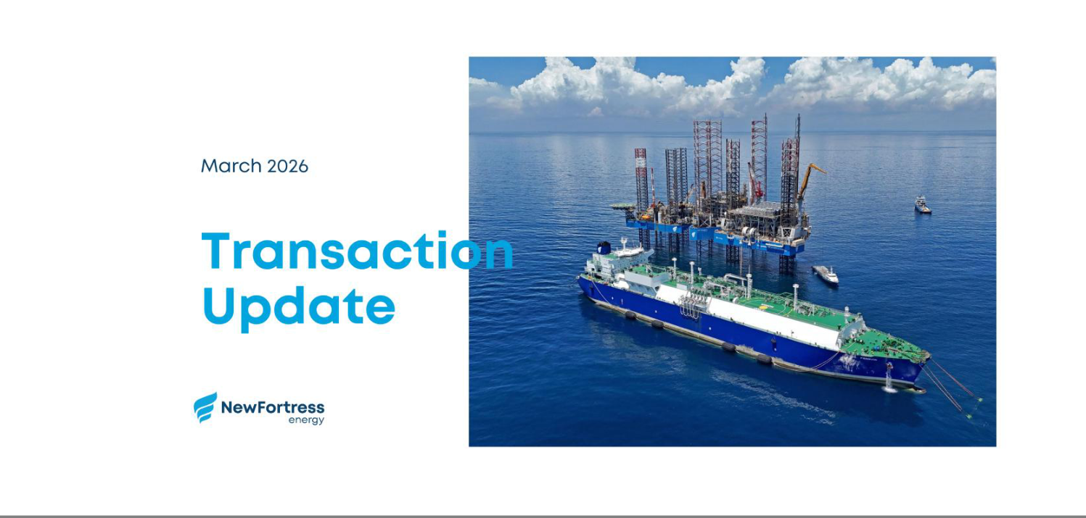

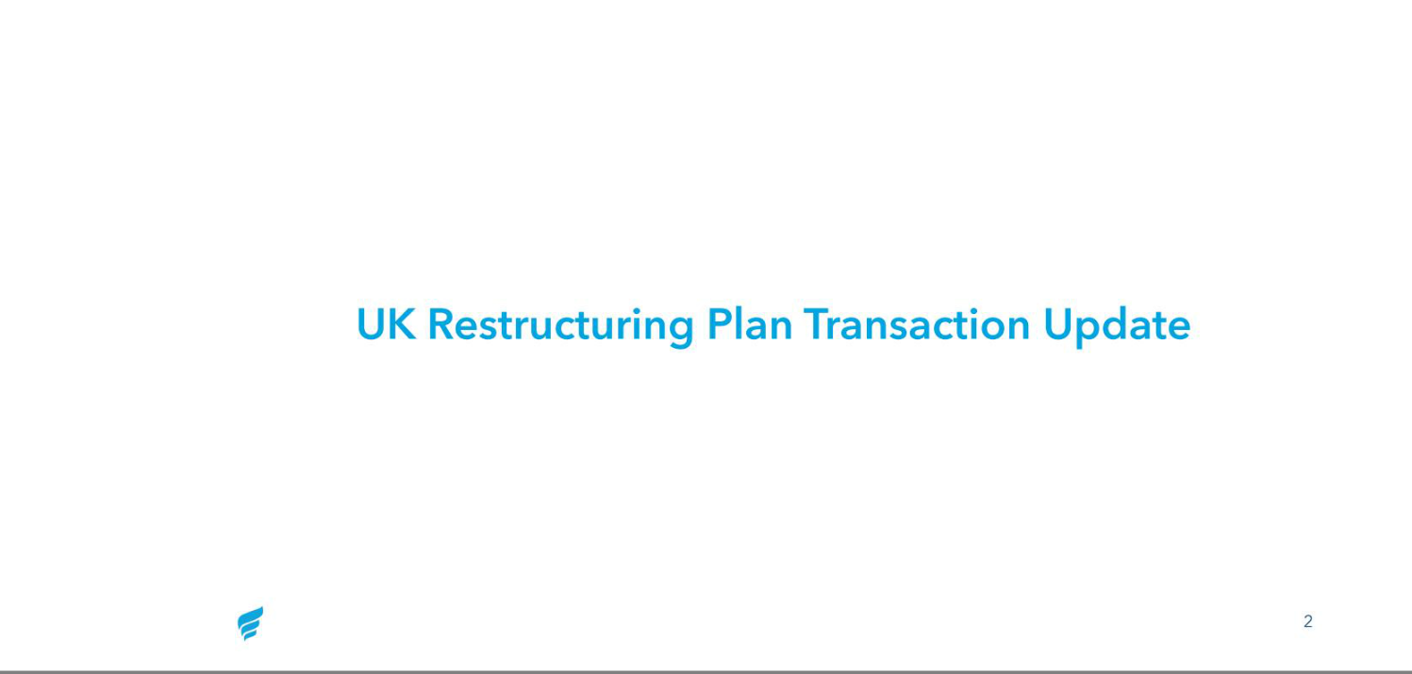

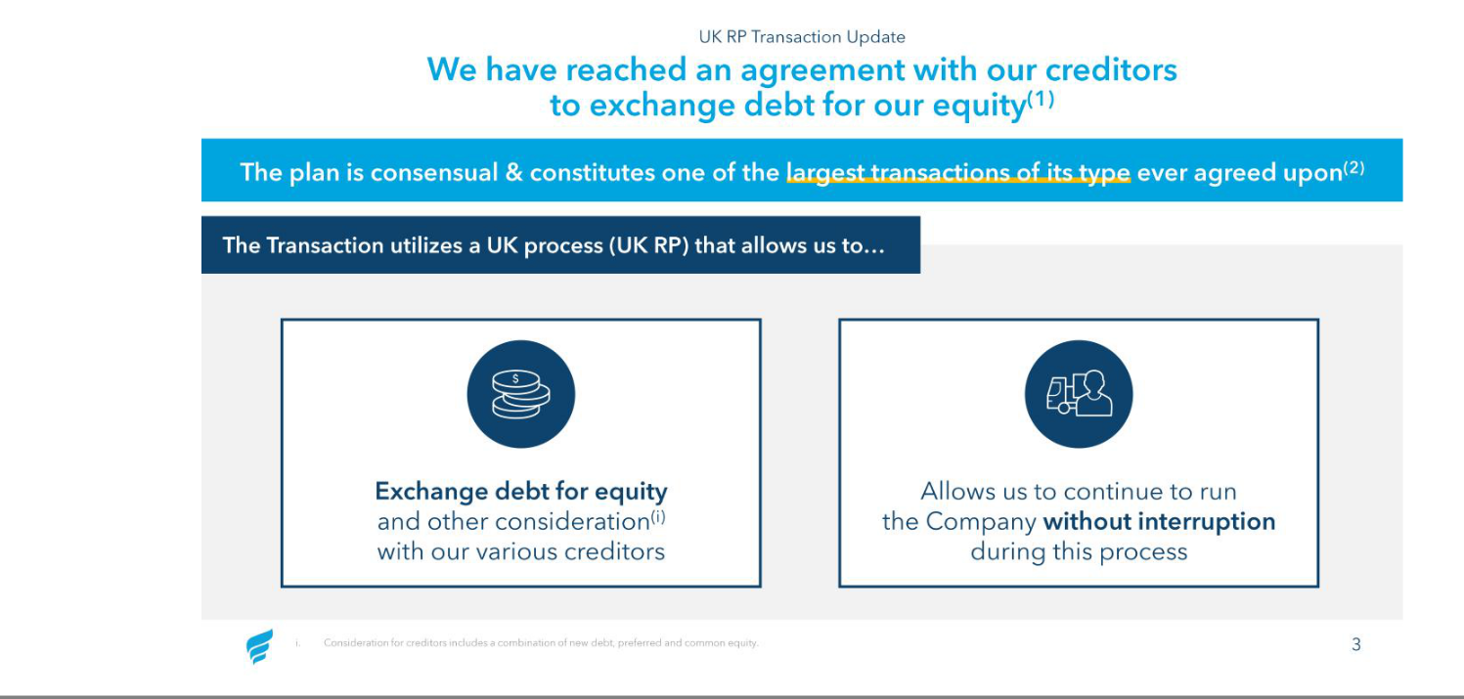

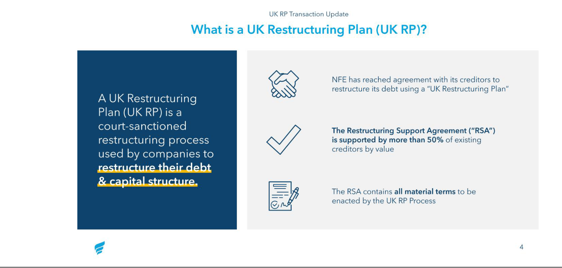

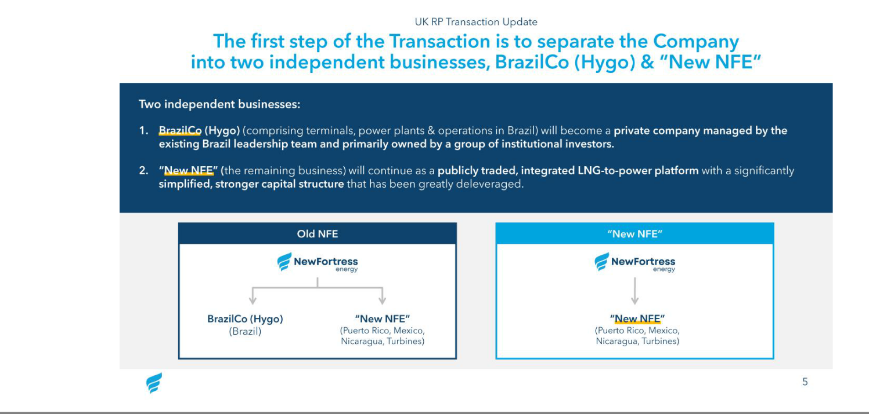

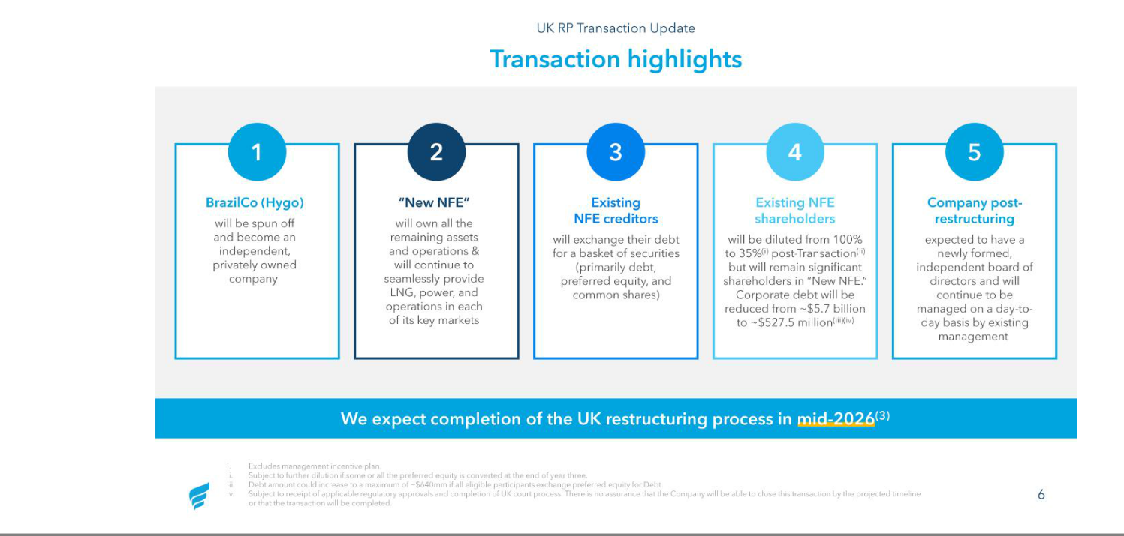

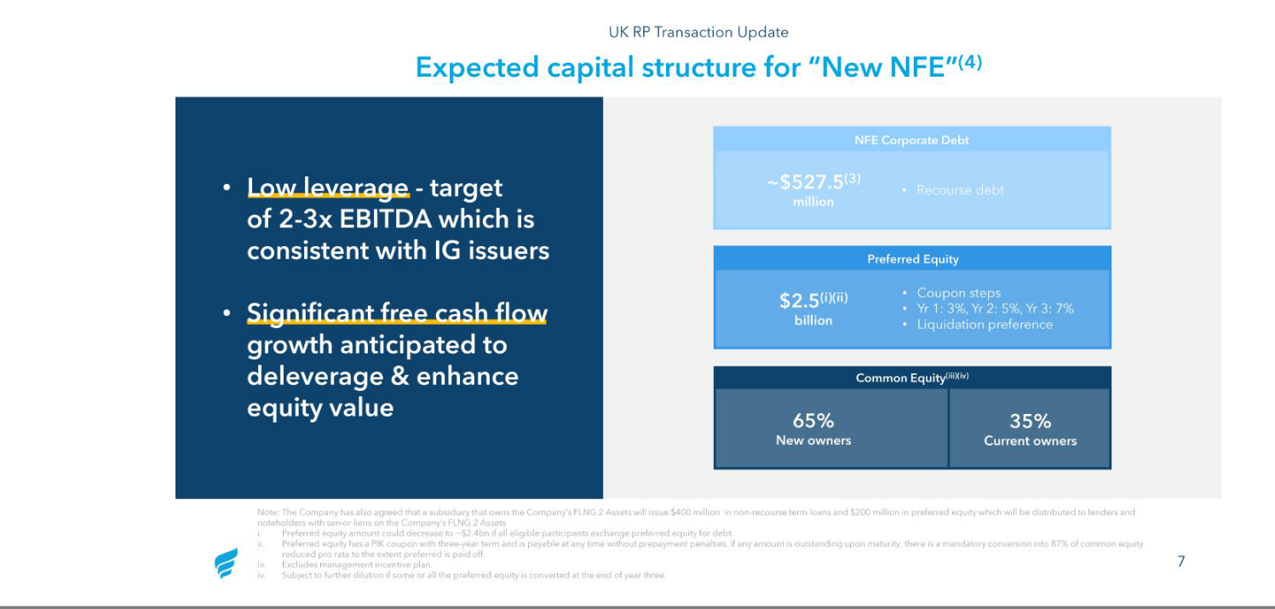

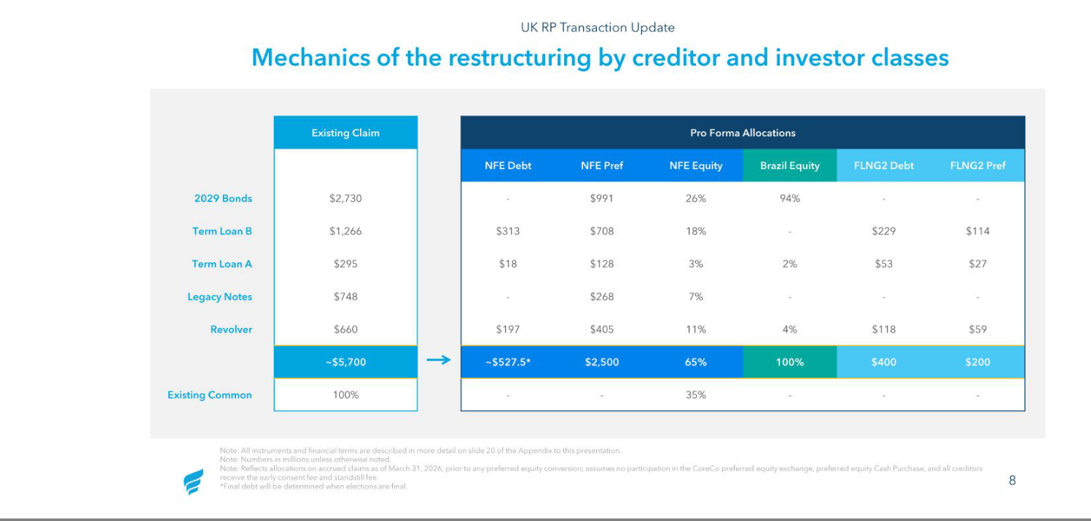

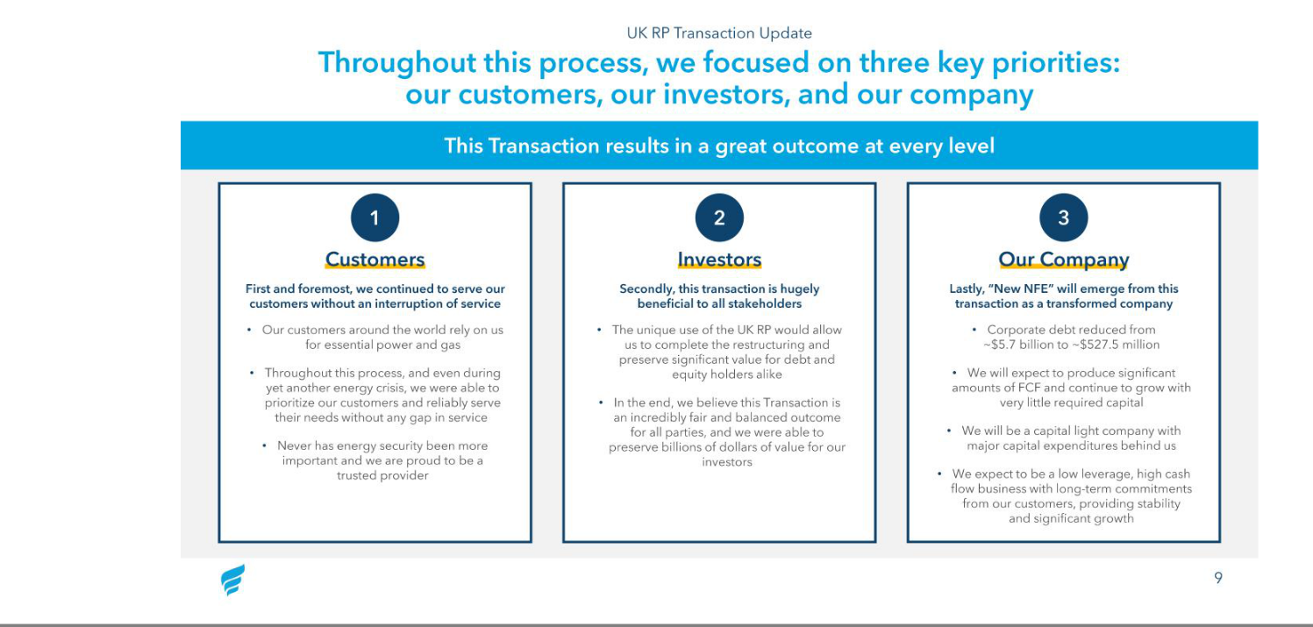

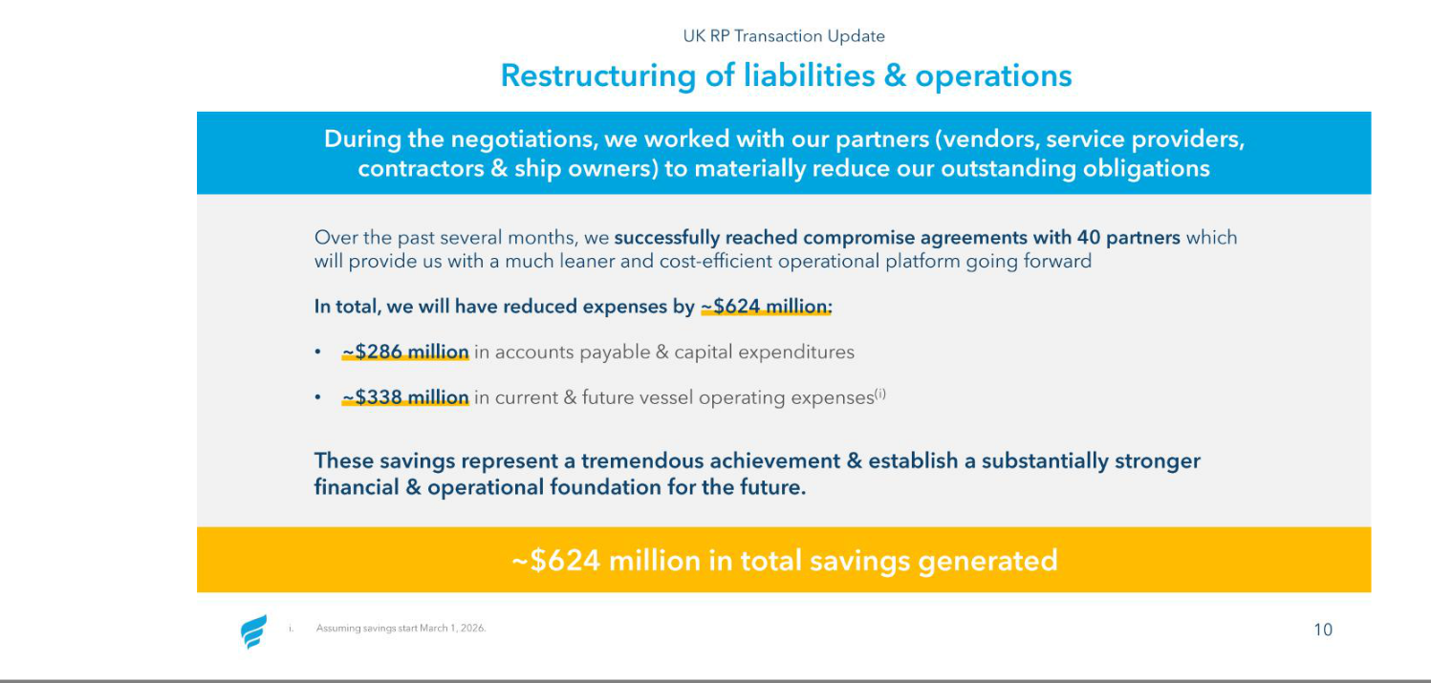

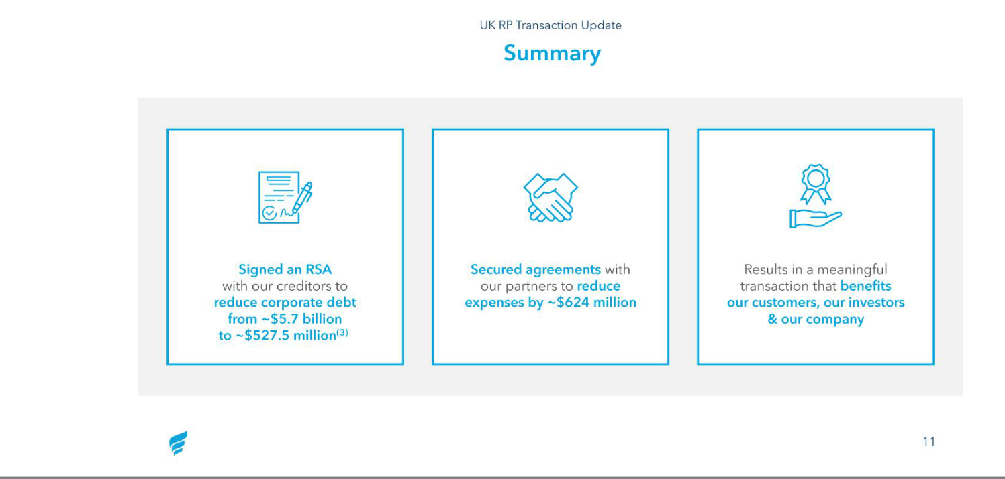

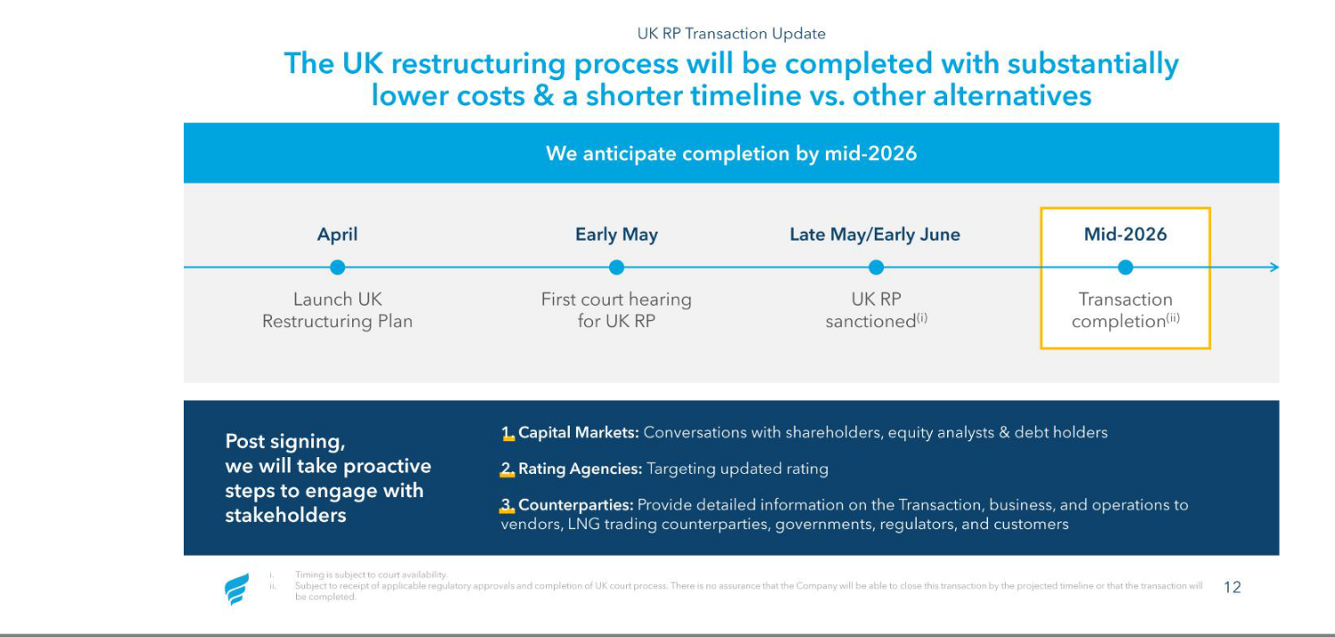

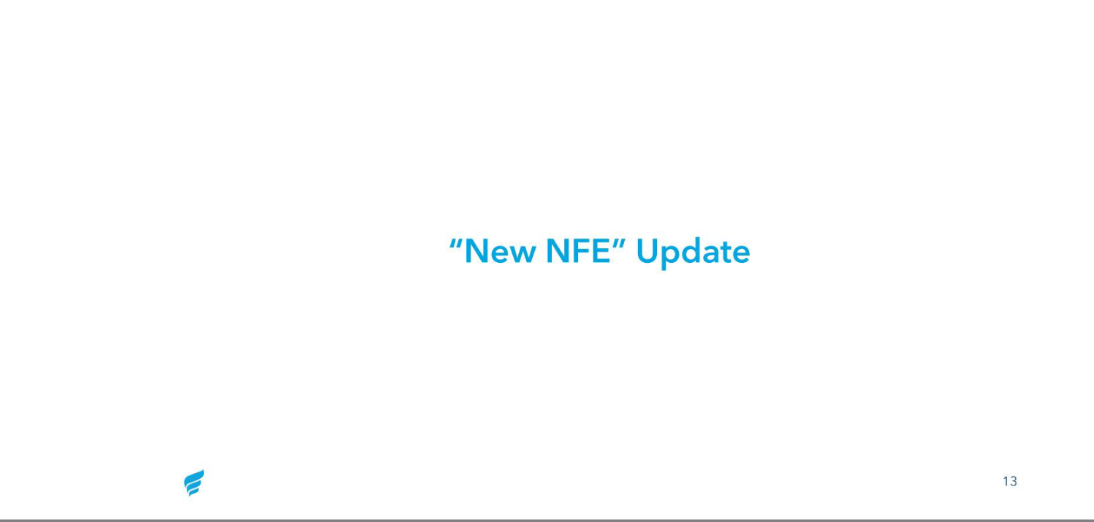

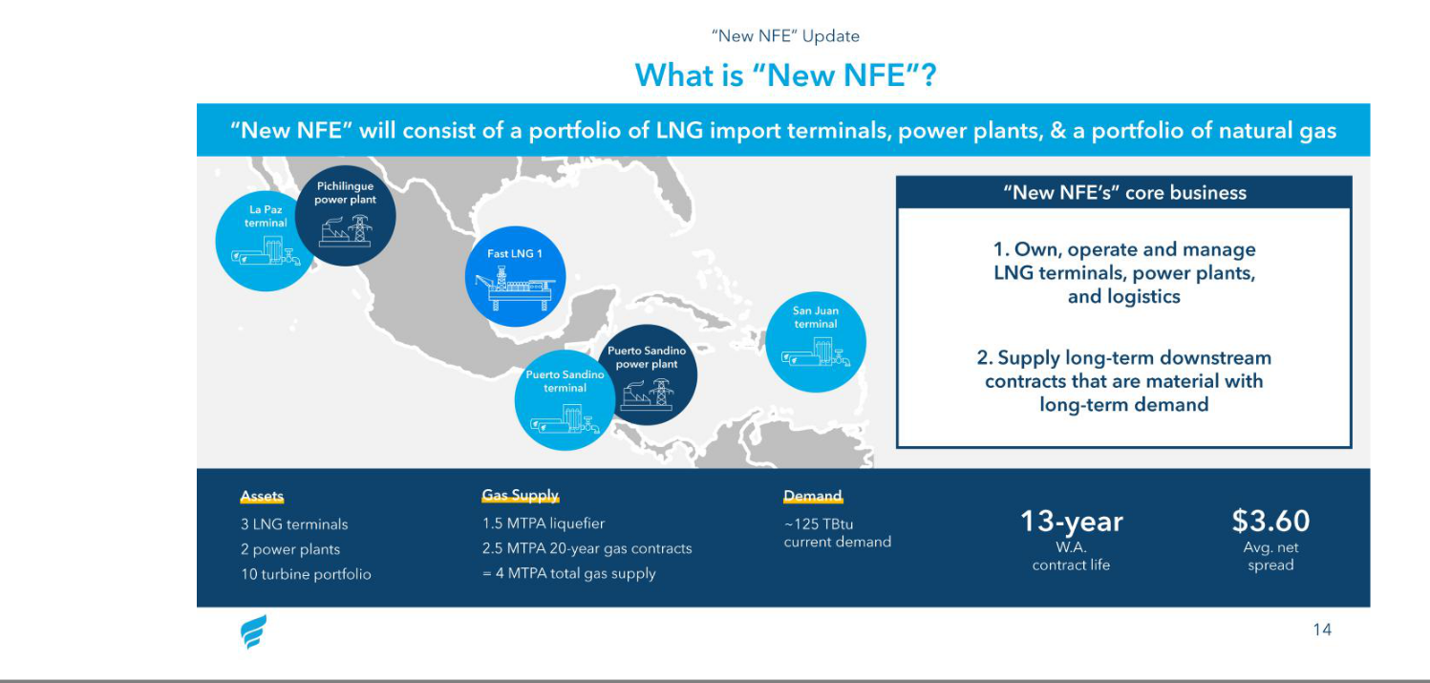

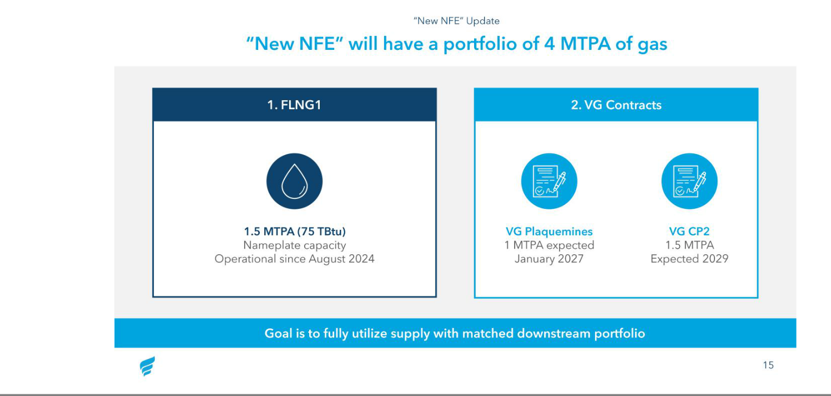

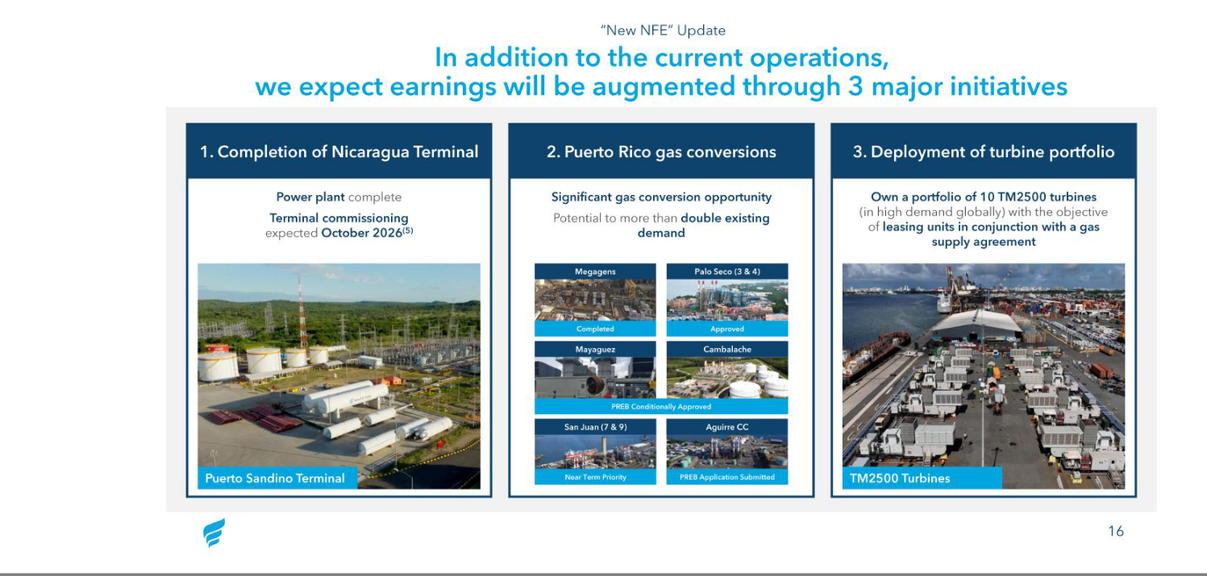

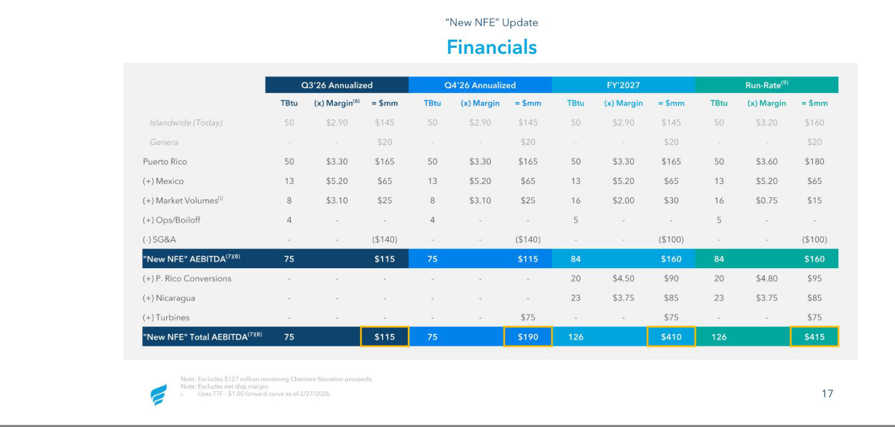



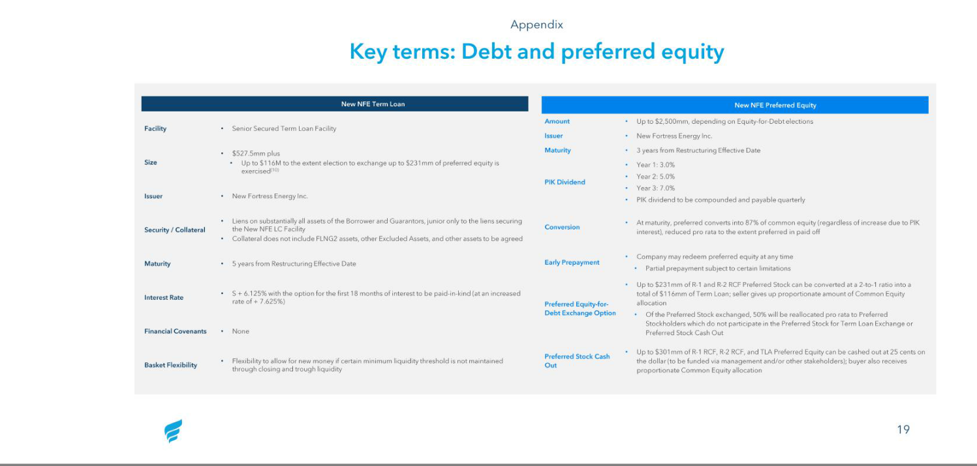

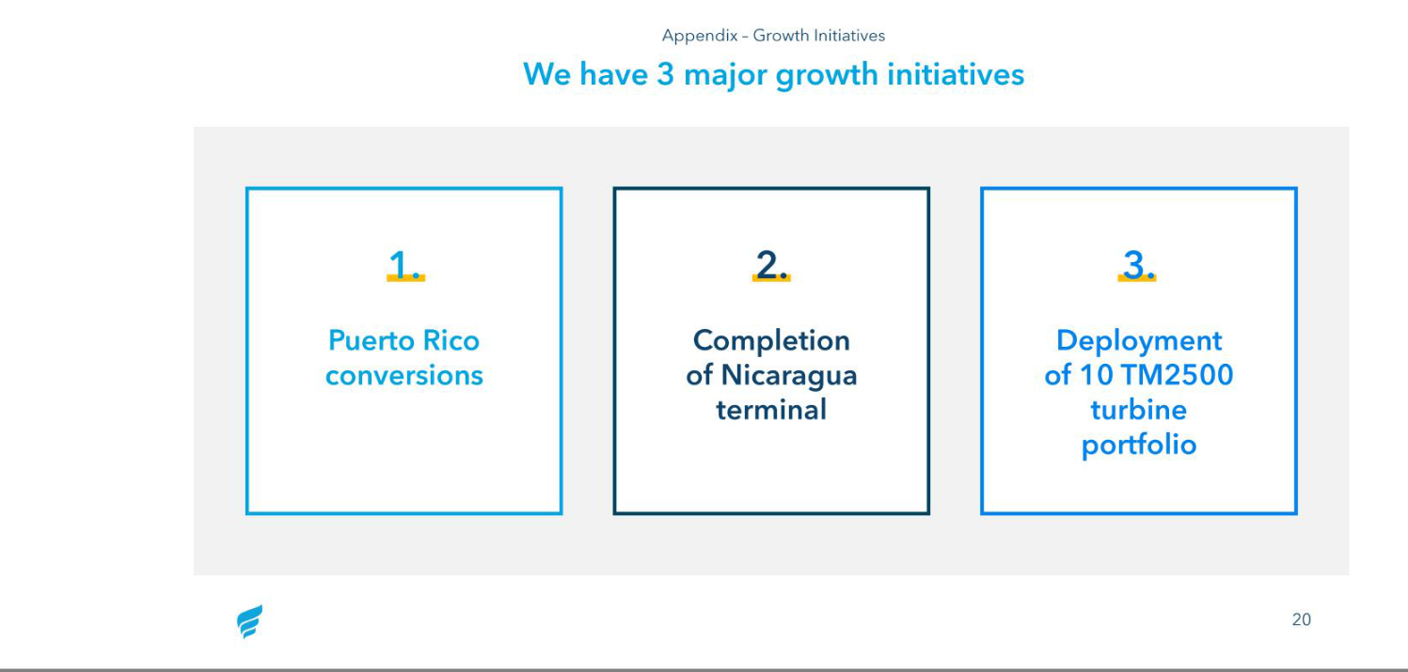

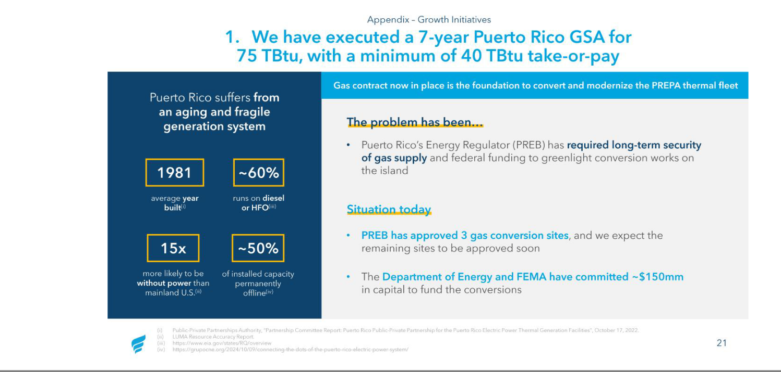

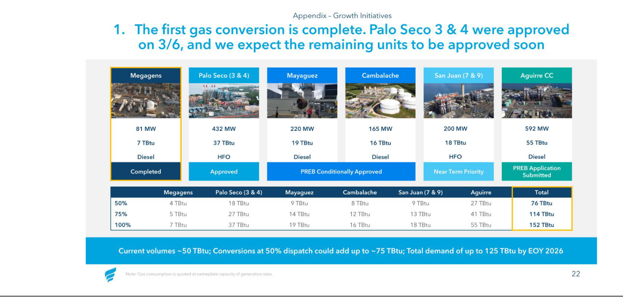

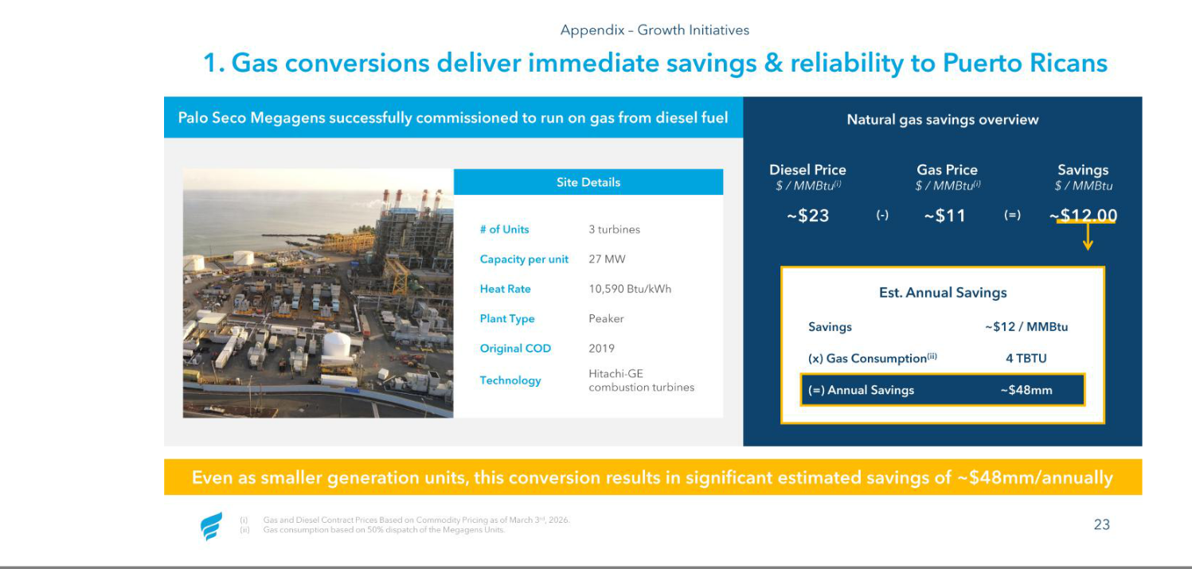

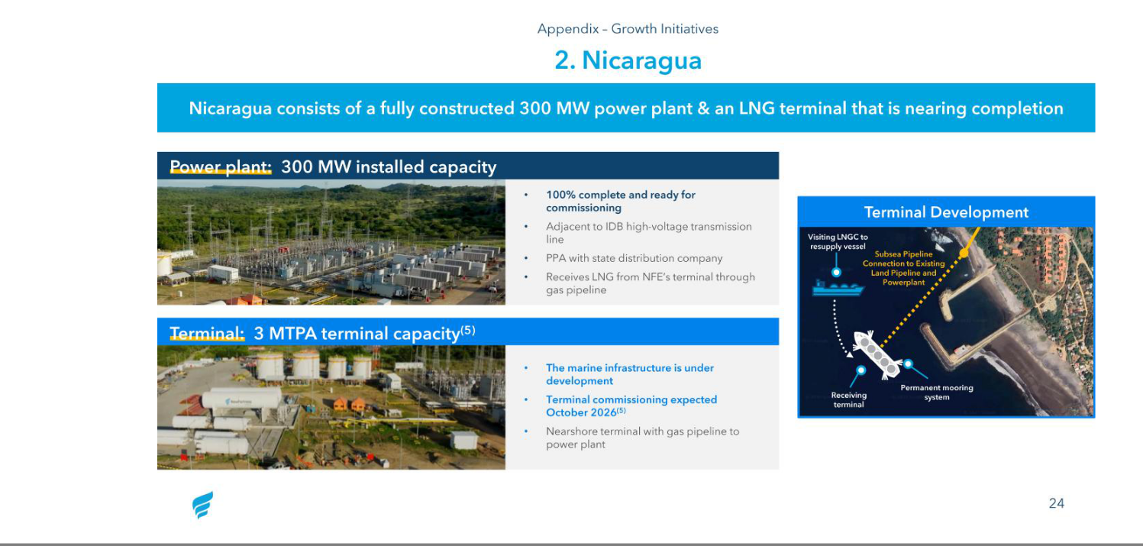

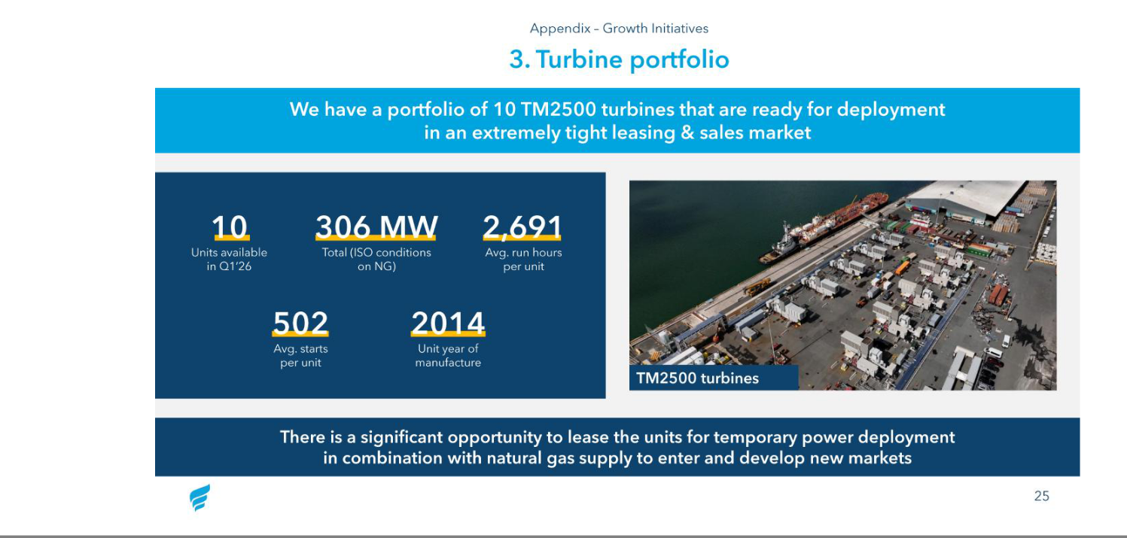

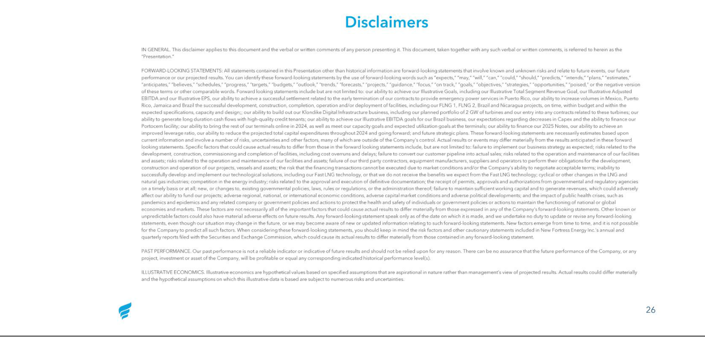

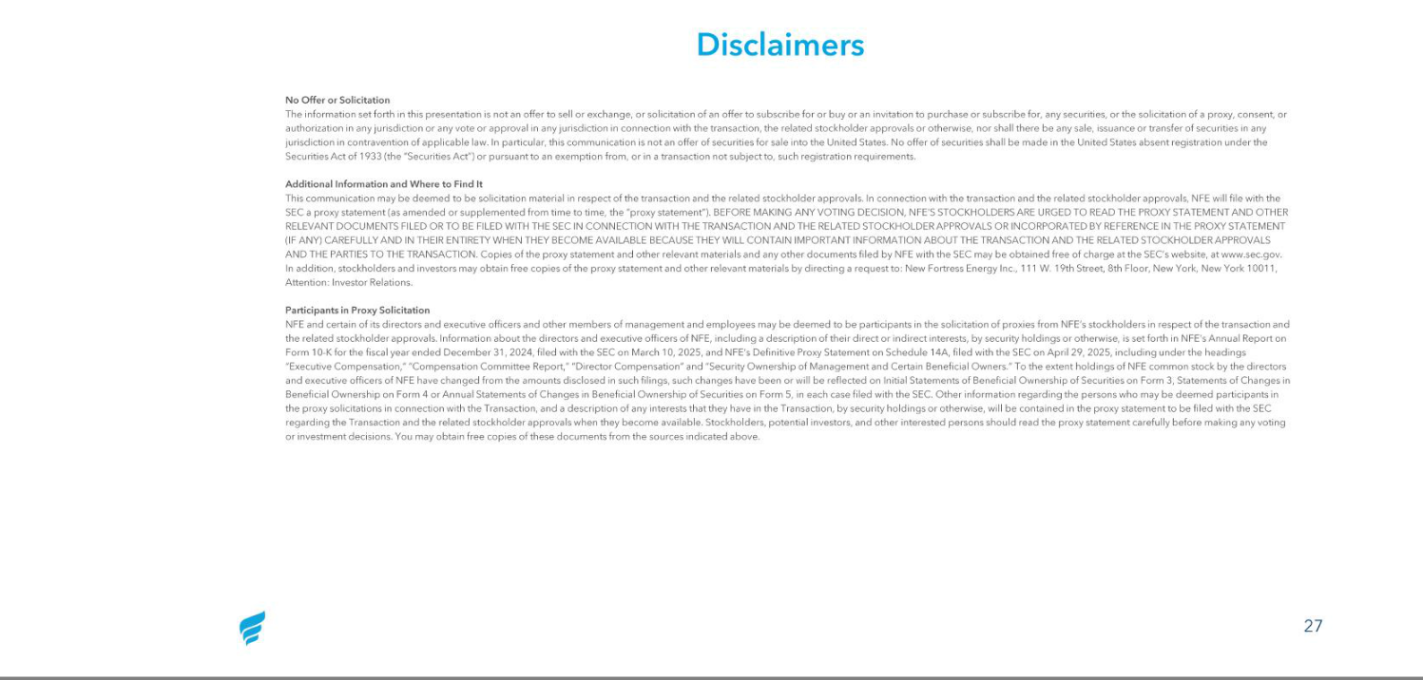

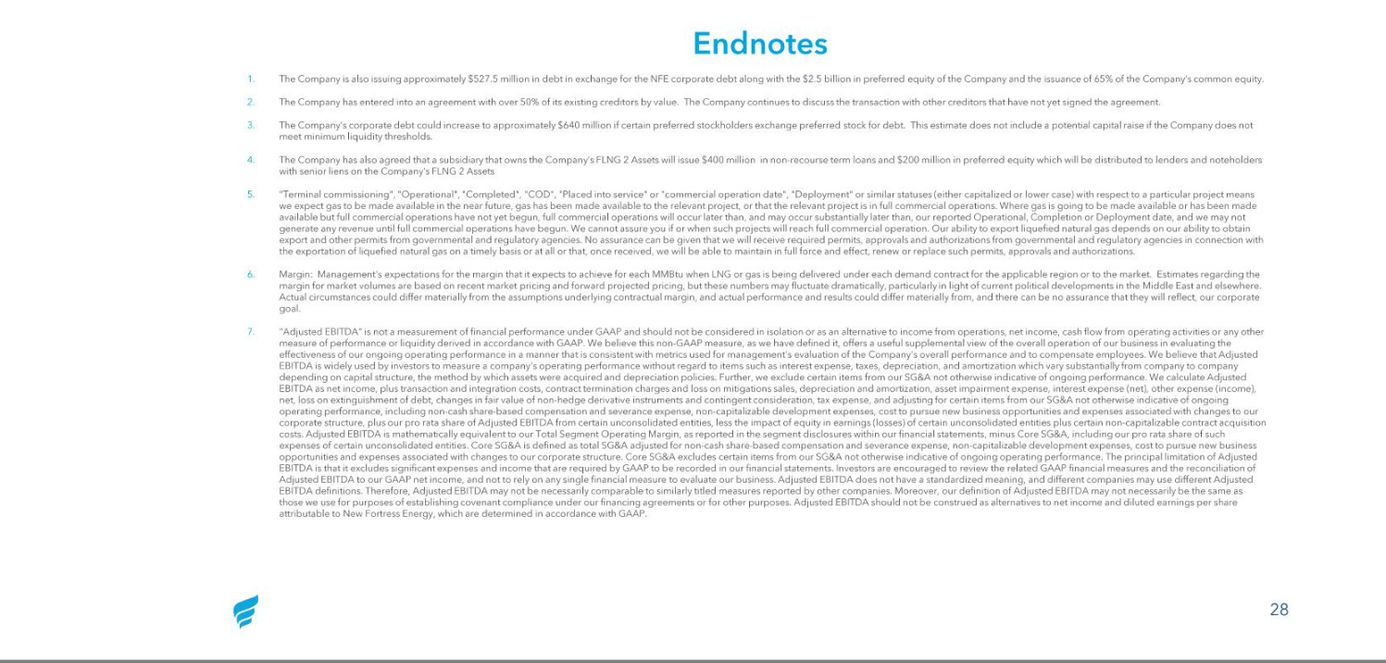

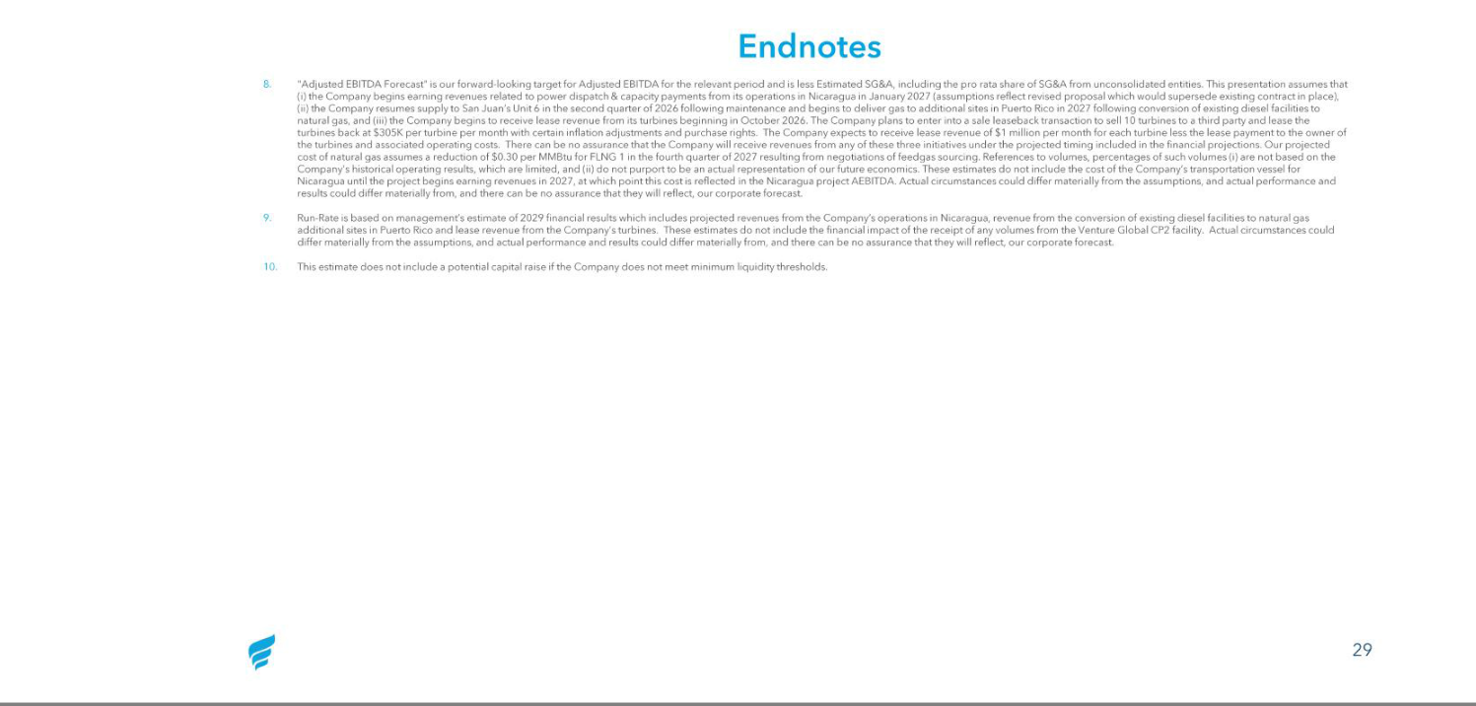


New Fortress Energy Announces Separation of Brazilian Operations as Part of Broader NFE Inc. Recapitalization Transaction

NEW YORK, NY; RIO DE JANEIRO, BRAZIL — March 17, 2026 — New Fortress Energy Inc. (NASDAQ: NFE) ("NFE") today announced it will separate its Brazilian operations into an independent, standalone energy platform (“BrazilCo” or “the Company”) as part of NFE’s broader recapitalization transaction (the “Transaction”) to be implemented via consensual UK Restructuring Plan (“UK RP”). This separation is expected to position BrazilCo for continued growth while strengthening Brazil’s energy infrastructure and security.

Following the closing of transaction, the newly independent Brazilian entity, headquartered in Rio de Janeiro, will be owned by a consortium of leading global institutional investors with deep expertise in infrastructure development and long-term value creation, extensive experience investing across Brazilian asset classes and over $20 trillion in assets under management.

The new ownership group is committed to supporting the Company with a strong, well-capitalized balance sheet designed to enable disciplined growth, operational resilience, and long-term value creation. The Company will continue to be led by Brazil-based executives Leandro Cunha and Jeremy Dawson, each of whom brings decades of experience as energy operators. Their continued leadership will help to ensure smooth execution and completion of existing projects in Barcarena, while positioning the business for expansion across southern Brazil utilizing the Company’s TGS Terminal in Santa Catarina. With the support of the Company’s new shareholders, Leandro and Jeremy will work to maintain strong existing relationships with local stakeholders, customers, investors, contractors, and regulatory counterparties.

Driving Brazil's Energy Future

As an independent platform, the Company will be well positioned to address Brazil's growing energy demand and the country's increasing focus on reliable, secure and flexible energy solutions.

The Company’s key strategic priorities and assets include:

- Standalone Gas and Vessel Supply: Securing standalone gas supply and vessel support remains a top priority for BrazilCo with a process underway to fulfil these needs in the coming months. BrazilCo will maintain existing gas supply from NFE through the pendency of the UK RP.

- Barcarena Cluster: Advancing and completing the development of the 624 MW CELBA 2 and 1.6 GW PortoCem power plants, supplied by the 5.9 MTPA Barcarena terminal, to bring critical energy infrastructure online

- TGS Terminal: Advancing and realizing the potential of the Terminal de Gás Sul (TGS) opportunity in Santa Catarina including participation in expected LRCAP capacity auctions in March 2026. TGS is a cornerstone infrastructure asset for southern Brazil, providing critical and flexible access to natural gas for power generation in a region with limited alternative gas supply options. This critical asset provides opportunity to further enhance economic development beyond opportunity via the

LRCAP capacity auctions as BrazilCo continues to pursue supply opportunities with industrial partners in line with the Company’s successful strategy in Barcarena.

Together, the Barcarena and TGS projects are expected to drive meaningful economic development and employment growth, creating opportunities for hundreds of direct construction jobs and thousands of indirect employment opportunities across engineering, operations, and support services.

This separation will occur at a corporate level above the Brazil structure and will not affect the underlying business or day-to-day operations in Brazil. BrazilCo remains committed to working with local suppliers, contractors, and communities to maximize local economic benefits and development.

“This new chapter marks an important milestone for our business in Brazil,” said Leandro Cunha, Managing Director of BrazilCo. “With a strong portfolio of strategic infrastructure assets and projects under development, we believe the Company is well positioned to continue delivering reliable and flexible energy solutions to support Brazil’s growth. The strength and commitment of our new shareholder group, combined with their deep experience in delivering infrastructure assets, further reinforces our ability to execute on our projects and capture the significant opportunities ahead.”

The transaction is expected to close in mid-2026, subject to customary conditions and regulatory approvals.

About BrazilCo

Following the separation, the Brazilian entity will operate as an independent energy infrastructure platform focused on liquefied natural gas (LNG) importation, regasification, and power generation. With strategic assets in Barcarena and Santa Catarina and a strong and well-capitalized financial foundation, the Company is committed to delivering reliable, cleaner energy solutions that support Brazilian industry and economic growth.

Cautionary Statement Regarding Forward-Looking Statements

This press release includes “forward-looking statements,” within the meaning of Section 27A of the Securities Act and Section 21E of the Exchange Act, including, in particular, any statements about our plans, strategies, objectives, initiatives, roadmap and prospects. We generally use the words “may,” “will,” “could,” “expect,” “anticipate,” “believe,” “estimate,” “plan,” “intend,” “aim” and similar expressions in this press release to identify forward-looking statements. We have based these forward-looking statements on our current views with respect to future events and financial performance. Actual results could differ materially from those projected in the forward-looking statements. These forward-looking statements, include, but are not limited to, statements related to the Transaction, including NFE’s ability to complete the Transaction on the terms currently contemplated, on the timeline contemplated or at all; the Company’s business following its separation from NFE; and NFE’s and the Company’s ability to realize the intended benefits of the Transaction. NFE’s actual results may differ materially from those anticipated in these forward-looking statements as a result of certain risks and other factors. Additional risks that could cause future results to differ from those expressed by any forward-looking statement are described in NFE’s reports filed with the U.S. Securities and Exchange Commission, including in the section entitled “Risk Factors” in Part I, Item 1A of NFE’s Annual Report on Form 10-K for the fiscal year ended December 31, 2024 and the section entitled “Risk Factors” in Part II, Item 1A of NFE’s Quarterly Report on Form 10-Q for the quarter ended September 30, 2025. You should not put undue reliance on any forward-looking statements. You should understand that many important factors, including those identified herein, could cause our results to differ materially from those expressed or suggested in any forward-looking statement. Except as required by law, we do not undertake any obligation to update or revise these forward-looking statements to reflect new information or events or circumstances that occur after the date of the filing of this press release or to reflect the occurrence of unanticipated events or otherwise.

No Offer or Solicitation

The information set forth in this press release is not an offer to sell or exchange, or solicitation of an offer to subscribe for or buy or an invitation to purchase or subscribe for, any securities, or the solicitation of a proxy, consent, or authorization in any jurisdiction or any vote or approval in any jurisdiction in connection with the Transaction, the related stockholder approvals or otherwise, nor shall there be any sale, issuance or transfer of securities in any jurisdiction in contravention of applicable law. In particular, this communication is not an offer of securities for sale into the United States. No offer of securities shall be made in the United States absent registration under the Securities Act of 1933 (the “Securities Act”) or pursuant to an exemption from, or in a transaction not subject to, such registration requirements.

Additional Information and Where to Find It

This communication may be deemed to be solicitation material in respect of the Transaction and the related stockholder approvals. In connection with the Transaction and the related stockholder approvals, NFE will file with the SEC a proxy statement (as amended or supplemented from time to time, the “proxy statement”). BEFORE MAKING ANY VOTING DECISION, NFE’S
STOCKHOLDERS ARE URGED TO READ THE PROXY STATEMENT AND OTHER RELEVANT DOCUMENTS FILED OR TO BE FILED WITH THE SEC IN CONNECTION WITH THE TRANSACTION AND THE RELATED STOCKHOLDER APPROVALS OR INCORPORATED BY REFERENCE IN THE PROXY STATEMENT (IF ANY) CAREFULLY AND IN THEIR ENTIRETY WHEN THEY BECOME AVAILABLE BECAUSE THEY WILL CONTAIN IMPORTANT INFORMATION ABOUT THE TRANSACTION AND THE RELATED STOCKHOLDER APPROVALS AND THE PARTIES TO THE TRANSACTION. Copies of the proxy statement and other relevant materials and any other documents filed by NFE with the SEC may be obtained free of charge at the SEC’s website, at www.sec.gov. In addition, stockholders and investors may obtain free copies of the proxy statement and other relevant materials by directing a request to: New Fortress Energy Inc., 111 W. 19th Street, 8th Floor, New York, New York 10011, Attention: Investor Relations.

Participants in Proxy Solicitation

NFE and certain of its directors and executive officers and other members of management and employees may be deemed to be participants in the solicitation of proxies from NFE’s stockholders in respect of the Transaction and the related stockholder approvals. Information about the directors and executive officers of NFE, including a description of their direct or indirect interests, by security holdings or otherwise, is set forth in NFE’s Annual Report on Form 10-K for the fiscal year ended December 31, 2024, filed with the SEC on March 10, 2025, and NFE’s Definitive Proxy Statement on Schedule 14A, filed with the SEC on April 29, 2025, including under the headings “Executive Compensation,” “Compensation Committee Report,” “Director Compensation” and “Security Ownership of Management and Certain Beneficial Owners.” To the extent holdings of NFE common stock by the directors and executive officers of NFE have changed from the amounts disclosed in such filings, such changes have been or will be reflected on Initial Statements of Beneficial Ownership of Securities on Form 3, Statements of Changes in Beneficial Ownership on Form 4 or Annual Statements of Changes in Beneficial Ownership of Securities on Form 5, in each case filed with the SEC. Other information regarding the persons who may be deemed participants in the proxy solicitations in connection with the Transaction, and a description of any interests that they have in the Transaction, by security holdings or otherwise, will be contained in the proxy statement to be filed with the SEC regarding the Transaction and the related stockholder approvals when they become available. Stockholders, potential investors, and other interested persons should read the proxy statement carefully before making any voting or investment decisions. You may obtain free copies of these documents from the sources indicated above.

# # #

Investors

ir@newfortressenergy.com

Media

press@newfortressenergy.com

Source: New Fortress Energy Inc.

