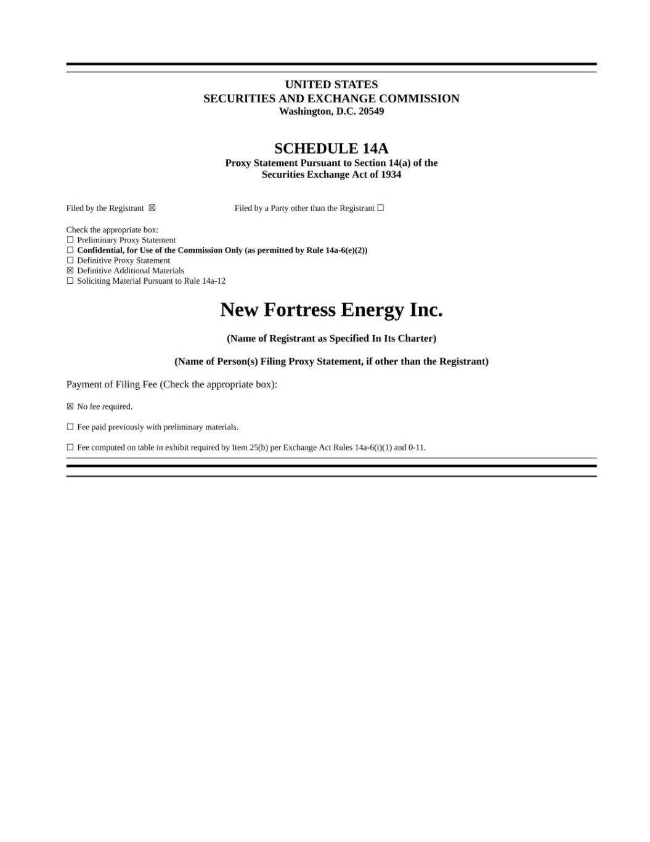

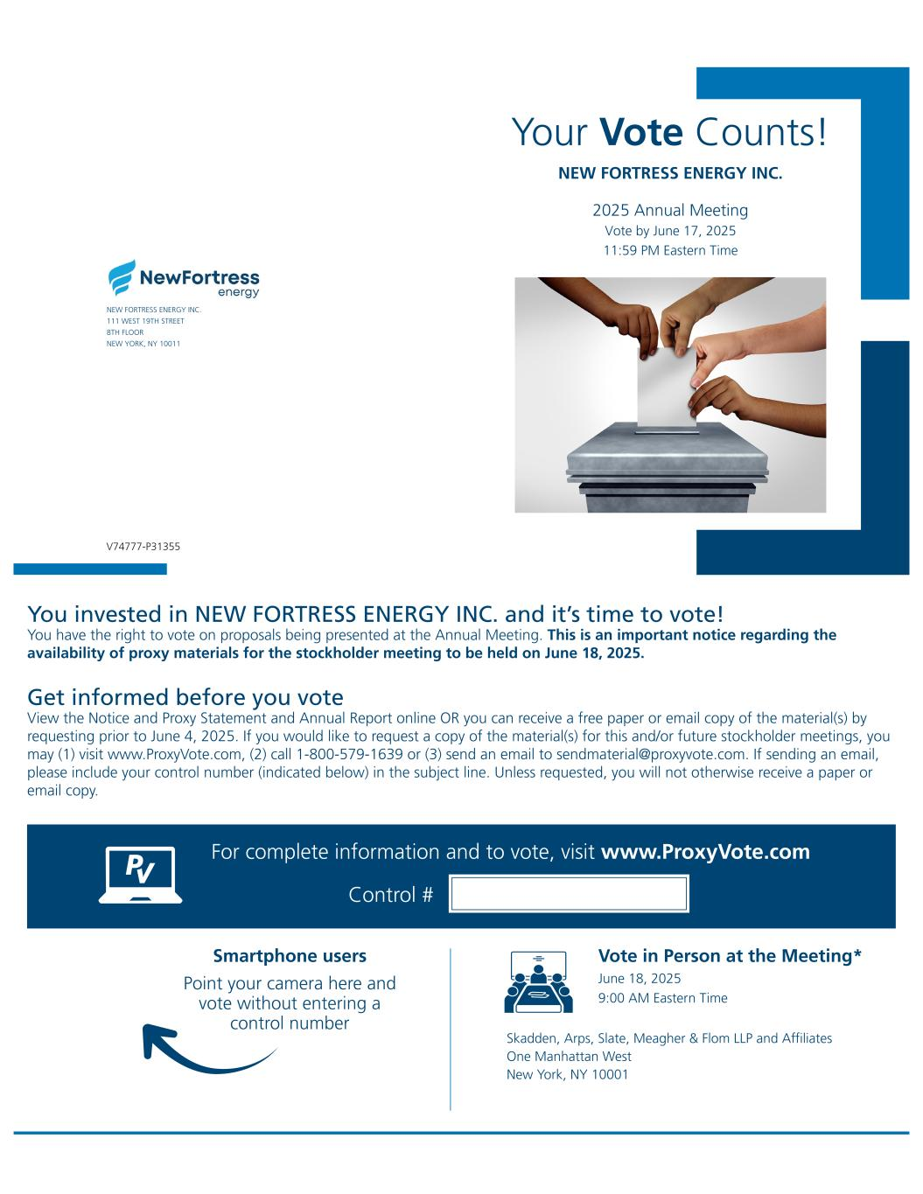
Your Vote Counts! Smartphone users Point your camera here and vote without entering a control number For complete information and to vote, visit www.ProxyVote.com Control # V74777-P31355 NEW FORTRESS ENERGY INC. 111 WEST 19TH STREET 8TH FLOOR NEW YORK, NY 10011 NEW FORTRESS ENERGY INC. 2025 Annual Meeting Vote by June 17, 2025 11:59 PM Eastern Time Vote in Person at the Meeting* June 18, 2025 9:00 AM Eastern Time Skadden, Arps, Slate, Meagher & Flom LLP and Affiliates One Manhattan West New York, NY 10001 You invested in NEW FORTRESS ENERGY INC. and it’s time to vote! You have the right to vote on proposals being presented at the Annual Meeting. This is an important notice regarding the availability of proxy materials for the stockholder meeting to be held on June 18, 2025. Get informed before you vote View the Notice and Proxy Statement and Annual Report online OR you can receive a free paper or email copy of the material(s) by requesting prior to June 4, 2025. If you would like to request a copy of the material(s) for this and/or future stockholder meetings, you may (1) visit www.ProxyVote.com, (2) call 1-800-579-1639 or (3) send an email to sendmaterial@proxyvote.com. If sending an email, please include your control number (indicated below) in the subject line. Unless requested, you will not otherwise receive a paper or email copy.

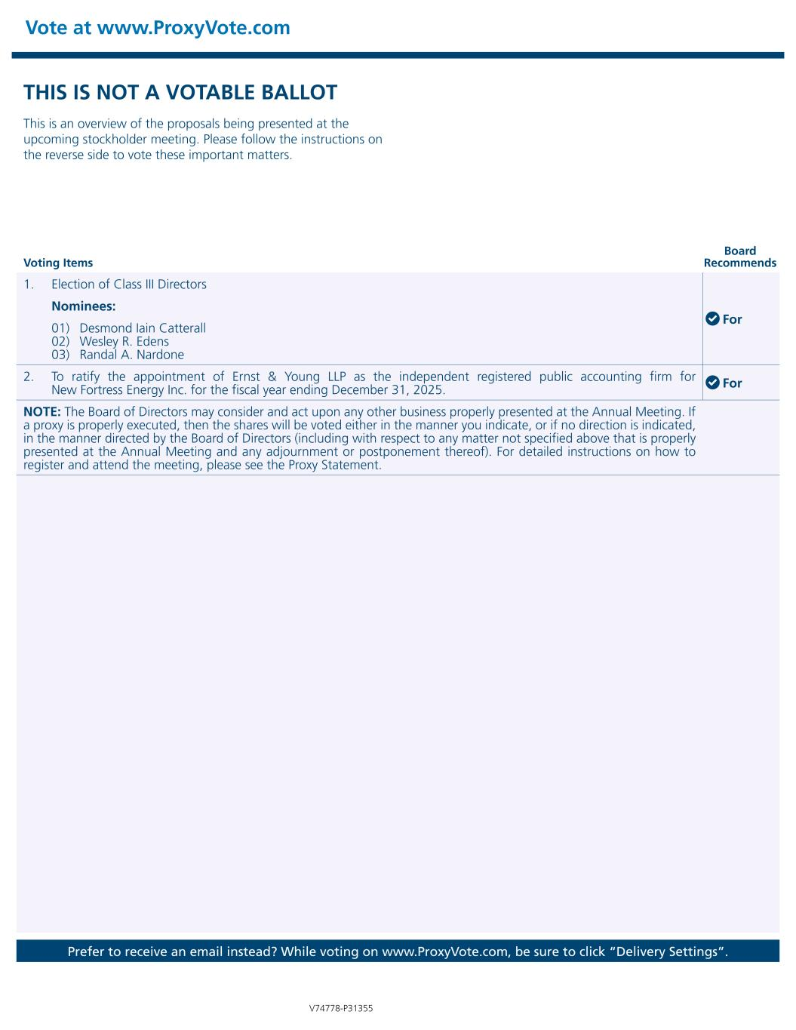
Vote at www.ProxyVote.com Prefer to receive an email instead? While voting on www.ProxyVote.com, be sure to click “Delivery Settings”. V74778-P31355 Voting Items Board Recommends THIS IS NOT A VOTABLE BALLOT This is an overview of the proposals being presented at the upcoming stockholder meeting. Please follow the instructions on the reverse side to vote these important matters. 1. Election of Class III Directors For Nominees: 01) Desmond Iain Catterall 02) Wesley R. Edens 03) Randal A. Nardone 2. To ratify the appointment of Ernst & Young LLP as the independent registered public accounting firm for New Fortress Energy Inc. for the fiscal year ending December 31, 2025. For NOTE: The Board of Directors may consider and act upon any other business properly presented at the Annual Meeting. If a proxy is properly executed, then the shares will be voted either in the manner you indicate, or if no direction is indicated, in the manner directed by the Board of Directors (including with respect to any matter not specified above that is properly presented at the Annual Meeting and any adjournment or postponement thereof). For detailed instructions on how to register and attend the meeting, please see the Proxy Statement.

