UNITED STATES
SECURITIES AND EXCHANGE COMMISSION
Washington, D.C. 20549
FORM 8-K
CURRENT REPORT
PURSUANT TO SECTION 13 OR 15(D)
OF THE SECURITIES EXCHANGE ACT OF 1934

Date of Report (Date of earliest event reported): March 26, 2024

New Fortress Energy Inc.
(Exact name of registrant as specified in its charter)

Delaware |  |  | 001-38790 |  |  | 83-1482060
(State or Other Jurisdiction of Incorporation) |  |  | (Commission File Number) |  |  | (IRS Employer Identification No.)

111 W. 19th Street, 8th Floor  New York, NY |  |  |  |  |  | 10011
(Address of Principal Executive Offices) |  |  |  |  |  | (Zip Code)
Registrant’s Telephone Number, Including Area Code: (516) 268-7400

Check the appropriate box below if the Form 8-K filing is intended to simultaneously satisfy the filing obligation of the registrant under any of the following provisions:

☐ |  |  | Written communications pursuant to Rule 425 under the Securities Act (17 CFR 230.425)
☐ |  |  | Soliciting material pursuant to Rule 14a-12 under the Exchange Act (17 CFR 240.14a-12)
☐ |  |  | Pre-commencement communications pursuant to Rule 14d-2(b) under the Exchange Act (17 CFR 240.14d-2(b))
☐ |  |  | Pre-commencement communications pursuant to Rule 13e-4(c) under the Exchange Act (17 CFR 240.13e-4(c))

Securities registered pursuant to Section 12(b) of the Act:

Title of each class |  |  | Trading Symbol(s) |  |  | Name of each exchange on which registered
Class A Common Stock, par value $0.01 per share |  |  | “NFE” |  |  | NASDAQ Global Select Market

Indicate by check mark whether the registrant is an emerging growth company as defined in Rule 405 of the Securities Act of 1933 (§230.405 of this chapter) or Rule 12b-2 of the Securities Exchange Act of 1934 (§240.12b-2 of this chapter).

☐ Emerging growth company

If an emerging growth company, indicate by check mark if the registrant has elected not to use the extended transition period for complying with any new or revised financial accounting standards provided pursuant to Section 13(a) of the Exchange Act ☐

Item 8.01. Other Events.

On March 26, 2024, New Fortress Energy Inc. (the “Company”) filed a prospectus supplement (the “Resale Prospectus Supplement”) to its previously filed automatic shelf registration statement on Form S-3 (File No. 333-277611) registering the resale of up to an aggregate of 2,064,517 shares of the Company’s Class A common stock, par value $0.01 per share (the “Shares”) which may be used by Ceiba Energy US LP, the selling securityholder identified therein (the “Selling Securityholder”), to resell the Shares covered thereby.

The Shares are issuable upon conversion of the 4.8% Series A Convertible Preferred Stock of the Company, par value $0.01 per share, issued pursuant to a Certificate of Designations, dated March 20, 2024, to Ceiba Energy Fundo de Investimento em Participações Multiestratégia - Investimento no Exterior (“Ceiba FIP”) pursuant to a Share Exchange Agreement, dated as of December 22, 2023, by and among the Company, Ceiba FIP and Portocem Geração de Energia S.A., and assigned thereafter by Ceiba FIP to the Selling Securityholder. The Company will not receive any proceeds from any sale of Shares by the Selling Securityholder.

The Company is filing this report to provide the legal opinion as to the validity of the Shares covered by the Resale Prospectus Supplement, which opinion is attached hereto as Exhibit 5.1 and is incorporated herein by reference.

Item 9.01. Financial Statements and Exhibits.

(d) Exhibits

Exhibit  No. |  |  |  |  |  | Description
5.1 |  |  |  |  |  | Opinion of Skadden, Arps, Slate, Meagher & Flom LLP regarding the validity of the Shares.
104 |  |  |  |  |  | Cover Page Interactive Data File (embedded within the Inline XBRL document).

SIGNATURES

Pursuant to the requirements of the Securities Exchange Act of 1934, the registrant has duly caused this report to be signed on its behalf by the undersigned, hereunto duly authorized.

 |  |  | NEW FORTRESS ENERGY INC.
Date:March 26, 2024 |  |  | By: |  |  | /s/ Christopher S. Guinta
 |  |  | Name: |  |  | Christopher S. Guinta
 |  |  | Title: |  |  | Chief Financial Officer

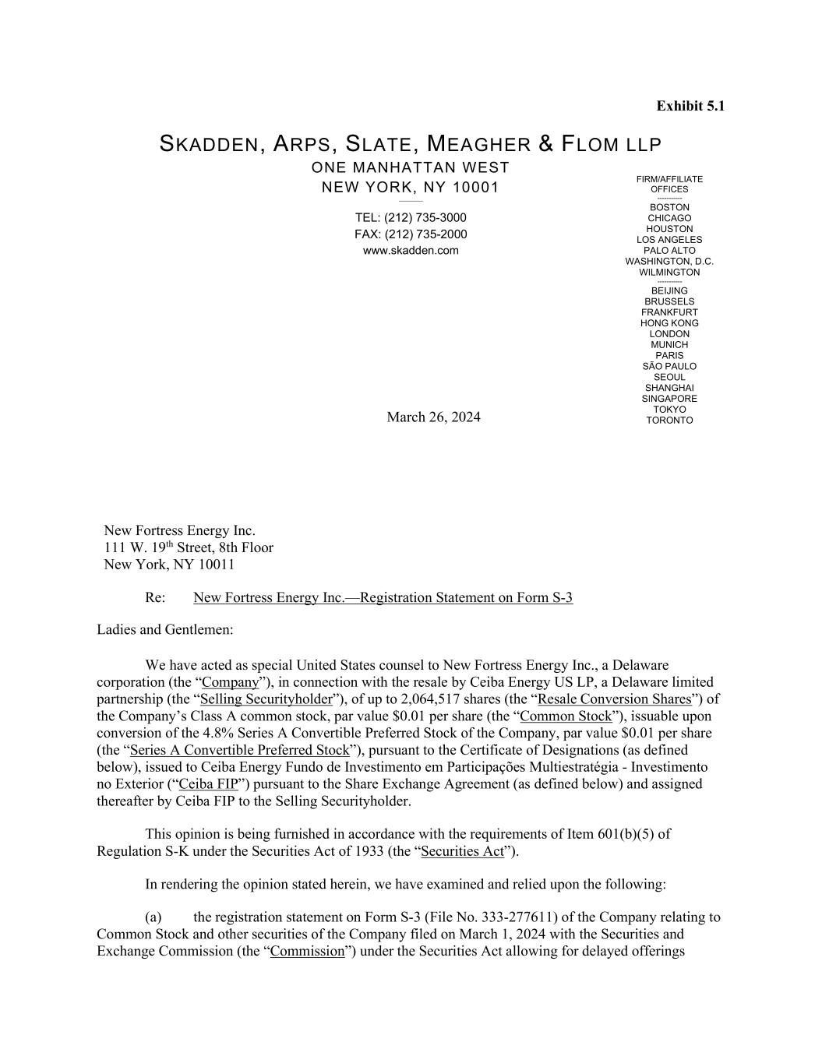

FIRM/AFFILIATE OFFICES ----------- BOSTON CHICAGO HOUSTON LOS ANGELES PALO ALTO WASHINGTON, D.C. WILMINGTON ----------- BEIJING BRUSSELS FRANKFURT HONG KONG LONDON MUNICH PARIS SÃO PAULO SEOUL SHANGHAI SINGAPORE TOKYO TORONTO Exhibit 5.1 SKADDEN, ARPS, SLATE, MEAGHER & FLOM LLP ONE MANHATTAN WEST NEW YORK, NY 10001 ________ TEL: (212) 735-3000 FAX: (212) 735-2000 www.skadden.com March 26, 2024 New Fortress Energy Inc. 111 W. 19th Street, 8th Floor New York, NY 10011 Re: New Fortress Energy Inc.—Registration Statement on Form S-3 Ladies and Gentlemen: We have acted as special United States counsel to New Fortress Energy Inc., a Delaware corporation (the “Company”), in connection with the resale by Ceiba Energy US LP, a Delaware limited partnership (the “Selling Securityholder”), of up to 2,064,517 shares (the “Resale Conversion Shares”) of the Company’s Class A common stock, par value $0.01 per share (the “Common Stock”), issuable upon conversion of the 4.8% Series A Convertible Preferred Stock of the Company, par value $0.01 per share (the “Series A Convertible Preferred Stock”), pursuant to the Certificate of Designations (as defined below), issued to Ceiba Energy Fundo de Investimento em Participações Multiestratégia - Investimento no Exterior (“Ceiba FIP”) pursuant to the Share Exchange Agreement (as defined below) and assigned thereafter by Ceiba FIP to the Selling Securityholder. This opinion is being furnished in accordance with the requirements of Item 601(b)(5) of Regulation S-K under the Securities Act of 1933 (the “Securities Act”). In rendering the opinion stated herein, we have examined and relied upon the following: (a) the registration statement on Form S-3 (File No. 333-277611) of the Company relating to Common Stock and other securities of the Company filed on March 1, 2024 with the Securities and Exchange Commission (the “Commission”) under the Securities Act allowing for delayed offerings

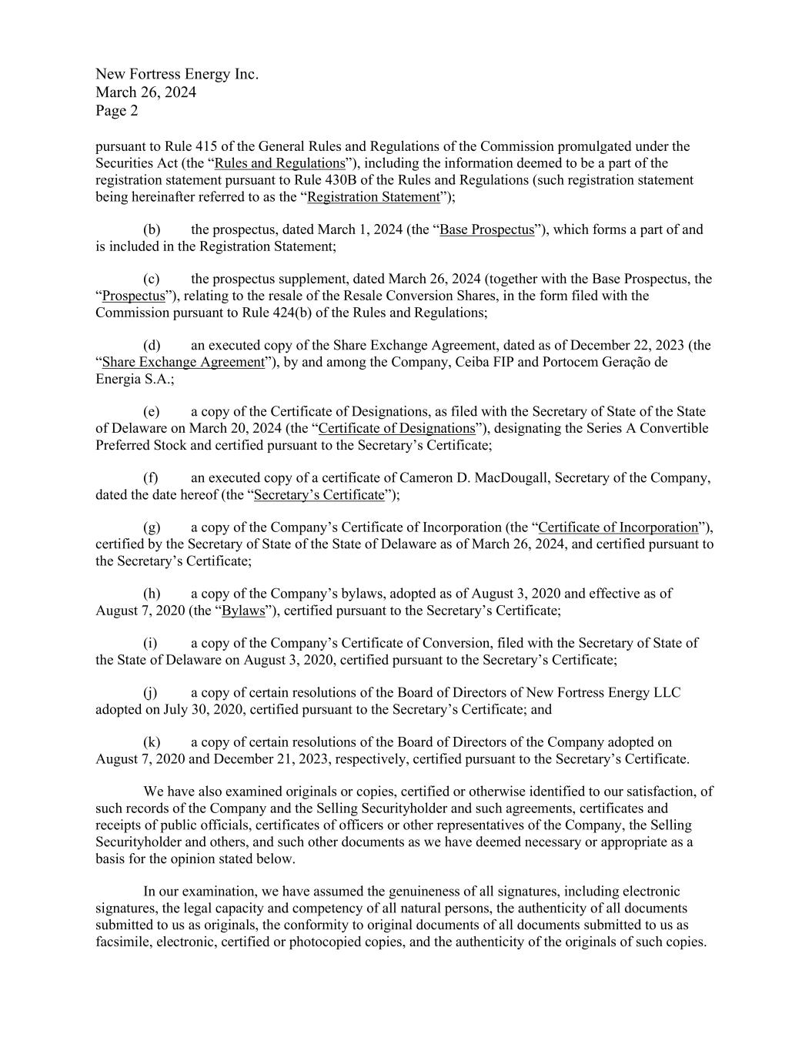
New Fortress Energy Inc. March 26, 2024 Page 2 pursuant to Rule 415 of the General Rules and Regulations of the Commission promulgated under the Securities Act (the “Rules and Regulations”), including the information deemed to be a part of the registration statement pursuant to Rule 430B of the Rules and Regulations (such registration statement being hereinafter referred to as the “Registration Statement”); (b) the prospectus, dated March 1, 2024 (the “Base Prospectus”), which forms a part of and is included in the Registration Statement; (c) the prospectus supplement, dated March 26, 2024 (together with the Base Prospectus, the “Prospectus”), relating to the resale of the Resale Conversion Shares, in the form filed with the Commission pursuant to Rule 424(b) of the Rules and Regulations; (d) an executed copy of the Share Exchange Agreement, dated as of December 22, 2023 (the “Share Exchange Agreement”), by and among the Company, Ceiba FIP and Portocem Geração de Energia S.A.; (e) a copy of the Certificate of Designations, as filed with the Secretary of State of the State of Delaware on March 20, 2024 (the “Certificate of Designations”), designating the Series A Convertible Preferred Stock and certified pursuant to the Secretary’s Certificate; (f) an executed copy of a certificate of Cameron D. MacDougall, Secretary of the Company, dated the date hereof (the “Secretary’s Certificate”); (g) a copy of the Company’s Certificate of Incorporation (the “Certificate of Incorporation”), certified by the Secretary of State of the State of Delaware as of March 26, 2024, and certified pursuant to the Secretary’s Certificate; (h) a copy of the Company’s bylaws, adopted as of August 3, 2020 and effective as of August 7, 2020 (the “Bylaws”), certified pursuant to the Secretary’s Certificate; (i) a copy of the Company’s Certificate of Conversion, filed with the Secretary of State of the State of Delaware on August 3, 2020, certified pursuant to the Secretary’s Certificate; (j) a copy of certain resolutions of the Board of Directors of New Fortress Energy LLC adopted on July 30, 2020, certified pursuant to the Secretary’s Certificate; and (k) a copy of certain resolutions of the Board of Directors of the Company adopted on August 7, 2020 and December 21, 2023, respectively, certified pursuant to the Secretary’s Certificate. We have also examined originals or copies, certified or otherwise identified to our satisfaction, of such records of the Company and the Selling Securityholder and such agreements, certificates and receipts of public officials, certificates of officers or other representatives of the Company, the Selling Securityholder and others, and such other documents as we have deemed necessary or appropriate as a basis for the opinion stated below. In our examination, we have assumed the genuineness of all signatures, including electronic signatures, the legal capacity and competency of all natural persons, the authenticity of all documents submitted to us as originals, the conformity to original documents of all documents submitted to us as facsimile, electronic, certified or photocopied copies, and the authenticity of the originals of such copies.

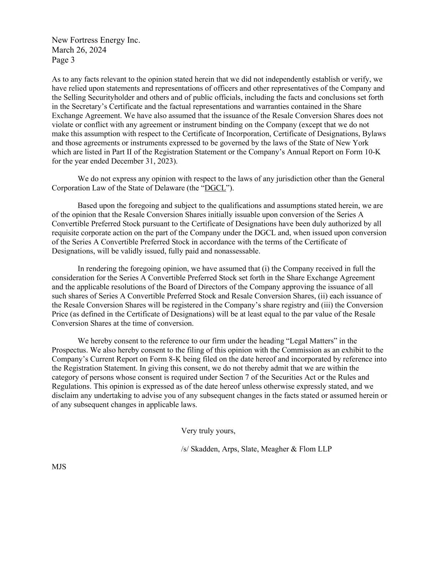
New Fortress Energy Inc. March 26, 2024 Page 3 As to any facts relevant to the opinion stated herein that we did not independently establish or verify, we have relied upon statements and representations of officers and other representatives of the Company and the Selling Securityholder and others and of public officials, including the facts and conclusions set forth in the Secretary’s Certificate and the factual representations and warranties contained in the Share Exchange Agreement. We have also assumed that the issuance of the Resale Conversion Shares does not violate or conflict with any agreement or instrument binding on the Company (except that we do not make this assumption with respect to the Certificate of Incorporation, Certificate of Designations, Bylaws and those agreements or instruments expressed to be governed by the laws of the State of New York which are listed in Part II of the Registration Statement or the Company’s Annual Report on Form 10-K for the year ended December 31, 2023). We do not express any opinion with respect to the laws of any jurisdiction other than the General Corporation Law of the State of Delaware (the “DGCL”). Based upon the foregoing and subject to the qualifications and assumptions stated herein, we are of the opinion that the Resale Conversion Shares initially issuable upon conversion of the Series A Convertible Preferred Stock pursuant to the Certificate of Designations have been duly authorized by all requisite corporate action on the part of the Company under the DGCL and, when issued upon conversion of the Series A Convertible Preferred Stock in accordance with the terms of the Certificate of Designations, will be validly issued, fully paid and nonassessable. In rendering the foregoing opinion, we have assumed that (i) the Company received in full the consideration for the Series A Convertible Preferred Stock set forth in the Share Exchange Agreement and the applicable resolutions of the Board of Directors of the Company approving the issuance of all such shares of Series A Convertible Preferred Stock and Resale Conversion Shares, (ii) each issuance of the Resale Conversion Shares will be registered in the Company’s share registry and (iii) the Conversion Price (as defined in the Certificate of Designations) will be at least equal to the par value of the Resale Conversion Shares at the time of conversion. We hereby consent to the reference to our firm under the heading “Legal Matters” in the Prospectus. We also hereby consent to the filing of this opinion with the Commission as an exhibit to the Company’s Current Report on Form 8-K being filed on the date hereof and incorporated by reference into the Registration Statement. In giving this consent, we do not thereby admit that we are within the category of persons whose consent is required under Section 7 of the Securities Act or the Rules and Regulations. This opinion is expressed as of the date hereof unless otherwise expressly stated, and we disclaim any undertaking to advise you of any subsequent changes in the facts stated or assumed herein or of any subsequent changes in applicable laws. Very truly yours, /s/ Skadden, Arps, Slate, Meagher & Flom LLP MJS

