Table of Contents

UNITED STATES

SECURITIES AND EXCHANGE COMMISSION

WASHINGTON, DC 20549
FORM 10-K

- ANNUAL REPORT PURSUANT TO SECTION 13 OR 15(d) OF THE SECURITIES EXCHANGE ACT OF 1934

For the year ended December 31, 2025

OR

- TRANSITION REPORT PURSUANT TO SECTION 13 OR 15(d) OF THE SECURITIES EXCHANGE ACT OF 1934

For the transition period from _______ to_______
Commission File Number: 001-38790

New Fortress Energy Inc.

(Exact Name of Registrant as Specified in its Charter)

Delaware | 83-1482060
(State or other jurisdiction of incorporation or organization) | (I.R.S. Employer Identification No.)
111 W. 19th Street, 8th Floor
New York, NY | 10011
(Address of principal executive offices) | (Zip Code)

Registrant’s telephone number, including area code: (516) 268-7400

Securities registered pursuant to Section 12(b) of the Act:

 | Title of each class |  | Trading Symbol(s) |  | Name of each exchange on which
 |  |  | Trading Symbol(s) |  |  | registered
Class A common stock |  |  | NFE |  | Nasdaq Global Select Market

Securities registered pursuant to Section 12(g) of the Act: None

Indicate by check mark if the registrant is a well-known seasoned issuer, as defined in Rule 405 of the Securities Act. Yes o No x

Indicate by check mark if the registrant is not required to file reports pursuant to Section 13 or Section 15(d) of the Act. Yes o No x

Indicate by check mark whether the registrant (1) has filed all reports required to be filed by Section 13 or 15(d) of the Securities Exchange Act of 1934 during the preceding 12 months (or for such shorter period that the registrant was required to file such reports), and (2) has been subject to such filing requirements for the past 90 days. Yes x No o

Indicate by check mark whether the registrant has submitted electronically every Interactive Data File required to be submitted pursuant to Rule 405 of Regulation S-T (§ 232.405 of this chapter) during the preceding 12 months (or for such shorter period that the registrant was required to submit such files). Yes x No o

Indicate by check mark whether the registrant is a large accelerated filer, an accelerated filer, a non-accelerated filer, a smaller reporting company, or an emerging growth company. See the definitions of “large accelerated filer,” “accelerated filer,” “smaller reporting company” and “emerging growth company” in Rule 12b-2 of the Exchange Act.

Table of Contents

Large accelerated filer o | Accelerated filer x
Non-accelerated filer o | Smaller reporting company ☐
 | Emerging growth company ☐

If an emerging growth company, indicate by check mark if the registrant has elected not to use the extended transition period for complying with any new or revised financial accounting standards provided pursuant to Section 13(a) of the Exchange Act. o

Indicate by check mark whether the registrant has filed a report on and attestation to its management’s assessment of the effectiveness of its internal control over financial reporting under Section 404(b) of the Sarbanes-Oxley Act (15 U.S.C. 7262(b)) by the registered public accounting firm that prepared or issued its audit report. x

If securities are registered pursuant to Section 12(b) of the Act, indicate by check mark whether the financial statements of the registrant included in the filing reflect the correction of an error to previously issued financial statements.
x
Indicate by check mark whether any of those error corrections are restatements that required a recovery analysis of incentive-based compensation received by any of the registrant’s executive officers during the relevant recovery period pursuant to §240.10D-1(b). o

Indicate by check mark whether the registrant is a shell company (as defined in Rule 12b-2 of the Exchange Act). Yes o No x

The aggregate market value of the voting and non-voting common equity held by non-affiliates of the registrant computed as of June 30, 2025 (the last business day of the registrant’s most recently completed second fiscal quarter), based on the closing price of the Class A common stock on the Nasdaq Global Select Market, was $557.5 million.

At March 31, 2026, the registrant had 285,634,650 shares of Class A common stock outstanding.

Documents Incorporated by Reference:

Portions of the registrant’s definitive proxy statement for the registrant’s 2026 annual meeting, to be filed within 120 days after the close of the registrant’s fiscal year, are incorporated by reference into Part III of this Annual Report on Form 10-K.

Table of
 |  | Contents
 |  |  |  |  |  |  |  |  |  |  |  |  |  |  |  |  |  |  |  |  |  |  | Table of Contents
 | GLOSSARY OF TERMS |  |  |  |  |  |  |  |  |  |  |  |  |  |  |  |  |  |  |  |  |  |  |  |  |  |  |  |  |  |  |  |  |  | 1
 | CAUTIONARY STATEMENT ON FORWARD-LOOKING STATEMENTS |  |  |  |  |  |  |  |  |  |  |  |  |  |  |  |  |  |  |  |  |  |  |  |  |  |  |  |  |  |  |  |  |  | 2
 | PART I |  |  |  |  |  |  |  |  |  |  |  |  |  |  |  |  |  |  |  |  |  |  |  |  |  |  |  |  |  |  |  |  |  | 4
 | Items 1 and 2. Business and Properties |  |  |  |  |  |  |  |  |  |  |  |  |  |  |  |  |  |  |  |  |  |  |  |  |  |  |  |  |  |  |  |  |  | 4
 | Item 1A. |  |  |  |  |  |  |  | Risk Factors |  |  |  |  |  |  |  |  |  |  |  |  |  |  |  |  |  |  |  |  |  |  |  |  |  | 20
 | Item 1B. |  |  |  |  |  |  |  | Unresolved Staff Comments. |  |  |  |  |  |  |  |  |  |  |  |  |  |  |  |  |  |  |  |  |  |  |  |  |  | 62
 | Item 1C. |  |  |  |  |  |  |  | Cybersecurity |  |  |  |  |  |  |  |  |  |  |  |  |  |  |  |  |  |  |  |  |  |  |  |  |  | 62
 | Item 3. |  |  |  |  |  |  |  | Legal Proceedings. |  |  |  |  |  |  |  |  |  |  |  |  |  |  |  |  |  |  |  |  |  |  |  |  |  | 63
 | Item 4. |  |  |  |  |  |  |  | Mine Safety Disclosures. |  |  |  |  |  |  |  |  |  |  |  |  |  |  |  |  |  |  |  |  |  |  |  |  |  | 64
 | PART II |  |  |  |  |  |  |  |  |  |  |  |  |  |  |  |  |  |  |  |  |  |  |  |  |  |  |  |  |  |  |  |  |  | 65
 | Item 5. |  |  |  |  |  |  |  | Market for the Registrant’s Common Equity, Related Shareholder Matters and Issuer |  |  |  |  |  |  |  |  |  |  |  |  |  |  |  |  |  |  |  |  |  |  |  |  |  | 65
 |  |  |  |  |  |  |  |  | Purchases of Equity Securities. |  |  |  |  |  |  |  |  |  |  |  |  |  |  |  |  |  |  |  |  |  |  |  |  |  | 65
 | Item 6. |  |  |  |  |  |  |  | [Reserved.] |  |  |  |  |  |  |  |  |  |  |  |  |  |  |  |  |  |  |  |  |  |  |  |  |  | 66
 | Item 7.
 |  |  |  |  |  |  |  |  | Management’s Discussion and Analysis of Financial Condition and Results of Operations. |  |  |  |  |  |  |  |  |  |  |  |  |  |  |  |  |  |  |  |  |  |  |  |  |  | 67
 | Item 7A. |  |  |  |  |  |  |  | Quantitative and Qualitative Disclosures About Market Risk. |  |  |  |  |  |  |  |  |  |  |  |  |  |  |  |  |  |  |  |  |  |  |  |  |  | 95
 | Item 8. |  |  |  |  |  |  |  | Financial Statements and Supplementary Data. |  |  |  |  |  |  |  |  |  |  |  |  |  |  |  |  |  |  |  |  |  |  |  |  |  | 95
 | Item 9. |  |  |  |  |  |  |  | Changes in and Disagreements With Accountants on Accounting and Financial Disclosure. |  |  |  |  |  |  |  |  |  |  |  |  |  |  |  |  |  |  |  |  |  |  |  |  |  | 95
 | Item 9A. |  |  |  |  |  |  |  | Controls and Procedures. |  |  |  |  |  |  |  |  |  |  |  |  |  |  |  |  |  |  |  |  |  |  |  |  |  | 96
 | Item 9B. |  |  |  |  |  |  |  | Other Information. |  |  |  |  |  |  |  |  |  |  |  |  |  |  |  |  |  |  |  |  |  |  |  |  |  | 99
 | Item 9C. |  |  |  |  |  |  |  | Disclosure Regarding Foreign Jurisdictions that Prevent Inspections. |  |  |  |  |  |  |  |  |  |  |  |  |  |  |  |  |  |  |  |  |  |  |  |  |  | 99
 | PART III |  |  |  |  |  |  |  |  |  |  |  |  |  |  |  |  |  |  |  |  |  |  |  |  |  |  |  |  |  |  |  |  |  | 100
 | Item 10. |  |  |  |  |  |  |  | Directors, Executive Officers and Corporate Governance. |  |  |  |  |  |  |  |  |  |  |  |  |  |  |  |  |  |  |  |  |  |  |  |  |  | 100
 | Item 11. |  |  |  |  |  |  |  | Executive Compensation |  |  |  |  |  |  |  |  |  |  |  |  |  |  |  |  |  |  |  |  |  |  |  |  |  | 100
 | Item 12. |  |  |  |  |  |  |  | Security Ownership of Certain Beneficial Owners and Management and Related Stockholder |  |  |  |  |  |  |  |  |  |  |  |  |  |  |  |  |  |  |  |  |  |  |  |  |  | 100
 |  |  |  |  |  |  |  |  | Matters. |  |  |  |  |  |  |  |  |  |  |  |  |  |  |  |  |  |  |  |  |  |  |  |  |  | 100
 | Item 13.
 |  |  |  |  |  |  |  |  | Certain Relationships and Related Transactions, and Director Independence. |  |  |  |  |  |  |  |  |  |  |  |  |  |  |  |  |  |  |  |  |  |  |  |  |  | 100
 | Item 14. |  |  |  |  |  |  |  | Principal Accountant Fees and Services. |  |  |  |  |  |  |  |  |  |  |  |  |  |  |  |  |  |  |  |  |  |  |  |  |  | 100
 | PART IV |  |  |  |  |  |  |  |  |  |  |  |  |  |  |  |  |  |  |  |  |  |  |  |  |  |  |  |  |  |  |  |  |  | 101
 | Item 15. |  |  |  |  |  |  |  | Exhibits, Financial Statement Schedules. |  |  |  |  |  |  |  |  |  |  |  |  |  |  |  |  |  |  |  |  |  |  |  |  |  | 101
 | Item 16. |  |  |  |  |  |  |  | Form 10-K Summary |  |  |  |  |  |  |  |  |  |  |  |  |  |  |  |  |  |  |  |  |  |  |  |  |  | 111
 | SIGNATURES |  |  |  |  |  |  |  |  |  |  |  |  |  |  |  |  |  |  |  |  |  |  |  |  |  |  |  |  |  |  |  |  |  | 112
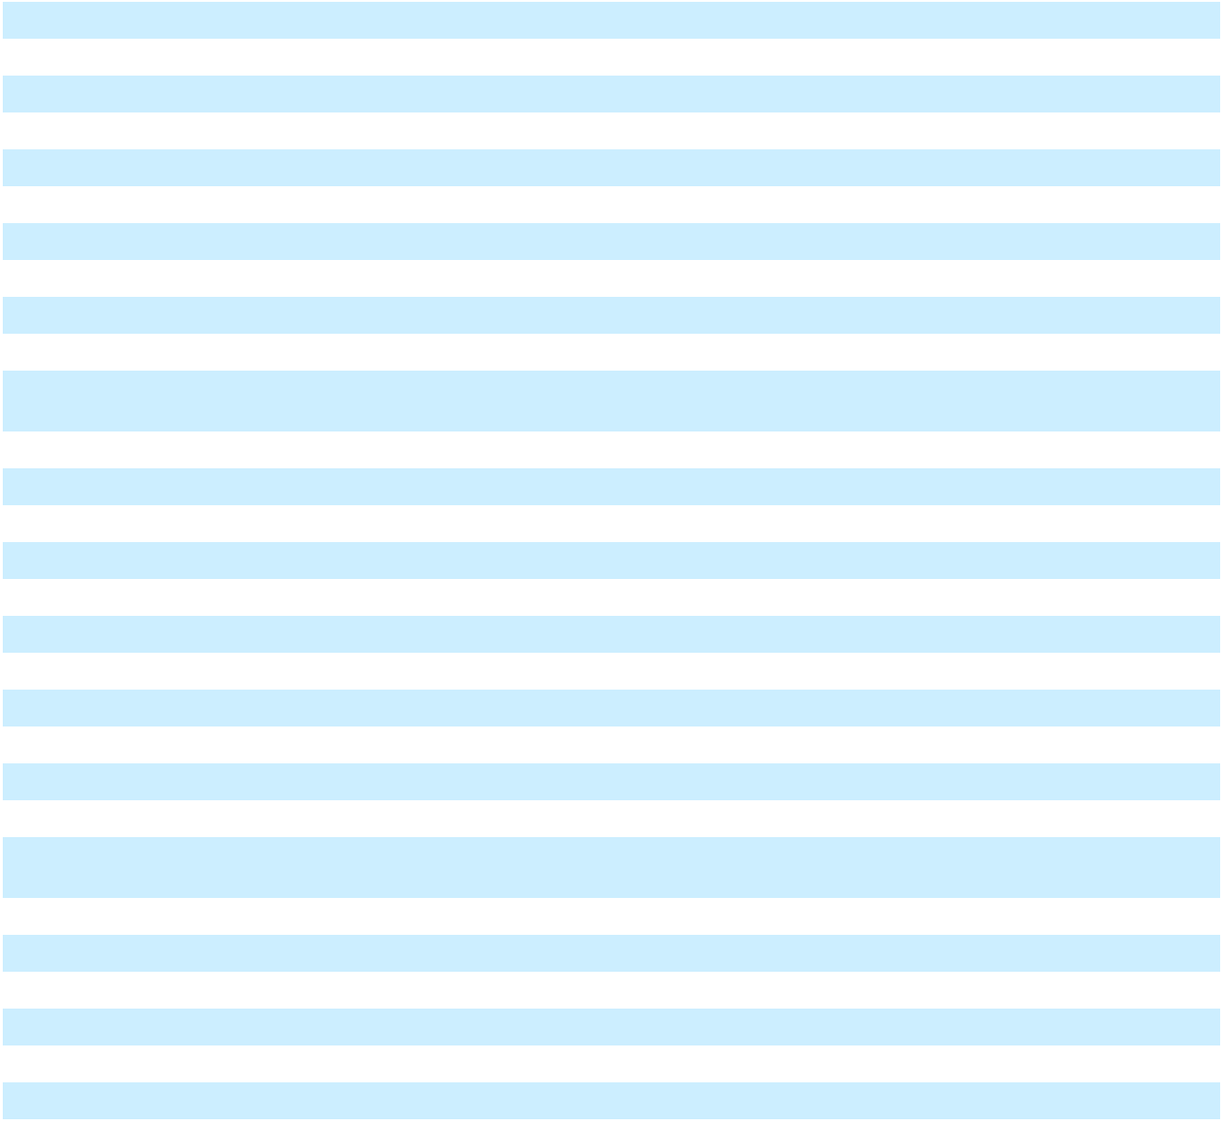

Table of Contents

GLOSSARY OF TERMS

As commonly used in the liquefied natural gas industry, to the extent applicable and as used in this Annual Report on Form 10-K for the year ended December 31, 2025 (this “Annual Report”), the terms listed below have the following meanings:

ADO automotive diesel oil

Bcf/yr billion cubic feet per year

Btu the amount of heat required to raise the temperature of one avoirdupois pound of pure water from 59

degrees Fahrenheit to 60 degrees Fahrenheit at an absolute pressure of 14.696 pounds per square inch gage

CAA Clean Air Act

CERCLA Comprehensive Environmental Response, Compensation and Liability Act

CWA Clean Water Act

DOE U.S. Department of Energy

DOT U.S. Department of Transportation

EPA U.S. Environmental Protection Agency

FTA countries countries with which the United States has a free trade agreement providing for national treatment for
trade in natural gas

GAAP generally accepted accounting principles in the United States

GHG greenhouse gases

GSA gas sales agreement

GW gigawatt

Henry Hub a natural gas pipeline located in Erath, Louisiana that serves as the official delivery location for
futures contracts on the New York Mercantile Exchange

ISO container International Organization of Standardization, an intermodal container

LNG natural gas in its liquid state at or below its boiling point at or near atmospheric pressure

MMBtu one million Btus, which corresponds to approximately 12.1 gallons of LNG

mtpa metric tons per year

kV kilovolt

MW megawatt. We estimate 2,500 LNG gallons would be required to produce one megawatt.

NGA Natural Gas Act of 1938, as amended

non-FTA countries countries without a free trade agreement with the United States providing for national treatment for trade in natural gas and with which trade is permitted

OPA Oil Pollution Act

PHMSA Pipeline and Hazardous Materials Safety Administration

PPA power purchase agreement

SSA steam supply agreement

TBtu one trillion Btus, which corresponds to approximately 12,100,000 gallons of LNG

1

Table of Contents

CAUTIONARY STATEMENT ON FORWARD-LOOKING STATEMENTS

This Annual Report contains forward-looking statements regarding, among other things, our plans, strategies, prospects and projections, both business and financial. All statements contained in this Annual Report other than historical information are forward-looking statements that involve known and unknown risks and relate to future events, our future financial performance or our projected business results. In some cases, you can identify forward-looking statements by terminology such as “may,” “will,” “could,” “should,” “expects,” “intends,” “plans,” “anticipates,” “believes,” “estimates,” “predicts,” “projects,” “targets,” “potential” or “continue” or the negative of these terms or other comparable terminology. Such forward-looking statements are necessarily estimates based upon current information and involve a number of risks and uncertainties. Actual events or results may differ materially from the results anticipated in these forward-looking statements as a result of a variety of factors. While it is impossible to identify all such factors, factors that could cause actual results to differ materially from those estimated by us include:

- adequately addressing the substantial doubt as to our ability to continue as a going concern and satisfy our liquidity needs, including the consummation of certain items that management expects to occur and other transactions intended to enhance our liquidity;

- our ability to successfully consummate the Restructuring Transaction (as defined herein), on the timeline contemplated or at all, and our ability to realize the intended benefits of such transaction;

- risks related to the implementation of the Restructuring Transaction, including diverting management’s attention and resources, increased costs, and adverse effects on our relationships with customers, suppliers, employees, and other stakeholders;

- operational, financial, tax and other risks related to the separation of the Company into two independent entities as part of the Restructuring Transaction;

- our ability to maintain effective internal control over financial reporting and disclosure controls and procedures, including our ability to remediate our material weaknesses in our internal control over financial reporting and the timing of any such remediation;

- the results of our subsidiaries, affiliates, joint ventures and special purpose entities in which we invest and their ability to make dividends or distributions to us;

- construction and operational risks related to our facilities and assets, including cost overruns and delays;

- failure of LNG or natural gas to be a competitive source of energy in the markets in which we operate, and seek to operate;

- complex regulatory and legal environments related to our business, assets and operations, including actions by governmental entities or changes to regulation or legislation, in particular related to our permits, approvals and authorizations for the construction and operation of our facilities;

- delays or failure to obtain and maintain approvals and permits from governmental and regulatory agencies;

- failure to obtain a return on our investments for the development of our projects and assets and the implementation of our business strategy;

- failure to maintain sufficient working capital for the development and operation of our business and assets;

- failure to convert our customer pipeline into actual sales;

- lack of asset, geographic or customer diversification, including loss of one or more of our customers;

- competition from third parties in our business;

- cyclical or other changes in the demand for and price of LNG and natural gas;

2

Table of Contents

- inability to procure LNG at necessary quantities or at favorable prices to meet customer demand, or otherwise to manage LNG supply and price risks, including hedging arrangements;

- inability to successfully develop and implement our technological solutions;

- inability to service our debt and comply with our covenant restrictions;

- inability to obtain additional financing to effect our strategy;

- inability to maintain the listing of our Class A common stock on the Nasdaq stock market or another national securities exchange;

- inability to successfully complete mergers, sales, divestments or similar transactions related to our businesses or assets or to integrate such businesses or assets and realize the anticipated benefits, including the anticipated benefits from the sale of our Jamaica Business (as defined below) and our strategy and plans for the remaining portion of the Company, including the structure, form, timing and nature of potential actions with respect to the Company’s business in the future and characteristics of the business going forward;

- economic, political, social and other risks related to the jurisdictions in which we do, or seek to do, business;

- weather events or other natural or manmade disasters or phenomena;

- any future pandemic or any other major health and safety incident;

- increased labor costs, disputes or strikes, and the unavailability of skilled workers or our failure to attract and retain qualified personnel;

- changes in law, economic and financial conditions, including the effect of the tax treatment of, or changes in tax laws applicable to, us or our business or of an investment in our Class A common stock, and changing trade policies and tariffs and the related uncertainty thereof; and

- other risks described in the “Risk Factors” section of this Annual Report.

All forward-looking statements speak only as of the date of this Annual Report. When considering forward-looking statements, you should keep in mind the risks set forth under “Item 1A. Risk Factors” and other cautionary statements included in this Annual Report. The cautionary statements referred to in this section also should be considered in connection with any subsequent written or oral forward-looking statements that may be issued by us or persons acting on our behalf. We undertake no duty to update these forward-looking statements, even though our situation may change in the future. Furthermore, we cannot guarantee future results, events, levels of activity, performance, projections or achievements.

3

Table of Contents

PART I

Items 1 and 2. Business and Properties

Unless the context otherwise requires, references to “Company,” “NFE,” “we,” “our,” “us” or like terms refer to New Fortress Energy Inc. and its subsidiaries.

Planned Debt Restructuring

The Company did not make certain interest and principal payments that were due during the fiscal quarters ended December 31, 2025 and March 31, 2026 on (i) the 12.000% Senior Secured Notes due 2029 (the “New 2029 Notes”) issued by NFE Financing LLC, an indirect subsidiary of the Company (“NFE Financing”), (ii) the Company’s Credit Agreement, dated as of July 19, 2024 (the “Term Loan A Credit Agreement”), (iii) the Company’s Credit Agreement, dated as of October 30, 2023 (the “Term Loan B Credit Agreement”), (iv) the Company’s Credit Agreement, dated as of April 15,
2021 (the “Revolving Credit Agreement”), and (iv) the EB-5 Loan Agreement (as defined herein), and events of default arose under these debt agreements upon the expiration of contractual grace periods. Additionally, the Company did not make interest and principal payments that were due on March 15 and March 31, 2026, respectively, on (a) the 6.500% Senior Secured Notes due 2026 issued by the Company (the “2026 Notes”) and (b) the 8.750% Senior Secured Notes due 2029 issued by the Company (the “2029 Notes”), which will result in events of default under each series of notes on April 15 and April 30, 2026, respectively. The indentures and credit agreements underlying substantially all of our outstanding debt includes cross-acceleration and/or cross-default provisions that upon such acceleration of the outstanding principal of any of the debt in default, all of the Company’s other outstanding debt would be payable on demand.

On March 17, 2026, the Company entered into a restructuring support agreement (together with all exhibits, annexes and schedules thereto, the “RSA”) with certain of its lenders and noteholders, including:

- certain members of an ad hoc group of holders of the New 2029 Notes;

- certain members of an ad hoc group of term lenders under the Term Loan B Credit Agreement;

- certain holders of debt under the Revolving Credit Agreement, being lenders under a facility currently drawn at approximately $100 million (the “R-1 Revolving Credit Facility”) and under a facility currently drawn at approximately $560 million (the “R-2 Revolving Credit Facility”);

- certain members of an ad hoc group of term lenders under the Term Loan A Credit Agreement; and

- a majority of the members of a group of creditors with recourse to the collateral assets in the Company’s core business, but not to the Company’s Fast LNG (or “FLNG”) assets or Brazil business, including (1) holders of the 2026 Notes and holders of the 2029 Notes and (2) creditors of the debt under that certain Credit Agreement, dated as of November 22, 2024, by and among the Company, as the borrower, the guarantors from time to time party thereto, NFE Brazil Investments LLC, as the lender, and Wilmington Savings Fund Society, FSB, as the administrative agent and as collateral agent (the “Series I Credit Agreement”), and under that certain Credit Agreement, dated as of December 6, 2024, by and among the Company, as the borrower, the guarantors from time to time party thereto, NFE Financing, as the lender, and Wilmington Savings Funds Society, FSB, as the administrative agent and as collateral agent (the “Series II Credit Agreement”) (collectively, the “Supporting Creditors”).

Holders of or lenders under the debt instruments described above that are not already party to the RSA may become Additional Supporting Creditors (as defined in the RSA) by executing and delivering a joinder in accordance with the terms of the RSA.

The RSA sets forth principal terms for a comprehensive restructuring of the Company’s principal funded debt obligations (the “Restructuring Transaction”). The RSA contemplates, among other things, the following material terms:

- The Company will separate into two independent companies: one generally comprising the Company’s businesses and assets in Brazil and land in Wyalusing, Pennsylvania (“BrazilCo”), and the other generally comprising the Company’s other businesses and assets, which will be retained by the Company (“CoreCo”);

4

Table of Contents

- Obligations under the 2026 Notes, the 2029 Notes, the Term Loan A Credit Agreement, the Term Loan B Credit Agreement, the Revolving Credit Agreement, the New 2029 Notes, and certain intercompany credit agreements will be exchanged (in each case on a ratable basis) for one or a combination of the following debt obligations and equity securities:

  - 100% of the common equity interests in BrazilCo;

  - approximately $571.3 million in senior secured term loans incurred by the Company, as borrower, and guaranteed by each subsidiary of the Company that will be part of CoreCo (subject to customary exclusions and other exclusions to be agreed) (“New CoreCo Term Loans”);

  - convertible preferred stock of the Company with an aggregate liquidation preference of approximately $2.46 billion (“CoreCo Convertible Preferred Stock”);

  - shares representing 65% of the Company’s Class A common stock as of the closing date of the Restructuring Transaction, before giving effect to shares authorized under an incentive plan for directors, officers, and other employees of the Company or any conversion of the CoreCo Convertible Preferred Stock into NFE Class A common stock;

  - $400.0 million in non-recourse term loans incurred or issued by the subsidiary that owns the Company’s Fast LNG 2 assets (“FLNG 2 Co”), payable in full on the third anniversary of the closing date of the Restructuring Transaction, guaranteed by certain subsidiaries of FLNG 2 Co and secured by substantially all assets of FLNG 2 Co and such subsidiaries; and/or

  - $200.0 million in non-convertible, preferred equity (the “FLNG 2 Preferred Equity”) issued by FLNG 2 Co.

- Corporate governance matters regarding CoreCo;

- Letters of credit issued under the Company’s existing Letter of Credit Facility (as defined herein) or Revolving Facility (as defined herein) will be backstopped or replaced by letters of credit issued under new fully committed letter of credit facilities for each of CoreCo and BrazilCo;

- Certain other existing debt facilities and other liabilities will be refinanced, renegotiated, or compromised, or will remain outstanding in accordance with their existing terms;

- All shares of the Company’s Class A common stock outstanding immediately prior to the consummation of the Restructuring Transaction will remain outstanding and will represent 35% of the Company’s Class A common stock issued and outstanding following the consummation of the Restructuring Transaction (but before giving effect to shares authorized under the incentive plan for directors, officers and other employees of the Company or any conversion of the CoreCo Convertible Preferred Stock into NFE Class A common stock); and

- If required in order to meet a consolidated minimum liquidity threshold ($100 million) on the closing date of the Restructuring Transaction, the Company will offer to all eligible creditors the opportunity to participate in a capital raise, pursuant to which the Company would raise up to $35 million in aggregate principal amount of additional New CoreCo Term Loans and, to the extent the consolidated minimum liquidity threshold would not be met after giving effect to the additional New CoreCo Term Loans, junior term loans secured by a second-priority lien in an amount so that the consolidated minimum liquidity threshold would be met.

Provided certain conditions are met (as set out in the RSA), the Company will pay to holders of or lenders under the debt instruments described above that become Supporting Creditors on or before 5:00 p.m. New York City time on April 8, 2026, an early consent fee (the “Early Consent Fee”) in an amount equal to 0.75% of the principal amount of such Supporting Creditors’ pro rata claim in:

- the principal outstanding under the 2026 Notes for each supporting holder of 2026 Notes;

- the principal outstanding under the 2029 Notes for each supporting holder of 2029 Notes;

5

Table of Contents

- the principal outstanding under the Term Loan B Credit Agreement for each supporting lender under the Term Loan B Credit Agreement;

- the principal outstanding under the R-1 Revolving Credit Facility for each supporting lender under the R-1 Revolving Credit Facility;

- for each supporting lender under the R-2 Revolving Credit Facility, (i) the principal outstanding under the R-2 Revolving Credit Facility, plus (ii) a share of principal outstanding under the Series I Credit Agreement and the Series II Credit Agreement in proportion to the share of recoveries for lenders under the R-2 Revolving Credit Facility in respect of certain assets of NFE Financing together with a guarantee from Bradford County Real Estate Partners LLC (the “Brazil Collateral”) governed by an intercreditor agreement dated December 6, 2024 (the “Brazil Parent ICA”);

- for each supporting lender under the Term Loan A Credit Agreement, (i) the principal outstanding under the Term Loan A Credit Agreement, plus (ii) a share of principal outstanding under the Series I Credit Agreement and the Series II Credit Agreement in proportion to the share of recoveries for lenders under the Term Loan A Credit Agreement in respect of the Brazil Collateral under the Brazil Parent ICA; and

- for each supporting holder of the New 2029 Notes, a share of principal outstanding under the Series I Credit Agreement and the Series II Credit Agreement in proportion to the share of recoveries for holders of the New 2029 Notes in respect of the Brazil Collateral under the Brazil Parent ICA.

The Company has received strong indications of support for the Restructuring Transaction from holders and lenders representing over 95% of its approximately $5.8 billion principal amount of aggregate indebtedness, including approximately 93% of holders of the 2026 Notes, 87% of holders of the 2029 Notes, 98% of holders of the New 2029 Notes, 100% of lenders under the Term Loan A Credit Agreement, 88% of lenders under the Term Loan B Credit Agreement, and 100% of lenders of the Revolving Credit Facility as of April 1, 2026.

A Supporting Creditor’s entitlement to the Early Consent Fee will be determined by reference to the aggregate principal amount of notes and loans held by that Supporting Creditor as of the record date specified to creditors for voting under the Restructuring Plans (as defined below). Such early consent fee will be payable in kind in the form of the consideration to be afforded to such Supporting Creditors under the Restructuring Plans. Separately, the Company has agreed to pay each lender under the Revolving Credit Agreement that agrees to forbear from taking any enforcement action under the Revolving Credit Agreement a standstill fee in an amount equal to 2.00% of the outstanding loans made by such forbearing lender, provided that a simple majority of lenders under the Revolving Credit Agreement agree to forbear.

Summary of the CoreCo Convertible Preferred Stock and FLNG 2 Preferred Equity

Pursuant to the terms of the RSA, the CoreCo Convertible Preferred Stock will mandatorily convert on the third anniversary of the closing date of the Restructuring Transaction into shares of NFE Class A common stock representing 87% of the fully diluted Class A common stock of NFE as of the closing date of the Restructuring Transaction (after giving effect to the shares of NFE Class A common stock to be issued on the closing date of the Restructuring Transaction and the incentive plan for directors, officers and other employees of the Company). The conversion rate of the CoreCo Convertible Preferred Stock will be subject to customary adjustments for stock splits, distributions, reorganizations and reclassifications, as well as to certain price-based anti-dilution adjustments for subsequent issuances of NFE Class A common stock (or securities convertible into NFE Class A common stock) made by the Company while the CoreCo Convertible Preferred Stock remains outstanding (subject to certain exempt issuances). CoreCo will have the right to redeem or repurchase the CoreCo Convertible Preferred Stock from time to time with certain sources of proceeds enumerated in the RSA. Holders of the CoreCo Convertible Preferred Stock will be entitled, in arrears, to a cumulative quarterly compounding dividend, which will accrue automatically via an increase to liquidation preference, with a cumulative per annum preferred return of 3.0%, 5.0% and 7.0% in each of the three years, respectively, prior to conversion. The CoreCo Convertible Preferred Stock will participate on an as-converted basis in any dividends and distributions on, and vote together with holders of, NFE Class A common stock. The CoreCo Convertible Preferred Stock will be subordinated in right of payment to all existing and future indebtedness of CoreCo and senior in right of payment to all existing and future equity securities of CoreCo.

The FLNG 2 Preferred Equity will be issued by FLNG 2 Co at the closing date of the Restructuring Transaction pursuant to the RSA and will reflect economic and structural features substantially similar to those of the CoreCo Convertible

6

Table of Contents

Preferred Stock, except as otherwise provided herein. CoreCo will have the right to redeem the FLNG 2 Preferred Equity from time to time with certain sources of proceeds enumerated in the RSA. The Company will not pay any dividends on the FLNG 2 Preferred Equity. The FLNG 2 Preferred Equity will be subordinated in right of payment to all existing and future indebtedness of FLNG 2 Co and senior in right of payment to all existing and future equity securities of FLNG 2 Co.

Summary of the New CoreCo Term Loans

The Company expects to use the proceeds of the New CoreCo Term Loans to refinance, on a cashless basis, certain of the loans and other obligations outstanding under the Revolving Credit Agreement and Term Loan B Credit Agreement. If necessary, the cash proceeds of up to $35 million of additional New CoreCo Term Loans will be used to satisfy the consolidated minimum liquidity threshold required by the RSA. The New CoreCo Term Loans will mature five years after the closing date of the Restructuring Transaction and will amortize at a rate of 1% per annum, paid quarterly. The New CoreCo Term Loans will be guaranteed, jointly and severally, on a senior secured basis by each subsidiary that is a guarantor under the Letter of Credit Facility on the closing date of the Restructuring Transaction, and will be secured by substantially the same collateral as the collateral that currently secures the Letter of Credit Facility, subject to certain exceptions, including the Company’s FLNG 2 assets. To the extent the minimum liquidity threshold is not satisfied after giving effect to the funding of the New CoreCo Term Loans, the Company is permitted to incur additional indebtedness that will be guaranteed by the same guarantors guaranteeing the New CoreCo Term Loans and secured by a second-priority lien on all of the collateral securing the New CoreCore Term Loans.

The New CoreCo Term Loans may be voluntarily prepaid by the Company, in whole or in part, subject to prepayment premiums for optional prepayments equal to 102% of the aggregate principal amount of such term loan prepaid plus accrued and unpaid interest during the first year after the closing of the New CoreCo Credit Agreement, and at par plus accrued and unpaid interest thereafter. The Company will be required to prepay the New CoreCo Term Loans at par with the net proceeds of non-ordinary course asset sales, condemnations and certain other events enumerated in the RSA.

Holder Elections

Certain holders of debt under the Revolving Credit Agreement and Term Loan A Credit Agreement may elect to receive their pro rata share of $45 million in lieu of the BrazilCo Common Equity they would receive in exchange for their debt. Holders of debt under the Revolving Credit Agreement may elect to receive additional New CoreCo Term Loans in lieu of the CoreCo Convertible Preferred Stock they would receive in exchange for their claims, at a rate of 50% of the liquidation preference of the CoreCo Convertible Preferred Stock in aggregate principal amount of New CoreCo Term Loans.

In addition, one or more directors and officers of the Company and, potentially, certain Supporting Creditors and/or third-party investors, as determined by such directors and officers, will offer to purchase from holders of debt under the Revolving Credit Agreement and Term Loan A Credit Agreement a limited number of shares of CoreCo Convertible Preferred Stock allocated to such holders (subject to certain terms and conditions, including that the relevant holder timely elects to participate in such arrangements) for a cash purchase price of 25% of the liquidation preference of such shares of CoreCo Convertible Preferred Stock.

The Restructuring Plans

The Company expects to complete the Restructuring Transaction through restructuring plans promoted by each of two indirect subsidiaries of the Company, (i) NFE Global Holdings Limited (“NFE Global”) and (ii) NFE Brazil Newco Limited (“NFE Brazil Newco”) (each, a “PlanCo”) under Part 26A of the UK Companies Act 2006 (for each PlanCo, the “Restructuring Plan” and together, the “Restructuring Plans”) and sanctioned by the High Court of Justice in England (the “UK High Court”). NFE Global will propose a Restructuring Plan (the “CoreCo Plan”) that will compromise the debt under the Series I Credit Agreement, Series II Credit Agreement, 2026 Notes, 2029 Notes, Revolving Credit Agreement, Term Loan A Credit Agreement and Term Loan B Credit Agreement, and NFE Brazil Newco will propose a Restructuring Plan (the “BrazilCo Plan”) that will compromise the debt under the New 2029 Notes. The PlanCos will seek recognition of the Restructuring Plans in the United States pursuant to chapter 15 of the U.S. Bankruptcy Code. The Restructuring Plans will bind all relevant creditors, and release the obligations of the Company and all guarantors, under the debt instruments addressed in the Restructuring Plans; however, neither the Company nor any of its subsidiaries other than the PlanCos anticipate being parties to the Restructuring Plans proceedings in the UK High Court, the chapter 15 recognition proceedings or any other restructuring, bankruptcy or insolvency proceeding in connection with the Restructuring Transaction.

7

Table of Contents

The RSA sets forth the commitments of the Company and the Supporting Creditors to, among other things, cooperate in good faith to negotiate the definitive documents necessary or advisable to effect the Restructuring Transaction, use their commercially reasonable efforts to consummate the Restructuring Transaction in accordance with such definitive documents, and refrain from taking any actions, the substantial purpose of which is to object to, impede, obstruct, or materially delay the implementation of the Restructuring Transaction (including by supporting or consenting to any alternative transaction, subject, in the case of the Company, to a “fiduciary out”). In addition, the Supporting Creditors have agreed to forbear from exercising remedies (or directing or consenting to any such exercise of remedies) with respect to certain specified defaults and events of default under the applicable debt instruments while the RSA is in effect.

The parties’ obligations to consummate the Restructuring Transaction are subject to the satisfaction of certain conditions, including the UK High Court’s entry of an order sanctioning the Restructuring Plans and the recognition of that order in the United States pursuant to chapter 15 of the U.S. Bankruptcy Code, completion of definitive documents acceptable to the parties in accordance with standards set forth in the RSA, approval of certain matters by the Company’s stockholders, receipt of required regulatory and third-party consents and approvals, and satisfaction of certain process “milestones”.

The RSA may be terminated by the Company and/or the Supporting Creditors, as applicable, upon the occurrence of specified events defined in the RSA, including, without limitation, if (1) a material, uncured breach of certain parties’ representations, warranties, covenants, or obligations under the RSA occurs, (2) any of the conditions to the closing of the Restructuring Transaction (including the timely satisfaction of any of the process “milestones” prescribed in the RSA) is not timely satisfied or waived, (3) certain issued letters of credit are drawn or (4) the Restructuring Transaction has not closed by September 15, 2026 (which date may be automatically extended by up to 90 calendar days in certain circumstances and further extended with the consent of certain parties in accordance with the terms of the RSA through December 31, 2026). In addition, the Company may terminate the RSA if the Company’s board of directors determines, upon the advice of counsel, that the Company’s continued performance under the RSA would be inconsistent with the fiduciary duties of the Company’s directors.

The Company intends to submit certain proposals in connection with the Restructuring Transaction to the Company’s stockholders at its 2026 Annual Meeting of Stockholders, including, among other things, an amendment to the Company’s Certificate of Incorporation (the “Certificate of Incorporation”) to increase the number of authorized shares of the Company’s Class A common stock; approval for the potential issuance of common stock exceeding 20% of the current outstanding shares to comply with Nasdaq rules; an amendment to the Company’s 2019 Omnibus Incentive Plan (the “Incentive Plan”) to increase the number of shares available for grants; and an amendment to the Certificate of Incorporation to authorize a reverse stock split at a ratio to be determined by the Company’s board of directors (collectively, the “Stockholder Proposals”). The Restructuring Transaction is conditioned upon approval of all of the Stockholder Proposals.

Although we intend to pursue the Restructuring Transaction in accordance with the terms set forth in the RSA, there can be no assurance that we will satisfy all of the conditions under the RSA and complete the Restructuring Transaction as contemplated or at all. If we are unable to complete the Restructuring Transaction or any other alternative transactions, we will be required or compelled to pursue additional restructuring initiatives to preserve value and optionality, including possible out of court restructurings, or in-court relief, in the UK or the U.S., which could have a material and adverse impact on stockholders.

As part of our ongoing discussions with creditors, we have determined that it was not probable that we would pursue the development of certain Fast LNG projects, the ZeroParks hydrogen project and our Klondike power and data center development business. In addition, as we expect to divest our Brazil business upon effectuation of the Restructuring Transaction, our discussion of our business below is focused on our business after the Restructuring Transaction. Subsequent to the Restructuring Transaction, we plan to focus on operational efficiency of our facilities and cost effective completion of in-process development projects, with the objective of returning to profitability and generating shareholder value.

Business Overview

We are a global energy infrastructure company founded to help address energy poverty and accelerate the world’s transition to reliable, affordable and clean energy. We own and operate natural gas and liquefied natural gas (“LNG”) infrastructure, and an integrated fleet of ships and logistics assets to rapidly deliver turnkey energy solutions to global markets. Collectively, our assets and operations reinforce global energy security, enable economic growth, enhance environmental stewardship and transform local industries and communities around the world.

8

Table of Contents

We deliver targeted energy solutions by employing an integrated LNG supply and delivery model:

LNG and Natural Gas Supply and Liquefaction – We supply LNG and natural gas regasified from LNG to our own power plants and to our customers. Our first floating liquefaction unit, which we refer to as “FLNG 1”, began producing LNG in July 2024, and we source a significant portion of our LNG needs from this facility. Currently, demand for LNG above FLNG 1’s capacity is acquired from third party suppliers in open market purchases. Starting in 2027, we expect to meet this demand under long-term supply contracts, which are based on an index such as Henry Hub plus a fixed fee component.

Shipping – We lease, own or operate a fleet of two floating storage and regasification units (“FSRUs”) and seven liquefied natural gas carriers (“LNGCs”) and floating storage units (“FSUs”). Six vessels are owned by Energos Infrastructure (“Energos”). We also charter vessels to and from third parties as well as from Energos.

Facilities – Through our network of current and planned downstream facilities and logistics assets, we are strategically positioned to deliver gas and power solutions to our customers seeking either to transition from environmentally dirtier distillate fuels such as automotive diesel oil (“ADO”) and heavy fuel oil (“HFO”) or to purchase natural gas to meet their current fuel needs.

Our Business Model

As an integrated gas-to-power energy infrastructure company, our business model spans the entire production and delivery chain from natural gas procurement and liquefaction to shipping, logistics, facilities and conversion or development of natural gas-fired power generation. We currently conduct our downstream terminal operations at the following facilities:

- our landed micro-fuel handling facility in San Juan, Puerto Rico (the “San Juan Facility”), and

- our LNG receiving facility (the “La Paz Facility”) and gas-fired power plant (the “La Paz Power Plant”) at the Port of Pichilingue in Baja California Sur, Mexico.

In addition, we are currently developing facilities in Nicaragua and Ireland, as described below in more detail. We are in active discussions with additional customers to develop projects in multiple regions around the world who may have significant demand for additional power, LNG and natural gas, although there can be no assurance that these discussions will result in additional contracts or that we will be able to achieve our target pricing or margins.

On May 14, 2025, we completed the sale of our Jamaica business, including operations at the LNG import terminal in Montego Bay, the offshore floating storage and regasification terminal in Old Harbour and the 150 MW Combined Heat and Power Plant in Clarendon, along with the associated infrastructure (the “Jamaica Business”). We received cash proceeds of approximately $678.5 million, with an additional $98.6 million of proceeds held in escrow to be returned to us based on the terms of the sale agreement. The proceeds were partially used to repay all outstanding South Power Bonds of $227.2 million and certain transaction costs.

On April 1, 2026, we completed the Turbine Sale-Leaseback Transaction (as defined herein) with respect to certain turbines located in Puerto Rico for a purchase price of $265.9 million. The net proceeds from the Turbine Sale-Leaseback Transaction were used to repay certain indebtedness, thereby reducing our leverage profile.

Our Facilities

We build facilities in locations where the need for natural gas is significant. We design and construct natural gas and power facilities to meet the supply and demand specifications of our current and potential future customers in an applicable region. In these markets, we first seek to identify and establish “beachhead” target markets for the sale of LNG, natural gas or natural gas-fired power, and we then seek to supply natural gas or power under long-term downstream contracts. Finally, our goal is to expand within the market and supply natural gas or power to additional industrial and transportation customers.

Our facilities position us to acquire and supply LNG to customers and natural gas-fired power in a number of attractive markets around the world. Downstream, we have seven facilities that are either operational or under active development. We currently have two operational LNG terminal facilities and two under active development, as well as one operational

9

Table of Contents

power plant facility and two power plant facilities under active development, as described below. Our LNG facilities currently operating or under development are expected to be capable of receiving up to approximately 435,000 MMBtu from LNG per day depending upon the needs of our customers and potential demand in the region.

Set forth below is additional detail regarding each of our LNG and power facilities:

San Juan, Puerto Rico – Our San Juan Facility became fully operational in July 2020. It is designed as a landed micro-fuel handling facility located in the Port of San Juan, Puerto Rico. The San Juan Facility has multiple truck loading bays to provide LNG to on-island industrial users. The San Juan Facility is near the Puerto Rico Electric Power Authority (“PREPA”) San Juan Power Plant and serves as our supply hub for the PREPA San Juan Power Plant and other industrial end-user customers in Puerto Rico.

In 2023, we entered into agreements for the installation and operation of approximately 350 MW of power to be generated at the Palo Seco Power Plant and San Juan Power Plant in Puerto Rico as well as the supply of natural gas and ADO. Our customer was contracted by the U.S. Army Corps of Engineers to support the island’s grid stabilization project with additional power capacity to enable maintenance and repair work on Puerto Rico’s power system and grid. We commissioned 350 MW of duel-fuel power generation using our gas supply in less than 180 days. In March 2024, our contract to provide emergency power services to support the grid stabilization project was terminated, and we completed a series of transactions that included the sale of turbines and related equipment deployed to support the grid stabilization project to PREPA. In December 2025, we entered into a settlement agreement, pursuant to which the Company will receive a total of $142.0 million as equitable adjustment related to the early termination of our contract to provide emergency power services. We received $52.6 million of payment in February 2026 and expect to receive the remaining balance in the first half of 2026.

In December 2025, we were awarded a new 7-year gas supply agreement with PREPA to deliver up to 75 TBtu of natural gas annually from our San Juan Facility. The new contract establishes security of supply in San Juan for power plants currently running on natural gas and also provides for incremental natural gas volumes to be delivered, allowing for the conversion of additional gas-ready plants currently burning diesel. We do not expect to have to incur significant capital expenditures to be able to supply these additional locations.

In 2023, our wholly-owned subsidiary, Genera PR LLC (“Genera”), was awarded a 10-year contract for the operation and maintenance of PREPA’s thermal generation assets with the goal of reducing costs and improving reliability of power generation in Puerto Rico. The service period under the contract commenced on July 1, 2023, and we receive an annual management fee for the services provided.

La Paz, Baja California Sur, Mexico – Our La Paz Facility commenced operations in the fourth quarter of 2021. It is an LNG receiving facility located at the Port of Pichilingue in Baja California Sur, Mexico, receiving LNG via ISO containers on an offshore supply vehicle from a nearby vessel. Beginning in 2021, we have entered into a gas sales agreement with CFEnergia (“CFE”), a subsidiary of Federal Electricity Commission (Comisión Federal de Electricidad), Mexico’s power utility, for the supply of natural gas to power plants located at Punta Prieta and Coromuel in the State of Baja California Sur (“CFE Plants”). We continue to expand and extend our supply of natural gas to multiple CFE power generation facilities in Baja California Sur, and in the third quarter of 2024, we executed a 10-year gas sales agreement to supply natural gas to additional CFE facilities on take-or-pay basis.

The La Paz Facility also supplies our gas-fired power units located adjacent to the La Paz Facility (the “La Paz Power Plant”) and could have a maximum capacity of up to 135 MW of power. We placed the La Paz Power Plant into service in the third quarter of 2023. We expect to sell approximately 34,000 MMBtu from LNG per day to CFE and for use in the La Paz Power Plant.

Puerto Sandino, Nicaragua – We are developing an offshore liquefied natural gas receiving, transloading and regasification facility off the coast of Puerto Sandino, Nicaragua (the “Puerto Sandino Facility”). The Puerto Sandino Facility is expected to supply gas via a pipeline to our new approximately 300 MW natural gas-fired power plant in Puerto Sandino, Nicaragua (the “Nicaragua Power Plant”) that we will own and operate. We have entered into a 25-year power purchase agreement with Nicaragua’s electricity distribution companies. We expect to utilize approximately 57,000 MMBtu from LNG per day to provide natural gas to the Puerto Sandino Power Plant in connection with the 25-year power purchase agreement. Construction of the power plant is substantially complete, and we expect to complete the construction of the terminal and commission both the terminal and the power plant during 2026. As part of our long-term strategy, we

10

Table of Contents

are also evaluating solutions to optimize power generation and delivery to other markets, connected to our power plant through a regional transmission line.

Shannon, Ireland – We intend to develop and operate an LNG facility (the “Ireland Facility” and, together with the San Juan Facility, the La Paz Facility and the Puerto Sandino Facility, our “LNG Facilities”) and a power plant on the Shannon Estuary, near Tarbert, Ireland (the “Ireland Power Plant” and, together with the La Paz Power Plant, Nicaragua Power Plant, the “Power Plants,” and together with the LNG Facilities, the “Facilities”). In April 2023, we were awarded a capacity contract for the development of a power plant for approximately 353 MW of electricity generation with a duration of ten years as part of the auction process operated by Ireland’s Transmission System Operator.

In the third quarter of 2023, An Bord Pleanála (“ABP”), Ireland’s planning commission, denied our application for the development of an LNG terminal and power plant. We challenged this decision, and in September 2024, the High Court of Ireland ruled that the ABP did not have appropriate grounds for the denial of our permit. In March 2025, ABP withdrew their appeal to the September 2024 decision of the High Court of Ireland. ABP is now reconsidering our planning application in accordance with Irish Law. Further, in March 2025, An Coimisiún Pleanála (previously ABP) granted our application to construct a 600 MW power plant and a separate application to construct the 220kV electricity interconnect. We are able to fuel this power plant via our LNG marine import terminal, if approved, or using gas provided from our permitted pipeline interconnection. The continued development of this project is uncertain and there are multiple risks, including regulatory risks, that could preclude the development of this project; however, management continues to assess all options in respect of future developments for the land held.

Santa Catarina, Brazil - We placed our Santa Catarina Facility in service in the fourth quarter of 2024. The Santa Catarina Facility is located on the southern coast of Brazil. We have developed and constructed a 33-kilometer, 20-inch pipeline that connects the Santa Catarina Facility to the existing inland Transportadora Brasileira Gasoduto Bolivia-Brasil S.A. (“TBG”) pipeline via an interconnection point in the municipality of Garuva. The Santa Catarina Facility and associated pipeline are expected to have a total addressable market of 15 million cubic meters per day of natural gas. In March 2026, the Company entered into a term sheet to lease its Santa Catarina Facility to a third party that is expected to commence in August 2026.

In August 2024, we acquired 100% of the outstanding equity interest of Usina Termeletrica de Lins S.A. (“Lins”), which owns key rights and permits to develop a natural gas-fired power plant for up to 2.05GW located in the State of São Paulo, within the city limits of Lins. The Santa Catarina Facility will supply natural gas to the Lins power project, and is expected to commence operations in 2031.

Barcarena, Brazil - The Barcarena Facility consists of an FSRU and associated infrastructure, including mooring and offshore and onshore pipelines. The Barcarena Facility is capable of delivering almost 600,000 MMBtu from LNG per day and storing up to 160,000 cubic meters of LNG. We have entered into a 15-year gas supply agreement with a subsidiary of Norsk Hydro ASA for the supply of natural gas to the Alunorte Alumina Refinery in Pará, Brazil, through our Barcarena Facility. We have substantially completed our Barcarena Facility and are in process of final commissioning.

The Barcarena Facility will also supply our new 630 MW combined cycle natural gas-fired power plant located in Pará, Brazil (the “Barcarena Power Plant”). The power plant is fully contracted under multiple 25-year power purchase agreements to supply electricity to the national electricity grid. We expect to place the Barcarena Power Plant into service in the first half of 2026.

In March 2024, we closed the acquisition of PortoCem Geração de Energia S.A. (“PortoCem”), a wholly-owned subsidiary of Ceiba Fundo de Investimento em Participações Multiestratégia- Investimento no Exterior (“Ceiba Energy”). PortoCem is the owner of a 15-year 1.6GW capacity reserve contract in Brazil. We have transferred the 1.6 GW capacity reserve contract to a site owned by NFE that is adjacent to the Barcarena Facility, where NFE is building the 1.6 GW simple cycle, natural gas-fired power plant (“PortoCem Power Plant”) to supply the capacity reserve contract using gas from the Barcarena Facility. We expect the PortoCem Power Plant to be completed in 2026.

Upon effectuation of the Restructuring Transaction, we expect to no longer own BrazilCo, including the Barcarena Facility, Barcarena Power Plant, Santa Catarina Facility, and PortoCem Power Plant.

11

Table of Contents

LNG Supply

NFE provides reliable, affordable and clean energy supplies to customers around the world, and we currently satisfy customer demand with production from FLNG 1, which we expect to generate up to 70 TBtus annually. We have binding contracts for LNG volumes from two separate U.S. LNG facilities, each with a 20-year term, which are expected to commence in 2027 and 2029. Additional LNG needed to supply expansion of our operations in Puerto Rico and/or our Nicaragua Power Plant will be provided by open market purchases until the commencement of these LNG supply contracts.

Geopolitical events have substantially impacted and may continue to impact the natural gas and LNG markets, which have experienced significant volatility in recent years, including recently due to the war with Iran. Our pricing in contracts with customers is largely based on the Henry Hub index price plus a fixed fee component. Pricing for feed gas purchased for own Fast LNG production is based on Henry Hub, which allows us to mitigate exposure to variability in LNG prices. Our long-term supply contracts also contain pricing based on Henry Hub, however, until the commencement of these long-term supply contracts, a portion of our LNG needs will be purchased on the open market which exposes us to volatility in LNG pricing.

Fast LNG

Our first Fast LNG unit, FLNG 1, has been deployed off the coast of Altamira, Tamaulipas, Mexico. The 1.4 million ton per annum (“MTPA”) FLNG unit utilizes CFE’s firm pipeline transportation capacity on the Sur de Texas-Tuxpan Pipeline to receive feedgas volumes. FLNG 1 is fully commissioned, and we are in the process of increasing available liquefaction capacity through optimization projects.

The Fast LNG design pairs advancements in modular, midsize liquefaction technology with jack up rigs, semi-submersible rigs or similar marine floating infrastructure to enable a lower cost and faster deployment schedule than other greenfield alternatives. Semi-permanently moored floating storage unit(s) provide LNG storage alongside the floating liquefaction infrastructure, which can be deployed anywhere there is abundant and stranded natural gas. Fast LNG is anchored by key benefits over conventional liquefaction projects. In particular, we believe installing modular equipment in a shipyard will meaningfully expedite timelines. In addition, placing solutions offshore provides greater access to natural gas and optimized marine logistics.

Following the completion of the Restructuring Transaction, we do not plan to incur significant capital expenditures to develop our second 1.4 MTPA Fast LNG unit (“FLNG 2”). We are in active discussions with third parties to co-develop FLNG 2, which is expected to take approximately 24 months to complete from the time our partner is engaged. Estimated cost to complete is uncertain and is dependent upon final design and engineering, but we currently expect the remaining cost to be between $750.0 million and $1,500.0 million.

Our Shipping Assets

Our shipping assets include: FSRUs, FSUs and LNGCs, which are primarily commercially operated by us or opportunistically leased to customers under long-term or spot arrangements when not being used in our operations. FSRUs provide offshore storage and regasification capabilities and are generally less costly and substantially faster to deploy compared to the construction and development of land-based LNG regasification and storage facilities. FSUs are floating storage assets, which often provide storage for LNG but are also capable of transporting LNG when required. LNGCs are vessels that transport LNG and are compatible with many LNG loading and receiving terminals globally.

Our shipping assets are included in our two operating segments, Ships and Terminals and Infrastructure. The Ships operating segment includes vessels that were part of a historical financing transaction. We exclude such vessels from the Ships operating segment and include them in our Terminals and Infrastructure operating segment once we begin to use the vessels in our own operations.

Set forth below are tables containing additional detail regarding each vessel in our operating segments:

Ships Segment:

12

Table of Contents

 | Name | Type | Capacity (cubic | Owner | Contract | Location
 | Name | Type | meters of LNG) | Owner | Type | Location
 | Nusantara Regas Satu | FSRU | 125,000 | Energos | Lease | Indonesia
Terminals and Infrastructure Segment:
 | Name | Type | Capacity (cubic | Owner | Contract | Location
 | Name | Type | meters of LNG) | Owner | Type | Location
 | Orion Sea | LNGC/FSU | 174,000 | JP Morgan | Lease | Various
 | Energy Endurance | LNGC / FSU | 174,000 | Alpha Gas | Lease | Various
 | Energos Celsius | FSRU | 161,000 | Energos | Lease | Brazil
 | NFE Penguin | LNGC / FSU | 161,000 | Energos | Lease | Mexico
 | Gaslog Singapore | LNGC / FSU | 155,000 | Gaslog | Lease | Various
 | Energos Maria | LNGC / FSU | 146,000 | Energos | Lease | Various
 | Energos Grand | LNGC / FSU | 146,000 | Energos | Lease | Mexico
 | Energos Princess | LNGC / FSU | 138,000 | Energos | Lease | Various
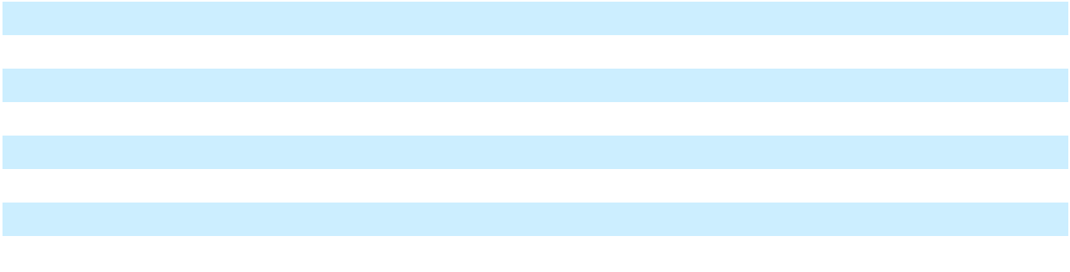

We also lease, own and operate various operating service vessels, tugboats and other vessels to support our global operations.

Our Current Customers

Our downstream customers are, and we expect future customers to be, a mix of power, transportation and industrial users of natural gas and LNG, as well as local power generation, distribution companies, including private and governmental owned or controlled. We seek to substantially reduce our customers’ fuel costs while providing them with a cleaner-burning, more environmentally-friendly fuel source. We also intend to sell power directly to some of our customers.

We seek to enter into long-term take-or-pay contracts to deliver natural gas or LNG. Pricing for any particular customer depends on the size of the customer, purchased volume, the customer’s credit profile, the complexity of the delivery and the infrastructure required to deliver it.

We continue to have significant concentrations in revenue. Revenue from one customer constituted 30% of total revenue in 2025; no other customers comprised more than 10% of our revenue. We expect to have more significant concentrations in revenue in the near term upon divestiture of our Brazil business as a result of the Restructuring Transaction.

We have several contracts with government-affiliated entities in the countries in which we operate. In Puerto Rico, we have gas sales agreements with PREPA, and Genera operates and maintains PREPA’s thermal generation assets. In Mexico, we have entered into a gas sales agreement with CFE. In Nicaragua, we have entered into a 25-year power purchase agreement with Nicaragua’s electricity distribution companies, some of which are wholly or partially owned or controlled by governmental entities.

Competition

In marketing LNG and natural gas, we compete for sales of LNG and natural gas primarily with LNG distribution companies who focus on sales of LNG without our integrated approach which includes terminal services and power. We also compete with a variety of natural gas marketers who may have affiliated distribution partners, including:

- major integrated marketers whose advantages include large amounts of capital and the ability to offer a wide range of services and market numerous products other than natural gas;

- producer marketers who sell natural gas they produce or which is produced by an affiliated company;

13

Table of Contents

- small geographically focused marketers who focus their marketing on the geographic area in which their affiliated distributor operates; and

- aggregators who gather small volumes of natural gas from various sources, combine them and sell the larger volumes for more favorable prices and terms than would be possible selling the smaller volumes separately.

Despite these competitors, we do not expect to experience significant competition for our LNG logistics services with respect to the Facilities to the extent we have entered into GSAs or other long-term agreements we serve through the Facilities. If and when we have to replace our agreements with our counterparties, we may compete with other then-existing LNG logistics companies for these customers.

In purchasing LNG, we compete for supplies of LNG with:

- large, multinational and national companies with longer operating histories, a stronger credit profile, more development experience, greater name recognition, larger staffs and substantially greater financial, technical and marketing resources;

- oil and gas producers who sell or control LNG derived from their international oil and gas properties; and

- purchasers located in other countries where prevailing market prices can be substantially different from those in the United States.

Government Regulation

Our infrastructure business and operations are subject to extensive regulation under federal, state and local statutes, rules, regulations and laws, as well as foreign regulations and laws. These laws require, among other things, consultations with appropriate federal, state and other agencies and that we obtain, maintain and comply with applicable permits, approvals and other authorizations for the siting and conduct of our business. These regulatory requirements increase our costs of operations and construction, and failure to comply with such laws could result in consequences such as substantial penalties and/or the issuance of administrative orders to cease or restrict operations until we are in compliance.

DOE Export

The DOE issued an order authorizing us, through our subsidiary, NFEnergía LLC, to import LNG from various international sources by vessel at our San Juan Facility over the two-year period beginning March 26, 2024. NFEnergía LLC must renew its authorization every two years and is in the process of attaining such authorization from the DOE for the two-year period beginning on March 26, 2026. Imports of LNG are deemed to be consistent with the public interest under Section 3 of the Natural Gas Act (“NGA”) and applications for such imports must be granted without modification or delay. In August 2024, we received authorization from the DOE to export up to 1.4 million tonnes per annum of LNG to non-FTA countries from our Altamira Facility for a term of five years.

FERC Authorization

The Federal Energy Regulatory Commission (“FERC”) regulates the siting, construction and operation of “LNG terminals” under NGA Section 3. In consultation with our outside counsel and, where appropriate, FERC staff, we have designed and constructed our U.S. facilities so that they do not meet the statutory definition of an “LNG terminal” as interpreted by FERC pursuant to its case law. On March 19, 2021, as upheld on rehearing on July 15, 2021, FERC determined that our San Juan Facility is subject to its jurisdiction and directed us to file an application for authorization to operate the San Juan Facility within 180 days of the order, which was September 15, 2021, but also found that allowing operation of the San Juan Facility to continue during the pendency of an application is in the public interest. The FERC orders were affirmed by the United States Court of the Appeals for the District of Columbia Circuit (“D.C. Circuit”) on June 14, 2022. In order to comply with the FERC’s directive, on September 15, 2021, we filed an application for authorization to operate the San Juan Facility, which remains pending.

On July 18, 2023, we filed for an amendment to the March 19, 2021 and July 15, 2021 FERC orders allowing the continued operation of the San Juan Facility during the pendency of the formal application to allow us to construct and interconnect 220 feet of incremental 10-inch pipeline needed to supply natural gas for temporary power generation solicited through the Puerto Rico Power Stabilization Task Force. On July 31, 2023, FERC issued an order stating that it would not

14

Table of Contents

take action to prevent the construction and operation of the pipeline and interconnect and on January 30, 2024, FERC reaffirmed the order allowing the construction and operation to continue. On September 19, 2025, the D.C. Circuit denied a petition challenging this FERC order, holding that the order reflected an unreviewable exercise of enforcement discretion rather than a de facto authorization for construction or operation. The deadline to seek a writ of certiorari from that decision has expired.

On September 26, 2024, the United States Coast Guard (“USCG”) filed a Letter of Recommendation (“LOR”) with FERC in which it assessed our Letter of Intent dated April 12, 2024, and our Waterway Suitability Assessment, dated August 26, 2024, in respect of future ship to ship transfers with alternative vessels, and recommended against the allowance of the proposed operations. Further, on September 26, 2024, the USCG issued a Letter of Warning in respect of our ongoing ship to ship transfers of LNG operations within the San Juan port limits. On October 21, 2024, we filed an appeal with the USCG under 33 CFR 160.7. In December 2024 and February 2025, we submitted an updated Letter of Intent and Waterway Suitability Assessments detailing our alternative operational plans to the USCG. In concert with our collaboration with the USCG regarding our new operational plans, we withdrew our appeal on February 14, 2025. On January 12, 2026, the Acting Captain of the Port of San Juan for the USCG issued a LOR in response to NFE’s filings. The LOR determined that the Port of San Juan waterway is suitable for the transit and docking of larger LNG Carriers.

On October 25, 2024, FERC issued a notice of intent to prepare an Environmental Impact Statement, which included, among other things, two public scoping sessions in Puerto Rico held on November 18, 2024 in accordance with the National Environmental Policy Act.

Pipeline and Hazardous Materials Safety Administration

Many LNG facilities are also subject to regulation by the Department of Transportation (“DOT”), through PHMSA; PHMSA has established requirements relating to the design, installation, testing, construction, operation, replacement and management of “pipeline facilities,” which PHMSA has defined to include certain LNG facilities that liquefy, store, transfer or vaporize natural gas transported by pipeline in interstate or foreign commerce. PHMSA has promulgated detailed, comprehensive regulations governing LNG facilities under its jurisdiction at Title 49, Part 193 of the United States Code of Federal Regulations. These regulations address LNG facility siting, design, construction, equipment, operations, maintenance, personnel qualifications and training, fire protection and security. Variances from these regulations may require obtaining a special permit from PHMSA, the issuance of which is subject to public notice and comment and consultation with other federal agencies, which could result in delays, perhaps substantial in length, to the construction of our facilities where such variances are needed; additionally, PHMSA may condition, revoke, suspend or modify the special permits it issues.

Environmental Regulation

Our infrastructure and operations are subject to various international, federal, state and local laws and regulations as well as foreign laws and regulations relating to the protection of the environment, natural resources and human health. These laws and regulations may require the installation of controls on emissions and structures to prevent or mitigate any potential harm to human health and the environment or require certain protocols to be in place for mitigating or responding to accidental or intentional incidents at certain facilities. These laws and regulations may also lead to substantial penalties for noncompliance and substantial liabilities for incidents arising out of the operation of our facilities. Many of these laws and regulations restrict or prohibit the types, quantities and concentration of substances that can be released into the environment and can lead to substantial civil and criminal fines and penalties for non-compliance.

Other local laws and regulations, including local zoning laws, critical infrastructure regulations and fire protection codes, may also affect where and how we operate.

The costs of compliance with these requirements are not expected to have a material adverse effect on our business, financial condition or results of operations.

Environmental Regulation in Mexico

Mexican law comprehensively regulates the energy sector, including all aspects of the receipt, delivery, import, export, storage, marketing, liquefaction, and regasification of LNG; the generation and transmission of electricity; and the environmental impact of all these activities. Various Mexican federal agencies regulate these activities including, the Ministry of Energy, Ministry of the Navy, Ministry of Environment and Natural Resources, Ministry of Infrastructure,

15

Table of Contents

Communication and Transportation, the Energy Regulatory Commission, and the Safety, Energy & Environment Agency. State and local agencies are also involved in regulating these activities, issuing permits and authorizing the use of property for such purposes. To obtain permits and approvals required under Mexican law for the development, construction and operation of energy-related projects in Mexico, such projects must first complete environmental and social impact assessments, which are subject to the evaluation by the authorities. In addition, all hydrocarbon projects must include an environmental risk assessment, which is based on a thorough risk analysis made prior to each stage and aimed at identifying potential design and operational hazards. Mexican law allows the governmental entities and, in certain cases, individuals, to pursue claims against violations of environmental laws or permits issued pursuant to such laws.

Environmental Regulation in Nicaragua

The regulation of activities with the potential to impact the environment in Nicaragua are largely regulated by the Natural Resource and Environment Ministry. Nicaragua regulates many areas of environmental protection. In order to obtain various permits for operations, a project must complete environmental and social impact analyses according to Nicaraguan law. While Nicaragua does not currently have any legislation specifically addressing the receipt, handling, and distribution of natural gas, such laws may be passed in the future.

Environmental Regulation in Ireland

The operation of the facilities will be regulated via additional licenses and consents including from the Environmental Protection Agency (EPA); the Commission for Regulation of Utilities (CRU); the Health and Safety Authority (HSA); and the Local Planning Authority (Kerry Co. Council (KCC)). Additionally, the Shannon Foynes Port Company (SFPC) has statutory jurisdiction over marine activities. The LNG Terminal and Power Plant will also have to operate within the provisions of a number of codes, such as the EirGrid Transmission Network Grid Code, Single Electricity Market Trading and Settlement Code and GNI Code of Operations. We are in the process of applying for all these necessary permits, licenses and consents to build and complete the Ireland Facility. The issuance of many of these permits may be subject to administrative or judicial challenges, including by non-governmental groups that act on behalf of citizens.

Environmental Regulation in Puerto Rico

Our operations in Puerto Rico are subject to various state and federal laws and regulations relating to the protection of the environment, natural resources and human health. Environmental statutes and regulations are largely implemented by the Puerto Rico Department of Environment and Natural Resources, which also oversees certain EPA delegated programs. As part of its operations, our San Juan Facility is required to comply with Clean Water Act requirements for stormwater and Clean Air Act requirements for facility emission sources. These laws and their related regulations require permits for the operation of the facilities and the implementation of mitigation measures to address environmental impacts of facility operations. Additionally, our operations in Puerto Rico are subject to regulation by the Department of Transportation and Public Works (“DTOP”). DTOP has been delegated authority from DOT to regulate both the distribution of natural gas through road transportation and facilities that operate natural gas pipelines. All deliveries of LNG by truck in Puerto Rico are subject to federal requirements for the ISO containers that hold the LNG and for the transport of the LNG by truck. Any expansion or increased stringency of these requirements may increase compliance costs for our operations in Puerto Rico.

U.S. and International Maritime Regulations of LNG Vessels

The International Maritime Organization (“IMO”) is the United Nations agency that provides international regulations governing shipping and international maritime trade. The requirements contained in the International Safety Management Code for the Safe Operation of Ships and for Pollution Prevention (the “ISM Code”) promulgated by the IMO govern the shipping of our LNG cargos and the operations of any vessels we use in our operations. Among other requirements, the ISM Code requires the party with operational control of a vessel to develop an extensive safety management system that includes, among other things, the adoption of a policy for safety and environmental protection setting forth instructions and procedures for operating its vessels safely and describing procedures for responding to emergencies.

Vessels that transport gas, including LNGCs, are also subject to regulation under various international programs such as the International Code for the Construction and Equipment of Ships Carrying Liquefied Gases in Bulk (the “IGC Code”) published by the IMO. The IGC Code provides a standard for the safe carriage of LNG and certain other liquid gases by prescribing the design and construction standards of vessels involved in such carriage, and includes specific air emissions limits, including on sulfur oxide and nitrogen oxide emissions from ship exhausts.

16

Table of Contents

We contract with leading vessel providers in the LNG industry and look to them to ensure that each of our chartered vessels is in compliance with applicable international and in-country requirements. Nevertheless, the IMO continues to review and introduce new regulations and we cannot with any certainty predict what additional regulations, if any, may be passed by the IMO and what effect, if any, such regulation may have on our operations.

Import and Export Control Laws and Regulations

We conduct business throughout the world, and our business activities and services are subject to various applicable import and export control laws and regulations of the United States and other countries, particularly countries in the Caribbean, Latin America, Europe and the other countries in which we seek to do business. We must also comply with trade and economic sanctions laws, including the U.S. Commerce Department’s Export Administration Regulations and economic and trade sanctions regulations maintained by the U.S. Treasury Department’s Office of Foreign Assets Control. For example, in 2018, U.S. legislation was approved to restrict U.S. aid to Nicaragua and between 2018 and 2022, U.S. and European governmental authorities imposed a number of sanctions against entities and individuals in or associated with the governments of Nicaragua and Venezuela. Following the invasion of Ukraine by Russia in 2022, U.S., European, U.K. and other governmental authorities imposed a number of sanctions against entities and individuals in Russia or connected to Russia, including sanctions specifically targeting the Russian oil and gas industry. Violations of governmental export control and economic sanctions laws and regulations could result in negative consequences to us, including government investigations, sanctions, criminal or civil fines or penalties, more onerous compliance requirements, loss of authorizations needed to conduct aspects of our international business, reputational harm and other adverse consequences. Moreover, it is possible that we could invest both time and capital into a project involving a counterparty who may become subject to sanctions. If any of our counterparties becomes subject to sanctions as a result of these laws and regulations, changes thereto or otherwise, we may face an array of issues, including, but not limited to, (i) having to suspend our development or operations on a temporary or permanent basis, (ii) being unable to recuperate prior invested time and capital or being subject to lawsuits, or (iii) investigations or regulatory proceedings that could be time-consuming and expensive to respond to and which could lead to criminal or civil fines or penalties.

Anti-corruption Laws and Regulations

We are also subject to anti-corruption laws and regulations, including the U.S. Foreign Corrupt Practices Act (“FCPA”), the U.K. Bribery Act and local anti-bribery laws, which generally prohibit companies and their intermediaries from making improper payments to foreign officials for the purpose of obtaining or keeping business and/or other benefits. Some of the jurisdictions in which we currently operate present heightened risks for FCPA issues, such as Nicaragua, Brazil and Mexico. Furthermore, our strategy has been, and continues to be, dependent in part on our ability to expand our operations in additional emerging markets, including in Latin America, Asia and Africa. Efforts to expand our operations in these markets could expose us to additional risks related to anti-corruption laws and regulations. Although we have adopted policies and procedures that are designed to assist us, our officers, directors, employees and other intermediaries in complying with the FCPA and other anti-corruption laws and regulations, developing and implementing policies and procedures is a complex endeavor, particularly given the high level of complexity of these laws and regulations. There is no assurance that these policies and procedures have or will work effectively all of the time or protect us against liability under anti-corruption laws and regulations, including the FCPA, for actions taken by our officers, directors, employees and other intermediaries with respect to our business or any businesses that we may acquire, particularly in high-risk jurisdictions.

Suppliers

We expect to continue to supply our downstream customers with LNG and natural gas sourced primarily from our own FLNG production, supplemented by purchases on the open market, prior to the commencement of our long-term LNG supply contracts in 2027.

Seasonality

Our operations can be affected by seasonal weather, which can temporarily affect our revenues, the delivery of LNG and the construction of our Facilities. For example, activity in the Caribbean is often lower during the North Atlantic hurricane season of June through November, and following a hurricane, activity may decrease further as there may be business interruptions as a result of damage or destruction to our Facilities or the countries in which we operate. Due to these seasonal fluctuations, results of operations for individual quarterly periods may not be indicative of the results that may be realized on an annual basis. Severe weather in the countries where our Facilities are located may delay completion

17

Table of Contents

of our Facilities under development and related infrastructure, adversely affect our operations of our Facilities and affect the markets in which we operate. We are also particularly exposed to the risks posed by hurricanes, tropical storms and their collateral effects, in particular with respect to fleet operations and floating offshore liquefaction units.

Our Insurance Coverage

We maintain customary insurance coverage for our business and operations. Our domestic insurance related to property, equipment, automobile, general liability and workers’ compensation is provided through policies customary for the business and exposures presented, subject to deductibles typical in the industry. Internationally, we also maintain insurance, including policies related to property, equipment, automobile, marine, pollution liability, general liability and the portion of workers’ compensation not covered under a governmental program.

We maintain property insurance, including named windstorm and flood, related to the operation of the San Juan Facility and the La Paz Facility, and builders risk insurance at our Facilities under development.

Human Capital

We had 596 NFE full-time employees and 699 Genera full-time employees as of December 31, 2025. We depend upon our skilled workforce to manage, operate and plan for our business. Recruitment and retention of talent across our company enables growth and innovation across a multitude of corporate initiatives, and this is one of our top priorities.

Our Human Resources team oversees human capital management, including talent attraction and retention, compensation and bonuses, employee relations, employee engagement and training and development in the various countries in which we operate.

Culture and Inclusivity

Our employees are critical to the success of our business. We value a broad range of perspectives in our workplace and are committed to maintaining culture where our employees feel valued, welcomed and can thrive. We are subject to various federal, state and local laws related to labor and employment, including matters related to workplace discrimination, harassment and unlawful retaliation in the jurisdictions in which we operate. We have developed and published our Code of Business Conduct, which sets out a guideline in connection with these matters and reflects our high expectations for an ethical workplace where employees are treated with dignity and respect. Because labor and employment laws and regulations can differ among the jurisdictions in which we operate, our Code of Business Conduct operates as a guideline for practices, but does not cover every legal aspect in each of our locations.

We are committed to advancing our culture of inclusivity through the following actions, among others:

- collecting and analyzing employee workforce data;

- conducting harassment trainings; and

- expanding employee benefits to include additional health programs such as mental health support and medical concierge services.

Employee Health, Safety and Wellness

We are subject to various health, safety, and environmental laws and regulations in the jurisdictions in which we operate. We have developed and published a Health, Safety, Security and Environment (HSSE) Strategic Framework, which sets out a guideline in connection with risk management, education/training, emergency response, incident management, performance measurement and other key programmatic drivers. Because health, safety, and environmental laws and regulations can differ among the jurisdictions in which we operate, our HSSE Strategic Framework operates as a guideline for practices, but is not binding or required. We also have developed and published a contractor safety management handbook for our contractors.

For the year ended December 31, 2025, we had no fatalities across our operating sites.

18

Table of Contents

Property

We lease space for our offices in New York, New York, Houston, Texas, Rio de Janeiro, Brazil, Mexico City, Mexico and San Juan, Puerto Rico, and in other regions in which we operate. We own land in Pennsylvania and Ireland that can be used for future developments. Additionally, the properties on which our Facilities are located are generally subject to long-term leases and rights-of-way. Our leased properties are subject to various lease terms and expirations.

Sustainability

Since our founding in 2014, sustainability has been at the core of our mission and vision. We believe that a sustainable future built on positive energy is the way forward. To advance both our business model and the interests of our stakeholders— including our people, shareholders and investors, partners, the communities we serve, and the wider public —we have established three key sustainability goals: (i) protect and preserve the environment, (ii) empower people worldwide and (iii) invest in communities. Our sustainability initiatives and investments under each of these goals are highlighted below.

Protect and Preserve the Environment

We are committed to our goal to protect and preserve the environment, and we progress this goal by providing cleaner energy solutions around the world. With our projects, we strive to reduce carbon emissions and increase energy efficiency. By helping our customers convert from traditional fuels such as oil or coal to LNG as their energy source, we seek to reduce air-polluting emissions of nitrogen oxide (NOx), carbon dioxide (CO2), sulfur oxide (SOx), and fine particulate matter, among others. Moreover, we believe that the use of LNG as a complement to renewable power options is helping the transition to a sustainably-sourced energy future.

Empower People Worldwide

We are committed to our goal to provide access to affordable, reliable, cleaner energy. To that end, we help our customers customize and implement LNG energy solutions designed to lower their energy costs, reduce their environmental footprint, and improve their energy efficiency, either by converting their existing power generation to LNG or by building brand-new gas-fired facilities. In addition, we seek to provide a reliable supply of LNG to our customers, wherever located, through our established, integrated LNG logistics chain.

Invest in Communities

We are committed to our goal to improve lives and support people, especially in the communities where we operate.

For the year ended December 31, 2025, we:

- Hired 142 full-time employees globally, prioritizing local hires in each region;

- Donated $0.2 million through our employee charity matching program;

- Hosted a technical visit for top-performing Electrical and Mechanical Engineering students from the Federal University of the State of Pará, Brazil, supporting regional technical and scientific development through hands-on exposure to thermal power plant construction and assembly;

- Developed a pilot vegetable garden in the Acuí Community of Brazil to support 150 people, promoting environmental education, sustainable land use, and preservation of traditional knowledge;

- Supported women in completing a cutting and sewing course, resulting in certifications and professional empowerment; contributed five industrial sewing machines to the São Sebastião de Burajuba quilombola community in Brazil;

- Sponsored the Museu das Amazônias in Belém, Brazil, for 7,000 visitors, supporting a landmark cultural initiative celebrating the Amazon’s identities, ecosystems, and heritage;

- Provided safe drinking water through rainwater systems, benefiting 1,200 people, including 600 students, across schools, businesses, restaurants, and the Combu Health Center in Brazil;

19

Table of Contents

- Raised funding to provide adult diapers for older adults through Lions Club International, and collected and donated toys to support 150 children in La Paz, Mexico;

- Sponsored the neighborhood baseball team from Guaynabo, Puerto Rico.

Available Information

We are required to file or furnish any annual, quarterly and current reports, proxy statements and other documents with the SEC under the Securities Exchange Act of 1934, as amended (the “Exchange Act”). The SEC maintains an internet website that contains reports, proxy and information statements and other information regarding issuers, including us, that file electronically with the SEC. The public can obtain any documents that we file with the SEC, including this Annual Report, at www.sec.gov.

We also make available free of charge through our website, www.newfortressenergy.com, our Annual Report on Form 10-K, Quarterly Reports on Form 10-Q, Current Reports on Form 8- K, and, if applicable, amendments to those reports filed or furnished pursuant to Section 13(a) of the Exchange Act as soon as reasonably practicable after we electronically file such material with, or furnish it to, the SEC. Information on our website or any other website is not incorporated by reference into, and does not constitute a part of, this Annual Report.

Item 1A. Risk Factors

An investment in our Class A common stock involves a high degree of risk. You should carefully consider the risks described below. If any of the following risks were to occur, the value of our Class A common stock could be materially adversely affected or our business, financial condition and results of operations could be materially adversely affected and thus indirectly cause the value of our Class A common stock to decline. Additional risks not presently known to us or that we currently deem immaterial could also materially affect our business and the value of our Class A common stock. As a result of any of these risks, known or unknown, you may lose all or part of your investment in our Class A common stock. The risks discussed below also include forward-looking statements, and actual results may differ substantially from those discussed in these forward-looking statements. See “Cautionary Statement on Forward-Looking Statements.”

Summary Risk Factors

Some of the factors that could materially and adversely affect our business, financial condition, results of operations or prospects include the following:

Risks Related to Our Business

- We are subject to risks and uncertainties associated with the Restructuring Transaction, the Restructuring Plans and the RSA;

- Our ability to continue as a going concern is dependent upon our ability to complete the Restructuring Transaction and delay capital expenditures;
- Ongoing events of default subject to forbearance could result in the acceleration of substantially all of our indebtedness;
- The separation of the Company into two independent entities as part of the Restructuring Transaction may result in operational, financial, tax and other risks, and there can be no assurance that the anticipated benefits of the separation will be realized;

- The market price of our Class A common stock may decline in the future as a result of the Restructuring Transaction, including the proposed equity issuances and future grants under the Incentive Plan;

- We have identified material weaknesses in our internal control over financial reporting, including material weaknesses identified as part of the restatement of our financial statements for the years ended December 31, 2024 and 2023 and the interim periods in the years ended December 31, 2025 and 2024, and our management has concluded that our disclosure controls and procedures were not effective as of December 31, 2025;

- Operation of our infrastructure, facilities and vessels involves significant risks;

- We depend on third-party contractors, operators and suppliers;

- Failure of LNG to be a competitive source of energy in the markets in which we operate, and seek to operate, could adversely affect our expansion strategy;

20

Table of Contents

- We operate in a highly regulated environment and our operations could be adversely affected by actions by governmental entities or changes to regulations and legislation;
- Failure to obtain and maintain permits, approvals and authorizations from governmental and regulatory agencies and third parties on favorable terms could impede operations and construction;
- When we invest significant capital to develop a project, we are subject to the risk that the project is not successfully developed and that our customers do not fulfill their payment obligations to us following our capital investment in a project;

- Our ability to generate revenues is substantially dependent on our current and future long-term agreements and the performance by customers under such agreements;
- Because we are currently dependent upon a limited number of customers, the loss of a significant customer could adversely affect our operating results;
- We may not be able to convert our anticipated customer pipeline into binding long-term contracts, and if we fail to convert potential sales into actual sales, we will not generate the revenues and profits we anticipate;
- Cyclical or other changes in the demand for and price of LNG and natural gas may adversely affect our business and the performance of our customers;
- We seek to develop innovative and new technologies as part of our strategy that are not yet proven and may not realize the time and cost savings we expect to achieve;
- We have incurred, and may in the future incur, a significant amount of debt;

- Existing and future environmental, social, health and safety laws and regulations could result in increased or more stringent compliance requirements, which may be difficult to comply with or result in additional costs;
- We are subject to numerous governmental export laws, and trade and economic sanctions laws and regulations, and anti-corruption laws and regulation;
- We may incur impairments to long-lived assets;

- Weather events or other natural or manmade disasters or phenomena could have a material adverse effect on our operations and projects, as well as on the economies in the markets in which we operate or plan to operate;
- Information technology failures and cyberattacks could affect us significantly;

- Our insurance may be insufficient to cover losses that may occur to our property or result from our operations;

- Our success depends on key members of our management;

- We may experience increased labor costs and regulation, and the unavailability of skilled workers or our failure to attract and retain qualified personnel, could adversely affect us;

Risks Related to the Jurisdictions in Which We Operate

- We are subject to the economic, political, social and other conditions in the jurisdictions in which we operate;

- Our financial condition and operating results may be adversely affected by foreign exchange fluctuations;

Risks Related to Ownership of Our Class A Common Stock

- The market price and trading volume of our Class A common stock has in the past and may continue to be volatile, which has subjected and may in the future subject us to securities class action litigation and could result in rapid and substantial losses for our stockholders;

- Prior to the consummation of the Restructuring Transaction, a small number of our original investors have the ability to direct a significant amount of our common stock, and their interests may conflict with those of our other stockholders;

- The declaration and payment of dividends to holders of our Class A common stock is at the discretion of our board of directors and we do not expect to pay dividends for the foreseeable future;
- The incurrence or issuance of debt which ranks senior to our Class A common stock upon our liquidation and future issuances of equity or equity-related securities, which would dilute the holdings of our existing Class A common stockholders and may be senior to our Class A common stock for the purposes of making distributions, periodically or upon liquidation, may negatively affect the market price of our Class A common stock;

- Sales or issuances of our Class A common stock could adversely affect the market price of our Class A common stock;

- We may be unable to maintain the listing of our common stock on the Nasdaq stock market or another national securities exchange;

General Risks

21

Table of Contents

- We are a holding company and our operational and consolidated financial results are dependent on the results of our subsidiaries, affiliates, joint ventures and special purpose entities in which we invest;
- We have in the past and may in the future continue to engage in mergers, sales and acquisitions, reorganizations or similar transactions related to our businesses or assets and we may fail to successfully complete such transaction or to realize the expected value;
- A change in tax laws in any country in which we operate could adversely affect us; and

- We are currently and may in the future be involved in legal proceedings and may experience unfavorable outcomes.

Risks Related to Our Business

We are subject to risks and uncertainties associated with the Restructuring Transaction, the Restructuring Plans and the RSA.

On March 17, 2026, we entered into a RSA with certain of our key creditors, which contemplates a comprehensive restructuring of our principal funded debt obligations. The Company intends to implement the Restructuring Transaction through UK court-sanctioned Restructuring Plans promoted by two indirect subsidiaries, with recognition sought in the U.S. under chapter 15 of the U.S. Bankruptcy Code, which will bind all lenders and noteholders and release the Company and all guarantors from obligations under the relevant debt instruments. For additional detail on the RSA, the Restructuring Plans and the Restructuring Transaction, see “Items 1 and 2. Business and Properties—Planned Debt Restructuring.”

The successful implementation of the RSA, the Restructuring Plans and the Restructuring Transaction is critical to our ability to continue as a going concern and is subject to numerous conditions, milestones, and approvals, including the consent of various creditor groups, certain stockholder approvals and approval by the UK High Court and U.S. Bankruptcy Court, and regulatory authorities. Failure to satisfy or obtain waivers for these conditions or to meet required milestones could result in the termination of the RSA, loss of creditor support, or inability to consummate the Restructuring Transaction as contemplated. There can be no assurance that the Restructuring Transaction will be completed on the terms described, on the anticipated timeline, or at all. Failure to consummate the Restructuring Transaction could result in the Company being required or compelled to pursue additional restructuring initiatives to preserve value and optionality, including possible out-of-court restructurings, or in-court relief, in the UK or the U.S., which could have a material adverse effect on our business, financial condition, results of operations, and the value of our securities.

We are subject to additional risks in connection with the Restructuring Transaction, the Restructuring Plans and the

RSA, including the following:

- our ability to obtain the UK High Court’s approval of the Restructuring Plans and recognition of the Restructuring Plans in the United States pursuant to chapter 15 of the U.S. Bankruptcy Code;

- our ability to comply with the milestones set forth in the RSA;

- the costs of the Restructuring Transaction and related fees;

- the process of implementing the Restructuring Transaction may divert management’s attention and resources, result in increased costs, and adversely affect our relationships with customers, suppliers, employees, and other stakeholders;

- the implementation of the Restructuring Transaction is expected to result in significant dilution to existing holders of our Class A common stock and existing stockholders will exercise even less influence over management than they currently have;

- the value of our Class A common stock may be highly volatile or decline as a result of the Restructuring Transaction;

- potential delisting of our Class A common stock by NASDAQ as a consequence of the Restructuring Transaction;

- our ability to maintain our relationships with our other creditors, employees, customers, vendors, suppliers and other third parties;

22

Table of Contents

- our ability to maintain contracts that are critical to our operations;

- our ability to execute competitive contracts with third parties;

- our ability to attract, motivate, and retain key employees;

- our ability to retain our current management team; and

- the actions and decisions of our stockholders, creditors and other third parties who have interests in the Restructuring Transaction and the RSA that may be inconsistent with our plans.

Because of the risks and uncertainties associated with the Restructuring Transaction, we may not be able to predict or quantify the ultimate impact the Restructuring Transaction may have on our business, cash flows, liquidity, financial condition, and results of operations, nor can we accurately predict the ultimate impact the Restructuring Transaction may have on our corporate or capital structure.

Our ability to continue as a going concern is dependent upon our ability to complete the Restructuring Transaction and delay capital expenditures.

As discussed in Note 3 to the consolidated financial statements included elsewhere in this Annual Report, management has concluded that, our current liquidity and forecasted cash flows from operations are not probable to be sufficient to support, in full, obligations as they become due over the next twelve-month period, and there is substantial doubt as to the Company’s ability to continue as a going concern. If the Restructuring Transaction is not consummated as contemplated, the Company will be required or compelled to pursue alternative in-court restructuring initiatives to preserve value, which would have a material and adverse impact on stockholders. The process of implementing the Restructuring Transaction and the associated Restructuring Plans is subject to significant risks and uncertainties, including the need for sanction by the UK High Court, recognition in the United States under chapter 15 of the U.S. Bankruptcy Code, and approval of several stockholder proposals. See “Risks Related to our Business—We are subject to risks and uncertainties associated with the Restructuring Transaction, the Restructuring Plans and the RSA.” There is no assurance that these approvals will be obtained on the anticipated timeline or at all. The Company and its creditors must also negotiate and finalize definitive documentation, and any failure to reach agreement or to satisfy the process milestones could result in termination of the RSA, after which creditors may pursue enforcement actions that could accelerate the Company’s financial distress. In addition, volatility in financial markets, changes in interest rates, or adverse economic developments could impact the Company’s ability to raise additional capital or refinance obligations, even during the restructuring process. The Company must also meet a consolidated minimum liquidity threshold at closing, and if this threshold is not met, it may be required to raise additional capital under tight time constraints, which may not be possible on acceptable terms.

Even if the Restructuring Transaction is completed, the Company will continue to face substantial risks. Its future performance will depend on its ability to execute its revised business plan, which may be subject to operational, regulatory, and market risks, and it may require additional funding in the future to support operations, capital expenditures, or growth initiatives. There is no assurance that such funding will be available on favorable terms, or at all. The new debt and equity instruments issued in the restructuring may impose significant restrictions on the Company’s operations, including limitations on incurring additional indebtedness, asset sales, and distributions. The restructuring will result in significant dilution to existing equity holders, and the value of new equity securities may be volatile and subject to further decline. Even if the Restructuring Transaction is completed, substantial risks will remain that could adversely affect the Company’s financial condition, results of operations, and events of default under the Company’s debt agreements detailed below, management has concluded that there is substantial doubt as to the Company’s ability to continue as a going concern.

If the RSA is terminated, our ability to consummate the Restructuring Plans may be materially and adversely affected.

The RSA contains a number of termination events, upon the occurrence of which certain parties to the RSA may terminate the agreement. If the RSA is terminated as to all parties thereto, each of the parties will be released from its obligations in accordance with the terms of the RSA. Such termination may result in the loss of support for the Restructuring Plans by the parties to the RSA, which could adversely affect our ability to confirm and consummate the Restructuring Plans. If the Restructuring Plans are not consummated, there can be no assurance that any new plan would be as favorable to holders of claims against the Company as contemplated by the RSA.

23

Table of Contents

Effectiveness of the Restructuring Plans requires the approval of the Restructuring Plan creditors.

Pursuant to Part 26A of the UK Companies Act 2006, in order for the CoreCo Plan to become legally binding on NFE Global and the creditors subject to the CoreCo Plan, either: (a) a majority representing 75% in value of each class of CoreCo Plan creditors present and voting at the meeting ordered to be summoned by the UK High Court votes in favor of the CoreCo Plan; or (b) a majority representing 75% in value of at least one class of CoreCo Plan creditors votes in favor of the CoreCo Plan and the UK High Court is satisfied that: (i) that class would receive a payment and/or have a genuine economic interest in NFE Global in the relevant alternative, and (ii) each dissenting class would be no worse off under the CoreCo Plan than in the relevant alternative; the BrazilCo Plan to become legally binding on NFE Brazil Newco and the creditors subject to the BrazilCo Plan, a majority representing 75% in value of the class of BrazilCo Plan Creditors votes in favor of the BrazilCo Plan, (the “BrazilCo Plan Requisite Approval”). In order for the Restructuring Plans to become effective, the Restructuring Plans must then be sanctioned by an order of the UK High Court, and an official copy of the order must be delivered to the Registrar of Companies in England and Wales for registration. The Restructuring Plans are conditional upon each other. If the Restructuring Plans become effective (i) the CoreCo Plan creditors will be bound by the terms of the CoreCo Plan, and (ii) the BrazilCo Plan creditors will be bound by the terms of the BrazilCo Plan, in both cases from the effective date of the Restructuring Plans. Although creditors that are party to the RSA are expected to vote in favor of the Restructuring Plans, in the event that the RSA was terminated in accordance with its terms, any Restructuring Plan creditor that was party to the RSA would cease to be bound by its obligation to support the Restructuring Plans. If the BrazilCo Plan Requisite Approval is not obtained, the Restructuring Plans will not become effective and the Restructuring Transaction will not be implemented. Even if the CoreCo Plan creditors approve the CoreCo Plan and the BrazilCo Plan creditors approve the BrazilCo Plan, the Restructuring Plans may be objected to and may not be completed. If the CoreCo Plan is approved at the creditor meetings for the CoreCo Plan and the BrazilCo Plan is approved at the creditor meeting for the BrazilCo Plan, it is possible for a person with an interest in the relevant Restructuring Plans (whether a Restructuring Plan creditor or otherwise) to lodge objections to the relevant Restructuring Plans with the UK High Court, and, if such objections have been lodged, to attend or be represented at the Restructuring Plans sanction hearing to make representations that the relevant Restructuring Plans should not be approved and/or to appeal against the granting of the sanction order. Therefore, there can be no assurance that objections will not be made at or before the sanction hearing, or that an appeal will not be made against the grant of the sanction order and that any such objections or appeal will not delay or possibly prevent the Restructuring Transaction.

Effectiveness of the Restructuring Plans requires the sanction of the UK High Court.

In order for the Restructuring Plans to become effective, they must receive the sanction of the UK High Court. The UK High Court will not sanction the Restructuring Plans unless it is satisfied that the correct procedures have been followed, the proposed arrangements are fair and that there are no other reasons why the Restructuring Plans should not be approved. There can be no assurance that the UK High Court will determine that the Restructuring Plans are fair or that the UK High Court will not conclude that there are other reasons why the Restructuring Plans should not be sanctioned. If the UK High Court does not exercise its discretion to sanction the Restructuring Plans, or sanctions either Restructuring Plans subject to conditions or amendments which: (i) the Company deems unacceptable; or (ii) would have (directly or indirectly) a material adverse effect on the interests of any Restructuring Plan creditor and such conditions or amendments are not approved by the Restructuring Plan creditors, the Restructuring Plans will not become effective and the Restructuring Transaction will not be implemented.

Certain of the Company’s contracts may contain termination clauses which could be triggered by the Restructuring Plans.

The Company may be party to certain contracts that contain termination provisions which may be triggered by the Restructuring Plans (in particular, if a view is taken that the Restructuring Transaction constitutes a “reorganization” of either PlanCo). Certain of these material contracts might also be terminable as a result of insolvency-related events. There can be no assurance that the Company has identified all contracts material to its business with termination clauses that may be triggered by the Restructuring Plans or insolvency-related events. If the Company triggers such a termination clause in any of its material contracts (or in a number of contracts that, when looked at together, are material to its business) and a consent or waiver is not obtained from the relevant counterparty, such counterparty may terminate or threaten to terminate the contract, which could have a material adverse effect on the Company’s business, operating results, financial condition

or prospects.

24

Table of Contents

The Restructuring Plans may not be recognized or enforced in the United States or Mexico.

It is contemplated that the PlanCos will seek recognition of the Restructuring Plans under Chapter 15, Title 11 of the U.S. Bankruptcy Code. However, there is a possibility that the U.S. Bankruptcy Court will not recognize the Restructuring Plans under Chapter 15, Title 11 of the U.S. Bankruptcy Code. Notwithstanding the view expressed in the foreign expert opinion obtained by the PlanCos, if the U.S. Bankruptcy Court declines to issue the U.S. Chapter 15 recognition order, the Restructuring Plans may not be recognized or be enforceable against a Restructuring Plan creditor in the United States. In these circumstances, the Restructuring Plan creditors would not be prevented from trying to enforce their rights in the applicable courts, as they otherwise would be if the U.S. Chapter 15 recognition order were granted. The PlanCos intend to obtain a foreign expert opinion that the Restructuring Plans will be recognized in Mexico. Notwithstanding the view expressed in the foreign expert opinion, the Restructuring Plans may not be recognized or be enforceable against a Restructuring Plan creditor in Mexico. In these circumstances, the Restructuring Plan creditors would not be prevented from trying to enforce their rights in the applicable courts.

Ongoing events of default subject to forbearance could result in the acceleration of substantially all of our indebtedness.

We are currently in default under the New 2029 Notes, Revolving Credit Agreement, the Term Loan A Credit Agreement, the Term Loan B Credit Agreement, the 2026 Notes, the 2029 Notes and certain intercompany debt. Such defaults are subject to forbearance under the RSA pursuant to which the lenders have agreed, subject to certain conditions, to refrain from exercising remedies with respect to specified defaults until termination of the RSA or the closing of the Restructuring Transaction. If the Restructuring Transaction is not consummated or the RSA is terminated, the applicable lenders or holders could accelerate the outstanding indebtedness under each of the foregoing debt instruments.

In addition, in March 2026, the Company entered into a forbearance agreement pursuant to which the lenders under the Letter of Credit Facility agreed not to exercise any remedies, subject to certain conditions, and to refrain from exercising remedies with respect to certain defaults until September 15, 2026. If the forbearance agreement is terminated, the lenders thereunder could accelerate the outstanding indebtedness. There can be no assurance that the lenders will agree to extend the forbearance period, waive existing or future defaults, or otherwise continue to refrain from exercising remedies. If the forbearance arrangement is terminated or not extended or if the Restructuring Transaction is not completed, the lenders could accelerate the outstanding indebtedness under the Letter of Credit Facility.

If our indebtedness under any of the foregoing facilities or agreements were accelerated, we would not have sufficient liquidity to repay such amounts, and we may be forced to seek additional waivers, amendments, or alternative restructuring transactions, including potentially commencing formal insolvency proceedings. Any of these outcomes could materially and adversely affect our business, financial condition, and results of operations.

The separation of the Company into two independent entities as part of the Restructuring Transaction may result in operational, financial, tax and other risks, and there can be no assurance that the anticipated benefits of the separation will be realized.

If consummated, the Restructuring Transaction will result in a substantial reduction of the Company’s indebtedness, as well as the divestiture in full of BrazilCo, which holds the Company’s Brazil business. The loss of the Brazil business will materially reduce the Company’s asset base, revenue streams, and geographic diversification. The Brazil business includes major facilities such as the Barcarena Facility, the Barcarena Power Plant, and the PortoCem Power Plant, all of which are either operational or in advanced stages of development and are expected to generate substantial revenues under long-term contracts. Upon completion of the Restructuring Transaction, the Company will no longer own or consolidate the results of these businesses, which will have a material effect on our consolidated results of operations and financial condition. The planned separation, including the transfer of equity interests in certain subsidiaries to creditors or third parties, introduces significant operational, financial, and legal uncertainties. The divestiture of a core business may disrupt ongoing operations, result in the loss of key personnel, customers, or suppliers associated with the Brazil business, and require substantial management attention and resources to manage the transition. The Company may also face challenges in reallocating resources, restructuring remaining operations, and maintaining relationships with stakeholders who may perceive the Company as less diversified or less stable following the loss of a major business segment. There is no assurance that the separation will achieve its intended benefits, and the Company may face challenges in executing the separation efficiently or in a manner that preserves value for stakeholders. In addition, the Company may be exposed to additional risks related to the allocation of liabilities, potential disputes with creditors or counterparties, and the need to comply with regulatory and contractual obligations arising from the separation.

25

Table of Contents

The market price of our Class A common stock may decline in the future as a result of the Restructuring Transaction, including the proposed equity issuances and future grants under the Incentive Plan.

As part of the Restructuring Transaction contemplated by the RSA, certain existing lenders and noteholders will receive a substantial number of shares of newly-issued CoreCo Convertible Preferred Stock and Class A common stock. The Company will issue to these lenders and noteholders CoreCo Convertible Preferred Stock that is mandatorily convertible after three years into a number of shares of Class A common stock representing 87% of the fully-diluted Class A common stock outstanding as of the closing of the Restructuring Transaction (after giving effect to the shares of the Company’s Class A common stock to be issued on the closing date of the Restructuring Transaction and shares authorized under the Incentive Plan), and holders of the CoreCo Convertible Preferred Stock will vote on an as-converted basis with the Class A common stock during the first three years. Additionally, the Company will issue to certain existing lenders and noteholders shares of Class A common stock representing 65% of the Company’s Class A common stock as of the closing date of the Restructuring Transaction (before giving effect to shares authorized under the Incentive Plan or any conversion of the CoreCo Convertible Preferred Stock into the Company’s Class A common stock). If approved, the number of shares reserved under the Incentive Plan would represent approximately 10% of the Class A common stock outstanding as of the closing date of the Restructuring Transaction (before giving effect to any conversion of the CoreCo Convertible Preferred Stock). These parties may (subject to any contractual limitations, if applicable) seek to sell their shares. Other stockholders may also seek to sell shares held by them following, or in anticipation of, the completion of the Restructuring Transaction. Sales of substantial amounts of Class A common stock in the public market, or the perception that these sales could occur, coupled with the increase in the outstanding number of shares of Class A common stock relative to shares outstanding as of the date of this Annual Report, could cause the market price of our Class A common stock to decline.

We have identified material weaknesses in our internal control over financial reporting, including material weaknesses identified as part of the restatement of our financial statements for the years ended December 31, 2024 and 2023 and the interim periods in the year ended December 31, 2025 and 2024, and our management has concluded that our disclosure controls and procedures were not effective as of December 31, 2025. Failure to remediate the material weaknesses or any other material weaknesses that we identify in the future, or if we otherwise fail to maintain an effective system of internal controls, could result in material misstatements in our financial statements and impact our ability to accurately or timely report our financial condition or results of operations. In addition, investors may lose confidence in the accuracy and completeness of our financial reports and the trading price of our common stock may decline.

Pursuant to Section 404 of the Sarbanes-Oxley Act of 2002, as amended, our management is required to report on, and our independent registered public accounting firm is required to attest to, the effectiveness of our internal control over financial reporting. The rules governing the standards that must be met for management to assess our internal control over financial reporting are complex and require significant documentation, testing and possible remediation. In addition, if we fail to maintain adequate internal control over financial reporting, we will not be able to conclude on an ongoing basis that we have effective internal control over financial reporting in accordance with Section 404 of the Sarbanes-Oxley Act of 2002. If we fail to achieve and maintain an effective internal control environment, we could suffer misstatements in our financial statements and fail to meet our reporting obligations, which would likely cause investors to lose confidence in our reported financial information. This could result in significant expenses to remediate any internal control deficiencies and lead to a decline in our stock price.

The Company has identified material weaknesses in the Company’s internal control over financial reporting, including material weaknesses identified as part of the restatement of our financial statements for the years ended December 31, 2024 and 2023 and the interim periods in the year ended December 31, 2025 and 2024, and concluded that our disclosure controls and procedures were not effective as of December 31, 2025. A material weakness is a deficiency, or a combination of deficiencies, in internal control over financial reporting, such that there is a reasonable possibility that a material misstatement of a Company’s annual or interim financial statements will not be prevented or detected on a timely basis. For further discussion of the material weaknesses, see Item 9A, Controls and Procedures.

We are in the process of implementing remediation plans intended to address these material weaknesses. However, we may not be successful in remediating the material weaknesses identified by management, or be able to identify and remediate additional control deficiencies, including material weaknesses, in the future. If not remediated, our failure to establish and maintain effective disclosure controls and procedures and internal control over financial reporting could result in material misstatements in our financial statements and a failure to meet our reporting and financial obligations, including stock exchange listing requirements and debt instruments’ covenants regarding the timely filing of periodic reports, and adversely impact our liquidity, access to capital markets and perceptions of our creditworthiness, each of which could have

26

Table of Contents

a material adverse effect on our financial condition and the trading price of our common stock or cause investors or customers to lose confidence in our reported financial information.

Our ability to implement our business strategy may be materially and adversely affected by many known and unknown factors.

Our business strategy relies on a variety of factors, including our ability to successfully market LNG, natural gas, steam, and power to our customers, develop and maintain cost-effective logistics in our supply chain and construct, develop and operate energy-related infrastructure in the countries where we operate, and expand our projects and operations to other countries where we do not currently operate, among others. These assumptions are subject to significant economic, competitive, regulatory and operational uncertainties, contingencies and risks, many of which are beyond our control, including, among others:

- inability to achieve our target costs for the purchase, liquefaction and export of natural gas and/or LNG and our target pricing for long-term contracts;

- failure to develop strategic relationships;

- failure to obtain required governmental and regulatory approvals for the construction and operation of these projects and other relevant approvals;

- unfavorable laws and regulations, changes in laws or unfavorable interpretation or application of laws and regulations; and

- uncertainty regarding the timing, pace and extent of economic growth in the United States, the other jurisdictions in which we operate and elsewhere, which in turn will likely affect demand for crude oil and natural gas.

Furthermore, as part of our business strategy, we target customers who have not been traditional purchasers of natural gas, including customers in developing countries, and these customers may have greater credit risk than typical natural gas purchasers. Therefore, we may be exposed to greater customer credit risk than other companies in the industry. Our credit procedures and policies may be inadequate to sufficiently eliminate risks of nonpayment and nonperformance.

Our strategy may evolve over time. Our future ability to execute our business strategy is uncertain, and it can be expected that one or more of our assumptions will prove to be incorrect and that we will face unanticipated events and circumstances that may adversely affect our ability to execute our business strategy and adversely affect our business, financial condition and results of operations.

We are subject to various construction risks.

We are involved in the development of complex small, medium and large-scale engineering and construction projects, including our facilities, liquefaction facilities, power plants, and related infrastructure, which are often developed in multiple stages involving commercial and governmental negotiations, site planning, due diligence, permit requests, environmental impact studies, permit applications and review, marine logistics planning and transportation and end-user delivery logistics. In addition to our facilities, these infrastructure projects can include the development and construction of facilities as part of our customer contracts. Projects of this type are subject to a number of risks including, among others:

- engineering, environmental or geological problems;

- shortages or delays in the delivery of equipment and supplies;

- government or regulatory approvals, permits or other authorizations;

- failure to meet technical specifications or adjustments being required based on testing or commissioning;

- construction, commissioning or operating accidents that could result in personal injury or loss of life;

- lack of adequate and qualified personnel to execute the project;

27

Table of Contents

- weather interference; and

- potential labor shortages, work stoppages or labor union disputes.

Furthermore, because of the nature of our infrastructure, we are dependent on interconnection with transmission systems and other infrastructure projects of third parties, including our customers, and/or governmental entities. Such third-party projects can be greenfield or brownfield projects, including modifications to existing infrastructure or increases in capacity to existing facilities, among others, and are subject to various construction risks and additional operational monitoring and balancing requirements that may impact the design of facilities to be constructed. Delays from such third parties or governmental entities could prevent connection to our projects and generate delays in our ability to develop our own projects. In addition, a primary focus of our business is the development of projects in foreign jurisdictions, including in locations where we have no prior development experience, and we expect to continue expanding into new jurisdictions in the future. These risks can be increased in jurisdictions where legal processes, language differences, cultural expectations, currency exchange requirements, political relations with the U.S. government, changes in the political views and structure, government representatives, new regulations, regulatory reviews, employment laws and diligence requirements can make it more difficult, time-consuming and expensive to develop a project. See “–Risks Related to the Jurisdictions in Which We Operate—We are subject to the economic, political, social and other conditions in the jurisdictions in which we operate.”

The occurrence of any one of these factors, whatever the cause, could result in unforeseen delays or cost overruns to our projects. Delays in the development beyond our estimated timelines, or amendments or change orders to our construction contracts, could result in increases to our development costs beyond our original estimates, which could require us to obtain additional financing or funding and could make the project less profitable than originally estimated or possibly not profitable at all. Further, any such delays could cause a delay in our anticipated receipt of revenues, a loss of one or more customers, and our inability to meet milestones or conditions precedents in our customer contracts, which could lead to delay penalties and potentially a termination of agreements with our customers. We have experienced time delays and cost overruns in the construction and development of our projects as a result of the occurrence of various of the above factors, including our first Fast LNG project in Altamira, Mexico, and no assurance can be given that we will not continue to experience in the future similar events, any of which could have a material adverse effect on our business, operating results, cash flows and liquidity.

Operation of our infrastructure, facilities and vessels involves significant risks.

Our existing infrastructure, facilities and vessels and expected future operations and businesses face operational risks, including, but not limited to, the following:

- performing below expected levels of efficiency or capacity or required changes to specifications for continued operations;

- breakdowns or failures of equipment or shortages or delays in the delivery of supplies;

- operational errors by trucks, including trucking accidents while transporting natural gas, LNG or any other chemical or hazardous substance;

- risks related to operators and service providers of tankers or tugs used in our operations;

- operational errors by us or any contracted facility, port or other operator of related third-party infrastructure;

- failure to maintain the required government or regulatory approvals, permits or other authorizations;

- accidents, fires, explosions or other events or catastrophes;

- lack of adequate and qualified personnel;

- potential labor shortages, work stoppages or labor union disputes;

- weather-related or natural disaster interruptions of operations;

28

Table of Contents

- pollution, release of or exposure to toxic substances or environmental contamination affecting operations;

- inability, or failure, of any counterparty to any facility-related agreements to perform their contractual obligations;

- decreased demand by our customers; and

- planned and unplanned power outages or failures to supply due to scheduled or unscheduled maintenance.

In particular, we are subject to risks related to the operation of power plants, liquefaction facilities, marine and other LNG operations with respect to our facilities, FSRU and LNG carriers, which operations are complex and technically challenging and subject to mechanical risks and problems. In particular, marine LNG operations are subject to a variety of risks, including, among others, marine disasters, piracy, bad weather, mechanical failures, environmental accidents, epidemics, grounding, fire, explosions and collisions, human error, and war and terrorism. An accident involving our cargos or any of our chartered vessels could result in death or injury to persons, loss of property or environmental damage; delays in the delivery of cargo; loss of revenues; termination of charter contracts; governmental fines, penalties or restrictions on conducting business; higher insurance rates; and damage to our reputation and customer relationships generally. Any of these circumstances or events could increase our costs or lower our revenues. If our chartered vessels suffer damage as a result of such an incident, they may need to be repaired. Repairs and maintenance costs for existing vessels are difficult to predict and may be substantially higher than for vessels we have operated since they were built and result in higher than anticipated operating expenses or require additional capital expenditures. The loss of earnings while these vessels are being repaired would decrease our results of operations. If a vessel we charter were involved in an accident with the potential risk of environmental impacts or contamination, the resulting media coverage could have a material adverse effect on our reputation, our business, our results of operations and cash flows and weaken our financial condition. Our offshore operating expenses depend on a variety of factors including crew costs, provisions, deck and engine stores and spares, lubricating oil, insurance, maintenance and repairs and shipyard costs, many of which are beyond our control. Other factors, such as increased cost of qualified and experienced seafaring crew and changes in regulatory requirements, could also increase operating expenditures. Future increases to operational costs are likely to occur. If costs rise, they could materially and adversely affect our results of operations. In addition, operational problems may lead to loss of revenue or higher than anticipated operating expenses or require additional capital expenditures. Any of these results could harm our business, financial condition and results of operations.

We cannot assure you that future occurrences of any of the events listed above or any other events of a similar or dissimilar nature would not significantly decrease or eliminate the revenues from, or significantly increase the costs of operating, our facilities or assets.

We depend on third-party contractors, operators and suppliers.

We rely on third-party contractors, equipment manufacturers, suppliers and operators for the development, construction and operation of our projects and assets. We have not yet entered into binding contracts for the construction, development and operation of all of our facilities and assets, and we cannot assure you that we will be able to enter into the contracts required on commercially favorable terms, if at all, which could expose us to fluctuations in pricing and potential changes to our planned schedule. If we are unable to enter into favorable contracts, we may not be able to construct and operate these assets as expected, or at all. Furthermore, these agreements are the result of arms-length negotiations and subject to change. There can be no assurance that contractors and suppliers will perform their obligations successfully under their agreements with us. If any contractor is unable or unwilling to perform according to the negotiated terms and timetable of its respective agreement for any reason or terminates its agreement for any reason, we would be required to engage a substitute contractor, which could be particularly difficult in certain of the markets in which we plan to operate. Although some agreements may provide for liquidated damages if the contractor or supplier fails to perform in the manner required with respect to its obligations, the events that trigger such liquidated damages may delay or impair the completion or operation of the facility, and any liquidated damages that we receive may be delayed or insufficient to cover the damages that we suffer as a result of any such delay or impairment, including, among others, any covenants or obligations by us to pay liquidated damages or penalties under our agreements with our customers, development services, the supply of natural gas, LNG or steam and the supply of power, as well as increased expenses or reduced revenue. Such liquidated damages may also be subject to caps on liability, and we may not have full indemnification from our contractors to compensate us for such payments and other consequences. We may hire contractors to perform work in jurisdictions where they do not have previous experience, or contractors we have not previously hired to perform work in jurisdictions we are beginning to develop, which may lead to such contractors being unable to perform according to their respective agreements. Furthermore, we may have disagreements with our contractors about different elements of the construction

29

Table of Contents

process, which could lead to the assertion of rights and remedies under their contracts and increase the cost of the applicable facility or result in a contractor’s unwillingness to perform further work. If we are unable to construct and commission our facilities and assets as expected, or, when and if constructed, they do not accomplish our goals or performance expectations, or if we experience delays or cost overruns in design, construction, commissioning or operation, our business, operating results, cash flows and liquidity could be materially and adversely affected.

Failure of LNG to be a competitive source of energy in the markets in which we operate, and seek to operate, could adversely affect our expansion strategy.

Our operations are, and will be, dependent upon LNG being a competitive source of energy in the markets in which we operate. In the United States, due mainly to a historic abundant supply of natural gas and discoveries of substantial quantities of unconventional or shale natural gas, imported LNG has not developed into a significant energy source. The success of the domestic liquefaction component of our business plan is dependent, in part, on the extent to which natural gas can, for significant periods and in significant volumes, be produced in the United States at a lower cost than the cost to produce some domestic supplies of other alternative energy sources, and that it can be transported at reasonable rates through appropriately scaled infrastructure. LNG prices have increased materially in the past, including in August 2021 through the end of 2022, and global events, such as Russia’s invasion of Ukraine and global inflationary pressures, have generated further energy pricing volatility, which have had and may in the future have an adverse effect on market pricing of LNG and global demand for our products, as well as our ability to remain competitive in the markets in which we operate. Potential expansion in the Caribbean, Latin America and other parts of the world where we may operate is primarily dependent upon LNG being a competitive source of energy in those geographical locations. For example, in the Caribbean, due mainly to a lack of regasification infrastructure and an underdeveloped international market for natural gas, natural gas has not yet developed into a significant energy source. In Brazil, hydroelectric power generation is the predominant source of electricity and LNG is one of several other energy sources used to supplement hydroelectric generation. The success of our operations is dependent, in part, on the extent to which LNG can, for significant periods and in significant volumes, be produced internationally and delivered to our customers at a lower cost than the cost to deliver other alternative energy sources.

Political instability in foreign countries that export LNG, or strained relations between such countries and countries in the Caribbean and Latin America, may also impede the willingness or ability of LNG suppliers and merchants in such countries to export LNG to the Caribbean, Latin America and other countries where we operate or seek to operate. Furthermore, some foreign suppliers of LNG may have economic or other reasons to direct their LNG to other markets or from or to our competitors’ LNG facilities. Natural gas also competes with other sources of energy, including coal, oil, nuclear, hydrogen, hydroelectric, wind and solar energy, which may become available at a lower cost in certain markets. As a result of these and other factors, natural gas may not be a competitive source of energy in the markets we intend to serve or elsewhere. The failure of natural gas to be a competitive supply alternative to oil and other alternative energy sources could adversely affect our ability to deliver LNG or natural gas to our customers on a commercial basis, which could have a material adverse effect on our business, ability to realize benefits from future projects, results of operations, financial condition, liquidity and prospects.

We operate in a highly regulated environment and our operations could be adversely affected by actions by governmental entities or changes to regulations and legislation.

Our business is highly regulated and subject to numerous governmental laws, rules, regulations and requires permits, authorizations and various governmental and agency approvals, in the various jurisdictions in which we operate, that impose various restrictions and obligations that may have material effects on our business and results of operations. Each of the applicable regulatory requirements and limitations is subject to change, either through new regulations enacted on the federal, state or local level, or by new or modified regulations that may be implemented under existing law. The nature and extent of any changes in these laws, rules, regulations and permits may be unpredictable, have retroactive effects, and may have material effects on our business. Future legislation and regulations or changes in existing legislation and regulations, or interpretations thereof, such as those relating to power, natural gas or LNG operations, including exploration, development and production activities, liquefaction, regasification or transportation of our products, could cause additional expenditures, restrictions and delays in connection with our operations as well as other future projects, the extent of which cannot be predicted and which may require us to limit substantially, delay or cease operations in some circumstances.

In addition, these rules and regulations are assessed, managed, administered and enforced by various governmental agencies and bodies, whose actions and decisions could adversely affect our business or operations. In the United States

30

Table of Contents

and Puerto Rico, approvals of the DOE under Section 3 of the NGA, as well as several other material governmental and regulatory permits, approvals and authorizations, including under the CAA and the CWA and their state analogues, may be required in order to construct and operate an LNG facility and export LNG. Permits, approvals and authorizations obtained from the DOE and other federal and state regulatory agencies also contain ongoing conditions, and additional requirements may be imposed. On December 17, 2024, the DOE publicly released a multi-volume study of its view of the potential effects of U.S. LNG exports on the domestic economy (the “2024 LNG Export Study”); U.S. households and consumers; communities that live near locations where natural gas is produced or exported; domestic and international energy security, including effects of U.S. trading partners; and the environment and climate. The DOE stated that it intends to use this study to inform its public interest review of and future decisions regarding exports to non-FTA nations. On May 19, 2025, the DOE released its Response to Comments on the 2024 LNG Export Study. While the current U.S. administration supports and is widely expected to continue to support LNG exports, there can be no assurance as to its future policies, or the impact of those policies on our existing and future projects.

Certain federal permitting processes may trigger the requirements of the National Environmental Policy Act (“NEPA”), which requires federal agencies to evaluate major agency actions that have the potential to significantly impact the environment. Compliance with NEPA may extend the time and/or increase the costs for obtaining necessary governmental approvals associated with our operations and create independent risk of legal challenges to the adequacy of the NEPA analysis, which could result in delays that may adversely affect our business, contracts, financial condition, operating results, cash flow, liquidity and profitability. On July 15, 2020, the White House Council on Environmental Quality issued a final rule revising its NEPA regulations. The Council on Environmental Quality has announced that it is engaged in an ongoing and comprehensive review of the revised regulations and is assessing whether and how the Council may ultimately undertake a new rulemaking to revise the regulations. The impacts of any such future revisions that may be adopted are uncertain and indeterminable for the foreseeable future. On June 18, 2020, we received an order from FERC, which asked us to explain why our San Juan Facility is not subject to FERC’s jurisdiction under section 3 of the NGA. On March 19, 2021, as upheld on rehearing on July 15, 2021, FERC determined that our San Juan Facility is subject to its jurisdiction and directed us to file an application for authorization to operate the San Juan Facility but also found that allowing operation of the San Juan Facility to continue during the pendency of an application is in the public interest. In order to comply with the FERC’s directive, on September 15, 2021, we filed an application for authorization to operate the San Juan Facility, which remains pending. For additional detail, see “Management’s Discussion and Analysis of Financial Condition and Results of Operations - Other Matters.”

We may not comply with each of these requirements in the future, or at all times, including any changes to such laws and regulations or their interpretation. The failure to satisfy any applicable legal requirements may result in the suspension of our operations, the imposition of fines and/or remedial measures, suspension or termination of permits or other authorization, as well as potential administrative, civil and criminal penalties, which may significantly increase compliance costs and the need for additional capital expenditures.

Failure to obtain and maintain permits, approvals and authorizations from governmental and regulatory agencies and third parties on favorable terms could impede operations and construction.

The design, construction and operation of our infrastructure, facilities and businesses, including our FSRUs, FLNG units and LNG carriers, the import and export of LNG, exploration and development activities, and the transportation of natural gas, among others, are highly regulated activities at the national, state and local levels and are subject to various approvals and permits. The process to obtain the permits, approvals and authorizations we need to conduct our business, and the interpretations of those rules, is complex, time-consuming, challenging and varies in each jurisdiction in which we operate. We may be unable to obtain such approvals on terms that are satisfactory for our operations and on a timeline that meets our commercial obligations. Many of these permits, approvals and authorizations require public notice and comment before they can be issued, which can lead to delays to respond to such comments, and even potentially to revise the permit application. Jurisdiction-specific employment, labor, and subcontracting laws may also affect contracting strategies and impact construction and operations. We may also be (and have been in select circumstances) subject to local opposition, including citizens groups or non-governmental organizations such as environmental groups, which may create delays and challenges in our permitting process and may attract negative publicity, which may create an adverse impact on our reputation. In addition, such rules change frequently and are often subject to discretionary interpretations, including administrative and judicial challenges by regulators, all of which may make compliance more difficult and may increase the length of time it takes to receive regulatory approval for our operations, particularly in countries where we operate, such as Mexico and Brazil. No assurance can be given that we will be able to obtain approval of all applications or receive the required permits, approvals and authorizations from governmental and regulatory agencies related to our projects with favorable terms on a timely basis or at all. We cannot make any assurance as to if or when we will receive these permits,

31

Table of Contents

which are needed prior to commencing certain construction activities related to our projects. Any administrative and judicial challenges to our permits can delay and protract the process for obtaining and implementing permits and can also add significant costs and uncertainty. We cannot control the outcome of any review or approval process, including whether or when any such permits and authorizations will be obtained, the terms of their issuance, or possible appeals or other potential interventions by third parties that could interfere with our ability to obtain and maintain such permits and authorizations or the terms thereof. Furthermore, we are developing new technologies and operate in jurisdictions that may lack mature legal and regulatory systems and may experience legal instability, which may be subject to regulatory and legal challenges, instability or clarity of application of laws, rules and regulations to our business and new technology, which can result in difficulties and instability in obtaining or securing required permits or authorizations. In addition, our LNG transportation activities are subject to broad array of regulations, and our operations are dependent upon obtaining and maintaining required permits and authorizations. For example, the United States Coast Guard (“USCG”) regulates the navigable waterways through which vessels we own, lease or direct must traverse to supply LNG in Puerto Rico. Our business in Puerto Rico must comply with all applicable Coast Guard regulations. If we are incorrect in our interpretation of applicable requirements, of if there is a change in the interpretation or application of those requirements, the Coast Guard could determine that we have not complied with applicable requirements, which could lead to fines or restrictions on our operations. For example, on September 26, 2024, we received a letter from the Coast Guard alleging that some aspects of our vessel operations may not comply with all applicable requirements. On October 21, 2024, we filed an appeal with USCG under 33 CFR 160.7. However, in December 2024 and February 2025, we submitted an updated Letter of Intent and Waterway Suitability Assessments detailing our alternative operational plans to the USCG. In concert with our collaboration with the USCG regarding our new operational plans, we withdrew our appeal on February 14, 2025. On January 12, 2026, the Acting Captain of the Port of San Juan for the USCG issued a LOR in response to NFE’s filings. The LOR determined that the Port of San Juan waterway is suitable for the transit and docking of larger LNG Carriers.

There is no assurance that in the future we will obtain and maintain required permits and authorizations on favorable terms, or that we will be able to obtain them on a timely basis, and we may not be able to complete our projects, start or continue our operations, recover our investment in our projects and may be subject to financial penalties or termination under our customer and other agreements, which could have a material adverse effect on our business, financial condition, operating results, liquidity and prospects.

When we invest significant capital to develop a project, we are subject to the risk that the project is not successfully developed and that our customers do not fulfill their payment obligations to us following our capital investment in a project.

A key part of our business strategy is to attract new customers by agreeing to finance and develop new facilities, power plants, liquefaction facilities and related infrastructure in order to win new customer contracts for the supply of natural gas, LNG, steam or power. This strategy requires us to invest capital and time to develop a project in exchange for the ability to sell our products and generate fees from customers in the future. When we develop these projects, our required capital expenditure may be significant, and we typically do not generate meaningful fees from customers until the project has commenced commercial operations, which may take a year or more to achieve. If the project is not successfully developed for any reason, we face the risk of not recovering some or all of our invested capital, which may be significant. If the project is successfully developed, we face the risks that our customers may not fulfill their payment obligations or may not fulfill other performance obligations that impact our ability to collect payment. Our customer contracts and development agreements do not fully protect us against this risk and, in some instances, may not provide any meaningful protection from this risk. This risk is heightened in foreign jurisdictions, particularly if our counterparty is a government or government-related entity because any attempt to enforce our contractual or other rights may involve long and costly litigation where the ultimate outcome is uncertain. If we invest capital in a project where we do not receive the payments we expect, we will have less capital to invest in other projects, our liquidity, results of operations and financial condition could be materially and adversely affected, and we could face the inability to comply with the terms of our existing debt or other agreements, which would exacerbate these adverse effects.

Failure to maintain sufficient working capital could limit our growth and harm our business, financial condition and results of operations.

We have significant working capital requirements, primarily driven by the time difference between the time when we incur costs to build and/or purchase our Facilities and other projects and the time in which we receive revenues from customers after such Facilities and other projects are complete. We also experience timing date differences between the date we pay for natural gas and the payment dates we offer our customers. Differences between the date when we pay our suppliers and the date when we receive payments from our customers may adversely affect our liquidity and our cash

32

Table of Contents

flows. We expect our working capital needs to increase as our total business increases. If we do not have sufficient working capital, we may not be able to pursue our growth strategy, respond to competitive pressures or fund key strategic initiatives, such as the development of our facilities, which may harm our business, financial condition and results of operations.

Our ability to generate revenues is substantially dependent on our current and future long-term agreements and the performance by customers under such agreements.

Our business strategy relies upon our ability to successfully market our products to our existing and new customers and enter into or replace our long-term supply and services agreements for the sale of natural gas, LNG, steam and power. If we contract with our customers on short-term contracts, our pricing can be subject to more fluctuations and less favorable terms, and our earnings are likely to become more volatile. An increasing emphasis on the short-term or spot LNG market may in the future require us to enter into contracts based on variable market prices, as opposed to contracts based on a fixed rate, which could result in a decrease in our cash flow in periods when the market price for shipping LNG is depressed or insufficient funds are available to cover our financing costs for related vessels. Our ability to generate cash is dependent on these customers’ continued willingness and ability to continue purchasing our products and services and to perform their obligations under their respective contracts. Their obligations may include certain nomination or operational responsibilities, construction or maintenance of their own facilities which are necessary to enable us to deliver and sell natural gas or LNG, and compliance with certain contractual representations and warranties. Further, adverse economic conditions in our industry, including as a result of changing trade policies and tariffs and the related uncertainty thereof, increase the risk of nonpayment and nonperformance by customers, particularly customers that have sub-investment grade credit ratings. In addition, PREPA is currently subject to bankruptcy proceedings pending in the U.S. District Court for the District of Puerto Rico. As a result, PREPA’s ability to meet its payment obligations under its contracts will be largely dependent upon funding from federal sources. Specifically, PREPA’s contracting practices in connection with restoration and repair of PREPA’s electrical grid in Puerto Rico, and the terms of certain of those contracts, have been subject to comment and are the subject of review and hearings by U.S. federal and Puerto Rican governmental entities. Certain of our subsidiaries are counterparties to contracts with governmental entities, including PREPA. Although these contracts require payment and performance of certain obligations, we remain subject to the statutory limitations on enforcement of those contractual provisions that protect these governmental entities. In the event that PREPA or any applicable governmental counterparty does not have or does not obtain the funds necessary to satisfy their obligations to us under our agreements, or if they terminate our agreements prior to the end of the agreed term, our financial condition, results of operations and cash flows could be materially and adversely affected. If any of these customers fails to perform its obligations under its contract for the reasons listed above or for any other reason, our ability to provide products or services and our ability to collect payment could be negatively impacted, which could materially adversely affect our operating results, cash flow and liquidity, even if we were ultimately successful in seeking damages from such customer for a breach of contract.

Our current lack of asset and geographic diversification could have an adverse effect on our business, contracts, financial condition, operating results, cash flow, liquidity and prospects.

Our results of operations for the year ended December 31, 2025, include our San Juan Facility, La Paz Facility and certain industrial end-users, and exclude developments in our Puerto Sandino Facility, Barcarena Facility, Santa Catarina Facility and Ireland Facility. Mexico and Puerto Rico have historically experienced economic volatility and the general condition and performance of their economies, over which we have no control, may affect our business, financial condition and results of operations. Mexico and Puerto Rico are subject to acts of terrorism or sabotage and natural disasters, in particular hurricanes, extreme weather conditions, crime and similar other risks which may negatively impact our operations in the region. See “—Risks Related to the Jurisdictions in Which We Operate—We are subject to the economic, political, social and other conditions in the jurisdictions in which we operate.” We may also be affected by trade restrictions, such as tariffs or other trade controls. For instance, there continues to be significant uncertainty about the future relationship between the United States and other countries, including with respect to trade policies, treaties, government regulations, sanctions, tariffs, and application thereof. For example, in April 2025, the U.S. government began imposing tariffs intended to address trade deficits and inconsistent economic treatment of importation between the United States and other countries. In response, China, among others, has announced retaliatory tariffs against certain imports from the United States. Although we are continuing to evaluate the impact of these evolving developments, we cannot provide any assurance about the ultimate outcome or impact of these developments or other changes in trade policies, including the imposition, application or enforceability of tariffs between the United States and other countries. Furthermore, changes to trade policies, retaliatory measures, the ability to obtain refunds for previously paid tariffs that have subsequently been invalidated or prolonged uncertainty in trade relationships may negatively impact our operations and financial results,

33

Table of Contents

including through resulting supply chain disruptions, increased economic nationalism, negative macroeconomic conditions and increased operational complexity and costs.

Additionally, tourism is a significant driver of economic activity in these geographies and directly and indirectly affects local demand for our LNG and therefore our results of operations. Trends in tourism in these geographies are primarily driven by the economic condition of the tourists’ home country or territory, the condition of their destination, and the availability, affordability and desirability of air travel and cruises. Additionally, unexpected factors could reduce tourism at any time, including local or global economic downturns, recessions, terrorism, travel restrictions, pandemics, severe weather or natural disasters. Due to our current lack of asset and geographic diversification, an adverse development at our operating facilities, in the energy industry or in the economic conditions in these geographies, would have a significantly greater impact on our financial condition and operating results than if we maintained more diverse assets and operating areas.

Because we are currently dependent upon a limited number of customers, the loss of a significant customer could adversely affect our operating results.

Our current results of operations and liquidity are, and will continue to be in the near future, substantially dependent upon a limited number of customers, including CFE and PREPA, which have each entered into long-term GSAs. Our operating results are currently contingent on our ability to maintain LNG, natural gas, steam and power sales to these customers. Our near-term ability to generate cash is dependent on these customers’ continued willingness and ability to continue purchasing our products and services and to perform their obligations under their respective contracts. The loss of any of these customers or the early termination of any of these contracts could have an adverse effect on our revenues and we may not be able to enter into a replacement agreement on terms as favorable as the terminated agreement. We may be unable to accomplish our business plan to diversify and expand our customer base by attracting a broad array of customers, which could negatively affect our business, results of operations and financial condition.

We may not be able to convert our anticipated customer pipeline into binding long-term contracts, and if we fail to convert potential sales into actual sales, we will not generate the revenues and profits we anticipate.

We are actively pursuing a significant number of new contracts for the sale of LNG, natural gas, steam, and power with multiple counterparties in multiple jurisdictions. Counterparties commemorate their purchasing commitments for these products in various degrees of formality ranging from traditional contracts to less formal arrangements, including non-binding letters of intent, non-binding memorandums of understanding, non-binding term sheets and responses to requests for proposals with potential customers. These agreements and any award following a request for proposals are subject to negotiating final definitive documents. The negotiation process may cause us or our potential counterparty to adjust the material terms of the agreement, including the price, term, schedule and any related development obligations. We cannot assure you if or when we will enter into binding definitive agreements for transactions initially described in non-binding agreements, and the terms of our binding agreements may differ materially from the terms of the related non-binding agreements. In addition, the effectiveness of our binding agreements can be subject to a number of conditions precedent that may not materialize, rendering such agreements non-effective. Moreover, while certain of our long-term contracts contain minimum volume commitments, our expected sales to customers under existing contracts may be substantially in excess of such minimum volume commitments. Our near-term ability to generate cash is dependent on these customers’ continued willingness and ability to nominate in excess of such minimum quantities and to perform their obligations under their respective contracts. Given the variety of sales processes and counterparty acknowledgments of the volumes they will purchase, we sometimes identify potential sales volumes as being either “Committed” or “In Discussion.” “Committed” volumes generally refer to the volumes that management expects to be sold under binding contracts or awards under requests for proposals. “In Discussion” volumes generally refer to volumes related to potential customers that management is actively negotiating, responding to a request for proposals, or with respect to which management anticipates a request for proposals or competitive bid process to be announced based on discussions with potential customers. Management’s estimations of “Committed” and “In Discussion” volumes may prove to be incorrect. Accordingly, we cannot assure you that “Committed” or “In Discussion” volumes will result in actual sales, and such volumes should not be used to predict the Company’s future results. We may never sign a binding agreement to sell our products to the counterparty, or we may sell much less volume than we estimate, which could result in our inability to generate the revenues and profits we anticipate, having a material adverse effect on our results of operations and financial condition.

34

Table of Contents

Our contracts with our customers are subject to termination under certain circumstances.

Our contracts with our customers contain various termination rights. For example, each of our long-term customer contracts, including the contracts with PREPA, contain various termination rights allowing our customers to terminate the contract, including, without limitation:

- upon the occurrence of certain events of force majeure;

- if we fail to make available specified scheduled cargo quantities;

- the occurrence of certain uncured payment defaults;

- the occurrence of an insolvency event; and

- the occurrence of certain uncured, material breaches

In addition, we have short-term customer contracts with renewal rights which the customer may choose not to renew. We may not be able to replace these contracts on desirable terms, or at all, if they are terminated. Contracts that we enter into in the future may contain similar provisions. If any of our current or future contracts are terminated, such termination could have a material adverse effect on our business, contracts, financial condition, operating results, cash flows, liquidity and prospects.

Competition in the LNG industry is intense, and some of our competitors have greater financial, technological and other resources than we currently possess.

A substantial majority of our revenue is dependent upon our LNG sales to third parties. We operate in the highly competitive industry for LNG and face intense competition from independent, technology-driven companies as well as from both major and other independent oil and natural gas companies and utilities, in the various markets in which we operate and many of which have been in operation longer than us. Various factors relating to competition may prevent us from entering into new or replacement customer contracts on economically comparable terms to existing customer contracts, or at all, including, among others:

- increases in worldwide LNG production capacity and availability of LNG for market supply;

- increases in demand for natural gas but at levels below those required to maintain current price equilibrium with respect to supply;

- increases in the cost to supply natural gas feedstock to our liquefaction projects;

- increases in the cost to supply LNG feedstock to our facilities;

- decreases in the cost of competing sources of natural gas, LNG or alternate fuels such as coal, HFO and ADO;

- decreases in the price of LNG; and

- displacement of LNG or fossil fuels more broadly by alternate fuels or energy sources or technologies (including but not limited to nuclear, wind, hydrogen, solar, biofuels and batteries) in locations where access to these energy sources is not currently available or prevalent.

In addition, we may not be able to successfully execute on our strategy to supply our existing and future customers with LNG produced primarily at our own liquefaction facilities and GSAs. Various competitors have and are developing LNG facilities in other markets, which will compete with our LNG facilities, including our Fast LNG solution. Some of these competitors have longer operating histories, more development experience, greater name recognition, larger staffs, larger and more versatile fleets, and substantially greater financial, technical and marketing resources than we currently possess. We also face competition for the contractors needed to build our facilities and skilled employees. See “—We may experience increased labor costs and regulation, and the unavailability of skilled workers or our failure to attract and retain qualified personnel, as well as our ability to comply with such labor laws, could adversely affect us.” The superior resources that some of these competitors have available for deployment could allow them to compete successfully against

35

Table of Contents

us, which could have a material adverse effect on our business, ability to realize benefits from future projects, results of operations, financial condition, liquidity and prospects. We anticipate that an increasing number of offshore transportation companies, including many with strong reputations and extensive resources and experience will enter the LNG transportation market and the FSRU market. This increased competition may cause greater price competition for our products. As a result of these factors, we may be unable to expand our relationships with existing customers or to obtain new customers on a favorable basis, if at all, which would have a material adverse effect on our business, results of operations and financial condition.

Cyclical or other changes in the demand for and price of LNG and natural gas may adversely affect our business and the performance of our customers.

Our business and the development of energy-related infrastructure and projects generally is based on assumptions about the future availability and price of natural gas and LNG and the prospects for international natural gas and LNG markets. Natural gas and LNG prices have at various times been and may become volatile due to one or more of the following factors:

- additions to competitive regasification capacity in North America, Brazil, Europe, Asia and other markets, which could divert LNG or natural gas from our business;

- changing trade policies and tariffs and the related uncertainty thereof, including the imposition of and enforceability of tariffs by China or any other jurisdiction on imports of LNG from the United States, trade wars, barriers or restrictions, or threats of such actions;

- insufficient or oversupply of natural gas liquefaction or export capacity worldwide;

- insufficient LNG tanker capacity;

- weather conditions and natural disasters;

- reduced demand and lower prices for natural gas;

- increased natural gas production deliverable by pipelines, which could suppress demand for LNG;

- decreased oil and natural gas exploration activities, including shut-ins and possible proration, which may decrease the production of natural gas;

- cost improvements that allow competitors to offer LNG regasification services at reduced prices;

- changes in supplies of, and prices for, alternative energy sources, such as coal, oil, nuclear, hydroelectric, wind and solar energy, which may reduce the demand for natural gas;

- changes in regulatory, tax or other governmental policies regarding imported or exported LNG, natural gas or alternative energy sources, which may reduce the demand for imported or exported LNG and/or natural gas;

- political conditions in natural gas producing regions;

- adverse relative demand for LNG compared to other markets, which may decrease LNG imports into or exports from North America; and

- cyclical trends in general business and economic conditions that cause changes in the demand for natural gas.

Adverse trends or developments affecting any of these factors, including the timing of the impact of these factors in relation to our purchases and sales of natural gas and LNG could result in increases in the prices we have to pay for natural gas or LNG, which could materially and adversely affect the performance of our customers, and could have a material adverse effect on our business, contracts, financial condition, operating results, cash flows, liquidity and prospects. Certain actions by the Organization of Petroleum Exporting Countries (“OPEC”) related to the supply of oil in the market have caused volatility and disruption in the price of oil which may negatively impact our potential customers’ willingness or ability to enter into new contracts for the purchase of natural gas. Additionally, in situations where our supply chain has

36

Table of Contents

capacity constraints and as a result we are unable to receive all volumes under our long-term LNG supply agreements, our supplier may sell volumes of LNG in a mitigation sale to third parties. In these cases, the factors above may impact the price and amount we receive under mitigation sales and we may incur losses that would have an adverse impact on our financial condition, results of operations and cash flows. Conversely, as in recent years, market conditions may increase LNG values to historically high levels. These elevated market values increase the economic incentives an LNG seller has to fail to deliver LNG cargos to us if they can sell the same LNG cargos at a higher price to another buyer in the market after giving effect to any contractual penalties the seller would owe to us for failing to deliver. Our contracts may not require an LNG seller to compensate us for the full current market value of an LNG cargo that we have purchased, and if so, we may not be contractually entitled to receive full economic indemnification upon an LNG seller’s failure to deliver an LNG cargo to us. Recently, the LNG industry has experienced increased volatility. If market disruptions and bankruptcies of third-party LNG suppliers and shippers negatively impacts our ability to purchase a sufficient amount of LNG or significantly increases our costs for purchasing LNG, our business, operating results, cash flows and liquidity could be materially and adversely affected. There can be no assurance we will achieve our target cost or pricing goals. In particular, because we have not currently procured fixed-price, long-term LNG supply to meet all future customer demand, increases in LNG prices and/or shortages of LNG supply could adversely affect our profitability. Our actual costs and any profit realized on the sale of our LNG may vary from the estimated amounts on which our contracts for feedgas were originally based. There is inherent risk in the estimation process, including significant changes in the demand for and price of LNG as a result of the factors listed above, many of which are outside of our control. If LNG were to become unavailable for current or future volumes of natural gas due to repairs or damage to supplier facilities or tankers, lack of capacity, impediments to international shipping or any other reason, our ability to continue delivering natural gas, power or steam to end-users could be restricted, thereby reducing our revenues. Any permanent interruption at any key LNG supply chains that caused a material reduction in volumes transported on or to our tankers and facilities could have a material adverse effect on our business, financial condition, operating results, cash flow, liquidity and prospects.

Developments related to the ongoing war between Russia and Ukraine and the ongoing conflicts in the Middle East, as well as geopolitical instability in Venezuela, could adversely affect our business, contracts, financial condition, operating results, cash flows, liquidity and prospects.

Recent and ongoing geopolitical tensions and conflicts in key oil- and gas-producing regions, including Iran, Venezuela, the Middle East, and Eastern Europe, have created significant uncertainty and volatility in global energy markets. Our business, financial condition, results of operations, and prospects could be materially and adversely affected by developments in these regions, including but not limited to: military conflicts, sanctions, retaliatory measures, disruptions to energy infrastructure, and changes in global supply and demand dynamics for LNG and related commodities.

For example, the escalation of hostilities involving Iran—including direct military actions, attacks on shipping vessels in the Strait of Hormuz (a critical chokepoint for global LNG and oil transport), and retaliatory strikes by or against Iran and its regional allies—has resulted in, and may continue to result in, increased shipping and insurance costs, supply chain disruptions, heightened security risks, and significant volatility in global energy prices. A prolonged or expanded conflict in the region could further disrupt international energy trade flows, constrain access to or increase the cost of imported energy and feedstock supplies, and negatively impact demand for LNG and other energy commodities. Similarly, Venezuela, which holds some of the world’s largest proven oil reserves, has experienced significant political, economic, and social instability, compounded by extensive international sanctions, including on its state-owned oil company. Any changes in the status of these sanctions, or a material increase in Venezuelan hydrocarbon production, could alter global supply dynamics and exert downward pressure on oil and LNG prices, adversely affecting our competitive position and financial performance.

In addition, the imposition, expansion, or relaxation of sanctions or other trade restrictions by the United States, European Union, or other governments in response to geopolitical events in Iran, Venezuela, or other regions may impact our ability to source, transport, or sell LNG and related products, or may increase compliance costs and operational complexity. Our vessels, supply chain, and customer relationships could be adversely affected by disruptions in global shipping routes, increased risk of vessel seizures or attacks, or changes in insurance market conditions, including the potential loss or increased cost of war-risk coverage for vessels operating in or near conflict zones. We cannot predict the extent or duration of these geopolitical risks, nor their potential impact on global energy markets, LNG prices, or our operations. Any material escalation or regional expansion of conflicts, or significant changes in the regulatory or sanctions environment, could have a material adverse effect on our business, financial condition, results of operations, cash flows, and future growth prospects.

37

Table of Contents

Our risk management strategies cannot eliminate all LNG price and supply risks. In addition, any non-compliance with our risk management strategies could result in significant financial losses.

Our strategy is to maintain a manageable balance between LNG purchases, on the one hand, and sales or future delivery obligations, on the other hand. Through these transactions, we seek to earn a margin for the LNG purchased by selling LNG for physical delivery to third-party users, such as public utilities, shipping/marine cargo companies, industrial users, railroads, trucking fleets and other potential end-users converting from traditional ADO or oil fuel to natural gas. These strategies cannot, however, eliminate all price risks. For example, any event that disrupts our anticipated supply chain could expose us to risk of loss resulting from price changes if we are required to obtain alternative supplies to cover these transactions. We are also exposed to basis risks when LNG is purchased against one pricing index and sold against a different index. Moreover, we are also exposed to other risks, including price risks on LNG we own, which must be maintained in order to facilitate transportation of the LNG to our customers or to our facilities. If we were to incur a material loss related to commodity price risks, it could have a material adverse effect on our financial position, results of operations and cash flows.

Any use of hedging arrangements may adversely affect our future operating results or liquidity.

To reduce our exposure to fluctuations in the price, volume and timing risk associated with the purchase of natural gas, we have entered and may in the future enter into futures, swaps and option contracts traded or cleared on the Intercontinental Exchange and the New York Mercantile Exchange or over-the-counter (“OTC”) options and swaps with other natural gas merchants and financial institutions. Hedging arrangements would expose us to risk of financial loss in some circumstances, including when expected supply is less than the amount hedged, the counterparty to the hedging contract defaults on its contractual obligations, or there is a change in the expected differential between the underlying price in the hedging agreement and actual prices received. The use of derivatives also may require the posting of cash collateral with counterparties, which can impact working capital when commodity prices change.

We are dependent on third-party LNG suppliers and the development of our own portfolio is subject to various risks and assumptions.

Under our GSAs, PPAs, capacity reservation agreements and SSAs, we are required to deliver to our customers specified amounts of LNG, natural gas, power and steam, respectively, at specified times and within certain specifications, all of which requires us to obtain sufficient amounts of LNG from third-party LNG suppliers or our own portfolio. We may not be able to purchase or receive physical delivery of sufficient quantities of LNG to satisfy those delivery obligations, which may provide a counterparty with the right to terminate its GSA, PPA, capacity reservation agreement or SSA, as applicable, or subject us to remedial obligations under those agreements. While we have entered into supply agreements for the purchase of LNG between 2026 and 2047, we may need to purchase significant additional LNG volumes to meet our delivery obligations to our downstream customers. Price fluctuations in natural gas and LNG may make it expensive or uneconomical for us to acquire adequate supply of these items or to sell our inventory of natural gas or LNG at attractive prices. Failure to secure contracts for the purchase of a sufficient amount of LNG or at favorable prices could materially and adversely affect our business, operating results, cash flows and liquidity.

The development of our own portfolio of LNG is subject to various risks and assumptions. In particular, the estimation of proved gas reserves involves subjective judgments and determinations based on available geological, technical, contractual, and economic information. Estimates can change over time because of new information from production or drilling activities, changes in economic factors, such as oil and gas prices, alterations in the regulatory policies of host governments, or other events. Estimates also change to reflect acquisitions, divestments, new discoveries, extensions of existing fields and mines, and improved recovery techniques. Published proved gas reserves estimates could also be subject to correction because of errors in the application of rules and changes in guidance. Downward adjustments could indicate lower future production volumes and could also lead to impairment of assets. This could have a material adverse effect on our business, operating results, cash flows and liquidity. There is also a risk that one or more of our existing supply agreements could be cancelled by our counterparties, particularly if there are concerns regarding our ability to perform our obligations under such agreements or due to other contractual provisions. The cancellation of any of our supply agreements could significantly reduce our access to LNG, disrupt our ability to fulfill our commitments to downstream customers, and have a material adverse effect on our business, financial condition, results of operations, and liquidity.

Additionally, we are dependent upon third-party LNG suppliers and shippers and other tankers and facilities to provide delivery options to and from our tankers and energy-related infrastructure. If any third parties were to default on their obligations under our contracts or seek bankruptcy protection, we may not be able to replace such contracts or purchase

38

Table of Contents

LNG on the spot market or receive a sufficient quantity of LNG in order to satisfy our delivery obligations under our GSAs, PPAs, capacity reservation agreements and SSAs or at favorable terms. Under tanker charters, we are obligated to make payments for our chartered tankers regardless of use. We may not be able to enter into contracts with purchasers of LNG in quantities equivalent to or greater than the amount of tanker capacity we have purchased, as our vessels may be too small for those obligations. Any such failure to purchase or receive delivery of LNG or natural gas in sufficient quantities could result in our failure to satisfy our obligations to our customers, which could lead to losses, penalties, indemnification and potentially a termination of agreements with our customers. Furthermore, we may seek to litigate any such breaches by our third-party LNG suppliers and shippers. Such legal proceedings may involve claims for substantial amounts of money and we may not be successful in pursing such claims. Even if we are successful, any litigation may be costly and time-consuming. If any such proceedings were to result in an unfavorable outcome, we may not be able to recover our losses (including lost profits) or any damages sustained from our agreements with our customers. See “—General Risks—We are and may be involved in legal proceedings and may experience unfavorable outcomes.” These actions could also expose us to adverse publicity, which might adversely affect our reputation and therefore, our results of operations. Further, it could have an adverse effect on our business, operating results, cash flows and liquidity, which could in turn materially and adversely affect our liquidity to make payments on our debt or comply with our financial ratios and other covenants. See “—We have incurred, and may in the future incur, a significant amount of debt.”

LNG that is processed, transported and/or stored on FSRUs and transported via pipeline is subject to risk of loss or damage.

LNG processed, transported and stored on FSRUs may be subject to loss or damage resulting from equipment malfunction, faulty handling, cargo aging or otherwise. Where we have chartered in, but subsequently not outchartered an FSRU, which in turn results in our being unable to transfer risk of loss or damage, we could bear the risk of loss or damage to all those volumes of LNG for the period of time during which those applicable volumes of LNG are stored on an FSRU or are dispatched to a pipeline. Any such disruption to the supply of LNG and natural gas may lead to delays, disruptions or curtailments in the production of power at our facilities, which could materially and adversely affect our revenues, financial condition and results of operations.

We rely on tankers and other vessels outside of our fleet for our LNG transportation and transfer.

In addition to our own fleet of vessels, we rely on third-party ocean-going tankers and freight carriers (for ISO containers) for the transportation of LNG and use ship-to-ship kits to transfer LNG between ships. We may not be able to successfully enter into contracts or renew existing contracts to charter tankers on favorable terms or at all, which may result in us not being able to meet our obligations. Our ability to enter into contracts or renew existing contracts will depend on prevailing market conditions upon expiration of the contracts governing the leasing or charter of the applicable assets. Therefore, we may be exposed to increased volatility in terms of charter rates and contract provisions. Fluctuations in charter rates result from changes in the supply of LNG tankers and demand for capacity and changes in the demand for seaborne carriage of commodities. Because the factors affecting the supply and demand are outside of our control and are highly unpredictable, the nature, timing, direction and degree of changes in industry conditions are also unpredictable. Likewise, our counterparties may seek to terminate or renegotiate their charters or leases with us. If we are not able to renew or obtain new charters or leases in direct continuation, or if new charters or leases are entered into at rates substantially above the existing rates or on terms otherwise less favorable compared to existing contractual terms, our business, prospects, financial condition, results of operations and cash flows could be materially adversely affected.

Furthermore, our ability to provide services to our customers could be adversely impacted by shifts in tanker market dynamics, shortages in available cargo carrying capacity, changes in policies and practices such as scheduling, pricing, routes of service and frequency of service, or increases in the cost of fuel, taxes and labor, emissions standards, maritime regulatory changes, sanctions and other factors not within our control. The availability of the tankers could be delayed to the detriment of our LNG business and our customers because the construction and delivery of LNG tankers require significant capital and long construction lead times. Changes in ocean freight capacity, which are outside our control, could negatively impact our ability to provide natural gas if LNG shipping capacity is adversely impacted and LNG transportation costs increase because we may bear the risk of such increases and may not be able to pass these increases on to our customers.

The operation of ocean-going tankers and kits carries inherent risks. These risks include the possibility of natural disasters; mechanical failures; grounding, fire, explosions and collisions; piracy; human error; epidemics; and war and terrorism. We do not currently maintain a redundant supply of ships, ship-to-ship kits or other equipment. As a result, if our current equipment fails, is unavailable or insufficient to service our LNG purchases, production, or delivery commitments

39

Table of Contents

we may need to procure new equipment, which may not be readily available or be expensive to obtain. Any such occurrence could delay the start of operations of facilities we intend to commission, interrupt our existing operations and increase our operating costs. Any of these results could have a material adverse effect on our business, financial condition and operating results.

Hire rates for FSRUs and LNG carriers may fluctuate substantially. If rates are lower when we are seeking a new charter, our earnings may decline.

Hire rates for FSRUs and LNG carriers fluctuate over time as a result of changes in the supply-demand balance relating to the market requirements for FSRUs and LNG carries and future FSRU and LNG carrier capacity. This supply-demand relationship largely depends on a number of factors outside of our control. For example, driven in part by an increase in LNG production capacity, the market supply particularly of LNG carriers has been increasing. We believe that this and any future expansion of the global LNG carrier fleet may have a negative impact on charter hire rates, vessel utilization and vessel values, the impact of which could be amplified if the expansion of LNG production capacity does not keep pace with fleet growth. The LNG market is also closely connected to world natural gas and LNG prices and energy markets, which it cannot predict. A substantial or extended decline in demand for natural gas or LNG could adversely affect our ability to charter or re-charter our vessels at acceptable rates or to acquire and profitably operate new vessels. Accordingly, this could have a material adverse effect on our earnings, financial condition, operating results and prospects.

We may not be able to fully utilize the capacity of our FSRUs and other facilities.

Our FSRU facilities have excess capacity that is currently not dedicated to a particular anchor customer. Part of our business strategy is to utilize undedicated excess capacity of our FSRU facilities to serve additional downstream customers in the regions in which we operate. However, we have not secured, and we may be unable to secure, commitments for all of our excess capacity. Factors which could cause us to contract less than full capacity include difficulties in negotiations with potential counterparties, timing of start-up of new third party projects and factors outside of our control such as the price of and demand for LNG for a particular project. Failure to secure commitments for less than full capacity could impact our future revenues and materially adversely affect our business, financial condition and operating results.

The operation of our vessels is dependent on our ability to deploy our vessels to an NFE terminal or to long-term charters.

Our principal strategy for our FSRU and LNG carriers is to provide steady and reliable shipping, regasification and offshore operations to NFE terminals and, to the extent favorable to our business, replace or enter into new long-term carrier time charters for our vessels. For new LNG projects, LNG ships continue to be provided on a long-term basis, though the level of spot voyages and short-term time charters of less than 12 months in duration together with medium term charters of up to five years has increased in recent years. This trend is expected to continue as the spot market for LNG expands and becomes more liquid. More frequent changes to vessel sizes, propulsion technology and emissions profile, retirements of older vessels, together with an increasing desire by charterers to access modern tonnage could also reduce the appetite of charterers to commit to long-term charters that match their full requirement period. As a result, the duration of long-term charters could also decrease over time. We may also face increased difficulty entering into long-term time charters upon the expiration or early termination of our contracts. The process of obtaining long-term charters for FSRUs and LNG carriers is highly competitive and generally involves an intensive screening process and competitive bids, and often extends for several months. If we lose any of our charterers and are unable to re-deploy the related vessel to a NFE terminal or into a new replacement contract for an extended period of time, we will not receive any revenues from the deliveries from that vessel, but we will be required to pay expenses necessary to maintain the vessel in seaworthy operating condition.

Vessel values may fluctuate substantially and, if these values are lower at a time when we are attempting to dispose of vessels, we may incur a loss.

Vessel values can fluctuate substantially over time due to a number of different factors, including:

- prevailing economic conditions in the natural gas and energy markets;

- a substantial or extended decline in demand for LNG;

- increases in the supply of vessel capacity without a commensurate increase in demand;

40

Table of Contents

- the size, tank type and age of a vessel; and

- the cost of retrofitting, steel prices or modifying existing vessels, as a result of technological advances in vessel design or equipment, changes in applicable environmental or other regulations or standards, customer requirements or otherwise.

As our owned or chartered vessels age, the expenses associated with maintaining and operating them are expected to increase, which could have an adverse effect on our business and operations if we do not maintain sufficient cash reserves for maintenance and replacement capital expenditures. Moreover, the cost of a replacement vessel could be significant and subject to market pricing.

During the period a vessel is subject to a charter, we will not be permitted to sell it to take advantage of increases in vessel values without the charterers’ consent. If a charter terminates, we may be unable to re-deploy the affected vessels at market rates or for our operations and, rather than continue to incur costs to maintain and finance them, we may seek to dispose of them. When vessel values are low, we may not be able to dispose of vessels at a reasonable price when we wish to sell vessels, and conversely, when vessel values are elevated, we may not be able to acquire additional vessels at attractive prices when we wish to acquire additional vessels, which could adversely affect our business, results of operations, cash flow, and financial condition.

The carrying values of our vessels may not represent their fair market value at any point in time because the market prices of secondhand vessels tend to fluctuate with changes in charter rates, vessel availability and the cost of new build vessels, steel prices and foreign exchange rates. Our vessels are reviewed for impairment whenever events or changes in circumstances indicate that the carrying amount may not be recoverable. We recognized an impairment charge on one of our vessels for the year ended December 31, 2023 and we cannot assure you that we will not recognize impairment losses on our vessels in future years. Any impairment charges incurred as a result of declines in charter rates could negatively affect our business, financial condition, or operating results.

Maritime claimants could arrest our vessels, which could interrupt our cash flow.

If we are in default on certain kinds of obligations related to our vessels, such as those to our lenders, crew members, suppliers of goods and services to our vessels or shippers of cargo, these parties may be entitled to a maritime lien against one or more of our vessels. In many jurisdictions, a maritime lien holder may enforce its lien by arresting a vessel through foreclosure proceedings. In a few jurisdictions, claimants could try to assert “sister ship” liability against one vessel in our fleet for claims relating to another of our vessels. The arrest or attachment of one or more of our vessels could interrupt our cash flow and require us to pay to have the arrest lifted. Under some of our present charters, if the vessel is arrested or

41

Table of Contents

detained (for as few as 14 days in the case of one of our charters) as a result of a claim against us, we may be in default of our charter and the charterer may terminate the charter. This would negatively impact our revenues and cash flows.

We seek to develop innovative and new technologies as part of our strategy that are not yet proven and may not realize the time and cost savings we expect to achieve.

We analyze and seek to implement innovative and new technologies that complement our businesses to reduce our costs, achieve efficiencies for our business and our customers and advance our long-term goals, such as our ISO container distribution system, our Fast LNG solution and our green hydrogen project. The success of our current operations and future projects will depend in part on our ability to create and maintain a competitive position in the natural gas liquefaction industry. We have developed our Fast LNG strategy to procure and deliver LNG to our customers more quickly and cost-effectively than traditional LNG procurement and delivery strategies used by other market participants. See “—Our Fast LNG technology a new strategy and may encounter unforeseen or unknown operational risks.” We continue to develop our ISO container distribution systems in the various markets where we operate. We expect to make additional investments in this field in the future. Because these technologies are innovative, we may be making investments in unproven business strategies and technologies with which we have limited or no prior development or operating experience. As an investor in these technologies, it is also possible that we could be exposed to claims and liabilities, expenses, regulatory challenges and other risks. We may not be able to successfully develop these technologies, and even if we succeed, we may ultimately not be able to realize the time, revenues and cost savings we currently expect to achieve from these strategies, which could adversely affect our financial results.

Technological innovation may impair the economic attractiveness of our projects.

The success of our current operations and future projects will depend in part on our ability to create and maintain a competitive position in the natural gas liquefaction industry, including using technologies. Such technologies may be rendered obsolete or uneconomical by legal or regulatory requirements, technological advances, more efficient and cost-effective processes or entirely different approaches developed by one or more of our competitors or others, which could materially and adversely affect our business, ability to realize benefits from future projects, results of operations, financial condition, liquidity and prospects.

Our Fast LNG technology is a new strategy and may encounter unforeseen or unknown operational risks.

We have developed our Fast LNG strategy to procure and deliver LNG to our customers more quickly and cost-effectively than traditional LNG procurement and delivery strategies used by other market participants. Our ability to create and maintain a competitive position in the natural gas liquefaction industry may be adversely affected by unforeseen and unknown operational risks. We have commenced operations at our first Fast LNG facility. We are exploring opportunities to sell and complete development of our second FLNG facility and are therefore subject to construction risks, risks associated with third-party contracting (including the risk that we will not be able to execute contracts with third parties that are necessary to develop the project) and service providers, permitting and regulatory risks. See “—We are subject to various construction risks” and “—We depend on third-party contractors, operators and suppliers.” Because our Fast LNG technology is a new strategy, we are also exposed to unknown and unforeseen risks associated with the development of new technologies, including failure to meet design, engineering, or performance specifications, incompatibility of systems, inability to contract or employ third parties with sufficient experience in technologies used or inability by contractors to perform their work, delays and schedule changes, high costs and expenses that may be subject to increase or difficult to anticipate, regulatory and legal challenges, instability or clarity of application of laws, rules and regulations to the technology, and added difficulties in obtaining or securing required permits or authorizations, among others. For example, in April 2024, we experienced an incident involving equipment failure during the commissioning of our Fast LNG project in Altamira, Mexico, which delayed our commencement of operations and resulted in increased costs and delay of commencement of revenue generating activity. See “—Failure to obtain and maintain permits, approvals and authorizations from governmental and regulatory agencies and third parties on favorable terms could impede operations and construction.” The success and profitability of our Fast LNG technology is also dependent on the volatility of the price of natural gas and LNG compared to the related levels of capital spending required to implement the technology. Natural gas and LNG prices have at various times been and may become volatile due to one or more factors. Volatility or weakness in natural gas or LNG prices could render our LNG procured through Fast LNG too expensive for our customers, and we may not be able to obtain our anticipated return on our investment or make our technology profitable. In addition, we may seek to construct and develop liquefaction units as part of our Fast LNG in jurisdictions which could potentially expose us to increased political, economic, social and legal instability, a lack of regulatory clarity of application of laws, rules and regulations to our technology, or additional jurisdictional risks related to currency exchange, tariffs and other taxes,

42

Table of Contents

changes in laws, civil unrest, and similar risks. See “—Risks Related to the Jurisdictions in Which We Operate—We are subject to the economic, political, social and other conditions in the jurisdictions in which we operate.” Furthermore, as part of our business strategy for Fast LNG, we may enter into tolling agreements with third parties, including in developing countries, and these counterparties may have greater credit risk than typical. Therefore, we may be exposed to greater customer credit risk than other companies in the industry. Our credit procedures and policies may be inadequate to sufficiently eliminate risks of nonpayment and nonperformance. We may not be able to continue to successfully develop, construct and implement our Fast LNG projects, and even if we succeed in continuing to develop and construct the technology, we may ultimately not be able to realize the cost savings and revenues we currently expect to achieve them, which could result in a material adverse effect upon our operations and business.

We have incurred, and may in the future incur, a significant amount of debt. The agreements governing our significant indebtedness place restrictions on us and our subsidiaries, reducing operational and financing flexibility and creating default risks.

On an ongoing basis, we engage with lenders and other financial institutions in an effort to improve our liquidity and capital resources. As of December 31, 2025, we had approximately $8.3 billion aggregate principal amount of indebtedness outstanding on a consolidated basis (which does not include any unconsolidated debt). The terms and conditions of our indebtedness, including the 2026 Notes Indenture, the 2029 Notes Indenture, certain intercompany credit agreements and existing credit agreements, include restrictive covenants that may limit our ability to operate our business, to incur or refinance our debt, pay dividends or make distributions or make certain other restricted payments, create liens on our or our subsidiaries’ assets, sell or otherwise dispose of assets, engage in certain transactions, and require us to maintain certain financial ratios, among others, any of which may limit our ability to finance future operations and capital needs, react to changes in our business and in the economy generally, and to pursue business opportunities and activities. Refer to “Management’s Discussion and Analysis of Financial Condition and Results of Operations—Long Term Debt” for further discussion of our existing credit agreements.

Amendments and forbearances in connection with our Revolving Credit Agreement, Letter of Credit Agreement, Term Loan B Credit Agreement, Term Loan A Credit Agreement, the New 2029 Notes Indenture (defined below) and certain intercompany credit agreements have terms and conditions that impose additional restrictive covenants that further limit our ability to operate our business, to incur or refinance our debt, pay dividends or make distributions or make certain other restricted payments, create liens on our or our subsidiaries’ assets, sell or otherwise dispose of assets or engage in certain transactions.

The Company did not make certain interest and principal payments that were due during the fiscal quarters ended December 31, 2025 and March 31, 2026 under the New 2029 Notes, Term Loan A Credit Agreement, Term Loan B Credit Agreement, the Revolving Credit Agreement and the EB-5 Loan Agreement, resulting in events of default under these debt agreements. Additionally, the Company did not make interest and principal payments due in the fiscal quarter ended March 31, 2026 on the 2026 Notes and 2029 Notes, which will result in events of default under each series of notes if not cured within 30 days. The defaults under the New 2029 Notes, Term Loan A Credit Agreement, Term Loan B Credit Agreement and the Revolving Credit Agreement are subject to forbearance under the RSA pursuant to which the lenders have agreed, subject to certain conditions, to refrain from exercising remedies with respect to specified defaults until termination of the RSA or the closing of the Restructuring Transaction. If the Restructuring Transaction is not consummated or the RSA is terminated, the lenders and noteholders have the right to accelerate the outstanding principal balance and all other amounts owing under the New 2029 Notes, the Term Loan A Credit Agreement, Term Loan B Credit Agreement, the Revolving Credit Agreement and other loan documents. If the lenders and noteholders exercise such right, substantially all of the Company’s other outstanding debt would become payable on demand. In addition, the administrative agent under the Revolving Credit Agreement has the ability to exercise remedies on the collateral.

On March 17, 2026, we entered into a RSA with certain of our key creditors, which contemplates a comprehensive restructuring of our principal funded debt obligations. There can be no assurance that the Restructuring Transaction will be completed on the terms described, on the anticipated timeline, or at all. See “Our ability to continue as a going concern is dependent upon our ability to complete the Restructuring Transaction and delay capital expenditures” and “We are subject to risks and uncertainties associated with the Restructuring Transaction, the Restructuring Plans and the RSA.” The failure to consummate the Restructuring Transaction as contemplated by the RSA, or the occurrence of additional events or cross-acceleration, could result in the Company being required or compelled to pursue additional restructuring initiatives to preserve value and optionality, including possible out of court restructurings, or in-court relief, which could have a material and adverse impact on stockholders.

43

Table of Contents

Additionally, our existing credit agreements and the intercompany loan agreements securing, directly or indirectly, the New 2029 Notes require proceeds of certain asset sales be used to pay down existing indebtedness, which may further limit our ability to operate our business and finance future operations and capital needs.

Our ability to service our existing and any future debt will depend on our performance and operations, which is subject to factors that are beyond our control and compliance with covenants in the agreements governing such debt. We may be unable to maintain a level of cash flows from operating activities sufficient to permit us to fund our day-to-day operations or to pay the principal, premium, if any, and interest on our indebtedness. If our cash flows and capital resources are insufficient to fund our debt service obligations and other cash requirements, we could face substantial liquidity problems and could be forced to reduce or delay investments and capital expenditures or to sell assets or operations, seek additional capital or restructure or refinance our operations or indebtedness. If we cannot make scheduled payments on our debt, we will be in default and, as a result, lenders under and holder of any of our existing and future indebtedness could declare all outstanding principal and interest to be due and payable, the lenders under our debt instruments could terminate their commitments to loan money, our secured lenders could foreclose against the assets securing such borrowings and we could be forced into bankruptcy or liquidation. We may also incur additional debt to fund our business and strategic initiatives. If we incur additional debt and other obligations, the risks associated with our substantial leverage and the ability to service such debt would increase, which could have a material adverse effect on our business, results of operation and financial condition.

Despite our substantial level of indebtedness, we and our subsidiaries will be permitted to incur additional indebtedness in the future. This could further exacerbate the risks associated with our substantial indebtedness.

In addition, as our existing indebtedness matures, we may need to refinance that indebtedness with new indebtedness that may have a higher interest rate, which will increase our fixed costs. In accordance with the Restructuring Transaction, the Company will incur up to an aggregate amount of (i) $475 million of new term loans and $35 million of new term loans as a capital raise, each under the New CoreCo Credit Facility and (ii) $400 million of new term loans under the FLNG 2 Credit Facility.

Although the instruments governing our indebtedness contain restrictions on the incurrence of additional indebtedness, these restrictions are subject to a number of qualifications and exceptions and the indebtedness incurred in compliance with these restrictions could be substantial. If we incur additional debt and other obligations, the risks associated with our substantial leverage and the ability to service such debt would increase, which could have a material adverse effect on our business, results of operation and financial condition. For example, the New 2029 Notes issued pursuant to the New 2029 Indenture, issued in part to refinance our 6.750% Senior Secured Notes due 2025 (the “2025 Notes”), 2026 Notes and 2029 Notes, and in part to provide additional liquidity to the business, bear interest at a rate of 12.000% per annum, representing a significant increase in our annual interest expense, while also increasing our total aggregate principal amount of indebtedness outstanding. For additional detail, see “Management’s Discussion and Analysis of Financial Condition and Results of Operations—Recent Developments” and “Management’s Discussion and Analysis of Financial Condition and Results of Operations—Long Term Debt.”

We have entered into, and may in the future enter into or modify existing, joint ventures that might restrict our operational and corporate flexibility or require credit support.

We have entered into, and may in the future enter, into joint venture arrangements with third parties in respect of our projects and assets. For example, in August 2022, we established Energos, as a joint venture platform with certain funds or investment vehicles managed by Apollo, for the development of a global marine infrastructure platform, of which we owned 20% prior to our sale of approximately all of our 20% stake in February 2024. As we do not operate the assets owned by these joint ventures, our control over their operations is limited by provisions of the agreements we have entered into with our joint venture partners and by our percentage ownership in such joint ventures. Because we do not control all of the decisions of our joint ventures, it may be difficult or impossible for us to cause the joint venture to take actions that we believe would be in its or the joint venture’s best interests. For example, we cannot unilaterally cause the distribution of cash by our joint ventures. Additionally, as the joint ventures are separate legal entities, any right we may have to receive assets of any joint venture or other payments upon their liquidation or reorganization will be effectively subordinated to the claims of the creditors of that joint venture (including tax authorities, trade creditors and any other third parties that require such subordination, such as lenders and other creditors). Moreover, joint venture arrangements involve various risks and uncertainties, such as our commitment to fund operating and/or capital expenditures, the timing and amount of which we may not control, and our joint venture partners may not satisfy their financial obligations to the joint venture. We have provided and may in the future provide guarantees or other forms of credit support to our joint ventures and/or affiliates.

44

Table of Contents

Failure by any of our joint ventures, equity method investees and/or affiliates to service their debt requirements and comply with any provisions contained in their commercial loan agreements, including paying scheduled installments and complying with certain covenants, may lead to an event of default under the related loan agreement. As a result, if our joint ventures, equity method investees and/or affiliates are unable to obtain a waiver or do not have enough cash on hand to repay the outstanding borrowings, the relevant lenders may foreclose their liens on the relevant assets or vessels securing the loans or seek repayment of the loan from us, or both. Either of these possibilities could have a material adverse effect on our business. Further, by virtue of our guarantees with respect to our joint ventures and/or affiliates, this may reduce our ability to gain future credit from certain lenders.

The swaps regulatory and other provisions of the Dodd-Frank Act and the rules adopted thereunder and other regulations, including EMIR and REMIT, could adversely affect our ability to hedge risks associated with our business and our operating results and cash flows.

We have entered and may in the future enter into futures, swaps and option contracts traded or cleared on the Intercontinental Exchange and the New York Mercantile Exchange or OTC options and swaps with other natural gas merchants and financial institutions. Title VII of the Dodd-Frank Act established federal regulation of the OTC derivatives market and made other amendments to the Commodity Exchange Act that are relevant to our business. The provisions of Title VII of the Dodd-Frank Act and the rules adopted thereunder by the Commodity Futures Trading Commission (the “CFTC”), the SEC and other federal regulators may adversely affect the cost and availability of the swaps that we may use for hedging, including, without limitation, rules setting limits on the positions in certain contracts, rules regarding aggregation of positions, requirements to clear through specific derivatives clearing organizations and trading platforms, requirements for posting of margins, regulatory requirements on swaps market participants. Our counterparties that are also subject to the capital requirements set out by the Basel Committee on Banking Supervision in 2011, commonly referred to as “Basel III,” may increase the cost to us of entering into swaps with them or, although not required to collect margin from us under the margin rules, require us to post collateral with them in connection with such swaps in order to offset their increased capital costs or to reduce their capital costs to maintain those swaps on their balance sheets. Our subsidiaries and affiliates operating in Europe and the Caribbean may be subject to the European Market Infrastructure Regulation (“EMIR”) and the Regulation on Wholesale Energy Market Integrity and Transparency (“REMIT”) as wholesale energy market participants, which may impose increased regulatory obligations, including a prohibition to use or disclose insider information or to engage in market manipulation in wholesale energy markets, and an obligation to report certain data, as well as requiring liquid collateral. These regulations could significantly increase the cost of derivative contracts (including through requirements to post margin or collateral), materially alter the terms of derivative contracts, reduce the availability of derivatives to protect against certain risks that we encounter, and reduce our ability to monetize or restructure derivative contracts and to execute our hedging strategies. If, as a result of the swaps regulatory regime discussed above, we were to forgo the use of swaps to hedge our risks, such as commodity price risks that we encounter in our operations, our operating results and cash flows may become more volatile and could be otherwise adversely affected.

We may incur impairments to long-lived assets.

We test our long-lived assets for impairment whenever events or changes in circumstances indicate that the carrying amount of these assets may not be recoverable. Significant negative industry or economic trends, decline of our market capitalization, reduced estimates of future cash flows for our business segments or disruptions to our business, or adverse actions by governmental entities, changes to regulation or legislation have in the past and could in the future lead to an impairment charge of our long-lived assets. Our valuation methodology for assessing impairment requires management to make judgments and assumptions based on historical experience and to rely heavily on projections of future operating performance. Projections of future operating results and cash flows may vary significantly from results. In addition, if our analysis results in an impairment to our long-lived assets, we may be required to record a charge to earnings in our consolidated financial statements during a period in which such impairment is determined to exist, which may negatively impact our operating results.

Weather events or other natural or manmade disasters or phenomena, some of which may be adversely impacted by global climate change, could have a material adverse effect on our operations and projects, as well as on the economies in the markets in which we operate or plan to operate.

Weather events such as storms and related storm activity and collateral effects, or other disasters, accidents, catastrophes or similar events, natural or manmade, such as explosions, fires, seismic events, floods or accidents, could result in damage to our facilities, liquefaction facilities, or related infrastructure, interruption of our operations or our supply chain, as well as delays or cost increases in the construction and the development of our proposed facilities or other

45

Table of Contents

infrastructure. Changes in the global climate may have significant physical effects, such as increased frequency and severity of storms, floods and rising sea levels; if any such effects were to occur, they could have an adverse effect on our onshore and offshore operations. Due to the nature of our operations, we are particularly exposed to the risks posed by hurricanes, tropical storms and their collateral effects, in particular with respect to fleet operations, floating offshore liquefaction units and other infrastructure we may develop in connection with our Fast LNG technology. In particular, we may seek to construct and develop floating offshore liquefaction units as part of our Fast LNG in locations that are subject to risks posed by hurricanes and similar severe weather conditions or natural disasters or other adverse events or conditions that could severely affect our infrastructure, resulting in damage or loss, contamination to the areas, and suspension of our operations. For example, our operations in the Gulf of America and Latin America are frequently exposed to natural hazards such as sea-level rise, coastal flooding, cyclones, extreme heat, hurricanes, and earthquakes. These climate risks can affect our operations, potentially even damaging or destroying our facilities, leading to production downgrades, costly delays, reduction in workforce productivity, and potential injury to our people. In addition, jurisdictions with increased political, economic, social and legal instability, lack of regulatory clarity of application of laws, rules and regulations to our technology, and could potentially expose us to additional jurisdictional risks related to currency exchange, tariffs and other taxes, changes in laws, civil unrest, and similar risks. In addition, because of the location of some of our operations, we are subject to other natural phenomena, including earthquakes, such as the one that occurred near Puerto Rico in January 2020, which resulted in a temporary delay of development of our Puerto Rico projects, hurricanes and tropical storms. If one or more tankers, pipelines, facilities, liquefaction facilities, vessels, equipment or electronic systems that we own, lease or operate or that deliver products to us or that supply our facilities, liquefaction facilities, and customers’ facilities are damaged by severe weather or any other disaster, accident, catastrophe or similar event, our construction projects and our operations could be significantly interrupted, damaged or destroyed. These delays, interruptions and damages could involve substantial damage to people, property or the environment, and repairs could take a significant amount of time, particularly in the event of a major interruption or substantial damage. We do not, nor do we intend to, maintain insurance against all of these risks and losses. We may not be able to maintain desired or required insurance in the future at rates that we consider reasonable. See “—Our insurance may be insufficient to cover losses that may occur to our property or result from our operations.” The occurrence of a significant event, or the threat thereof, could have a material adverse effect on our business, contracts, financial condition, operating results, cash flow, liquidity and prospects.

Existing and future environmental, social, health and safety laws and regulations could result in increased or more stringent compliance requirements, which may be difficult to comply with or result in additional costs and may otherwise lead to significant liabilities and reputational damage.

Our business is now and will in the future be subject to extensive national, federal, state, municipal and local laws, rules and regulations, in the United States and in the jurisdictions where we operate, relating to the environment, social, health and safety and hazardous substances. These requirements regulate and restrict, among other things: the siting and design of our facilities; discharges to air, land and water, with particular respect to the protection of human health, the environment and natural resources and safety from risks associated with storing, receiving and transporting LNG, natural gas and other substances; the handling, storage and disposal of hazardous materials, hazardous waste and petroleum products; and remediation associated with the release of hazardous substances. Many of these laws and regulations, such as the CAA and the CWA, and analogous laws and regulations in the jurisdictions in which we operate, restrict or prohibit the types, quantities and concentrations of substances that can be emitted into the environment in connection with the construction and operation of our facilities and vessels, and require us to obtain and maintain permits and provide governmental authorities with access to our facilities and vessels for inspection and reports related to our compliance. Changes or new environmental, social, health and safety laws and regulations could cause additional expenditures, restrictions and delays in our business and operations, the extent of which cannot be predicted and which may require us to limit substantially, delay or cease operations in some circumstances. For example, in October 2017, the U.S. Government Accountability Office issued a legal determination that a 2013 interagency guidance document was a “rule” subject to the Congressional Review Act (“CRA”). This legal determination could open a broader set of agency guidance documents to potential disapproval and invalidation under the CRA, potentially increasing the likelihood that laws and regulations applicable to our business will become subject to revised interpretations in the future that we cannot predict. Revised, reinterpreted or additional laws and regulations that result in increased compliance costs or additional operating or construction costs and restrictions could have a material adverse effect on our business, contracts, financial condition, operating results, cash flow, liquidity and prospects.

Any failure in environmental, social, health and safety performance from our operations may result in an event that causes personal harm or injury to our employees, other persons, and/or the environment, as well as the imposition of injunctive relief and/or penalties or fines for non-compliance with relevant regulatory requirements or litigation. Such a failure, or a similar failure elsewhere in the energy industry (including, in particular, LNG liquefaction, storage,

46

Table of Contents

transportation or regasification operations), could generate public concern, which may lead to new laws and/or regulations that would impose more stringent requirements on our operations, have a corresponding impact on our ability to obtain permits and approvals, and otherwise jeopardize our reputation or the reputation of our industry as well as our relationships with relevant regulatory agencies and local communities. As the owner and operator of our facilities and owner or charterer of our vessels, we may be liable, without regard to fault or the lawfulness of the original conduct, for the release of certain types or quantities of hazardous substances into the environment at or from our facilities and for any resulting damage to natural resources, which could result in substantial liabilities, fines and penalties, capital expenditures related to cleanup efforts and pollution control equipment, and restrictions or curtailment of our operations. Any such liabilities, fines and penalties could exceed the limits of our insurance coverage. See “—Our insurance may be insufficient to cover losses that may occur to our property or result from our operations.” Individually or collectively, these developments could adversely impact our ability to expand our business, including into new markets.

Greenhouse Gases/Climate Change. The threat of climate change continues to attract considerable attention in the United States and around the world. Numerous proposals have been made and could continue to be made at the international, national, regional and state government levels to monitor and limit existing and future GHG emissions. As a result, our operations are subject to a series of risks associated with the processing, transportation, and use of fossil fuels and emission of GHGs. In the United States to date, no comprehensive climate change legislation has been implemented at the federal level, although various individual states and state coalitions have adopted or considered adopting legislation, regulations or other regulatory initiatives, including GHG cap and trade programs, carbon taxes, reporting and tracking programs, and emission restrictions, pollution reduction incentives, or renewable energy or low-carbon replacement fuel quotas. At the international level, the United Nations-sponsored “Paris Agreement” was signed by 197 countries who agreed to limit their GHG emissions through non-binding, individually-determined reduction goals every five years after 2020. On January 20, 2025, the current U.S. administration signed an executive order announcing the withdrawal of the United States from the Paris Agreement. Though most other countries (including those where we operate or plan to operate) have signed or acceded to this agreement. In addition, in January 2026, the current U.S. administration announced that the United States was withdrawing from the United Nations Framework Convention on Climate Change and the various climate-related programs under this Framework. The scope of future climate and GHG emissions-focused regulatory requirements, if any, remains uncertain. Governmental, scientific, and public concern over the threat of climate change arising from GHG emissions has resulted in increasing political uncertainty in the United States and worldwide. For example, based in part on the publicized climate plan and pledges by the U.S. government, there may be significant legislation, rulemaking, or executive orders that seek to address climate change, incentivize low-carbon infrastructure or initiatives, or ban or restrict the exploration and production of fossil fuels. Executive orders may be issued or federal legislation or regulatory initiatives may be adopted to achieve U.S. goals under the Paris Agreement. The current U.S. administration, however, has generally expressed opposition to regulatory initiatives aimed at restricting oil and gas operations and the impact the administration will have on any of these initiatives cannot be predicted.

Climate-related litigation and permitting risks are also increasing, as a number of cities, local governments and private organizations have sought to either bring suit against oil and natural gas companies in state or federal court, alleging various public nuisance claims, or seek to challenge permits required for infrastructure development. Fossil fuel producers are also facing general risks of shifting capital availability due to stockholder concern over climate change and potentially stranded assets in the event of future, comprehensive climate and GHG-related regulation. While several of these cases have been dismissed, there is no guarantee how future lawsuits might be resolved.

The adoption and implementation of new or more comprehensive international, federal or state legislation, regulations or other regulatory initiatives that impose more stringent restrictions on GHG emissions could result in increased compliance costs, and thereby reduce demand for or erode value for, the natural gas that we process and market. The potential increase in our operating costs could include new costs to operate and maintain our facilities, install new emission controls on our facilities, acquire allowances to authorize our GHG emissions, pay taxes related to our GHG emissions, and administer and manage a GHG emissions program. We may not be able to recover such increased costs through increases in customer prices or rates. In addition, changes in regulatory policies that result in a reduction in the demand for hydrocarbon products that are deemed to contribute to GHGs, or restrict their use, may reduce volumes available to us for processing, transportation, marketing and storage. Furthermore, political, litigation, and financial risks may result in reduced natural gas production activities, increased liability for infrastructure damages as a result of climatic changes, or an impaired ability to continue to operate in an economic manner. One or more of these developments could have a material adverse effect on our business, financial condition and results of operation.

Fossil Fuels. Our business activities depend upon a sufficient and reliable supply of natural gas feedstock, and are therefore subject to concerns in certain sectors of the public about the exploration, production and transportation of natural

47

Table of Contents

gas and other fossil fuels and the consumption of fossil fuels more generally. For example, PHMSA has promulgated detailed regulations governing LNG facilities under its jurisdiction to address siting, design, construction, equipment, operations, maintenance, personnel qualifications and training, fire protection and security. None of our LNG facilities currently under development are subject to PHMSA’s jurisdiction, but regulators and governmental agencies in the other jurisdictions in which we operate can impose similar siting, design, construction and operational requirements that can affect our projects, facilities, infrastructure and operations. Legislative and regulatory action, and possible litigation, in response to such public concerns may also adversely affect our operations. We may be subject to future laws, regulations, or actions to address such public concern with fossil fuel generation, distribution and combustion, greenhouse gases and the effects of global climate change. Our customers may also move away from using fossil fuels such as LNG for their power generation needs for reputational or perceived risk-related reasons. These matters represent uncertainties in the operation and management of our business, and could have a material adverse effect on our financial position, results of operations and cash flows.

Hydraulic Fracturing. Certain of our suppliers of natural gas and LNG employ hydraulic fracturing techniques to stimulate natural gas production from unconventional geological formations (including shale formations), which currently entails the injection of pressurized fracturing fluids (consisting of water, sand and certain chemicals) into a well bore. Moreover, hydraulically fractured natural gas wells account for a significant percentage of the natural gas production in the U.S.; the U.S. Energy Information Administration reported in 2016 that hydraulically fractured wells provided two-thirds of U.S. marketed gas production in 2015. Hydraulic fracturing activities can be regulated at the national, federal or local levels, with governmental agencies asserting authority over certain hydraulic fracturing activities and equipment used in the production, transmission and distribution of oil and natural gas, including such oil and natural gas produced via hydraulic fracturing. Such authorities may seek to further regulate or even ban such activities. For example, the Delaware River Basin Commission (“DRBC”), a regional body created via interstate compact responsible for, among other things, water quality protection, water supply allocation, regulatory review, water conservation initiatives, and watershed planning in the Delaware River Basin, has implemented a de facto ban on hydraulic fracturing activities in that basin since 2010 pending the approval of new regulations governing natural gas production activity in the basin. More recently, the DRBC has stated that it will consider new regulations that would ban natural gas production activity, including hydraulic fracturing, in the basin. If additional levels of regulation or permitting requirements were imposed on hydraulic fracturing operations, natural gas prices in North America could rise, which in turn could materially adversely affect the relative pricing advantage that has existed in recent years in favor of domestic natural gas prices (based on Henry Hub pricing).

The requirements for permits or authorizations to conduct these activities vary depending on the location where such drilling and completion activities will be conducted. Several jurisdictions have adopted or considered adopting regulations to impose more stringent permitting, public disclosure or well construction requirements on hydraulic fracturing operations, or to ban hydraulic fracturing altogether. As with most permitting and authorization processes, there is a degree of uncertainty as to whether a permit will be granted, the time it will take for a permit or approval to be issued and any conditions which may be imposed in connection with the granting of the permit. See “—Failure to obtain and maintain permits, approvals and authorizations from governmental and regulatory agencies and third parties on favorable terms could impede operations and construction.” Certain regulatory authorities have delayed or suspended the issuance of permits or authorizations while the potential environmental impacts associated with issuing such permits can be studied and appropriate mitigation measures evaluated. In addition, some local jurisdictions have adopted or considered adopting land use restrictions, such as city or municipal ordinances, that may restrict the performance of or prohibit the well drilling in general and/or hydraulic fracturing in particular. Increased regulation or difficulty in permitting of hydraulic fracturing, and any corresponding increase in domestic natural gas prices, could materially adversely affect demand for LNG and our ability to develop commercially viable LNG facilities.

Indigenous Communities. Indigenous communities—including, in Brazil, Afro-indigenous (“Quilombola”) communities—are subject to certain protections under international and national laws. Brazil has ratified the International Labor Organization’s Indigenous and Tribal Peoples Convention (“ILO Convention 169”), which states that governments are to ensure that members of tribes directly affected by legislative or administrative measures, including the grant of government authorizations, such as are required for our Brazilian operations, are consulted through appropriate procedures and through their representative institutions, particularly using the principle of consultation and participation of indigenous and traditional communities under the basis of free, prior, and informed consent (“FPIC”). Brazilian law does not specifically regulate the FPIC process for indigenous and traditional people affected by undertakings, nor does it set forth that individual members of an affected community shall render their FPIC on an undertaking that may impact them. However, in order to obtain certain environmental licenses for our operations, we are required to comply with the requirements of, consult with, and obtain certain authorizations from a number of institutions regarding the protection of indigenous interests: The Brazilian Institute of Environment and Renewable Resources, local environmental authorities in

48

Table of Contents

the localities in which we operate, the Federal Public Prosecutor’s Office and the National Indian Foundation (Fundação Nacional do Índio or “FUNAI”) (for indigenous people) or Palmares Cultural Foundation (Fundação Cultural Palmares) (for Quilombola communities).

Additionally, the American Convention on Human Rights (“ACHR”), to which Brazil is a party, sets forth rights and freedoms prescribed for all persons, including property rights without discrimination due to race, language, and national or social origin. The ACHR also provides for consultation with indigenous communities regarding activities that may affect the integrity of their land and natural resources. If Brazil’s legal process for consultation and the protection of indigenous rights is challenged under the ACHR and found to be inadequate, it could result in orders or judgments that could ultimately adversely impact our operations. For example, in February 2020, the Interamerican Court of Human Rights (“IACtHR”) found that Argentina had not taken adequate steps, in law or action, to ensure the consulting of indigenous communities and obtaining those communities’ free prior and informed consent for a project impacting their territories. IACtHR further found that Argentina had thus violated the ACHR due to infringements on the indigenous communities’ rights to property, cultural identity, a healthy environment, and adequate food and water by failing to take effective measures to stop harmful, third-party activities on the indigenous communities’ traditional land. As a result, IACtHR ordered Argentina, among other things, to achieve the demarcation and grant of title to the indigenous communities over their territory and the removal of third parties from the indigenous territory. We cannot predict whether this decision will result in challenges regarding the adequacy of existing Brazilian legal requirements related to the protection of indigenous rights, changes to the existing Brazilian government body consultation process, or impact our existing development agreements or negotiations for outstanding development agreements with indigenous communities in the areas in which we operate.

There are several indigenous communities that surround our operations in Brazil. Certain of our subsidiaries have entered into agreements with some of these communities that mainly provide for the use of their land for our operations, provide compensation for any potential adverse impact that our operations may indirectly cause to them, and negotiations with other such communities are ongoing. If we are not able to timely obtain the necessary authorizations or obtain them on favorable terms for our operations in areas where indigenous communities reside, our relationship with these communities deteriorates in future, or that such communities do not comply with any existing agreements related to our operations, we could face construction delays, increased costs, or otherwise experience adverse impacts on its business and results of operations.

Offshore operations. Our operations in international waters and in the territorial waters of other countries are regulated by extensive and changing international, national and local environmental protection laws, regulations, treaties and conventions in force in international waters, the jurisdictional waters of the countries in which we operate, as well as the countries of our vessels’ registration, including those governing oil spills, discharges to air and water, the handling and disposal of hazardous substances and wastes and the management of ballast water. The International Maritime Organization (“IMO”) International Convention for the Prevention of Pollution from Ships of 1973, as amended from time to time, and generally referred to as “MARPOL,” can affect operations of our chartered vessels. In addition, our chartered LNG vessels may become subject to the International Convention on Liability and Compensation for Damage in Connection with the Carriage of Hazardous and Noxious Substances by Sea (the “HNS Convention”), adopted in 1996 and subsequently amended by a Protocol to the HNS Convention in April 2010. Other regulations include, but are not limited to, the designation of Emission Control Areas under MARPOL, the IMO International Convention on Civil Liability for Oil Pollution Damage of 1969, as amended from time to time, the International Convention on Civil Liability for Bunker Oil Pollution Damage, the IMO International Convention for the Safety of Life at Sea of 1974, as amended from time to time, the International Safety Management Code for the Safe Operations of Ships and for Pollution Prevention, the IMO International Convention on Load Lines of 1966, as amended from time to time and the International Convention for the Control and Management of Ships’ Ballast Water and Sediments in February 2004.

In particular, development of offshore operations of natural gas and LNG are subject to extensive environmental, industry, maritime and social regulations. For example, the development and operation of our FLNG facility off the coast of Altamira, State of Tamaulipas, is subject to regulation by Mexico’s Ministry of Energy (Secretaría de Energía) (“SENER”), Mexico’s National Hydrocarbon Commission (“CNH”), the National Agency of Industrial Safety and Environmental Protection of the Hydrocarbons Sector (“ASEA”), among other relevant Mexican regulatory bodies. The laws and regulations governing activities in the Mexican energy sector have undergone significant reformation over the past decade, and the legal regulatory framework continues to evolve as SENER, the CNH and other Mexican regulatory bodies issue new regulations and guidelines as the industry develops. Such regulations are subject to change, so it is possible that SENER, the CNH or other Mexican regulatory bodies may impose new or revised requirements that could increase our operating costs and/or capital expenditures for operations in Mexican offshore waters. In addition, our

49

Table of Contents

operations in waters off the coast of Mexico are subject to regulation by ASEA. The laws and regulations governing the protection of health, safety and the environment from activities in the Mexican energy sector are also relatively new, having been significantly reformed in 2013 and 2014, and the legal regulatory framework continues to evolve as ASEA and other Mexican regulatory bodies issue new regulations and guidelines as the industry modernizes and adapts to market changes. Such regulations are subject to change, and it is possible that ASEA or other Mexican regulatory bodies may impose new or revised requirements that could increase our operating costs and/or capital expenditures for operations in Mexican offshore waters.

Moreover, the overall trends are towards more regulations and more stringent requirements which are likely to add to our costs of doing business. For example, IMO regulations limit the sulfur content of fuel oil for ships to 0.5 weight percent starting thus increasing the cost of fuel and increasing expenses for us. Similarly, the European Union extended its emissions trading scheme to maritime transport to reduce GHG emissions from vessels. We contract with industry leading vessel providers in the LNG market and look for them to take the lead in maintaining compliance with all such requirements, although the terms of our charter agreements may call for us to bear some or all of the associated costs. While we believe we are similarly situated with respect to other companies that charter vessels, we cannot assure you that these requirements will not have a material effect on our business.

Our chartered vessels operating in U.S. waters, now or in the future, will also be subject to various federal, state and local laws and regulations relating to protection of the environment, including the OPA, the CERCLA, the CWA and the CAA. In some cases, these laws and regulations require governmental permits and authorizations before conducting certain activities. These environmental laws and regulations may impose substantial penalties for noncompliance and substantial liabilities for pollution. Failure to comply with these laws and regulations may result in substantial civil and criminal fines and penalties. As with the industry generally, our chartered vessels’ operations will entail risks in these areas, and compliance with these laws and regulations, which may be subject to frequent revisions and reinterpretation, may increase our overall cost of business.

We are subject to numerous governmental export laws, and trade and economic sanctions laws and regulations, and anti-corruption laws and regulation.

We conduct business throughout the world, and our business activities and services are subject to various applicable import and export control laws and regulations of the United States and other countries, particularly countries in the Caribbean, Latin America, Europe and the other countries in which we seek to do business. We must also comply with trade and economic sanctions laws, including the U.S. Commerce Department’s Export Administration Regulations and economic and trade sanctions regulations maintained by the U.S. Treasury Department’s Office of Foreign Assets Control. For example, in 2018, U.S. legislation was approved to restrict U.S. aid to Nicaragua and between 2018 and 2022, U.S. and European governmental authorities imposed a number of sanctions against entities and individuals in or associated with the governments of Nicaragua and Venezuela. Following the invasion of Ukraine by Russia in 2022, U.S., European, U.K. and other governmental authorities imposed a number of sanctions against entities and individuals in Russia or connected to Russia, including sanctions specifically targeting the Russian oil and gas industry. Violations of governmental export control and economic sanctions laws and regulations could result in negative consequences to us, including government investigations, sanctions, criminal or civil fines or penalties, more onerous compliance requirements, loss of authorizations needed to conduct aspects of our international business, reputational harm and other adverse consequences. Moreover, it is possible that we could invest both time and capital into a project involving a counterparty who may become subject to sanctions. If any of our counterparties becomes subject to sanctions as a result of these laws and regulations, changes thereto or otherwise, we may face an array of issues, including, but not limited to, (i) having to suspend our development or operations on a temporary or permanent basis, (ii) being unable to recuperate prior invested time and capital or being subject to lawsuits, or (iii) investigations or regulatory proceedings that could be time-consuming and expensive to respond to and which could lead to criminal or civil fines or penalties.

We are also subject to anti-corruption laws and regulations, including the FCPA, the U.K. Bribery Act and local anti-bribery laws, which generally prohibit companies and their intermediaries from making improper payments to foreign officials for the purpose of obtaining or keeping business and/or other benefits. Some of the jurisdictions in which we currently operate present heightened risks for FCPA issues, such as Nicaragua, Jamaica, Brazil and Mexico. Furthermore, our strategy has been, and continues to be, dependent in part on our ability to expand our operations in additional emerging markets, including in Latin America, Asia and Africa. Efforts to expand our operations in these markets could expose us to additional risks related to anti-corruption laws and regulations. Although we have adopted policies and procedures that are designed to assist us, our officers, directors, employees and other intermediaries in complying with the FCPA and other anti-corruption laws and regulations, developing, implementing and maintaining policies and procedures is a complex

50

Table of Contents

endeavor, particularly given the high level of complexity of these laws and regulations. There is no assurance that these policies and procedures have or will work effectively all of the time or protect us against liability under anti-corruption laws and regulations, including the FCPA, for actions taken by our officers, directors, employees and other intermediaries with respect to our business or any businesses that we may acquire, particularly in high-risk jurisdictions.

Failure to comply with trade and economic sanctions laws and anti-corruption laws and regulations, including the FCPA, the U.K. Bribery Act and local anti-bribery laws, may subject us to costly and intrusive criminal and civil investigations as well as significant potential criminal and civil penalties and other remedial measures, including changes or enhancements to our procedures, policies and controls, the imposition of an independent compliance monitor, as well as potential personnel changes and disciplinary actions. In addition, non-compliance with such laws could constitute a breach of certain representations, warranties and covenants in our commercial or debt agreements, and cross-default provisions in certain of our agreements could mean that an event of default under certain of our commercial or debt agreements could trigger an event of default under our other agreements, including our debt agreements. Any adverse finding against us could also negatively affect our relationship and reputation with current and potential customers and regulators. In addition, in certain countries we serve or expect to serve our customers through third-party agents and other intermediaries. On occasion, we also use third-party agents and other intermediaries to assist us in exploring and entering new markets and to retain business. Violations of applicable import, export, trade and economic sanctions, and anti-corruption laws and regulations by these third-party agents or intermediaries may also result in adverse consequences and repercussions to us. The occurrence of any of these events could have a material adverse impact on our business, results of operations, financial condition, reputation, liquidity and future business prospects. The U.S. sanctions and embargo laws and regulations vary in their application, as they do not all apply to the same covered persons or proscribe the same activities, and such sanctions and embargo laws and regulations may change and be amended or strengthened over time.

Any such violation of applicable sanctions, embargo and anti-corruption laws and regulations could result in fines, penalties or other sanctions that could severely impact our ability to access U.S. capital markets and conduct our business. In addition, certain financial institutions may have policies against lending or extending credit to companies that have contracts with U.S. embargoed countries or countries identified by the U.S. government as state sponsors of terrorism, which could adversely affect our ability to access funding and liquidity, our financial condition and prospects.

Our charterers may inadvertently violate applicable sanctions and/or call on ports located in, or engage in transactions with, countries that are subject to restrictions imposed by the U.S. or other governments, which could adversely affect their business.

None of our vessels have called on ports located in countries subject to comprehensive sanctions and embargoes

imposed by the U.S. government or countries identified by the U.S. government as state sponsors of terrorism. When we charter our vessels to third parties we conduct comprehensive due diligence of the charterer and include contractual prohibitions on the charterer calling on ports in countries subject to comprehensive U.S. sanctions or otherwise engaging in commerce with such countries. However, our vessels may be sub-chartered out to a sanctioned party or call on ports of a sanctioned nation on charterers’ instruction, and without our knowledge or consent. If our charterers or sub-charterers violate applicable sanctions and embargo laws and regulations as a result of actions that do not involve us, those violations could in turn negatively affect our reputation and cause us to incur significant costs associated with responding to any investigation into such violations, or have other negative consequences for us.

Increasing transportation regulations may increase our costs and negatively impact our results of operations.

We are developing a transportation system specifically dedicated to transporting LNG using ISO tank containers and trucks to our customers and facilities. This transportation system may include trucks that we or our affiliates own and operate. Any such operations would be subject to various trucking safety regulations in the various countries where we operate, including those which are enacted, reviewed and amended by the Federal Motor Carrier Safety Administration (“FMCSA”). These regulatory authorities exercise broad powers, governing activities such as the authorization to engage in motor carrier operations, driver licensing, insurance requirements, and transportation of hazardous materials. To a large degree, intrastate motor carrier operations are subject to state and/or local safety regulations that mirror federal regulations but also regulate the weight and size dimensions of loads. Any trucking operations would be subject to possible regulatory and legislative changes that may increase our costs. Some of these possible changes include changes in environmental regulations, changes in the hours of service regulations which govern the amount of time a driver may drive or work in any specific period, onboard black box recorder device requirements, requirements to use electric vehicles or limits on vehicle weight and size. In addition to increased costs, fines and penalties, any non-compliance or violation of these regulations,

51

Table of Contents

could result in the suspension of our operations, which could have a material adverse effect on our business and consolidated results of operations and financial position.

Our chartered vessels operating in certain jurisdictions, including the United States, now or in the future, may be subject to cabotage laws, including the Merchant Marine Act of 1920, as amended (the “Jones Act”).

Certain activities related to our logistics and shipping operations may constitute “coastwise trade” within the meaning of laws and regulations of the U.S. and other jurisdictions in which we operate. Under these laws and regulations, often referred to as cabotage laws, including the Jones Act in the U.S., only vessels meeting specific national ownership, crewing and registration requirements or which are subject to an exception or exemption, may engage in such “coastwise trade.” When we operate or charter foreign-flagged vessels, we do so within the current interpretation of such cabotage laws with respect to permitted activities for foreign-flagged vessels. Significant changes in cabotage laws or to the interpretation of such laws in the places where we operate could affect our ability to operate or charter, or competitively operate or charter, our foreign-flagged vessels in those waters. If we do not continue to comply with such laws and regulations, we could incur severe penalties, such as fines or forfeiture of any vessels or their cargo, and any noncompliance or allegations of noncompliance could disrupt our operations in the relevant jurisdiction. Any noncompliance or alleged noncompliance could have a material adverse effect on our reputation, our business, our results of operations and cash flows, and could weaken our financial condition.

We may not own the land on which our projects are located and are subject to leases, rights-of-ways, easements and other property rights for our operations.

We have obtained long-term leases and corresponding rights-of-way agreements and easements with respect to the land on which various of our projects are located, including the San Juan Facility, facilities in Brazil such as the Garuva-Itapoa pipeline connecting the TBG pipeline to the Sao Francisco do Sul terminal, rights of way to the Petrobras/Transpetro OSPAR oil pipeline facilities, among others. In addition, our operations will require agreements with ports proximate to our facilities capable of handling the transload of LNG direct from our occupying vessel to our transportation assets. We may not own the land on which these facilities are located. As a result, we are subject to the possibility of increased costs to retain necessary land use rights as well as applicable law and regulations, including permits and authorizations from governmental agencies or third parties. If we were to lose these rights or be required to relocate, we would not be able to continue our operations at those sites and our business could be materially and adversely affected. If we are unable to enter into favorable contracts or to obtain the necessary regulatory and land use approvals on favorable terms, we may not be able to construct and operate our assets as anticipated, or at all, which could negatively affect our business, results of operations and financial condition.

We could be negatively impacted by sustainability-related matters.

Governments, investors, customers, employees and other stakeholders are increasingly focusing on corporate sustainability practices and disclosures, and expectations, laws and regulations in this area continue to evolve. We have announced, and may in the future announce, sustainability-focused goals, initiatives, investments and partnerships. These initiatives, aspirations, targets or objectives reflect our current plans and aspirations and are not guarantees that we will be able to achieve them. Our efforts to accomplish and accurately report on these initiatives and goals present numerous operational, regulatory, reputational, financial, legal, and other risks, any of which could have a material negative impact, including on our reputation and stock price.

In addition, the standards for tracking and reporting on sustainability matters are relatively new, have not been harmonized and continue to evolve. Our selection of disclosure frameworks that seek to align with various voluntary reporting standards may change from time to time and may result in a lack of comparative data from period to period. Moreover, our processes and controls may not always align with evolving voluntary standards for identifying, measuring, and reporting sustainability metrics, our interpretation of reporting standards may differ from those of others, and such standards may change over time, any of which could result in significant revisions to our goals or reported progress in achieving such goals. In this regard, the criteria by which our sustainability practices and disclosures are assessed may change due to the quickly evolving landscape, which could result in greater expectations of us and cause us to undertake costly initiatives to satisfy such new criteria. The increasing attention to corporate sustainability initiatives could also result in increased investigations and litigation or threats thereof. If we are unable to satisfy such new criteria, investors may conclude that our sustainability practices are inadequate. On the other hand, state attorneys general and other governmental authorities may take action against certain sustainability policies or practices, and we may become subject to restrictions on sustainability initiatives. If we fail or are perceived to have failed to achieve previously announced initiatives or goals or

52

Table of Contents

comply with various sustainability practices and regulations, or to accurately disclose our progress on such initiatives or goals, our reputation, business, financial condition and results of operations could be adversely impacted.

Information technology failures and cyberattacks could affect us significantly.

We rely on electronic systems and networks to communicate, control and manage our operations and prepare our financial management and reporting information. If we record inaccurate data or experience infrastructure outages, our ability to communicate and control and manage our business could be adversely affected. We face various security threats, including cybersecurity threats from third parties and unauthorized users to gain unauthorized access to sensitive information or to render data or systems unusable, threats to the security of our facilities, liquefaction facilities, and infrastructure or third-party facilities and infrastructure, such as processing plants and pipelines, and threats from terrorist acts, any of which could be enhanced or facilitated by AI. Our network systems and storage and other business applications, and the systems and storage and other business applications maintained by our third-party providers, have been in the past, and may be in the future, subjected to attempts to gain unauthorized access to our network or information, malfeasance or other system disruptions.

Our implementation of various technologies, procedures and controls to monitor and mitigate security threats and to increase security for our information, facilities, liquefaction facilities, and infrastructure may result in increased capital and operating costs. Moreover, there can be no assurance that such procedures and controls will be sufficient to prevent security breaches from occurring. If security breaches were to occur, they could lead to losses of sensitive information, critical infrastructure or capabilities essential to our operations. If we were to experience an attack and our security measures failed, the potential consequences to our business and the communities in which we operate could be significant and could harm our reputation and lead to financial losses from remedial actions, loss of business or potential liability.

Concerns relating to the responsible use of new and evolving technologies, such as AI, may result in reputational or financial harm and liability.

While the use of new and evolving technologies such as AI provides significant benefits, these technologies present a unique set of risks and challenges, including but not limited to dependency on accurate intelligence performance, potential security breaches, challenges in regulatory compliance, ethical considerations, potential workforce disruption, risks of intellectual property infringement, and other emerging technology, legal, social, and ethical risks. If we utilize AI solutions that have unintended consequences or may be deemed controversial, or if we are unable to develop effective internal policies and frameworks relating to the responsible use of AI, we may experience brand or reputational harm as well as potential legal liability. The use of AI could also increase our cost of doing business, and may change the way we operate in certain jurisdictions or impede our ability to do business in certain jurisdictions if we are unable to comply with regulations.

Our insurance may be insufficient to cover losses that may occur to our property or result from our operations.

Our current operations and future projects are subject to the inherent risks associated with construction of energy-related infrastructure, LNG, natural gas, power and maritime operations, shipping and transportation of hazardous substances, including explosions, pollution, release of toxic substances, fires, seismic events, hurricanes and other adverse weather conditions, acts of aggression or terrorism, and other risks or hazards, each of which could result in significant delays in commencement or interruptions of operations and/or result in damage to or destruction of the facilities, liquefaction facilities and assets or damage to persons and property. We do not, nor do we intend to, maintain insurance against all of these risks and losses. In particular, we do not generally carry business interruption insurance or political risk insurance with respect to political disruption in the countries in which we operate and that may in the future experience significant political volatility. Therefore, the occurrence of one or more significant events not fully insured or indemnified against could create significant liabilities and losses or delays to our development timelines, which could have a material adverse effect on our business, contracts, financial condition, operating results, cash flow, liquidity and prospects. Even if we choose to carry insurance for these events in the future, it may not be adequate to protect us from loss, which may include, for example, losses as a result of project delays or losses as a result of business interruption related to a political disruption. Any attempt to recover from loss from political disruption may be time-consuming and expensive, and the outcome may be uncertain. In addition, our insurance may be voidable by the insurers as a result of certain of our actions. Furthermore, we may be unable to procure adequate insurance coverage at commercially reasonable rates in the future. For example, environmental regulations have led in the past to increased costs for, and in the future may result in the lack of availability of, insurance against risks of environmental damage or pollution. Changes in the insurance markets attributable to terrorist attacks or political change may also make certain types of insurance more difficult or costly for us to obtain.

53

Table of Contents

Our success depends on key members of our management, the loss of any of whom could disrupt our business operations.

We depend to a large extent on the services of our chief executive officer, Wesley R. Edens, our other executive officers and other key employees. Mr. Edens does not have an employment agreement with us. The loss of the services of Mr. Edens or one or more of our other key executives or employees could disrupt our operations and increase our exposure to the other risks described in this Item 1A. Risk Factors. We do not maintain key man insurance on Mr. Edens or any of our employees. As a result, we are not insured against any losses resulting from the death of our key employees.

We may experience increased labor costs and regulation, and the unavailability of skilled workers or our failure to attract and retain qualified personnel, as well as our ability to comply with such labor laws, could adversely affect us.

We are dependent upon the available labor pool of skilled employees for the construction and operation of our facilities and liquefaction facilities, as well as our FSRUs, FLNGs and LNG carriers. We compete with other energy companies and other employers to attract and retain qualified personnel with the technical skills and experience required to construct and operate our infrastructure and assets and to provide our customers with the highest quality service. In addition, the tightening of the labor market due to the shortage of skilled employees may affect our ability to hire and retain skilled employees, impair our operations and require us to pay increased wages. We are subject to labor laws in the jurisdictions in which we operate and hire our personnel, which can govern such matters as minimum wage, overtime, union relations, local content requirements and other working conditions. For example, Brazil, where some of our vessels operate, require we hire a certain portion of local personnel to crew our vessels. Any inability to attract and retain qualified local crew members could adversely affect our operations, business, results of operations and financial condition. In addition, jurisdiction-specific employment, labor, and subcontracting laws may affect contracting strategies and impact construction and operations. A shortage in the labor pool of skilled workers or other general inflationary pressures or changes in applicable laws and regulations, could make it more difficult for us to attract and retain qualified personnel and could require an increase in the wage and benefits packages that we offer, thereby increasing our operating costs. Any increase in our operating costs could materially and adversely affect our business, financial condition, operating results, liquidity and prospects.

Our business could be affected adversely by labor disputes, strikes or work stoppages.

Some of our employees, particularly those in our Latin American operations, are represented by a labor union and are covered by collective bargaining agreements pursuant to applicable labor legislation. As a result, we are subject to the risk of labor disputes, strikes, work stoppages and other labor-relations matters. We could experience a disruption of our operations or higher ongoing labor costs, which could have a material adverse effect on our operating results and financial condition. Future negotiations with the unions or other certified bargaining representatives could divert management attention and disrupt operations, which may result in increased operating expenses and lower net income. Moreover, future agreements with unionized and non-unionized employees may be on terms that are not as attractive as our current agreements or comparable to agreements entered into by our competitors. Labor unions could also seek to organize some or all of our non-unionized workforce.

Risks Related to the Jurisdictions in Which We Operate

We are subject to the economic, political, social and other conditions in the jurisdictions in which we operate.

Our projects are located in the United States (including Puerto Rico), the Caribbean, Brazil, Mexico, Ireland, Nicaragua and other geographies and we have operations and derive revenues from additional markets. Furthermore, part of our strategy consists in seeking to expand our operations to other jurisdictions. As a result, our projects, operations, business, results of operations, financial condition and prospects are materially dependent upon economic, political, social and other conditions and developments in these jurisdictions. Some of these countries have experienced political, security, and social economic instability in the recent past and may experience instability in the future, including changes, sometimes frequent or marked, in energy policies or the personnel administering them, expropriation of property, cancellation or modification of contract rights, changes in laws and policies governing operations of foreign-based companies, including changing trade policies and tariffs and the related uncertainty thereof, unilateral renegotiation of contracts by governmental entities, redefinition of international boundaries or boundary disputes, foreign exchange restrictions or controls, currency fluctuations, royalty and tax increases and other risks arising out of governmental sovereignty over the areas in which our operations are conducted, as well as risks of loss due to acts of social unrest, terrorism, corruption and bribery. For example, in 2019, public demonstrations in Puerto Rico led to the governor’s

54

Table of Contents

resignation and the resulting political change interrupted the bidding process for the privatization of PREPA’s transmission and distribution systems. While our operations to date have not been materially impacted by the demonstrations or political changes in Puerto Rico, any substantial disruption in our ability to perform our obligations under any agreements with PREPA and/or Puerto Rico Public - Private Partnerships Authority (P3A) could have a material adverse effect on our financial condition, results of operations and cash flows. Furthermore, we cannot predict how our relationship that one of our subsidiaries, as agent of PREPA, could change their role as operator of PREPA’s legacy generation assets. Additionally, PREPA may seek to find alternative power sources or purchase substantially less natural gas from us than what we currently expect to sell to PREPA. In addition, we cannot predict how local sentiment and support for our subsidiaries’ operations in Puerto Rico could change now that Puerto Rico’s power generation systems have been privatized. Should our operations face material local opposition, it could materially adversely affect our ability to perform our obligations under our contracts or could materially adversely impact PREPA or any applicable governmental counterparty’s performance of its obligations to us. The governments in these jurisdictions differ widely with respect to structure, constitution and stability and some countries lack mature legal and regulatory systems. As our operations depend on governmental approval and regulatory decisions, we may be adversely affected by changes in the political structure or government representatives in each of the countries in which we operate. In addition, these jurisdictions, particularly emerging countries, are subject to risk of contagion from the economic, political and social developments in other emerging countries and markets.

Furthermore, some of the regions in which we operate have been subject to significant levels of terrorist activity and social unrest, particularly in the shipping and maritime industries. Past political conflicts in certain of these regions have included attacks on vessels, mining of waterways and other efforts to disrupt shipping in the area. In addition to acts of terrorism, vessels trading in these and other regions have also been subject, in limited instances, to piracy. Tariffs, trade embargoes and other economic sanctions by the United States or other countries against countries in the Middle East, Southeast Asia, Africa or elsewhere as a result of terrorist attacks, hostilities or otherwise may limit trading activities with those countries. See “—Our Charterers may inadvertently violate applicable sanctions and/or call on ports located in, or engage in transactions with, countries that are subject to restrictions imposed by the U.S. or other governments, which could adversely affect their business.” We do not, nor do we intend to, maintain insurance (such as business interruption insurance or terrorism) against all of these risks and losses. Any claims covered by insurance will be subject to deductibles, which may be significant, and we may not be fully reimbursed for all the costs related to any losses created by such risks. See “—Our insurance may be insufficient to cover losses that may occur to our property or result from our operations.” As a result, the occurrence of any economic, political, social and other instability or adverse conditions or developments in the jurisdictions in which we operate, could have a material adverse effect on our business, contracts, financial condition, operating results, cash flow, liquidity and prospects.

Our financial condition and operating results may be adversely affected by foreign exchange fluctuations.

While our consolidated financial statements are presented in U.S. dollars, we generate revenues and incur operating expenses and indebtedness in local currencies in the countries where we operate, such as, among others, the euro, the Mexican peso and the Brazilian real. The amount of our revenues denominated in a particular currency in a particular country typically varies from the amount of expenses or indebtedness incurred by our operations in that country given that certain costs may be incurred in a currency different from the local currency of that country, such as the U.S. dollar. Therefore, fluctuations in exchange rates used to translate other currencies into U.S. dollars could result in potential losses and reductions in our margins resulting from currency fluctuations, which may impact our reported consolidated financial condition, results of operations and cash flows from period to period. These fluctuations in exchange rates will also impact the value of our investments and the return on our investments. Additionally, some of the jurisdictions in which we operate may limit our ability to exchange local currency for U.S. dollars and elect to intervene by implementing exchange rate regimes, including sudden devaluations, periodic mini devaluations, exchange controls, dual exchange rate markets and a floating exchange rate system. There can be no assurance that non-U.S. currencies will not be subject to volatility and depreciation or that the current exchange rate policies affecting these currencies will remain the same. For example, the Mexican peso and the Brazilian real have experienced significant fluctuations relative to the U.S. dollar in the past. We may choose not to hedge, or we may not be effective in efforts to hedge, this foreign currency risk. See “—Risks Related to our Business—Any use of hedging arrangements may adversely affect our future operating results or liquidity.” Depreciation or volatility of these currencies against the U.S. dollar could cause counterparties to be unable to pay their contractual obligations under our agreements or to lose confidence in us and may cause our expenses to increase from time to time relative to our revenues as a result of fluctuations in exchange rates, which could affect the amount of net income that we report in future periods.

55

Table of Contents

Risks Related to Ownership of Our Class A Common Stock

The market price and trading volume of our Class A common stock has in the past and may continue to be volatile, which has subjected and may in the future subject us to securities class action litigation and could result in rapid and substantial losses for our stockholders.

The market price of our Class A common stock has in the past and may continue to be highly volatile and could be subject to wide fluctuations. In addition, the trading volume in our Class A common stock may fluctuate and cause significant price variations to occur. If the market price of our Class A common stock declines significantly, you may be unable to resell your shares at or above your purchase price, if at all. The market price of our Class A common stock may fluctuate or decline significantly in the future. Some of the factors that could negatively affect our share price or result in fluctuations in the price or trading volume of our Class A common stock include:

- a shift in our investor base;

- our quarterly or annual earnings, or those of other comparable companies;

- actual or anticipated fluctuations in our operating results;

- changes in accounting standards, policies, guidance, interpretations or principles;

- announcements by us or our competitors of significant investments, acquisitions or dispositions;

- the failure of securities analysts to cover our Class A common stock;

- changes in earnings estimates by securities analysts or our ability to meet those estimates;

- the operating and share price performance of other comparable companies;

- overall market fluctuations;

- general economic conditions; and

- developments in the markets and market sectors in which we participate.

Stock markets in the United States have experienced extreme price and volume fluctuations. Market fluctuations, as well as general political and economic conditions such as acts of terrorism, prolonged economic uncertainty, changing trade policies and tariffs, and the related uncertainty thereof, including the imposition of and enforceability of tariffs, trade wars, barriers or restrictions, or threats of such actions, the potential for worsening economic conditions, economic downturn, a recession or interest rate or currency rate fluctuations, could adversely affect the market price of our Class A common stock.

In addition, the completion of the Restructuring Transaction will result in significant dilution to existing holders of our Class A common stock. Upon consummation of the Restructuring Transaction, all shares of our Class A common stock outstanding immediately prior to the Restructuring Transaction will represent only 35% of the outstanding Class A common stock of the Company, with the remaining 65% being issued to creditors and other stakeholders as part of the restructuring. Furthermore, the mandatory conversion of the CoreCo Convertible Preferred Stock into Class A common stock on the third anniversary of the closing date of the Restructuring Transaction into a number of shares of Class A common stock representing 87% of the fully-diluted Class A common stock outstanding as of the closing of the Restructuring Transaction (after giving effect to the shares of the Company’s Class A common stock to be issued on the closing date of the Restructuring Transaction and shares authorized under the Incentive Plan), will result in the issuance of additional shares, further diluting the ownership interests of existing stockholders. The potential for future issuances of common stock upon conversion of preferred equity or in connection with incentive plans may also increase the number of shares outstanding and place downward pressure on the market price of our Class A common stock.

In the past, securities class action litigation has often been brought against companies following periods of volatility in the market price of their securities. We are currently subject to a putative securities class action complaint relating to a drop in our share price and could become involved in additional litigation of this type in the future if our share price is volatile

56

Table of Contents

for any reason. This type of litigation could result in reputational damage, substantial costs and a diversion of management’s attention and resources needed to successfully run our business. For additional detail, see Item 3. Legal Proceedings.

Prior to the consummation of the Restructuring Transaction, a small number of our original investors have the ability to direct the voting of a significant amount of our common stock, and their interests may conflict with those of our other stockholders.

As of December 31, 2025, affiliates of certain entities controlled by Wesley R. Edens, Randal A. Nardone and affiliates of Fortress Investment Group LLC (“Founder Entities”) owned an aggregate of approximately 92,530,509 shares of Class A common stock, representing approximately 32.8% of our voting power, and affiliates of Energy Transition Holdings LLC, party to the Shareholders’ Agreement, own an aggregate of approximately 25,559,846 shares of our Class A common stock, representing approximately 9.0% of the voting power of our Class A common stock. The beneficial ownership of almost 50% of our voting stock means affiliates of the Founder Entities and Energy Transition Holdings LLC are able to have significant influence over matters requiring stockholder approval, including the election of directors, changes to our organizational documents and significant corporate transactions. This concentration of ownership makes it unlikely that any other holder or group of holders of our Class A common stock will be able to affect the way we are managed or the direction of our business. The interests of these parties with respect to matters potentially or actually involving or affecting us, such as future acquisitions, financings and other corporate opportunities and attempts to acquire us, may conflict with the interests of our other stockholders, including holders of the Class A common stock.

Given this concentrated ownership, the affiliates of the Founder Entities and Energy Transition Holdings LLC would have significant influence over any potential acquisition of us. The existence of a significant stockholder may have the effect of deterring hostile takeovers, delaying or preventing changes in control or changes in management, or limiting the ability of our other stockholders to approve transactions that they may deem to be in the best interests of our company. Moreover, the concentration of stock ownership with affiliates of the Founder Entities and Energy Transition Holdings LLC may adversely affect the trading price of our securities, including our Class A common stock, to the extent investors perceive a disadvantage in owning securities of a company with a significant stockholder.

Furthermore, New Fortress Energy Holdings has assigned, pursuant to the terms of the Shareholders’ Agreement, to the Founder Entities, New Fortress Energy Holdings’ right to designate a certain number of individuals to be nominated for election to our board of directors so long as its assignees collectively beneficially own at least 5% of the outstanding Class A common stock. The Shareholders’ Agreement provides that the parties to the Shareholders’ Agreement (including certain former members of New Fortress Energy Holdings) shall vote their stock in favor of such nominees. In addition, our Certificate of Incorporation provides the Founder Entities the right to approve certain material transactions so long as the Founder Entities and their affiliates collectively, directly or indirectly, own at least 30% of the outstanding Class A common stock.

Future sales and issuances of our Class A common stock, securities convertible or exchangeable into our Class A common stock or rights to purchase our Class A common stock could result in additional dilution of the percentage ownership of our shareholders and may cause our share price to fall.

To raise capital, we may sell substantial amounts of Class A common stock or securities convertible into our exchangeable for Class A common stock. These future issuances of Class A common stock or Class A common stock-related securities to purchase Class A common stock, together with the exercise of outstanding restricted stock units and any additional shares issued in connection with other transactions, if any, may result in material dilution to our investors. Such sales may also result in material dilution to our existing shareholders, and new investors could gain rights, preferences and privileges senior to those of holders of our Class A common stock. In particular, the completion of the Restructuring Transaction will result in significant dilution to existing holders of our Class A common stock. Upon consummation of the Restructuring Transaction, all shares of our Class A common stock outstanding immediately prior to the Restructuring Transaction will represent only 35% of the outstanding Class A common stock of the Company, with the remaining 65% being issued to creditors and other stakeholders as part of the restructuring. Furthermore, the mandatory conversion of the CoreCo Convertible Preferred Stock into Class A common stock on the third anniversary of the closing date of the Restructuring Transaction into a number of shares of Class A common stock representing 87% of the fully-diluted Class A common stock outstanding as of the closing date of the Restructuring Transaction (after giving effect to the shares of the Company’s Class A common stock to be issued on the closing date of the Restructuring Transaction and shares authorized under the Incentive Plan), will result in the issuance of additional shares, further diluting the ownership interests of existing stockholders.

57

Table of Contents

Our Certificate of Incorporation and By-Laws, as well as Delaware law, contain provisions that could discourage acquisition bids or merger proposals, which may adversely affect the market price of our Class A common stock and could deprive our investors of the opportunity to receive a premium for their Class A common stock.

Our Certificate of Incorporation and By-Laws authorize our board of directors to issue preferred stock (including the Series B Convertible Preferred Stock) without stockholder approval in one or more series, designate the number of stock constituting any series, and fix the rights, preferences, privileges and restrictions thereof, including dividend rights, voting rights, rights and terms of redemption, redemption price or prices and liquidation preferences of such series. If our board of directors elects to issue preferred stock, it could be more difficult for a third party to acquire us. In addition, some provisions of our Certificate of Incorporation and By-Laws could make it more difficult for a third party to acquire control of us, even if the change of control would be beneficial to our security holders. These provisions include:

- dividing our board of directors into three classes of directors, with each class serving staggered three-year terms;

- providing that any vacancies may, except as otherwise required by law, or, if applicable, the rights of holders of a series of preferred stock, only be filled by the affirmative vote of a majority of directors then in office, even if less than a quorum (provided that vacancies that results from newly created directors requires a quorum);

- permitting special meetings of our stockholders to be called only by (i) the chairman of our board of directors, (ii) a majority of our board of directors, or (iii) a committee of our board of directors that has been duly designated by the board of directors and whose powers include the authority to call such meetings;

- prohibiting cumulative voting in the election of directors;

- establishing advance notice provisions for stockholder proposals and nominations for elections to the board of directors to be acted upon at meetings of the stockholders; and

- providing that the board of directors is expressly authorized to adopt, or to alter or repeal certain provisions of our organizational documents to the extent permitted by law.

Additionally, our Certificate of Incorporation provides that we have opted out of Section 203 of the Delaware General Corporation Law. However, our Certificate of Incorporation includes a similar provision, which, subject to certain exceptions, prohibits us from engaging in a business combination with an “interested stockholder,” unless the business combination is approved in a prescribed manner. Subject to certain exceptions, an “interested stockholder” means any person who, together with that person’s affiliates and associates, owns 15% or more of our outstanding voting stock or an affiliate or associate of ours who owned 15% or more of our outstanding voting stock at any time within the previous three years, but shall not include any person who acquired such stock from the Founder Entities or Energy Transition Holdings LLC (except in the context of a public offering) or any person whose ownership of stock in excess of 15% of our outstanding voting stock is the result of any action taken solely by us. Our Certificate of Incorporation provides that the Founder Entities and Energy Transition Holdings LLC and any of their respective direct or indirect transferees, and any group as to which such persons are a party, do not constitute “interested stockholders” for purposes of this provision.

Our By-Laws designate the Court of Chancery of the State of Delaware as the sole and exclusive forum for certain types of actions and proceedings that may be initiated by our stockholders, which could limit our stockholders’ ability to obtain a favorable judicial forum for disputes with us or our directors, officers, employees or agents.

Our By-Laws provide that, unless we consent in writing to the selection of an alternative forum, the Court of Chancery of the State of Delaware is, to the fullest extent permitted by applicable law, the sole and exclusive forum for (i) any derivative action or proceeding brought on our behalf, (ii) any action asserting a claim of breach of a fiduciary duty owed by any of our directors, officers, employees or agents to us or our stockholders, (iii) any action asserting a claim against us or any of our directors, officers or employees arising pursuant to any provision of our organizational documents or the Delaware General Corporation Law, or (iv) any action asserting a claim against us or any of our directors, officers or employees that is governed by the internal affairs doctrine, in each such case subject to such Court of Chancery having personal jurisdiction over the indispensable parties named as defendants therein. Any person or entity purchasing or otherwise acquiring any interest in our stock will be deemed to have notice of, and consented to, the provisions described in the preceding sentence. This choice of forum provision may limit a stockholder’s ability to bring a claim in a judicial forum that it considers more likely to be favorable for disputes with us or our directors, officers, employees or agents, which may discourage such lawsuits against us and such persons. Alternatively, if a court were to find these provisions of

58

Table of Contents

our organizational documents inapplicable to, or unenforceable in respect of, one or more of the specified types of actions or proceedings, we may incur additional costs associated with resolving such matters in other jurisdictions, which could adversely affect our business, financial condition, results of operations or prospects.

The declaration and payment of dividends to holders of our Class A common stock is at the discretion of our board of directors and we do not expect to pay dividends for the foreseeable future.

We do not expect to pay dividends for the foreseeable future. Any future declaration and payment of dividends to holders of our Class A common stock will be at the discretion of our board of directors in accordance with applicable law and significant restrictions imposed by our debt agreements, and after taking into account various factors, including actual results of operations, liquidity and financial condition, net cash provided by operating activities, restrictions imposed by applicable law, restrictions imposed by our debt agreements, our taxable income, our operating expenses and other factors our board of directors deem relevant. Because we are a holding company and have no direct operations, we will only be able to pay dividends in the future from our available cash on hand and any funds we receive from our subsidiaries and our ability to receive distributions from our subsidiaries may be limited by the financing agreements to which they are subject.

The incurrence or issuance of debt which ranks senior to our Class A common stock upon our liquidation and future issuances of equity or equity-related securities, which would dilute the holdings of our existing Class A common stockholders and may be senior to our Class A common stock for the purposes of making distributions, periodically or upon liquidation, may negatively affect the market price of our Class A common stock.

We have incurred and may in the future incur or issue debt or issue equity or equity-related securities to finance our operations, acquisitions or investments. Any future incurrence or issuance of debt would increase our interest cost and could adversely affect our results of operations and cash flows. We are not required to offer any additional equity securities to existing Class A common stockholders on a preemptive basis. Therefore, additional issuances of Class A common stock, whether directly, through convertible securities, or exchangeable securities (including limited partnership interests in our operating partnership), warrants or options, will dilute the holdings of our existing Class A common stockholders and such issuances, or the perception of such issuances, may reduce the market price of our Class A common stock. Any preferred stock issued by us would likely have a preference on distribution payments, periodically or upon liquidation, which could eliminate or otherwise limit our ability to make distributions to Class A common stockholders. Because our decision to incur or issue additional debt or equity or equity-related securities in the future will depend on market conditions and other factors beyond our control, we cannot predict or estimate the amount, timing, nature or success of our future capital raising efforts. Thus, Class A common stockholders bear the risk that our future incurrence or issuance of debt or issuance of equity or equity-related securities will adversely affect the market price of our Class A common stock.

Sales or issuances of our Class A common stock could adversely affect the market price of our Class A common stock.

Sales of substantial amounts of our Class A common stock in the public market, or the perception that such sales might occur, including in connection with the proposed equity issuance in the Restructuring Transaction, could adversely affect the market price of our Class A common stock. The issuance of our Class A common stock in connection with property, portfolio or business acquisitions or the exercise of outstanding options or otherwise could also have an adverse effect on the market price of our Class A common stock.

An active, liquid and orderly trading market for our Class A common stock may not be maintained and the price of our Class A common stock may fluctuate significantly.

An active, liquid and orderly trading market for our Class A common stock may not be maintained. Active, liquid and orderly trading markets usually result in less price volatility and more efficiency in carrying out investors’ purchase and sale orders. The market price of our Class A common stock could vary significantly as a result of a number of factors, some of which are beyond our control. In the event of a drop in the market price of our Class A common stock, you could lose a substantial part or all of your investment in our Class A common stock.

We may be unable to maintain the listing of our common stock on the Nasdaq stock market or another national securities exchange.

Although our common stock is listed on Nasdaq, we must meet certain financial and liquidity criteria to maintain such listing. If we violate Nasdaq’s listing requirements, or if we fail to meet any of Nasdaq’s listing standards, our common stock may be delisted. In addition, our board of directors may determine that the cost of maintaining our listing on a

59

Table of Contents

national securities exchange outweighs the benefits of such listing. A delisting of our common stock from Nasdaq may materially impair our shareholders’ ability to buy and sell our common stock and could have an adverse effect on the market price of, and the efficiency of the trading market for, our common stock. The delisting of our common stock could significantly impair our ability to raise capital and the value of your investment.

In connection with the Restructuring Transaction, we will be issuing a significant number of new securities, including CoreCo Convertible Preferred Stock and additional shares of common stock, and will be effecting a corporate separation and other material changes to our capital structure. The consummation of the Restructuring Transaction is conditioned upon, among other things, stockholder approval of amendments to our Certificate of Incorporation to increase the number of authorized shares of common stock and to authorize a reverse stock split, as well as approval for the potential issuance of Class A common stock exceeding 20% of the current outstanding shares to comply with Nasdaq rules. If we are unable to obtain the necessary stockholder approvals or fail to comply with Nasdaq’s continued listing requirements as a result of the Restructuring Transaction, including requirements related to minimum market capitalization, public float, or other corporate governance standards, our common stock could be subject to delisting.

Furthermore, the significant dilution of existing holders of our Class A common stock and the potential for further dilution upon conversion of preferred equity or in connection with future incentive plans may adversely affect the market price and trading volume of our Class A common stock, increasing the risk that we may not satisfy Nasdaq’s listing standards. If our common stock is delisted as a result of the Restructuring Transaction or any related factors, it could materially and adversely affect the liquidity, market price, and value of your investment, and could significantly impair our ability to access the capital markets.

General Risks

We are a holding company and our operational and consolidated financial results are dependent on the results of our subsidiaries, affiliates, joint ventures and special purpose entities in which we invest.

We conduct our business mainly through our operating subsidiaries and affiliates, including joint ventures and other special purpose entities, which are created specifically to participate in projects or manage a specific asset. Our ability to meet our financial obligations is therefore related in part to the cash flow and earnings of our subsidiaries and affiliates and the ability or willingness of these entities to make distributions or other transfers of earnings to us in the form of dividends, loans or other advances and payments, which are governed by various shareholder agreements, joint venture financing and operating arrangements. In addition, some of our operating subsidiaries, joint venture and special purpose entities are subject to restrictive covenants related to their indebtedness, including restrictions on dividend distributions. Any additional debt or other financing could include similar restrictions, which would limit their ability to make distributions or other transfers of earnings to us in the form of dividends, loans or other advances and payments. Similarly, we may fail to realize anticipated benefits of any joint venture or similar arrangement, which could adversely affect our financial condition and results of operation.

We have and may in the future continue to engage in mergers, sales and acquisitions, divestments, reorganizations or similar transactions related to our businesses or assets and we may fail to successfully complete such transaction or to realize the expected value.

In furtherance of our business strategy, we have in the past and may continue to engage in mergers, purchases or sales, divestments, reorganizations or other similar transactions related to our businesses or assets in the future. Any such transactions have and may be subject to significant risks and contingencies, including the risk of integration, valuation and successful implementation, and we may not be able to realize the benefits of any such transactions. We have in the past and may continue to also engage in sales of our assets or sale and leaseback transactions that seek to monetize our assets and there is no guarantee that such sales of assets have or will be executed at the prices we desire or higher than the values we have or currently carry these assets at on our balance sheet. We do not know if we will be able to successfully complete any such transactions or whether we will be able to retain key personnel, suppliers or distributors. Our ability to successfully implement our strategy through such transactions depends upon our ability to identify, negotiate and complete suitable transactions and to obtain the required financing on terms acceptable to us. These efforts could be expensive and time consuming, disrupt our ongoing business and distract management. If we are unable to successfully complete our transactions, our business, financial condition, results of operations and prospects could be materially adversely affected.

The disposition of our Jamaica Business is expected to have a material adverse effect on our consolidated results of operations and consolidated financial condition and we may not be able to realize some or all of the anticipated benefits

60

Table of Contents

from the transaction. Failure to replace the earnings from our Jamaica Business could have a material adverse effect on our business, liquidity, consolidated results of operations and consolidated financial condition.

On May 14, 2025, we completed the sale of our Jamaica Business. After the repayment of all outstanding South Power Bonds in the amount of approximately $227.2 million and payment of certain transaction costs, we received net cash proceeds of approximately $678.5 million, with an additional $98.6 million of proceeds held in escrow and to be returned to the Company based on the terms of the sale agreement. During the fourth quarter of 2025, the Company and EELP agreed on a final closing statement and final purchase price for the sale of our Jamaica Business of approximately $1.03 billion, resulting in a $28.7 million payment due to EELP, which was paid using certain proceeds released from the escrow accounts. As of December 31, 2025, we had proceeds held in escrow of $41.0 million relating to certain indemnification matters, which are expected to resolve within the next 12 months. The remaining proceeds held in escrow of $17.0 million relating to indemnifications for certain tax related matters are expected to be released to us prior to the fiscal year ending December 31, 2029. We expect to benefit from the remaining net proceeds realized from such sale, including through repaying a portion of our corporate debt and reinvestment in our business. However, our consolidated results of operations and consolidated financial condition has been and is expected to be materially adversely affected by the disposition of this revenue generating asset. The loss of earnings from our Jamaica Business may diminish our ability to service our indebtedness and repay our indebtedness at maturity.

Furthermore, there can be no assurances that we will be able to realize the anticipated benefits from the transaction, including benefits related to a reduction in our corporate debt and our ability to reinvest the proceeds profitably.

We expect revenue streams from our projects in Nicaragua and Puerto Rico, as well as in Brazil (subject to the separation of the Brazil business contemplated by the RSA), which we continue to develop as previously disclosed, to help offset the loss of revenue from our Jamaica Business, but there is no guarantee that we can successfully commence operations on our currently anticipated timelines or at all or that once operations commence such operations will be profitable. In the future, our capital expenses and operational expenses may increase due to expected increased sales, operational costs, and general and administrative costs and, therefore, our operating losses may continue or even increase after completion of these projects. If these projects do not successfully replace the revenues lost due to the disposition of our Jamaica Business, our business, liquidity, consolidated results of operations and consolidated financial condition could be materially and adversely affected.

A change in tax laws in any country in which we operate could adversely affect us.

Tax laws, regulations and treaties are highly complex and subject to interpretation. Consequently, we are subject to changing laws, treaties and regulations in and between the countries in which we operate. Our tax expense is based on our interpretation of the tax laws in effect at the time the expense was incurred. A change in tax laws, regulations, or treaties, or in the interpretation thereof, could result in a materially higher tax expense or a higher effective tax rate on our earnings. Our after-tax profitability could be affected by numerous factors, including the availability of tax credits, exemptions and other benefits to reduce our tax liabilities, changes in the relative amount of our earnings subject to tax in the various jurisdictions in which we operate, the potential expansion of our business into or otherwise becoming subject to tax in additional jurisdictions, changes to our existing businesses and operations, the extent of our intercompany transactions and the extent to which taxing authorities in the relevant jurisdictions respect those intercompany transactions. Our after-tax profitability may also be affected by changes in the relevant tax laws and tax rates, regulations, administrative practices and principles, judicial decisions, and interpretations, in each case, possibly with retroactive effect. For example, the Organization for Economic Cooperation and Development is coordinating negotiations among more than 140 countries with the goal of achieving consensus around substantial changes to international tax policies, including the implementation of a minimum global effective tax rate of 15%. Various countries have implemented the legislation and others may in the future, which could increase our effective tax rate.

We are currently and may in the future be involved in legal proceedings and may experience unfavorable outcomes.

We are currently and may in the future be subject to material legal proceedings in the course of our business or otherwise, including, but not limited to, actions relating to contract disputes, business practices, intellectual property, real estate and leases, and other commercial, tax, regulatory and permitting matters. We are currently subject to a putative securities class action complaint relating to a drop in our share price and could become involved in additional litigation of this type in the future if our share price is volatile for any reason. For additional detail, see Item 3. Legal Proceedings. Such legal proceedings may involve claims for substantial amounts of money or for other relief or might necessitate changes to our business or operations, and the defense of such actions may be both time-consuming and expensive. Moreover, the

61

Table of Contents

process of litigating requires substantial time, which may distract our management. Even if we are successful, any litigation may be costly, and may approximate the cost of damages sought. These actions could also expose us to adverse publicity, which might adversely affect our reputation and therefore, our results of operations. Further, if any such proceedings were to result in an unfavorable outcome, it could have an adverse effect on our business, financial position and results of operations.

If we fail to develop or maintain an effective system of internal controls, we may not be able to accurately report our financial results or prevent fraud. As a result, current and potential stockholders could lose confidence in our financial reporting, which would harm our business and the trading price of our Class A common stock.

Effective internal controls are necessary for us to provide reliable financial reports, prevent fraud and operate successfully as a publicly traded company. If we cannot provide reliable financial reports or prevent fraud, our reputation and operating results would be harmed. We have previously identified material weaknesses in our internal control over financial reporting, and we have restated certain of our previously issued financial statements. There can be no assurance that additional material weaknesses will not be identified in the future or that we will not be required to restate our financial statements for other periods. We cannot be certain that we will be able to maintain adequate controls over our financial processes and reporting in the future or that we will be able to comply with our obligations under Section 404 of the Sarbanes-Oxley Act. Any failure to develop or maintain effective internal controls, or difficulties encountered in implementing or improving our internal controls, could result in additional material weaknesses, harm our operating results or cause us to fail to meet our reporting obligations. Ineffective internal controls could also cause investors to lose confidence in our reported financial information, which would likely have a negative effect on the trading price of our Class A common stock.

If securities or industry analysts do not publish research or reports about our business, if they adversely change their recommendations regarding our Class A common stock or if our operating results do not meet their expectations, our share price could decline.

The trading market for our Class A common stock will be influenced by the research and reports that industry or securities analysts publish about us or our business. If one or more of these analysts cease coverage of our company or fail to publish reports on us regularly, we could lose viability in the financial markets, which in turn could cause our share price or trading volume to decline.

Item 1B. Unresolved Staff Comments.

None.

Item 1C. Cybersecurity.

Risk Management and Strategy

The Company assesses risks from cybersecurity threats, monitors its information systems for potential vulnerabilities and tests those systems pursuant to the Company’s cybersecurity standards, processes and practices, which are integrated into the Company’s overall risk management processes. To protect the Company’s information systems from cybersecurity threats, including those related to third-party service providers, the Company uses various security tools, such as third party vendors that help the Company identify, escalate, investigate, resolve and recover from security incidents in a timely manner. All tools and support are reviewed annually and tuned to meet the evolving threat landscape. The Company’s cybersecurity procedures and standards are reviewed and overseen by the Company’s cybersecurity group.

The cybersecurity group holds periodic meetings and reviews metrics it deems appropriate, including any incidents and threats, and the current state of cybersecurity issues and threats in the industry. These efforts include developing a threat model that assesses potential damage to the Company’s business and the likelihood of threat. We test the risk prioritization rankings of our threat model with external data about breaches and incidents reported by governmental agencies, including the Cybersecurity and Infrastructure Security Agency and National Security Agency. The Company partners with third parties to assess the effectiveness of our cybersecurity prevention and response systems and processes as needed.

62

Table of Contents

For high priority incidents, the cybersecurity group will manage a risk-appropriate response, which may include the use of third-party vendors to support any investigation, response, and remediation efforts. Updates regarding any incidents are provided to management as appropriate.

To date, cybersecurity threats, including as a result of any previous cybersecurity incidents, have not materially affected and we believe are not reasonably likely to materially affect the Company, including its business strategy, results of operations or financial condition.

Governance

Management oversees the Company’s risk management process, including cybersecurity risks, and receives updates regarding any cybersecurity incidents directly from the cybersecurity group as appropriate. The Vice President of IT Infrastructure leads our cybersecurity group and has over 25 years of experience in information security. Management will evaluate any cybersecurity risks, concerns and issues and determine whether to escalate such issues to the Board or any of its committees. Our Board is responsible for the oversight of management as well as the business and affairs of the Company. In carrying out this responsibility, the Board discusses and receives regular updates on a wide variety of matters affecting the Company.

Risks

Please see the risk factor captioned “Information technology failures and cyberattacks could affect us significantly” in Part I, Item 1A. “Risk Factors” for additional description of cybersecurity risks and potential related impacts on the Company.

Item 3. Legal Proceedings.

From time to time, we are involved in, and may in the future become involved in, various legal and regulatory claims and proceedings relating to claims arising out of our operations and activities in the normal course of business. If we become a party to proceedings in the future, we may be unable to predict with certainty the ultimate outcome of such claims and proceedings. Refer to Note 25 - Commitments and Contingencies to the consolidated financial statements included in Part II, Item 8. These matters also include the following:

In re New Fortress Energy Inc. Securities Litigation, 24-cv-07032 (S.D.N.Y.)

On September 17, 2024, plaintiff Mikolaj Bojdol filed a putative class action lawsuit in the U.S. District Court for the Southern District of New York against the Company and certain officers alleging violations of Sections 10(b) and 20(a) of the Exchange Act and certain rules promulgated thereunder relating to statements concerning the Company’s FLNG project in Altamira, Mexico. On November 1, 2024, plaintiff Taylor Anderson filed a similar class action lawsuit also in the U.S. District Court for the Southern District of New York. The cases were consolidated and a lead plaintiff was appointed on December 17, 2024. The lead plaintiff filed an amended complaint on February 18, 2025 asserting claims on behalf of persons and entities that purchased the Company’s securities between September 20, 2022 and August 8, 2024 and seeks compensatory damages, interest, fees, and costs. On February 19, 2026, the Court denied the defendants’ motion to dismiss. The Company believes the claims are without merit and intends to vigorously defend against this lawsuit.

Derivative Cases

On June 11, 2025, John Weis filed a shareholder derivative action against current and former members of the Board of Directors of the Company in the U.S. District Court for the Southern District of New York. On June 13, 2025, Robert Troha also filed a shareholder derivative action against certain of the Company’s executive officers and current and former members of the Board of Directors of the Company in the U.S. District Court for the Southern District of New York. On June 26, 2025, Adrian Little similarly filed a shareholder derivative action against certain of the Company’s executive officers and current and former members of the Board of Directors of the Company in the U.S. District Court for the Southern District of New York and on July 2, 2025, Alexander Smith filed a similar shareholder derivative action against certain of the Company’s executive officers and current and former members of the Board of Directors of the Company in the U.S. District Court for the Southern District of New York. All plaintiffs seek to allege on behalf of the Company that defendants breached fiduciary duties by allegedly making false or misleading statements, approving the making of false or misleading statements, and/or withholding information regarding the Altamira FLNG project. The actions allege violations of Section 14(a) of the Securities and Exchange Act of 1934 and Rule 14a-9 with respect to the 2023 and 2024 Proxy

63

Table of Contents

Statements, Sections 10(b) and 20(a) of the Securities and Exchange Act of 1934, breaches of fiduciary duties, gross mismanagement, aiding and abetting breaches of fiduciary duties, unjust enrichment and waste of corporate assets. The actions were consolidated on August 6, 2025. The action was stayed on October 7, 2025.

If we become a party to proceedings in the future, we may be unable to predict with certainty the ultimate outcome of such claims and proceedings.

Item 4. Mine Safety Disclosures.

Not applicable.

64

Table of Contents

PART II

Item 5. Market for the Registrant’s Common Equity, Related Shareholder Matters and Issuer Purchases of Equity Securities.

Market Information

Our Class A common stock is traded on the Nasdaq Global Select Market under the symbol “NFE.” On March 31, 2026, there were 34 holders of record of our Class A common stock. This number does not include shareholders whose shares are held for them in “street name” meaning that such shares are held for their accounts by a broker or other nominee. The actual number of beneficial shareholders is greater than the number of holders of record.

Dividends

During the year ended December 31, 2025, we did not declare or pay any dividends on our Class A common stock. During the year ended December 31, 2024, we declared dividends of $0.10 per share of our Class A common stock totaling $61.5 million, of which $41.0 million have been paid. Under certain intercompany agreements entered into in conjunction with the debt exchange and refinancing transactions completed in the fourth quarter of 2024, New Fortress Energy Inc. is no longer permitted to pay dividends to common shareholders declared after September 30, 2024.

Share Performance Graph

The following graph compares the cumulative total return to shareholders on our Class A common stock relative to the S&P 500, iShares Global Clean Energy ETF Index (“ICLN”), Vanguard Energy ETF (“VDE”), and Energy Select Sector SPDR Fund (“XLE”), including reinvestment of dividends.

The graph assumes that on December 31, 2020, $100 was invested in our Class A shares and in each index based on the closing market price, and that all dividends were reinvested. The returns shown are based on historical results and are not intended to suggest future performance.

The following Performance Graph and related information is being furnished and shall not be deemed “soliciting material” or “filed” with the SEC, nor shall such information be incorporated by reference into any future filing under the Securities Act or the Exchange Act, except to the extent we specifically incorporate it by reference into such filing.
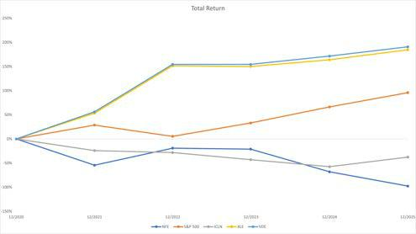

65

Table of Contents
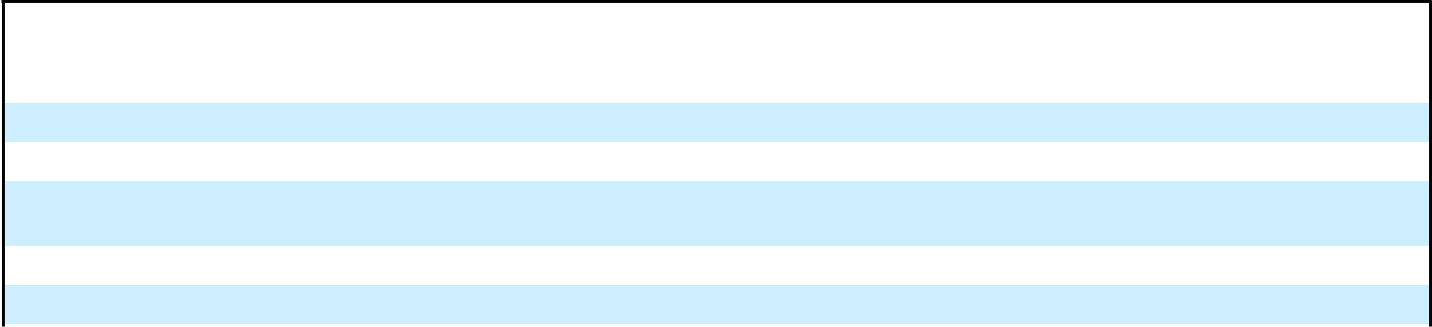

Cumulative Total Return Percentage

Company / Index |  | December | December | December | December | December | December
 |  | 31, 2020⁽¹⁾ | 31, 2021⁽¹⁾ | 31, 2022⁽¹⁾ | 31, 2023⁽¹⁾ | 31, 2024⁽¹⁾ | 31, 2025⁽¹⁾
NFE |  | 100.0% | (54.4)% | (19.1)% | (21.1)% | (68.1)% | (97.6)%
S&P 500 |  | 100.0% | 28.7% | 5.4% | 33.0% | 66.3% | 96.0%
iShares Global Clean Energy ETF Index |  | 100.0% | (24.2)% | (28.3)% | (42.9)% | (57.6)% | (37.6)%
(“ICLN”)
Energy Select Sector SPDR Fund (“XLE”) |  | 100.0% | 53.3% | 151.7% | 150.1% | 163.9% | 184.7%
Vanguard Energy ETF (“VDE”) |  | 100.0% | 56.2% | 154.4% | 154.4% | 171.6% | 190.8%
(1) | Last trading day of the month

Item 6. [Reserved.]

66

Table of Contents

Item 7. Management’s Discussion and Analysis of Financial Condition and Results of Operations.

Certain information contained in the following discussion and analysis, including information with respect to our plans, strategy, projections and expected timeline for our business and related financing, includes forward-looking statements. Forward-looking statements are estimates based upon current information and involve a number of risks and uncertainties. Actual events or results may differ materially from the results anticipated in these forward-looking statements as a result of a variety of factors.

You should read “Part 1, Item 1A. Risk Factors” and “Cautionary Statement on Forward-Looking Statements” elsewhere in this Annual Report on Form 10-K (“Annual Report”) for a discussion of important factors that could cause actual results to differ materially from the results described in or implied by the forward-looking statements contained in the following discussion and analysis.

The comparison of the years ended December 31, 2024 and 2023 can be found in our Annual Report on Form 10-K for the year ended December 31, 2024 located within “Part II, Item 7. Management’s Discussion and Analysis of Financial Condition and Results of Operations.”

The accompanying Management’s Discussion and Analysis of Financial Condition and Results of Operations gives effect to the restatement of our previously issued audited consolidated financial statements for the years ended December 31, 2024 and December 31, 2023 and our previously issued unaudited consolidated financial statements for each of the interim periods ended March 31, 2024, June 30, 2024, September 30, 2024, March 31, 2025, June 30, 2025, and September 30, 2025. Please refer to “—Recent Developments—Restatement of Previously Issued Financial Statements” and Note 1 and Note 33 of our notes to the consolidated financial statements included in this Annual Report for further discussion.

The following information should be read in conjunction with our audited consolidated financial statements and accompanying notes included elsewhere in this Annual Report. Our financial statements have been prepared in accordance with generally accepted accounting principles in the United States of America (“GAAP”). This information is intended to provide investors with an understanding of our past performance and our current financial condition and is not necessarily indicative of our future performance. Please refer to “—Factors Impacting Comparability of Our Financial Results” for further discussion. Unless otherwise indicated, dollar amounts are presented in millions.

Unless the context otherwise requires, references to “Company,” “NFE,” “we,” “our,” “us” or like terms refer to New Fortress Energy Inc. and its subsidiaries.

Overview

Liquidity and going concern

As part of preparing the financial statements included in this Annual Report, we have evaluated whether conditions exist that give rise to substantial doubt as to our ability to continue as a going concern. Due to the events of default under our debt agreements detailed below, management has concluded that there is substantial doubt as to our ability to continue as a going concern. On March 17, 2026, we entered into the RSA with certain lenders and noteholders under each of these facilities, and upon completion of the transactions contemplated in this agreement, we expect to have a new capital structure and the current debt facilities in default will no longer be outstanding. Existing and potential events of default include missed interest payments under the New 2029 Notes, Term Loan B Credit Agreement, Term Loan A Credit Agreement and Revolving Credit Agreement and other Specified Defaults (as defined in the RSA), as described in the RSA, which are subject to forbearance in accordance with the RSA. Additionally, the Company did not make interest and

67

Table of Contents

principal payments due in the fiscal quarter ended March 31, 2026 on the 2026 Notes and the 2029 Notes, which will result in events of default under each series of notes if not cured within 30 days.

Restructuring Support Agreement and Restructuring Transaction

In response to the Company’s ongoing liquidity challenges, and the events of default under the Company’s indentures and credit agreement, on March 17, 2026, the Company entered into a RSA with the Supporting Creditors, including a majority of the holders of the New 2029 Notes, a majority of the lenders under the Term Loan B Credit Agreement and a majority of the lenders under the Revolving Facility. The RSA provides a framework for a comprehensive restructuring transaction designed to address the Company’s capital structure and restore financial stability. Under the terms of the RSA, the holders of the New 2029 Notes will receive 100% of the common equity interests of BrazilCo, the parent company of NFE’s Brazil business, in exchange for the retirement of all New 2029 Notes. In addition, the Supporting Creditors will receive one or a combination of the following: senior secured term loans, non-recourse term loans secured by the Company’s Fast LNG assets, shares of a new class of NFE’s preferred stock as well as shares of NFE’s Class A common stock, and shares of FLNG 2 preferred stock. Certain lenders have also agreed to provide the Company with incremental funding in exchange for additional term loans or additional letter of credit facility capacity to support ongoing operations and liquidity needs.

Upon completion of the Restructuring Transaction, NFE expects to divest its Brazil business, including the Barcarena Facility, Barcarena Power Plant, Santa Catarina Facility, and PortoCem Power Plant. The effectuation of the restructuring will result in a significant reduction of the Company’s outstanding debt and annual interest expense, as the debt facilities currently in default will no longer be outstanding. The Company’s future business will be focused on operational efficiency of its remaining facilities and the cost-effective completion of in-process development projects, with the objective of returning to profitability and generating shareholder value. However, the consummation of the Restructuring Transaction is subject to a number of conditions and approvals, some of which are outside the Company’s control, and there can be no assurance that the transactions will be completed as contemplated. If the restructuring is not successfully implemented, the Company may be required to pursue alternative restructuring initiatives, including possible in-court proceedings, which could have a material adverse impact on stakeholders.

For further discussion of the RSA, the Restructuring Plans and the Restructuring Transaction, see “Items 1 and 2. Business and Properties—Planned Debt Restructuring.”

Business overview

We are a global energy infrastructure company founded to help address energy poverty and accelerate the world’s transition to reliable, affordable and clean energy. We own and operate natural gas and liquefied natural gas (“LNG”) infrastructure, and an integrated fleet of ships and logistics assets to rapidly deliver turnkey energy solutions to global markets. Collectively, our assets and operations reinforce global energy security, enable economic growth, enhance environmental stewardship and transform local industries and communities around the world.

Our chief operating decision maker makes resource allocation decisions and assesses performance on the basis of two operating segments, Terminals and Infrastructure and Ships.

Our Terminals and Infrastructure segment includes the entire production and delivery chain from natural gas procurement and liquefaction to logistics, shipping, facilities and conversion or development of natural gas-fired power generation. Our first floating liquefaction unit, which we refer to as “FLNG 1”, began producing LNG in July 2024, and we source a significant portion of our LNG needs from this facility. Currently, demand for LNG above FLNG 1’s capacity is acquired from third party suppliers in open market purchases. Starting in 2027, we expect to meet this demand under long-term supply contracts, which are based on an index such as Henry Hub plus a fixed fee component. The Terminals and Infrastructure segment includes all terminal operations in Puerto Rico, Mexico and Brazil, as well as vessels utilized in our terminal or logistics operations. We centrally manage our LNG supply and the deployment of our vessels utilized in our terminal, logistics or sub-charter operations, which allows us to optimally manage our LNG supply and fleet.

Our Ships segment currently includes one vessel which is currently chartered under a long-term arrangement to a third party and is part of the Energos Formation Transaction (defined below). Vessels that have been in our Ships segment transitioned to the Terminals and Infrastructure segment once we began to utilize the vessels in our own operations.

On May 14, 2025, we completed the sale of our Jamaica business, including operations at the LNG import terminal in Montego Bay, the offshore floating storage and regasification terminal in Old Harbour and the 150 MW Combined Heat

68

Table of Contents

and Power Plant in Clarendon, along with the associated infrastructure (the “Jamaica Business”). We received cash proceeds of approximately $961.9 million, with an additional $58.0 million of proceeds held in escrow to be returned to us based on the terms of the sale agreement. The proceeds were partially used to repay all outstanding South Power Bonds of $227.2 million and certain transaction costs.

Our Current Operations – Terminals and Infrastructure

Our management team has successfully employed our strategy to secure long-term contracts with significant customers, including, the Puerto Rico Electric Power Authority (“PREPA”), and Comisión Federal de Electricidad (“CFE”), Mexico’s power utility, each of which is described in more detail below. Our assets built to service these significant customers have been designed with capacity to service other customers.

San Juan Facility

Our San Juan Facility became fully operational in the third quarter of 2020. It is designed as a landed micro-fuel handling facility located in the Port of San Juan, Puerto Rico. The San Juan Facility has multiple truck loading bays to provide LNG to on-island industrial users. The San Juan Facility is near the PREPA San Juan Power Plant and serves as our supply hub for the PREPA San Juan Power Plant and industrial end-user customers in Puerto Rico.

In 2023, we entered into agreements for the installation and operation of approximately 350 MW of additional power to be generated at the Palo Seco Power Plant and San Juan Power Plant in Puerto Rico as well as the supply of natural gas. Our customer was contracted by the U.S. Army Corps of Engineers to support the island’s grid stabilization project with additional power capacity to enable maintenance and repair work on Puerto Rico’s power system and grid. We commissioned 350 MW of duel-fuel power generation using our gas supply in less than 180 days. In March 2024, our contract to provide emergency power services to support the grid stabilization project was terminated, and we completed a series of transactions that included the sale of turbines and related equipment deployed to support the grid stabilization project to PREPA. In December 2025, we entered into a settlement agreement, pursuant to which the Company will receive a total of $142.0 million as equitable adjustment related to the early termination of our contract to provide emergency power services. We expect to receive the balance in the first half of 2026.

In December 2025, we were awarded a new 7-year gas supply agreement with PREPA to deliver up to 75 TBtu of natural gas annually from our San Juan Facility. The new contract establishes security of supply in San Juan for power plants currently running on natural gas and also provides for incremental natural gas volumes to be delivered, allowing for the conversion of additional gas-ready plants currently burning diesel. We do not expect to have to incur significant capital expenditures to be able to supply these additional locations.

In 2023, our wholly-owned subsidiary, Genera PR LLC (“Genera”), was awarded a 10-year contract for the operation and maintenance of PREPA’s thermal generation assets with the goal of reducing costs and improving reliability of power generation in Puerto Rico. The service period under the contract commenced on July 1, 2023, and we receive an annual management fee for the services provided.

La Paz Facility

In 2021, we began commercial operations at the Port of Pichilingue in Baja California Sur, Mexico (the “La Paz Facility”). The La Paz Facility also supplies our gas-fired power units located adjacent to the La Paz Facility (the “La Paz Power Plant”) and could have a maximum capacity of up to 135 MW of power. We placed the La Paz Power Plant into service in the third quarter of 2023.

In the third quarter of 2024, we executed an amendment to the gas sales agreement to multiple CFE power generation facilities in Baja California Sur on a take-or-pay basis that extended the term to ten years from November 3, 2024, and amended the annual minimum volumes.

Santa Catarina Facility

We placed our Santa Catarina Facility in service in the fourth quarter of 2024. The Santa Catarina Facility is located on the southern coast of Brazil. We have developed and constructed a 33-kilometer, 20-inch pipeline that connects the Santa Catarina Facility to the existing inland Transportadora Brasileira Gasoduto Bolivia-Brasil S.A. (“TBG”) pipeline via an interconnection point in the municipality of Garuva. The Santa Catarina Facility and associated pipeline are expected to

69

Table of Contents

have a total addressable market of 15 million cubic meters per day of natural gas. In March 2026, the Company entered into a term sheet to lease its Santa Catarina Facility to a third party that is expected to commence in August 2026.

In August 2024, we acquired 100% of the outstanding equity interest of Usina Termeletrica de Lins S.A. (“Lins”), which owns key rights and permits to develop a natural gas-fired power plant for up to 2.05GW located in the State of São Paulo, within the city limits of Lins. The Santa Catarina Facility will supply natural gas to the Lins power project, and is expected to commence operations in 2031.

Upon effectuation of the Restructuring Transaction, we expect to no longer own BrazilCo, including the Santa Catarina Facility.

FLNG 1

Our first Fast LNG unit (“FLNG 1”) has been deployed off the coast of Altamira, Tamaulipas, Mexico. The 1.4 million ton per annum (“MTPA”) FLNG unit utilizes CFE’s firm pipeline transportation capacity on the Sur de Texas-Tuxpan Pipeline to receive feedgas volumes. This first FLNG unit has been fully commissioned, and we are in the process of increasing available liquefaction capacity through optimization projects.

Our LNG Supply and Cargo Sales

NFE provides reliable, affordable and clean energy supplies to customers around the world, and we currently satisfy customer demand with production from FLNG 1, which we expect to generate up to 70 TBtus annually. We have binding contracts for LNG volumes from two separate U.S. LNG facilities, each with a 20-year term, which are expected to commence in 2027 and 2029. Additional LNG needed to supply expansion of our operations in Puerto Rico and/or our Nicaragua Power Plant will be provided by open market purchases until the commencement of these LNG supply contracts.

Geopolitical events have substantially impacted and may continue to impact the natural gas and LNG markets, which have experienced significant volatility in recent years. Our pricing in contracts with customers is largely based on the Henry Hub index price plus a fixed fee component. Pricing for feed gas purchased for own Fast LNG production is based on Henry Hub, which allows us to mitigate exposure to variability in LNG prices. Our long-term supply contracts also contain pricing based on Henry Hub, however, until the commencement of these long-term supply contracts, a portion of our LNG needs will be purchased on the open market which exposures us to volatility in LNG pricing.

Our Current Operations – Ships

Our shipping assets include Floating Storage and Regasification Units (“FSRUs”), Floating Storage Units (“FSUs”) and LNG carriers (“LNGCs”). Our shipping assets are included in both of our operating segments. Certain vessels are currently chartered to third parties under long-term arrangements and are included in the Energos Formation Transaction (defined below); such vessels are included in our Ships segment. At the expiration of third party charters of these vessels, we plan to utilize these vessels for our own operational purposes. Vessels we operate at our terminal operations or that we decide to sub-charter are included in our Terminals and Infrastructure segment.

In August 2022, we completed a transaction (the “Energos Formation Transaction”) with an affiliate of Apollo Global Management, Inc., pursuant to which we transferred ownership of eleven vessels to Energos in exchange for approximately $1.85 billion in cash and a 20% equity interest in Energos. Ten of the vessels were subject to current or future charters with NFE and one vessel (the Nanook) was not subject to a future NFE charter. The in-place and future charters to NFE of ten vessels prevent the recognition of the sale of those vessels to Energos, and the proceeds associated with these vessels have been treated as a failed sale leaseback. As a result, these ten vessels continue to be recognized on our Consolidated Balance Sheet as Property, plant and equipment, and the proceeds are recognized as debt. Consistent with this treatment as a failed sale leaseback, (i) the third party charter revenues continue to be recognized by us as Vessel charter revenue; (ii) the costs of operating the vessels is included in Vessel operating expenses for the remaining terms of the third-party charters and (iii) such revenues are included as part of debt service for the sale leaseback financing debt and are included in additional financing costs within Interest expense, net. In February 2024, we sold substantially all of our stake in Energos.

In November 2025, we completed a transaction with Energos, pursuant to which the Company early terminated the long-term charter agreements with Energos for Energos Eskimo, Energos Winter, Energos Igloo and Energos Freeze and novated associated sub-charter agreements for these vessels to Energos, in exchange for cash consideration of $150.0

70

Table of Contents

million. This transaction resulted in the sale of these vessels that were previously accounted for as a failed sale leaseback. Upon closing of the transaction, the Company derecognized these vessels with a net book value of $667.0 million from Property, plant and equipment, derecognized debt of $734.2 million, and recognized a gain of $217.1 million. The Company will also no longer recognize charter revenues and vessel operating expenses associated with these vessels.

Our Development Projects

Our projects currently under development include our development of a second modular liquefaction facility to provide a source of low-cost supply of LNG to customers around the world through our Fast LNG technologies; our LNG terminal (“Barcarena Facility”) and power plants located in Pará, Brazil; our LNG terminal facility and power plant in Puerto Sandino, Nicaragua (“Puerto Sandino Facility”); and our LNG terminal and power plant in Ireland (“Ireland Facility”). Subsequent to the Restructuring Transaction, we will focus on operational efficiency of our current facilities and cost-effective completion of in-process development projects.

The design, development, construction and operation of our projects are highly regulated activities and subject to various approvals and permits. The process to obtain required permits, approvals and authorizations is complex, time-consuming, challenging and varies in each jurisdiction in which we operate. We obtain required permits, approvals and authorizations in due course in connection with each milestone for our projects.

We describe each of our current development projects below.

Fast LNG

Following the completion of the Restructuring Transaction, we do not plan to incur significant capital expenditures to develop our second 1.4 MTPA Fast LNG unit (“FLNG 2”). We are in active discussions with third parties to co-develop FLNG 2, which is expected to take approximately 24 months to complete from the time our partner is engaged. Estimated cost to complete is uncertain and is dependent upon final design and engineering, but we currently expect the remaining cost to be between $750.0 million and $1,500.0 million.

Barcarena Facility

The Barcarena Facility consists of an FSRU and associated infrastructure, including mooring and offshore and onshore pipelines. The Barcarena Facility is capable of delivering almost 600,000 MMBtu from LNG per day and storing up to 160,000 cubic meters of LNG. We have entered into a 15-year gas supply agreement with a subsidiary of Norsk Hydro ASA for the supply of natural gas to the Alunorte Alumina Refinery in Pará, Brazil, through our Barcarena Facility. We have substantially completed our Barcarena Facility and are in process of final commissioning.

The Barcarena Facility will also supply our new 630 MW combined cycle natural gas-fired power plant located in Pará, Brazil (the “Barcarena Power Plant”). The power plant is fully contracted under multiple 25-year power purchase agreements to supply electricity to the national electricity grid. We expect to place the Barcarena Power Plant into service in the first half of 2026.

In March 2024, we closed the acquisition of PortoCem Geração de Energia S.A. (“PortoCem”), a wholly-owned subsidiary of Ceiba Fundo de Investimento em Participações Multiestratégia- Investimento no Exterior (“Ceiba Energy”). PortoCem is the owner of a 15-year 1.6 GW capacity reserve contract in Brazil. We have transferred the 1.6 GW capacity reserve contract to a site owned by NFE that is adjacent to the Barcarena Facility, where NFE is building the 1.6 GW simple cycle, natural gas-fired power plant (“PortoCem Power Plant”) to supply the capacity reserve contract using gas from the Barcarena Facility. We expect the PortoCem Power Plant to be completed in 2026.

Upon effectuation of the Restructuring Transaction, we expect to no longer own BrazilCo, including the Barcarena Facility, Barcarena Power Plant and PortoCem Power Plant.

Puerto Sandino Facility

We are developing an offshore liquefied natural gas receiving, transloading and regasification facility in Puerto Sandino, Nicaragua, as well as a pipeline connecting the facility with our Puerto Sandino Power Plant. We have entered into a 25-year PPA with Nicaragua’s electricity distribution companies, and we expect to utilize approximately 57,000 MMBtu from LNG per day to provide natural gas to the Puerto Sandino Power Plant in connection with the 25-year power

71

Table of Contents

purchase agreement. Construction of the power plant is substantially complete, and we expect to complete the construction of the terminal and commission both the terminal and the power plant during 2026. As part of our long-term strategy, we are also evaluating solutions to optimize power generation and delivery to other markets, connected to our power plant through a regional transmission line.

Ireland Facility

We intend to develop and operate an LNG facility and power plant on the Shannon Estuary, near Tarbert, Ireland. In April 2023, we were awarded a capacity contract for the development of a power plant for approximately 353 MW of electricity generation with a duration of ten years as part of the auction process operated by Ireland’s Transmission System Operator.

In the third quarter of 2023, An Bord Pleanála (“ABP”), Ireland’s planning commission, denied our application for the development of an LNG terminal and power plant. We challenged this decision, and in September 2024, the High Court of Ireland ruled that ABP did not have appropriate grounds for the denial of our permit. In March 2025, ABP withdrew their appeal to the September 2024 decision of the High Court of Ireland. ABP is now reconsidering our planning application in accordance with Irish Law.

Further, in March 2025, ABP granted our application to construct a 600 MW power plant and a separate application to construct the 220 kV electricity interconnect. We are able to fuel this power plant via our LNG marine import terminal, if approved, or using gas provided from our permitted pipeline interconnection. The continued development of this project is uncertain and there are multiple risks, including regulatory risks, which could preclude the development of this project; however, management continues to assess all options in respect of future developments for the land held.

Recent Developments

Restructuring Support Agreement and Restructuring Transaction

On March 17, 2026, NFE entered into the RSA with the Supporting Creditors. Under the RSA, the Supporting Creditors agree to support the Restructuring Transaction, which involves a comprehensive restructuring of the Company’s principal funded debt obligations. For further discussion on the RSA, the Restructuring Plans and the Restructuring Transaction, see “Items 1 and 2. Business and Properties—Planned Debt Restructuring.”

Restatement of Previously Issued Financial Statements

As previously reported on the Company’s Current Report on Form 8-K filed on March 17, 2026, during the preparation of the Company’s consolidated financial statements for the year ended December 31, 2025, the Company identified errors in its historical consolidated statements of cash flows and determined that adjustments are required to previously issued audited consolidated financial statements. Accordingly, the Company is restating its previously issued audited consolidated financial statements for the years ended December 31, 2024 and December 31, 2023. During the periods covered by the financial statements, the Company delayed payments to certain vendors on certain significant development projects, which allowed the Company to improve its working capital and liquidity. Payments for capital expenditures significantly outside of a vendor’s customary payment terms should be classified as financing activities, as opposed to investing activities, which is how these payments were presented in the previously issued financial statements. In connection with the restatement, the Company is also correcting unrelated errors identified in prior periods. Additionally, the Company’s unaudited consolidated financial statements as of and for each of the interim periods ended March 31, 2024, June 30, 2024, September 30, 2024, March 31, 2025, June 30, 2025, and September 30, 2025 are being restated to correct the classification of capital expenditures paid outside of customary payment terms, as well as to correct other unrelated errors. Refer to Note 1 and Note 33 of our notes to the consolidated financial statements included in this Annual Report for further discussion.

Other Matters

On June 18, 2020, we received an order from the Federal Energy Regulatory Commission (“FERC”), which asked us to explain why our San Juan Facility is not subject to FERC’s jurisdiction under section 3 of the NGA. Because we do not believe that the San Juan Facility is jurisdictional, we provided our reply to FERC on July 20, 2020 and requested that FERC act expeditiously. On March 19, 2021, FERC issued an order that the San Juan Facility does fall under FERC jurisdiction. FERC directed us to file an application for authorization to operate the San Juan Facility within 180 days of

72

Table of Contents

the order, which was September 15, 2021, but also found that allowing operation of the San Juan Facility to continue during the pendency of an application is in the public interest. FERC also concluded that no enforcement action against us is warranted, presuming we comply with the requirements of the order. Parties to the proceeding, including the Company, sought rehearing of the March 19, 2021 FERC order, and FERC denied all requests for rehearing in an order issued on July 15, 2021; the FERC order was affirmed by the United States Court of Appeals for the District of Columbia Circuit (“D.C. Circuit”) on June 14, 2022. In order to comply with the FERC’s directive, on September 15, 2021, we filed an application for authorization to operate the San Juan Facility, which remains pending.

On July 18, 2023, we filed for an amendment to the March 19, 2021 and July 15, 2021 FERC orders allowing the continued operation of the San Juan Facility during the pendency of the formal application to allow us to construct and interconnect 220 feet of incremental 10-inch pipeline needed to supply natural gas for temporary power generation solicited through the Puerto Rico Power Stabilization Task Force. On July 31, 2023, FERC issued an order stating that it would not take action to prevent the construction and operation of the pipeline and interconnect and on January 30, 2024, FERC reaffirmed the order allowing the construction and operation to continue. On September 19, 2025, the D.C. Circuit denied a petition challenging this FERC order, holding that the order reflected an unreviewable exercise of enforcement discretion rather than a de facto authorization for construction or operation. The deadline to seek a writ of certiorari from that decision has expired.

On September 26, 2024, the United States Coast Guard (“USCG”) filed a Letter of Recommendation (“LOR”) with FERC in which it assessed our Letter of Intent dated April 12, 2024, and our Waterway Suitability Assessment, dated August 26, 2024, in respect of future ship to ship transfers with alternative vessels, and recommended against the allowance of the proposed operations. Further, on September 26, 2024, the USCG issued a Letter of Warning in respect of our ongoing ship to ship transfers of LNG operations within the San Juan port limits. On October 21, 2024, we filed an appeal with the USCG under 33 CFR 160.7. In December 2024 and February 2025, we submitted an updated Letter of Intent and Waterway Suitability Assessments detailing our alternative operational plans to the USCG. In concert with our collaboration with the USCG regarding our new operational plans, we withdrew our appeal on February 14, 2025. On January 12, 2026, the Acting Captain of the Port of San Juan for the USCG issued a LOR in response to NFE’s filings. The LOR determined that the Port of San Juan waterway is suitable for the transit and docking of larger LNG Carriers.

On October 25, 2024, FERC issued a notice of intent to prepare an Environmental Impact Statement, which included, among other things, two public scoping sessions in Puerto Rico held on November 18, 2024 in accordance with the National Environmental Policy Act.

Factors Impacting Comparability of Our Financial Results

Our historical results of operations and cash flows are not indicative of results of operations and cash flows to be expected in the future, principally for the following reasons:

- Our historical results of operations include our Jamaica Business. In May 2025, we completed the sale of our Jamaica Business, and we no longer include the results of operations of the Montego Bay Facility and Old Harbour Facility in our financial statements.

Our results of operations include the cost of operating FLNG 1. We placed our first Fast LNG project into service in the fourth quarter of 2024. This project represents our largest ever capital project and placing the asset into service from an accounting perspective that has significantly increased the depreciation recognized in the current period; such depreciation also impacts the cost of LNG delivered from the FLNG facility. This also increased interest expense as we are no longer able to capitalize borrowing costs associated this development.

We source a significant portion of our LNG needs from FLNG 1. Currently, demand for LNG above FLNG 1’s capacity is acquired from third party suppliers in open market purchases. Starting in 2027, we expect to meet this demand under long-term supply contracts, which are based on an index such as Henry Hub plus a fixed fee component.

- Our historical financial results include BrazilCo and do not reflect the contemplated effect of the Restructuring Transaction. The Restructuring Transaction contemplates the separation of our Brazil business, the exchange of existing debt for new debt and equity securities (including the issuance of CoreCo Convertible Preferred Stock and new shares of our Class A common stock), and the incurrence of new term loans and preferred equity at various subsidiaries. These changes will materially impact our reported interest expense, outstanding debt, equity

73

Table of Contents

balances, cost of borrowing and earnings per share calculations. In addition, the mandatory conversion of CoreCo Convertible Preferred Stock, potential future equity issuances, and the implementation of new incentive plans may result in further dilution and changes to our financial metrics. As a result, our future financial results will not be directly comparable to our historical results.

- We have reached compromise agreements to reduce expenses which are not reflected in our historical financial results. Over the past several months, we reached compromise agreements with vendors, service providers and other partners to materially reduce our outstanding obligations. These cost savings are expected to further impact the comparability of our financial results to prior periods by lowering our ongoing expense base and improving our overall financial position moving forward.

74

Table of Contents

Results of Operations – Three Months Ended December 31, 2025 compared to Three Months Ended September 30, 2025 (As Restated) and Year Ended December 31, 2025 compared to Year Ended December 31, 2024 (As Restated)

Performance of our two segments, Terminals and Infrastructure and Ships, is evaluated based on Segment Operating Margin. Segment Operating Margin reconciles to Consolidated Segment Operating Margin as reflected below, which is a non-GAAP measure. We reconcile Consolidated Segment Operating Margin to GAAP Gross margin, inclusive of depreciation and amortization. Consolidated Segment Operating Margin is mathematically equivalent to Revenue minus Cost of sales (excluding depreciation and amortization reflected separately) minus Operations and maintenance minus Vessel operating expenses, each as reported in our financial statements. We believe this non-GAAP measure, as we have defined it, offers a useful supplemental measure of the overall performance of our operating assets in evaluating our profitability in a manner that is consistent with metrics used for management’s evaluation of the overall performance of our operating assets.

Consolidated Segment Operating Margin is not a measurement of financial performance under GAAP and should not be considered in isolation or as an alternative to Gross margin, income from operations, net income, cash flow from operating activities or any other measure of performance or liquidity derived in accordance with GAAP. As Consolidated Segment Operating Margin measures our financial performance based on operational factors that management can impact in the short-term, items beyond the control of management in the short term, such as depreciation and amortization are excluded. As a result, this supplemental metric affords management the ability to make decisions and facilitates measuring and achieving optimal financial performance of our current operations. The principal limitation of this non-GAAP measure is that it excludes significant expenses and income that are required by GAAP. A reconciliation is provided for the non-GAAP financial measure to the most directly comparable GAAP measure, Gross margin. Investors are encouraged to review the related GAAP financial measures and the reconciliation of the non-GAAP financial measure to our Gross margin, and not to rely on any single financial measure to evaluate our business.

The tables below present our segment information for the three months ended December 31, 2025 and September 30, 2025, and for the year ended December 31, 2025 and December 31, 2024:

Three Months Ended December 31, 2025

(in thousands of $) |  | Terminals and |  |  | Ships |  |  | Total |  | Consolidation |  |  |  |  | Consolidated
(in thousands of $) |  | Infrastructure |  |  | Ships |  |  | Segment |  | and Other⁽³⁾
Total revenues | $ | 379,067 | $ |  | 16,677 | $ |  | 395,744 | $ |  | — |  |  |  | $ | 395,744
Cost of sales⁽¹⁾ |  | 211,157 |  |  | — |  |  | 211,157 |  |  | — |  |  |  |  | 211,157
Vessel operating expenses⁽⁴⁾ |  | 690 |  |  | 3,363 |  |  | 4,053 |  |  | — |  |  |  |  | 4,053
Operations and maintenance⁽⁴⁾ |  | 48,866 |  |  | — |  |  | 48,866 |  |  | — |  |  |  |  | 48,866
Segment Operating Margin | $ | 118,354 |  | $ | 13,314 |  | $ | 131,668 |  | $ | — |  |  |  | $ | 131,668
 |  | Three Months Ended December 31, 2025
(in thousands of $) |  |  |  |  |  |  |  |  |  |  |  |  |  |  | Consolidated
Gross margin (GAAP) |  |  |  |  |  |  |  |  |  |  | $ |  |  |  |  | 86,671
Depreciation and amortization |  |  |  |  |  |  |  |  |  |  |  |  |  |  |  | 44,997
Consolidated Segment Operating Margin (Non-GAAP) |  |  |  |  |  |  |  |  |  |  |  | $ |  |  |  | 131,668
 |  | Three Months Ended September 30, 2025 (As Restated)
(in thousands of $) |  | Terminals and |  |  | Ships |  |  | Total |  | Consolidation |  |  |  |  | Consolidated
(in thousands of $) |  | Infrastructure |  |  | Ships |  |  | Segment |  | and Other⁽³⁾
Total revenues | $ | 306,309 | $ |  | 25,602 | $ |  | 331,911 | $ |  | — |  |  |  | $ | 331,911
Cost of sales⁽¹⁾ |  | 196,908 |  |  | — |  |  | 196,908 |  |  | — |  |  |  |  | 196,908
Vessel operating expenses⁽⁴⁾ |  | 1,940 |  |  | 5,357 |  |  | 7,297 |  |  | — |  |  |  |  | 7,297
Operations and maintenance⁽⁴⁾ |  | 57,301 |  |  | — |  |  | 57,301 |  |  | — |  |  |  |  | 57,301
Segment Operating Margin | $ | 50,160 |  | $ | 20,245 |  | $ | 70,405 |  | $ | — |  |  |  | $ | 70,405
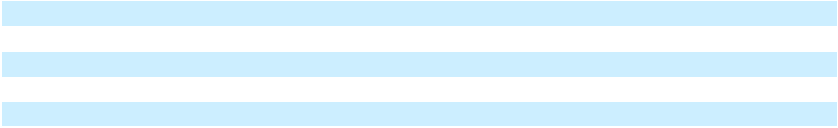

75

Table of Contents

Three Months Ended September 30, 2025 (As Restated)

(in thousands of $) |  |  |  |  |  |  |  |  |  |  |  |  |  |  | Consolidated
Gross margin (GAAP) |  |  |  |  |  |  |  |  |  |  |  |  |  | $ |  | 21,075
Depreciation and amortization |  |  |  |  |  |  |  |  |  |  |  |  |  |  |  | 49,330
Consolidated Segment Operating Margin (Non-GAAP) |  |  |  |  |  |  |  |  |  |  |  |  |  | $ |  | 70,405
 |  |  |  |  |  |  | Year Ended December 31, 2025
 |  |  | Terminals and |  |  |  | Ships |  |  | Total |  | Consolidation |  |  | Consolidated
(in thousands of $) |  |  | Infrastructure |  |  |  | Ships |  |  | Segment |  | and Other⁽²⁾
Total revenues |  | $ | 1,384,693 | $ |  |  | 119,344 | $ |  | 1,504,037 | $ |  | — | $ |  | 1,504,037
Cost of sales⁽¹⁾ |  |  | 918,603 |  |  |  | — |  |  | 918,603 |  |  | — |  |  | 918,603
Vessel operating expenses⁽⁴⁾ |  |  | 4,407 |  |  |  | 22,187 |  |  | 26,594 |  |  | — |  |  | 26,594
Operations and maintenance⁽⁴⁾ |  |  | 218,511 |  |  |  | — |  |  | 218,511 |  |  | — |  |  | 218,511
Segment Operating Margin |  | $ | 243,172 |  |  | $ | 97,157 |  | $ | 340,329 |  | $ | — |  | $ | 340,329
 |  |  | Year Ended December 31, 2025
(in thousands of $) |  |  |  |  |  |  |  |  |  |  |  |  |  |  | Consolidated
Gross margin (GAAP) |  |  |  |  |  |  |  |  |  |  |  |  |  | $ |  | 136,821
Depreciation and amortization |  |  |  |  |  |  |  |  |  |  |  |  |  |  |  | 203,508
Consolidated Segment Operating Margin (Non-GAAP) |  |  |  |  |  |  |  |  |  |  |  |  |  |  | $ | 340,329
 |  |  |  | Year Ended December 31, 2024 (As Restated)
 |  |  | Terminals and |  |  |  | Ships |  |  | Total |  | Consolidation |  |  | Consolidated
(in thousands of $) |  |  | Infrastructure |  |  |  | Ships |  |  | Segment |  | and Other⁽²⁾
Total revenues⁽⁵⁾ |  | $ | 2,041,580 | $ |  |  | 170,587 | $ |  | 2,212,167 | $ |  | 146,777 | $ |  | 2,358,944
Cost of sales⁽¹⁾ |  |  | 1,065,181 |  |  |  | — |  |  | 1,065,181 |  |  | — |  |  | 1,065,181
Vessel operating expenses⁽⁴⁾ |  |  | — |  |  |  | 33,372 |  |  | 33,372 |  |  | — |  |  | 33,372
Operations and maintenance⁽⁴⁾ |  |  | 170,763 |  |  |  | — |  |  | 170,763 |  |  | — |  |  | 170,763
Deferred earnings from |  |  | 150,000 |  |  |  | — |  |  | 150,000 |  |  | (150,000) |  |  | —
contracted sales⁽³⁾ |  |  | 150,000 |  |  |  | — |  |  | 150,000 |  |  | (150,000) |  |  | —
Segment Operating Margin |  | $ | 955,636 |  |  | $ | 137,215 |  | $ | 1,092,851 |  | $ | (3,223) |  | $ | 1,089,628
 |  |  | Year Ended December 31, 2024 (As Restated)
(in thousands of $) |  |  |  |  |  |  |  |  |  |  |  |  |  |  | Consolidated
Gross margin (GAAP) |  |  |  |  |  |  |  |  |  |  |  |  |  | $ |  | 930,837
Depreciation and amortization |  |  |  |  |  |  |  |  |  |  |  |  |  |  |  | 158,791
Consolidated Segment Operating Margin (Non-GAAP) |  |  |  |  |  |  |  |  |  |  |  |  |  |  | $ | 1,089,628
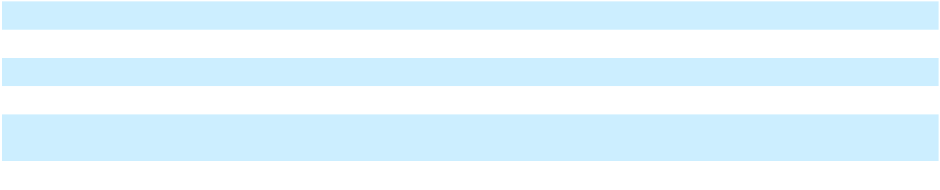

- Cost of sales is presented exclusive of costs included in Depreciation and amortization in the Consolidated Statements of Operations and Comprehensive (Loss) Income.

- For the year ended December 31, 2024, Consolidation and Other adjusts for the inclusion of deferred earnings from contracted sales of $150.0 million which were recognized during the third and fourth quarters of 2024.

- Deferred earnings from contracted sales represent forward sales transactions that were contracted in the second and third quarters of 2024 and prepayment for these sales was received. Revenue has been recognized in the Consolidated Statements of Operations and Comprehensive (Loss) Income during the third and fourth quarters of 2024.

- Operations and maintenance and Vessel operating expenses are directly attributable to revenue-producing activities of our terminals and vessels and are included in the calculation of Gross margin as defined under GAAP.

76

Table of Contents

- For the year ended December 31, 2024, Consolidation and Other adjusts for $3.2 million in amortization of intangible assets recognized upon acquisition of certain vessels with in-place leases, which was recorded in Vessel charter revenue; such amortization is excluded from Total Segment Operating Margin reviewed by our CODM.

Terminals and Infrastructure Segment

Three Months Ended,

 |  | December |  | September
(in thousands of $) |  | December |  | 30, 2025 (As |  |  |  | Change
(in thousands of $) |  | 31, 2025 |  |  | Restated) |  |  | Change
Total revenues | $ | 379,067 | $ |  | 306,309 | $ |  | 72,758
Cost of sales (exclusive of depreciation and amortization) |  | 211,157 |  |  | 196,908 |  |  | 14,249
Vessel operating expenses |  | 690 |  |  | 1,940 |  |  | (1,250)
Operations and maintenance |  | 48,866 |  |  | 57,301 |  |  | (8,435)
Segment Operating Margin | $ | 118,354 |  | $ | 50,160 |  | $ | 68,194
 |  |  |  | Year Ended,
 |  | December |  |  | December
(in thousands of $) |  | December |  | 31, 2024 (As |  |  |  | Change
(in thousands of $) |  | 31, 2025 |  |  | Restated) |  |  | Change
Total revenues | $ | 1,384,693 | $ |  | 2,041,580 | $ |  | (656,887)
Cost of sales (exclusive of depreciation and amortization) |  | 918,603 |  |  | 1,065,181 |  |  | (146,578)
Vessel operating expenses |  | 4,407 |  |  | — |  |  | 4,407
Operations and maintenance |  | 218,511 |  |  | 170,763 |  |  | 47,748
Deferred earnings from contracted sales |  | — |  |  | 150,000 |  |  | (150,000)
Segment Operating Margin | $ | 243,172 |  | $ | 955,636 |  | $ | (712,464)
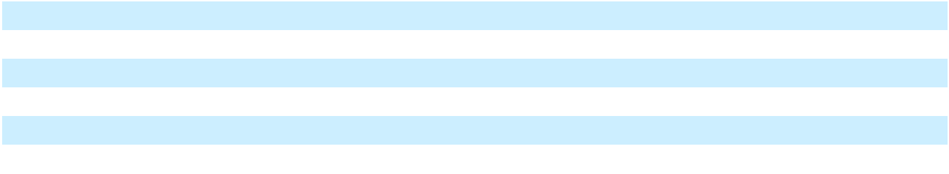

Total revenue

Total revenue for the Terminals and Infrastructure Segment increased by $72.8 million for the three months ended December 31, 2025 as compared to the three months ended September 30, 2025. The increase was primarily driven by cargo sales, contract settlement, and power trading revenue, offset by lower volumes delivered to our terminals. The average Henry Hub index pricing used to invoice our downstream customers increased by 15% for the three months ended December 31, 2025 as compared to the three months ended September 30, 2025.

- In December 2025, we entered into a settlement agreement with our customer for $142.0 million, related to the early termination of our contract to provide emergency power services in Puerto Rico, and we recognized revenue of $74.8 million.

- We recognized $69.4 million of revenue from cargo sales in the three months ended December 31, 2025. No cargo sales revenue was recognized in the three months ended September 30, 2025.

- We are required to deliver power under power purchase agreements (“PPAs”) from the Barcarena Power Plant starting in the third quarter of 2025. The Barcarena Power Plant is currently being commissioned, and as such, we partnered with a local energy trader to supply the required power. Revenue recognized for the delivery of power under these PPAs in fourth quarter of 2025 increased from $93.9 million during the three months ended September 30, 2025 to $109.7 million during the three months ended December 31, 2025.

- The increases are partially offset by lower volumes delivered to our downstream terminal customers at the San Juan and Mexico facilities, primarily due to repairs and maintenance at our customers’ facilities and lower power generation by these power facilities. Total volumes delivered decreased from 10.7 TBtu in the third quarter of 2025 to 6.4 TBtu in the fourth quarter of 2025 As a result, revenue decreased by $67.8 million at the San Juan and

77

Table of Contents

the Mexico facilities. This decrease includes lower expected capacity payments in Mexico of $18.0 million attributable to lower availability of our La Paz Power Plant during the fourth quarter of 2025.

- The third-party vessel charter revenue decreased by $14.7 million due to the sale of certain vessels to Energos during the fourth quarter of 2025.

Total revenue for the Terminals and Infrastructure Segment decreased by $656.9 million for the year ended December 31, 2025 as compared to the year ended December 31, 2024, and segment revenue was impacted by the following in 2025:

- For the year ended December 31, 2024, we recognized $295.6 million of income from the novation of an LNG supply contract, of which $235.6 million was recognized as segment revenue. Only $6.4 million of novation income was recognized in the year ended December 31, 2025 related to the accretion of expected payments under the novated LNG supply contract.

- For the year ended December 31, 2025, volumes delivered to downstream customers were 45.1 TBtu as compared to 81.3 TBtu for the year ended December 31, 2024. The lower volumes in 2025 were primarily attributable to the termination of the grid stabilization project in the first quarter of 2024 and the sale of our Jamaica Business in May 2025.

  - In Jamaica, we delivered 9.4 TBtu from our Montego Bay Facility and Old Harbour Facility in 2025, compared to 26.5 TBtu during the year ended December 31, 2024, which resulted in a reduction of revenue of $216.4 million in 2025.

  - Revenue from the San Juan Facility in Puerto Rico decreased by $541.7 million in 2025, primarily due to the termination of the grid stabilization project, partially offset by $74.8 million revenue recognized from the settlement contract related to the termination.

  - During 2024, we recognized an incentive fee of $15.7 million as incentive fees under our subsidiary Genera’s operations and maintenance contract with PREPA. No such incentive fees were earned during 2025. In 2025, our revenue decreased by $14.8 million due to lower costs that were passed through to our customer under Genera’s operations and maintenance contract.

  - Lastly, revenue decreased by $14.4 million due to sale of our Miami Facility in 2024.

The decrease in revenue for the year ended December 31, 2025 was partially offset by an increase due to the following:

- Revenue from cargos sales increased by $75.4 million for the year ended December 31, 2025, compared with the year ended December 31, 2024.

- Starting in the third quarter of 2025, we partnered with a local energy trader to supply the power required under power purchase agreements in Brazil while the Barcarena Power Plant is being commissioned. Revenue recognized for the delivery of power under these power purchase agreements during the second half of 2025 was $203.6 million.

- During 2025, we entered into sub-charter agreements for Energos Eskimo, Energos Winter, and Energos Freeze, and recognized additional vessel charter revenues of $29.0 million during the year ended December 31, 2025, which is included in our Terminals and Infrastructure segment.

- The average Henry Hub index pricing used to invoice our downstream customers increased by 51% for the year ended December 31, 2025 as compared to the year ended December 31, 2024.

Cost of sales

Cost of sales includes the procurement of feed gas or LNG, as well as shipping and logistics costs to deliver LNG or natural gas to our facilities. We source LNG and natural gas from third parties and our own liquefaction facilities, including our Fast LNG unit which was placed into service in the fourth quarter of 2024. Costs to convert natural gas to LNG, including labor, depreciation and other direct costs to operate our liquefaction facilities are also included in Cost of sales.

78

Table of Contents

Our subsidiary, Genera, provides operations and maintenance services to PREPA’s thermal generation assets, and cost to provide these services is included in Cost of sales. Under our contract with PREPA, we pass all of these costs onto PREPA, and such billings are recognized as revenue.

Cost of sales increased $14.2 million for the three months ended December 31, 2025 as compared to the three months ended September 30, 2025. The increase was primarily driven by increases in cost of cargo sales of $54.3 million as there were no cargos sales during the three months ended September 30, 2025, which were partially offset by a decrease due to lower volumes delivered. We delivered 40% lower volumes to our customers during the three months ended December 31, 2025 resulting in a decrease in cost of LNG consumed by $44.2 million. Our cost of acquiring and producing LNG decreased to $8.58 per MMBtu for the three months ended December 31, 2025 from $9.40 per MMBtu for the three months ended September 30, 2025.

Cost of sales decreased by $146.6 million for the year ended December 31, 2025 as compared to the year ended

December 31, 2024, which was attributable to the following activity:

- We delivered 45% less volume to our downstream terminal customers in the current year compared to 2024, principally due to the sale of our Jamaica Business, which resulted in a $122.7 million decrease in our LNG cost of sales. In addition, cost of LNG delivered at our Puerto Rico operations decreased by $103.4 million in 2025 compared to 2024 due to lower volumes delivered in 2025, primarily as a result of termination of our customer’s grid stabilization project in the first quarter of 2024.

- Vessel costs decreased by $53.6 million, for the year ended December 31, 2025 as compared to the year ended December 31, 2024 due to reduced number of vessels chartered in our fleet. We assigned vessels used in the Jamaica Business to the buyer, and we redelivered certain vessels after their charters ended in the 2025.

- We recognized payroll and other operating costs of $80.3 million to provide services under Genera’s operations and maintenance contract for the year ended December 31, 2025 compared to $100.2 million for the year ended December 31, 2024; these costs are passed onto PREPA.

The decrease in cost of sales for the year ended December 31, 2025 as compared to the year ended December 31, 2024 was offset by the following:

- Although the volumes delivered decreased, our cost of LNG increased to $8.93 per MMBtu for the year ended December 31, 2025 compared to $7.20 per MMBtu for the year ended December 31, 2024. The increase was primarily driven by higher gas prices. The average Henry Hub index pricing increased by 51% for the year ended December 31, 2025 as compared to the year ended December 31, 2024.

- We incurred $89.7 million cost of sales in 2025 related to the delivery of power under power purchase agreements from the Barcarena Power Plant. No such costs were incurred in 2024.

- Cost of cargo sales increased by $47.2 million in 2025 compared to 2024, reflecting less favorable pricing on certain cargo purchases.

- Higher costs incurred due to increased volumes delivered from our La Paz Facility.

The weighted-average cost of our LNG inventory balance to be used in our operations as of December 31, 2025 and December 31, 2024 was $8.35 per MMBtu and $6.90 per MMBtu, respectively.

79

Table of Contents

Vessel operating expenses

Vessel operating expenses relate to direct costs such as crewing, repairs and maintenance, insurance, stores, lube oils, communication expenses, management fees associated with operating vessels.

We incurred $4.4 million of vessel operating expenses for the year ended December 31, 2025. No such costs were incurred in this segment in 2024. Vessel operating expenses were immaterial to our results of operations for the three months ended December 31, 2025 and September 30, 2025.

Operations and maintenance

Operations and maintenance includes costs of operating our facilities, exclusive of costs to convert that are reflected in Cost of sales.

Operations and maintenance decreased by $8.4 million for the three months ended December 31, 2025 as compared to the three months ended September 30, 2025. In November 2025, we completed a transaction with Energos, that resulted in sale of four vessels. Following the transaction, we ceased incurring operating costs for three of the vessels that were part of our Terminals and Infrastructure segment. In addition, our operating expenses decreased due to the expiration of an operating lease, reduction in port fees, and decreased spare parts usage at our terminals.

Operations and maintenance increased by $47.7 million for the year ended December 31, 2025 as compared to the year ended December 31, 2024. The increase is primarily due to Fast LNG unit and the Santa Catarina Facility that were placed in service at the end of 2024. The increase was also driven by higher vessel charter costs as more vessels were deployed in our terminal operations during 2025. These impacts were partially offset by the sale of our Jamaica Business in May 2025.

Deferred earnings from contracted sales

During 2024, we completed forward sales and received prepayments from the buyers of $150.0 million. The prepayments were based on the fair market value of these sales as compared to our supply cost, and our CODM includes these results in this evaluation of Terminals and Infrastructure operations. Revenue for these sales were recognized in our Consolidated Statements of Operations and Comprehensive (Loss) Income in 2024, and as such, these deferred earnings do not impact the total segment operating margin recognized for the year ended December 31, 2024.

Ships Segment

Three Months Ended,

 |  | December |  |  | September
(in thousands of $) |  | December |  | 30, 2025 (As |  |  |  | Change
(in thousands of $) |  | 31, 2025 |  |  | Restated) |  |  | Change
Total revenues | $ | 16,677 | $ |  | 25,602 | $ |  | (8,925)
Vessel operating expenses |  | 3,363 |  |  | 5,357 |  |  | (1,994)
Segment Operating Margin | $ | 13,314 |  | $ | 20,245 |  | $ | (6,931)
 |  |  |  | Year Ended,
 |  | December |  | December 31,
(in thousands of $) |  | December |  |  | 2024 (As |  |  | Change
(in thousands of $) |  | 31, 2025 |  |  | Restated) |  |  | Change
Total revenues | $ | 119,344 | $ |  | 170,587 | $ |  | (51,243)
Vessel operating expenses |  | 22,187 |  |  | 33,372 |  |  | (11,185)
Segment Operating Margin | $ | 97,157 |  | $ | 137,215 |  | $ | (40,058)

Revenue in the Ships segment is comprised of operating lease revenue under time charters, fees for positioning and repositioning vessels as well as the reimbursement of certain vessel operating costs. As of December 31, 2025, one vessel included in the Energos Formation Transaction was under a third-party charter and is included in this segment.

80

Table of Contents

Total revenue

Total revenue for the Ships segment decreased by $8.9 million from the three months ended September 30, 2025 to the three months ended December 31, 2025. In November 2025, we completed a transaction with Energos, pursuant to which we early terminated the long-term charter agreements with Energos for certain vessels, including Energos Igloo, which was included in the Ships segment at September 30, 2025. This transaction resulted in a sale of Energos Igloo to Energos and a reduction in charter revenue for the three months ended December 31, 2025 compared to the three months ended September 30, 2025.

Total revenue for the Ships segment decreased by $51.2 million for the year ended December 31, 2025 as compared to the year ended December 31, 2024. Subsequent to the Energos Formation Transaction, we continue to be, for accounting purposes, the owner of certain vessels included in the transaction, and as such, we continue to recognize revenue from the charter of these vessels to third parties. We excluded such vessels from the Ships segment and included them in our Terminals and Infrastructure segment as certain third-party charters expired and we began to use the vessels in our own operations during the year ended December 31, 2025.

Vessel operating expenses

Vessel operating expenses include direct costs associated with operating a vessel, such as crewing, repairs and maintenance, insurance, stores, lube oils, communication expenses, and management fees. We also recognize voyage expenses within Vessel operating expenses, which principally consist of fuel consumed before or after the term of time charter or when the vessel is off hire. Under time charters, the majority of voyage expenses are paid by customers. To the extent that these costs are a fixed amount specified in the charter, which is not dependent upon redelivery location, the estimated voyage expenses are recognized over the term of the time charter.

Vessel operating expenses decreased by $2.0 million from the three months ended September 30, 2025 to the three months ended December 31, 2025. Vessel operating expenses decreased by $11.2 million for the year ended December 31, 2025 as compared to the year ended December 31, 2024. The vessel operating expenses were lower during the three months and the year ended December 31, 2025 as all vessels aside from Nusantara Regas Satu were either utilized in our terminal operations following the conclusion of their third party charters, or were sold as part of the vessel sale transaction to Energos, as discussed above.

81

Table of
Table of | Contents
Other operating results
 |  |  |  |  | Three Months Ended, |  |  |  |  |  |  |  |  |  | Year Ended,
 |  |  |  |  | December |  | September |  |  |  |  |  | December |  |  | December
(in thousands of $) |  |  |  |  | December |  | 30, 2025 (As |  |  |  | Change |  | December |  | 31, 2024 (As |  |  |  | Change
 |  |  |  |  | 31, 2025 |  |  | Restated) |  |  | Change | 31, 2025 |  |  |  | Restated) |  |  | Change
Selling, general and |  |  |  | $ | 112,596 | $ |  | 86,467 | $ |  | 26,129 | $ 307,442 |  | $ |  | 293,378 |  | $ | 14,064
administrative |  |  |  |  |  |  |  |  |  |  |  |  |  |  |  |  |  | $ | 14,064
Transaction and integration |  |  |  |  | 54,792 |  |  | 19,679 |  |  | 35,113 | 161,756 |  |  |  | 12,279 |  |  | 149,477
costs |  |  |  |  | 54,792 |  |  | 19,679 |  |  | 35,113 |  |  |  |  | 12,279 |  |  | 149,477
Depreciation and |  |  |  |  | 44,997 |  |  | 49,330 |  |  | (4,333) | 203,508 |  |  |  | 158,791 |  |  | 44,717
amortization |  |  |  |  | 44,997 |  |  | 49,330 |  |  | (4,333) |  |  |  |  | 158,791 |  |  | 44,717
Asset impairment expense |  |  |  |  | 732,954 |  |  | 4,782 |  |  | 728,172 | 860,865 |  |  |  | 16,494 |  |  | 844,371
(Gain) loss on sale |  |  |  |  | (199,944) |  |  | — |  |  | (199,944) | (670,938) |  |  |  | 80,207 |  |  | (751,145)
Goodwill impairment |  |  |  |  | 15,938 |  |  | — |  |  | 15,938 |  | 598,110 |  |  | — |  |  | 598,110
expense |  |  |  |  | 15,938 |  |  | — |  |  | 15,938 |  | 598,110 |  |  | — |  |  | 598,110
Total operating expenses |  |  |  |  | 761,333 |  |  | 160,258 |  |  | 601,075 |  | 1,460,743 |  |  | 561,149 |  |  | 899,594
Operating (loss) income |  |  |  |  | (629,664) |  |  | (89,853) |  |  | (539,811) | (1,120,414) |  |  |  | 528,479 |  |  | (1,648,893)
Interest expense |  |  |  |  | 192,929 |  |  | 198,218 |  |  | (5,289) | 777,845 |  |  |  | 316,337 |  |  | 461,508
Other (income) expense, net |  |  |  |  | 5,934 |  |  | (30,566) |  |  | 36,500 | (147,593) |  |  |  | 116,308 |  |  | (263,901)
Loss on extinguishment of |  |  |  |  | (850) |  |  | — |  |  | (850) |  | 19,937 |  |  | 270,063 |  |  | (250,126)
debt, net |  |  |  |  | (850) |  |  | — |  |  | (850) |  | 19,937 |  |  | 270,063 |  |  | (250,126)
(Loss) income before |  |  |  |  | (827,676) |  |  | (257,505) |  |  | (570,171) | (1,770,603) |  |  |  | (174,229) |  |  | (1,596,374)
income taxes |  |  |  |  | (827,676) |  |  | (257,505) |  |  | (570,171) |  |  |  |  | (174,229) |  |  | (1,596,374)
Tax provision |  |  |  |  | 19,386 |  |  | 5,496 |  |  | 13,890 |  | 61,350 |  |  | 70,308 |  |  | (8,958)
Net loss |  |  |  | $ | (847,062) |  | $ | (263,001) |  | $ | (584,061) |  | $(1,831,953) |  | $ | (244,537) |  | $ | (1,587,416)
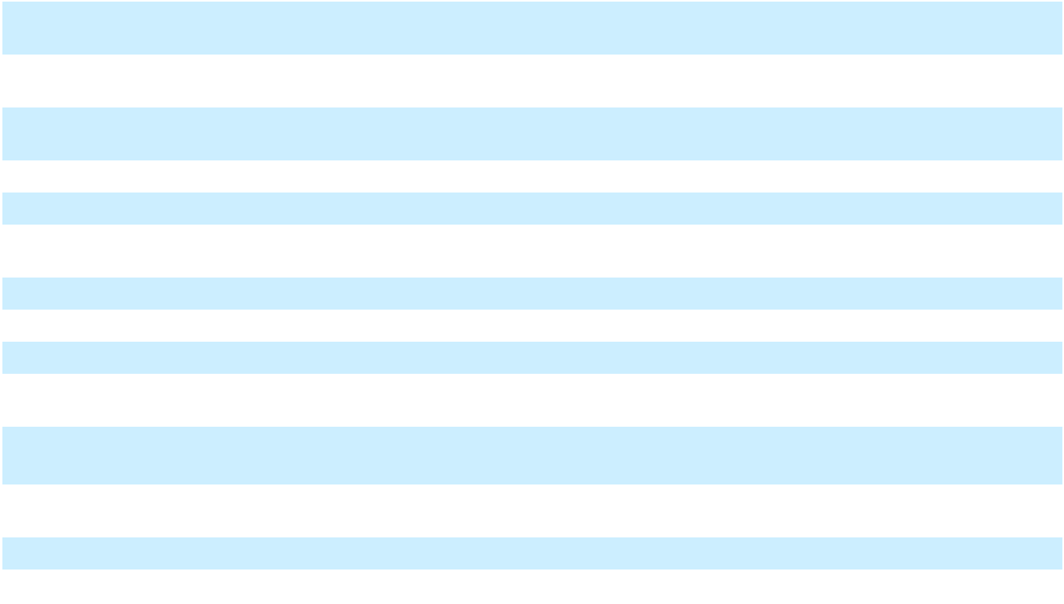

Selling, general and administrative

Selling, general and administrative includes compensation expenses for our corporate employees, employee travel costs, insurance, professional fees for our advisors, and screening costs for projects that are in initial stages and development is not yet probable.

Selling, general and administrative increased by $26.1 million for the three months ended December 31, 2025 as compared to the three months ended September 30, 2025. During the three months ended December 31, 2025, we recorded $45.6 million contingent losses related to certain legal proceedings compared to $18.6 million loss recorded during the three months ended September 30, 2025.

Selling, general and administrative increased by $14.1 million for the year ended December 31, 2025, compared to the year ended December 31, 2024. The increase was primarily due to provision for certain legal matters of $64.2 million with our customers and vendors. In addition, legal and professional fees increased by $8.5 million, mostly attributable to certain litigation and arbitration proceedings. These increases were largely offset by a $35.9 million reduction of share-based compensation expense in 2025 primarily due to the vesting of a large number of restricted share units at the beginning of 2025. Screening costs for development projects decreased by $11.5 million due to lower activity to develop potential projects during 2025. Lastly, our bad debt expense decreased by $14.1 million in 2025, primarily due to a reversal of an allowance for bad debt as a result of a settlement agreement entered with our customer as discussed above.

Transaction and integration costs

We incurred transaction and integration costs of $54.8 million and $19.7 million, respectively, during the three months ended December 31, 2025 and September 30, 2025, which is primarily comprised of professional and consulting fees relating to our debt restructuring process, as well as costs incurred for certain debt amendments.

82

Table of Contents

We incurred $161.8 million of transaction and integration costs during the year ended December 31, 2025. In addition to the professional and consulting fees related to our debt restructuring, we incurred $71.1 million of transaction costs directly attributable to the sale of the Jamaica Business, which included fees associated with novating a vessel charter to the buyer and contingent fees due to our advisors. Remaining transaction and integration costs relate to legal fees and other third party costs incurred in connection with amendments to credit agreements, which were accounted for as modifications.

The transaction and integration costs of $12.3 million during the year ended December 31, 2024 primarily relate to legal fees and other third party costs incurred by the Company in connection with the amendments of credit agreements, which were accounted for as modifications.

Depreciation and amortization

Depreciation and amortization decreased by $4.3 million for the three months ended December 31, 2025 as compared to the three months ended September 30, 2025. The decrease was primarily attributable to the sale of certain vessels to Energos during the fourth quarter of 2025 as discussed above.

Depreciation and amortization increased by $44.7 million for the year ended December 31, 2025 as compared to the year ended December 31, 2024. The increase in depreciation expense resulted from the Fast LNG project and the Santa Catarina Facility being placed into service in December 2024, and was partially offset by a reduction following the sale of certain turbines and equipment to PREPA in the first half of 2024, and the sale of our Jamaica Business in May 2025.

Asset impairment expense

During the three months ended December 31, 2025, as part of the Company’s ongoing discussions with creditors, the Company has determined that it was not probable that it would pursue the development of certain Fast LNG projects and the ZeroParks hydrogen project and recognized impairment charges of $733.0 million to reduce the carrying values of the asset groups to their estimated fair value.

During the three months ended September 30, 2025, we determined that it was not probable that we would pursue development of certain projects and recognized an impairment charge of $4.8 million relating to costs incurred on these development projects.

During the year ended December 31, 2025, we recognized an impairment charge of $860.9 million, principally related to the Fast LNG project and the ZeroParks hydrogen project discussed above, the Lakach deepwater project and the development project in Pennsylvania. During the year ended December 31, 2024, we recognized an impairment expense of $16.5 million related to the sale of our Miami Facility.

Goodwill impairment expense

During the three months ended December 31, 2025, we recognized an impairment of goodwill of $15.9 million in our Ships segment, primarily as a result of a reduction in forecasted cash flows following the sale of certain vessels to Energos. There was no goodwill impairment expense recognized for the three months ended September 30, 2025.

During the year ended December 31, 2025, we recognized an impairment of goodwill of $582.2 million in our Terminals and Infrastructure segment, primarily as a result of (i) the significant increase in the WACC which reflected a higher company specific risk premium, and (ii) a reduction in forecasted cash flows following changes in customer revenue projections and the timing of completion of development projects.

Following the impairments recognized in the Terminals and Infrastructure and Ships segments described above, the remaining goodwill has been fully impaired.

There was no goodwill impairment expense recognized for the year ended December 31, 2024.

(Gain) loss on sale

For the three months ended December 31, 2025, the Company recorded a gain of $199.9 million. In November 2025, we completed a transaction with Energos, pursuant to which the Company early terminated the long-term charter

83

Table of Contents

agreements with Energos for certain vessels and novated associated sub-charter agreements for these vessels to Energos, in exchange for cash consideration of $150.0 million. The Company recognized a gain of $217.1 million from the transaction.

For the year ended December 31, 2025, the Company recorded a gain of $670.9 million. In addition to the vessel sale transaction discussed above, in May 2025, the Company completed the sale of its Jamaica Business, and recognized a gain of $453.8 million from the sale.

During the year ended December 31, 2024, the Company recognized a loss of $80.2 million from the sale of turbines and related equipment to the PREPA.

Interest expense

Interest expense decreased by $5.3 million for the three months ended December 31, 2025 as compared to the three months ended September 30, 2025, primarily due to lower debt resulting from the vessel sale transaction during the fourth quarter of 2025.

Interest expense increased by $461.5 million during the year ended December 31, 2025 as compared to the year ended December 31, 2024, primarily due to higher debt balances outstanding as well as increased borrowing rates. In addition, we also capitalized lower interest expense of $339.6 million for the year ended December 31, 2025 compared to $501.9 million for the year ended December 31, 2024, as the Fast LNG project and Santa Catarina Facility were placed into service at the end of 2024.

Other expense (income), net

Other expense, net and other income, net was $5.9 million and $30.6 million for the three months ended December 31, 2025 and September 30, 2025, respectively. Other income, net and other expense, net was $147.6 million and $116.3 million for the year ended December 31, 2025 and December 31, 2024, respectively.

Other income (expense), net for the third and fourth quarters of 2025, as well as for the years ended 2025 and 2024, primarily reflected remeasurement gains and losses on U.S. dollar denominated debt held by our Brazil subsidiary, driven by fluctuations in the Brazilian Real relative to the U.S. Dollar. The losses were partially offset by interest income, and realized and unrealized gains on foreign currency derivative contracts. The interest income was derived largely from the restricted cash for our development projects in Brazil.

Loss on extinguishment of debt, net

The Company had no material extinguishment of debt for the three months ended December 31, 2025 and September 30, 2025.

During 2025, we reduced the available capacity under our Revolving Facility by $270.0 million and recognized $10.6 million of loss on extinguishment of debt, which represents the write-off of unamortized deferred financing costs. We also recognized $5.9 million of loss on extinguishment of debt related to the repayment of the South Power Bonds in conjunction with closing of the sale of our Jamaica Business. Additionally, we made a partial repayment of the Term Loan A using proceeds from the sale and incurred a partial extinguishment loss of $3.0 million.

During 2024, we repaid all of the 2025 Notes and a portion of the 2026 Notes and 2029 Notes, and recognized as a loss on extinguishment of debt totaling $235.4 million. In Brazil, we repaid the PortoCem Bridge Loan with proceeds from the PortoCem Debenture issuance and recorded a loss on extinguishment of $25.0 million. In addition, during the first quarter of 2024, we recognized prepayment premium and unamortized financing costs of $7.9 million in connection with the prepayment of the Equipment Notes. During the same period, we also recognized a premium over the repurchase price of $1.9 million in connection with the cash tender offer to repurchase $375.0 million of the outstanding 2025 Notes.

Tax provision

We recognized a tax provision of $61.4 million for the year ended December 31, 2025 compared to a tax provision of $70.3 million for the year ended December 31, 2024. For the year ended December 31, 2025, the tax provision was primarily driven by valuation allowance against deferred tax assets related to losses in U.S. operations and losses generated by foreign operations in Brazil and Mexico.

84

Table of Contents

Liquidity and Capital Resources

Cash Flows

The following table summarizes the changes to our cash flows for the year ended December 31, 2025 and 2024, respectively:

 |  | Year Ended December 31,
(in thousands) |  | 2025 |  |  | 2024 (as |  |  | Change
(in thousands) |  | 2025 |  |  | Restated) |  |  | Change
Cash flows from:
Operating activities | $ | (583,382) | $ |  | 602,206 | $ |  | (1,185,588)
Investing activities |  | 465,763 |  |  | (1,584,054) |  |  | 2,049,817
Financing activities |  | (543,640) |  |  | 1,718,511 |  |  | (2,262,151)
Net (decrease) increase in cash, cash equivalents, and restricted cash | $ | (661,259) | $ |  | 736,663 | $ |  | (1,397,922)
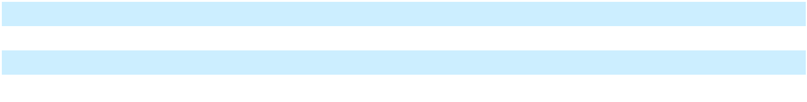

Cash (used in) / provided by operating activities

Our cash flow used in operating activities was $583.4 million for the year ended December 31, 2025, which decreased by $1,185.6 million from cash provided by operating activities of $602.2 million for the year ended December 31, 2024. Our net loss for the year ended December 31, 2025, when adjusted for non-cash items, increased by $1.2 billion from the year ended December 31, 2024.

Cash outflows during the year ended December 31, 2025 includes significant interest payments resulting from both higher amounts of outstanding debt and increased interest rates. Cash paid for interest, excluding capitalized interest, during 2025 totaled approximately $352.2 million. Additionally, we have incurred significant professional and consulting fees relating to our capital restructuring process. We have recognized reduced cash flows following the sale of our Jamaica Business. Following the sale of the Jamaica Business, we continue to incur operational and administrative costs that supported all of our operations, including Jamaica. Additionally, our first FLNG unit was placed in service at the end of 2024, and we have incurred increased operational and maintenance costs as we optimize our LNG production process.

Cash provided by / (used in) investing activities

Our cash flow provided by investing activities was $465.8 million for the year ended December 31, 2025, which increased by $2.0 billion from cash used in investing activities of $1.6 billion for the year ended December 31, 2024. Cash inflows from investing activities during the year ended December 31, 2025 were primarily from proceeds of $961.9 million from the sale of the Jamaica Business and $150.0 million from the sale of Energos vessels. Cash inflows were offset by $908.8 million of capital expenditures of which $257.9 million was paid significantly beyond our vendors customary payment terms, and as such, is presented as a financing activity. Capital expenditures were used for continued construction of the PortoCem Power Plant and the Puerto Sandino Facility, and for expansion projects in Puerto Rico.

Cash outflows from investing activities during the year ended December 31, 2024 were primarily used for continued development of our Fast LNG project and the construction of the PortoCem Power Plant and Barcarena Power Plant. Cash outflows were offset by proceeds from the sale of assets including the sale of turbines and related equipment to PREPA, our investment in Energos, the Mazo and the Miami Facility.

Cash (used in) / provided by financing activities

Our cash flow used in financing activities was $543.6 million for the year ended December 31, 2025, which decreased by $2.3 billion from cash provided by financing activities of $1.7 billion for the year ended December 31, 2024. During the year ended December 31, 2025 we had total borrowings of $1.4 billion, a portion of which were used to repay the Barcarena Debentures in full. We also repaid a portion of our Revolving Facility and repaid our short-term borrowings under repurchase agreements, prior to drawing again on these facilities. In conjunction with closing the sale of the Jamaica Business, we repurchased all outstanding South Power Bonds for $227.1 million.

85

Table of Contents

During the year ended December 31, 2024 we had total borrowings of $5.9 billion, with such borrowings primarily used to fund development of the Fast LNG project, Barcarena Power Plant, and PortoCem Power Plant. Such borrowings were also used to repay a portion of the 2025 Notes and various asset level financings in Puerto Rico and Brazil. We also repaid a portion of our Revolving Facility and short-term borrowings under repurchase agreements, prior to again drawing on these facilities.

Contractual Obligations

We are committed to make cash payments in the future pursuant to certain contracts. The following table summarizes certain contractual obligations in place as of December 31, 2025 and includes those contractual obligations of BrazilCo, which will no longer be owed by us upon completion of the Restructuring Transaction:

(in thousands) |  | Total |  |  | Year 1 |  | Years 2 to 3 |  |  | Years 4 to 5 |  |  | More than 5
(in thousands) |  | Total |  |  | Year 1 |  |  |  |  |  |  |  |  | years
Long-term debt obligations | $ | 9,661,351 | $ |  | 7,452,300 | $ |  | 391,064 | $ |  | 264,245 | $ |  | 1,553,742
Purchase obligations |  | 17,954,542 |  |  | 211,618 |  |  | 769,000 |  |  | 1,769,116 |  |  | 15,204,808
Lease obligations |  | 538,443 |  |  | 104,559 |  |  | 174,499 |  |  | 112,386 |  |  | 146,999
Total | $ | 28,154,336 | $ |  | 7,768,477 | $ |  | 1,334,563 | $ |  | 2,145,747 | $ |  | 16,905,549

Long-term debt obligations

For information on our long-term debt obligations, see “—Liquidity and Capital Resources—Long-Term Debt.” The amounts included in the table above are based on the total debt balance, scheduled maturities or accelerated maturities under the events of default, and interest rates in effect as of December 31, 2025 and includes certain obligations that will not be owed by us upon completion of the Restructuring Transaction.

A portion of our long-term debt obligations will be paid to Energos under charters of vessels included in the Energos Formation Transaction to third parties. The residual value of these vessels also forms a part of the obligation and will be recognized as a bullet payment at the end of the charters. As neither these third party charter payments nor the residual value of these vessels represent cash payments due by NFE, such amounts have been excluded from the table above.

Purchase obligations

We are party to contractual purchase commitments for the purchase, production and transportation of LNG and natural gas, as well as engineering, procurement and construction agreements to develop our terminals and related infrastructure. Our commitments to purchase LNG and natural gas are principally take-or-pay contracts, which require the purchase of minimum quantities of LNG and natural gas, and these commitments are designed to assure sources of supply and are not expected to be in excess of normal requirements. Certain LNG purchase commitments are subject to conditions precedent, and we include these expected commitments in the table above beginning when delivery is expected assuming that all contractual conditions precedent are met. For purchase commitments priced based upon an index such as Henry Hub, the amounts shown in the table above are based on the spot price of that index as of December 31, 2025.

We have construction purchase commitments in connection with our development projects, including our Puerto Sandino Facility, Barcarena Facility, Barcarena Power Plant and PortoCem Power Plant, and any remaining unpaid commitments on our FLNG projects. Commitments included in the table above include commitments under engineering, procurement and construction contracts where a notice to proceed has been issued. Our remaining committed capital expenditures, inclusive of invoiced amounts in Accounts payable, towards these projects is approximately $271 million. We have secured financing commitments to continue to develop our Barcarena Power Plant and PortoCem Power Plant, which represents approximately $97 million of our upcoming committed capital expenditures.

Following the completion of the Restructuring Transaction, we do not plan to incur significant capital expenditures to develop FLNG 2. We are in active discussions with third parties to co-develop FLNG 2, which is expected to take approximately 24 months to complete from the time our partner is engaged. Estimated cost to complete is uncertain and is dependent upon final design and engineering, but we currently expect the remaining cost to be between $750.0 million and $1,500.0 million.

Lease obligations

86

Table of Contents

Future minimum lease payments under non-cancellable lease agreements, inclusive of fixed lease payments for renewal periods we are reasonably certain will be exercised, are included in the above table. Our lease obligations are primarily related to LNG vessel time charters, marine port leases, ISO tank leases, office space, and a land lease.

Long-Term Debt

New 2029 Notes

On November 6, 2024, we entered into an exchange and subscription agreement (the “Exchange and Subscription Agreement”) with certain holders (the “Supporting Holders”) of our outstanding 2026 Notes and 2029 Notes. Pursuant to the Exchange and Subscription Agreement (i) NFE Financing, an indirect subsidiary of NFE, sold to the Supporting Holders approximately $1,210.4 million aggregate principal amount of NFE Financing’s 12.000% Senior Secured Notes due 2029 (the “New 2029 Notes”) (the transactions described in clause (i), the “Subscription Transactions”) and (ii) NFE Financing issued to the Supporting Holders approximately $1,519.7 million aggregate principal amount of New 2029 Notes in a dollar-for-dollar exchange for a portion of our 2026 Notes and 2029 Notes (the transactions described in clause (ii), the “Exchange Transactions” and together with the Subscription Transactions, the “Refinancing Transactions”).

NFE Financing issued $2,730.1 million aggregate principal amount of New 2029 Notes pursuant to the Refinancing Transactions. The Company utilized $886.6 million of these net proceeds from the Subscription Transactions to repay in full the outstanding aggregate principal amount and accrued interest on the 2025 Notes. The remainder of the net proceeds from the New 2029 Notes issued pursuant to the Subscription Transactions were used for general corporate purposes.

Pursuant to the Exchange and Subscription Agreement, upon consummation of the Refinancing Transactions, the Supporting Holders received a commitment fee equal to either (i) 5% of the aggregate principal amount of such Supporting Holder’s New 2029 Notes, payable in shares of Class A common stock of the Company, at a price of $8.63 per share (the “Commitment Fee Shares”), (ii) 2% of the aggregate principal amount of such Supporting Holder’s New 2029 Notes, payable in kind in the form of additional New 2029 Notes (the “Commitment Fee Notes”), or (iii) a combination of the foregoing. The Company issued 15,700,998 Commitment Fee Shares to the Supporting Holders in satisfaction of its commitment fee obligations under the Exchange and Subscription Agreement, and $5.4 million Commitment Fee Notes were issued and included in the total New 2029 Notes issuance.

The New 2029 Notes were issued pursuant to, and are governed by, an indenture (the “New 2029 Notes Indenture”). The New 2029 Notes are senior, secured obligations of NFE Financing, and interest is payable semi-annually in arrears at a rate of 12.000% per annum on May 15 and November 15 of each year, beginning on May 15, 2025. The New 2029 Notes will mature on November 15, 2029, provided that the maturity date shall be accelerated to the date that is 91 days prior to the stated maturity date of any of our other indebtedness, subject to certain exceptions as described in the New 2029 Notes Indenture, if more than $100.0 million aggregate principal amount of such other indebtedness remains outstanding on such date.

NFE Financing may redeem some or all of the New 2029 Notes at redemption prices set forth in the New 2029 Notes Indenture; such redemption prices and any “make-whole” premiums are based on the timing of the redemption. Further, upon the occurrence of certain other events, including change of control and certain distributions from our Brazil business, NFE Financing may be required to make an offer to repurchase all of the New 2029 Notes at prices specified in the New 2029 Notes Indenture.

The New 2029 Notes Indenture contains default provisions that would allow these holders to accelerate the maturity date under the New 2029 Notes following the occurrence of a default by the Company or any of its subsidiaries on indebtedness for borrowed money if the principal amount of such indebtedness is equal to $10.0 million in the case of NFE Financing and $100.0 million in the case of the Company and any of its other subsidiaries unless such defaulted indebtedness has been discharged, the default has been cured or the holders have rescinded or waived the acceleration, notice or action giving rise to the event of default.

NFE Financing did not make the interest payment of $163.8 million due to holders of the New 2029 Notes on November 17, 2025. An event of default under the New 2029 Notes Indenture arose on November 20, 2025, when the contractual grace period for interest payments on such notes expired. Such defaults are subject to forbearance under the RSA pursuant to which the holders have agreed, subject to certain conditions, to refrain from exercising remedies with respect to specified defaults until termination of the RSA or the closing of the Restructuring Transaction. If the Restructuring Transaction is not consummated or the RSA is terminated, the holders thereunder could accelerate the

87

Table of Contents

outstanding indebtedness. Upon completion of the Restructuring Transaction contemplated under the RSA, the New 2029 Notes will no longer be outstanding.

2026 Notes

In April 2021, we issued $1,500.0 million of 6.50% senior secured notes in a private offering pursuant to Rule 144A under the Securities Act (the “2026 Notes”). Interest is payable semi-annually in arrears on March 31 and September 30 of each year; no principal payments are due until maturity on September 30, 2026. We may redeem the 2026 Notes, in whole or in part, at any time prior to maturity, subject to certain make-whole premiums.

The 2026 Notes are guaranteed, jointly and severally, on a senior secured basis by certain domestic and foreign subsidiaries. Subsequent to the Refinancing Transactions, the 2026 Notes are subject to the 2026 Supplemental Indenture.

The Company did not make the interest payment of $10.4 million due to holders of the 2026 Notes on March 15, 2026. An event of default under the indenture governing the 2026 Notes will arise on April 15, 2026, when the contractual grace period for interest payments on such notes expires. Additionally, the Company has not entered into a forbearance agreement with respect to the 2026 Notes, and as a result, the holders of the 2026 Notes are not restricted from exercising remedies in connection with such event of default. Uncured events of default exist under this indenture and the credit agreements, and as such, the outstanding principal balance of the 2026 Notes has been presented as a current liability. Upon completion of the Restructuring Transaction contemplated under the RSA, the 2026 Notes will no longer be outstanding.

2029 Notes

In March 2024, we issued $750.0 million of 8.75% senior secured notes in a private offering pursuant to Rule 144A under the Securities Act (the “2029 Notes”). Interest is payable semi-annually in arrears on March 15 and September 15 of each year; no principal payments are due until maturity on March 15, 2029. We may redeem the 2029 Notes, in whole or in part, at any time prior to maturity, subject to certain make-whole premiums.

The 2029 Notes are guaranteed on a senior secured basis by each domestic subsidiary and foreign subsidiary that is a guarantor under the 2026 Notes. Subsequent to the Refinancing Transactions, the 2029 Notes are subject to the 2029 Supplemental Indenture.

The Company did not make the interest payment of $16.6 million due to holders of the 2029 Notes on March 31, 2026. An event of default under the indenture governing the 2029 Notes will arise on April 30, 2026, when the contractual grace period for interest payments on such notes expires. Additionally, the Company has not entered into a forbearance agreement with respect to the 2029 Notes, and as a result, the holders of the 2029 Notes are not restricted from exercising remedies in connection with such event of default. Uncured events of default exist under this indenture and the credit agreements, and as such, the outstanding principal balance of the 2029 Notes has been presented as a current liability. Upon completion of the Restructuring Transaction contemplated under the RSA, the 2029 Notes will no longer be outstanding.

Revolving Facility

In April 2021, we entered into a credit agreement (the “Revolving Credit Agreement”) for a $200.0 million senior secured revolving credit facility (the “Revolving Facility”). The obligations under the Revolving Facility are guaranteed by certain of the Company’s subsidiaries, including those that own the Company’s offshore FLNG facility at Altamira (“FLNG 1 Project”) and FLNG 2, and are secured by substantially the same collateral securing the obligations under certain intercompany loans entered into in conjunction with the Refinancing Transactions, as well as the assets comprising the FLNG 1 Project and FLNG 2.

The borrowings under the Revolving Facility bear interest at a Secured Overnight Financing Rate (“SOFR”) based rate plus a margin based upon usage of the Revolving Facility. The rates applicable to outstanding borrowings as of

88

Table of Contents

December 31, 2025 and 2024 were 7.51% and 8.22%, respectively. Borrowings under the Revolving Facility may be prepaid, at our option, at any time without premium.

Through May 2024, the Revolving Facility was amended to increase the borrowing capacity to $1,000 million. The amendments did not impact the interest rate or term of the Revolving Facility, and no deferred costs were written off. As of December 31, 2025 and 2024, $660 million and $1,000 million was outstanding under the Revolving Facility, respectively.

In May 2025, we entered into an amendment to the Revolving Credit Agreement to, among other things, (i) provide for a covenant holiday with respect to the consolidated first lien debt ratio and fixed charge coverage ratio contained therein for the fiscal quarter ended June 30, 2025, (ii) permit $270.0 million of proceeds from the sale of the Jamaica Business to be used to prepay and terminate a portion of loans and commitments currently outstanding and otherwise not require the proceeds of the sale of the Jamaica Business to be used to prepay loans and commitments, (iii) provide that the asset sale sweep mandatory prepayment will no longer apply once aggregate commitments are reduced to $550.0 million and (iv) restrict the Company from prepaying the 2026 Notes in excess of $200.0 million other than to avoid springing maturities unless any such prepayment is made using proceeds from refinancing indebtedness or capital contributions.

In May 2025, we repaid $270.0 million of outstanding revolving loans under the Revolving Facility which permanently reduced the borrowing capacity to $730.0 million. Additionally, we have issued letters of credit of $69.5 million in 2025, and including the outstanding letters of credit, we have fully utilized the borrowing capacity of $729.9 million as of December 31, 2025.

In November 2025, we amended our Revolving Credit Agreement to, among other things, (i) add a covenant restricting our ability to modify the New 2029 Notes Forbearance Agreement in a matter adverse to the lenders under the Revolving Credit Agreement without consent, including extensions of the forbearance period, (ii) provide a covenant holiday with respect to the consolidated first lien debt ratio, the fixed charge coverage ratio and minimum liquidity for the fiscal quarters ended September 30, 2025 with respect to the consolidated first lien debt ratio and the fixed charge coverage ratio and December 31, 2025 with respect to minimum liquidity, (iii) add a covenant restricting the ability of the Borrower to amend certain existing debt in a way that would modify the choice of law provisions of such debt, and (iv) add new events of default that would occur if the New 2029 Notes Forbearance Agreement is materially breached or does not remain in effect or if any payment is made on the outstanding principal or interest for the 2026 Notes, the 2029 Notes, the Term Loan A Credit Agreement, the Term Loan B Credit Agreement, certain intercompany agreements and the New 2029 Notes.

In December 2025, we entered into an amendment to the Revolving Credit Agreement to, among other things, provide that if the Company fails to maintain the Term Loan A Forbearance Agreement and the Term Loan B Forbearance Agreement in full force and effect or materially violates its terms, an event of default would occur under the Revolving Credit Agreement. If such events of default occur, the lenders would have the right to accelerate the repayment of the outstanding principal under the Revolving Credit Agreement. If the lenders and issuing banks choose to exercise such rights under those facilities, substantially all of the Company’s outstanding indebtedness could be accelerated, and the Company may be required or compelled to pursue additional restructuring initiatives to preserve value and optionality, including possible out of court restructurings, or in-court relief, which could have a material and adverse impact on stockholders. The amendment also, among other things and subject to certain exceptions described therein, removes certain flexibility the Company had to pay dividends and other distributions, incur indebtedness for borrowed money, consummate asset sales, make intercompany transfer of assets and make investments.

The Company is required to comply with the below covenants under the Revolving Credit Agreement:

- Beginning with the fiscal quarter ended March 31, 2025, for quarters in which the Revolving Facility is greater than 50% drawn, the Consolidated First Lien Debt Ratio must be below the following: (i) 6.50 to 1.00, for the fiscal quarter ended December 31, 2025, (ii) 7.25 to 1.00, for the fiscal quarters ending March 31, 2026 through September 30, 2026, and (iii) 6.75 to 1.00, for the fiscal quarter ending December 31, 2026 and each fiscal quarter

89

Table of Contents

thereafter. The Consolidated First Lien Debt Ratio test was not tested for the Test Periods ending June 30, 2025 and September 30, 2025.

- Beginning with fiscal quarter ended March 31, 2025, the Fixed Charge Coverage Ratio must be less than or equal to (i) 1.00 to 1.00, for the fiscal quarter ended December 31, 2025 and each fiscal quarter thereafter. The Fixed Charge Coverage Ratio test was not tested for the Test Periods ended June 30, 2025 and September 30, 2025.

- The Company is also required to maintain a minimum consolidated liquidity of (i) $50.0 million as of the last day of each month and (ii) $100.0 million as of the last day of any fiscal quarter (other than for the fiscal quarter ended December 31, 2025, which shall not be tested).

The Company was not in compliance with the Consolidated First Lien Debt Ratio and the Fixed Charge Coverage Ratio as of December 31, 2025. Such defaults are subject to forbearance under the RSA pursuant to which the lenders have agreed subject to certain conditions, to refrain from exercising remedies with respect to specified defaults until termination of the RSA or the closing of the Restructuring Transaction. If the Restructuring Transaction is not consummated or the RSA is terminated, the lenders thereunder could accelerate the outstanding indebtedness. Upon completion of the Restructuring Transaction contemplated under the RSA, the Revolving Facility will no longer be outstanding.

Letter of Credit Facility

In July 2021, we entered into an uncommitted letter of credit and reimbursement agreement (the “Letter of Credit Agreement”) with a bank for the issuance of letters of credit for an aggregate amount of up to $75.0 million (the “Letter of Credit Facility”). Through December 31, 2023, the Letter of Credit Facility was amended multiple times to increase the availability to $350.0 million. In 2025, the Letter of Credit Facility was amended multiple times to reduce the availability to $195.0 million. As of December 31, 2025, the Company had $195.0 million of letters of credit outstanding under the Letter of Credit Facility.

The obligations under the Letter of Credit Facility are guaranteed by certain of our subsidiaries, including those that own our FLNG 1 Project and FLNG 2. The Letter of Credit Facility is secured by substantially the same collateral as the first lien obligations under the Revolving Facility and Term Loan B Credit Agreement.

In November 2025, we entered into the eleventh amendment to the Letter of Credit Agreement to, among other things,

- extend the maturity date of the Letter of Credit Facility to March 31, 2026, (b) provide for a covenant holiday with respect to the consolidated first lien debt ratio and fixed charge coverage ratio covenants contained therein for the fiscal quarters ended December 31, 2025, (c) remove the minimum liquidity requirement contained therein with respect to each fiscal quarter, (d) remove certain flexibility we had to pay dividends and other distributions, and (e) restrict our ability to make payments of principal or interest accruing on certain outstanding indebtedness. As of December 31, 2025, the Company had $195.0 million of letters of credit outstanding under the Letter of Credit Facility.

Term Loan B Credit Agreement

On August 3, 2023, we entered into a credit agreement (the “Bridge Term Loan Agreement”) pursuant to which the lenders funded term loans (the “Bridge Term Loans”) in an aggregate principal amount of $400.0 million. The Bridge Term Loans were initially set to mature on August 1, 2024 and were payable in full on the maturity date. The Bridge Term Loans bore interest at a per annum rate equal to Adjusted Term SOFR (as defined in the Bridge Term Loan Agreement) plus 3.50%.

On October 30, 2023, we entered into a credit agreement (the “Term Loan B Credit Agreement”) pursuant to which the lenders funded term loans in an aggregate principal amount of $856.0 million (“Term Loan B”). Borrowings were issued at a discount, and we received proceeds of $787.5 million. The proceeds from the Term Loan B issuance were used to repay the Bridge Term Loans and may be used for working capital and other general corporate purposes. The Term Loan B will mature on the earliest of (i) October 30, 2028 if the 2026 Notes are refinanced in full prior to their maturity and (ii) July 31, 2026, if any of the 2026 Notes remain outstanding as of such date. Quarterly principal payments of approximately $2.1 million are required beginning March 2024.

The obligations under the Term Loan B are guaranteed by certain of our subsidiaries, including those that own our FLNG 1 Project and FLNG 2. The Term Loan B is secured by substantially the same collateral as the first lien obligations under the 2026 Notes, the Revolving Facility, and, in addition, is secured by assets compromising our FLNG 1 Project.

90

Table of Contents

The Term Loan B bears interest at a per annum rate equal to Adjusted Term SOFR (as defined in the Term Loan B Credit Agreement) plus 5.0%. We may prepay the Term Loan B at its option subject to prepayment premiums until October 2025 and customary break funding costs. We are required to prepay the Term Loan B with the net proceeds of certain asset sales, condemnations, and debt and convertible securities issuances, in each case subject to certain exceptions and thresholds. Additionally, commencing with the fiscal quarter ended December 31, 2024, we will be required to prepay the Term Loan B with our Excess Cash Flow (as defined in the Term Loan B Credit Agreement).

In March 2025, we entered into an amendment to the Term Loan B Credit Agreement. Pursuant to the amendment, certain lenders agreed to provide incremental term loans in an aggregate principal amount of up to $425.0 million, which increased the total outstanding principal amount to $1,272.4 million (“Term Loan B”). The incremental term loans were issued at a discount, and we received proceeds, net of discount, of $391.0 million. The incremental term loans are subject to the same maturity date as the term loans under the original agreement. Quarterly principal payments of approximately $3.2 million were required beginning June 2025.

The obligations under the Term Loan B are guaranteed by certain of our subsidiaries, including those that own our FLNG 1 Project and FLNG 2. The Term Loan B is secured by substantially the same collateral as the first lien obligations under the 2026 Notes, the Revolving Facility, and, in addition, is secured by assets compromising the FLNG 1 Project. The Term Loan B Credit Agreement contains usual and customary representations and warranties, and usual and customary affirmative and negative covenants. No financial covenant compliance is required under the Term Loan B.

The Term Loan B bears interest at a per annum rate equal to Adjusted Term SOFR (as defined in the amendment) plus 5.5%. The Company may prepay the Term Loan B at its option subject to prepayment premiums until March 10, 2028 and customary break funding costs. The Company is required to prepay the Term Loan B with the net proceeds of certain asset sales, condemnations, and debt and convertible securities issuances and with the Company’s Excess Cash Flow (as defined in the amendment), in each case subject to certain exceptions and thresholds. The Company must comply with the same covenant requirements as those under the original agreement.

The Term Loan B contains cross acceleration provisions that would allow these lenders to accelerate the maturity date of outstanding principal under the Term Loan B upon an acceleration of outstanding principal balances under other credit agreements and indentures, including the New 2029 Notes Indenture, Revolving Credit Agreement and Term Loan A Credit Agreement. Uncured events of default exist under the Term Loan B Credit Agreement, as well as these other indentures and credit agreements, and as such, the outstanding principal balance of the Term Loan B has been presented as a current liability. Upon completion of the Restructuring Transaction contemplated under the RSA, the Term Loan B will no longer be outstanding.

Term Loan A Credit Agreement

In July 2024, we entered into a credit agreement (“Term Loan A Credit Agreement”) for a senior secured, multiple draw term loan facility in an aggregate principal amount of up to $700.0 million (“Term Loan A”). During 2024, we drew $350.0 million on the Term Loan A.

In March 2025, the Company entered into an amendment to the Term Loan A Credit Agreement. Pursuant to the amendment, the future borrowing commitments are reduced to zero, eliminating the potential for future borrowings under the Term Loan A Credit Agreement. In May 2025, the Company entered into an additional amendment to the Term Loan A Credit Agreement, which, among other things, (i) requires $55.0 million of proceeds from the sale of the Jamaica Business to be used to prepay a portion of loans currently outstanding; (ii) increases the applicable margin to 6.70% for SOFR loans and 5.70% for Base Rate Loans and implement a Term SOFR floor of 4.30% for the initial term loans and a base rate minimum of 5.30%; (iii) requires the Company to make mandatory prepayments with 12.5% of proceeds of a request for equitable adjustment and any other proceeds related to the early termination of contracts associated with the grid stabilization project in Puerto Rico, if and when such proceeds are received. Additionally, this amendment amends certain of the financial covenants, whereby the consolidated first lien debt ratio cannot exceed (i) 6.50 to 1.00, for the fiscal quarter ended December 31, 2025, (ii) 7.25 to 1.00, for the fiscal quarters ending March 31, 2026 and September 30, 2026 and (iii) 6.75 to 1.00, for the fiscal quarter ending December 31, 2026 and each fiscal quarter thereafter. The amendment added a fixed charge coverage ratio covenant and removed the debt to total capitalization covenant. The Company cannot permit

91

Table of Contents

the fixed charge coverage ratio for the Company and its restricted subsidiaries to be less than or equal to 1.00 to 1.00 for the fiscal quarter ended September 30, 2025 and each fiscal quarter thereafter.

The obligations under the Term Loan A Credit Agreement are guaranteed, jointly and severally, on a senior secured basis by each subsidiary that is a guarantor under the 2026 Notes, 2029 Notes, our Revolving Facility, our letter of credit facility (the “Letter of Credit Facility”) and our Term Loan B, other than the guarantors comprising the FLNG 1 Project (who guarantee the Revolving Facility, the Letter of Credit Facility, and the Term Loan B). The obligations under the Term Loan A Credit Agreement are secured by substantially the same collateral as the collateral securing such facilities, with the exception of the collateral comprising the FLNG 1 Project (which secures the Revolving Facility, the Letter of Credit Facility, and the Term Loan B). Additionally, the Term Loan A is guaranteed by the entities, and secured by the assets, comprising FLNG 2. An equal priority intercreditor agreement governs the treatment of the collateral.

The Term Loan A will mature in July 2027 and is payable in full on the maturity date. In the event that our existing 2026 Notes are not refinanced or repaid at least 60 days prior to maturity, amounts outstanding under the Term Loan A will become due and payable on such date. We may prepay the Term Loan A at its option without premium or penalty at any time subject to customary break funding costs. We are required to prepay the Term Loan A with the net proceeds of certain asset sales, condemnations, debt and convertible securities issuances, and extraordinary receipts related to FLNG 2. Additionally, commencing with the first fiscal quarter after the Completion Date, we will be required to prepay the Term Loan A with FLNG 2’s Excess Cash Flow (as defined in the Term Loan A Credit Agreement).

The Term Loan A Credit Agreement contains usual and customary representations, warranties and affirmative and negative covenants for financings of this type, including certain representations and warranties related to FLNG 2. The Term Loan A Credit Agreement includes certain other covenants related solely to FLNG 2, including limitations on capital expenditures, restrictions on additional accounts, and restrictions on amendments or termination of certain material documents related to FLNG 2.

The Term Loan A contains cross acceleration provisions that would allow these lenders to accelerate the maturity date of outstanding principal under the Term Loan A upon an acceleration of outstanding principal balances under other credit agreements and indentures, including the New 2029 Notes Indenture, Revolving Credit Agreement and Term Loan B Credit Agreement. Uncured events of default exist under the Term Loan A Credit Agreement, as well as these other indentures and credit agreements, and as such, the outstanding principal balance of the Term Loan A has been presented as a current liability. Upon completion of the Restructuring Transaction contemplated under the RSA, the Term Loan A will no longer be outstanding.

Short-term Borrowings

We may, from time to time, enter into sales and repurchase agreements with a financial institution, whereby we sell to the financial institution an LNG cargo and concurrently enter into an agreement to repurchase the same LNG cargo immediately with the repurchase price payable at a future date, generally not to exceed 90-days from the date of the sale and repurchase (the “Short-term Borrowings”). As of December 31, 2025, we had $73.2 million due under these arrangements. During 2025, the we executed multiple amendments to this financing arrangement primarily to extend payment terms. Each of these amendments was accounted for as a debt modification. We did not incur material costs and fees associated with the modifications.

Vessel Financing Obligation

In connection with the Energos Formation Transaction, we entered into long-term time charter agreements for certain vessels for periods of up to 20 years. Vessels chartered to us at the time of closing were classified as finance leases. Additionally, our charter of certain other vessels will commence only upon the expiration of the vessel’s existing third-party charters. These forward starting charters prevented the recognition of a sale of the vessels to Energos. As such, we accounted for the Energos Formation Transaction as a failed sale-leaseback and has recorded a financing obligation for consideration received.

We continue to be the owner for accounting purposes of vessels included in the Energos Formation Transaction (except the Nanook), and as such, we recognize revenue and operating expenses related to vessels under charter to third parties. Revenue recognized from these third-party charters form a portion of the debt service for the financing obligation; at inception of the arrangement, the effective interest rate on this financing obligation was approximately 18.10% and includes the cash flows that Energos receives from these third-party charters. Charter payments due in 2025 include $57.8

92

Table of Contents

million that will be treated as a payment of principal, and this amount is included within the current portion of long-term debt.

In November 2025, the Company completed a transaction with Energos, pursuant to which the Company early terminated the long-term charter agreements with Energos for Energos Eskimo, Energos Winter, Energos, Igloo and Energos Freeze and novated associated sub-charter agreements for these vessels to Energos. This transaction resulted in the sale of these vessels that were previously accounted for as a failed sale leaseback. Upon closing of the transaction, the Company derecognized these vessels from Property, plant and equipment with a carrying value of $667.0 million, and derecognized debt of $734.2 million.

Tugboat Financing

In December 2023, we sold and leased back four tugboat vessels for 15 years receiving proceeds of $46.7 million. (“Tugboat Financing”). The leasebacks of the tugboat vessels were classified as finance leases, and as such, we accounted for the Tugboat Financing as a failed sale-leaseback and has recorded a financing obligation for consideration received. The effective interest rate on this financing obligation is approximately 16.92%.

Brazil Financing Notes

In February 2025, one of our consolidated subsidiaries entered into an agreement to issue up to $350.0 million

aggregate principal amount of 15.0% Senior Secured Notes due 2029 (the “Brazil Financing Notes”) at a purchase price of

97.75% of par. The Brazil Financing Notes mature on August 30, 2029; the principal is due in full on the maturity date.

Interest is payable quarterly in arrears beginning on June 30, 2025, and for the first 30 months that the Brazil Financing

Notes are outstanding, interest due can be paid in kind and added to the principal amount. A portion of the proceeds from

the issuance of the Brazil Financing Notes of $208.7 million was used to repay the Barcarena Debentures in full.

The Brazil Financing Notes contain usual and customary representations and warranties, and usual and customary affirmative and negative covenants. No financial covenant compliance is required under the Brazil Financing Notes.

The repayment of the Barcarena Debentures was evaluated on a creditor-by-creditor basis to determine whether the transaction should be accounted for as a modification or extinguishment of debt. As a result of this evaluation, a portion of the repayment was determined to be an extinguishment of debt and, therefore, the Company recorded a debt extinguishment loss of $0.4 million to write off a pro-rata amount of unamortized issuance costs.

The outstanding principal balance of Brazil Financing Notes has been presented as a current liability as the Company provides a parent company guarantee under the agreement and uncured events of default exist under certain indentures and credit agreements. Upon completion of the Restructuring Transaction contemplated under the RSA, NFE will no longer own BrazilCo, including the Brazil Financing Notes.

PortoCem Debentures

PortoCem Debentures included a non-automatic early maturity provision whereby upon multiple downgrades of the

Company’s credit rating, early maturity may be declared if approved by the majority of debenture holders. Our credit

ratings were downgraded during 2025, the debenture holders have unanimously permanently waived their ability to declare

an early maturity event due to these credit rating downgrades in exchange for two additional bank guarantees, totaling

$129.1 million. During 2025, the Company provided the first required $50.0 million bank guarantee, which may be drawn

by the debenture holders if there is a breach under the Equity Contribution Agreement; an additional bank guarantee of

$79.1 million is required to be provided by May 10, 2026, subject to a 45 day cure period. Based on the Company’s current

liquidity, the Company determined that it is not currently probable that the bank guarantee can be provided absent an

agreement with its existing creditors or new lenders, and as such the PortoCem Debentures have been classified as a current

liability. If the Company fails to provide the bank guarantee of $79.1 million, an automatic early maturity event will occur,

and substantially all of the Company’s outstanding indebtedness would be payable on demand. In addition, certain of the

creditors that have executed the RSA would have the right to terminate the RSA if the debenture holders declare an

automatic early maturity.

Upon completion of the Restructuring Transaction contemplated under the RSA, NFE will no longer own BrazilCo, or be subject to the PortoCem Debentures.

93

Table of Contents

South Power 2029 Bonds

On May 14, 2025, we completed the sale of the Jamaica Business. In conjunction with closing, we repurchased all outstanding South Power Bonds for $227.2 million, including a 1.0% prepayment penalty and accrued interest.

Turbine Financing

In May 2024, we executed a loan agreement with a lender to borrow $148.5 million under a promissory note secured by certain turbines owned by a wholly-owned subsidiary of ours (the “Turbine Financing”). The Turbine Financing bears interest at 10.30%, and the principal is partially repayable in monthly installments over the 36-month term of the loan with the balance due upon maturity in June 2027.

The Turbine Financing contains usual and customary representations and warranties, and usual and customary affirmative and negative covenants. The Turbine Financing does not contain any restrictive financial covenants. We were required to pay a deposit of approximately $6.0 million that will be held by the lender throughout the term of the borrowing recorded in Other non-current assets, net.

EB-5 Loan Agreement

On July 21, 2023, we entered into a loan agreement under the U.S. Citizenship and Immigration Services EB-5 Program (“EB-5 Loan Agreement”) to pay for the development and construction of a new green hydrogen facility in Texas. The maximum aggregate principal amount available under the EB-5 Loan Agreement is $100.0 million, and outstanding borrowings bear interest at a fixed rate of 4.75%. The loan matures in 5 years from the initial advance with an option to extend the maturity by two one-year periods. It is expected that the loan will be secured by NFE’s green hydrogen facility, and NFE has provided a guarantee of the obligations under the EB-5 Loan Agreement. As of December 31, 2025, the availability under the EB-5 Loan Agreement has been fully funded, and there is an aggregate principal amount of $100.0 million outstanding.

The EB-5 Loan Agreement contains usual and customary representations and warranties, and usual and customary affirmative and negative covenants. The EB-5 Loan Agreement does not contain any restrictive financial covenants.

Summary of Critical Accounting Estimates

The preparation of consolidated financial statements in conformity with GAAP requires us to make certain estimates and assumptions that affect the amounts reported in the consolidated financial statements and the accompanying notes. Changes in facts and circumstances or additional information may result in revised estimates, and actual results may differ from these estimates. We evaluate our estimates and related assumptions regularly, and we believe that the accounting policies discussed below are critical to understanding our historical and future performance, as these policies relate to the more significant areas involving management’s judgments and estimates.

Impairment of long-lived assets

We perform a recoverability assessment of long-lived assets whenever events or changes in circumstances indicate that the carrying amount of an asset may not be recoverable. Indicators may include, but are not limited to, an impairment of goodwill, adverse changes in the regulatory environment in a jurisdiction where we operate, unfavorable events impacting the supply chain for LNG to our operations, a decision to discontinue the development of a long-lived asset, early termination of a significant customer contract or the introduction of newer technology. We exercise judgment in determining if any of these events represent an impairment indicator requiring a recoverability assessment.

When performing a recoverability assessment, the Company measures whether the estimated future undiscounted net cash flows expected to be generated by the asset exceeds its carrying value. The undiscounted cash flows consist of cash flows from current contracts, future projected contracts, estimated capital expenditures, and estimated residual or scrap values. The recoverability assessment also considers the probability of development, which may be impacted by the viability of the projects and our liquidity position. In the event that an asset does not meet the recoverability test, the carrying value of the asset will be adjusted to fair value resulting in an impairment charge.

94

Table of Contents

Recent Accounting Standards

For descriptions of recently issued accounting standards, refer to Note 5 of our notes to consolidated financial statements included in this Annual Report.

Item 7A. Quantitative and Qualitative Disclosures About Market Risks.

In the normal course of business, we encounter several significant types of market risks including commodity and interest rate risks.

Commodity Price Risk

Commodity price risk is the risk of loss arising from adverse changes in market rates and prices. Our exposure to market risk associated with LNG price changes may adversely impact our business. Our pricing in contracts with customers is largely based on the Henry Hub index price plus a fixed fee component. Pricing for feed gas purchased for own Fast LNG production is based on Henry Hub, which allows us to mitigate exposure to variability in LNG prices. Our long-term supply contracts also contain pricing based on Henry Hub, however, until the commencement of these long-term supply contracts, a portion of our LNG needs will be purchased on the open market which exposes us to volatility in LNG pricing.

Interest Rate Risk

The 2026 Notes, 2029 Notes, New 2029 Notes, Brazil Financing Notes, EB-5 Loan, Portocem Debentures and Turbine Financing (each defined above) were issued with a fixed rate of interest, and as such, a change in interest rates would impact the fair value of the debt outstanding but such a change would have no impact on our results of operations or cash flows. A 100-basis point increase or decrease in the market interest rate would decrease or increase the fair value of our fixed rate debt by approximately $31 million. The sensitivity analysis presented is based on certain simplifying assumptions, including instantaneous change in interest rate and parallel shifts in the yield curve.

Interest under the Term Loan A Credit Agreement and Term Loan B have components based on the Secured Overnight Financing Rate (“SOFR”), and the BNDES Term Loan has components based on BNDES fixed rate. A 100-basis point increase or decrease in the market interest rates would decrease or increase our annual interest expense by approximately $18 million.

Foreign Currency Exchange Risk

We have transactions, assets and liabilities denominated in Brazilian reais, and our Brazilian subsidiaries and investments receive income and pay expenses in Brazilian reais. Based on our Brazilian reais revenues and expenses, a 10% depreciation of the U.S. dollar against the Brazilian reais would result in a decline of approximately $4 million of pre-tax net income for the year ended December 31, 2025. During 2024, we entered into a series of foreign exchange forward contracts and zero-cost collar options to reduce exchange rate risk associated with U.S. dollar borrowings and expected capital expenditures. As of December 31, 2025, the notional amount of outstanding foreign exchange contracts was approximately $12.9 million.

Outside of Brazil, our operations are primarily conducted in U.S. dollars, and as such, our results of operations and cash flows have not materially been impacted by fluctuations due to changes in foreign currency exchange rates. We currently incur a limited amount of costs in foreign jurisdictions other than Brazil that are paid in local currencies. As we expect our international operations to continue to grow in the near term, we may enter into derivative or hedging transactions with third parties to manage our exposure to changes in foreign currency exchange risks as we expand our international operations.

Item 8. Financial Statements and Supplementary Data.

Our Consolidated Financial Statements, together with the report of our independent registered public accounting firm, begin on page F-1 of this Annual Report and are incorporated herein by reference.

Item 9. Changes in and Disagreements With Accountants on Accounting and Financial Disclosure.

None.

95

Table of Contents

Item 9A. Controls and Procedures.

Disclosure Controls and Procedures

In accordance with Rule 13a-15(b) of the Securities Exchange Act of 1934, as amended ("Exchange Act"), we have performed, with the participation of the Chief Executive Officer ("CEO") and the Chief Financial Officer ("CFO"), an evaluation of the effectiveness of the Company’s disclosure controls and procedures as defined in Rules 13a-15(e) and 15d-15(e) of the Exchange Act. Based on that evaluation, our CEO and CFO concluded that the Company’s disclosure controls and procedures were not effective as of December 31, 2025, as a result of material weaknesses in our internal control over financial reporting as described below.

Given the material weaknesses in the Company’s internal control over financial reporting, we performed additional procedures to ensure that our consolidated financial statements included in this Annual Report on Form 10-K were prepared in accordance with accounting principles generally accepted in the United States (“US GAAP”). Following such additional procedures, management concluded that the consolidated financial statements included in this Annual Report present fairly, in all material respects, our financial position as of December 31, 2025 and 2024, and the results of operations and cash flows for each of the three years in the period ended December 31, 2025.

Previously Reported Material Weaknesses

During fiscal year 2025, with the oversight of the Audit Committee of the Board of Directors, the Company began implementing a remediation plan to address the material weakness identified as of December 31, 2024, related to the assessment and disclosure of events that have occurred that permit lenders to require repayment prior to the debt's stated maturity, including non-automatic events of early maturity. The Company designed and implemented additional controls over the internal communication to accounting and financial reporting personnel of the occurrence of events that permit a lender to require accelerated payments or repayment of a debt obligation before its maturity. While we believe that our remediation efforts have addressed the communication of breaches of non-financial covenants to the appropriate personnel, the additional controls have only operated for the quarter ended December 31, 2025, and therefore have not operated for a sufficient period of time for management to conclude, through formal testing, that these controls are operating effectively. As such, we have concluded in management’s report on internal control over financial reporting below that the Company continues to have a material weakness in its internal control related to the assessment and disclosure of events that have occurred that permit lenders to require repayment prior to a debt instrument's stated maturity.

Additionally, remediation efforts are in process to address the material weakness identified during the quarter ended March 31, 2025, related to management’s determination that there were an insufficient number of personnel with an appropriate level of knowledge and experience of US GAAP that are commensurate with the Company’s financial reporting requirements specific to certain areas involving complex accounting and non-routine transactions. Remediation efforts include hiring additional personnel with appropriate knowledge of US GAAP, enhancing training of our finance and accounting personnel, and engaging experienced consultants where necessary. Our remediation efforts are still in process. As such, we have concluded in management’s report on internal control over financial reporting below that the Company continues to have a material weakness in its internal control due to an insufficient number of personnel with the requisite knowledge of US GAAP.

During the third quarter of 2025, as a result of turnover in IT and accounting personnel, we identified a material weakness in the internal controls over certain aspects of our information technology information systems supporting the financial reporting process. Specifically, we identified design and operating deficiencies in multiple IT systems related to
- restricting user access to certain financial applications and data to the appropriate personnel, and (ii) monitoring, documenting and approving system or data changes. We began remediation efforts during the fourth quarter of 2025, and these efforts are still in process. Our efforts include the design and implementation of additional IT general controls, recruitment of additional IT personnel, and additional training of IT personnel. Based on our progress to date, we have concluded in management’s report on internal control over financial reporting below that the Company continues to have a material weakness in its internal control related to deficiencies in certain IT general controls.

Management’s Report on Internal Control Over Financial Reporting

Our management is responsible for establishing and maintaining adequate internal control over financial reporting. Internal control over financial reporting is defined in Rules 13a-15(f) and 15d-15(f) under the Exchange Act as the process designed to provide reasonable assurance regarding the reliability of financial reporting and the preparation of financial

96

Table of Contents

statements for external purposes in accordance with generally accepted accounting principles. Because of its inherent limitations, internal control over financial reporting may not prevent or detect misstatements. Also, projections of any evaluation of effectiveness to future periods are subject to the risk that controls may become inadequate because of changes in conditions, or that the degree of compliance with policies or procedures may deteriorate.

As of December 31, 2025, our management assessed the effectiveness of our internal control over financial reporting based on the framework set forth by the Committee of Sponsoring Organizations of the Treadway Commission in “Internal Control – Integrated Framework (2013).” Based on this assessment, management concluded that our internal control over financial reporting was not effective as of December 31, 2025, due to the material weaknesses described below.

A material weakness is a deficiency, or a combination of deficiencies, in internal control over financial reporting, such that there is a reasonable possibility that a material misstatement of the Company’s annual or interim financial statements will not be prevented or detected on a timely basis.

As outlined in more detail below, during 2025, the Company experienced the departure of key personnel (including the Company’s previous Chief Accounting Officer) who held control responsibilities related to areas involving complex accounting considerations and non-routine transactions, which resulted in a material weakness in the Company’s internal control over financial reporting. During the third and fourth quarters of 2025, the Company replaced and added personnel in certain key finance, accounting, and IT roles, and utilized external contractors to supplement certain roles. The Company requires additional time to ensure we identify, hire and retain qualified personnel who possess the necessary experience to fulfill the responsibilities of the respective roles. Further, the Company’s ongoing efforts to complete a restructuring of its debt have resulted in additional areas of focus to which management needed to devote significant time and effort, limiting the ability to focus on remediating the material weaknesses previously identified. As a result of these facts and circumstances and the status of our remediation efforts for existing deficiencies, we identified deficiencies in internal controls associated with the control environment, control activities, and information and communication components of the COSO framework that constitute a material weakness. The deficiencies relate to the (i) selection and development of control activities that mitigate risks to acceptable levels, including those related to general controls over technology; (ii) recruitment, development, and retention of competent individuals in alignment with the Company’s objectives; (iii) performance of control activities in accordance with established policies and procedures; (iv) generation and use of relevant, quality information and (v) communication of information, including objectives and responsibilities for internal control, necessary to support the functioning of internal control.

As a result of these facts and circumstances, the material weaknesses identified below have not been remediated as of December 31, 2025.

- We identified a material weakness in the operation of our internal controls related to the assessment and disclosure of events that have occurred permitting lenders to require repayment prior to the debt’s stated maturity, including non-automatic events of early maturity. Timely communication of the triggering of any early maturity provision, including non-automatic early maturity provisions, is necessary to ensure that the Company’s debt is appropriately classified on its balance sheet, disclosures are complete and accurate, and the Company’s going concern evaluation includes all relevant information. The controls that we have designed and implemented in the current year to ensure prompt and timely notification to those responsible for accounting and financial reporting of an event that permits a lender to require the repayment of a debt obligation before its maturity have not operated for a sufficient period of time for management to conclude that the material weakness has been remediated.

- During 2025, the Company experienced the departure of key personnel (including the Company’s previous Chief Accounting Officer) who held control responsibilities related to areas involving complex accounting considerations and non-routine transactions. The turnover also came at a time of significant transactional activity. Management determined that the Company had a material weakness because it did not have a sufficient number of personnel with an appropriate level of knowledge and experience of US GAAP areas with complex accounting and non-routine transactions that are commensurate with the Company’s financial reporting requirements. This internal control deficiency resulted in material errors to the 2025 interim financial statements that were identified and corrected as part of the Restatement and constitutes a material weakness in the control environment.

- As a result of turnover in IT and accounting personnel in the current year, we identified a material weakness in the internal controls over certain aspects of our information technology information systems supporting the financial reporting process. Specifically, we identified design and operating deficiencies in our enterprise resource planning and consolidation systems related to (i) restricting user access to certain financial applications and data to the

97

Table of Contents

appropriate personnel, and (ii) monitoring, documenting and approving system or data changes. These systems are utilized in the performance of transactional and management review controls that comprise the principal element of the Company’s system of internal control over financial reporting and are relevant to the preparation of its consolidated financial statements. As a result of these deficiencies, the related process-level IT dependent manual and automated application controls were deemed ineffective because their reliability depends on information and configurations from the affected IT systems, and controls over substantially all significant financial statement accounts are impacted.

- During the preparation of the Company’s consolidated financial statements for the year ended December 31, 2025, the Company determined that it did not maintain effective controls over the classification and presentation of cash transactions in the consolidated statements of cash flows. Specifically, the Company did not design and implement internal controls over the classification and presentation of delayed vendor payments for capital expenditures in the consolidated statement of cash flows. This resulted in material errors in our previously issued consolidated statements of cash flows for the years ended December 31, 2024 and 2023, as well as the interim periods in 2024 and 2025, which were corrected as part of the Restatement. The Company has concluded that these deficiencies represented a material weakness as of December 31, 2025. Management has also concluded the material weakness existed in the prior year.

- Additionally, during the preparation of the Company’s consolidated financial statements for the year ended December 31, 2025, the Company determined that it did not maintain effective controls over the completeness, accuracy, and presentation and disclosure of its accounting for income taxes, including the determination of income tax expense, income taxes payable and deferred income tax assets and liabilities, and the related valuation allowance. Specifically, the Company did not have sufficient resources and tax accounting expertise resulting in insufficient or ineffective review and approval practices, which resulted in misstatements (including significant return to provision adjustments) not being prevented or detected in a timely manner. Furthermore, the Company did not have sufficient processes to effectively reconcile the deferred tax accounts to supporting detail and to verify the data used in computations on a timely basis. These control deficiencies resulted in adjustments which were identified and corrected to the income tax provision, deferred tax assets and liabilities, and the valuation allowance as part of the Restatement. We concluded that this constitutes a material weakness as of December 31, 2025. Management has also concluded the material weakness existed in the prior year.

Notwithstanding the material weaknesses identified above, management has concluded that the consolidated financial statements contained in this Annual Report on Form 10-K fairly present, in all material respects, our financial condition, results of operations and cash flows for the fiscal years presented in conformity with US GAAP.

The Company’s independent registered public accounting firm, Ernst & Young LLP, has audited the effectiveness of the Company’s internal control over financial reporting as of December 31, 2025, and has expressed an adverse opinion, which appears in their report.

Remediation Plan of Material Weaknesses in Internal Control over Financial Reporting

In response to the matters identified, with the oversight of the Audit Committee, we commenced a process to remediate the underlying control deficiencies contributing to the above material weaknesses and will continue these efforts throughout 2026. Our plan for remediation activities includes the following:

- Effectively operating our controls over the internal communication of triggering events related to non-financial covenants contained within our debt agreements to demonstrate that these controls are operating as designed

- Providing targeted training to key stakeholders, which will include conducting and delivering training on a regular basis to our finance and accounting, legal, treasury and IT team members on how to execute internal control responsibilities

- Continuing to recruit additional personnel with an appropriate level of US GAAP knowledge and experience and providing additional training, especially within areas involving complex accounting considerations and non-routine transactions. In 2025, we hired personnel in multiple roles in the accounting and financial reporting teams and engaged external resources to augment these teams

98

Table of Contents

- Recruiting additional internal resources and engaging external consultants with knowledge of income tax accounting, and providing focused training to existing and new tax control owners over the control procedures, including the precision of review within existing income tax controls

- Recruiting additional IT personnel with experience in the Company’s operating systems and in the operation of IT general controls

- Designing and implementing additional control activities to address risks related to areas of complex accounting and non-routine transactions, and ensuring that these controls operate at a level of precision to identify all potentially material misstatements of the Company’s consolidated interim and annual financial statements

- Designing and implementing additional controls around the classification and presentation of transactions within the statements of cash flows

- Designing and implementing additional control activities to increase and formalize internal communication of relevant information

- Designing and implementing additional IT general controls, and effectively operating existing IT general controls, related to financial accounting and reporting systems, including implementing monitoring controls, as appropriate

The actions that we are taking are subject to ongoing senior management review, as well as audit committee oversight. We may also conclude that additional measures may be required to remediate the material weaknesses. We will continue to monitor the design and effectiveness of these and other processes, procedures and controls and make any further changes that management deems appropriate. Management remains committed to remediating these material weaknesses and maintaining an effective internal control environment.

Changes in Internal Control Over Financial Reporting

Except as described above, there were no changes in our internal control over financial reporting (as defined in Rule 13a-15(f) and Rule 15d-15(f) under the Exchange Act) that occurred during the quarter ended December 31, 2025 that have materially affected, or are reasonably likely to materially affect, our internal control over financial reporting.

Item 9B. Other Information.

None.

Item 9C. Disclosure Regarding Foreign Jurisdictions that Prevent Inspections.

None.

99

Table of Contents

Part III

Item 10. Directors, Executive Officers and Corporate Governance.

The information required by this Item 10 is set forth in the Company’s Proxy Statement to be filed with the SEC within 120 days after December 31, 2025 in connection with our 2026 annual meeting of shareholders (the “2026 Proxy Statement”) under the heading “Proposal No. 1 Election of Directors,” the subheadings “Information Concerning Our Directors, Including the Director Nominees,” “Insider Trading Policies and Procedures,” “Code of Conduct” and “The Board and its Committees—Audit Committee,” and the headings “Management” and if applicable, “Security Ownership of Management and Certain Beneficial Owners—Delinquent Section 16(a) Reports” and is incorporated herein by reference.

Item 11. Executive Compensation

The information required by this Item 11 is set forth in the Company’s 2026 Proxy Statement under the headings “Executive Compensation” (other than the information under the subheading “Pay Versus Performance”), “Compensation Committee Report” and “Director Compensation” and is incorporated herein by reference.

Item 12. Security Ownership of Certain Beneficial Owners and Management and Related Shareholder Matters.

The information required by this Item 12 is set forth in the Company’s 2026 Proxy Statement under the heading “Security Ownership of Management and Certain Beneficial Owners” and is incorporated herein by reference.

Item 13. Certain Relationships and Related Transactions, and Director Independence.

The information required by this Item 13 is set forth in the Company’s 2026 Proxy Statement under the headings “Certain Relationships and Related Transactions” and “Proposal No. 1 Election of Directors—Determination of Director Independence” and is incorporated herein by reference.

Item 14. Principal Accountant Fees and Services.

The information required by this Item 14 is set forth in the Company’s 2026 Proxy Statement under the heading “Proposal No. 2 Approval of Appointment of Ernst & Young LLP as Independent Registered Public Accounting Firm— Principal Accountant Fees and Services” and is incorporated herein by reference.

100

Table of Contents

Part IV

Item 15. Exhibits, Financial Statement Schedules.

The financial statements of New Fortress Energy Inc. and consolidated subsidiaries are included in Item 8 of this Form 10-K (Form 10-K). Refer to “Index to Financial Statements” set forth of page F-1.

The report of New Fortress Energy’s independent registered public accounting firm (PCAOB ID:#42) with respect to the above-referenced financial statements and their report on internal control over financial reporting are included in Item 8 and Item 9A of this Form 10-K at the page numbers F-2 and F-4, respectively. Their consent appears as Exhibit 23.1 of this Form 10-K.

(2) Financial Statement Schedule.

See Schedule II set forth on page F-110.

(b) Exhibits.

The exhibits required to be filed by this Item 15(b) are set forth in the Exhibit Index included below.

 | Exhibit |  |  | Description
Number |  |  |  | Description
3.1 |  |  |  | Certificate of Conversion of New Fortress Energy Inc. (incorporated by reference to Exhibit 99.2 to the
 |  |  |  | Registrant’s Quarterly Report on Form 10-Q filed with the SEC on August 4, 2020).
3.2 |  |  |  | Certificate of Incorporation of New Fortress Energy Inc. (incorporated by reference to Exhibit 99.3 to the
 |  |  |  | Registrant’s Quarterly Report on Form 10-Q filed with the SEC on August 4, 2020).
3.3 |  |  |  | Bylaws of New Fortress Energy Inc. (incorporated by reference to Exhibit 99.4 to the Registrant’s
 |  |  |  | Quarterly Report on Form 10-Q filed with the SEC on August 4, 2020).
4.1 |  |  |  | Description of the Registrant’s Securities Registered Pursuant to Section 12 of the Securities Exchange
 |  |  |  | Act of 1934 (incorporated by reference to Exhibit 4.1 to the Registrant’s Annual Report on Form 10-K,
 |  |  |  | filed with the SEC on March 1, 2022).
10.1† |  |  |  | Form of Director Restricted Share Unit Award Agreement (incorporated by reference to Exhibit 10.4 to
 |  |  |  | the Registrant’s Registration Statement on Form S-1/A, filed with the SEC on December 24, 2018).
10.2† |  |  |  | Restricted Share Unit Award Agreement under the Amended and Restated New Fortress Energy Inc.
 |  |  |  | 2019 Omnibus Incentive Plan (incorporated by reference to Exhibit 10.5 to the Registrant’s Quarterly
 |  |  |  | Report on Form 10-Q, filed with the Commission on November 8, 2022).
10.3 |  |  |  | Shareholders’ Agreement, dated February 4, 2019, by and among New Fortress Energy LLC, New
 |  |  |  | Fortress Energy Holdings LLC, Wesley R. Edens and Randal A. Nardone (incorporated by reference to
 |  |  |  | Exhibit 4.1 to the Registrant’s Current Report on Form 8-K, filed with the SEC on February 5, 2019).
10.4 |  |  |  | Administrative Services Agreement, dated February 4, 2019, by and between New Fortress Intermediate
 |  |  |  | LLC and FIG LLC (incorporated by reference to Exhibit 10.3 to the Registrant’s Current Report on Form
 |  |  |  | 8-K, filed with the SEC on February 5, 2019).
10.5† |  |  |  | Indemnification Agreement (Edens) (incorporated by reference to Exhibit 10.4 to the Registrant’s Current
 |  |  |  | Report on Form 8-K, filed with the SEC on February 5, 2019).
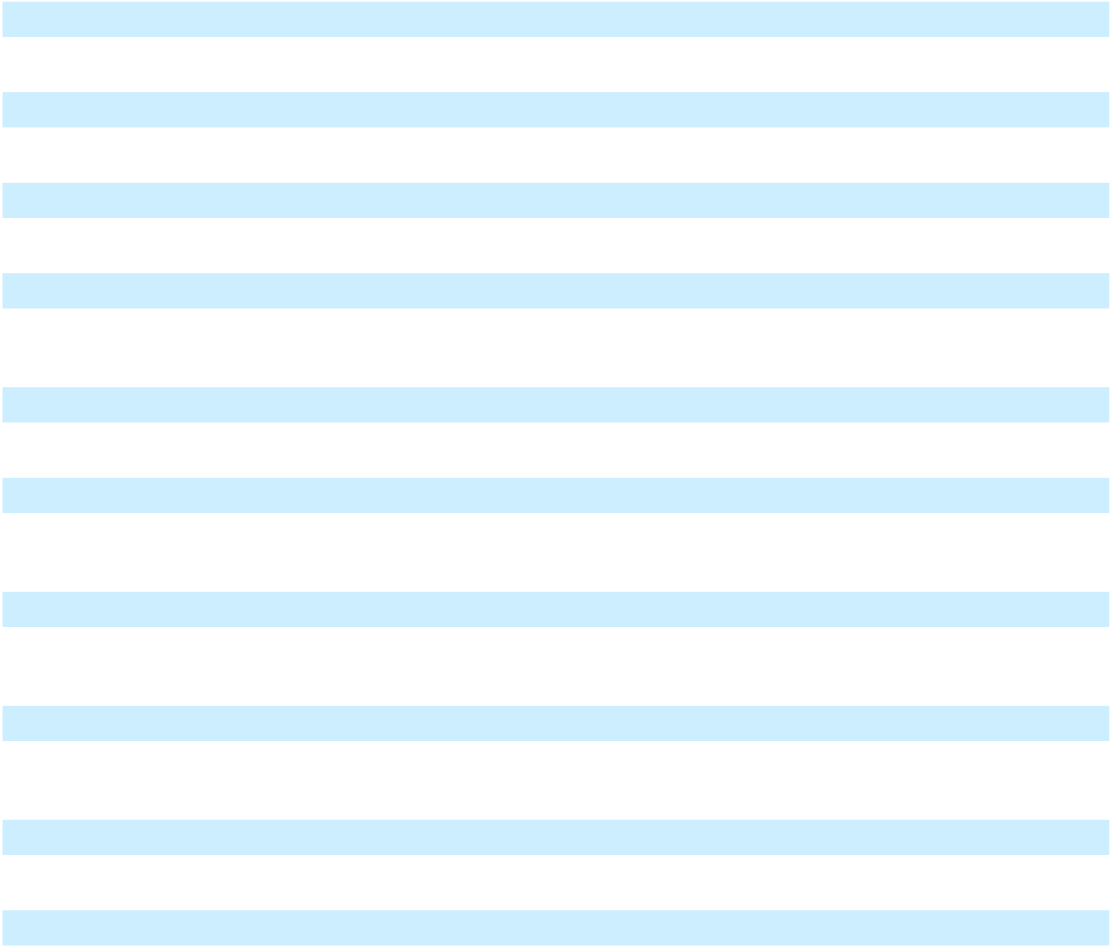

101

Table of Contents

10.6† |  | Indemnification Agreement (Guinta) (incorporated by reference to Exhibit 10.5 to the Registrant’s
 |  | Current Report on Form 8-K, filed with the SEC on February 5, 2019).
10.7† |  | Indemnification Agreement (Catterall) (incorporated by reference to Exhibit 10.7 to the Registrant’s
 |  | Current Report on Form 8-K, filed with the SEC on February 5, 2019).
10.8† |  | Indemnification Agreement (Grain) (incorporated by reference to Exhibit 10.8 to the Registrant’s Current
 |  | Report on Form 8-K, filed with the SEC on February 5, 2019).
10.9† |  | Indemnification Agreement (Griffin) (incorporated by reference to Exhibit 10.9 to the Registrant’s
 |  | Current Report on Form 8-K, filed with the SEC on February 5, 2019).
10.10† |  | Indemnification Agreement (Sledge) (incorporated by reference to Exhibit 10.16 to the Registrant’s
 |  | Quarterly Report on Form 10-Q, filed with the SEC on June 30, 2025).
10.11† |  | Indemnification Agreement (Nardone) (incorporated by reference to Exhibit 10.11 to the Registrant’s
 |  | Current Report on Form 8-K, filed with the SEC on February 5, 2019).
10.12† |  | Indemnification Agreement (Wanner) (incorporated by reference to Exhibit 10.12 to the Registrant’s
 |  | Current Report on Form 8-K, filed with the SEC on February 5, 2019).
10.13† |  | Indemnification Agreement (Jay) (incorporated by reference to Exhibit 10.15 to the Registrant’s
 |  | Quarterly Report on Form 10-Q, filed with the SEC on May 4, 2023).
10.14† |  | Indemnification Agreement, dated as of April 29, 2025, by and between New Fortress Energy LLC and
 |  | Michael Lowe (incorporated by reference to Exhibit 10.15 to the Registrant’s Quarterly Report on Form
 |  | 10-Q, filed with the SEC on June 30, 2025).
10.15† |  | Letter Agreement, dated as of March 14, 2017, by and between NFE Management LLC and Christopher
 |  | S. Guinta (incorporated by reference to Exhibit 10.17 to the Registrant’s Annual Report on Form 10-K,
 |  | filed with the SEC on March 1, 2023).
10.16 |  | Indenture, dated April 12, 2021, by and among the Company, an issuer, the subsidiary guarantors from
 |  | time to time party thereto, and U.S. Bank National Association, as trustee and as notes collateral agent
 |  | (incorporated by reference to Exhibit 4.1 to the Registrant’s Current Report on Form 8-K, filed with the
 |  | SEC on April 12, 2021).
10.17 |  | Pledge and Security Agreement, dated April 12, 2021, by and among the Company, the subsidiary
 |  | guarantors, from time to time party thereto, and U.S. Bank National Association, as notes collateral agent
 |  | (incorporated by reference to Exhibit 4.2 to the Registrant’s Current Report on Form 8-K, filed with the
 |  | SEC on April 12, 2021).
10.18 |  | First Supplemental Indenture, dated as of June 11, 2021, between Golar GP LLC (now known as NFE GP
 |  | LLC), as Guaranteeing Subsidiary, and U.S. Bank Trust Company, National Association (as successor in
 |  | interest to U.S. Bank National Association), as trustee (incorporated by reference to Exhibit 10.29 to the
 |  | Registrant’s Annual Report on Form 10-K, filed with the SEC on March 1, 2023).
10.19 |  | Second Supplemental Indenture, dated as of September 13, 2021, between NFE Mexico Power Holdings
 |  | Limited and NFE Mexico Terminal Holdings Limited, as Guaranteeing Subsidiaries, and U.S. Bank Trust
 |  | Company, National Association (as successor in interest to U.S. Bank National Association), as trustee
 |  | (incorporated by reference to Exhibit 10.30 to the Registrant’s Annual Report on Form 10-K, filed with
 |  | the SEC on March 1, 2023).


102

Table of Contents

10.20 | Third Supplemental Indenture, dated as of November 24, 2021, between NFE International Shipping
 | LLC, NFE Global Shipping LLC, NFE Grand Shipping LLC and NFE International Holdings Limited, as
 | Guaranteeing Subsidiaries, and U.S. Bank Trust Company, National Association (as successor in interest
 | to U.S. Bank National Association), as trustee (incorporated by reference to Exhibit 10.31 to the
 | Registrant’s Annual Report on Form 10-K, filed with the SEC on March 1, 2023).
10.21 | Fourth Supplemental Indenture, dated as of March 23, 2022, between NFE UK Holdings Limited, NFE
 | Global Holdings Limited and NFE Bermuda Holdings Limited, as Guaranteeing Subsidiaries, and U.S.
 | Bank Trust Company, National Association (as successor in interest to U.S. Bank National Association),
 | as trustee (incorporated by reference to Exhibit 10.32 to the Registrant’s Annual Report on Form 10-K,
 | filed with the SEC on March 1, 2023).
10.22 | Fifth Supplemental Indenture, dated as of December 22, 2022, between NFE Andromeda Chartering
 | LLC, as Guaranteeing Subsidiary, and U.S. Bank Trust Company, National Association (as successor in
 | interest to U.S. Bank National Association), as trustee (incorporated by reference to Exhibit 10.33 to the
 | Registrant’s Annual Report on Form 10-K, filed with the SEC on March 1, 2023).
10.23 | Sixth Supplemental Indenture, dated as of October 18, 2024, between NFE International Holdings 1
 | Limited and NFE International Holdings 1 Limited (each a “Guaranteeing Subsidiary”) as Guaranteeing
 | Subsidiaries and U.S. Bank Trust Company, National Association (as successor in interest to U.S. Bank
 | National Association). (incorporated by reference to Exhibit 10.24 to the Registrant’s Annual Report on
 | Form 10-K, filed with the SEC on March 10, 2025).
10.24 | Seventh Supplemental Indenture, dated as of December 6, 2024, between the various Guaranteeing
 | Subsidiaries party thereto and U.S. Bank Trust Company, National Association (as successor in interest to
 | U.S. Bank National Association), as trustee. (incorporated by reference to Exhibit 10.25 to the
 | Registrant’s Annual Report on Form 10-K, filed with the SEC on March 10, 2025).
10.25 | Credit Agreement, dated as of April 15, 2021, by and among the Company, as the borrower, the
 | guarantors from time to time party thereto, the several lenders and issuing banks from time to time party
 | thereto, and Morgan Stanley Senior Funding, Inc,. as administrative agent and collateral agent
 | (incorporated by reference to Exhibit 10.2 to the Registrant’s Current Report on Form 8-K, filed with the
 | SEC on April 21, 2021).
10.26 | First Amendment to Credit Agreement, dated as of July 16, 2021 to the Credit Agreement, dated as of
 | April 15, 2021, by and among the Company, as the borrower, the guarantors from time to time partly
 | thereto, the several lenders and issuing banks from time to time partly thereto, and Morgan Stanley Senior
 | Funding, Inc., as administrative agent (incorporated by reference to Exhibit 10.30 to the Registrant’s
 | Annual Report on Form 10-K, filed with the SEC on March 1, 2022).
10.27 | Second Amendment to Credit Agreement, dated as of February 28, 2022 to the Credit Agreement, dated
 | as of April 15, 2021, by and among the Company, as the borrower, the guarantors from time to time party
 | thereto, the several lenders and issuing banks from time to time party thereto, and Morgan Stanley Senior
 | Funding, Inc., as administrative agent and collateral agent (incorporated by reference to Exhibit 10.31 to
 | the Registrant’s Annual Report on Form 10-K, filed with the SEC on March 1, 2022).
10.28 | Third Amendment to Credit Agreement, dated as of May 4, 2022 to the Credit Agreement, dated as of
 | April 15, 2021, by and among the Company, as the borrower, the guarantors from time to time party
 | thereto, the several lenders and issuing banks from time to time party thereto, and Morgan Stanley Senior
 | Funding, Inc., as administrative agent and collateral agent (incorporated by reference to Exhibit 10.32 to
 | the Registrant’s Quarterly Report on Form 10-Q, filed with the SEC on May 6, 2022).
10.29 | Fourth Amendment to Credit Agreement, dated as of February 7, 2023 to the Credit Agreement, dated as
 | of April 15, 2021, by and among the Company, as the borrower, the guarantors from time to time party
 | thereto, the several lenders and issuing banks from time to time party thereto, and MUFG Bank Ltd., as
 | administrative agent and collateral agent (incorporated by reference to Exhibit 10.38 to the Registrant’s
 | Annual Report on Form 10-K, filed with the SEC on March 1, 2023).


103

Table of Contents

10.30 |  | Fifth Amendment to Credit Agreement, dated as of September 15, 2023 to the Credit Agreement, dated as
 |  | of April 15, 2021, by and among the Company, as the borrower, the guarantors from time to time party
 |  | thereto, the several lenders and issuing banks from time to time party thereto, and MUFG Bank Ltd., as
 |  | administrative agent and collateral agent (incorporated by reference to Exhibit 10.39 to the Registrant’s
 |  | Quarterly Report on Form 10-Q, filed with the SEC on November 9, 2023).
10.31 |  | Sixth Amendment to Credit Agreement, dated as of December 18, 2023 to the Credit Agreement, dated as
 |  | of April 15, 2021, by and among the Company, as the borrower, the guarantors from time to time party
 |  | thereto, the several lenders and issuing banks from time to time party thereto, and MUFG Bank Ltd., as
 |  | administrative agent and collateral agent (incorporated by reference to Exhibit 10.40 to the Registrant’s
 |  | Annual Report on Form 10-K, filed with the SEC on February 29, 2024).
10.32 |  | Seventh Amendment to Credit Agreement, dated as of May 3, 2024 to the Credit Agreement, dated as of
 |  | April 15, 2021, by and among the Company, as the borrower, the guarantors from time to time party
 |  | thereto, the several lenders and issuing banks from time to time party thereto, and MUFG Bank Ltd., as
 |  | administrative agent and collateral agent. (incorporated by reference to Exhibit 10.41 to the Registrant’s
 |  | Quarterly Report on Form 10-Q, filed with the SEC on August 9, 2024).
10.33 |  | Amended and Restated Eighth Amendment to Credit Agreement, dated as of September 30, 2024 to the
 |  | Credit Agreement, dated as of April 15, 2021, by and among the Company, as the borrower, the
 |  | guarantors from time to time party thereto, the several lenders and issuing banks from time to time party
 |  | thereto, and MUFG Bank Ltd., as administrative agent and collateral agent (incorporated by reference to
 |  | Exhibit 10.42 to the Registrant’s Quarterly Report on Form 10-Q, filed with the SEC on November 12,
 |  | 2024).
10.34 |  | Ninth Amendment to Credit Agreement, dated as of November 6, 2024 to the Credit Agreement, dated as
 |  | of April 15, 2021, by and among the Company, as the borrower, the guarantors from time to time party
 |  | thereto, the several lenders and issuing banks from time to time party thereto, and MUFG Bank Ltd., as
 |  | administrative agent and collateral agent. (incorporated by reference to Exhibit 10.35 to the Registrant’s
 |  | Annual Report on Form 10-K, filed with the SEC on March 10, 2025).
10.35 |  | Tenth Amendment to Credit Agreement, dated as of November 22, 2024 to the Credit agreement, dated as
 |  | of April 15, 2021, by and among the Company, as the borrower, the guarantors from time to time party
 |  | thereto, the several lenders and issuing banks from time to time party thereto, and MUFG Bank Ltd., as
 |  | administrative agent and collateral agent. (incorporated by reference to Exhibit 10.36 to the Registrant’s
 |  | Annual Report on Form 10-K, filed with the SEC on March 10, 2025).
10.36 |  | Eleventh Amendment to Credit Agreement, dated as of January 31, 2025 to the Credit agreement, dated
 |  | as of April 15, 2021, by and among the Company, as the borrower, the guarantors from time to time party
 |  | thereto, the several lenders and issuing banks from time to time party thereto, and MUFG Bank Ltd., as
 |  | administrative agent and collateral agent. (incorporated by reference to Exhibit 10.39 to the Registrant’s
 |  | Quarterly Report on Form 10-Q, filed with the SEC on June 30, 2025)
10.37 |  | Amended and Restated Eleventh Amendment to Credit Agreement, dated as of March 3, 2025 to the
 |  | Credit agreement, dated as of April 15, 2021, by and among the Company, as the borrower, the
 |  | guarantors from time to time party thereto, the several lenders and issuing banks from time to time party
 |  | thereto, and MUFG Bank Ltd., as administrative agent and collateral agent.(incorporated by reference to
 |  | Exhibit 10.40 to the Registrant’s Quarterly Report on Form 10-Q, filed with the SEC on June 30, 2025)
10.38 |  | Twelfth Amendment to Credit Agreement, dated as of May 12, 2025 to the Credit Agreement, dated as of
 |  | April 15, 2021, by and among the Company, as the borrower, the guarantors from time to time party
 |  | thereto, the several lenders and issuing banks from time to time party thereto, and MUFG Bank Ltd., as
 |  | administrative agent and collateral agent (incorporated by reference to Exhibit 10.37 to the Registrant’s
 |  | Quarterly Report on Form 10-Q, filed with the SEC on September 5, 2025).
10.39* |  | Thirteenth Amendment to Credit Agreement, dated as of November 20, 2025 to the Credit Agreement,
 |  | dated as of April 15, 2021, by and among the Company, as the borrower, the guarantors from time to time
 |  | party thereto, the several lenders and issuing banks from time to time party thereto, and MUFG Bank
 |  | Ltd., as administrative agent and collateral agent.


104

Table of Contents


10.40* |  | Fourteenth Amendment to Credit Agreement, dated as of December 17, 2025 to the Credit Agreement,
 |  | dated as of April 15, 2021, by and among the Company, as the borrower, the guarantors from time to time
 |  | party thereto, the several lenders and issuing banks from time to time party thereto, and MUFG Bank
 |  | Ltd., as administrative agent and collateral agent.
10.41* |  | Conformed through the Fourteenth Amendment to Credit Agreement, dated as of December 17, 2025 to
 |  | the Credit Agreement, dated as of April 15, 2021, by and among the Company, as the borrower, the
 |  | guarantors from time to time party thereto, the several lenders and issuing banks from time to time party
 |  | thereto, and MUFG Bank Ltd., as administrative agent and collateral agent.
10.42 |  | Equity Purchase and Contribution Agreement, dated as of July 2, 2022, by and among Golar LNG
 |  | Partners LP and Hygo Energy Transition Ltd., as Sellers, AP Neptune Holdings Ltd, as Purchaser,
 |  | Floating Infrastructure Holdings LLC, as the Company, and Floating Infrastructure Intermediate LLC, as
 |  | Holdco Pledgor, and Floating Infrastructure Holdings finance LLC, as Borrower, and New Fortress
 |  | Energy Inc.(incorporated by reference to Exhibit 10.39 to Registrant’s Quarterly Report on Form 10-Q,
 |  | filed with the SEC on August 5, 2022).
10.43 |  | Uncommitted Letter of Credit and Reimbursement Agreement, dated as of July 16, 2021, by and among
 |  | the Company, as borrower, each of the guarantors party thereto, the lenders and issuing banks party
 |  | thereto and Natixis, New York Branch, as administrative agent and as collateral agent. (incorporated by
 |  | reference to Exhibit 10.42 to Registrant’s Quarterly Report on Form 10-Q, filed with the SEC on June 30,
 |  | 2025).
10.44 |  | Second Amendment to Uncommitted Letter of Credit and Reimbursement Agreement, dated as of July
 |  | 27, 2022 to the Uncommitted Letter of Credit and Reimbursement Agreement, dated as of July 16, 2021,
 |  | by and among the Company, as borrower, each of the guarantors party thereto, the lenders and issuing
 |  | banks party thereto and Natixis, New York Branch, as administrative agent and as collateral agent.
 |  | (incorporated by reference to Exhibit 10.40 to Registrant’s Quarterly Report on Form 10-Q, filed with the
 |  | SEC on June 30, 2022)
10.45 |  | Incremental Joinder Agreement to Uncommitted Letter of Credit and Reimbursement Agreement, dated
 |  | February 6, 2023, by and among the Company, as the borrower each of the guarantors party thereto, the
 |  | lenders and issuing banks party thereto and Natixis, New York Branch, as administrative agent
 |  | (incorporated by reference to Exhibit 10.45 to the Registrant’s Annual Report on Form 10-K, filed with
 |  | the SEC on March 1, 2023).
10.46 |  | Incremental Joinder Agreement to Uncommitted Letter of Credit and Reimbursement Agreement, dated
 |  | November 2, 2023, by and among the Company, as borrower, each of the guarantors party thereto, the
 |  | lenders and issuing bank party thereto and Natixis, New York Branch, as administrative agent
 |  | (incorporated by reference to Exhibit 10.44 to the Registrant’s Annual Report on Form 10-K, filed with
 |  | the SEC on February 29, 2024).
10.47 |  | Third Amendment to Uncommitted Letter of Credit and Reimbursement Agreement, dated May 17, 2024,
 |  | to the Uncommitted Letter of Credit and Reimbursement Agreement, dated as of July 16, 2021, by and
 |  | among the Company, as borrower, each of the guarantors party thereto, the lenders and issuing banks
 |  | party thereto and Natixis, New York Branch, as administrative agent and as collateral agent (incorporated
 |  | by reference to Exhibit 10.46 to the Registrant’s Quarterly Report on Form 10-Q, filed with the SEC on
 |  | August 9, 2024).
10.48 |  | Fourth Amendment to Uncommitted Letter of Credit and Reimbursement Agreement, dated September
 |  | 30, 2024, to the Uncommitted Letter of Credit and Reimbursement Agreement, dated as of July 16, 2021,
by and among the Company, the guarantors party thereto, the lenders and issuing banks party thereto and Natixis, New York Branch, as administrative agent and as collateral agent (incorporated by reference to Exhibit 10.48 to the Registrant’s Quarterly Report on Form 10-Q, filed with the SEC on November 12, 2024).

105

Table of Contents

10.49 | Fifth Amendment to Uncommitted Letter of Credit and Reimbursement Agreement, dated November 6,
 | 2024 to the Uncommitted Letter of Credit and Reimbursement Agreement, dated as of July 16, 2021, by
 | and among the Company, the guarantors party thereto, the lenders and issuing banks party thereto and
 | Natixis, New York Branch, as administrative agent and as collateral agent. (incorporated by reference to
 | Exhibit 10.44 to the Registrant’s Annual Report on Form 10-K, filed with the SEC on March 10, 2025).
10.50 | Sixth Amendment to Uncommitted Letter of Credit and Reimbursement Agreement, dated November 22,
 | 2024 to the Uncommitted Letter of Credit and Reimbursement Agreement, dated as of July 16, 2021, by
 | and among the Company, the guarantors party thereto, the lenders and issuing banks party thereto and
 | Natixis, New York Branch, as administrative agent and as collateral agent. (incorporated by reference to
 | Exhibit 10.45 to the Registrant’s Annual Report on Form 10-K, filed with the SEC on March 10, 2025).
10.51 | Seventh Amendment to Uncommitted Letter of Credit and Reimbursement Agreement, dated January 31,
 | 2025 to the Uncommitted Letter of Credit and Reimbursement Agreement, dated as of July 16, 2021, by
 | and among the Company, the guarantors party thereto, the lenders and issuing banks party thereto and
 | Natixis, New York Branch, as administrative agent and as collateral agent. (incorporated by reference to
 | Exhibit 10.50 to the Registrant’s Quarterly Report on Form 10-Q, filed with the SEC on June 30, 2025)
10.52 | Amended and Restated Seventh Amendment to Uncommitted Letter of Credit and Reimbursement
 | Agreement, dated March 3, 2025 to the Uncommitted Letter of Credit and Reimbursement Agreement,
 | dated as of July 16, 2021, by and among the Company, the guarantors party thereto, the lenders and
 | issuing banks party thereto and Natixis, New York Branch, as administrative agent and as collateral
 | agent. (incorporated by reference to Exhibit 10.51 to the Registrant’s Quarterly Report on Form 10-Q,
 | filed with the SEC on June 30, 2025)
10.53 | Eighth Amendment to Uncommitted Letter of Credit and Reimbursement Agreement, dated May 12,
 | 2025 to the Uncommitted Letter of Credit and Reimbursement Agreement, dated as of July 16, 2021, by
 | and among the Company, the guarantors party thereto, the lenders and issuing banks party thereto and
 | Natixis, New York Branch, as administrative agent and as collateral agent (incorporated by reference to
 | Exhibit 10.52 to the Registrant’s Quarterly Report on Form 10-Q, filed with the SEC on September 5,
 | 2025).
10.54 | Deferral Agreement, dated as of July 2, 2025, by and among the Company, each of the Guarantors as of
 | the date hereof, and certain financial institutions party to the Uncommitted Letter of Credit and
 | Reimbursement Agreement, dated as of July 16, 2021 as lenders and signatory hereto (incorporated by
 | reference to Exhibit 10.54 to the Registrant’s Quarterly Report on Form 10-Q, filed with the SEC on
 | November 21, 2025).
10.55 | Second Deferral Agreement, dated as of July 17, 2025, by and among the Company, each of the
 | Guarantors as of the date hereof, and certain financial institutions party to the Uncommitted Letter of
 | Credit and Reimbursement Agreement, dated as of July 16, 2021 as lenders and signatory hereto
 | (incorporated by reference to Exhibit 10.55 to the Registrant’s Quarterly Report on Form 10-Q, filed with
 | the SEC on November 21, 2025).
10.56 | July Extension Agreement, dated as of July 24, 2025, by and among the Company, each of the Guarantors
 | as of the date hereof, and each of the financial institutions party to the Uncommitted Letter of Credit and
 | Reimbursement Agreement, dated as of July 16, 2021 as lenders and issuing banks (incorporated by
 | reference to Exhibit 10.56 to the Registrant’s Quarterly Report on Form 10-Q, filed with the SEC on
 | November 21, 2025).
10.57 | Second Extension Agreement, dated as of July 31, 2025, by and among the Company, each of the
 | Guarantors as of the date hereof, and each of the financial institutions party to the Uncommitted Letter of
 | Credit and Reimbursement Agreement, dated as of July 16, 2021 as lenders and issuing banks

(incorporated by reference to Exhibit 10.57 to the Registrant’s Quarterly Report on Form 10-Q, filed with the SEC on November 21, 2025).

106

Table of Contents

10.58 |  | Ninth Amendment to Uncommitted Letter of Credit and Reimbursement Agreement, dated August 8,
 |  | 2025 to the Uncommitted Letter of Credit and Reimbursement Agreement, dated as of July 16, 2021, by
 |  | and among the Company, the guarantors party thereto, the lenders and issuing banks party thereto and
 |  | Natixis, New York Branch, as administrative agent and as collateral agent (incorporated by reference to
 |  | Exhibit 10.58 to the Registrant’s Quarterly Report on Form 10-Q, filed with the SEC on November 21,
 |  | 2025).
10.59 |  | Deferral Agreement, dated as of September 30, 2025, by and among the Company, each of the
 |  | Guarantors as of the date hereof, Natixis, New York Branch, as an issuing bank, and certain financial
 |  | institutions party to the Uncommitted Letter of Credit and Reimbursement Agreement, dated as of July
 |  | 16, 2021 as lenders and signatory hereto (incorporated by reference to Exhibit 10.59 to the Registrant’s
 |  | Quarterly Report on Form 10-Q, filed with the SEC on November 21, 2025).
10.60* |  | Tenth Amendment to Uncommitted Letter of Credit and Reimbursement Agreement, dated as of October
 |  | 24, 2025 to the Uncommitted Letter of Credit and Reimbursement Agreement, dated as of July 16, 2021,
 |  | by and among the Company, the guarantors party thereto, HSBC Bank USD, N.A., as an issuing bank,
 |  | and each of the financial institutions party thereto as lenders.
10.61* |  | Eleventh Amendment to Uncommitted Letter of Credit and Reimbursement Agreement, dated November
 |  | 14, 2025 to the Uncommitted Letter of Credit and Reimbursement Agreement, dated as of July 16, 2021,
 |  | by and among the Company, the guarantors party thereto, the lenders and issuing banks party thereto and
 |  | Natixis, New York Branch, as administrative agent and as collateral agent.
10.62* |  | Twelfth Amendment to Uncommitted Letter of Credit and Reimbursement Agreement, dated December
 |  | 11, 2025 to the Uncommitted Letter of Credit and Reimbursement Agreement, dated as of July 16, 2021,
 |  | by and among the Company, the guarantors party thereto, the lenders and issuing banks party thereto and
 |  | Natixis, New York Branch, as administrative agent and as collateral agent.
10.63* |  | Thirteenth Amendment to Uncommitted Letter of Credit and Reimbursement Agreement, dated
 |  | December 17, 2025 to the Uncommitted Letter of Credit and Reimbursement Agreement, dated as of July
 |  | 16, 2021, by and among the Company, the guarantors party thereto, the lenders and issuing banks party
 |  | thereto and Natixis, New York Branch, as administrative agent and as collateral agent.
10.64* |  | Conformed through the Thirteenth Amendment Agreement, dated December 17, 2025, by and among the
 |  | Company, the guarantors party thereto, the lenders and issuing banks party thereto and Natixis, New
 |  | York Branch, as administrative agent and as collateral agent.
10.65 |  | Credit Agreement, dated as of October 30, 2023, by and among the Company, as the borrower, the
 |  | guarantors from time to time party thereto, the several lenders from time to time party thereto, and
 |  | Morgan Stanley Senior Funding Inc., as administrative agent and collateral agent (incorporated by
 |  | reference to Exhibit 10.45 to the Registrant’s Annual Report on Form 10-K, filed with the SEC on
 |  | February 29, 2024).
10.66 |  | Second Amendment, dated March 3, 2025, to Credit Agreement, dated as of October 30, 2023, by and
 |  | among the Company, as the borrower, the guarantors from time to time party thereto, the several lenders
 |  | from time to time party thereto, and Morgan Stanley Senior Funding Inc., as administrative agent and
 |  | collateral agent. (incorporated by reference to Exhibit 10.53 to the Registrant’s Quarterly Report on Form
 |  | 10-Q, filed with the SEC on June 30, 2025)
10.67* |  | Forbearance Agreement, dated December 17, 2025, by and among the Company, as the borrower, the
 |  | guarantors, the lenders party hereto and Morgan Stanley Senior Funding Inc., as the administrative agent
 |  | and collateral agent under the Credit Agreement, dated as of October 30, 2023.
10.68 |  | Indenture, dated March 8, 2024, by and among New Fortress Energy Inc., the subsidiary guarantors from
 |  | time to time party thereto, and U.S. Bank Trust Company, National Association, as trustee and as notes
 |  | collateral agent (incorporated by reference to Exhibit 4.1 to the Registrant’s Current Report on Form 8-K,
 |  | filed with the SEC on March 8, 2024).


107

Table of Contents

10.69 |  | First Supplemental Indenture, dated as of October 18, 2024, between NFE International Holdings 1
 |  | Limited and NFE International Holdings 2 Limited, as Guaranteeing Subsidiaries, and U.S. Bank Trust
 |  | Company, National Association, as trustee. (incorporated by reference to Exhibit 10.48 to the Registrant’s
 |  | Annual Report on Form 10-K, filed with the SEC on March 10, 2025).
10.70 |  | Second Supplemental Indenture, dated as of December 6, 2024, by and among the Company, as issuer, by
 |  | and among New Fortress Energy Inc., as issuer, the guarantors party thereto and U.S. Bank Trust
 |  | Company, National Association, as trustee. (incorporated by reference to Exhibit 10.49 to the Registrant’s
 |  | Annual Report on Form 10-K, filed with the SEC on March 10, 2025).
10.71 |  | Pledge and Security Agreement, dated March 8, 2024, by and among the Company, the subsidiary
 |  | guarantors, from time to time party thereto, and U.S. Bank Trust Company, National Association, as
 |  | notes collateral agent (incorporated by reference to Exhibit 4.2 to the Registrant’s Current Report on
 |  | Form 8-K, filed with the SEC on March 8, 2024).
10.72 |  | Credit Agreement, dated as of July 19, 2024, by and among the Company, as the borrower, the guarantors
 |  | from time to time party thereto, the several lenders from time to time party thereto, and Morgan Stanley
 |  | Senior Funding Inc., as administrative agent and collateral agent. (incorporated by reference to Exhibit
 |  | 10.50 to the Registrant’s Quarterly Report on Form 10-Q, filed with the SEC on August 9, 2024).
10.73 |  | Amended and Restated First Amendment to Credit Agreement, dated as of September 30, 2024, by and
 |  | among the Company, as the borrower, the guarantors from time to time party thereto, the several lenders
 |  | from time to time party thereto, and Morgan Stanley Senior Funding Inc., as administrative agent and
 |  | collateral agent. (incorporated by reference to Exhibit 10.52 to the Registrant’s Annual Report on Form
 |  | 10-K, filed with the SEC on March 10, 2025).
10.74 |  | Second Amendment to Credit Agreement, dated as of November 14, 2024, by and among the Company,
 |  | as the borrower, the guarantors from time to time party thereto, the several lenders from time to time
 |  | party thereto, and Morgan Stanley Senior Funding Inc., as administrative agent and collateral agent.
 |  | (incorporated by reference to Exhibit 10.53 to the Registrant’s Annual Report on Form 10-K, filed with
 |  | the SEC on March 10, 2025).
10.75 |  | Third Amendment to Credit Agreement, dated as of November 22, 2024, by and among the Company, as
 |  | the borrower, the guarantors from time to time party thereto, the several lenders from time to time party
 |  | thereto, and Morgan Stanley Senior Funding Inc., as administrative agent and collateral agent.
 |  | (incorporated by reference to Exhibit 10.54 to the Registrant’s Annual Report on Form 10-K, filed with
 |  | the SEC on March 10, 2025).
10.76 |  | Fourth Amendment to Credit Agreement, dated as of March 3, 2025, by and among the Company, as the
 |  | borrower, the guarantors from time to time party thereto, the several lenders from time to time party
 |  | thereto, and Morgan Stanley Senior Funding Inc., as administrative agent and collateral agent.
 |  | (incorporated by reference to Exhibit 10.62 to the Registrant’s Quarterly Report on Form 10-Q, filed with
 |  | the SEC on June 30, 2025)
10.77 |  | Fifth Amendment to Credit Agreement, dated as of May 12, 2025, by and among the Company, as the
 |  | borrower, the guarantors from time to time party thereto, the several lenders from time to time party
 |  | thereto, and Morgan Stanley Senior Funding Inc., as administrative agent and collateral agent
 |  | (incorporated by reference to Exhibit 10.65 to the Registrant’s Quarterly Report on Form 10-Q, filed with
 |  | the SEC on September 5, 2025).
10.78* |  | Sixth Amendment to Credit Agreement, dated as of November 20, 2025, by and among the Company, as
 |  | the borrower, the guarantors from time to time party thereto, the several lenders from time to time party
 |  | thereto, and Morgan Stanley Senior Funding Inc., as administrative agent and collateral agent.
10.79* |  | Seventh Amendment to Credit Agreement, dated as of December 17, 2025, by and among the Company,
 |  | as the borrower, the guarantors from time to time party thereto, the several lenders from time to time
 |  | party thereto, and Morgan Stanley Senior Funding Inc., as administrative agent and collateral agent.


108

Table of Contents

10.80* |  |  | Conformed through the Seventh Amendment to Credit Agreement, dated as of December 17, 2025, by
 |  |  | and among the Company, as the borrower, the guarantors from time to time party thereto, the several
 |  |  | lenders from time to time party thereto, and Morgan Stanley Senior Funding Inc., as administrative agent
 |  |  | and collateral agent.
10.81* |  |  | Forbearance Agreement, dated December 17, 2025, by and among the Company, as the borrower, the
 |  |  | guarantors, the lenders party hereto and Morgan Stanley Senior Funding Inc., as the administrative agent
 |  |  | and collateral agent under the Credit Agreement, dated as of July 19, 2024.
10.82 |  |  | Series I Credit Agreement, dated as of November 22, 2024, among the Company, as the borrower, the
 |  |  | guarantors from time to time party thereto, the lenders from time to time party thereto and Wilmington
 |  |  | Savings Fund Society, FSB, as administrative agent and collateral agent. (incorporated by reference to
 |  |  | Exhibit 10.55 to the Registrant’s Annual Report on Form 10-K, filed with the SEC on March 10, 2025).
10.83 |  |  | Credit Agreement, dated as of November 22, 2024, among NFE Brazil Investments LLC, as the
 |  |  | borrower, NFE Financing LLC, as lender, the lenders from time to time party thereto and Wilmington
 |  |  | Savings Fund Society, FSB, as administrative agent and collateral agent. (incorporated by reference to
 |  |  | Exhibit 10.56 to the Registrant’s Annual Report on Form 10-K, filed with the SEC on March 10, 2025).
10.84 |  |  | Series II Credit Agreement, dated as of December 6, 2024, among the Company, as the borrower, the
 |  |  | guarantors from time to time party thereto, the lenders from time to time party thereto and Wilmington
 |  |  | Savings Fund Society, FSB, as administrative agent and collateral agent. (incorporated by reference to
 |  |  | Exhibit 10.57 to the Registrant’s Annual Report on Form 10-K, filed with the SEC on March 10, 2025).
10.85 |  |  | Indenture, dated November 22, 2024, by and among NFE Financing LLC, as issuer, the guarantors from
 |  |  | time to time party thereto, and Wilmington Savings Fund Society, FSB, as trustee. (incorporated by
 |  |  | reference to Exhibit 10.63 to the Registrant’s Annual Report on Form 10-K, filed with the SEC on March
 |  |  | 10, 2025).
10.86 |  |  | Registration Rights and Lock-up Agreement, dated as of December 6, 2024 by and among the Company
 |  |  | and the undersigned investors. (incorporated by reference to Exhibit 10.64 to the Registrant’s Annual
 |  |  | Report on Form 10-K, filed with the SEC on March 10, 2025).
10.87 |  |  | First Amendment to Registration Rights and Lock-up Agreement, dated as of January 8, 2025, by and
 |  |  | among the Company and the undersigned investors. (incorporated by reference to Exhibit 10.65 to the
 |  |  | Registrant’s Annual Report on Form 10-K, filed with the SEC on March 10, 2025).
10.88 |  |  | Second Amendment to Registration Rights and Lock-up Agreement, dated as of February 4, 2025, by and
 |  |  | among the Company and the undersigned investors. (incorporated by reference to Exhibit 10.66 to the
 |  |  | Registrant’s Annual Report on Form 10-K, filed with the SEC on March 10, 2025).
10.89* |  |  | Forbearance and Waiver Agreement, dated as of November 17, 2025, by and among NFE Financing
 |  |  | LLC, as the issuer, NFE Brazil Investments LLC, as the Brazil Parent, Bradford County Real Estate
 |  |  | Partners LLC, as a guarantor under and as defined in the 2029 Senior Notes Indenture, the undersigned
 |  |  | Holders of NFE Financing’s 12.000% Senior Secured Notes due 2029, acknowledged by Wilmington
 |  |  | Savings Fund Society, in its capacity as Trustee and Notes Collateral Agent under the 2029 Senior Notes
 |  |  | Indenture and its capacity as administrative agent and collateral agent under the Brazil Parent
 |  |  | Intercompany Credit Agreement, the Series II Intercompany Credit Agreement, and the Series I
 |  |  | Intercompany Credit Agreement, acknowledged and agreed by the Company.
10.90 |  |  | Form of New Fortress Energy Inc. Retention Agreement, dated as of [ ], 2025, is by and between New
 |  |  | Fortress Energy Inc., a Delaware corporation, and [ ] (the “Grantee”). (incorporated by reference to
 |  |  | Exhibit 10.85 to the Registrant’s Quarterly Report on Form 10-Q, filed with the SEC on November 21,
 |  |  | 2025).
19.1 |  |  | New Fortress Energy Inc. Firmwide Insider Trading Policy (incorporated by reference to Exhibit 19.1 to
 |  |  | the Registrant’s Annual Report on Form 10-K, filed with the SEC on March 10, 2025).
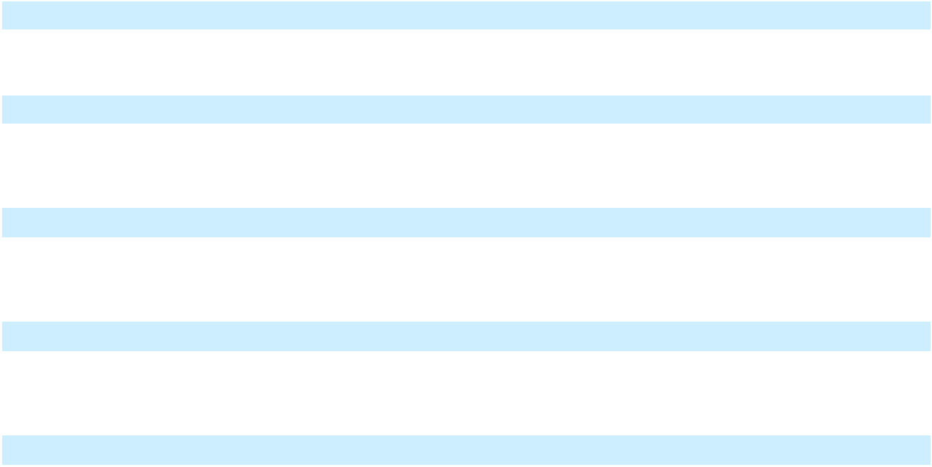
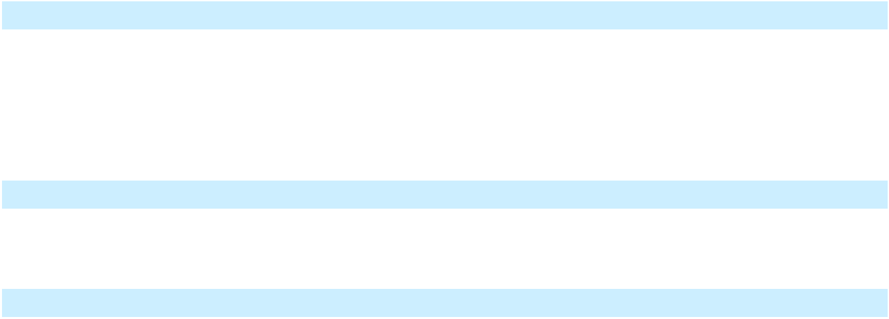

109

Table of Contents

21.1* |  |  |  | List of Subsidiaries of New Fortress Energy Inc.
23.1* |  |  |  | Consent of Ernst & Young LLP, independent registered public accounting firm.
31.1* |  |  |  | Certification by Chief Executive Officer pursuant to Rules 13a-14(a) and 15d-14(a) of the Exchange Act,
 |  |  |  | as adopted pursuant to Section 302 of the Sarbanes-Oxley Act of 2002.
31.2* |  |  |  | Certification by Chief Financial Officer pursuant to Rules 13a-14(a) and 15d-14(a) of the Exchange Act,
 |  |  |  | as adopted pursuant to Section 302 of the Sarbanes-Oxley Act of 2002.
32.1** |  |  |  | Certifications by Chief Executive Officer pursuant to Title 18 U.S.C. Section 1350, as adopted pursuant
 |  |  |  | to Section 906 of the Sarbanes-Oxley Act of 2002.
32.2** |  |  |  | Certifications by Chief Financial Officer pursuant to Title 18 U.S.C. Section 1350, as adopted pursuant to
 |  |  |  | Section 906 of the Sarbanes-Oxley Act of 2002.
97.1 |  |  |  | Clawback Policy of the Company, effective as of December 1, 2023 (incorporated by reference from
 |  |  |  | exhibit 97.1 to the Form 10-K dated February 29, 2024)
101.INS* |  |  |  | Inline XBRL Instance Document
101.SCH* |  |  |  | Inline XBRL Schema Document
101.CAL* |  |  |  | Inline XBRL Calculation Linkbase Document
101.LAB* |  |  |  | Inline XBRL Label Linkbase Document
101.PRE* |  |  |  | Inline XBRL Presentation Linkbase Document
101.DEF* |  |  |  | Inline XBRL Taxonomy Extension Definition Linkbase Document
104* |  |  |  | Cover Page Interactive Data File, formatted in Inline XBRL and contained in Exhibit 101

* Filed as an exhibit to this Annual Report

- Furnished as an exhibit to this Annual Report

† Compensatory plan or arrangement

110

Table of Contents

Item 16. Form 10-K Summary.

None.

111

Table of Contents

SIGNATURES

Pursuant to the requirements of 13 or 15(d) of the Securities Exchange Act of 1934, the registrant has duly caused this report to be signed on its behalf by the undersigned, thereunto duly authorized.

NEW FORTRESS ENERGY INC.

Date: April 13, 2026

By: | /s/ Christopher Guinta
Name: | Christopher S. Guinta
Title: | Chief Financial Officer

Pursuant to the requirements of the Securities Exchange Act of 1934, this report has been signed below by the following persons on behalf of the registrant in the capacities and on the dates indicated.

Name |  | Title |  | Date
/s/ Wesley R. Edens |  | Chief Executive Officer and Chairman |  | April 13, 2026
 |  | (Principal Executive Officer)
Wesley R. Edens |  | (Principal Executive Officer)
/s/ Christopher S. Guinta |  | Chief Financial Officer |  | April 13, 2026
 |  | (Principal Financial Officer)
Christopher S. Guinta |  | (Principal Financial Officer)
/s/ Michael T. Lowe |  | Chief Accounting Officer |  | April 13, 2026
 |  | (Principal Accounting Officer)
Michael T. Lowe |  | (Principal Accounting Officer)
/s/ Randal A. Nardone |  | Director |  | April 13, 2026
Randal A. Nardone
/s/ C. William Griffin |  | Director |  | April 13, 2026
C. William Griffin
/s/ Charles M. Sledge |  | Director |  | April 13, 2026
Charles M. Sledge
/s/ Timothy W. Jay |  | Director |  | April 13, 2026
Timothy W. Jay
/s/ David J. Grain |  | Director |  | April 13, 2026
David J. Grain
/s/ Desmond Iain Catterall |  | Director |  | April 13, 2026
Desmond Iain Catterall
/s/ Katherine E. Wanner |  | Director |  | April 13, 2026
Katherine E. Wanner

112

Table of
 |  | Contents
Index to Consolidated Financial Statements
 |  |  |  |  |  |  |  |  |  | Page
 | Report of Independent Registered Public Accounting Firm (PCAOB ID: #42) |  |  |  |  |  |  |  |  | F-2
 | Consolidated Balance Sheets |  |  |  |  |  |  |  |  | F-6
 | Consolidated Statements of Operations and Comprehensive (Loss) Income |  |  |  |  |  |  |  |  | F-7
 | Consolidated Statements of Changes in Stockholders’ Equity |  |  |  |  |  |  |  |  | F-8
 | Consolidated Statements of Cash Flows |  |  |  |  |  |  |  |  | F-9
 | Notes to Consolidated Financial Statements |  |  |  |  |  |  |  |  | F-11
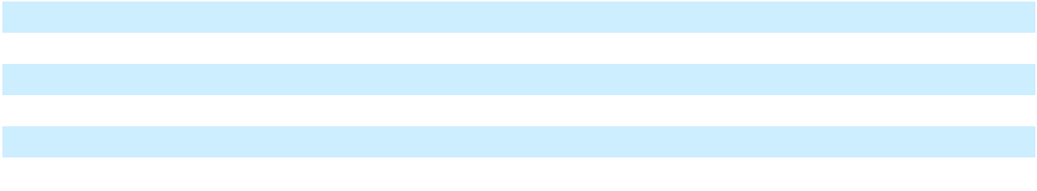

F-1

Table of Contents

Report of Independent Registered Public Accounting Firm

To the Stockholders and the Board of Directors of New Fortress Energy Inc.

Opinion on the Financial Statements

We have audited the accompanying consolidated balance sheets of New Fortress Energy Inc. (the Company) as of December 31, 2025 and 2024, the related consolidated statements of operations and comprehensive (loss) income, changes in stockholders’ equity and cash flows for each of the three years in the period ended December 31, 2025, and the related notes and financial statement schedule listed in the Index at Item 15(2) (collectively referred to as the “consolidated financial statements”). In our opinion, the consolidated financial statements present fairly, in all material respects, the financial position of the Company at December 31, 2025 and 2024, and the results of its operations and its cash flows for each of the three years in the period ended December 31, 2025, in conformity with U.S. generally accepted accounting principles.

We also have audited, in accordance with the standards of the Public Company Accounting Oversight Board (United States) (PCAOB), the Company's internal control over financial reporting as of December 31, 2025, based on criteria established in Internal Control—Integrated Framework issued by the Committee of Sponsoring Organizations of the Treadway Commission (2013 framework), and our report dated April 13, 2026 expressed an adverse opinion thereon.

The Company’s Ability to Continue as a Going Concern

The accompanying consolidated financial statements have been prepared assuming that the Company will continue as a going concern. As discussed in Note 3 to the financial statements, the Company has suffered losses from operations, has experienced events of default under its debt agreements, and has stated that substantial doubt exists about the Company’s ability to continue as a going concern. Management’s evaluation of the events and conditions and management’s plans regarding these matters are also described in Note 3. The consolidated financial statements do not include any adjustments that might result from the outcome of this uncertainty.

Restatement of 2024 and 2023 Financial Statements

As discussed in Note 1 to the consolidated financial statements, the 2024 and 2023 consolidated financial statements have been restated to correct misstatements.

Basis for Opinion

These financial statements are the responsibility of the Company's management. Our responsibility is to express an opinion on the Company’s financial statements based on our audits. We are a public accounting firm registered with the PCAOB and are required to be independent with respect to the Company in accordance with the U.S. federal securities laws and the applicable rules and regulations of the Securities and Exchange Commission and the PCAOB.

We conducted our audits in accordance with the standards of the PCAOB. Those standards require that we plan and perform the audit to obtain reasonable assurance about whether the financial statements are free of material misstatement, whether due to error or fraud. Our audits included performing procedures to assess the risks of material misstatement of the financial statements, whether due to error or fraud, and performing procedures that respond to those risks. Such procedures included examining, on a test basis, evidence regarding the amounts and disclosures in the financial statements. Our audits also included evaluating the accounting principles used and significant estimates made by management, as well as evaluating the overall presentation of the financial statements. We believe that our audits provide a reasonable basis for our opinion.

Critical Audit Matter

The critical audit matter communicated below is a matter arising from the current period audit of the financial statements that was communicated or required to be communicated to the audit committee and that: (1) relates to accounts or disclosures that are material to the financial statements and (2) involved our especially challenging, subjective or complex judgments. The communication of the critical audit matter does not alter in any way our opinion on the consolidated financial statements, taken as a whole, and we are not, by communicating the critical audit matter below, providing a separate opinion on the critical audit matter or on the accounts or disclosures to which it relates.

F-2

Table of Contents

Impairment of Construction in Progress

Description of the As described in Note 4, the Company performs a recoverability assessment for all long-lived

Matter assets, including construction in progress for development projects, whenever events or changes in circumstances indicate that the carrying value of those assets may not be recoverable. When the carrying value of an asset exceeds the undiscounted expected future cash flows, an impairment loss is recognized equal to the excess of the asset’s carrying value over its fair value.

As described in Note 17 to the consolidated financial statements, the Company identified an impairment indicator of goodwill following the significant decrease in its stock price, which similarly represented an indicator of impairment for the Company’s long-lived assets. This resulted in the Company performing a recoverability test of the long-lived assets within the asset groups comprising the reporting unit prior to the completion of the goodwill impairment test. During the year ended December 31, 2025, the Company determined that construction in progress asset groups for specific development projects were not recoverable and recognized an impairment loss of approximately $861 million, which represented the amount by which the carrying value exceeded the estimated fair value of these asset groups.

Auditing the measurement of the impairment loss was highly subjective due to the significant judgment in identifying the appropriate valuation techniques, evaluating assumptions underlying the highest and best use of the asset groups, and determining indicative market transactions utilized to estimate the fair value of the construction in progress asset groups.

How We Addressed To test the Company’s measurement of the impairment loss, our audit procedures included, among

the Matter in Our other things, evaluating the Company’s valuation methodologies, the completeness and accuracy

Audit of the key inputs, including comparable sales transactions, and significant assumptions utilized to arrive at the estimated fair value of the asset groups subject to impairment. We involved valuation specialists who assisted in evaluating the valuation methodologies, key assumptions and inputs used to measure the asset groups at fair value. For certain of the Company’s development projects, we also made inquiries of the project contractor to understand the alternate use and markets to support the estimated fair value of the asset group. We compared the cost basis of each asset group which was not recoverable to its respective fair values and recalculated the impairment loss. The nature and extent of our audit procedures over the measurement of the impairment loss considered the material weaknesses identified.

We have served as the Company’s auditor since 2016.

/s/ Ernst & Young LLP

Philadelphia, Pennsylvania

April 13, 2026

F-3

Table of Contents

Report of Independent Registered Public Accounting Firm

To the Stockholders and the Board of Directors of New Fortress Energy Inc.

Opinion on Internal Control Over Financial Reporting

We have audited New Fortress Energy Inc.’s internal control over financial reporting as of December 31, 2025, based on criteria established in Internal Control—Integrated Framework issued by the Committee of Sponsoring Organizations of the Treadway Commission (2013 framework) (the COSO criteria). In our opinion, because of the effect of the material weaknesses described below on the achievement of the objectives of the control criteria, New Fortress Energy Inc. (the Company) has not maintained effective internal control over financial reporting as of December 31, 2025, based on the COSO criteria.

A material weakness is a deficiency, or combination of deficiencies, in internal control over financial reporting, such that there is a reasonable possibility that a material misstatement of the company’s annual or interim financial statements will not be prevented or detected on a timely basis. The following material weaknesses have been identified and included in management’s assessment. Management has identified pervasive material weaknesses throughout the Company’s internal control processes that involve the control environment, control activities, and information and communication components of the COSO framework, and additional material weaknesses related to: (i) insufficient resources with appropriate knowledge and experience commensurate with the Company’s financial reporting requirements; (ii) controls associated with the communication of non-compliance with the non-financial covenants of its debt instruments; (iii) accounting for income taxes; (iv) the statement of cash flows; and (v) information technology general controls.

We also have audited, in accordance with the standards of the Public Company Accounting Oversight Board (United States) (PCAOB), the consolidated balance sheets of the Company as of December 31, 2025 and 2024, the related consolidated statements of operations and comprehensive (loss) income, and changes in stockholders’ equity and cash flows for each of the three years in the period ended December 31, 2025, and the related notes. These material weaknesses were considered in determining the nature, timing and extent of audit tests applied in our audit of the 2025 consolidated financial statements, and this report does not affect our report dated April 13, 2026, which expressed an unqualified opinion thereon that included an explanatory paragraph regarding the Company’s ability to continue as a going concern.

Basis for Opinion

The Company’s management is responsible for maintaining effective internal control over financial reporting and for its assessment of the effectiveness of internal control over financial reporting included in the accompanying Management’s Report on Internal Control Over Financial Reporting. Our responsibility is to express an opinion on the Company’s internal control over financial reporting based on our audit. We are a public accounting firm registered with the PCAOB and are required to be independent with respect to the Company in accordance with the U.S. federal securities laws and the applicable rules and regulations of the Securities and Exchange Commission and the PCAOB.

We conducted our audit in accordance with the standards of the PCAOB. Those standards require that we plan and perform the audit to obtain reasonable assurance about whether effective internal control over financial reporting was maintained in all material respects.

Our audit included obtaining an understanding of internal control over financial reporting, assessing the risk that a material weakness exists, testing and evaluating the design and operating effectiveness of internal control based on the assessed risk, and performing such other procedures as we considered necessary in the circumstances. We believe that our audit provides a reasonable basis for our opinion.

Definition and Limitations of Internal Control Over Financial Reporting

A company’s internal control over financial reporting is a process designed to provide reasonable assurance regarding the reliability of financial reporting and the preparation of financial statements for external purposes in accordance with generally accepted accounting principles. A company’s internal control over financial reporting includes those policies and procedures that (1) pertain to the maintenance of records that, in reasonable detail, accurately and fairly reflect the transactions and dispositions of the assets of the company; (2) provide reasonable assurance that transactions are recorded as necessary to permit preparation of financial statements in accordance with generally accepted accounting principles, and that receipts and expenditures of the company are being made only in accordance with authorizations of management and

F-4

Table of Contents

directors of the company; and (3) provide reasonable assurance regarding prevention or timely detection of unauthorized acquisition, use, or disposition of the company’s assets that could have a material effect on the financial statements.

Because of its inherent limitations, internal control over financial reporting may not prevent or detect misstatements. Also, projections of any evaluation of effectiveness to future periods are subject to the risk that controls may become inadequate because of changes in conditions, or that the degree of compliance with the policies or procedures may deteriorate.

/s/ Ernst & Young LLP

Philadelphia, Pennsylvania

April 13, 2026

F-5

Table of Contents

PART I

FINANCIAL INFORMATION

Item 8. Financial Statements

New Fortress Energy Inc.

Consolidated Balance Sheets

As of December 31, 2025 and 2024

(in thousands of U.S. dollars, except share and per share amounts)

 |  | December 31, |  |  | December 31,
 |  | December 31, |  |  | 2024
 |  | 2025 |  |  | (As Restated)
Assets
Current assets
Cash and cash equivalents | $ | 226,453 | $ |  | 492,881
Restricted cash |  | 130,489 |  |  | 472,696
Receivables, net of allowances of $17,800 and $15,651, respectively |  | 451,962 |  |  | 331,419
Inventory |  | 119,447 |  |  | 103,224
Prepaid expenses and other current assets, net |  | 400,347 |  |  | 212,340
Total current assets |  | 1,328,698 |  |  | 1,612,560
Construction in progress |  | 3,593,971 |  |  | 3,526,984
Property, plant and equipment, net |  | 4,892,737 |  |  | 5,928,919
Right-of-use assets |  | 411,817 |  |  | 618,733
Intangible assets, net |  | 187,596 |  |  | 179,510
Goodwill |  | — |  |  | 782,730
Deferred tax assets, net |  | — |  |  | 3,324
Other non-current assets, net |  | 140,804 |  |  | 270,465
Total assets | $ | 10,555,623 | $ |  | 12,923,225
Liabilities
Current liabilities
Current portion of long-term debt and short-term borrowings | $ | 7,073,477 | $ |  | 539,132
Accounts payable |  | 731,619 |  |  | 481,522
Accrued liabilities |  | 597,776 |  |  | 434,681
Current lease liabilities |  | 72,257 |  |  | 123,162
Other current liabilities |  | 177,809 |  |  | 174,517
Total current liabilities |  | 8,652,938 |  |  | 1,753,014
Long-term debt |  | 1,105,442 |  |  | 8,361,776
Non-current lease liabilities |  | 318,819 |  |  | 475,161
Deferred tax liabilities, net |  | 76,502 |  |  | 74,838
Other long-term liabilities |  | 92,291 |  |  | 167,165
Total liabilities |  | 10,245,992 |  |  | 10,831,954
Commitments and contingencies (Note 25)
Series B convertible preferred stock, $0.01 par value, — shares authorized, issued and outstanding as of
December 31, 2025 (96,746 as of December 31, 2024); aggregate liquidation preference of $— and $96,746 |  | — |  |  | 90,570
at December 31, 2025 and December 31, 2024 |  | — |  |  | 90,570
Stockholders’ equity
Class A common stock, $0.01 par value, 750.0 million shares authorized, 284.6 million issued and |  | 2,845 |  |  | 2,664
outstanding as of December 31, 2025; 266.5 million issued and outstanding as of December 31, 2024 |  | 2,845 |  |  | 2,664
Additional paid-in capital |  | 1,776,306 |  |  | 1,674,312
(Accumulated deficit) retained earnings |  | (1,650,592) |  |  | 193,561
Accumulated other comprehensive income |  | 54,088 |  |  | 7,504
Total stockholders’ equity attributable to NFE |  | 182,647 |  |  | 1,878,041
Non-controlling interest |  | 126,984 |  |  | 122,660
Total stockholders’ equity |  | 309,631 |  |  | 2,000,701
Total liabilities and stockholders’ equity | $ | 10,555,623 | $ |  | 12,923,225

`

The accompanying notes are an integral part of these consolidated financial statements.

F-6

Table of
Table of | Contents
New Fortress Energy Inc.
Consolidated Statements of Operations and Comprehensive (Loss) Income
For the years ended December 31, 2025, 2024 and 2023
(in thousands of U.S. dollars, except share and per share amounts)
 |  |  |  | Year Ended December 31,
 |  |  |  | 2025 |  |  | 2024 |  |  | 2023
 |  |  |  | 2025 |  | (As Restated) |  |  | (As Restated)
Revenues
Operating revenue |  |  | $ | 1,179,508 | $ |  | 1,697,464 | $ |  | 2,060,212
Vessel charter revenue |  |  |  | 190,504 |  |  | 209,386 |  |  | 252,343
Contract novation income |  |  |  | 6,366 |  |  | 295,558 |  |  | —
Other revenue |  |  |  | 127,659 |  |  | 156,536 |  |  | 78,050
Total revenues |  |  |  | 1,504,037 |  |  | 2,358,944 |  |  | 2,390,605
Operating expenses
Cost of sales (exclusive of depreciation and amortization shown |  |  |  | 918,603 |  |  | 1,065,181 |  |  | 879,221
separately below) |  |  |  | 918,603 |  |  | 1,065,181 |  |  | 879,221
Vessel operating expenses |  |  |  | 26,594 |  |  | 33,372 |  |  | 45,439
Operations and maintenance |  |  |  | 218,511 |  |  | 170,763 |  |  | 175,559
Selling, general and administrative |  |  |  | 307,442 |  |  | 293,378 |  |  | 203,385
Transaction and integration costs |  |  |  | 161,756 |  |  | 12,279 |  |  | 6,946
Depreciation and amortization |  |  |  | 203,508 |  |  | 158,791 |  |  | 161,424
Goodwill impairment expense |  |  |  | 598,110 |  |  | — |  |  | —
Asset impairment expense |  |  |  | 860,865 |  |  | 16,494 |  |  | 10,958
(Gain) loss on sale |  |  |  | (670,938) |  |  | 80,207 |  |  | (27,978)
Total operating expenses |  |  |  | 2,624,451 |  |  | 1,830,465 |  |  | 1,454,954
Operating (loss) income |  |  |  | (1,120,414) |  |  | 528,479 |  |  | 935,651
Interest expense |  |  |  | 777,845 |  |  | 316,337 |  |  | 284,019
Other (income) expense, net |  |  |  | (147,593) |  |  | 116,308 |  |  | 10,408
Loss on extinguishment of debt, net |  |  |  | 19,937 |  |  | 270,063 |  |  | —
(Loss) income before income taxes |  |  |  | (1,770,603) |  |  | (174,229) |  |  | 641,224
Income from equity method investments |  |  |  | — |  |  | — |  |  | 9,972
Tax provision |  |  |  | 61,350 |  |  | 70,308 |  |  | 102,972
Net (loss) income |  |  |  | (1,831,953) |  |  | (244,537) |  |  | 548,224
Net (loss) income attributable to common stockholders
 |  |  | $ | (1,844,910) |  | $ | (272,256) |  | $ | 547,230
Net (loss) income per share – basic |  |  | $ | (6.63) |  | $ | (1.25) |  | $ | 2.66
Net (loss) income per share – diluted
 |  |  | $ | (6.63) |  | $ | (1.26) |  | $ | 2.65
Weighted average number of shares outstanding – basic |  |  |  | 278,474,487 |  |  | 217,578,487 |  |  | 205,942,837
Weighted average number of shares outstanding – diluted
 |  |  |  | 278,474,487 |  |  | 218,622,419 |  |  | 206,481,977
Other comprehensive (loss) income:
Currency translation adjustment |  |  |  | 48,453 |  |  | (65,612) |  |  | 18,564
Reclassification of net foreign currency translation adjustment realized |  |  |  | — |  |  | — |  |  | (1,457)
upon sale of foreign subsidiary |  |  |  | — |  |  | — |  |  | (1,457)
Comprehensive (loss) income |  |  |  | (1,783,500) |  |  | (310,149) |  |  | 565,331
Comprehensive (income) attributable to non-controlling interest |  |  |  | (13,521) |  |  | (5,623) |  |  | (1,412)
Comprehensive (loss) income attributable to stockholders |  |  | $ | (1,797,021) |  | $ | (315,772) |  | $ | 563,919


The accompanying notes are an integral part of these consolidated financial statements.

F-7

Table of Contents

New Fortress Energy Inc.

Consolidated Statements of Changes in Stockholders’ Equity

For the years ended December 31, 2025, 2024 and 2023

(in thousands of U.S. dollars, except share amounts)

 | Series B convertible preferred |  |  |  |  | Class A common stock |  |  |  |  |  | Additional |  |  | Retained |  |  | Accumulated |  |  |  |  |  | Total
 | stock |  |  |  |  |  |  |  |  |  |  | Additional |  |  | earnings |  |  | other |  |  |  |  |  | Total
 |  |  |  |  |  |  |  |  |  |  |  | paid-in |  |  | (Accumulated |  | comprehensive |  |  | Non-controlling |  |  |  | stockholders’
 | Shares |  |  | Amount |  | Shares |  |  | Amount |  |  | paid-in |  |  |  |  |  |  |  |  |  |  |  | stockholders’
 | Shares |  |  | Amount |  | Shares |  |  | Amount |  |  | capital |  |  | deficit) |  |  | income |  |  | Interest |  |  | equity
Balance as of January 1, 2023 | — | $ |  | — | 208,770,088 |  | $ |  | 2,088 | $ |  | 1,170,254 | $ |  | 62,080 | $ |  | 55,398 | $ |  | 152,039 | $ |  | 1,441,859
Net income (As Restated) | — |  |  | — |  | — |  |  | — |  |  | — |  |  | 547,230 |  |  | — |  |  | 994 |  |  | 548,224
Other comprehensive income (As Restated) | — |  |  | — |  | — |  |  | — |  |  | — |  |  | — |  |  | 16,689 |  |  | 418 |  |  | 17,107
Share-based compensation expense | — |  |  | — |  | — |  |  | — |  |  | 1,573 |  |  | — |  |  | — |  |  | — |  |  | 1,573
Acquisition and cancellation of shares | — |  |  | — | (4,100,000) |  |  |  | (41) |  |  | (123,778) |  |  | — |  |  | — |  |  | — |  |  | (123,819)
Issuance of shares for vested share-based
compensation awards | — |  |  | — | 689,401 |  |  |  | 3 |  |  | — |  |  | — |  |  | — |  |  | — |  |  | 3
Shares withheld from employees related to share-
based compensation, at cost | — |  |  | — | (328,083) |  |  |  | — |  |  | (9,519) |  |  | — |  |  | — |  |  | — |  |  | (9,519)
Dividends | — |  |  | — |  | — |  |  | — |  |  | — |  |  | (81,976) |  |  | — |  |  | (15,676) |  |  | (97,652)
Balance as of Balance as of December 31, 2023
(As Restated) | — | $ |  | — | 205,031,406 |  | $ |  | 2,050 | $ |  | 1,038,530 | $ |  | 527,334 | $ |  | 72,087 | $ |  | 137,775 | $ |  | 1,777,776
Net loss (As Restated)
Net loss (As Restated) | — |  |  | — |  | — |  |  | — |  |  | — |  |  | (251,189) |  |  | — |  |  | 6,652 |  |  | (244,537)
Other comprehensive loss (As Restated) | — |  |  | — |  | — |  |  | — |  |  | — |  |  | — |  |  | (64,583) |  |  | (1,029) |  |  | (65,612)
Share-based compensation expense | — |  |  | — |  | — |  |  | — |  |  | 50,625 |  |  | — |  |  | — |  |  | — |  |  | 50,625
Class A stock issued, net of issuance costs | — |  |  | — | 61,389,733 |  |  |  | 614 |  |  | 562,201 |  |  | — |  |  | — |  |  | — |  |  | 562,815
Issuance of shares for vested share-based
compensation awards | — |  |  | — | 54,035 |  |  |  | — |  |  | — |  |  | — |  |  | — |  |  | — |  |  | —
Shares withheld from employees related to share-
based compensation, at cost | — |  |  | — | (16,081) |  |  |  | — |  |  | (435) |  |  | — |  |  | — |  |  | — |  |  | (435)
Issuance of preferred stock and deemed dividend
(Note 27) | 96,746 |  |  | 107,189 |  | — |  |  | — |  |  | 6,772 |  |  | (17,605) |  |  | — |  |  | — |  |  | (10,833)
Conversion of Series B convertible preferred stock | — |  |  | (16,619) |  | — |  |  | — |  |  | 16,619 |  |  | — |  |  | — |  |  | — |  |  | 16,619
Dividends | — |  |  | — |  | — |  |  | — |  |  | — |  |  | (64,979) |  |  | — |  |  | (20,738) |  |  | (85,717)
Balance as of Balance as of December 31, 2024
(As Restated) | 96,746 | $ |  | 90,570 | 266,459,093 |  | $ |  | 2,664 | $ |  | 1,674,312 | $ |  | 193,561 | $ |  | 7,504 | $ |  | 122,660 | $ |  | 2,000,701
Net income (loss)
Net income (loss) | — |  |  | — |  | — |  |  | — |  |  | — |  |  | (1,843,606) |  |  | — |  |  | 11,653 |  |  | (1,831,953)
Other comprehensive income | — |  |  | — |  | — |  |  | — |  |  | — |  |  | — |  |  | 46,585 |  |  | 1,869 |  |  | 48,454
Share-based compensation expense | — |  |  | — |  | — |  |  | — |  |  | 14,546 |  |  | — |  |  | — |  |  | — |  |  | 14,546
Class A stock issued, net of issuance costs | — |  |  | — | 661,207 |  |  |  | 7 |  |  | 363 |  |  | — |  |  | — |  |  | — |  |  | 370
Acquisition of non-controlling interest | — |  |  | — |  | — |  |  | — |  |  | (1,356) |  |  | — |  |  | — |  |  | 533 |  |  | (823)
Issuance of shares for vested share-based
compensation awards | — |  |  | — | 752,456 |  |  |  | 7 |  |  | — |  |  | — |  |  | — |  |  | — |  |  | 7
Shares withheld from employees related to share-
based compensation, at cost | — |  |  | — | (322,804) |  |  |  | (3) |  |  | (1,807) |  |  | — |  |  | — |  |  | — |  |  | (1,810)
Conversion of Series B convertible preferred stock | (96,746) |  |  | (91,433) | 17,002,859 |  |  |  | 170 |  |  | 91,004 |  |  | — |  |  | — |  |  | — |  |  | 91,174
Dividends | — |  |  | 863 |  | — |  |  | — |  |  | (756) |  |  | (548) |  |  | — |  |  | (9,731) |  |  | (11,035)
Balance as of December 31, 2025 | — | $ |  | — | 284,552,811 |  | $ |  | 2,845 | $ |  | 1,776,306 | $ |  | (1,650,593) | $ |  | 54,089 | $ |  | 126,984 | $ |  | 309,631
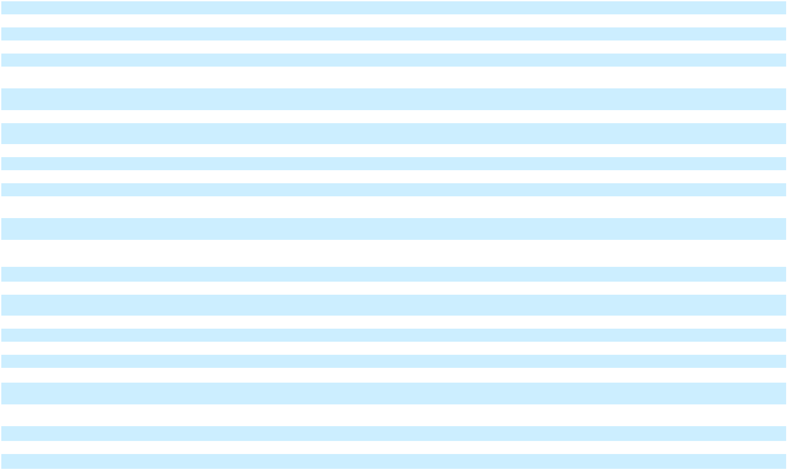

The accompanying notes are an integral part of these consolidated financial statements.

F-8

Table of Contents

New Fortress Energy Inc.

Consolidated Statements of Cash Flows

For the years ended December 31, 2025, 2024 and 2023

(in thousands of U.S. dollars)

 |  | Year Ended December 31,
 |  | 2025 |  | 2024 (as Restated) |  |  | 2023 (as Restated)
Cash flows from operating activities
Net (loss) income | $ | (1,831,953) | $ |  | (244,537) | $ |  | 548,224
Adjustments for:
Amortization of deferred financing costs and debt guarantee, net |  | 53,983 |  |  | 31,313 |  |  | 6,589
Depreciation and amortization |  | 242,346 |  |  | 159,302 |  |  | 161,424
Deferred taxes |  | 25,847 |  |  | (3,332) |  |  | 13,812
Share-based compensation |  | 14,546 |  |  | 50,625 |  |  | 1,573
Asset impairment expense |  | 860,865 |  |  | 16,494 |  |  | 10,958
Goodwill impairment expense |  | 598,110 |  |  | — |  |  | —
Earnings recognized from vessels chartered to third parties transferred to Energos |  | (48,279) |  |  | (95,487) |  |  | (156,997)
(Gain) loss on sale of assets, net |  | (670,938) |  |  | 80,207 |  |  | (27,978)
Loss on extinguishment of debt |  | 19,937 |  |  | 270,063 |  |  | —
Other |  | 93 |  |  | 165,976 |  |  | 77,055
Changes in operating assets and liabilities, net of acquisitions:
(Increase) decrease in receivables |  | (216,387) |  |  | 67,709 |  |  | (41,629)
(Increase) in inventories |  | (38,360) |  |  | (251) |  |  | (42,290)
(Increase) decrease in other assets |  | (62,021) |  |  | (71,233) |  |  | 43,205
Decrease in right-of-use assets |  | 63,424 |  |  | 164,136 |  |  | 83,537
Increase in accounts payable/accrued liabilities |  | 513,528 |  |  | 194,163 |  |  | 89,095
(Decrease) in lease liabilities |  | (76,112) |  |  | (160,604) |  |  | (74,576)
Increase (decrease) in other liabilities |  | (32,011) |  |  | (22,338) |  |  | 126,577
Net cash (used in) provided by operating activities |  | (583,382) |  |  | 602,206 |  |  | 818,579
Cash flows from investing activities
Capital expenditures |  | (650,811) |  |  | (2,130,641) |  |  | (2,919,768)
Sale of Jamaica Business |  | 961,865 |  |  | — |  |  | —
Sale of vessels to Energos |  | 150,000 |  |  | — |  |  | —
Sale of equity method investment |  | — |  |  | 136,365 |  |  | 100,000
Other asset sales |  | — |  |  | 328,999 |  |  | 16,464
Sale of Miami Facility |  | — |  |  | 58,336 |  |  | —
Other investing activities |  | 4,709 |  |  | 22,887 |  |  | 9,227
Net cash provided by (used in) investing activities |  | 465,763 |  |  | (1,584,054) |  |  | (2,794,077)
Cash flows from financing activities
Proceeds from borrowings of debt |  | 1,375,495 |  |  | 5,865,299 |  |  | 3,014,567
Payments made for capital expenditures paid beyond customary vendor payment terms |  | (257,943) |  |  | (506,057) |  |  | (103,889)
Repayment of debt |  | (1,606,841) |  |  | (3,801,034) |  |  | (695,688)
Payment of deferred financing costs |  | (28,340) |  |  | (146,722) |  |  | (37,806)
Payment of dividends |  | (3,472) |  |  | (65,310) |  |  | (723,962)
Issuance of Class A stock |  | — |  |  | 386,583 |  |  | —
Other financing activities |  | (22,539) |  |  | (14,248) |  |  | (28,161)
Net cash (used in) provided by financing activities |  | (543,640) |  |  | 1,718,511 |  |  | 1,425,061
Impact of changes in foreign exchange rates on cash and cash equivalents |  | 52,624 |  |  | (81,900) |  |  | 6,168
Net (decrease) increase in cash, cash equivalents and restricted cash |  | (608,635) |  |  | 654,763 |  |  | (544,269)
Cash, cash equivalents and restricted cash – beginning of period |  | 965,577 |  |  | 310,814 |  |  | 855,083
Cash, cash equivalents and restricted cash – end of period | $ | 356,942 | $ |  | 965,577 | $ |  | 310,814


The accompanying notes are an integral part of these consolidated financial statements.

F-9

Table of Contents

New Fortress Energy Inc.

Consolidated Statements of Cash Flows

For the years ended December 31, 2025, 2024 and 2023

(in thousands of U.S. dollars)

 |  |  | Year Ended December 31,
 |  |  | 2025 |  | 2024 (as Restated) |  |  | 2023 (as Restated)
Cash paid for interest, net of capitalized interest |  | $ | 352,242 | $ |  | 90,318 | $ |  | 106,481
 |  |  | Year Ended December 31,
 |  |  | 2025 |  | 2024 (as Restated) |  |  | 2023 (as Restated)
Supplemental disclosure of non-cash investing and financing activities:
Changes in accounts payable and accrued liabilities associated with construction in progress and
property, plant and equipment additions |  | $ | (183,785) | $ |  | (236,561) | $ |  | 322,854
Accounts payable and accrued liabilities associated with construction in progress and property, plant
and equipment additions |  |  | 233,809 |  |  | 494,462 |  |  | 738,419
Principal payments on financing obligation paid to Energos by third party charters |  |  | (30,811) |  |  | (21,731) |  |  | (66,866)
 |  |  | 734,172 |  |  | — |  |  | —
Non-cash settlement of Vessel Financing Obligation |  |  | 734,172 |  |  | — |  |  | —
Proceeds held in escrow |  |  | 58,000 |  |  | — |  |  | —
Accrued dividend |  |  | — |  |  | 20,507 |  |  | —
Preferred shares issued and debt assumed in PortoCem acquisition |  |  | — |  |  | (125,198) |  |  | —
Fair value of contingent payments in the Lins acquisition |  |  | — |  |  | 8,080 |  |  | —
Deemed dividend related to Series B preferred stock |  |  | — |  |  | (17,605) |  |  | —
Non-cash financing costs |  |  | — |  |  | 181,928 |  |  | —
Consideration received on asset sale |  |  | — |  |  | — |  |  | 27,704
Shares received in Hilli Exchange |  |  | — |  |  | — |  |  | (122,754)
Investment in Energos |  |  | — |  |  | — |  |  | 1,501
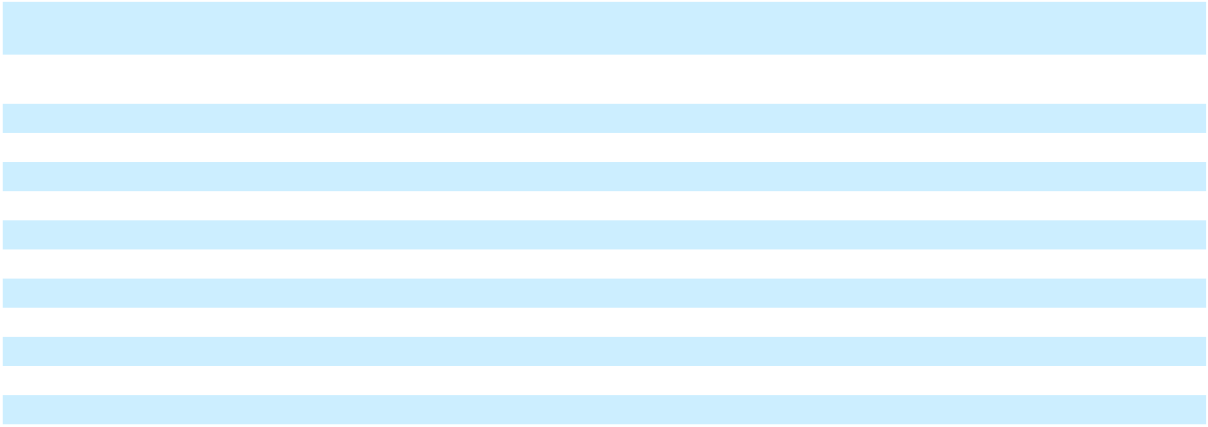

The following table identifies the balance sheet line-items included in Cash and cash equivalents, Current restricted cash, and Non-current restricted cash presented in Other non-current assets, net on the Consolidated Balance Sheets (Note 19) presented in the Consolidated Statement of Cash Flows:

 |  | Year Ended December 31,
 |  | 2025 |  |  | 2024
Cash and cash equivalents |  | 226,453 |  |  | 492,881
Current restricted cash |  | 130,489 |  |  | 472,696
Cash, cash equivalents and restricted cash – end of period | $ | 356,942 | $ |  | 965,577

The accompanying notes are an integral part of these consolidated financial statements.

F-10

Table of Contents

1. Restatement of Previously Issued Financial Statements

During the preparation of New Fortress Energy Inc.’s (“NFE,” together with its subsidiaries, the “Company”) consolidated financial statements for the year ended December 31, 2025, the Company identified errors in the Company’s historical consolidated statements of cash flows, which impacted previously issued audited consolidated financial statements for the years ended December 31, 2024 and 2023 (the “Restatement”). During the periods covered by the financial statements, the Company delayed payments to certain vendors on certain significant development projects, which allowed the Company to improve its working capital and liquidity. Payments for capital expenditures significantly outside of a vendor's customary payment terms should be classified as financing activities, as opposed to investing activities, which is how these payments were presented in the previously issued financial statements. In connection with the Restatement, the Company is also correcting unrelated errors identified by the Company in prior periods, including errors related to the measurement of deferred taxes, calculation of interest capitalization, certain misclassification between Construction in progress and Property, plant and equipment, net, certain income statement misclassification between depreciation and amortization expense and revenue and understatement of accruals (collectively with the cash flow errors relating to delayed vendor payments, “Misstatements”).

Impact of the Restatement

The following tables present the impact of the restatement, including the correction of unrelated errors identified by the Company in prior periods to the specific line items presented in the previously issued audited Consolidated Financial Statements for the years ended December 31, 2024 and 2023. The amounts labeled "As Reported" were derived from the consolidated financial statements as originally filed on the Annual Report on Form 10-K/A on June 30, 2025. The amounts labeled “Adjustments” represent the impact of correcting the Misstatements. The effects of the restatement have been corrected in all impacted tables and disclosures throughout the audited Consolidated Financial Statements. Refer to Note 33 for the restatement of the unaudited Condensed Consolidated Financial Statements for the quarterly and year-to-date (as

F-11

Table of Contents

applicable) periods ended March 31, 2024, June 30, 2024, September 30, 2024, March 31, 2025, June 30, 2025, and September 30, 2025.

F-12

Table of
Table of | Contents
Restated Consolidated Balance Sheets
 |  |  |  | As of December 31, 2023
Assets |  |  | As Reported |  |  | Adjustments |  |  | As Restated
Current assets
Cash and cash equivalents |  |  | $ | 155,414 | $ |  | — | $ |  | 155,414
Restricted cash |  |  |  | 155,400 |  |  | — |  |  | 155,400
Receivables, net of allowances of $1,158 |  |  |  | 342,371 |  |  | 610 |  |  | 342,981
Inventory |  |  |  | 113,684 |  |  | 2,500 |  |  | 116,184
Prepaid expenses and other current assets, net |  |  |  | 213,104 |  |  | (308) |  |  | 212,796
Total current assets |  |  |  | 979,973 |  |  | 2,802 |  |  | 982,775
Construction in progress |  |  |  | 5,348,294 |  |  | (5,921) |  |  | 5,342,373
Property, plant and equipment, net |  |  |  | 2,481,415 |  |  | — |  |  | 2,481,415
Equity method investments |  |  |  | 137,793 |  |  | — |  |  | 137,793
Right-of-use assets |  |  |  | 588,385 |  |  | — |  |  | 588,385
Intangible assets, net |  |  |  | 51,815 |  |  | — |  |  | 51,815
Goodwill |  |  |  | 776,760 |  |  | 16,380 |  |  | 793,140
Deferred tax assets, net |  |  |  | 9,907 |  |  | — |  |  | 9,907
Other non-current assets, net |  |  |  | 126,903 |  |  | (1,069) |  |  | 125,834
Total assets |  |  | $ | 10,501,245 | $ |  | 12,192 | $ |  | 10,513,437
Liabilities
Current liabilities
Current portion of long-term debt and short-term borrowings |  |  | $ | 292,625 | $ |  | — | $ |  | 292,625
Accounts payable |  |  |  | 549,489 |  |  | (3,321) |  |  | 546,168
Accrued liabilities |  |  |  | 471,675 |  |  | 14,608 |  |  | 486,283
Current lease liabilities |  |  |  | 164,548 |  |  | — |  |  | 164,548
Other current liabilities |  |  |  | 227,951 |  |  | (14,759) |  |  | 213,192
Total current liabilities |  |  |  | 1,706,288 |  |  | (3,472) |  |  | 1,702,816
Long-term debt |  |  |  | 6,510,523 |  |  | — |  |  | 6,510,523
Non-current lease liabilities |  |  |  | 406,494 |  |  | — |  |  | 406,494
Deferred tax liabilities, net |  |  |  | 44,444 |  |  | 15,757 |  |  | 60,201
Other long-term liabilities |  |  |  | 55,627 |  |  | — |  |  | 55,627
Total liabilities |  |  |  | 8,723,376 |  |  | 12,285 |  |  | 8,735,661
Stockholders’ equity
Class A common stock, $0.01 par value, 205.0 million issued and |  |  |  | 2,050 |  |  | — |  |  | 2,050
outstanding as of December 31, 2023 |  |  |  | 2,050 |  |  | — |  |  | 2,050
Additional paid-in capital |  |  |  | 1,038,530 |  |  | — |  |  | 1,038,530
Retained earnings |  |  |  | 527,986 |  |  | (652) |  |  | 527,334
Accumulated other comprehensive income |  |  |  | 71,528 |  |  | 559 |  |  | 72,087
Total stockholders’ equity attributable to NFE |  |  |  | 1,640,094 |  |  | (93) |  |  | 1,640,001
Non-controlling interest |  |  |  | 137,775 |  |  | — |  |  | 137,775
Total stockholders’ equity |  |  |  | 1,777,869 |  |  | (93) |  |  | 1,777,776
Total liabilities and stockholders’ equity |  |  | $ | 10,501,245 | $ |  | 12,192 | $ |  | 10,513,437


F-13

Table of Contents

 |  | As of December 31, 2024
 | As Reported |  |  | Adjustments |  |  | As Restated
Assets
Current assets
Cash and cash equivalents | $ | 492,881 | $ |  | — | $ |  | 492,881
Restricted cash |  | 472,696 |  |  | — |  |  | 472,696
Receivables, net of allowances of $13,629 (as reported) and $15,651 |  | 335,813 |  |  | (4,394) |  |  | 331,419
(as restated) |  | 335,813 |  |  | (4,394) |  |  | 331,419
Inventory |  | 103,224 |  |  | — |  |  | 103,224
Prepaid expenses and other current assets, net |  | 205,496 |  |  | 6,844 |  |  | 212,340
Total current assets |  | 1,610,110 |  |  | 2,450 |  |  | 1,612,560
Construction in progress |  | 3,574,389 |  |  | (47,405) |  |  | 3,526,984
Property, plant and equipment, net |  | 5,842,807 |  |  | 86,112 |  |  | 5,928,919
Right-of-use assets |  | 618,733 |  |  | — |  |  | 618,733
Intangible assets, net |  | 179,510 |  |  | — |  |  | 179,510
Goodwill |  | 766,350 |  |  | 16,380 |  |  | 782,730
Deferred tax assets, net |  | 2,698 |  |  | 626 |  |  | 3,324
Other non-current assets, net |  | 272,899 |  |  | (2,434) |  |  | 270,465
Total assets | $ | 12,867,496 | $ |  | 55,729 | $ |  | 12,923,225
Liabilities
Current liabilities
Current portion of long-term debt and short-term borrowings | $ | 539,132 | $ |  | — | $ |  | 539,132
Accounts payable |  | 473,736 |  |  | 7,786 |  |  | 481,522
Accrued liabilities |  | 391,359 |  |  | 43,322 |  |  | 434,681
Current lease liabilities |  | 128,362 |  |  | (5,200) |  |  | 123,162
Other current liabilities |  | 174,829 |  |  | (312) |  |  | 174,517
Total current liabilities |  | 1,707,418 |  |  | 45,596 |  |  | 1,753,014
Long-term debt |  | 8,355,703 |  |  | 6,073 |  |  | 8,361,776
Non-current lease liabilities |  | 475,161 |  |  | — |  |  | 475,161
Deferred tax liabilities, net |  | 73,198 |  |  | 1,640 |  |  | 74,838
Other long-term liabilities |  | 166,358 |  |  | 807 |  |  | 167,165
Total liabilities |  | 10,777,838 |  |  | 54,116 |  |  | 10,831,954
Series B convertible preferred stock, $0.01 par value, 96,746 shares
authorized, issued and outstanding as of December 31, 2024; |  | 90,570 |  |  | — |  |  | 90,570
aggregate liquidation preference of $96,746 at December 31, 2024 |  | 90,570 |  |  | — |  |  | 90,570
Stockholders’ equity
Class A common stock, $0.01 par value, 750.0 million shares
authorized, 266.5 million issued and outstanding as of |  | 2,664 |  |  | — |  |  | 2,664
December 31, 2024 |  | 2,664 |  |  | — |  |  | 2,664
Additional paid-in capital |  | 1,674,312 |  |  | — |  |  | 1,674,312
Retained earnings |  | 196,363 |  |  | (2,802) |  |  | 193,561
Accumulated other comprehensive income |  | 3,089 |  |  | 4,415 |  |  | 7,504
Total stockholders’ equity attributable to NFE |  | 1,876,428 |  |  | 1,613 |  |  | 1,878,041
Non-controlling interest |  | 122,660 |  |  | — |  |  | 122,660
Total stockholders’ equity |  | 1,999,088 |  |  | 1,613 |  |  | 2,000,701
Total liabilities and stockholders’ equity | $ | 12,867,496 | $ |  | 55,729 | $ |  | 12,923,225


F-14

Table of
Table of | Contents
Restated Consolidated Statements of Operations and Comprehensive (Loss) Income
 |  |  |  | Year Ended December 31, 2023
 |  |  | As Reported |  |  | Adjustments |  |  | As Restated
Revenues
Operating revenue |  |  | $ | 2,060,212 | $ |  | — | $ |  | 2,060,212
Vessel charter revenue |  |  |  | 276,843 |  |  | (24,500) |  |  | 252,343
Other revenue |  |  |  | 76,241 |  |  | 1,809 |  |  | 78,050
Total revenues |  |  |  | 2,413,296 |  |  | (22,691) |  |  | 2,390,605
Operating expenses
Cost of sales (exclusive of depreciation and amortization shown |  |  |  | 877,451 |  |  | 1,770 |  |  | 879,221
separately below) |  |  |  | 877,451 |  |  | 1,770 |  |  | 879,221
Vessel operating expenses |  |  |  | 45,439 |  |  | — |  |  | 45,439
Operations and maintenance |  |  |  | 166,785 |  |  | 8,774 |  |  | 175,559
Selling, general and administrative |  |  |  | 205,104 |  |  | (1,719) |  |  | 203,385
Transaction and integration costs |  |  |  | 6,946 |  |  | — |  |  | 6,946
Depreciation and amortization |  |  |  | 187,324 |  |  | (25,900) |  |  | 161,424
Asset impairment expense |  |  |  | 10,958 |  |  | — |  |  | 10,958
Loss (gain) on sale of assets, net |  |  |  | (29,378) |  |  | 1,400 |  |  | (27,978)
Total operating expenses |  |  |  | 1,470,629 |  |  | (15,675) |  |  | 1,454,954
Operating income |  |  |  | 942,667 |  |  | (7,016) |  |  | 935,651
Interest expense |  |  |  | 277,842 |  |  | 6,177 |  |  | 284,019
Other expense (income), net |  |  |  | 10,408 |  |  | — |  |  | 10,408
Income before income from equity method investments and |  |  |  | 654,417 |  |  | (13,193) |  |  | 641,224
income taxes |  |  |  | 654,417 |  |  | (13,193) |  |  | 641,224
Income from equity method investments |  |  |  | 9,972 |  |  | — |  |  | 9,972
Tax provision (benefit) |  |  |  | 115,513 |  |  | (12,541) |  |  | 102,972
Net income |  |  |  | 548,876 |  |  | (652) |  |  | 548,224
Net income attributable to common stockholders
 |  |  | $ | 547,882 |  | $ | (652) |  | $ | 547,230
Net income per share – basic |  |  | $ | 2.66 |  | $ | — |  | $ | 2.66
Net income per share – diluted
 |  |  | $ | 2.65 |  | $ | — |  | $ | 2.65
Weighted average number of shares outstanding – basic |  |  |  | 205,942,837 |  |  | — |  |  | 205,942,837
Weighted average number of shares outstanding – diluted
 |  |  |  | 206,481,977 |  |  | — |  |  | 206,481,977
Other comprehensive income:
Currency translation adjustment |  |  |  | 18,005 |  |  | 559 |  |  | 18,564
Reclassification of net foreign currency translation adjustment realized |  |  |  | (1,457) |  |  | — |  |  | (1,457)
upon sale of foreign subsidiary |  |  |  | (1,457) |  |  | — |  |  | (1,457)
Comprehensive income |  |  |  | 565,424 |  |  | (93) |  |  | 565,331
Comprehensive (income) attributable to non-controlling interest |  |  |  | (1,412) |  |  | — |  |  | (1,412)
Comprehensive income attributable to stockholders |  |  | $ | 564,012 |  | $ | (93) |  | $ | 563,919


F-15

Table of Contents

 |  | Year Ended December 31, 2024
 | As Reported |  |  | Adjustments |  |  | As Restated
Revenues
Operating revenue | $ | 1,698,348 | $ |  | (884) | $ |  | 1,697,464
Vessel charter revenue |  | 212,609 |  |  | (3,223) |  |  | 209,386
Contract novation income |  | 295,558 |  |  | — |  |  | 295,558
Other revenue |  | 158,345 |  |  | (1,809) |  |  | 156,536
Total revenues |  | 2,364,860 |  |  | (5,916) |  |  | 2,358,944
Operating expenses
Cost of sales (exclusive of depreciation and amortization shown |  | 1,064,667 |  |  | 514 |  |  | 1,065,181
separately below) |  | 1,064,667 |  |  | 514 |  |  | 1,065,181
Vessel operating expenses |  | 33,372 |  |  | — |  |  | 33,372
Operations and maintenance |  | 174,313 |  |  | (3,550) |  |  | 170,763
Selling, general and administrative |  | 285,520 |  |  | 7,858 |  |  | 293,378
Transaction and integration costs |  | 12,279 |  |  | — |  |  | 12,279
Depreciation and amortization |  | 162,014 |  |  | (3,223) |  |  | 158,791
Asset impairment expense |  | 16,494 |  |  | — |  |  | 16,494
Loss on sale of assets, net |  | 77,562 |  |  | 2,645 |  |  | 80,207
Total operating expenses |  | 1,826,221 |  |  | 4,244 |  |  | 1,830,465
Operating income |  | 538,639 |  |  | (10,160) |  |  | 528,479
Interest expense |  | 328,377 |  |  | (12,040) |  |  | 316,337
Other expense (income), net |  | 113,077 |  |  | 3,231 |  |  | 116,308
Loss on extinguishment of debt, net |  | 270,063 |  |  | — |  |  | 270,063
(Loss) before income taxes |  | (172,878) |  |  | (1,351) |  |  | (174,229)
Tax provision |  | 69,509 |  |  | 799 |  |  | 70,308
Net (loss) |  | (242,387) |  |  | (2,150) |  |  | (244,537)
Net (loss) attributable to common stockholders
Net (loss) attributable to common stockholders | $ | (270,106) |  | $ | (2,150) |  | $ | (272,256)
Net (loss) per share – basic | $ | (1.24) |  | $ | (0.01) |  | $ | (1.25)
Net (loss) per share – diluted
Net (loss) per share – diluted | $ | (1.25) |  | $ | (0.01) |  | $ | (1.26)
Weighted average number of shares outstanding – basic |  | 217,578,487 |  |  | — |  |  | 217,578,487
Weighted average number of shares outstanding – diluted
Weighted average number of shares outstanding – diluted |  | 218,622,419 |  |  | — |  |  | 218,622,419
Other comprehensive (loss) income:
Currency translation adjustment |  | (69,468) |  |  | 3,856 |  |  | (65,612)
Comprehensive (loss) |  | (311,855) |  |  | 1,706 |  |  | (310,149)
Comprehensive (income) attributable to non-controlling interest |  | (5,623) |  |  | — |  |  | (5,623)
Comprehensive (loss) income attributable to stockholders | $ | (317,478) |  | $ | 1,706 |  | $ | (315,772)


F-16

Table of
Table of | Contents
Restated Consolidated Statements of Changes in Stockholders’ Equity
 |  |  | Series B |  |  |  |  |  |  |  |  |  |  |  |  | Accumulated
 |  |  | convertible |  |  |  | Class A common |  |  |  |  |  |  |  |  | Accumulated
 |  |  |  |  |  |  |  |  |  |  |  | Additional |  |  |  | other |  | Non- |  | Total
 |  |  | preferred stock |  |  |  | stock |  |  |  |  | Additional |  |  |  | other |  | Non- |  | Total
 |  |  |  |  |  |  |  |  |  |  |  | paid-in |  | Accumulated |  | comprehensive |  | controlling |  | stockholders’
As Reported |  |  | Shares |  | Amount |  | Shares |  |  | Amount |  | capital |  | deficit |  | (loss) income |  | Interest |  | equity
Balance as of December 31, 2022 |  |  | — |  | — |  | 208,770,088 |  |  | 2,088 |  | 1,170,254 |  | 62,080 |  | 55,398 |  | 152,039 |  | 1,441,859
Net income
 |  |  | — |  | — |  | — |  |  | — |  | — |  | 547,882 |  | — |  | 994 |  | 548,876
Other comprehensive income |  |  | — |  | — |  | — |  |  | — |  | — |  | — | 16,130 |  | 418 |  | 16,548
Share-based compensation expense |  |  | — |  | — |  | — |  |  | — | 1,573 |  |  | — |  | — |  | — | 1,573
Acquisition and cancellation of shares |  |  | — |  | — | (4,100,000) |  |  |  | (41) | (123,778) |  |  | — |  | — |  | — | (123,819)
Issuance of shares for vested share-
based compensation awards |  |  | — |  | — | 689,401 |  |  |  | 3 |  | — |  | — |  | — |  | — | 3
Shares withheld from employees
related to share-based compensation,
at cost |  |  | — |  | — | (328,083) |  |  |  | — | (9,519) |  |  | — |  | — |  | — | (9,519)
Dividends |  |  | — |  | — |  | — |  |  | — |  | — |  | (81,976) |  | — |  | (15,676) |  | (97,652)
Balance as of December 31, 2023 (As |  |  | — |  | — | 205,031,406 |  |  |  | 2,050 | 1,038,530 |  | 527,986 |  | 71,528 |  | 137,775 |  | 1,777,869
Reported) |  |  | — |  | —
2023 Adjustments
Net income (loss) |  |  | — |  | — |  | — |  |  | — |  | — | (652) |  |  | — |  | — | (652)
Other comprehensive income (loss) |  |  | — |  | — |  | — |  |  | — |  | — |  | — |  | 559 |  | — |  | 559
Total Adjustments |  |  | — |  | — |  | — |  |  | — |  | — | (652) |  | 559 |  |  | — | (93)
As Restated
Balance as of December 31, 2022 |  |  | — |  | — |  | 208,770,088 |  |  | 2,088 |  | 1,170,254 |  | 62,080 |  | 55,398 |  | 152,039 |  | 1,441,859
Net income (loss)
 |  |  | — |  | — |  | — |  |  | — |  | — |  | 547,230 |  | — |  | 994 |  | 548,224
Other comprehensive income (loss) |  |  | — |  | — |  | — |  |  | — |  | — |  | — | 16,689 |  | 418 |  | 17,107
Share-based compensation expense |  |  | — |  | — |  | — |  |  | — | 1,573 |  |  | — |  | — |  | — | 1,573
Class A stock issued, net of issuance
costs |  |  | — |  | — | (4,100,000) |  |  |  | (41) | (123,778) |  |  | — |  | — |  | — | (123,819)
Issuance of shares for vested share-
based compensation awards |  |  | — |  | — | 689,401 |  |  |  | 3 |  | — |  | — |  | — |  | — | 3
Shares withheld from employees
related to share-based compensation,
at cost |  |  | — |  | — | (328,083) |  |  |  | — | (9,519) |  |  | — |  | — |  | — | (9,519)
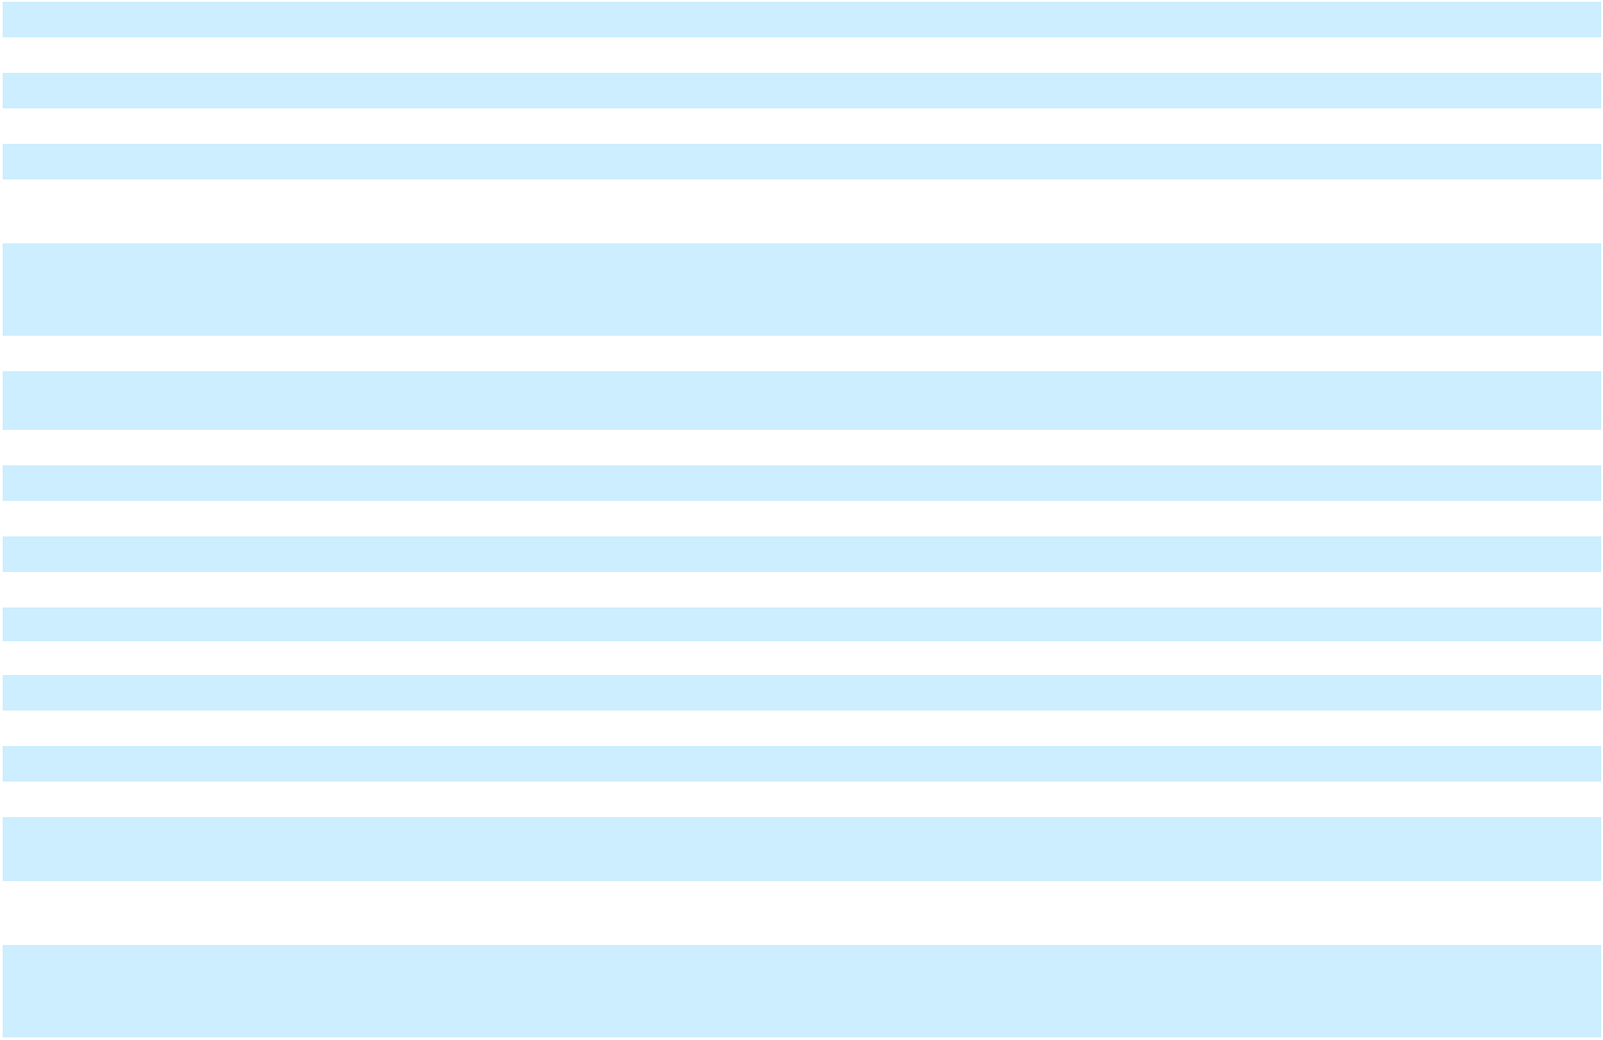

F-17

Table of Contents

Issuance of preferred stock and
deemed dividend (Note 4) | — |  | — |  | — |  |  | — |  | — | (81,976) |  |  | — |  | (15,676) |  | (97,652)
Balance as of December 31, 2023 (As | — |  | — | 205,031,406 |  |  |  | 2,050 | 1,038,530 |  | 527,334 |  | 72,087 |  | 137,775 |  | 1,777,776
Restated) | — |  | —
 | Series B |  |  |  |  |  |  |  |  |  |  |  |  | Accumulated
 | convertible |  |  |  | Class A common |  |  |  |  |  |  |  |  | Accumulated
 |  |  |  |  |  |  |  |  |  | Additional |  |  |  | other |  | Non- |  | Total
 | preferred stock |  |  |  | stock |  |  |  |  | Additional |  |  |  | other |  | Non- |  | Total
 |  |  |  |  |  |  |  |  |  | paid-in |  | Accumulated |  | comprehensive |  | controlling |  | stockholders’
As Reported | Shares |  | Amount |  | Shares |  |  | Amount |  | capital |  | deficit |  | (loss) income |  | Interest |  | equity
Balance as of December 31, 2023 (As | — |  | — |  | 205,031,406 |  |  | 2,050 |  | 1,038,530 |  | 527,986 |  | 71,528 |  | 137,775 |  | 1,777,869
Reported) | — |  | — |  | 205,031,406
Net income (loss)
Net income (loss) | — |  | — |  | — |  |  | — |  | — |  | (249,039) |  | — |  | 6,652 |  | (242,387)
Other comprehensive income (loss) | — |  | — |  | — |  |  | — |  | — |  | — | (68,439) |  | (1,029) |  | (69,468)
Share-based compensation expense | — |  | — |  | — |  |  | — | 50,625 |  |  | — |  | — |  | — | 50,625
Class A stock issued, net of issuance
costs | — |  | — | 61,389,733 |  |  |  | 614 | 562,201 |  |  | — |  | — |  | — | 562,815
Issuance of shares for vested share-
based compensation awards | — |  | — | 54,035 |  |  |  | — |  | — |  | — |  | — |  | — |  | —
Shares withheld from employees
related to share-based compensation,
at cost | — |  | — | (16,081) |  |  |  | — | (435) |  |  | — |  | — |  | — | (435)
Issuance of preferred stock and
deemed dividend | 96,746 | 107,189 |  |  | — |  |  | — | 6,772 |  | (17,605) |  |  | — |  | — | (10,833)
Conversion of Series B convertible
preferred stock | — | (16,619) |  |  | — |  |  | — | 16,619 |  |  | — |  | — |  | — | 16,619
Dividends | — |  | — |  | — |  |  | — |  | — |  | (64,979) |  | — |  | (20,738) |  | (85,717)
Balance as of December 31, 2024 (As | 96,746 | 90,570 |  | 266,459,093 |  |  |  | 2,664 | 1,674,312 |  | 196,363 |  | 3,089 |  | 122,660 |  | 1,999,088
Reported) | 96,746
2024 Adjustments
Balance as of December 31, 2023 | — |  | — |  | — |  |  | — |  | — | (652) |  | 559 |  |  | — | (93)
Net income (loss) | — |  | — |  | — |  |  | — |  | — | (2,150) |  |  | — |  | — | (2,150)
Other comprehensive income (loss) | — |  | — |  | — |  |  | — |  | — |  | — |  | 3,856 |  | — |  | 3,856
Total Adjustments | — |  | — |  | — |  |  | — |  | — | (2,802) |  | 4,415 |  |  | — | 1,613
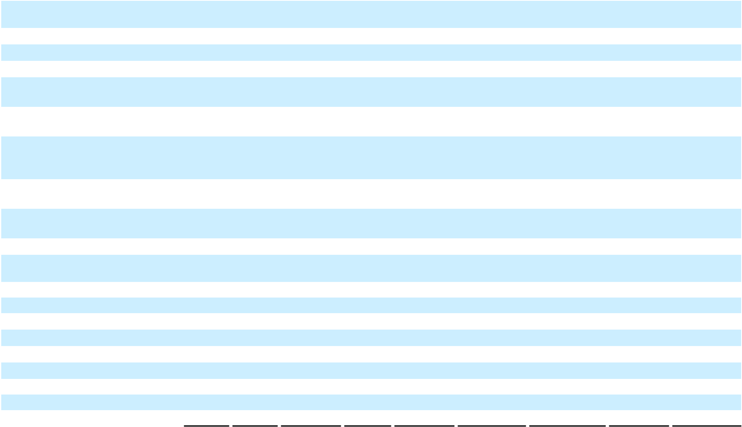

As Restated

F-18

Table of Contents
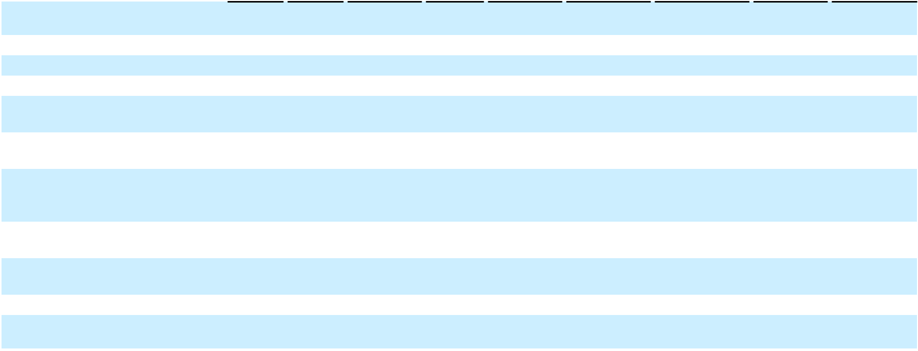

Balance as of December 31, 2023 (As | — |  | — | 205,031,406 |  | 2,050 |  | 1,038,530 |  | 527,334 |  | 72,087 |  | 137,775 |  | 1,777,776
Restated) | —
Net income (loss)
Net income (loss) | — |  | — |  | — |  | — |  | — |  | (251,189) |  | — |  | 6,652 |  | (244,537)
Other comprehensive income (loss) | — |  | — |  | — |  | — |  | — |  | — | (64,583) |  | (1,029) |  | (65,612)
Share-based compensation expense | — |  | — |  | — |  | — | 50,625 |  |  | — |  | — |  | — | 50,625
Class A stock issued, net of issuance
costs | — |  | — | 61,389,733 |  | 614 |  | 562,201 |  |  | — |  | — |  | — | 562,815
Issuance of shares for vested share-
based compensation awards | — |  | — | 54,035 |  |  | — |  | — |  | — |  | — |  | — |  | —
Shares withheld from employees
related to share-based compensation,
at cost | — |  | — | (16,081) |  |  | — | (435) |  |  | — |  | — |  | — | (435)
Issuance of preferred stock and
deemed dividend | 96,746 | 107,189 |  |  | — |  | — | 6,772 |  | (17,605) |  |  | — |  | — | (10,833)
Conversion of Series B convertible
preferred stock | — | (16,619) |  |  | — |  | — | 16,619 |  |  | — |  | — |  | — | 16,619
Dividends | — |  | — |  | — |  | — |  | — |  | (64,979) |  | — |  | (20,738) |  | (85,717)
Balance as of December 31, 2024 (As | 96,746 | 90,570 |  | 266,459,093 |  | 2,664 |  | 1,674,312 |  | 193,561 |  | 7,504 |  | 122,660 |  | 2,000,701
Restated)

F-19

Table of
Table of | Contents
Restated Consolidated Statements of Cash Flows
 |  |  |  | Year Ended December 31, 2023
Cash flows from operating activities |  |  | As Reported |  |  | Adjustments |  |  | As Restated
Net income |  |  | $ | 548,876 | $ |  | (652) | $ |  | 548,224
Adjustments for:
Amortization of deferred financing costs and debt guarantee, net |  |  |  | 6,589 |  |  | — |  |  | 6,589
Depreciation and amortization |  |  |  | 187,324 |  |  | (25,900) |  |  | 161,424
Deferred taxes |  |  |  | 14,938 |  |  | (1,126) |  |  | 13,812
Share-based compensation |  |  |  | 1,573 |  |  | — |  |  | 1,573
Asset impairment expense |  |  |  | 10,958 |  |  | — |  |  | 10,958
Earnings recognized from vessels chartered to third parties
transferred to Energos |  |  |  | (156,997) |  |  | — |  |  | (156,997)
Gain on sale of assets, net |  |  |  | (29,378) |  |  | 1,400 |  |  | (27,978)
Other |  |  |  | 51,493 |  |  | 25,562 |  |  | 77,055
Changes in operating assets and liabilities:
(Increase) in receivables |  |  |  | (41,019) |  |  | (610) |  |  | (41,629)
(Increase) in inventories |  |  |  | (39,790) |  |  | (2,500) |  |  | (42,290)
Decrease in other assets |  |  |  | 41,828 |  |  | 1,377 |  |  | 43,205
Decrease in right-of-use assets |  |  |  | 83,537 |  |  | — |  |  | 83,537
Increase in accounts payable/accrued liabilities |  |  |  | 78,065 |  |  | 11,030 |  |  | 89,095
(Decrease) in lease liabilities |  |  |  | (74,576) |  |  | — |  |  | (74,576)
Increase in other liabilities |  |  |  | 141,335 |  |  | (14,758) |  |  | 126,577
Net cash provided by operating activities |  |  |  | 824,756 |  |  | (6,177) |  |  | 818,579
Cash flows from investing activities
Capital expenditures |  |  |  | (3,029,834) |  |  | 110,066 |  |  | (2,919,768)
Sale of equity method investment |  |  |  | 100,000 |  |  | — |  |  | 100,000
Asset sales |  |  |  | 16,464 |  |  | — |  |  | 16,464
Other investing activities |  |  |  | 9,227 |  |  | — |  |  | 9,227
Net cash used in investing activities |  |  |  | (2,904,143) |  |  | 110,066 |  |  | (2,794,077)
Cash flows from financing activities
Proceeds from borrowings of debt |  |  |  | 3,005,387 |  |  | 9,180 |  |  | 3,014,567
Payments made for capital expenditures paid beyond customary
vendor payment terms |  |  |  |  |  |  | (103,889) |  |  | (103,889)
Payment of deferred financing costs |  |  |  | (37,806) |  |  | — |  |  | (37,806)
Repayment of debt |  |  |  | (686,508) |  |  | (9,180) |  |  | (695,688)
Payment of dividends |  |  |  | (723,962) |  |  | — |  |  | (723,962)
Other financing activities |  |  |  | (28,161) |  |  | — |  |  | (28,161)
Net cash provided by financing activities |  |  |  | 1,528,950 |  |  | (103,889) |  |  | 1,425,061
Impact of changes in foreign exchange rates on cash and cash |  |  |  | 6,168 |  |  | — |  |  | 6,168
equivalents |  |  |  | 6,168 |  |  | — |  |  | 6,168
Net decrease in cash, cash equivalents and restricted cash |  |  |  | (544,269) |  |  | — |  |  | (544,269)
Cash, cash equivalents and restricted cash – beginning of period |  |  |  | 855,083 |  |  | — |  |  | 855,083
Cash, cash equivalents and restricted cash – end of period |  |  | $ | 310,814 |  | $ | — |  | $ | 310,814
 |  |  |  | Year Ended December 31, 2023
 |  |  | As Reported |  |  | Adjustments |  |  | As Restated
Cash paid for interest, net of capitalized interest |  |  | $ | 100,304 | $ |  | 6,177 | $ |  | 106,481
Cash paid for taxes |  |  |  | 52,897 |  |  | — |  |  | 52,897


F-20

Table of Contents
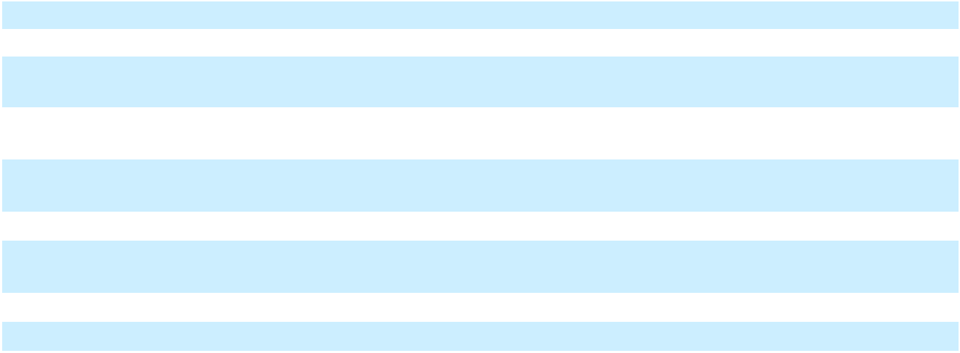

 |  | Year Ended December 31, 2023
 | As Reported |  |  | Adjustments |  |  | As Restated
Supplemental disclosure of non-cash investing and financing
activities:
Changes in accounts payable and accrued liabilities associated with
construction in progress and property, plant and equipment additions | $ | 322,598 | $ |  | 256 | $ |  | 322,854
Accounts payable and accrued liabilities associated with construction in
progress and property, plant and equipment additions |  | 738,163 |  |  | 256 |  |  | 738,419
Consideration received on asset sale |  | 27,704 |  |  | — |  |  | 27,704
Principal payments on financing obligation paid to Energos by third
party charters |  | (66,866) |  |  | — |  |  | (66,866)
Shares received in Hilli Exchange |  | (122,754) |  |  | — |  |  | (122,754)
Investment in Energos |  | 1,501 |  |  | — |  |  | 1,501

F-21

Table of Contents

 |  | Year Ended December 31, 2024
 | As Reported |  |  | Adjustments |  |  | As Restated
Cash flows from operating activities
Net loss | $ | (242,387) | $ |  | (2,150) | $ |  | (244,537)
Adjustments for:
Amortization of deferred financing costs and debt
guarantee, net |  | 33,173 |  |  | (1,860) |  |  | 31,313
Depreciation and amortization |  | 162,525 |  |  | (3,223) |  |  | 159,302
Deferred taxes |  | 5,466 |  |  | (8,798) |  |  | (3,332)
Share-based compensation |  | 50,625 |  |  | — |  |  | 50,625
Asset impairment expense |  | 16,494 |  |  | — |  |  | 16,494
Earnings recognized from vessels chartered to third parties
transferred to Energos |  | (95,487) |  |  | — |  |  | (95,487)
Loss on sale of assets, net |  | 77,562 |  |  | 2,645 |  |  | 80,207
Loss on extinguishment of debt |  | 270,063 |  |  | — |  |  | 270,063
Other |  | 158,025 |  |  | 7,951 |  |  | 165,976
Changes in operating assets and liabilities:
Decrease in receivables |  | 64,726 |  |  | 2,983 |  |  | 67,709
(Increase) in inventories |  | (2,751) |  |  | 2,500 |  |  | (251)
(Increase) in other assets |  | (65,445) |  |  | (5,788) |  |  | (71,233)
Decrease in right-of-use assets |  | 164,136 |  |  | — |  |  | 164,136
Increase in accounts payable/accrued liabilities |  | 187,792 |  |  | 6,371 |  |  | 194,163
(Decrease) in lease liabilities |  | (160,604) |  |  | — |  |  | (160,604)
(Decrease) in other liabilities |  | (37,171) |  |  | 14,833 |  |  | (22,338)
Net cash provided by operating activities |  | 586,742 |  |  | 15,464 |  |  | 602,206
Cash flows from investing activities
Capital expenditures |  | (2,621,234) |  |  | 490,593 |  |  | (2,130,641)
Sale of equity method investment |  | 136,365 |  |  | — |  |  | 136,365
Asset sales |  | 328,999 |  |  | — |  |  | 328,999
Sale of Miami Facility |  | 58,336 |  |  | — |  |  | 58,336
Other investing activities |  | 22,887 |  |  | — |  |  | 22,887
Net cash used in investing activities |  | (2,074,647) |  |  | 490,593 |  |  | (1,584,054)
Cash flows from financing activities
Proceeds from borrowings of debt |  | 5,865,299 |  |  | — |  |  | 5,865,299
Payments made for capital expenditures paid beyond
customary vendor payment terms |  | — |  |  | (506,057) |  |  | (506,057)
Payment of deferred financing costs |  | (146,722) |  |  | — |  |  | (146,722)
Repayment of debt |  | (3,801,034) |  |  | — |  |  | (3,801,034)
Issuance of Class A stock |  | 386,583 |  |  | — |  |  | 386,583
Payment of dividends |  | (65,310) |  |  | — |  |  | (65,310)
Other financing activities |  | (14,248) |  |  | — |  |  | (14,248)
Net cash provided by financing activities |  | 2,224,568 |  |  | (506,057) |  |  | 1,718,511
Impact of changes in foreign exchange rates on cash and |  | (81,900) |  |  | — |  |  | (81,900)
cash equivalents |  | (81,900) |  |  | — |  |  | (81,900)


F-22

Table of Contents
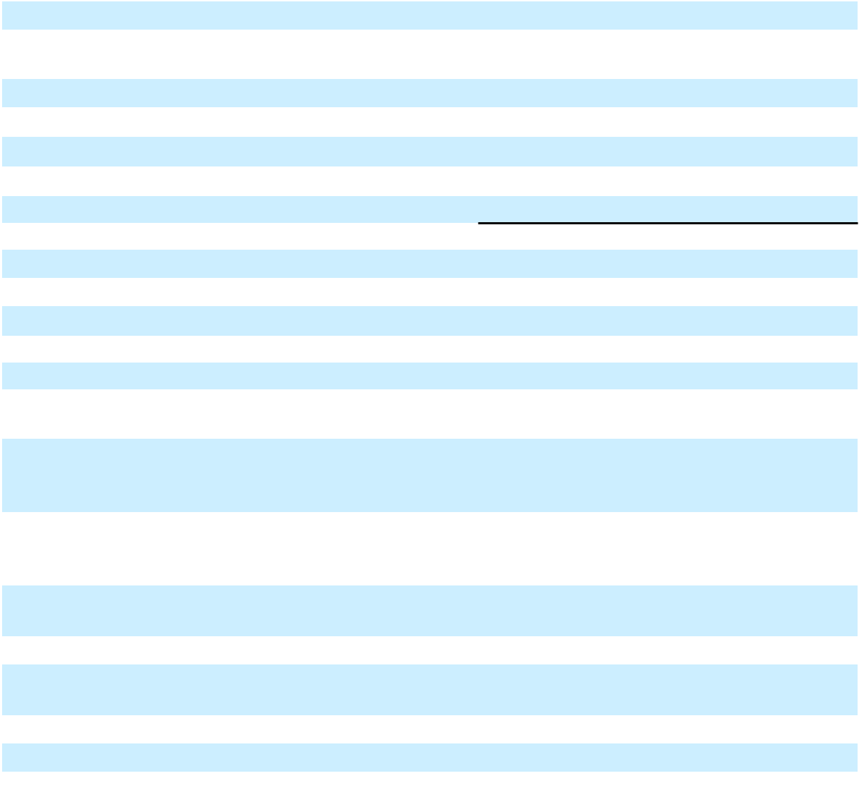

Net increase in cash, cash equivalents and restricted cash |  | 654,763 |  |  | — |  |  | 654,763
Cash, cash equivalents and restricted cash – beginning of
period |  | 310,814 |  |  | — |  |  | 310,814
Cash, cash equivalents and restricted cash – end of period $ |  | 965,577 | $ |  | — $ |  |  | 965,577

Cash paid for interest, net of capitalized interest Cash paid for taxes

Supplemental disclosure of non-cash investing and financing activities:

Changes in accounts payable and accrued liabilities associated with construction in progress and property, plant and equipment additions

Accounts payable and accrued liabilities associated with construction in progress and property, plant and equipment additions

Principal payments on financing obligation paid to Energos by third party charters

Accrued dividend

Preferred shares issued and debt assumed in PortoCem acquisition

Fair value of contingent payments in the Lins acquisition

Deemed dividend related to Series B preferred stock

Non-cash financing costs

2. Organization

Year Ended December 31, 2024

As Reported |  |  | Adjustments |  |  | As Restated
$ | 105,784 | $ |  | (15,466) | $ |  | 90,318
 | 27,932 |  |  | — |  |  | 27,932
 | Year Ended December 31, 2024
As Reported |  |  | Adjustments |  |  | As Restated

$ | (267,366) | $ | 30,805 | $ | (236,561)
 | 463,657 |  | 30,805 |  | 494,462
 | (21,731) |  | — |  | (21,731)
 | 20,507 |  | — |  | 20,507
 | (125,198) |  | — |  | (125,198)
 | 8,080 |  | — |  | 8,080
 | (17,605) |  | — |  | (17,605)
 | 181,928 |  | — |  | 181,928

The Company, a Delaware corporation, is a global energy infrastructure company founded to help address energy poverty and accelerate the world’s transition to reliable, affordable and clean energy. The Company owns and operates natural gas and liquefied natural gas (“LNG”) infrastructure, ships and logistics assets to rapidly deliver turnkey energy solutions to global markets. The Company has liquefaction, regasification and power generation operations in the United States, Brazil and Mexico. The Company has marine operations with vessels operating under time charters and in the spot market globally.

The Company currently conducts its business through two operating segments, Terminals and Infrastructure and Ships. The business and reportable segment information reflects how the Chief Operating Decision Maker (“CODM”) regularly reviews and manages the business. The Company’s CODM is its Chief Executive Officer.

3. Going Concern and Planned Debt Restructuring

F-23

Table of Contents

The accompanying financial statements have been prepared on the basis that the Company will continue as a going concern over the next twelve months from the date of issuance of these financial statements, which assumes the realization of assets and the satisfaction of liabilities in the normal course of business. Due, in part, to the events of default under the Company’s debt agreements detailed below, management has concluded that there is substantial doubt as to the Company’s ability to continue as a going concern. The consolidated financial statements do not include any adjustments to the carrying amounts and classification of assets, liabilities, and reported expenses that may be necessary if the Company were unable to continue as a going concern. On March 17, 2026, the Company entered into an RSA (defined below) with certain noteholders and lenders, and upon completion of the transactions contemplated in this agreement, the Company will have a new capital structure and the current debt facilities in default will no longer be outstanding.

Events of default on outstanding debt are summarized as follows:

- NFE Financing LLC, a subsidiary of the Company (“NFE Financing”), did not make the interest payment of

$163,800 due to holders of the New 2029 Notes on November 17, 2025. An event of default under the indenture governing the New 2029 Notes arose on November 20, 2025, when the contractual grace period for interest payments on such notes expired. On November 18, 2025, the Company and certain of its subsidiaries, including NFE Financing, entered into a forbearance agreement with the beneficial holders of greater than 70% of the New 2029 Notes (the “New 2029 Notes Forbearance Agreement”), pursuant to which such beneficial holders agreed to forbear from accelerating or exercising remedies in respect of such event of default. The New 2029 Notes Forbearance Agreement was initially in effect through December 15, 2025, and the Company continues to have forbearance for defaults covered by the New 2029 Notes Forbearance Agreement and other specified defaults in the RSA as long as the RSA remains in effect.

- The Company did not make the interest payment of $30,644 due under the Term Loan B Credit Agreement on December 10, 2025. An event of default under the Term Loan B Credit Agreement arose on December 17, 2025, when the contractual grace period for interest payments on the loans expired. On December 17, 2025, the Company and certain of its subsidiaries entered into a forbearance agreement with certain lenders of the Term Loan B (the “Term Loan B Forbearance Agreement”), pursuant to which such lenders agreed to forbear from accelerating or exercising remedies in respect of such events of default. The Company also did not make the principal payment of $3,181 due on December 31, 2025, and the event of default arising from the failure to make this principal payment was also covered by the Term Loan B Forbearance Agreement. The Term Loan B Forbearance Agreement was originally scheduled to terminate on January 9, 2026, and the Company continues to have forbearance for defaults covered by the Term Loan B Forbearance Agreement and other specified defaults in the RSA as long as the RSA remains in effect.

- The Company did not make the interest payment of $1,647 due under the Term Loan A Credit Agreement on December 10, 2025. An event of default under the Term Loan A Credit Agreement arose on December 17, 2025, when the contractual grace period for interest payments on the loans expired. On December 17, 2025, the Company and certain of its subsidiaries entered into a forbearance agreement (the “Term Loan A Forbearance Agreement”), with certain lenders of the Term Loan A, pursuant to which such lenders agreed to forbear from accelerating or exercising remedies in respect of such event of default. The Term Loan A Forbearance Agreement was initially in effect through January 9, 2026, and the Company continues to have forbearance for defaults covered by the Term Loan A Forbearance Agreement and other specified defaults in the RSA as long as the RSA remains in effect.

- The Company did not make any interest payments, approximately $13,128 in the aggregate, due under the Revolving Facility, beginning with the payment due on November 28, 2025. An event of default under the Revolving Facility arose on January 13, 2026, when the contractual grace period for interest payments on the loans expired. The Company and certain of its subsidiaries subsequently entered into a forbearance agreement (the “RCF Forbearance Agreement”) with certain lenders to the Revolving Facility, pursuant to which such lenders agreed to forbear from accelerating or exercising remedies in respect of such event of default. The RCF Forbearance Agreement was initially in effect through January 23, 2026, and the Company continues to have forbearance for defaults covered by the RCF Forbearance Agreement and other specified defaults in the RSA as long as the RSA remains in effect.

Planned restructuring transactions

F-24

Table of Contents

On March 17, 2026, the Company entered into a restructuring support agreement (together with all exhibits, annexes and schedules thereto, the “RSA”) with certain of its lenders and noteholders, including:

- certain members of an ad hoc group of holders of the New 2029 Notes;

- certain members of an ad hoc group of term lenders under the Term Loan B Credit Agreement;

- certain holders of debt under the Revolving Credit Agreement, being lenders under a facility currently drawn at approximately $100 million (the “R-1 Revolving Credit Facility”) and under a facility currently drawn at approximately $560 million (the “R-2 Revolving Credit Facility”);

- certain members of an ad hoc group of term lenders under the Term Loan A Credit Agreement; and

- a majority of the members of a group of creditors with recourse to the collateral assets in the Company’s core business, but not to the Company’s Fast LNG assets (or “FLNG”) or Brazil business, including (1) holders of the 2026 Notes and holders of the 2029 Notes and (2) creditors of the debt under that certain Credit Agreement, dated as of November 22, 2024, by and among the Company, as the borrower, the guarantors from time to time party thereto, NFE Brazil Investments LLC, as the lender, and Wilmington Savings Fund Society, FSB, as the administrative agent and as collateral agent (the “Series I Credit Agreement”) and under that certain Credit Agreement, dated as of December 6, 2024, by and among the Company, as the borrower, the guarantors from time to time party thereto, NFE Financing, as the lender, and Wilmington Savings Fund Society, FSB, as the administrative agent and as collateral agent (the “Series II Credit Agreement”) (collectively, the “Supporting Creditors”).

Holders of or lenders under the debt instruments described above that are not already party to the RSA may become Additional Supporting Creditors (as defined in the RSA) by executing and delivering a joinder in accordance with the terms of the RSA.

The RSA sets forth principal terms for a comprehensive restructuring of the Company’s principal funded debt obligations (the “Restructuring Transaction”). The RSA contemplates, among other things, the following material terms:

- The Company will separate into two independent companies: one generally comprising the Company’s businesses and assets in Brazil and land in Wyalusing, Pennsylvania (“BrazilCo”), and the other generally comprising the Company’s other businesses and assets, which will be retained by NFE (“CoreCo”);

- Obligations under the 2026 Notes, the 2029 Notes, the Term Loan A Credit Agreement, the Term Loan B Credit Agreement, the Revolving Credit Agreement, the New 2029 Notes, and certain intercompany credit agreements will be exchanged (in each case on a ratable basis) for one or a combination of the following debt obligations and equity securities:

  - 100% of the common equity interests in BrazilCo;

  - approximately $571,300 in senior secured term loans incurred by the Company, as borrower, and guaranteed by each subsidiary of the Company that will be part of CoreCo (subject to customary exclusions and other exclusions to be agreed) (“New CoreCo Term Loans”);

  - convertible preferred stock of NFE with an aggregate liquidation preference of approximately $2,460,000 (“CoreCo Convertible Preferred Stock”);

  - shares representing 65% of the Company’s Class A common stock as of the closing date of the Restructuring Transaction, before giving effect to shares authorized under an incentive plan for directors, officers and other employees of the Company or any conversion of the CoreCo Convertible Preferred Stock into NFE Class A common stock;

  - $400,000 in non-recourse term loans incurred or issued by the subsidiary that owns the Company’s Fast LNG 2 assets (“FLNG 2 Co”), payable in full on the third anniversary of the closing date of the Restructuring Transaction, guaranteed by certain subsidiaries of FLNG 2 Co and secured by substantially all assets of FLNG 2 Co and such subsidiaries; and / or

F-25

Table of Contents

  - $200,000 in non-convertible, preferred equity (the “FLNG 2 Preferred Equity”) issued by FLNG 2 Co.

- Corporate governance matters regarding CoreCo;

- Letters of credit issued under the Company’s existing Letter of Credit Facility or Revolving Facility will be backstopped or replaced by letters of credit issued under new fully committed letter of credit facilities for each of CoreCo and BrazilCo;

- Certain other existing debt facilities and other liabilities will be refinanced, renegotiated, or compromised, or will remain outstanding in accordance with their existing terms;

- All shares of the Company’s Class A common stock outstanding immediately prior to the consummation of the Restructuring Transaction will remain outstanding and will represent 35% of the Company’s Class A common stock issued and outstanding following the consummation of the Restructuring Transaction (but before giving effect to shares authorized under an incentive plan for directors, officers and other employees of the Company or any conversion of the CoreCo Convertible Preferred Stock into NFE Class A common stock); and

- If required in order to meet a consolidated minimum liquidity threshold ($100,000) on the closing date of the Restructuring Transaction, the Company will offer to all eligible creditors the opportunity to participate in a capital raise, pursuant to which the Company would raise up to $35,000 in aggregate principal amount of additional New CoreCo Term Loans and, to the extent the consolidated minimum liquidity threshold would not be met after giving effect to the additional New CoreCo Term Loans, junior term loans secured by a second-priority lien in an amount so that the consolidated minimum liquidity threshold would be met.

Provided certain conditions are met (as set out in the RSA), the Company will pay to holders of or lenders under the debt instruments described above that become Supporting Creditors on or before 5:00 p.m. New York City time on April 8, 2026, an early consent fee (the “Early Consent Fee”) in an amount equal to 0.75% of the principal amount of such Supporting Creditors’ pro rata claim in:

- the principal outstanding under the 2026 Notes for each supporting holder of 2026 Notes;

- the principal outstanding under the 2029 Notes for each supporting holder of 2029 Notes;

- the principal outstanding under the Term Loan B Credit Agreement for each supporting lender under the Term Loan B Credit Agreement;

- the principal outstanding under the R-1 Revolving Credit Facility for each supporting lender under the R-1 Revolving Credit Facility;

- for each supporting lender under the R-2 Revolving Credit Facility, (i) the principal outstanding under the R-2 Revolving Credit Facility, plus (ii) a share of principal outstanding under the Series I Credit Agreement and the Series II Credit Agreement in proportion to the share of recoveries for lenders under the R-2 Revolving Credit Facility in respect of certain assets of NFE Financing together with a guarantee from Bradford County Real Estate Partners LLC (the “Brazil Collateral”) under an intercreditor agreement dated December 6, 2024 (the “Brazil Parent ICA”);

- for each supporting lender under the Term Loan A Credit Agreement, (i) the principal outstanding under the Term Loan A Credit Agreement, plus (ii) a share of principal outstanding under the Series I Loan Debt and the Series II Loan Debt in proportion to the share of recoveries for lenders under the Term Loan A Credit Agreement in respect of the Brazil Collateral under the Brazil Parent ICA; and

- for each supporting holder of the New 2029 Notes, a share of principal outstanding under the Series I Loan Debt and the Series II Loan Debt in proportion to the share of recoveries for holders of the New 2029 Notes in respect of the Brazil Collateral under the Brazil Parent ICA

The Company has received strong indications of support for the Restructuring Transaction from holders and lenders representing over 95% of its approximately $5.8 billion principal amount of aggregate indebtedness, including approximately 93% of holders of the 2026 Notes, 87% of holders of the 2029 Notes, 98% of holders of the New 2029

F-26

Table of Contents

Notes, 100% of lenders under the Term Loan A Credit Agreement, 88% of lenders under the Term Loan B Credit Agreement, and 100% of lenders of the Revolving Credit Facility as of April 1, 2026.

A Supporting Creditor’s entitlement to the Early Consent Fee will be determined by reference to the aggregate principal amount of notes and loans held by that Supporting Creditor as of the record date specified to creditors for voting under the Restructuring Plans (as defined below). Such early consent fee will be payable in kind in the form of the consideration to be afforded to such Supporting Creditors under the Restructuring Plans. Separately, the Company has agreed to pay each lender under the Revolving Credit Agreement that agrees to forbear from taking any enforcement action under the Revolving Credit Agreement a standstill fee in an amount equal to 2.00% of the outstanding loans made by such forbearing lender, provided that a simple majority of lenders under the Revolving Credit Agreement agree to forbear.

Summary of the CoreCo Convertible Preferred Stock and FLNG 2 Preferred Equity

Pursuant to the terms of the RSA, the CoreCo Convertible Preferred Stock will mandatorily convert on the third anniversary of the closing date of the Restructuring Transaction into shares of NFE Class A common stock representing 87% of the fully diluted Class A common stock of NFE as of the closing date of the Restructuring Transaction (after giving effect to the shares of NFE Class A common stock to be issued on the closing date of the Restructuring Transaction and the incentive plan for directors, officers and other employees of the Company). The conversion rate of the CoreCo Convertible Preferred Stock will be subject to customary adjustments for stock splits, distributions, reorganizations and reclassifications, as well as to certain price-based anti-dilution adjustments for subsequent issuances of NFE Class A common stock (or securities convertible into NFE Class A common stock) made by the Company while the CoreCo Convertible Preferred Stock remains outstanding (subject to certain exempt issuances). CoreCo will have the right to redeem or repurchase the CoreCo Convertible Preferred Stock from time to time with certain sources of proceeds enumerated in the RSA. Holders of the CoreCo Convertible Preferred Stock will be entitled, in arrears, to a cumulative quarterly compounding dividend, which will accrue automatically via an increase to liquidation preference, with a cumulative per annum preferred return of 3.0%, 5.0% and 7.0% in each of the three years, respectively, prior to conversion. The CoreCo Convertible Preferred Stock will participate on an as-converted basis in any dividends and distributions on, and vote together with holders of, NFE Class A common stock. The CoreCo Convertible Preferred Stock will be subordinated in right of payment to all existing and future indebtedness of CoreCo and senior in right of payment to all existing and future equity securities of CoreCo.

The FLNG 2 Preferred Equity will be issued by FLNG 2 Co at the closing date of the Restructuring Transaction pursuant to the RSA and will reflect economic and structural features substantially similar to those of the CoreCo Convertible Preferred Stock, except as otherwise provided herein. CoreCo will have the right to redeem the FLNG 2 Preferred Equity from time to time with certain sources of proceeds enumerated in the RSA. The Company will not pay any dividends on the FLNG 2 Preferred Equity. The FLNG 2 Preferred Equity will be subordinated in right of payment to all existing and future indebtedness of FLNG 2 Co and senior in right of payment to all existing and future equity securities of FLNG 2 Co.

Summary of the New CoreCo Term Loans

The Company expects to use the proceeds of the New CoreCo Term Loans to refinance, on a cashless basis, certain of the loans and other obligations outstanding under the Revolving Credit Agreement and Term Loan B Credit Agreement. If necessary, the cash proceeds of up to $35,000 of additional New CoreCo Term Loans will be used to satisfy the consolidated minimum liquidity threshold required by the RSA. The New CoreCo Term Loans will mature five years after the closing date of the Restructuring Transaction and will amortize at a rate of 1% per annum, paid quarterly. The New CoreCo Term Loans will be guaranteed, jointly and severally, on a senior secured basis by each subsidiary that is a guarantor under the Letter of Credit Facility on the closing date of the Restructuring Transaction, and will be secured by substantially the same collateral as the collateral that currently secures the Letter of Credit Facility, subject to certain exceptions, including the Company’s FLNG 2 assets. To the extent the minimum liquidity threshold is not satisfied after giving effect to the funding of the New CoreCo Term Loans, the Company is permitted to incur additional indebtedness that will be guaranteed by the same guarantors guaranteeing the New CoreCo Term Loans and secured by a second-priority lien on all of the collateral securing the New CoreCore Term Loans.

The New CoreCo Term Loans may be voluntarily prepaid by the Company, in whole or in part, subject to prepayment premiums for optional prepayments equal to 102% of the aggregate principal amount of such term loan prepaid plus accrued and unpaid interest during the first year after the closing of the New CoreCo Credit Agreement, and at par plus accrued and unpaid interest thereafter. The Company will be required to prepay the New CoreCo Term Loans at par with the net proceeds of non-ordinary course asset sales, condemnations and certain other events enumerated in the RSA.

F-27

Table of Contents

Holder Elections

Certain holders of debt under the Revolving Credit Agreement and the Term Loan A Credit Agreement may elect to receive their pro rata share of $45,000 in lieu of the BrazilCo Common Equity they would receive in exchange for their debt. Holders of debt under the Revolving Credit Agreement may elect to receive additional New CoreCo Term Loans in lieu of the CoreCo Convertible Preferred Stock they would receive in exchange for their claims, at a rate of 50% of the liquidation preference of the CoreCo Convertible Preferred Stock in aggregate principal amount of New CoreCo Term Loans.

In addition, one or more directors and officers of the Company and, potentially, certain Supporting Creditors and/or third-party investors, as determined by such directors and officers, will offer to purchase from holders of debt under the Revolving Credit Agreement and Term Loan A Credit Agreement a limited number of shares of CoreCo Convertible Preferred Stock allocated to such holders (subject to certain terms and conditions, including that the relevant holder timely elects to participate in such arrangements) for a cash purchase price of 25% of the liquidation preference of such shares of CoreCo Convertible Preferred Stock.

The Restructuring Plans

The Company expects to complete the Restructuring Transaction through restructuring plans promoted by each of two indirect subsidiaries of the Company, (i) NFE Global Holdings Limited (“NFE Global”) and (ii) NFE Brazil Newco Limited (“NFE Brazil Newco”) (each, a “PlanCo”) under Part 26A of the UK Companies Act 2006 (for each PlanCo, the “Restructuring Plan”, and together, the “Restructuring Plans”) and sanctioned by the High Court of Justice in England (the “UK High Court”). NFE Global will propose a Restructuring Plan (the “CoreCo Plan”) that will compromise the debt under the Series I Credit Agreement, Series II Credit Agreement, 2026 Notes, 2029 Notes, Revolving Credit Agreement, Term Loan A Credit Agreement and Term Loan B Credit Agreement and NFE Brazil Newco will propose a Restructuring Plan (the “BrazilCo Plan”) that will compromise the debt under the New 2029 Notes. The PlanCos will seek recognition of the Restructuring Plans in the United States pursuant to chapter 15 of the U.S. Bankruptcy Code. The Restructuring Plans will bind all relevant creditors, and release the obligations of the Company and all guarantors, under the debt instruments addressed in the Restructuring Plans; however, neither the Company nor any of its subsidiaries other than the PlanCos anticipate being parties to the Restructuring Plans proceedings in the UK High Court, the chapter 15 recognition proceedings or any other restructuring, bankruptcy or insolvency proceeding in connection with the Restructuring Transaction.

The RSA sets forth the commitments of the Company and the Supporting Creditors to, among other things, cooperate in good faith to negotiate the definitive documents necessary or advisable to effect the Restructuring Transaction, use their commercially reasonable efforts to consummate the Restructuring Transaction in accordance with such definitive documents, and refrain from taking any actions that would impede or would otherwise be inconsistent with the Restructuring Transaction (including by supporting or consenting to any alternative transaction, subject, in the case of the Company, to a “fiduciary out”). In addition, the Supporting Creditors have agreed to forbear from exercising remedies (or directing or consenting to any such exercise of remedies) with respect to certain specified defaults and events of default under the applicable debt instruments while the RSA is in effect.

The parties’ obligations to consummate the Restructuring Transaction are subject to the satisfaction of certain conditions, including the UK High Court’s entry of an order sanctioning the Restructuring Plans and the recognition of that order in the United States pursuant to chapter 15 of the U.S. Bankruptcy Code, completion of definitive documents acceptable to the parties in accordance with standards set forth in the RSA, approval of certain matters by the Company’s stockholders, receipt of required regulatory and third-party consents and approvals, and satisfaction of certain process “milestones”.

The RSA may be terminated by the Company and/or the Supporting Creditors, as applicable, upon the occurrence of specified events defined in the RSA, including, without limitation, if (1) a material, uncured breach of certain parties’ representations, warranties, covenants, or obligations under the RSA occurs, (2) any of the conditions to the closing of the Restructuring Transaction (including the timely satisfaction of any of the process “milestones” prescribed in the RSA) is not timely satisfied or waived, (3) certain issued letters of credit are drawn or (4) the Restructuring Transaction has not closed by September 15, 2026 (which date may be automatically extended by up to 90 calendar days in certain circumstances and further extended with the consent of certain parties in accordance with the terms of the RSA through December 31, 2026). In addition, the Company may terminate the RSA if the Company’s board of directors determines, upon the advice of counsel, that the Company’s continued performance under the RSA would be inconsistent with the fiduciary duties of the Company’s directors.

F-28

Table of Contents

The Company intends to submit certain proposals in connection with the Restructuring Transaction to the Company’s stockholders at its 2026 Annual Meeting of Stockholders, including, among other things, an amendment to the Company’s Certificate of Incorporation (the “Certificate of Incorporation”) to increase the number of authorized shares of NFE Class A common stock; approval for the potential issuance of common stock exceeding 20% of the current outstanding shares to comply with Nasdaq rules; an amendment to the Company’s 2019 Omnibus Incentive Plan to increase the number of shares available for grants; and an amendment to the Certificate of Incorporation to authorize a reverse stock split at a ratio to be determined by the Company’s board of directors (collectively, the “Stockholder Proposals”). The Restructuring Transaction is conditioned upon approval of all of the Stockholder Proposals.

Although the Company intends to pursue the Restructuring Transaction in accordance with the terms set forth in the RSA, there can be no assurance that the Company will satisfy all of the conditions under the RSA and complete the Restructuring Transaction as contemplated or at all. If the Company is unable to complete the Restructuring Transaction or any other alternative transactions, the Company will be required or compelled to pursue additional restructuring initiatives to preserve value and optionality, including possible out of court restructurings, or in-court relief, in the UK or the U.S., which could have a material and adverse impact on stockholders. As there are conditions under the RSA that are not in the Company’s control, the execution of the RSA does not alleviate substantial doubt that the Company can continue as a going concern.

4. Significant accounting policies

The principal accounting policies adopted are set out below.

- Basis of presentation and principles of consolidation

The accompanying consolidated financial statements contained herein were prepared in accordance with accounting principles generally accepted in the United States of America (“GAAP”). The consolidated financial statements include the accounts of the Company and its wholly-owned and majority-owned consolidated subsidiaries. The ownership interest of other investors in consolidated subsidiaries is recorded as a non-controlling interest. All significant intercompany transactions and balances have been eliminated on consolidation. Certain prior year amounts have been reclassified to conform to current year presentation.

Non-controlling interests are classified as a separate component of equity on the Consolidated Balance Sheets and Consolidated Statements of Changes in Stockholders’ Equity. Additionally, net income and comprehensive income (loss) attributable to non-controlling interests are reflected separately from consolidated net income and comprehensive income in the Consolidated Statements of Operations and Comprehensive (Loss) Income and Consolidated Statements of Changes in Stockholders’ Equity. Any change in ownership of a subsidiary while the controlling financial interest is retained is accounted for as an equity transaction between the controlling and non-controlling interests. Losses continue to be attributed to the non-controlling interests, even when the non-controlling interests’ basis has been reduced to zero.

- Use of estimates

The preparation of financial statements in conformity with GAAP requires management to make estimates and assumptions that affect the reported amounts of assets and liabilities, the disclosure of contingent assets and liabilities at the date of the consolidated financial statements and the reported amounts of revenues and expenses during the reporting period. Management evaluates its estimates and related assumptions regularly. Changes in facts and circumstances or additional information may result in revised estimates, and actual results may differ from these estimates.

- Foreign currencies

The Company has certain foreign subsidiaries in which the functional currency is the local currency. All of the assets and liabilities of these subsidiaries are translated to U.S. dollars at the exchange rate in effect at the balance sheet date; income and expense accounts are translated at average rates for the period. The effects of translating financial statements of foreign operations into our reporting currency are recognized as a cumulative translation adjustment in accumulated other comprehensive income.

The Company also has foreign subsidiaries that conduct business in currencies other than their respective functional currencies. Transactions are initially recorded in the subsidiaries’ functional currency at the exchange rate in effect on the dates of such transactions. On a monthly basis, these transactions are remeasured to an equivalent amount of the functional

F-29

Table of Contents

currency based on the applicable exchange rate in effect on the remeasurement date. Any adjustment required to remeasure a transaction to the equivalent amount of functional currency is recorded within Other (income) expense, net in the Consolidated Statements of Operations and Comprehensive (Loss) Income. Net realized foreign currency gains or losses relating to the differences between these recorded amounts and the functional currency equivalent actually received or paid are included within Other (income) expense, net in the Consolidated Statements of Operations and Comprehensive (Loss) Income.

Gains and losses on intercompany foreign currency transactions that are long-term in nature and which the Company does not intend to settle in the foreseeable future, are recognized in Accumulated other comprehensive income. Accumulated foreign currency translation adjustments are reclassified from Accumulated other comprehensive income to net income only when realized upon sale or upon complete or substantially complete liquidation of the investment in a foreign entity. If the Company commits to a plan to sell or liquidate a foreign entity, accumulated foreign currency translation adjustments would be included in carrying amounts in impairment assessments.

- Cash and cash equivalents

The Company considers all highly liquid investments with an original maturity of three months or less at the time of purchase to be cash equivalents.

- Restricted cash

Restricted cash consists of funds that are contractually restricted as to usage or withdrawal and have been presented separately from cash and cash equivalents on the Consolidated Balance Sheets.

- Receivables

Receivables are contractual rights to receive cash on a fixed or determinable date and are recognized on the balance sheet as the amount invoiced to the customer, net of an allowance for current expected credit losses. Accounts receivable are carried at amortized cost. Amounts are written off against the allowance when management is certain that outstanding amounts will not be collected. The Company estimates expected credit losses based on relevant information about the current credit quality of customers, past events, including historical experience, and reasonable and supportable forecasts that affect the collectability of the reported amount. Credit loss expense, inclusive of credit loss expense on all categories of financial assets, is recorded within Selling, general and administrative in the Consolidated Statements of Operations and Comprehensive (Loss) Income.

- Inventories

LNG and natural gas inventories, bunker fuel inventories and automotive diesel oil inventories are recorded at weighted average cost, and materials and other inventory are recorded at cost. The Company’s cost to convert natural gas to LNG, which primarily consists of labor, depreciation and other direct costs to operate liquefaction facilities, is reflected in Inventory on the Consolidated Balance Sheets.

Inventory is adjusted to the lower of cost or net realizable value each quarter. Changes in the value of inventory are recorded within Cost of sales in the Consolidated Statements of Operations and Comprehensive (Loss) Income.

LNG is subject to “boil-off,” a natural loss of gas volume over time when LNG is exposed to environments with temperatures above its optimum storage state. Boil-off losses are expensed through Cost of sales in the Consolidated Statements of Operations and Comprehensive (Loss) Income in instances where gas cannot be contained and recycled back into the production process.

- Construction in progress

Construction in progress is recorded at cost, and at the point at which the constructed asset is put into use, the full cost of the asset is reclassified from Construction in progress to Property, plant and equipment, net on the Consolidated Balance Sheets. Construction progress payments, engineering costs, certain direct payroll costs and other costs directly relating to the asset under construction are capitalized during the construction period, provided the completion of the construction project is deemed probable or if the costs are associated with activities that could be utilized in future projects. Prior to putting projects into service the Company may utilize gas to test and commission the assets, and the Company may be able

F-30

Table of Contents

to invoice our customers for gas used in commissioning. Amounts received as a result of the sale of test gas reduce the Construction in progress balance. Depreciation is not recognized during the construction period and commences when the assets are ready for their intended use, which may require management to make subjective judgments and assumptions about the conditions necessary for the assets to be capable of operating in the intended manner.

The interest cost associated with major development and construction projects is capitalized during the construction period and included in the cost of the project in Construction in progress.

- Property, plant and equipment, net

Property, plant and equipment is initially recorded at cost. Expenditures for construction activities and betterments that extend the useful life of the asset are capitalized. Vessel refurbishment costs are capitalized and depreciated over the vessels’ remaining economic useful lives. Refurbishment costs increase the capacity or improve the efficiency or safety of vessels and equipment. Expenditures for routine maintenance and repairs for assets in the Terminals and Infrastructure segment are charged to expense as incurred within Operations and maintenance in the Consolidated Statements of Operations and Comprehensive (Loss) Income; such expenditures for assets in the Ships segment that do not improve the operating efficiency or extend the useful lives of the vessels are expensed as incurred within Vessel operating expenses.

Major maintenance and overhauls of the Company’s power plant and terminals are capitalized and depreciated over the expected period until the next anticipated major maintenance or overhaul.

Drydocking expenditures, including drydocking expenditures related to vessels that were included in the Energos Formation Transaction (defined below), are capitalized when incurred and amortized over the period until the next anticipated drydocking, which is generally five years. For vessels, the Company utilizes the “built-in overhaul” method of accounting and segregates vessel costs into those that should be depreciated over the useful life of the vessel and those that relate to drydocking at periodic intervals. If drydocking occurs prior to the expected timing, a cumulative adjustment to recognize the change in expected timing of drydocking is recognized within Depreciation and amortization in the Consolidated Statements of Operations and Comprehensive (Loss) Income.

The Company depreciates property, plant and equipment less the estimated residual value using the straight-line depreciation method over the estimated economic life of the asset or lease term, whichever is shorter using the following useful lives:

 | Useful life
 | (Yrs)
Vessels | 5-40
Terminal and power plant equipment | 5-50
Power facilities | 18-20
ISO containers and other equipment | 3-10
LNG liquefaction facilities | 7-40
Gas pipelines | 10-45
Leasehold improvements | 2-27
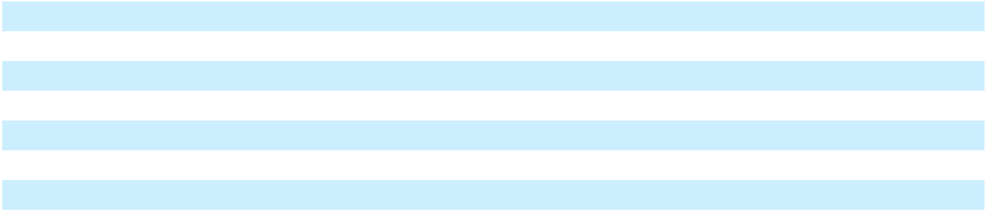

The Company reviews the remaining useful life of its assets on a regular basis to determine whether changes have taken place that would suggest that a change to depreciation policies is warranted.

Upon retirement or disposal of property, plant and equipment, the cost and related accumulated depreciation are removed from the account, and the resulting gains or losses, if any, are recorded in (Gain) loss on sale in the Consolidated Statements of Operations and Comprehensive (Loss) Income. When a vessel is disposed, any unamortized drydocking expenditure is recognized as part of the gain or loss on disposal in the period of disposal.

- Impairment of long-lived assets

The Company performs a recoverability assessment of long-lived assets whenever events or changes in circumstances indicate that the carrying amount of an asset may not be recoverable. Indicators may include, but are not limited to, an impairment of goodwill, adverse changes in the regulatory environment in a jurisdiction where the Company operates,

F-31

Table of Contents

unfavorable events impacting the supply chain for LNG to the Company’s operations, a decision to discontinue the development of a long-lived asset, early termination of a significant customer contract or the introduction of newer technology.

When performing a recoverability assessment, the Company measures whether the estimated future undiscounted net cash flows expected to be generated by the asset exceeds its carrying value. In the event that an asset does not meet the recoverability test, the carrying value of the asset will be adjusted to fair value resulting in an impairment charge, included in Asset impairment expense in the Consolidated Statements of Operations and Comprehensive (Loss) Income.

Depending on the underlying nature of the asset group, the fair value is determined using a market approach, which uses Level 2 inputs, including quoted prices for similar assets or market corroborated inputs; or an income approach, which uses Level 3 inputs, including assumptions as to undiscounted projected cash flows to be generated over the remaining useful life of the primary asset of the asset group at the lowest level with identifiable cash flows that are independent of other assets.

- Investments in equity securities

Investments in equity securities are carried at fair value and included in Other non-current assets on the Consolidated Balance Sheets, with gains or losses recorded in earnings in Other (income) expense, net in the Consolidated Statements of Operations and Comprehensive (Loss) Income. Investments in non-publicly traded equity instruments without a readily determinable fair value are recorded at cost, adjusted for observable price changes in orderly transactions for the identical or similar securities of the same issuer and changes resulting from impairments, if any.

- Cloud computing costs

The Company capitalizes the costs incurred during the implementation stage for cloud computing or hosting arrangements. Costs incurred in the preliminary project stage and post-implementation stage, which includes maintenance and training costs, are expensed as incurred. Such costs are recorded in Transaction and integration costs in the Consolidated Statements of Operations and Comprehensive (Loss) Income. Capitalized software costs are amortized over the straight-line method over three to five years and are recorded in Other non-current assets, net on the Consolidated Balance Sheets. Amortization expense is recorded in Selling, general and administrative in the Consolidated Statements of Operations and Comprehensive (Loss) Income.

- Intangible assets

Upon a business combination or asset acquisition, the Company may obtain identifiable intangible assets. Intangible assets with a finite life are amortized over the estimated useful life of the asset under the straight-line method.

Indefinite lived intangible assets are not amortized. Intangible assets with an indefinite useful life are tested for impairment on an annual basis, on October 1st of each year, or more frequently if changes in circumstances indicate that it is more likely than not that the asset is impaired. Indefinite lived intangible assets are evaluated for impairment either under the qualitative assessment option or the two-step quantitative test. If the carrying amount of an intangible asset being tested for impairment exceeds its fair value, the excess is recognized as impairment expense in the Consolidated Statements of Operations and Comprehensive (Loss) Income.

- Goodwill

Goodwill includes the excess of the purchase price over the fair value of the net tangible and intangible assets acquired in a business combination.

The Company reviews the carrying values of goodwill at least annually to assess impairment since these assets are not amortized. An annual impairment assessment is conducted as of October 1st of each year. Additionally, the Company reviews the carrying value of goodwill whenever events or changes in circumstances indicate that its carrying amount may not be recoverable.

For an annual goodwill impairment assessment, an optional qualitative analysis may be performed. If the option is not elected or if it is more likely than not that the fair value of a reporting unit is less than its carrying amount, then a two-step goodwill impairment test is performed to identify potential goodwill impairment and to measure an impairment loss.

F-32

Table of Contents

A goodwill impairment assessment compares the fair value of a respective reporting unit with its carrying amount, including goodwill. The estimate of fair value of the respective reporting unit is based on the best information available as of the date of assessment, which primarily incorporates assumptions about operating results, business plans, income projections, anticipated future cash flows and market data. If goodwill is determined to be impaired, an impairment loss, measured at the amount by which the reporting unit’s carrying amount exceeds its fair value, not to exceed the carrying amount of goodwill, is recorded. The impairment is recognized as Goodwill impairment expense in the Consolidated Statements of Operations and Comprehensive (Loss) Income

- Debt and debt issuance costs

We evaluate the terms of our debt arrangements to determine whether they contain an embedded derivative that is required to be bifurcated. Any embedded derivatives that are required to be bifurcated are recorded at fair value within Other current liabilities and Other long-term liabilities on the Consolidated Balance Sheets. We classify a debt obligation as current when it is due or will be due on demand as a result of certain acceleration provisions, including but not limited to non-compliance with covenant requirements, within one year from the balance sheet date.

Costs directly related to the issuance of debt are reported on the Consolidated Balance Sheets as a reduction from the carrying amount of the recognized debt liability and amortized over the term of the debt using the effective interest method. Unamortized debt issuance costs associated with the revolving credit agreement, facilities for the issuance of letters of credit and other similar arrangements are presented as an asset within Other non-current assets on the Consolidated Balance Sheets (regardless of whether there are any amounts outstanding under the credit facility) and amortized over the life of the particular arrangement. Interest and related amortization of debt issuance costs recognized during major development and construction projects are capitalized and included in the cost of the project.

The Company evaluates changes to debt arrangements to determine whether the changes represent a modification or extinguishment to the old debt arrangement. The evaluation is also performed when fees are paid to or on behalf of the lenders in order to obtain covenant waivers, forbearance or other contractual changes that impact the instruments cash flows. If a debt instrument is deemed to be modified, all new lender fees are capitalized, and third-party fees associated with the previous lenders are recognized as expense within Transaction and integration costs in the Consolidated Statements of Operations and Comprehensive (Loss) Income. If an extinguishment of debt instruments has occurred, the unamortized financing fees associated with the extinguished instrument and lender fees are expensed to Loss on extinguishment of debt, net in the Consolidated Statements of Operations and Comprehensive (Loss) Income. In the event an amendment to the Revolving Facility (defined below) reduces the borrowing capacity of any lenders, the portion of any unamortized fees associated with such lender is expensed on a pro-rata basis in proportion to the decrease in the borrowing capacity.

- Contingencies

The Company may be involved in legal actions in the ordinary course of business. A loss contingency is recognized in the consolidated financial statements when it is probable a liability has been incurred and the amount of the loss can be reasonably estimated, which is recorded at the low end of the range of potential losses and presented within Selling, general and administrative in the Consolidated Statements of Operations and Comprehensive (Loss) Income. The Company discloses any loss contingencies that do not meet both conditions if there is a reasonable possibility that a loss may have been incurred. Gain contingencies are not recorded until realized.

- Revenue recognition

Terminals and Infrastructure

Within the Terminals and Infrastructure segment, the Company’s contracts with customers may contain one or several performance obligations usually consisting of the sale of LNG, natural gas, power and steam, which are outputs from the Company’s natural gas-fueled infrastructure. The transaction price for each of these contracts is structured using similar inputs and factors regardless of the output delivered to the customer. The customers consume the benefit of the natural gas, power and steam when they are delivered by the Company to the customer’s power generation facilities or interconnection facility. Natural gas, power and steam qualify as a series with revenue being recognized over time using an output method, based on the quantity of natural gas, power or steam that the customer has consumed. LNG is delivered in containers transported by truck to customer sites but may also be delivered via vessel to an unloading point specified in a contract. Revenue from sales of LNG is recognized at the point in time at which the LNG transfers to the customer, depending on

F-33

Table of Contents

the terms of the contract. Because the nature, timing and uncertainty of revenue and cash flows are substantially the same for LNG, natural gas, power and steam, the Company has presented Operating revenue on an aggregated basis.

The Company has concluded that the variable consideration included in its agreements meets the exception for allocating variable consideration. As such, the variable consideration for these contracts is allocated to each distinct unit of LNG, natural gas, power or steam delivered and recognized when that distinct unit is delivered to the customer.

The Company’s contracts with industrial end-user customers to supply natural gas or LNG may contain a lease of equipment or vessels, which may be accounted for as a finance or operating lease. For operating leases, the Company has elected the practical expedient to combine revenue for the sale of natural gas or LNG and operating lease income as the timing and pattern of transfer of the components are the same. The Company has concluded that the predominant component of the transaction is the sale of natural gas or LNG and therefore has not separated the lease component. The lease component of such operating leases is recognized as Operating revenue in the Consolidated Statements of Operations and Comprehensive (Loss) Income. The Company allocates consideration in agreements containing finance leases between lease and non-lease components based on the relative fair value of each component. The fair value of the lease component is estimated based on the estimated standalone selling price of the same or similar equipment leased to the customer. The Company estimates the fair value of the non-lease component by forecasting volumes and pricing of gas to be delivered to the customer over the lease term.

The current and non-current portion of finance leases are recorded within Prepaid expenses and other current assets and Other non-current assets, net on the Consolidated Balance Sheets, respectively. For finance leases accounted for as sales-type leases, the profit from the sale of equipment is recognized upon lease commencement in Other revenue in the Consolidated Statements of Operations and Comprehensive (Loss) Income. The lease payments for finance leases are segregated into principal and interest components similar to a loan. Interest income is recognized on an effective interest method over the lease term and included in Other revenue in the Consolidated Statements of Operations and Comprehensive (Loss) Income. The principal component of the lease payment is reflected as a reduction to the net investment in the lease.

Other revenue includes revenue recognized by the Company’s subsidiary, Genera PR LLC (“Genera”), under its contract for the operation and maintenance of Puerto Rico Electric Power Authority’s (“PREPA”) thermal generation assets. Under this agreement, Genera is reimbursed for pass-through expenses, including payroll expenses of Genera employees. Genera is the principal for operation and maintenance services, and the Company recognizes revenue for amounts to be reimbursed by PREPA in the period such expenses are incurred. Genera is also eligible for performance-based incentive fees, which are considered variable consideration.

The Company estimates the amount of variable consideration as the most likely amount, which is included in the transaction price to the extent that it is probable that a significant reversal of cumulative revenue recognized will not occur when the uncertainty associated with the variable consideration is resolved. The determination of estimated amounts included in the transaction price is based largely upon an assessment of the uncertainties associated with the variable consideration, including the susceptibility of payment to factors outside of the Company’s control. The Company considers all information that is reasonably available, including historical information and estimates of future performance.

In addition, the Company’s agreements may include a significant financing component, and the Company recognizes revenue for the interest income component over the term of the financing as Other revenue. The Company elected the practical expedient under which the Company does not adjust consideration for the effects of a significant financing component for those contracts where the Company expects at contract inception that the period between transferring goods to the customer and receiving payment from the customer will be one year or less.

The timing of revenue recognition, billings and cash collections results in receivables, contract assets and contract liabilities. Receivables represent unconditional rights to consideration. Contract assets include unbilled amounts resulting from contracts, in which the performance obligation is satisfied and revenue is recognized while our right to receipt is conditional upon certain considerations. Contract assets are recognized within Prepaid expenses and other current assets, net and Other non-current assets, net on the Consolidated Balance Sheets. Contract liabilities consist of deferred revenue and are recognized within Other current liabilities and Other long-term liabilities on the Consolidated Balance Sheets.

Shipping and handling costs are not considered to be separate performance obligations. All such shipping and handling activities are performed prior to the customer obtaining control of the LNG or natural gas.

F-34

Table of Contents

The Company collects sales taxes from its customers based on sales of taxable products and remits such collections to the appropriate taxing authority. The Company has elected to present sales tax collections in the Consolidated Statements of Operations and Comprehensive (Loss) Income on a net basis and, accordingly, such taxes are excluded from reported revenues.

Ships

Charter contracts for the use of the FSRUs and LNG carriers are leases as the contracts convey the right to obtain substantially all of the economic benefits from the use of the asset and allow the customer to direct the use of that asset.

At inception, the Company makes an assessment on whether the charter contract is an operating lease or a finance lease. Renewal periods and termination options are included in the lease term if the Company believes such options are reasonably certain to be exercised by the lessee. Generally, lease accounting commences when the asset is made available to the customer, however, where the contract contains specific customer acceptance testing conditions, the lease will not commence until the asset has successfully passed the acceptance test. The Company assesses leases for modifications when there is a change to the terms and conditions of the contract that results in a change in the scope or the consideration of the lease.

Revenue includes lease payments under charters accounted for as operating leases and fees for repositioning vessels. Revenue generated from charters contracts is recorded over the term of the charter on a straight-line basis as service is provided and is included in Vessel charter revenue in the Consolidated Statements of Operations and Comprehensive (Loss) Income. Lease payments include fixed payments (including in-substance fixed payments that are unavoidable) and variable payments based on a rate or index. For operating leases, the Company has elected the practical expedient to combine service revenue and operating lease income as the timing and pattern of transfer of the components are the same. Variable lease payments are recognized in the period in which the circumstances on which the variable lease payments are based become probable or occur.

Repositioning fees are included in Vessel charter revenue and are recognized at the end of the charter when the fee becomes fixed. However, where there is a fixed amount specified in the charter, which is not dependent upon redelivery location, the fee is recognized evenly over the term of the charter.

Costs directly associated with the execution of the lease or costs incurred after lease inception but prior to the commencement of the lease that directly relate to preparing the asset for the contract are capitalized and amortized in Vessel operating expenses in the Consolidated Statements of Operations and Comprehensive (Loss) Income over the lease term.

- Sale or transfer of nonfinancial assets

The Company accounts for the sale of nonfinancial long-lived assets, including vessels under failed sale leaseback transaction, in accordance with ASC 610-20, Gains and Losses from the Derecognition of Nonfinancial Assets. An asset is derecognized when control transfers to the buyer, which generally occurs upon delivery of the asset and the satisfaction of all substantive conditions under the sale agreement, or when the conditions that led to failed sale leaseback accounting cease to exist. Proceeds from the disposition of an asset are measured based on the contractual sales price, adjusted for any variable or contingent consideration to the extent such amounts are not constrained. Gains or losses on the disposition of an asset are recorded within (Gain) loss on sale in the Consolidated Statements of Operations and Comprehensive (Loss) Income, and reflect the difference between the net proceeds received and the asset’s carrying amount at the date control transfers.

- Leases, as lessee

The Company has entered into lease agreements primarily for the use of LNG vessels, marine port space, office space, land and equipment. Right-of-use (“ROU”) assets recognized for these leases represent the Company’s right to use an underlying asset for the lease term, and the lease liabilities represent the Company’s obligation to make lease payments arising from the lease. ROU assets and lease liabilities are recognized at the lease commencement date based on the estimated present value of fixed lease payments over the lease term.

F-35

Table of Contents

Leases with terms of 12 months or less are excluded from ROU assets and lease liabilities on the balance sheet, and short-term lease payments are recognized on a straight-line basis over the lease term. Variable payments under short-term leases are recognized in the period in which the obligation that triggers the variable payment becomes probable.

The Company, as lessee, has also elected the practical expedient not to separate lease and non-lease components for marine port space, office space, land and equipment leases. The Company separates the lease and non-lease components for vessel leases. The allocation of lease payments between lease and non-lease components has been determined based on the relative fair value of each component. The fair value of the lease component is estimated based on the estimated standalone price of leasing a bareboat vessel. The fair value of the non-lease component is estimated based on the estimated standalone price of operating the respective vessel, inclusive of the costs of the crew and other operating costs.

The Company has elected the land easement practical expedient, which allows the Company to continue to account for pre-existing land easements as intangible assets under the accounting policy that existed before adoption of ASC 842 Leases.

- Share-based compensation

The Company adopted the New Fortress Energy Inc. 2019 Omnibus Incentive Plan (the “Incentive Plan”), effective as of February 4, 2019. Under the Incentive Plan, the Company may issue options, share appreciation rights, restricted shares, restricted share units (“RSUs”), performance share units (“PSUs”) or other share-based awards to selected officers, employees, non-employee directors and select non-employees of NFE or its affiliates. The Company accounts for share-based compensation in accordance with ASC 718, Compensation and ASC 505, Equity, which require all share-based payments to employees and members of the board of directors to be recognized as expense in the consolidated financial statements based on their grant date fair values. The fair value is adjusted for material non-public information that the Company may be aware of as of the grant date. The Company has elected not to estimate forfeitures of its share-based compensation awards but recognizes the reversal in compensation expense in the period in which the forfeiture occurs.

The Company has granted RSUs to certain employees that will settle in shares of a subsidiary owning the Company’s Brazil operations. These RSUs contain a performance condition, and vesting is determined based on achievement of certain milestones subsequent to the grant. Compensation expense is recognized on a straight-line basis over the respective service period based on the expected achievement of each milestone. At each reporting period, the Company reassesses the probability of the achievement of the milestones, and any increase or decrease in share-based compensation expense resulting from an adjustment in the number of shares expected to vest is treated as a cumulative catch-up in the period of adjustment.

- Lessor expense recognition

Vessel operating expenses are recognized when incurred. Vessel operating expenses include crewing, repairs and maintenance, insurance, stores, lube oils, communication expenses and third-party management fees. Initial direct costs include costs directly related to the negotiation and consummation of the lease and are deferred and recognized in Vessel operating expenses over the lease term.

- Transaction, integration and restructuring costs

Transaction, integration and restructuring costs is comprised of costs related to business combinations, dispositions and corporate restructuring activities. These costs include advisory, legal, accounting, valuation and other professional or consulting fees.

This caption also includes gains or losses recognized in connection with business combinations, including the settlement of preexisting relationships between the Company and an acquired entity. Financing costs which are not deferred as part of the cost of financing on the balance sheet including fees associated with debt modifications are recognized within this caption. The Company expenses cloud computing costs incurred during the preliminary project stage and post-implementation stage, and these amounts are presented within this caption.

- Taxation

The Company accounts for income taxes in accordance with ASC 740, Accounting for Income Taxes (“ASC 740”), under which deferred tax assets and liabilities are recognized for the future tax consequences attributable to differences between the financial statement carrying amounts and the tax bases of assets and liabilities by applying the enacted tax rates in

F-36

Table of Contents

effect for the year in which the differences are expected to reverse. Such net tax effects on temporary differences are reflected on the Company’s Consolidated Balance Sheets as deferred tax assets and liabilities. Deferred tax assets are reduced by a valuation allowance when the Company believes that it is more-likely-than-not that some portion or all of the deferred tax assets will not be realized.

The Company recognizes the effect of tax positions only if those positions are more likely than not of being sustained. Recognized tax positions are measured at the largest amount that is greater than 50 percent likely of being realized upon ultimate settlement with the relevant tax authority. Conclusions reached regarding tax positions are continually reviewed based on ongoing analyses of tax laws, regulations and interpretations thereof. To the extent that the Company’s assessment of the conclusions reached regarding tax positions changes as a result of the evaluation of new information, such change in estimate will be recorded in the period in which such determination is made. The Company reports interest and penalties relating to an underpayment of income taxes, if applicable, as a component of income tax expense.

The Company has elected to treat amounts incurred under the global intangible low-taxed income (“GILTI”) rules as an expense in the period in which the tax is accrued. Accordingly, no deferred tax assets or liabilities are recorded related to GILTI.

Other taxes

Certain subsidiaries may be subject to payroll taxes, excise taxes, property taxes, sales and use taxes, in addition to income taxes in foreign countries in which they conduct business. In addition, certain subsidiaries are exposed to local state taxes, such as franchise taxes. Local, state and any other taxes that are not income taxes are recorded within Selling, general and administrative in the Consolidated Statements of Operations and Comprehensive (Loss) Income.

- Net income per share

Basic net income per share (“EPS”) is computed by dividing net income attributable to Class A common stock by the weighted average number of shares of Class A common stock outstanding. The dilutive effect of outstanding awards, if any, is reflected in diluted earnings per share by application of the treasury stock method or if-converted method, as applicable.

- Acquisitions

Business combinations are accounted for under the acquisition method. On acquisition, the identifiable assets acquired and liabilities assumed are measured at their fair values at the date of acquisition. Any excess of the purchase price over the fair values of the identifiable net assets acquired is recognized as goodwill. Acquisition-related costs are expensed as incurred as Transaction and integration costs in the Consolidated Statements of Operations and Comprehensive (Loss) Income. The results of operations of acquired businesses are included in the Company’s Consolidated Statements of Operations and Comprehensive (Loss) Income from the date of acquisition.

If the assets acquired do not meet the definition of a business, the transaction is accounted for as an asset acquisition and no goodwill is recognized. Costs incurred in conjunction with asset acquisitions are included in the purchase price, and any excess consideration transferred over the fair value of the net assets acquired is reallocated to the identifiable assets based on their relative fair values.

- Equity method investments

The Company accounts for investments in entities over which the Company has significant influence, but do not meet the criteria for consolidation, under the equity method of accounting. Under the equity method of accounting, the Company’s investment is recorded at cost. In the case of equity method investments acquired as part of a business combination or acquired in exchange for the contribution of assets or entities to the investee, the investment is initially recorded at the acquisition date fair value of the investment. The carrying amount is adjusted for the Company’s share of the earnings or losses, and dividends received from the investee reduce the carrying amount of the investment. The Company allocates the difference between the fair value of investments acquired in a business combination and the Company’s proportionate share of the carrying value of the underlying assets, or basis difference, across the assets and liabilities of the investee. The basis difference assigned to amortizable net assets is included in Income from equity method investments in the Consolidated Statements of Operations and Comprehensive (Loss) Income. When the Company’s share of losses in an

F-37

Table of Contents

investee equals or exceeds the carrying value of the investment, no further losses are recognized unless the Company has incurred obligations or made payments on behalf of the investee.

The Company periodically assesses if impairment indicators exist at equity method investments. When an impairment is observed, any excess of the carrying amount over its estimated fair value is recognized as impairment expense when the loss in value is deemed other-than-temporary and included in Income from equity method investments in the Consolidated Statements of Operations and Comprehensive (Loss) Income.

- Loss of control of subsidiary

When there is a loss of control over a subsidiary, the Company de-consolidates the entity as of the date the Company ceases to have a controlling financial interest. The Company accounts for the deconsolidation of a subsidiary by recognizing a gain or loss in the Consolidated Statements of Operations and Comprehensive (Loss) Income, measured by the difference between the aggregate of the fair value of the consideration received, fair value of any retained non-controlling interest in the former subsidiary and the carrying amount of any non-controlling interest in the former subsidiary with the carrying amount of the former subsidiary’s assets and liabilities. If a change of ownership interest causes a loss of control of a foreign entity, in addition to de-recognizing the assets and liabilities, the Company will also de-recognize any amounts previously recorded in other comprehensive income.

(ab) Guarantees

Guarantees issued by the Company, excluding those that are guaranteeing the Company’s own performance, are recognized at fair value at the time that the guarantees are issued and recognized in Other current liabilities or Other non-current liabilities on the Consolidated Balance Sheets. Depending on the nature of the guarantee, the Company recognizes its release from risk over the term of the guarantee using one of the following methods: (i) only upon either expiration or settlement of the guarantee, or (ii) by a systematic and rational amortization method. If it becomes probable that the Company will have to perform under a guarantee, the Company will recognize an additional liability if the amount of the loss can be reasonably estimated.

(ac) Derivatives

The Company may enter into derivative positions to reduce market risks associated with interest rates, foreign exchange rates and commodity prices. The Company also accounts for arrangements that require the Company to pay sellers contingent payments in asset acquisitions as derivatives. All derivative instruments are initially recorded at fair value as either assets or liabilities on the Consolidated Balance Sheets and subsequently remeasured to fair value, regardless of the purpose or intent for holding the derivative, unless they qualify for a Normal Purchases and Normal Sales (“NPNS”) exception. The Company has not designated any derivatives as cash flow or fair value hedges; however, certain instruments may be considered economic hedges. Cash inflows and outflows related to commodity derivatives, foreign currency and interest rate swap are classified in the Consolidated Statements of Cash Flows based on the risk that the instrument is intended to mitigate, which may be operating, investing or financing.

Revenues and expenses on contracts that qualify for the NPNS exception are recognized when the underlying physical transaction is delivered under other applicable GAAP (e.g., ASC 606 or ASC 705). While these contracts are considered derivative financial instruments under ASC 815, Derivatives and Hedging, they are not recorded at fair value, but on an accrual basis of accounting. If it is determined that a transaction designated as NPNS no longer meets the scope exception, the fair value of the related contract is recorded on the balance sheet and immediately recognized through earnings.

5. Adoption of new and revised standards

New standards, amendments and interpretations issued but not effective for the year beginning January 1, 2025:

In November 2024, the FASB issued ASU 2024-03, Income Statement—Reporting Comprehensive Income—Expense Disaggregation Disclosures (Subtopic 220-40): Disaggregation of Income Statement Expenses. These amendments require public business entities to disclose additional information about specific expense categories in the notes to financial statements at each interim and annual reporting period. ASU 2024-03 will be effective for annual reporting periods beginning after December 15, 2026, and interim reporting periods beginning after December 15, 2027. Early adoption is permitted. The amendments can be applied prospectively or retrospectively. The Company is currently reviewing the impact that the adoption of ASU 2024-03 may have on the Company’s financial statements and disclosures.

F-38

Table of Contents

In July 2025, the FASB issued ASU No. 2025-05, Financial Instruments-Credit Losses (Topic 326) - Measurement of Credit Losses for Accounts Receivable and Contract Assets. The amendment provides a practical expedient that allows entities to assume that current conditions as of the balance sheet date do not change for the remaining life of the asset when estimating expected credit losses for current accounts receivable and current contract assets. The amendments of the ASU should be applied prospectively and are effective for annual periods beginning after December 15, 2025, and interim reporting periods within those annual reporting periods. Early adoption is permitted in both interim and annual reporting periods in which financial statements have not yet been issued or made available for issuance. The Company is currently evaluating the impact that the adoption of ASU 2025-05 may have on the Company’s financial statements and disclosures.

In September 2025, the FASB issued ASU No. 2025-06, Intangibles—Goodwill and Other—Internal-Use Software (Subtopic 350-40). The amendments remove all references to prescriptive and sequential software development stages (referred to as “project stages”) throughout Subtopic 350-40 and specify that the disclosures in Subtopic 360-10, Property, Plant, and Equipment—Overall, are required for all capitalized internal-use software costs, regardless of how those costs are presented in the financial statements. The amendments are effective for annual periods beginning after December 15, 2027, and interim reporting periods within those annual reporting periods. Early adoption is permitted. The amendments can be applied prospectively, on a modified retrospective basis, or retrospectively. The Company is currently evaluating the impact that the adoption of ASU 2025-06 may have on the Company’s financial statements and disclosures.

In September 2025, the FASB issued ASU No. 2025-07, Derivatives and Hedging (Topic 815) and Revenue from Contracts with Customers (Topic 606). The amendments provide a scope exception to exclude from derivative accounting nonexchange-traded contracts with underlyings that are based on operations or activities specific to one of the parties to the contract. The amendments are effective for annual periods beginning after December 15, 2026, and interim reporting periods within those annual reporting periods. Early adoption is permitted. The amendments can be applied prospectively or on a modified retrospective basis. The Company is currently evaluating the impact that the adoption of ASU 2025-07 may have on the Company’s financial statements and disclosures.

New and amended standards adopted by the Company:

In December 2023, the FASB issued ASU 2023-09, Income Taxes (Topic 740): Improvements to Income Tax Disclosures, requiring companies to annually disclose specific categories in the effective tax rate reconciliation and provide additional information for reconciling items that meet a quantitative threshold. Further, the ASU requires disclosure of income taxes paid (net of refunds received) disaggregated by federal (national), state and foreign taxes and to disaggregate the information by jurisdiction based on a quantitative threshold. The amendments in this ASU are effective for annual periods beginning after December 15, 2024, and early adoption is permitted. The amendments should be applied on a prospective basis, but retrospective application is permitted. The Company has adopted ASU 2023-09 on a prospective basis and included the new disclosures in Note 24.

In March 2024, the FASB issued ASU 2024-01, Compensation—Stock Compensation (Topic 718): Scope Application of Profits Interest and Similar Awards, providing illustrative guidance to help entities determine whether profits interest and similar awards should be accounted for as share-based payment arrangements within the scope of Topic 718. The amendments in this ASU are effective for annual periods beginning after December 15, 2024, and interim periods within those annual periods. Early adoption is allowed, and the amendments can be applied on a prospective or retrospective basis. The Company adopted ASU 2024-01 on January 1, 2025 and will apply the amendments on a prospective basis. The Company has not entered into any new or amended agreements which would require the application of the guidance.

The Company has reviewed all other recently issued accounting pronouncements and concluded that such pronouncements are either not applicable to the Company or no material impact is expected in the consolidated financial statements as a result of future adoption.

6. Dispositions (As Restated)

Jamaica business sale

In March 2025, the Company entered into an equity and asset purchase agreement (the “EAPA”) to sell the Company’s Jamaica business, including operations at the LNG import terminal in Montego Bay, the offshore floating storage and regasification terminal in Old Harbour and the 150 megawatt Combined Heat and Power Plant in Clarendon, along with the associated infrastructure (the “Jamaica Business”) to Excelerate Energy Limited Partnership (“EELP”), a subsidiary of Excelerate Energy, Inc. for cash consideration of $1,055,000, before certain purchase price adjustments.

F-39

Table of Contents

On May 14, 2025, the Company completed the sale of the Jamaica Business. After the repayment of all outstanding South Power Bonds in the amount of $227,157 (Note 22) and payment of certain transaction costs, the Company received net proceeds of approximately $678,480, with an additional $98,635 of proceeds held in escrow. During the fourth quarter of 2025, the Company and EELP agreed on a final closing statement and final purchase price of $1,026,936, resulting in $28,673 payment due to EELP, which was fully settled using certain proceeds released from the escrow accounts.

As of December 31, 2025, proceeds held in escrow of $41,000 are presented within Prepaid expenses and other current assets, net (Note 13) relating to certain indemnification matters, which are expected to resolve within the next 12 months. The remaining proceeds held in escrow of $17,000 relating to indemnifications for certain tax related matters are presented within Other non-current assets, net on the Consolidated Balance Sheets as these proceeds are expected to be released to the Company prior to the year ending December 31, 2029.

The book value of the Jamaica Business at the time of sale was $568,035 and the Company recognized a gain of $453,809 during the year ended December 31, 2025, which is presented in (Gain) loss on sale in the Consolidated Statements of Operations and Comprehensive (Loss) Income. The Company incurred $71,148 of transaction costs directly attributable to the sale, including fees for novating a vessel charter to the buyer and contingent fees due to the Company’s advisors. These transaction costs are presented within Transactions and integration costs in the Consolidated Statements of Operations and Comprehensive (Loss) Income. The Company also recognized guarantee liabilities of $4,659 associated with the escrow indemnification matters. As of December 31, 2025, $2,696 of guarantee liabilities are presented within Other current liabilities and Other long-term liabilities on the Consolidated Balance Sheets. The divestiture did not meet the criteria to be reported as discontinued operations as it did not represent a strategic shift for the Company. Until the date of sale, the

F-40

Table of Contents

Company reported the operating results for the Jamaica Business in the Company’s Consolidated Statements of Operations and Comprehensive (Loss) Income in the Terminals and Infrastructure segment.

The following is a summary of the carrying amounts of the major classes of assets and liabilities as of closing:

 | May 14, 2025
Assets
Current:
Cash and cash equivalents | $ | 6,421
Restricted cash |  | 650
Receivables, net of allowances |  | 65,330
Inventory |  | 24,373
Prepaid expenses and other current assets, net |  | 4,752
Total current assets |  | 101,526
Non-current:
Construction in progress |  | 1,934
Property, plant and equipment, net |  | 305,982
Right-of-use assets |  | 144,719
Intangible assets, net |  | 623
Goodwill |  | 184,620
Deferred tax assets, net |  | 13,937
Other non-current assets, net |  | 33,872
Total non-current assets | $ | 685,687
Total assets | $ | 787,213
Liabilities
Current:
Accounts payable | $ | 8,922
Accrued liabilities |  | 14,572
Current lease liabilities |  | 19,805
Other current liabilities |  | 6,208
Total current liabilities |  | 49,507
Non-current:
Non-current lease liabilities |  | 122,085
Deferred tax liabilities, net |  | 42,197
Other long-term liabilities |  | 5,389
Total non-current liabilities | $ | 169,671
Total liabilities | $ | 219,178


The following is a summary of the income from continuing operations before taxes for the operations of the Jamaica Business:

Year Ended December 31,

2025 2024 2023

Income from continuing operations before taxes $ 13,634 $ 57,646 $ 67,608

Equipment sale

In March 2024, the Company completed a series of transactions that included the sale of turbines and related equipment to the Puerto Rico Electric Power Authority (“PREPA”) under an Asset Purchase Agreement (“APA”). The book value of the

F-41

Table of Contents

turbines and equipment at the time of sale was $368,799, and the Company recognized a loss of $80,207 during the year ended December 31, 2024 in (Gain) loss on sale in the Consolidated Statements of Operations and Comprehensive (Loss) Income.

The Company’s contract to provide emergency power services to support the grid stabilization project was also terminated as part of the sale transaction. All unrecognized contract liabilities and cost to fulfill at the time of termination were recognized to Operating revenues and Operations and maintenance, respectively, in the Consolidated Statements of Operations and Comprehensive (Loss) Income. The Company has pursued remedies available under the customer contract, and in December 2025 the Company entered into a settlement agreement with its customer related to these remedies. See Note 8 for further discussion of this settlement agreement.

7. Variable Interest Entities

The Company has formed a partnership (“SCP”) with an energy trader to structure a power trading operation to fulfill certain of the Company’s current year power purchase agreement operations. The Company holds an 87.5% partnership interest in SCP with the remaining interest held by the local energy trader. SCP determines the results of the structured trading operation and distributes any profits to the partners pro-ratably based on the ownership percentage, and the Company is responsible for any losses incurred in the structured operation. The Company has determined that SCP is a Variable Interest Entity (“VIE”) and consolidates the results of operations of SCP as the Company is the primary beneficiary of the VIE; accordingly, SCP has been presented on a consolidated basis in the accompanying consolidated financial statements.

For the year ended December 31, 2025, the Company recognized results of the trading operation of $114,551, which was recorded as a reduction of cost within Cost of sales in the Consolidated Statements of Operations and Comprehensive (Loss) Income. The local energy trader’s share of these results of $13,197 is included in Comprehensive income (loss) attributable to non-controlling interest in the Consolidated Statements of Operations and Comprehensive (Loss) Income. As of December 31, 2025, the Consolidated Balance Sheet includes a receivable of $56,632 from the energy trader.

8. Revenue recognition (As Restated)

Operating revenue in the Consolidated Statements of Operations and Comprehensive (Loss) Income includes revenue from sales of LNG and natural gas as well as outputs from the Company’s natural gas-fueled power generation facilities, including power and steam, and the sale of LNG cargos. Included in operating revenue are LNG cargo sales to customers of $276,404, $291,000, and $618,521 for the years ended December 31, 2025, 2024 and 2023, respectively. LNG cargo sales included $332,000 of contract settlements for the year ended December 31, 2023. There were no such contract settlements for the years ended December 31, 2025 and 2024.

In December 2025, the Company entered into a settlement agreement with its customer, pursuant to which it will receive a total of $142,000 as equitable adjustment related to the early termination of the contract to provide emergency power services. The proceeds will be used to settle the $67,195 outstanding accounts receivable with the customer, and the remaining variable consideration of $74,805 was recognized as Operating revenue in the Consolidated Statements of Operations and Comprehensive (Loss) Income.

The table below summarizes the activity in Other revenue:
 |  | Year Ended December 31,
 |  | 2025 |  |  | 2024 |  |  | 2023
 |  | 2025 |  | (As Restated) |  |  | (As Restated)
Operation and maintenance revenue | $ | 115,935 | $ |  | 145,786 | $ |  | 51,709
Interest income and other revenue |  | 11,724 |  |  | 10,750 |  |  | 26,341
Total other revenue | $ | 127,659 | $ |  | 156,536 | $ |  | 78,050

Operation and maintenance revenue is recognized by the Company’s subsidiary Genera PR LLC (“Genera”), under its contract for the operation and maintenance of PREPA’s thermal generation assets. Under this agreement, Genera is paid a fixed annual fee and reimbursed for pass-through expenses, including payroll expenses of Genera employees. Amounts recognized in the year ended December 31, 2024 also include $15,707 of variable consideration for incentive fees earned

F-42

Table of Contents

for cost savings realized by PREPA. No such incentive fees were recognized during the year ended December 31, 2025 and 2023, and all other variable consideration associated with cost savings realized by PREPA has been fully constrained.

Under most customer contracts, invoicing occurs once the Company’s performance obligations have been satisfied, at which point payment is unconditional. As of December 31, 2025 and 2024, receivables related to revenue from contracts with customers totaled $388,683 and $326,550, respectively, and were included in Receivables, net on the Consolidated Balance Sheets, net of current expected credit losses of $17,424 and $15,650, respectively. Other items included in Receivables, net that are not related to revenue from contracts with customers represent lease receivables and receivables due under the structured trading operation (Note 7), which are accounted for outside the scope of ASC 606.

Contract assets include unbilled amounts resulting from contracts, in which the performance obligation is satisfied and revenue is recognized while our right to receipt is conditional upon certain considerations. The Company has recognized contract liabilities, comprised of unconditional payments due or paid under the contracts with customers prior to the Company’s satisfaction of the related performance obligations. The contract assets and contract liabilities balances as of December 31, 2025 and 2024 are detailed below:

 | December 31, |  |  | December 31,
 |  | 2025 |  |  | 2024
Contract assets, net - current | $ | 21,791 | $ |  | 44,902
Contract assets, net - non-current |  | 10,375 |  |  | 20,270
Total contract assets, net | $ | 32,166 |  | $ | 65,172
Contract liabilities, net - current | $ | 14,133 | $ |  | 14,415
Contract liabilities, net - non-current |  | 9,750 |  |  | 11,750
Total contract liabilities, net | $ | 23,883 | $ |  | 26,165
Revenue recognized in the year from:
Amounts included in contract liabilities at the beginning of the year | $ | 4,051 | $ |  | 82,454
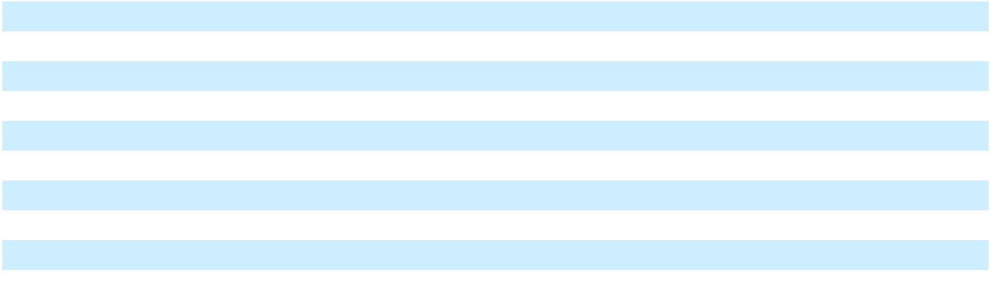

Contract assets are presented net of expected credit losses of $297 and $158 as of December 31, 2025 and 2024, respectively.

The Company has recognized costs to fulfill contracts with customers, which primarily consist of expenses required to enhance resources to deliver under agreements with these customers. These costs can include set-up and mobilization costs incurred ahead of the service period, and such costs will be recognized on a straight-line basis over the expected term of the agreement. As of December 31, 2025, the Company has capitalized $12,027, of which $1,602 of these costs is presented within Prepaid expenses, net and other current assets, net and $10,425 is presented within Other non-current assets, net on the Consolidated Balance Sheets. As of December 31, 2024, the Company had capitalized $22,797, of which $2,205 of these costs was presented within Prepaid expenses and other current assets, net and $20,592 was presented within Other non-current assets, net on the Consolidated Balance Sheets.

In addition to the revenue recognized under ASC 606, in the fourth quarter of 2024, the Company novated an LNG supply contract to a customer, and the Company received a payment of $295,558. As this payment was non-refundable and relieved the Company of a portion of its guarantee obligation under this arrangement (Note 21), these payments were recognized as contract novation income with the revenue caption in the Consolidated Statements of Operations and Comprehensive (Loss) Income. In 2025, the Company recognized $6,366 of contract novation income, which represents the accretion to the remaining payments that will be made between the third quarter of 2026 and the first quarter of 2028 (Note 13).

Transaction price allocated to remaining performance obligations

Some of the Company’s contracts are short-term in nature with a contract term of less than a year. The Company applied the optional exemption not to report any unfulfilled performance obligations related to these contracts.

The Company has arrangements in which LNG, natural gas or outputs from the Company’s power generation facilities are sold on a “take-or-pay” basis whereby the customer is obligated to pay for the minimum guaranteed volumes even if it does

F-43

Table of Contents

not take delivery. The price under these agreements is typically based on a market index plus a fixed margin. The fixed transaction price allocated to the remaining performance obligations under these arrangements represents the fixed margin multiplied by the outstanding minimum guaranteed volumes. The Company expects to recognize this revenue over the following time periods. The pattern of recognition reflects the minimum guaranteed volumes in each period:

Period |  | Revenue
2026 | $ | 530,896
2027 |  | 721,523
2028 |  | 710,471
2029 |  | 699,451
2030 |  | 698,801
Thereafter |  | 7,016,823
Total | $ | 10,377,965
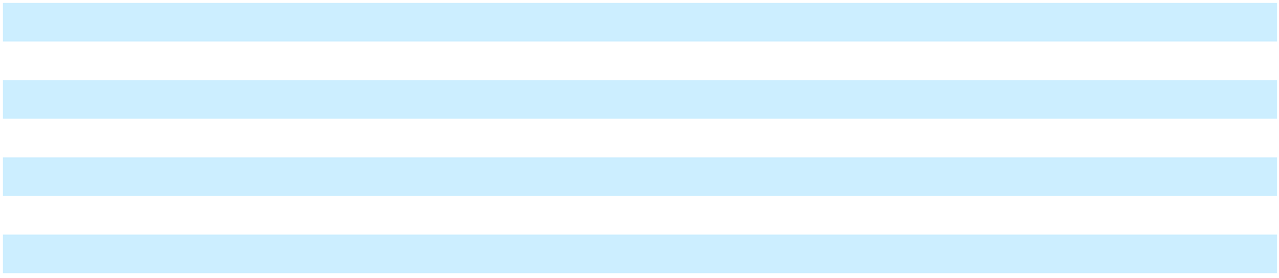

For all other sales contracts that have a term exceeding one year, the Company has elected the practical expedient in ASC

- Under this expedient, the Company does not disclose the transaction price allocated to remaining performance obligations if the variable consideration is allocated entirely to a wholly unsatisfied performance obligation. For these excluded contracts, the sources of variability are (a) the market index prices of natural gas used to price the contracts, and

(b) the variation in volumes that may be delivered to the customer. Both sources of variability are expected to be resolved at or shortly before delivery of each unit of LNG, natural gas or power. As each unit of LNG, natural gas or power represents a separate performance obligation, future volumes are wholly unsatisfied.

Lessor arrangements

Vessels that are chartered to customers under operating leases are recognized within Vessels in Note 16. Vessels that are accounted for as a failed sale leaseback as of December 31, 2025, including those vessels chartered to third parties, continue to be recognized on the Consolidated Balance Sheets, and as such, the carrying amount of these vessels that are leased to third parties under long-term operating leases is as follows:

 | December 31, |  |  | December 31,
 |  | 2025 |  |  | 2024
Property, plant and equipment | $ | 154,196 | $ |  | 602,192
Accumulated depreciation |  | (38,661) |  |  | (83,135)
Property, plant and equipment, net | $ | 115,535 | $ |  | 519,057

As further discussed in Note 16, during 2025, the Company sold certain vessels, including two vessels that were under operating leases at December 31, 2024.

The components of lease income from vessel operating leases for the years ended December 31, 2025, 2024 and 2023 are shown below, inclusive of vessels accounted for as a failed sale leaseback. Vessel charter revenue in the Consolidated Statements of Operations and Comprehensive (Loss) Income includes amortization of intangible assets recognized from acquisition of certain vessels with in-place leases, which is not included in the table below.

 |  | Year ended December 31,
 |  | 2025 |  |  | 2024 |  |  | 2023
 |  | 2025 |  | (As Restated) |  |  | (As Restated)
Operating lease income | $ | 174,790 | $ |  | 194,913 | $ |  | 276,113
Variable lease income |  | 15,714 |  |  | 17,696 |  |  | 730
Total operating lease income | $ | 190,504 | $ |  | 212,609 | $ |  | 276,843

Cash receipts on long-term vessel charters that are part of the Energos Financing Transaction are received by Energos. As such, future cash receipts from both operating leases and finance leases were not significant as of December 31, 2025.

F-44

Table of Contents

9. Leases, as lessee (As Restated)

The Company has operating leases primarily for the use of LNG vessels, marine port space, office space, land and equipment under non-cancellable lease agreements. The Company’s leases may include multiple optional renewal periods that are exercisable solely at the Company’s discretion. Renewal periods are included in the lease term when the Company is reasonably certain that the renewal options would be exercised, and the associated lease payments for such periods are reflected in the right-of-use (“ROU”) asset and lease liability.

The Company’s leases include fixed lease payments which may include escalation terms based on a fixed percentage or may vary based on an inflation index or other market adjustments. Escalations resulting from changes in inflation indices and market adjustments, as well as other lease costs that depend on the use of the underlying asset, are not considered lease payments when calculating the lease liability or ROU asset. Instead, such payments are accounted for as variable lease cost when the condition that triggers the variable payment becomes probable. Variable lease cost includes contingent rent payments for office space based on the percentage occupied by the Company in addition to common area charges and other charges that are variable in nature. The Company also has a component of lease payments that are variable related to the LNG vessels, in which the Company may receive credits based on the performance of the LNG vessels during the period.

As of December 31, 2025 and 2024, ROU assets, current lease liabilities and non-current lease liabilities consisted of the following:

 | December 31, |  |  | December 31,
 |  |  |  |  | 2024 (As
 |  | 2025 |  |  | Restated)
Operating right-of-use assets | $ | 394,795 | $ |  | 599,937
Finance right-of-use assets ⁽¹⁾ |  | 17,022 |  |  | 18,796
Total right-of-use assets | $ | 411,817 | $ |  | 618,733
Current lease liabilities:
Operating lease liabilities | $ | 69,832 | $ |  | 119,191
Finance lease liabilities |  | 2,425 |  |  | 3,971
Total current lease liabilities | $ | 72,257 | $ |  | 123,162
Non-current lease liabilities:
Operating lease liabilities | $ | 318,118 | $ |  | 471,961
Finance lease liabilities |  | 701 |  |  | 3,200
Total non-current lease liabilities | $ | 318,819 | $ |  | 475,161
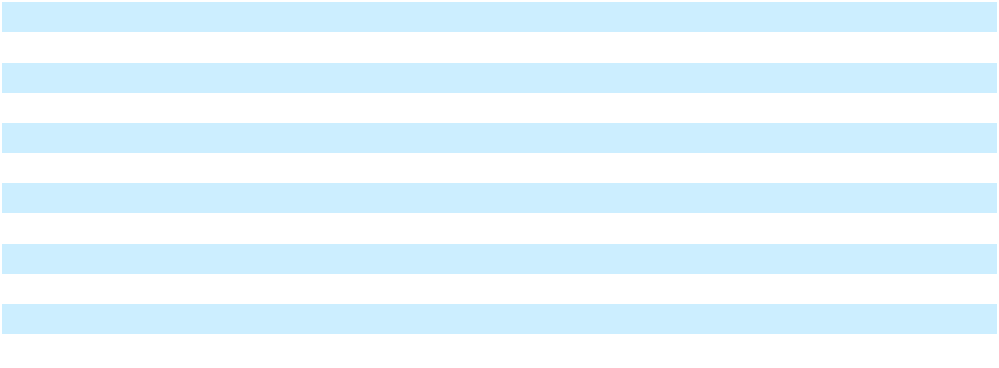

- Finance lease ROU assets are recorded net of accumulated amortization of $4,860 and $8,134 as of December 31, 2025 and 2024, respectively.

During the fourth quarter of 2025, the Company modified two vessel leases to include short-term payment deferrals that did not change the overall lease term or the scope of the underlying leased assets. The amendments were accounted for as lease modifications under ASC 842 and as part of the remeasurement of lease liabilities, the incremental borrowing rate was reassessed as of the respective modification date.

During 2024, the Company terminated the finance lease of certain turbines and purchased the turbines. Immediately subsequent to the purchase of the turbines, the assets were sold as part of the sale of assets to PREPA in 2024 (Refer to Note 6). The termination of the lease resulted in the write-off of the right-of-use asset and lease liability of $23,431 and $29,443, respectively, which was included in the book value of the turbines and the related loss upon sale (Note 5).

In addition, the Company terminated the operating lease of three turbines during 2024. The termination of the lease resulted in the write-off of the right-of-use asset and lease liability of $21,821 and $25,762, respectively, and a loss on lease termination of $4,789 recognized within Other (income) expense, net in the Consolidated Statements of Operations and Comprehensive (Loss) Income.

F-45

Table of Contents

For the years ended December 31, 2025, 2024, and 2023, the Company’s operating lease cost recorded within the

Consolidated Statements of Operations and Comprehensive (Loss) Income was as follows:

 |  | Year Ended December 31,
 |  | 2025 |  |  | 2024 |  |  | 2023
Fixed lease cost | $ | 109,916 | $ |  | 161,830 | $ |  | 109,873
Variable lease cost |  | 1,174 |  |  | 2,984 |  |  | 4,601
Short-term lease cost |  | 2,161 |  |  | 8,603 |  |  | 23,903
Lease cost - Cost of sales | $ | 97,041 | $ |  | 147,539 | $ |  | 88,608
Lease cost - Operations and maintenance |  | 10,338 |  |  | 17,961 |  |  | 42,520
Lease cost - Selling, general and administrative |  | 5,872 |  |  | 7,917 |  |  | 7,249
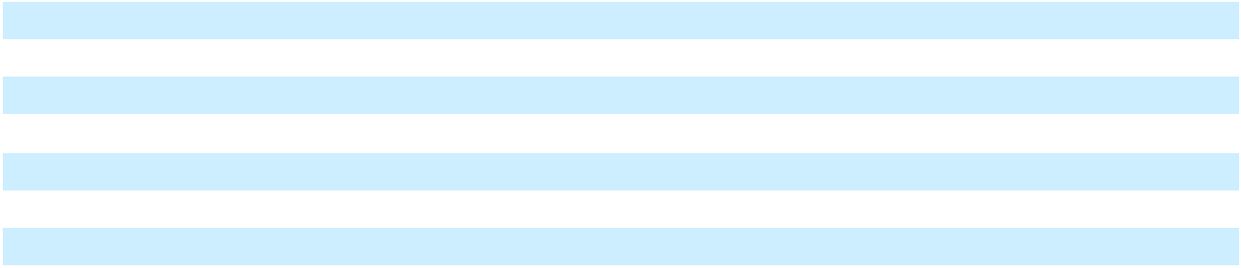

For the years ended December 31, 2025, 2024 and 2023, the Company has capitalized $20,259, $36,288 and $61,320 of lease costs, respectively. Capitalized costs include vessels used during the commissioning of development projects. Short-term lease costs for vessels chartered by the Company to transport inventory from a supplier’s facilities to the Company’s storage locations are capitalized to inventory.

The Company has leases of ISO tanks and a parcel of land that are recognized as finance leases. For the years ended December 31, 2025, 2024 and 2023, the Company’s finance interest expense and amortization recorded in Interest expense and Depreciation and amortization, respectively, within the Consolidated Statements of Operations and Comprehensive (Loss) Income were as follows:

 |  | Year Ended December 31,
 |  | 2025 |  |  | 2024 |  |  | 2023
Interest expense related to finance leases | $ | 281 | $ |  | 981 | $ |  | 3,706
Amortization of right-of-use asset related to finance leases |  | 1,481 |  |  | 6,132 |  |  | 19,337

Cash paid for operating leases is reported in operating activities in the Consolidated Statements of Cash Flows. Supplemental cash flow information related to leases was as follows for the years ended December 31, 2025, 2024 and 2023:

 |  | Year Ended December 31,
 |  | 2025 |  |  | 2024 |  |  | 2023
Operating cash outflows for operating lease liabilities | $ | 147,694 | $ |  | 175,862 | $ |  | 133,132
Financing cash outflows for finance lease liabilities |  | 4,324 |  |  | 9,500 |  |  | 21,187
Right-of-use assets obtained in exchange for new operating lease |  | — |  |  | 206,344 |  |  | 265,537
liabilities |  | — |  |  | 206,344 |  |  | 265,537
Right-of-use assets obtained in exchange for new finance lease |  | — |  |  | — |  |  | 47,672
liabilities |  | — |  |  | — |  |  | 47,672
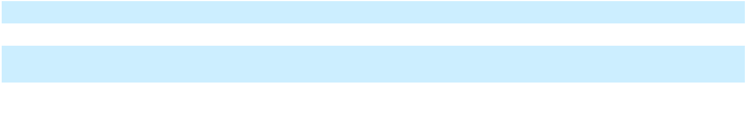

F-46

Table of Contents

The future payments due under operating and finance leases as of December 31, 2025 are as follows:

 |  | Operating |  |  | Financing
 |  | Leases |  |  | Leases
2026 | $ | 102,058 | $ |  | 2,501
2027 |  | 87,902 |  |  | 89
2028 |  | 86,419 |  |  | 89
2029 |  | 62,394 |  |  | 89
2030 |  | 49,814 |  |  | 89
Thereafter |  | 146,325 |  |  | 674
Total Lease Payments | $ | 534,912 | $ |  | 3,531
Less: effects of discounting |  | 146,962 |  |  | 405
Present value of lease liabilities | $ | 387,950 |  | $ | 3,126
Current lease liability | $ | 69,832 | $ |  | 2,425
Non-current lease liability |  | 318,118 |  |  | 701
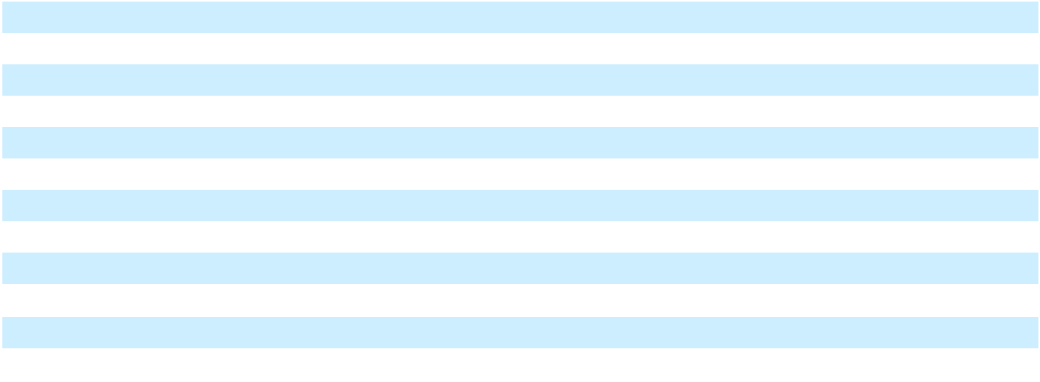

As of December 31, 2025, the weighted-average remaining lease term for operating leases was 6.9 years and finance leases was 3.6 years. Because the Company generally does not have access to the rate implicit in the lease, the incremental borrowing rate is utilized as the discount rate. The weighted average discount rate associated with operating leases as of December 31, 2025 and 2024 was 9.7% and 10.3%, respectively. The weighted average discount rate associated with finance leases as of December 31, 2025 and 2024 was 5.5% and 5.2%, respectively.

10. Financial instruments (As Restated)

Foreign currency risk management

During 2024, the Company entered into a series of foreign exchange forward contracts and zero-cost collars to reduce exchange rate risk associated with U.S. dollar borrowings and expected capital expenditures. As of December 31, 2025 and 2024, the notional amount of outstanding foreign exchange contracts was approximately $12,900 and $211,547, respectively. These instruments are expected to settle through the third quarter of 2026. The amount of loss (gain) recognized in Other (income) expense, net in the Consolidated Statements of Operations and Comprehensive (Loss) Income for the years ended December 31, 2025 and 2024 is as follows:

 |  | Year Ended December 31,
Financial instrument |  | 2025 |  |  | 2024
Foreign exchange forward contracts | $ | 13,992 | $ |  | (11,706)
Zero-cost collar options |  | 4,889 |  |  | (15,466)
Total realized and unrealized loss (gain) recognized | $ | 18,881 | $ |  | (27,172)

The Company does not hold or issue instruments for speculative purposes, and the counterparties to such contracts are major banking and financial institutions. Credit risk exists to the extent that the counterparties are unable to perform under the contracts; however, the Company does not anticipate non-performance by any counterparties.

Embedded contingent interest derivative

During 2024, the Company entered into a side letter with lenders in the Term Loan A Credit Agreement, under which the Company’s interest on the Term Loan A would increase by 2% if the lenders demand that the Company pursue a refinancing of the Term Loan A and the Company is not able to successfully refinance as defined in the side letter. This contingent interest feature meets the definition of a derivative and requires bifurcation from the debt host contract. Changes

F-47

Table of Contents

to the fair value of this derivative are recognized within Interest expense, net in the Consolidated Statements of Operations and Comprehensive (Loss) Income.

Fair value

Fair value measurements and disclosures require the use of valuation techniques to measure fair value that maximize the use of observable inputs and minimize use of unobservable inputs. These inputs are prioritized as follows:

- Level 1 – observable inputs such as quoted prices in active markets for identical assets or liabilities.

- Level 2 – inputs other than quoted prices included within Level 1 that are observable, either directly or indirectly, such as quoted prices for similar assets or liabilities or market corroborated inputs.

- Level 3 – unobservable inputs for which there is little or no market data and which require the Company to develop its own assumptions about how market participants price the asset or liability.

The valuation techniques that may be used to measure fair value are as follows:

- Market approach – uses prices and other relevant information generated by market transactions involving identical or comparable assets or liabilities.

- Income approach – uses valuation techniques, such as the discounted cash flow technique, to convert future amounts to a single present amount based on current market expectations about those future amounts.

- Cost approach – based on the amount that currently would be necessary to replace the service capacity of an asset (replacement cost).

The Company uses the market approach when valuing investment in equity securities and foreign exchange forward contracts which are recorded in Prepaid expenses and other current assets, net, Other non-current assets, net and Other current liabilities on the Consolidated Balance Sheets as of December 31, 2025 and 2024.

The Company uses the income approach for valuing the contingent consideration derivative liabilities and embedded contingent interest derivative. The contingent consideration derivative liabilities represent consideration due to the sellers in asset acquisitions when certain contingent events occur and are recorded within Other current liabilities and Other long-term liabilities based on the timing of expected settlement. The embedded contingent interest derivative represents incremental interest payments due to the lenders when certain contingent events occur and is recorded within Other current liabilities and Other long-term liabilities based on the timing of expected payments.

The fair value of derivative instruments is estimated considering current interest rates, foreign exchange rates, closing quoted market prices and the creditworthiness of counterparties. The Company estimates fair value of the contingent consideration derivative liabilities using a discounted cash flows method with discount rates based on the average yield curve for bonds with similar credit ratings and matching terms to the discount periods as well as a probability of the contingent events occurring. The Company estimates fair value of the embedded contingent interest derivative using a discounted cash flows method with discount rate based on the effective interest rate for the debt host instrument as well as a probability of the contingent events occurring.

F-48

Table of Contents

The following table presents the Company’s financial assets and financial liabilities, including those that are measured at fair value, as of December 31, 2025 and 2024:
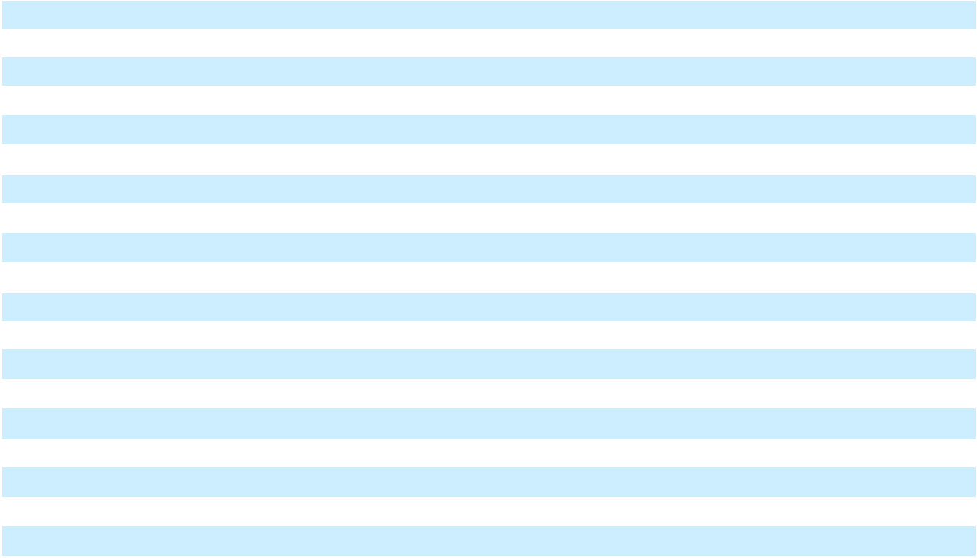

 |  | Level 1 |  |  | Level 2 |  |  | Level 3 |  |  | Total
December 31, 2025
Assets
Investment in equity securities | $ | — | $ |  | — | $ |  | 8,678 | $ |  | 8,678
Foreign exchange contracts |  | — |  |  | 474 |  |  | — |  |  | 474
Liabilities
Contingent consideration derivative liabilities |  | — |  |  | — |  |  | 32,586 |  |  | 32,586
Embedded contingent interest derivative |  | — |  |  | — |  |  | 1,970 |  |  | 1,970
December 31, 2024 (As Restated)
Assets
Investment in equity securities | $ | — | $ |  | — | $ |  | 8,678 | $ |  | 8,678
Foreign exchange contracts |  | — |  |  | 22,055 |  |  | — |  |  | 22,055
Liabilities
Foreign exchange contracts |  | — |  |  | 1,168 |  |  | — |  |  | 1,168
Contingent consideration derivative liabilities |  | — |  |  | — |  |  | 41,984 |  |  | 41,984
Embedded contingent interest derivative |  | — |  |  | — |  |  | 2,696 |  |  | 2,696

The Company believes the carrying amounts of cash and cash equivalents, accounts receivable and accounts payable approximated their fair value as of December 31, 2025 and 2024 and are classified as Level 1 within the fair value hierarchy.

The table below summarizes the total (gains) losses for instruments measured at Level 3 in the fair value hierarchy. The (gains) losses for contingent consideration derivative liabilities and embedded contingent interest derivative are recorded within Other (income) expense, net, and Interest expense, respectively, in the Consolidated Statements of Operations and Comprehensive (Loss) Income for the years ended December 31, 2025, 2024 and 2023 are shown below:

 |  | Year Ended December 31,
 |  | 2025 |  |  | 2024 |  |  | 2023
 |  | 2025 |  | (As Restated) |  |  |  | 2023
Unrealized (gain) loss
Contingent consideration derivative liabilities | $ | (9,639) | $ |  | (1,959) | $ |  | (4,801)
Embedded contingent interest derivative |  | (726) |  |  | 488 |  |  | —
Realized (gain) loss
Contingent consideration derivative liabilities |  | 1,116 |  |  | — |  |  | —
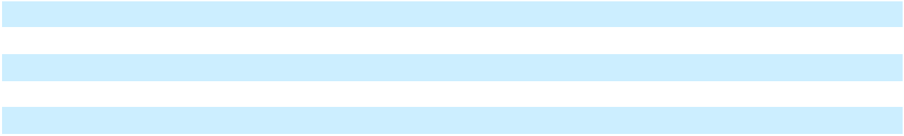

During the years ended December 31, 2025 and 2024, the Company had no transfers in or out of Level 3 in the fair value hierarchy. During the first quarter of 2024, the Company sold substantially all of its investment in Energos; this investment had been accounted for as an equity method investment (Note 14). The Company retained an investment in Energos valued at $1,000, which is shown as a Level 3 investment in equity securities in the table above.

F-49

Table of
Table of | Contents
11. Restricted cash
As of December 31, 2025 and 2024, restricted cash consisted of the following:
 |  |  | December 31, |  |  | December 31,
 |  |  |  | 2025 |  |  | 2024
Cash restricted under the terms of loan agreements |  |  | $ | 90,105 | $ |  | 422,098
Collateral for letters of credit and performance bonds |  |  |  | 40,384 |  |  | 50,598
Total restricted cash |  |  | $ | 130,489 | $ |  | 472,696

Uses of cash proceeds under the BNDES Term Loan, Brazil Financing Notes and PortoCem Debentures (see Note 22) are restricted to certain payments to construct the Company’s power plants in Brazil.

12. Inventory
As of December 31, 2025 and 2024, inventory consisted of the following:
 | December 31, |  |  | December 31,
 |  | 2025 |  |  | 2024
LNG and natural gas inventory | $ | 100,101 | $ |  | 67,232
Automotive diesel oil inventory, bunker fuel, materials, supplies and other |  | 19,346 |  |  | 35,992
Total inventory | $ | 119,447 | $ |  | 103,224

Inventory is adjusted to the lower of cost or net realizable value each quarter. Changes in the value of inventory are recorded within Cost of sales in the Consolidated Statements of Operations and Comprehensive (Loss) Income. In 2023, the Company acquired a spot cargo at a higher cost to obtain a new customer contract, and the net realizable value of this cargo was below the cost, resulting in an inventory adjustment of $6,232 during the year ended December 31, 2023. No inventory adjustments were recognized during the year ended December 31, 2025 and 2024.

13. Prepaid expenses and other current assets (As Restated)

As of December 31, 2025 and 2024, prepaid expenses and other current assets consisted of the following:

 | December 31, |  |  | December 31,
 |  |  |  |  | 2024 (As
 |  | 2025 |  |  | Restated)
Prepaid expenses | $ | 24,245 | $ |  | 26,947
Recoverable taxes |  | 163,399 |  |  | 98,101
Contract assets (Note 8) |  | 21,791 |  |  | 44,902
Proceeds held in escrow (Note 6) |  | 41,000 |  |  | —
Short-term receivable |  | 65,921 |  |  | —
Deferred financing costs |  | 18,876 |  |  | —
Income taxes receivable |  | 15,963 |  |  | 5,216
Other current assets |  | 49,152 |  |  | 37,174
Total prepaid expenses and other current assets, net | $ | 400,347 | $ |  | 212,340
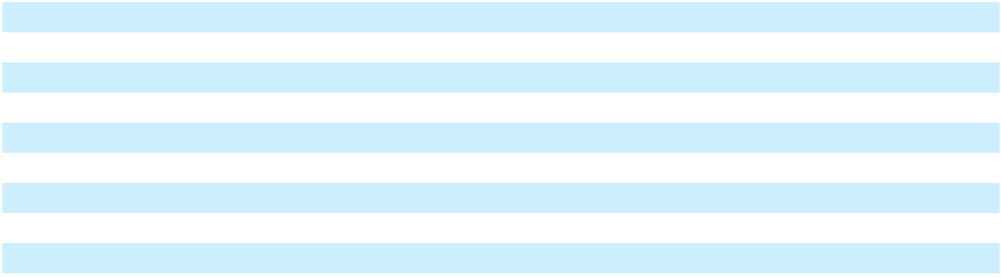

In the fourth quarter of 2024, the Company novated an LNG supply contract to a customer. In conjunction with this novation, the Company agreed to guarantee the performance of the LNG supplier (Note 21). In exchange for this guarantee, the Company will receive payments totaling $126,668 from the counterparty. These payments will be made between the third quarter of 2026 through the first quarter of 2028, and a portion of the discounted value of the payment stream has

F-50

Table of Contents

been recorded as a receivable. The balance has been presented as short-term and long-term (Note 19) based on the expected timing of receipt.

Financing costs for the year ended December 31, 2025 includes deferred costs associated with the Company’s Revolving Facility. The income tax receivable represents the expected refund resulting from the carryback of foreign tax credits to past tax year. The remaining balance of other current assets as of December 31, 2025 and 2024 primarily consists of derivative assets recognized for foreign currency exchange contracts (Note 10), and deposits.

14. Equity method investments
Changes in the balance of the Company’s equity method investments are as follows:
 | December 31, |  |  | December 31,
 |  | 2025 |  |  | 2024
Equity method investments as of beginning of period | $ | — | $ |  | 137,793
Capital contributions |  | — |  |  | 6,794
Sale of equity method investments |  | — |  |  | (144,587)
Equity method investments as of end of period | $ | — | $ |  | —

Energos

In August 2022, the Company completed a transaction with an affiliate of Apollo Global Management, Inc., pursuant to which the Company transferred ownership of 11 vessels to Energos Infrastructure (“Energos”) in exchange for approximately $1.85 billion in cash and a 20% equity interest in Energos (the “Energos Formation Transaction”). Ten of the vessels were subject to current or future charters with the Company, which prevents the recognition of the sale of those vessels to Energos, and the proceeds associated with these vessels have been treated as a failed sale leaseback. As a result, these ten vessels continued to be recognized on the Consolidated Balance Sheets as Property, plant and equipment, and the proceeds were recognized as debt. The Company’s equity investment provided certain rights, including representation on the Energos board of directors, that gave the Company significant influence over the operations of Energos, and as such, the investment was accounted for under the equity method. Energos was also an affiliate, and all transactions with Energos were transactions with an affiliate.

In February 2024, the Company sold substantially all of its stake in Energos. As a result of the transaction, the Company has recognized an other than temporary impairment (“OTTI”) of the investment in Energos totaling $5,277 for the year ended December 31, 2023, and this loss was recognized in Income from equity method investments in the Consolidated Statements of Operations and Comprehensive (Loss) Income. Nonrecurring, Level 2 inputs were used to estimate the fair value of the investment for the purpose of recognizing the OTTI. The sale was completed on February 14, 2024 and the Company received proceeds of $136,365, resulting in a loss of $7,222 presented within Other (income) expense, net in the Consolidated Statements of Operations and Comprehensive (Loss) Income. The Company retained an investment in Energos valued at $1,000, which has been recognized within Other non-current assets. Following the disposition of substantially all of the stake in Energos, the Company no longer has significant influence over Energos.

Due to the timing and availability of financial information of Energos, the Company recognized its proportional share of the income or loss from the equity method investment on a financial reporting lag of one fiscal quarter. For the year ended December 31, 2023, the Company has recognized earnings from Energos of $9,263. There were no earnings from Energos for the year ended December 31, 2025 and 2024.

F-51

Table of Contents

15. Construction in progress (As Restated)

The Company’s construction in progress activity during the years ended December 31, 2025 and 2024 is detailed below:

 | December 31, |  |  | December 31,
 |  |  |  |  | 2024 (As
 |  | 2025 |  |  | Restated)
Construction in progress as of beginning of period | $ | 3,526,984 | $ |  | 5,342,373
Additions |  | 943,483 |  |  | 2,268,072
Asset impairment expense |  | (843,742) |  |  | —
Impact of currency translation adjustment |  | 142,852 |  |  | (196,854)
Assets placed in service |  | (173,672) |  |  | (3,886,607)
Dispositions (Note 6) |  | (1,934) |  |  | —
Construction in progress as of end of period | $ | 3,593,971 | $ |  | 3,526,984

Interest expense of $339,564, $501,862 and $289,632, inclusive of amortized debt issuance costs, was capitalized for the years ended December 31, 2025, 2024 and 2023, respectively. For the year ended December 31, 2025, no recoverable taxes were capitalized. For the year ended December 31, 2024, Recoverable taxes of $45,996 were capitalized, representing a non-cash addition to Construction in progress.

During the year ended December 31, 2025, the Company recognized asset impairment expense primarily relating to certain Fast LNG projects, the ZeroParks hydrogen project, the Lakach deepwater project, and the development project in Pennsylvania. See Note 17 for further discussion of asset impairment expense. No asset impairment expense relating to construction in progress was recognized during the years ended December 31, 2024 and 2023.

The Company has significant development activities in Latin America, including significant projects in Brazil. Construction in progress relating to BrazilCo was $1,770,782 and $1,042,227 as of December 31, 2025 and 2024, respectively. The successful completion of these development projects is subject to various risks, such as obtaining government approvals, identifying suitable sites, securing financing and permitting, and ensuring contract compliance.

16. Property, plant and equipment, net (As Restated)

As of December 31, 2025 and 2024, the Company’s property, plant and equipment, net consisted of the following:

 | December 31, |  |  | December 31,
 |  |  |  |  | 2024
 |  | 2025 |  | (As Restated)
LNG liquefaction facilities | $ | 3,264,547 | $ |  | 3,395,192
Vessels |  | 974,105 |  |  | 1,580,553
Terminal and power plant equipment |  | 480,244 |  |  | 630,822
Gas pipelines |  | 291,355 |  |  | 323,196
Power facilities |  | 159,390 |  |  | 285,640
ISO containers and other equipment |  | 35,750 |  |  | 66,766
Land |  | 56,724 |  |  | 51,897
Leasehold improvements |  | 39,346 |  |  | 49,862
Accumulated depreciation |  | (408,724) |  |  | (455,009)
Total property, plant and equipment, net | $ | 4,892,737 | $ |  | 5,928,919
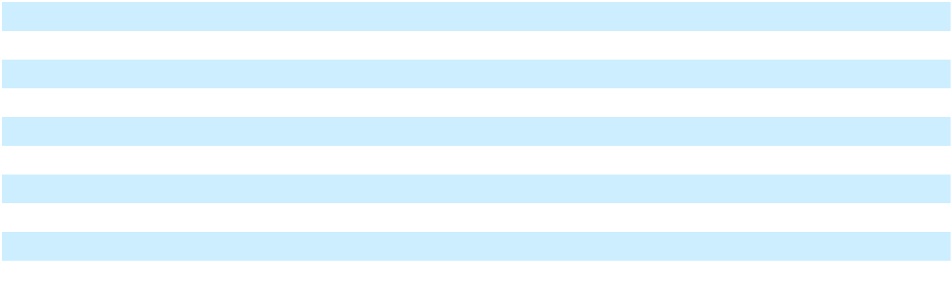

Property, plant and equipment, net includes certain vessels that are recognized as a failed sale leaseback as part of the Energos Formation Transaction (Note 14). In November 2025, the Company completed a transaction with Energos, pursuant to which the Company early terminated the long-term charter agreements with Energos for the Energos Eskimo, Energos Winter, Energos Igloo and Energos Freeze and novated associated sub-charter agreements for these vessels to Energos, in exchange for cash consideration of $150,000. This transaction resulted in the sale of these vessels that were

F-52

Table of Contents

previously accounted for as a failed sale leaseback. Upon closing of the transaction, the Company derecognized these vessels with a net book value of $667,043 from Property, plant and equipment, derecognized the related debt (Note 22), and recognized a gain of $217,129, which is presented in (Gain) loss on sale in the Consolidated Statements of Operations and Comprehensive (Loss) Income. The Company will also no longer recognize charter revenues and vessel operating expenses associated with these vessels.

Depreciation expense for the years ended December 31, 2025, 2024 and 2023 totaled $227,409, $144,166 and $141,069, respectively, of which $38,838, $511 and $905, respectively, is included within Cost of sales in the Consolidated Statements of Operations and Comprehensive (Loss) Income. The increase in depreciation recognized within Cost of sales in 2025 reflects the allocation of depreciation to LNG produced by the Company’s Fast LNG project that was placed into service at the end of 2024.

17. Impairment of long-lived assets

The Company performs a recoverability assessment of long-lived assets whenever events or changes in circumstances indicate that the carrying amount of an asset may not be recoverable. During the year ended December 31, 2025, the Company recognized asset impairment expense of $860,865 in the Terminals and Infrastructure segment:

- Due to the goodwill impairment triggering event identified in May 2025 (Note 18), the Company performed a recoverability test of its long-lived assets, including ROU assets and definite lived intangible assets. Based on the recoverability test performed, the Company recorded an impairment charge of $117,311, primarily relating to the Lakach deepwater project in the amount of $47,294, and the development project in Pennsylvania in the amount of $48,155. The Company has determined that it was not probable that it would pursue development of the Lakach deepwater project, and after this impairment, there are no longer any costs capitalized for this project. In testing the recoverability of the capitalized costs for the development project in Pennsylvania, the Company used a range of possible outcomes (which included using the land for a potential data center project) and concluded that the asset group was not recoverable. Accordingly, the Company recognized an impairment charge to reduce the carrying value of the asset group to its estimated fair value. The determination of the estimated fair value of the asset group used analyses obtained from independent third-party valuation specialists based on market observable inputs, representing Level 2 inputs.

- During the fourth quarter ended December 31, 2025, the Company recorded an impairment charge of $732,954, primarily relating to certain Fast LNG projects and the ZeroParks hydrogen project. As a part of the Company’s ongoing discussions with creditors during the fourth quarter of 2025, the Company has determined that it was not probable that it would pursue the development of these projects. Due to this triggering event identified during the quarter ended December 31, 2025, the Company performed a recoverability assessment and concluded that the carrying amounts of the related asset groups were not recoverable and recorded impairment charges to reduce the carrying values of the asset groups to their estimated fair value. Fair value was determined using a combination of observable market inputs and management estimates. The valuation used Level 3 inputs and considered expected recoverability based on alternative use, contractual economics, and available third-party market indications, consistent with assumptions that a market participant would apply at the measurement date.

During the second quarter of 2024, the Company entered into a definitive agreement to sell its LNG liquefaction facility located in Miami (the “Miami Facility”) for $62,000, subject to certain purchase price adjustments at close. The Company recognized an impairment loss of $16,016 within Asset impairment expense in the Terminals and Infrastructure segment, which includes the allocation of goodwill to this business disposition of $10,410.

During the fourth quarter of 2023, the Company entered into an agreement to sell the vessel, Mazo, for $22,400, and recognized an impairment of $10,958 within Asset impairment expense in the Ships segment. Nonrecurring, Level 2 inputs were used to estimate the fair value of the vessel for the purpose of recognizing the impairment. The sale closed in 2024, resulting in a gain of $392, included in (Gain) loss on sale in the Consolidated Statements of Operations and Comprehensive (Loss) Income.

F-53

Table of Contents

18. Goodwill and intangible assets (As Restated)

Goodwill

The Company reviews the carrying values of goodwill at least annually to assess impairment, and the annual impairment assessment is conducted as of October 1st of each year. Additionally, the Company reviews the carrying value of goodwill whenever events or changes in circumstances indicate that its carrying amount may not be recoverable.

In the second quarter and the fourth quarter of 2025, the Company identified impairment triggering events due to the significant decline in the Company’s stock price and the sale of certain vessels to Energos as discussed in Note 16, respectively. Using level 3 inputs, the Company performed a quantitative assessment of the relevant reporting units using the income approach, specifically a discounted cash flow method. This method required the Company to apply significant assumptions and unobservable inputs, including projected EBITDA, weighted average cost of capital (“WACC”) (and estimates included in the WACC) and terminal growth rate. Based on the impairment assessments, the Company recorded an impairment charge during the quarter ended June 30, 2025 in the Terminals and Infrastructure reporting unit primarily as a result of (i) the significant increase in the WACC which reflected a higher company specific risk premium, and (ii) a reduction in forecasted cash flows following changes in customer revenue projections and the timing of completion of development projects. The Company recorded an impairment charge during the quarter ended December 31, 2025 in the Ships reporting unit primarily as a result of a reduction in forecasted cash flows following the sale of certain vessels.

Below is a summary of the changes in the carrying value of goodwill by reportable segment for the year ended

December 31, 2025 and 2024:

 |  | Terminals and |  |  | Ships |  |  | Total
 |  | Infrastructure |  |  | Ships |  |  | Total
Balance at December 31, 2023 (As Restated) | $ | 777,202 | $ |  | 15,938 | $ |  | 793,140
Divestitures ⁽¹⁾ |  | (10,410) |  |  | — |  |  | (10,410)
Balance at December 31, 2024 (As Restated) | $ | 766,792 | $ |  | 15,938 | $ |  | 782,730
Divestitures ⁽²⁾ |  | (184,620) |  |  | — |  |  | (184,620)
Impairment losses |  | (582,172) |  |  | (15,938) |  |  | (598,110)
Balance at December 31, 2025 | $ | — | $ |  | — | $ |  | —

F-54

Table of Contents

- The Company allocated $10,410 of goodwill from the Terminal and Infrastructure reporting unit to the sale of the Miami Facility disposal group during the year ended December 31, 2024 on a relative fair value basis.

- The Company allocated $184,620 of goodwill from the Terminals and Infrastructure reporting unit to the sale of the Jamaica Business during the year ended December 31, 2025 on a relative fair value basis (See Note 6).

Intangible assets

The following tables summarize the composition of intangible assets as of December 31, 2025 and 2024:

 |  |  |  |  | December 31, 2025
 |  | Gross |  | Accumulated |  |  |  | Currency |  |  | Net |  | Weighted
 |  | Carrying |  |  |  |  | Translation |  |  |  | Carrying |  | Average
 |  | Amount |  | Amortization |  |  | Adjustment |  |  |  | Amount |  | Life
Definite-lived intangible assets
Acquired capacity reserve contract | $ | 162,045 | $ |  | (15,146) | $ |  | (14,908) | $ |  | 131,991 | 17
Permits and development rights |  | 61,894 |  |  | (9,572) |  |  | 1,574 |  |  | 53,896 | 34
Easements |  | 660 |  |  | (198) |  |  | — |  |  | 462 | 30
Indefinite-lived intangible assets
Easements |  | 1,191 |  |  | — |  |  | 56 |  |  | 1,247 |  | n/a
Total intangible assets | $ | 225,790 |  | $ | (24,916) |  | $ | (13,278) |  | $ | 187,596
 |  |  |  |  | December 31, 2024
 |  | Gross |  | Accumulated |  |  |  | Currency |  |  | Net |  | Weighted
 |  | Carrying |  |  |  |  | Translation |  |  |  | Carrying |  | Average
 |  | Amount |  | Amortization |  |  | Adjustment |  |  |  | Amount |  | Life
Definite-lived intangible assets
Acquired capacity reserve contract | $ | 162,045 | $ |  | (5,942) | $ |  | (31,301) | $ |  | 124,802 | 17
Favorable vessel charter contracts |  | 17,700 |  |  | (14,942) |  |  | — |  |  | 2,758 | 4
Permits and development rights |  | 61,894 |  |  | (6,417) |  |  | (5,793) |  |  | 49,684 | 34
Easements |  | 1,555 |  |  | (392) |  |  | — |  |  | 1,163 | 30
Indefinite-lived intangible assets
Easements |  | 1,191 |  |  | — |  |  | (88) |  |  | 1,103 |  | n/a
Total intangible assets | $ | 244,385 | $ |  | (27,693) | $ |  | (37,182) | $ |  | 179,510
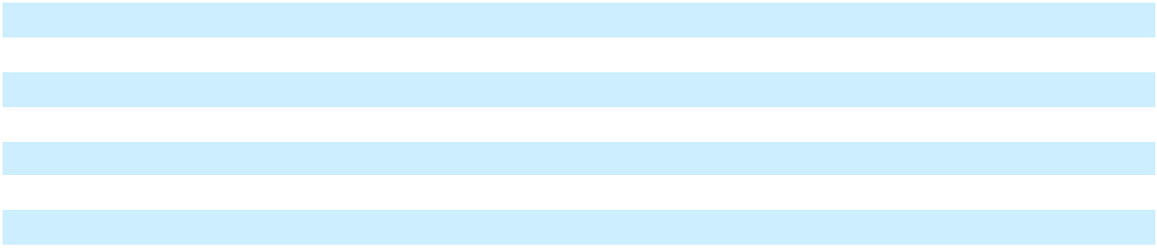
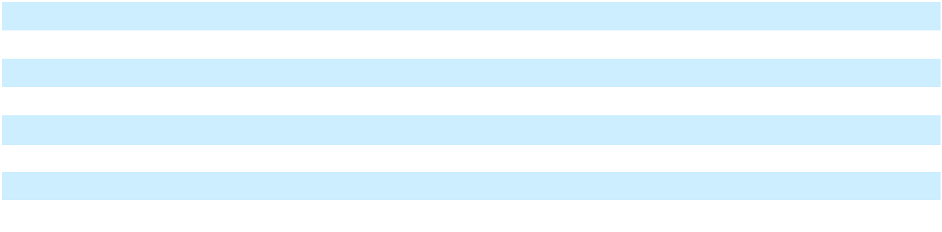

As of December 31, 2025 and 2024, the weighted-average remaining amortization periods for the intangible assets were

19.1 and 19.7 years, respectively. Amortization expense for the years ended December 31, 2025, 2024, and 2023 was

$13,456, $9,004, and $953, respectively, which were inclusive of reductions in expense for the amortization of unfavorable

contract liabilities.

In the third quarter of 2023, An Bord Pleanála (“ABP”), Ireland’s planning commission, denied our application for the development of an LNG terminal and power plant. We challenged this decision, and in September 2024, the High Court of Ireland ruled that the ABP did not have appropriate grounds for the denial of our permit. In March 2025, ABP withdrew their appeal to the September 2024 decision of the High Court of Ireland. ABP is now reconsidering our planning application in accordance with Irish Law. Further, in March 2025, An Coimisiún Pleanála (previously ABP) granted the Company’s application to construct a 600 MW power plant and a separate application to construct the 220 kV electricity interconnect. The Company is able to fuel this power plant via the LNG marine import terminal, if approved, or using gas provided from the Company’s permitted pipeline interconnection. The continued development of this project is uncertain and there are multiple risks, including regulatory risks, which could preclude the development of this project; however, management continues to assess all options in respect of future developments for the land held. As of December 31, 2025

F-55

Table of Contents

and 2024, the net book value of permits, development rights and other easements to be used in the development of the Company’s development project in Shannon, Ireland was $37,288 and $34,053, respectively.

The estimated aggregate amortization expense for each of the next five years is:
Year ended December 31:
2026 |  |  |  | $ | 10,713
2027 |  |  |  |  | 10,713
2028 |  |  |  |  | 10,713
2029 |  |  |  |  | 10,713
2030 |  |  |  |  | 10,713
Thereafter |  |  |  |  | 132,784
Total |  |  |  | $ | 186,349
19. Other non-current assets, net (As Restated)
As of December 31, 2025 and 2024, Other non-current assets consisted of the following:
 | December 31, |  |  | December 31,
 |  |  |  |  | 2024 (As
 |  | 2025 |  |  | Restated)
Long term receivables | $ | 55,522 |  | $ | 114,677
Contract asset, net (Note 8) |  | 10,375 |  |  | 20,270
Cost to fulfill (Note 8) |  | 10,425 |  |  | 20,592
Financing costs |  | — |  |  | 57,567
Other |  | 64,482 |  |  | 57,359
Total other non-current assets | $ | 140,804 |  | $ | 270,465
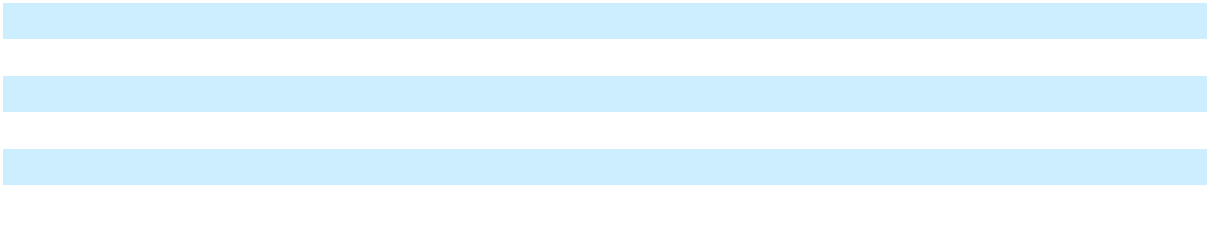

The long term receivables reflect the discounted value of payments expected in connection with the guarantee provided for the novated LNG supply contract with a customer (Note 13).

Other non-current assets includes proceeds held in escrow from the sale of the Jamaica Business (Note 4), security deposits, and investments in equity securities, which includes investments without a readily determinable fair value of $8,678 as of December 31, 2025 and 2024. The Company has not recognized any gains or losses in the value of these investments during 2025 and 2024. Financing costs as of December 31, 2024 includes deferred costs associated with the Company’s Revolving Facility and the Term Loan A Credit Agreement. Such balance as of December 31, 2025 was reclassified to Other current assets in line with the classification of the underlying debt (Refer to Note 13).

20. Accrued liabilities (As Restated)
As of December 31, 2025 and 2024, Accrued liabilities consisted of the following:
 | December 31, |  |  | December 31,
 |  |  |  |  | 2024 (As
 |  | 2025 |  |  | Restated)
Accrued interest | $ | 404,389 | $ |  | 84,566
Accrued development costs |  | 36,874 |  |  | 144,254
Accrued inventory |  | — |  |  | 93,319
Accrued litigation |  | 52,421 |  |  | —
Other accrued expenses |  | 104,092 |  |  | 112,542
Total accrued liabilities | $ | 597,776 | $ |  | 434,681

F-56

Table of Contents

Accrued litigation includes management’s estimate of probable losses for certain legal matters (see Note 25).

21. Other current liabilities (As Restated)
As of December 31, 2025 and 2024, Other current liabilities consisted of the following:
 | December 31, |  |  | December 31,
 |  |  |  |  | 2024 (As
 |  | 2025 |  |  | Restated)
Guarantee liabilities | $ | 64,765 | $ |  | —
Derivative liabilities |  | 31,977 |  |  | 25,932
Contract liabilities (Note 8) |  | 14,133 |  |  | 14,415
Income tax payable |  | 18,314 |  |  | 93,032
Due to affiliates |  | 4,662 |  |  | 11,530
Other current liabilities |  | 43,958 |  |  | 29,608
Total other current liabilities | $ | 177,809 | $ |  | 174,517

In 2024, the Company novated an LNG supply contract to a customer. In conjunction with this novation, the Company agreed to guarantee the performance of the LNG supplier, and in exchange for this guarantee, the customer will make payments to the Company between the third quarter of 2026 through the first quarter of 2028 totaling $126,668 (Note 13). The Company recognized a guarantee liability, which has been presented as short-term and long-term (Note 23) based on the timing of performance by the LNG supplier. Guarantee liabilities primarily consists of the liability relating to this novation.

Other current liabilities primarily consists of recoverable tax liabilities relating to the Company’s operations in Mexico and Brazil.

F-57

Table of
Table of | Contents
22. Debt (As Restated)
As of December 31, 2025 and 2024, debt consisted of the following:
 |  |  |  |  |  | December 31,
 |  |  | December 31, |  |  |  | 2024 (As
 |  |  |  | 2025 |  |  | Restated)
Corporate debt
Senior Secured Notes, due November 2029 |  |  | $ | 2,726,109 | $ |  | 2,728,269
Senior Secured Notes, due September 2026 |  |  |  | 510,162 |  |  | 509,022
Senior Secured Notes, due March 2029 |  |  |  | 234,244 |  |  | 233,789
Revolving Facility |  |  |  | 660,400 |  |  | 1,000,000
Term Loan B, due October 2028 |  |  |  | 1,166,784 |  |  | 776,353
Term Loan A, due July 2027 |  |  |  | 283,320 |  |  | 327,646
Short-term Borrowings |  |  |  | 73,224 |  |  | 179,890
Sale leaseback financing
Vessel Financing Obligation, due August 2042 |  |  |  | 634,501 |  |  | 1,366,293
Tugboat Financing, due December 2038 |  |  |  | 45,642 |  |  | 46,224
Asset level financing
PortoCem Debentures, due September 2040 |  |  |  | 849,115 |  |  | 729,259
BNDES Term Loan, due October 2045 |  |  |  | 376,923 |  |  | 350,525
Brazil Financing Notes, due August 2029 |  |  |  | 385,808 |  |  | —
South Power 2029 Bonds, due May 2029 |  |  |  | — |  |  | 217,871
Barcarena Debentures, due October 2028 |  |  |  | — |  |  | 194,571
Turbine Financing, due July 2027 |  |  |  | 133,687 |  |  | 142,549
EB-5 Loan, due July 2028 |  |  |  | 99,000 |  |  | 98,647
Total debt |  |  | $ | 8,178,919 |  | $ | 8,900,908
Current portion of long-term debt
 |  |  | $ | 7,073,477 |  | $ | 539,132
Long-term debt |  |  |  | 1,105,442 |  |  | 8,361,776
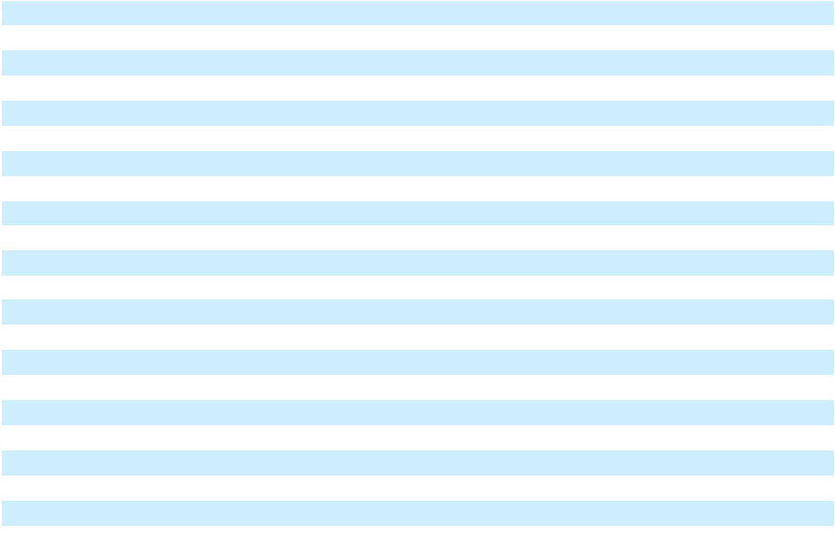

Debt is recorded at amortized cost on the Consolidated Balance Sheets. The outstanding debt balances under the 2026 Notes, 2029 Notes, New 2029 Notes, Term Loan B, Term Loan A, Revolving Facility, PortoCem Debentures, Brazil Financing Notes, EB-5 Loan and Tugboat Financing (each defined below) has been classified as current as of December 31, 2025, primarily due to the existing events of default and/or expected non-compliance with covenant requirements as described in Note 2 and below. The fair value of the Company’s debt was $4,382,841 and $9,087,891 as of December 31, 2025 and 2024, respectively, and was classified as Level 2 within the fair value hierarchy.

F-58

Table of
Table of | Contents
Our outstanding debt as of December 31, 2025 is repayable as follows:
 |  |  | December 31,
 |  |  |  | 2025
2026 |  |  | $ | 7,166,467
2027 |  |  |  | 185,163
2028 |  |  |  | 23,565
2029 |  |  |  | 25,207
2030 |  |  |  | 31,981
Thereafter |  |  |  | 897,324
Total debt |  |  | $ | 8,329,707
Less: deferred finance charges |  |  |  | (150,788)
Total debt, net of deferred finance charges |  |  | $ | 8,178,919

The Company’s future payments for the Vessel Financing Obligation include the expected carrying value of vessels that will be derecognized at the end of the lease term. The future payments also include third-party charter payments that will be received by Energos and included as part of debt service.

During the year ended December 31, 2025, the Company incurred $67,845 of restructuring costs that were recognized as expense in Transactions and integration costs in Consolidated Statements of Operations and Comprehensive (Loss) Income.

New 2029 Notes

On November 6, 2024, the Company entered into an exchange and subscription agreement (the “Exchange and Subscription Agreement”) with certain holders (the “Supporting Holders”) of the Company’s outstanding 2026 Notes and 2029 Notes (each defined below). Pursuant to the Exchange and Subscription Agreement, (i) NFE Financing LLC sold to the Supporting Holders approximately $1,210,396 aggregate principal amount of NFE Financing’s 12.0% Senior Secured Notes due 2029 (the “New 2029 Notes”) (the transactions described in clause (i), the “Subscription Transactions”) and (ii) NFE Financing issued to the Supporting Holders approximately $1,519,731 aggregate principal amount of New 2029 Notes in a dollar-for-dollar exchange for a portion of the Company’s 2026 Notes and 2029 Notes (the transactions described in clause (ii), the “Exchange Transactions” and together with the Subscription Transactions, the “Refinancing Transactions”).

NFE Financing issued $2,730,127 aggregate principal amount of New 2029 Notes pursuant to the Refinancing Transactions. The Company utilized $886,648 of these net proceeds from the Subscription Transactions to repay in full the outstanding aggregate principal amount and accrued interest on the 2025 Notes. The remainder of the net proceeds from the New 2029 Notes issued pursuant to the Subscription Transactions were used for general corporate purposes.

Pursuant to the Exchange and Subscription Agreement, upon consummation of the Refinancing Transactions, the Supporting Holders received a commitment fee equal to either (i) 5% of the aggregate principal amount of such Supporting Holder’s New 2029 Notes, payable in shares of Class A common stock of the Company, at a price of $8.63 per share (the “Commitment Fee Shares”), (ii) 2% of the aggregate principal amount of such Supporting Holder’s New 2029 Notes, payable in kind in the form of additional New 2029 Notes (the “Commitment Fee Notes”), or (iii) a combination of the foregoing. The Company issued 15,700,998 Commitment Fee Shares to the Supporting Holders in satisfaction of its commitment fee obligations under the Exchange and Subscription Agreement, and $5,368 Commitment Fee Notes were issued and included in the total New 2029 Notes issuance.

The New 2029 Notes were issued pursuant to, and are governed by, an indenture (the “New 2029 Notes Indenture”). The New 2029 Notes are senior, secured obligations of NFE Financing, and interest is payable semi-annually in arrears at a rate of 12.0% per annum on May 15 and November 15 of each year, beginning on May 15, 2025. The New 2029 Notes will mature on November 15, 2029, provided that the maturity date shall be accelerated to the date that is 91 days prior to the stated maturity date of any other indebtedness of the Company, subject to certain exceptions as described in the New 2029

F-59

Table of Contents

Notes Indenture, if more than $100,000 aggregate principal amount of such other indebtedness remains outstanding on such date.

NFE Financing may redeem some or all of the New 2029 Notes at redemption prices set forth in the New 2029 Notes Indenture; such redemption prices and any “make-whole” premiums are based on the timing of the redemption. Further, upon the occurrence of certain other events, including change of control and certain distributions from the Company’s Brazil business, NFE Financing may be required to make an offer to repurchase all of the New 2029 Notes at prices specified in the New 2029 Notes Indenture.

The New 2029 Notes are guaranteed by NFE Financing’s wholly-owned subsidiary, Bradford County Real Estate Partners LLC (the “New 2029 Notes Guarantor”) which owns the Company’s land in Wyalusing, Pennsylvania. The New 2029 Notes are secured by first-priority liens on: (a) all assets of NFE Financing, including approximately 45% of the equity in the entity that owns the Company’s Brazil business, and 100% of the equity in the New 2029 Notes Guarantor and (b) all assets of the New 2029 Notes Guarantor.

The New 2029 Notes Indenture provides for customary events of default which include (subject in certain cases to customary grace and cure periods), among others, acceleration and/or defaults of certain of the Company’s other indebtedness. The New 2029 Notes Indenture and other credit agreements associated with certain intercompany loans of NFE Financing, limit the ability of the Company to, among other things, incur additional indebtedness, incur liens that secure indebtedness, make restricted payments, create dividend restrictions and other payment restrictions, sell or transfer certain assets, in each case subject to certain exceptions and qualifications set forth in the New 2029 Notes Indenture and other indentures.

In conjunction with the Refinancing Transactions, the Supporting Holders agreed to consent to certain amendments to the indentures pursuant to which the 2026 Notes (such indenture, the “Existing 2026 Notes Indenture”) and the 2029 Notes (such indenture, the “Existing 2029 Notes Indenture”) were issued. These amendments allow the Company to subordinate the liens on certain of the collateral securing the obligations under each of the Existing 2026 Notes Indenture and Existing 2029 Notes Indenture to the liens on the same collateral securing certain intercompany loans due to NFE Financing, and to remove all covenants and events of default that may be removed in compliance with terms of such indentures (the “Indenture Amendments”). The adoption of the Indenture Amendments required the consent of holders of at least 66.67% the outstanding principal amount of each of the 2026 Notes and 2029 Notes. The Company received the required level of consent, and subsequently executed a supplemental indenture to the Existing 2026 Notes Indenture (the “2026 Supplemental Indenture”) and a supplemental indenture to the Existing 2029 Notes Indenture (the “2029 Supplemental Indenture,” and, together with the 2026 Supplemental Indenture, the “Supplemental Indentures”) effecting the Amendments. The Supplemental Indentures became effective on December 5, 2024.

The repayment of all of the 2025 Notes and the exchange of a portion of the 2026 Notes and 2029 Notes was treated as an extinguishment, and $11,442 of unamortized deferred debt issuance costs was recognized as a loss on extinguishment of debt in the Consolidated Statements of Operations and Comprehensive (Loss) Income. Fees paid to lenders, including the issuance of Commitment Fee Shares and Commitment Fee Notes, of $193,370 were included in the loss on extinguishment of debt. The Company also recognized $30,541 of loss on extinguishment of debt, which represents the fair value of the New 2029 Notes issued in excess of the carrying amount of debt exchanged or repaid. The New 2029 Notes are recorded at fair value on the date of the Refinancing Transactions and fees paid to third parties of $32,341 are amortized over the term of the New 2029 Notes.

As of December 31, 2025 and 2024, total remaining unamortized deferred financing costs for the New 2029 Notes of

$27,887 and $31,747, respectively. As of December 31, 2025 and 2024, total remaining unamortized premium for the New 2029 Notes were $23,839 and $29,890, respectively.

The New 2029 Notes Indenture contains cross default provisions that would allow the holders to accelerate the maturity date under the New 2029 Notes following the occurrence of a default by the Company or any of its subsidiaries on indebtedness for borrowed money if the principal amount of such indebtedness is equal to $10,000 in the case of NFE Financing and $100,000 in the case of the Company and any of its other subsidiaries unless such defaulted indebtedness has been discharged, the default has been cured or the holders have rescinded or waived the acceleration, notice or action giving rise to the event of default. Such defaults are subject to forbearance under the RSA pursuant to which the holders have agreed, subject to certain conditions, to refrain from exercising remedies with respect to specified defaults until termination of the RSA or the closing of the Restructuring Transaction. If the Restructuring Transaction is not consummated or the RSA is terminated, the holders thereunder could accelerate the outstanding indebtedness. Upon

F-60

Table of Contents

completion of the Restructuring Transaction contemplated under the RSA, the New 2029 Notes will no longer be outstanding.

2025 Notes

In 2020, the Company issued an aggregate amount of $1,250,000 of 6.75% senior secured notes in private offerings pursuant to Rule 144A under the Securities Act (the “2025 Notes”). In connection with the offering of the 2029 Notes (defined below) in March 2024, the Company completed a cash tender offer to repurchase $375,000 of the outstanding 2025 Notes, for an aggregate repurchase price of $376,875. The tender offer was closed and the partial repurchase of the 2025 Notes was completed in the first quarter of 2024. The premium over the repurchase price of $1,875 was recognized as Loss on extinguishment of debt, net in the Consolidated Statements of Operations and Comprehensive (Loss) Income. The remaining outstanding principal under the 2025 Notes was repaid in conjunction with the Refinancing Transactions.

2026 Notes

In April 2021, the Company issued $1,500,000 of 6.50% senior secured notes in a private offering pursuant to Rule 144A under the Securities Act (the “2026 Notes”). Interest is payable semi-annually in arrears on March 31 and September 30 of each year; no principal payments are due until maturity on September 30, 2026. The Company may redeem the 2026 Notes, in whole or in part, at any time prior to maturity, subject to certain make-whole premiums.

The 2026 Notes are guaranteed, jointly and severally, on a senior secured basis by certain domestic and foreign subsidiaries. Subsequent to the Refinancing Transactions, the 2026 Notes are subject to the 2026 Supplemental Indenture.

In connection with the issuance of the 2026 Notes, the Company incurred $25,240 in origination, structuring and other fees, which was deferred as a reduction of the principal balance of the 2026 Notes on the Consolidated Balance Sheets. As part of the Refinancing Transactions, the Company exchanged $989,121 of the 2026 Notes on a dollar-for-dollar basis for New 2029 Notes, resulting in a partial extinguishment. This partial extinguishment of the 2026 Notes resulted in the proportionate write-off of unamortized deferred financing fees, and as of December 31, 2025 and 2024, total remaining unamortized deferred financing costs for the 2026 Notes was $717 and $1,857, respectively.

The Company did not make the interest payment of $16,604 due to holders of the 2026 Notes on March 15, 2026. An event of default under the indenture governing the 2026 Notes will arise on April 15, 2026, when the contractual grace period for interest payments on such notes expires. The 2026 Supplemental Indenture contains cross acceleration provisions that would allow these lenders to accelerate the maturity date under the 2026 Notes upon an acceleration of outstanding principal balances under other credit agreements and indentures, including the Revolving Credit Agreement, Term Loan B Credit Agreement and Term Loan A Credit Agreement. Uncured events of default exist under these credit agreements, and as such, the outstanding principal balance of the 2026 Notes has been presented as a current liability. Upon completion of the Restructuring Transaction contemplated under the RSA, the 2026 Notes will no longer be outstanding.

2029 Notes

In March 2024, the Company issued $750,000 of 8.75% senior secured notes in a private offering pursuant to Rule 144A under the Securities Act (the “2029 Notes”). Interest is payable semi-annually in arrears on March 15 and September 15 of each year; no principal payments are due until maturity on March 15, 2029. The Company may redeem the 2029 Notes, in whole or in part, at any time prior to maturity, subject to certain make-whole premiums.

The 2029 Notes are guaranteed on a senior secured basis by each domestic subsidiary and foreign subsidiary that is a guarantor under the 2026 Notes. Subsequent to the Refinancing Transactions, the 2029 Notes are subject to the 2029 Supplemental Indenture.

In connection with the issuance of the 2029 Notes, the Company incurred $14,171 in origination, structuring and other fees, which was deferred as a reduction of the principal balance of the 2029 Notes on the Consolidated Balance Sheets. As part of the Refinancing Transactions, the Company exchanged $513,272 of the 2029 Notes on a dollar-for-dollar basis for New 2029 Notes, resulting in a partial extinguishment. This partial extinguishment of the 2029 Notes resulted in the proportionate write-off of unamortized deferred financing fees, and as of December 31, 2025 and 2024, total remaining unamortized deferred financing costs for the 2029 Notes were $2,484 and $2,939, respectively.

F-61

Table of Contents

The Company did not make the interest payment of $10,357 due to holders of the 2029 Notes on March 31, 2026. An event of default under the indenture governing the 2029 Notes will arise on April 30, 2026, when the contractual grace period for interest payments on such notes expired. The 2029 Supplemental Indenture contains cross acceleration provisions that would allow these lenders to accelerate the maturity date under the 2029 Notes upon an acceleration of outstanding principal balances under other credit agreements and indentures, including the Revolving Credit Agreement, Term Loan B Credit Agreement and Term Loan A Credit Agreement. Uncured events of default exist under these credit agreements, and as such, the outstanding principal balance of the 2029 Notes has been presented as a current liability. Upon completion of the Restructuring Transaction contemplated under the RSA, the 2029 Notes will no longer be outstanding.

Revolving Facility

In April 2021, the Company entered into a credit agreement (the “Revolving Credit Agreement”) for a $200,000 senior secured revolving credit facility (the “Revolving Facility”). The obligations under the Revolving Facility are guaranteed by certain of the Company’s subsidiaries, including those that own the Company’s offshore FLNG facility at Altamira (“FLNG 1 Project”) and FLNG 2 Co, and are secured by substantially the same collateral securing the obligations under certain intercompany loans entered into in conjunction with the Refinancing Transactions, as well as the assets comprising the FLNG 1 Project and FLNG 2.

The borrowings under the Revolving Facility bear interest at a Secured Overnight Financing Rate (“SOFR”) based rate plus a margin based upon usage of the Revolving Facility. The rates applicable to outstanding borrowings as of December 31, 2025 and 2024 were 7.51% and 8.22%, respectively. Borrowings under the Revolving Facility may be prepaid, at the option of the Company, at any time without premium.

Through May 2024, the Revolving Facility was amended to increase the borrowing capacity to $1,000,000. The amendments did not impact the interest rate or term of the Revolving Facility, and no deferred costs were written off. As of December 31, 2025 and 2024, $660,400 and $1,000,000 of revolving loans were outstanding under the Revolving Facility.

Concurrent with the Refinancing Transactions, the Company entered into an amendment with certain lenders in the Revolving Facility (the “Consenting Lenders”) to extend the maturity of their commitments from April 15, 2026 to October 15, 2027. The Consenting Lenders hold $900,000 of the total revolving commitments. The applicable margin payable on revolving borrowings to the Consenting Lenders increased by 100 basis points. The remainder of the Revolving Facility will mature in April 2026 with the potential for the Company to extend the maturity date once for a one-year increment. The Company is required to reduce the commitments with proceeds from certain assets sales and by certain amounts received from the settlement of the Company’s claims following the termination of the Company’s contract to provide emergency power services in Puerto Rico (Note 8).

In May 2025, the Company entered into an amendment to the Revolving Credit Agreement to, among other things, (i) provide for a covenant holiday with respect to the consolidated first lien debt ratio and fixed charge coverage ratio, (ii) permit $270,000 of proceeds from the sale of the Jamaica Business to be used to prepay and terminate a portion of loans and commitments currently outstanding and otherwise not require the proceeds of the sale of the Jamaica Business to be used to prepay loans and commitments, (iii) provide that the asset sale sweep mandatory prepayment will no longer apply once aggregate commitments are reduced to $550,000 and (iv) restrict the Company from prepaying the 2026 Notes in excess of $200,000 other than to avoid springing maturities unless any such prepayment is made using proceeds from refinancing indebtedness or capital contributions. In May 2025, the Company repaid $270,000 of outstanding revolving loans under the Revolving Facility which permanently reduced the borrowing capacity to $730,000. As a result, the Company recognized a Loss on extinguishment of debt, net of $10,634 in the Consolidated Statements of Operations and Comprehensive (Loss) Income representing write-off of unamortized deferred financing costs. The Company has issued letters of credit of $69,533 in 2025, and including the outstanding letters of credit, the Company has fully utilized the borrowing capacity of $729,933 as of December 31, 2025.

The Company incurred $48,612 in origination, structuring and other fees, associated with entry into the Revolving Facility, which includes additional fees incurred to expand the facility and extend the maturity through 2024. These costs have been

F-62

Table of Contents

capitalized within Other current assets on the Consolidated Balance Sheets. As of December 31, 2025 and 2024, total remaining unamortized deferred financing costs for the Revolving Facility was $18,878 and $38,190, respectively.

The Company is required to comply with the below covenants under the Revolving Credit Agreement:

- Beginning with the fiscal quarter ended March 31, 2025, for quarters in which the Revolving Facility is greater than 50% drawn, the Consolidated First Lien Debt Ratio must be below the following: (i) 6.50 to 1.00, for the fiscal quarter ended December 31, 2025, (ii) 7.25 to 1.00, for the fiscal quarters ending March 31, 2026 through September 30, 2026, and (iii) 6.75 to 1.00, for the fiscal quarter ending December 31, 2026 and each fiscal quarter thereafter. The Consolidated First Lien Debt Ratio test was not tested for the Test Periods ended June 30, 2025 and September 30, 2025.

- Beginning with fiscal quarter ended March 31, 2025, the Fixed Charge Coverage Ratio must be less than or equal to (i) 1.00 to 1.00, for the fiscal quarter ended December 31, 2025 and each fiscal quarter thereafter. The Fixed Charge Coverage Ratio test was not tested for the Test Periods ended June 30, 2025 and September 30, 2025.

- The Company is also required to maintain a minimum consolidated liquidity of (i) $50,000 as of the last day of each month and (ii) $100,000 as of the last day of any fiscal quarter (other than for the fiscal quarter ended December 31, 2025, which shall not be tested).

The Company was not in compliance with the Consolidated First Lien Debt Ratio and the Fixed Charge Coverage Ratio as of December 31, 2025. Under the RSA, the lenders under the Revolving Facility have agreed to not accelerate the outstanding principal for an event of default due to non-compliance with covenants. However, uncured events of default exist under the Revolving Credit Agreement, and as such, the outstanding principal balance has been presented as a current liability. Such defaults are subject to forbearance under the RSA pursuant to which the lenders have agreed, subject to certain conditions, to refrain from exercising remedies with respect to specified defaults until termination of the RSA or the closing of the Restructuring Transaction. If the Restructuring Transaction is not consummated or the RSA is terminated, the lenders thereunder could accelerate the maturity and the outstanding debt. Upon completion of the Restructuring Transaction contemplated under the RSA, the Revolving Facility will no longer be outstanding.

Letter of Credit Facility

In July 2021, the Company entered into an uncommitted letter of credit and reimbursement agreement (the “Letter of

Credit Agreement”) with a bank for the issuance of letters of credit for an aggregate amount of up to $75,000 (the “Letter

of Credit Facility”). Through December 31, 2023, the Letter of Credit Facility was amended multiple times to increase the

availability to $350,000. In 2025, the Letter of Credit Facility was amended multiple times to reduce the availability to

$195,000. As of December 31, 2025, the Company had $195,000 of letters of credit outstanding under the Letter of Credit

Facility.

The obligations under the Letter of Credit Facility are guaranteed by certain of the Company’s subsidiaries, including those that own our FLNG 1 Project and FLNG 2 Co. The Letter of Credit Facility is secured by substantially the same collateral as the first lien obligations under the Revolving Facility and the Term Loan B Credit Agreement.

During 2025, the Company entered into a number of amendments to its Letter of Credit Agreement in response to evolving liquidity needs, covenant requirements, and upcoming maturity and cash collateralization deadlines. Collectively, these amendments (i) provided various covenant holidays related to the consolidated first lien debt ratio and fixed charge coverage ratio, (ii) deferred or modified the timing of cash collateralization requirements, (iii) provided extensions of the maturity date of the Letter of Credit facility, (iv) revised or added provisions relating to commitment levels, asset sale sweep prepayment, and fees and pricing, (v) converted the facility from uncommitted to committed, and (vi) tightened certain restrictions on dividends, distributions, and the payment of principal or interest on specified indebtedness. These changes also incorporated enhanced limitations around the use of cash for repurchasing certain notes and aligned aspects of the facility with the Company’s broader capital structure initiatives.

In March 2026, the Company entered into an amendment to extend the maturity date to September 15, 2026.

The Company is required to comply with the below covenants under the Letter of Credit Agreement:

F-63

Table of Contents

- The Consolidated First Lien Debt Ratio must be below 7.25 to 1.00 for the fiscal quarter ended March 31, 2026. The Consolidated First Lien Debt Ratio test was not tested for the Test Periods ended June 30, 2025, September 30, 2025 and December 31, 2025.

- The Fixed Charge Coverage Ratio must be less than or equal to 1.00 to 1.00 for the fiscal quarter ended March 31, 2026 and each fiscal quarter thereafter. The Fixed Charge Coverage Ratio test was not be tested for the Test Periods ended June 30, 2025, September 30, 2025 and December 31, 2025.

- The Company is also required to maintain a minimum consolidated liquidity of $50,000 as of the last day of each month.

Additional lender fees and third party costs are capitalized within Other current assets on the Consolidated Balance Sheets. As of December 31, 2025 and 2024, total remaining unamortized costs for the Letter of Credit Facility was $4,057 and $766, respectively.

In March 2026, the Company entered into a forbearance agreement (“LCF Forbearance Agreement”), pursuant to which such lenders agreed not to exercise any remedies with respect to certain events of default under the Letter of Credit Facility. Unless earlier terminated, the LCF Forbearance Agreement will terminate on September 15, 2026. If the forbearance agreement is terminated, the lenders thereunder could require cash collateralization of all letters of credit outstanding under the Letter of Credit Facility. Under the RSA, a new letter of credit facility will be issued as upon completion of the Restructuring Transaction.

Term Loan B Credit Agreement

In October 2023, the Company entered into a credit agreement (the “Term Loan B Credit Agreement”) pursuant to which the lenders funded term loans in an aggregate principal amount of $856,000 (“Term Loan B”). Borrowings were issued at a discount, and the Company received proceeds of $787,520. The Term Loan B will mature on the earliest of (i) October 30, 2028 if the 2026 Notes are refinanced in full prior to their maturity and (ii) July 31, 2026, if any of the 2026 Notes remain outstanding as of such date. Quarterly principal payments of approximately $2,140 were required beginning March 2024.

The obligations under the Term Loan B Credit Agreement are guaranteed by certain of the Company’s subsidiaries, including those that own the Company’s FLNG 1 Project and FLNG 2 Co. The Term Loan B is secured by substantially the same collateral as the first lien obligations under the Revolving Facility and Letter of Credit Facility.

In March 2025, the Company entered into an amendment to the Term Loan B Credit Agreement. Pursuant to the

amendment, certain lenders agreed to provide incremental term loans in an aggregate principal amount of up to $425,000,

which increased the total outstanding principal amount to $1,272,440. The incremental term loans were issued at a

discount, and the Company received proceeds, net of discount, of $391,000. The incremental term loans are subject to the

same maturity date as the term loans under the original agreement. Quarterly principal payments of approximately $3,181

are required beginning June 2025. The amendment was accounted for as a modification, and fees paid to lenders of

$20,000 were deferred and are amortized over the remaining term of the Term Loan B Credit Agreement. The additional

third party costs associated with the amendment of $2,880 were recognized as expense in Transaction and integration costs

in the Consolidated Statements of Operations and Comprehensive (Loss) Income. In connection with the amendment, all

unused term loan commitments under the Term Loan A Credit Agreement were terminated.

As of December 31, 2025 and 2024, total remaining unamortized deferred financing costs, including the unamortized original issue discount, for the Term Loan B were $99,294 and $71,087, respectively.

The initial term loans under Term Loan B bear interest at a per annum rate equal to Adjusted Term SOFR (as defined in the Term Loan B Credit Agreement) plus 5.0%. The incremental term loans under the Term Loan B bear interest at a per annum rate equal to Adjusted Term SOFR plus 5.5%. The Company was permitted prepay the Term Loan B subject to prepayment premiums until March 2028 and customary break funding costs. The Company is required to prepay the Term Loan B with the net proceeds of certain asset sales, condemnations, and debt and convertible securities issuances, in each case subject to certain exceptions and thresholds. Additionally, the Company is required to prepay the Term Loan B with Excess Cash Flow (as defined in the Term Loan B Credit Agreement).The Company must comply with the same covenant

F-64

Table of Contents

requirements as those under the original agreement, which includes usual and customary affirmative and negative covenants.

The Term Loan B contains cross acceleration provisions that would allow the lenders to accelerate the maturity date under the Term Loan B upon an acceleration of outstanding principal balances under other credit agreements and indentures, including the New 2029 Notes Indenture, Revolving Credit Agreement and Term Loan A Credit Agreement. Uncured events of default exist under the Term Loan B Credit Agreement, as well as the other indentures and credit agreements, and as such, the outstanding principal balance of the Term Loan B has been presented as a current liability. Such defaults are subject to forbearance so long as the RSA is in effect and has not been terminated. If the Restructuring Transaction is not consummated or the RSA is terminated, the lenders thereunder could accelerate the maturity and the outstanding debt under the Term Loan B Credit Agreement. Upon completion of the Restructuring Transaction contemplated under the RSA, the Term Loan B will no longer be outstanding.

Term Loan A Credit Agreement

In July 2024, the Company entered into a credit agreement (“Term Loan A Credit Agreement”) for a senior secured, multiple draw term loan facility in an aggregate principal amount of up to $700,000 (“Term Loan A”). In connection with the issuance of the Term Loan A, the Company incurred $39,227 in origination, structuring and other fees, which was initially capitalized in Other non-current assets on the Consolidated Balance Sheets as the Term Loan A is a delayed draw term loan. In addition, the Company recorded a debt discount of $2,757 as a result of an embedded derivative (Note 10). During the year ended December 31, 2024, the Company drew $350,000 on the Term Loan A. The Term Loan A bore interest at a per annum rate equal to Term SOFR plus 3.75%, or at a base rate plus 2.75%, with increases by 0.25% every 180 days beginning on June 30, 2025.

The obligations under the Term Loan A Credit Agreement are guaranteed, jointly and severally, on a senior secured basis by each subsidiary that is a guarantor under the Revolving Facility, the Letter of Credit Facility and the Term Loan B, other than the guarantors comprising the FLNG 1 Project (who guarantee the Revolving Facility, Letter of Credit Facility and Term Loan B). The obligations under the Term Loan A Credit Agreement are secured by substantially the same collateral as the collateral securing such facilities, with the exception of the collateral comprising the FLNG 1 Project (which secures the Revolving Facility, Letter of Credit Facility and Term Loan B). Additionally, the Term Loan A is guaranteed by FLNG 2 Co, and secured by the assets, comprising FLNG 2. An equal priority intercreditor agreement governs the treatment of the collateral.

The Term Loan A will mature in July 2027 and is payable in full on the maturity date. In the event that the Company’s 2026 Notes are not refinanced or repaid at least 60 days prior to maturity, amounts outstanding under the Term Loan A will become due and payable on such date. The Company may prepay the Term Loan A at its option without premium or penalty at any time subject to customary break funding costs. The Company is required to prepay the Term Loan A with the net proceeds of certain asset sales, condemnations, debt and convertible securities issuances, and extraordinary receipts related to FLNG 2. Additionally, commencing with the first fiscal quarter after the date of completion of the FLNG 2 project, the Company will be required to prepay the Term Loan A with FLNG 2’s Excess Cash Flow (as defined in the Term Loan A Credit Agreement).

The Term Loan A Credit Agreement includes certain other covenants related solely to FLNG 2, including limitations on capital expenditures, restrictions on additional accounts, and restrictions on amendments or termination of certain material documents related to FLNG 2.

In March 2025, the Company entered into an amendment to the Term Loan A Credit Agreement. Pursuant to the amendment, the remaining undrawn commitments were reduced to zero, eliminating the potential for future borrowings under the Term Loan A Credit Agreement. As a result of the amendment, $18,121 of origination, structuring and other fees, which were previously capitalized in Other non-current assets on the Consolidated Balance Sheets were recognized as interest expense in the Consolidated Statements of Operations and Comprehensive (Loss) Income.

In May 2025, the Company entered into an additional amendment to the Term Loan A Credit Agreement, which, among other things, (i) required $55,000 of proceeds from the sale of the Jamaica Business to be used to prepay a portion of outstanding loans; (ii) increased the applicable margin to 6.70% for SOFR loans and 5.70% for Base Rate Loans and implemented a Term SOFR floor of 4.30% for the initial term loans and a base rate minimum of 5.30%; (iii) required the Company to make mandatory prepayments with 12.5% of proceeds of a request for equitable adjustment related to the early termination of contracts associated with the grid stabilization project in Puerto Rico, if and when such proceeds are

F-65

Table of Contents

received. Additionally, the amendment amended certain of the financial covenants, whereby the consolidated first lien debt ratio cannot exceed (i) 6.50 to 1.00, for the fiscal quarter ended December 31, 2025, (ii) 7.25 to 1.00, for the fiscal quarters ending March 31, 2026 and September 30, 2026 and (iii) 6.75 to 1.00, for the fiscal quarter ending December 31, 2026 and each fiscal quarter thereafter. The amendment added a fixed charge coverage ratio covenant and removed the debt to total capitalization covenant. The Company cannot permit the fixed charge coverage ratio for the Company and its restricted subsidiaries to be less than or equal to 1.00 to 1.00 for the fiscal quarter ended December 31, 2025 and each fiscal quarter thereafter.

Following the amendment, the Company repaid $55,000 of the Term Loan A using proceeds from the sale of the Jamaica Business (Note 6). This repayment was recognized as a partial extinguishment of debt, and a portion of unamortized deferred financing costs of $2,956 were written off within Loss on extinguishment of debt, net in the Consolidated Statements of Operations and Comprehensive (Loss) Income. As of December 31, 2025 and 2024, total remaining unamortized deferred financing costs and debt discount reducing the principal balance were $11,679 and $22,354, respectively.

The Term Loan A contains cross acceleration provisions that would allow the lenders to accelerate the maturity date under the Term Loan A upon an acceleration of outstanding principal balances under other credit agreements and indentures, including the New 2029 Notes Indenture, Revolving Credit Agreement and Term Loan B Credit Agreement. Uncured events of default exist under the Term Loan A Credit Agreement, as well as these other indentures and credit agreements, and as such, the outstanding principal balance of the Term Loan A has been presented as a current liability. Such defaults are subject to forbearance so long as the RSA is in effect and has not been terminated. If the Restructuring Transaction is not consummated or the RSA is terminated, the lenders thereunder could accelerate the maturity and the outstanding debt under the Term Loan A Credit Agreement. Upon completion of the Restructuring Transaction contemplated under the RSA, the Term Loan A will no longer be outstanding.

Short-term Borrowings

The Company has an LNG cargo financing arrangement where it may, from time to time, enter into sales and repurchase agreements with a financial institution, whereby the Company sells to the financial institution an LNG cargo and concurrently enters into an agreement to repurchase the same LNG cargo immediately with the repurchase price payable at a future date, generally not to exceed 90-days from the date of the sale and repurchase (the “Short-term Borrowings”). As of December 31, 2025, the Company had $73,224 due under repurchase arrangements with a weighted average interest rate of 14.79%. As of December 31, 2024, the Company had $179,890 due under repurchase arrangements with a weighted average interest rate of 8.87%. Borrowings under this arrangement are uncommitted, and as such, there can be no assurance that the Company will have a right to extend the due dates on outstanding balances or borrow additional amounts in the future. During 2025, the Company executed multiple amendments to this financing arrangement primarily to extend payment terms. Each of these amendments was accounted for as a debt modification. We did not incur material costs and fees associated with the modifications.

Vessel Financing Obligation

In August 2022, the Company completed a transaction to sell certain vessels to Energos and concurrently entered into long-term time charter agreements for certain vessels for periods of up to 20 years. Vessels chartered to the Company at the time of the transaction were classified as finance leases. Additionally, the Company’s charter of certain other vessels commence only upon the expiration of the vessel’s existing third-party charters. These forward starting charters prevented the recognition of a sale of these vessels. As such, the Company accounted for the transaction as a failed sale leaseback and has recorded a financing obligation for consideration received.

The Company continues to be the owner for accounting purposes of vessels that are treated as a failed sale leaseback, and as such, the Company recognizes revenue and operating expenses related to vessels under charter to third parties. Revenue recognized from these third-party charters form a portion of the debt service for the financing obligation; the weighted average effective interest rate on this financing obligation was approximately 18.1% and 13.4%, respectively, for the years ended December 31, 2025 and 2024, and includes the cash flows that Energos receives from these third-party charters.

As discussed in Note 16, in November 2025, the Company completed a transaction with Energos, pursuant to which the Company early terminated the long-term charter agreements with Energos for Energos Eskimo, Energos Winter, Energos Igloo and Energos Freeze and novated associated sub-charter agreements for these vessels to Energos. This transaction resulted in the sale of these vessels that were previously accounted for as a failed sale leaseback. Upon closing of the

F-66

Table of Contents

transaction, the Company derecognized these vessels from Property, plant and equipment with a carrying value of

$667,043, and derecognized debt of $734,172. Unamortized deferred financing costs of $3,093 were written off within (Gain) loss on sale in the Consolidated Statements of Operations and Comprehensive (Loss) Income.

As of December 31, 2025 and 2024, the remaining unamortized deferred financing costs for the Vessel Financing Obligation was $2,731 and $6,141, respectively.

Tugboat Financing

In December 2023, the Company sold and leased back four tugboat vessels for 15 years receiving proceeds of $46,728. (“Tugboat Financing”). The leasebacks of the tugboat vessels were classified as finance leases, and as such, the Company accounted for the Tugboat Financing as a failed sale-leaseback and has recorded a financing obligation for consideration received. The effective interest rate on this financing obligation is approximately 16.92%.

NFE provides a parent company guarantee under this financing obligation. Uncured events of default exist under the EB-5 Loan Agreement (as defined below), and as such, the outstanding principal balance of Tugboat Financing has been presented as a current liability.

Brazil Financing Notes

In February 2025, one of the Company’s consolidated subsidiaries entered into an agreement to issue up to $350,000 aggregate principal amount of 15.00% Senior Secured Notes due 2029 (the “Brazil Financing Notes”) at a purchase price of 97.75% of par. The Brazil Financing Notes mature on August 30, 2029; the principal is due in full on the maturity date. Interest is payable quarterly in arrears beginning on June 30, 2025, and for the first 30 months that the Brazil Financing Notes are outstanding, interest due can be paid in kind and added to the principal amount. A portion of the proceeds from the issuance of the Brazil Financing Notes of $208,727 was used to repay the Barcarena Debentures in full.

The repayment of the Barcarena Debentures was evaluated on a creditor-by-creditor basis to determine whether the transaction should be accounted for as a modification or extinguishment of debt. As a result of this evaluation, a portion of the repayment was determined to be an extinguishment of debt and, therefore, the Company recorded a debt extinguishment loss of $392 to write off a pro-rata amount of unamortized issuance costs. A portion of the repayment was treated as a modification, and fees and unamortized issuance costs amounted to $3,484 that were attributable to the lender that participated in both the Barcarena Debentures and the Brazil Financing Notes will be amortized over the life of the Brazil Financing Notes. The additional third-party fees associated with the Brazil Financing Notes of $4,171 were recognized as expense in Transaction and integration costs in the Consolidated Statements of Operations and Comprehensive (Loss) Income. As of December 31, 2025, total remaining unamortized deferred financing costs, including the unamortized original issue discount, for the Brazil Financing Notes were $10,167.

Although the Company does not believe that any event of default exists under the Brazil Financing Notes, on March 17, 2026, holders of a majority of the Brazil Financing Notes entered into a forbearance agreement, pursuant to which such holders agreed not to exercise any remedies with respect to any insolvency event of default under the Brazil Financing Notes that may result from the Company’s entry into the RSA and the insolvency proceedings contemplated by the RSA. The forbearance period terminates on the earlier of December 31, 2026 and the occurrence of certain events (such as an additional default or event of default under the Brazil Financing Notes).

NFE provides a parent company guarantee to holders of the Brazil Financing Notes. Uncured events of default exist under certain of NFE’s indentures and credit agreements, including the Revolving Credit Agreement, Term Loan B Credit Agreement and Term Loan A Credit Agreement, and as such, the outstanding principal balance of Brazil Financing Notes has been presented as a current liability. Upon completion of the Restructuring Transaction contemplated under the RSA, NFE will no longer own BrazilCo, or be subject to the Brazil Financing Notes.

PortoCem Financings

In November 2024, one of the Company’s indirect Brazilian subsidiaries, Portocem Geração de Energia S.A. (“PortoCem”), issued R$4.5 billion ($817,875 based on exchange rates in effect at December 31, 2025) of debentures (“PortoCem Debentures”). Borrowings bear interest at SOFR + 9.15%. No principal or interest payments are due until September 2027; at that point, PortoCem will be required to make semi-annual payments until maturity in September 2040. Proceeds received were utilized to repay a previously outstanding bridge loan, and the remaining proceeds are restricted to

F-67

Table of Contents

fund the construction of the PortoCem Power Plant. Portocem also entered into an Equity Contribution Agreement in November 2024 for the benefit of the debenture holders in which the Company agreed to contribute up to $50,000 in the event there are additional costs over the projected budget for the PortoCem Power Plant.

The repayment of the previous bridge loan was treated as an extinguishment, and the Company recognized $25,010 of repayment penalty and unamortized deferred financing fees as loss on extinguishment of debt in the Consolidated Statements of Operations and Comprehensive (Loss) Income at the time of repayment. The Company incurred $6,301 of new third party fees in conjunction with the repayment of the previous bridge loan and issuance of the PortoCem Debentures. As of December 31, 2025 and 2024, total remaining unamortized deferred financing costs for the PortoCem Debentures were $8,157 and $6,301, respectively.

The PortoCem Debentures included a non-automatic early maturity provision whereby upon multiple downgrades of the Company’s credit rating, early maturity may be declared if approved by the majority of debenture holders. The Company’s credit ratings were downgraded multiple times during 2025, and the debenture holders have unanimously permanently waived their ability to declare an early maturity event due to these credit rating downgrades in exchange for two additional bank guarantees totaling $129,100. During 2025, the Company provided the first required $50,000 bank guarantee, which may be drawn by the debenture holders if there is a breach under the Equity Contribution Agreement; an additional bank guarantee of $79,100 is required to be provided by May 10, 2026, subject to a 45 day cure period. Based on the Company’s current liquidity, the Company determined that it is not currently probable that the bank guarantee can be provided absent an agreement with its existing creditors or new lenders, and as such the PortoCem Debentures have been classified as a current liability. If the Company fails to provide the bank guarantee of $79,100, an automatic early maturity event will occur and substantially all of the Company’s outstanding indebtedness would be payable on demand. In addition, certain of the creditors that have executed the RSA would have the right to terminate the RSA if the debenture holders declare automatic early maturity.

Upon completion of the Restructuring Transaction contemplated under the RSA, NFE will no longer own BrazilCo, or be subject to the PortoCem Debentures.

Barcarena Financings

In October 2023, certain of the Company’s Brazilian subsidiaries entered into two long-term financing arrangements, fully funding the construction of the Company’s power plant located in Pará, Brazil (the “Barcarena Power Plant”). The parent of the owner of the Barcarena Power Plant entered into an agreement for the issuance of up to $200 million of convertible debentures maturing in October 2028 (“Barcarena Debentures”) and issued $180 million of the Barcarena Debentures prior to December 31, 2023. Interest on the Barcarena Debentures was due quarterly, and interest accrued at an annual rate of 12.0%, increasing 1.25% each year after the third anniversary of issuance.

The Company incurred $5,061 of structuring and other fees, and such fees were deferred as a reduction to the principal balance of the Barcarena Debentures. As of December 31, 2024, the remaining unamortized deferred financing costs for the Barcarena Debentures were $3,085. In February 2025, the Barcarena Debentures were repaid in full using proceeds from the issuance of the Brazil Financing Notes.

The owner of the Barcarena Power Plant entered into a credit agreement with BNDES, the Brazilian Development Bank (the “BNDES Credit Agreement”). The Company is able to borrow up to $355,566 under the BNDES Credit Agreement, segregated into three tranches based on the use of proceeds (“BNDES Term Loan”). The Company borrowed $344,735 under the BNDES Credit Agreement in 2024. Each tranche bears a different rate of interest ranging from 2.61% to 4.41% plus the fixed rate announced by BNDES. No principal payments are required until April 2026 and are due quarterly thereafter until maturity in 2045. Interest payments prior to April 2026 are made through an increase in the outstanding principal amount and are due quarterly thereafter.

The obligations under the BNDES Credit Agreement are guaranteed by certain indirect Brazilian subsidiaries that are constructing the Barcarena Power Plant, and are secured by the Barcarena Power Plant and receivables under the Barcarena Power Plant’s PPAs. These Brazilian subsidiaries are required to comply with customary affirmative and negative

F-68

Table of Contents

covenants, and the BNDES Credit Agreement also provides for customary events of default, prepayment and cure provisions.

South Power 2029 Bonds

In 2022, NFE South Power Holdings Limited, a wholly owned subsidiary of NFE, entered into an agreement for the issuance of secured bonds (“South Power 2029 Bonds”) and subsequently authorized the issuance of up to $285,000 in South Power 2029 Bonds. The South Power 2029 Bonds held an annual interest fixed rate of 6.5%. In May 2025, in conjunction with closing of the sale of its Jamaica Business (Note 5), the Company repurchased all outstanding South Power Bonds for $227,157, including a 1.0% prepayment penalty and accrued interest. The Company recognized a Loss on extinguishment of debt, net of $5,880 in the Consolidated Statements of Operations and Comprehensive (Loss) Income.

Turbine Financing

In May 2024, the Company executed a loan agreement with a lender to borrow $148,500 under a promissory note secured by certain turbines owned by a wholly-owned subsidiary of the Company (the “Turbine Financing”). The Turbine Financing bears interest at 10.30%, and the principal is partially repayable in monthly installments over the 36-month term of the loan with the balance due upon maturity in June 2027.

The Turbine Financing contains usual and customary representations and warranties, and usual and customary affirmative and negative covenants. The Turbine Financing does not contain any restrictive financial covenants. The Company was required to pay a deposit of approximately $5,963 that will be held by the lender throughout the term of the borrowing which was recorded in Other non-current assets, net on the Consolidated Balance Sheets.

Proceeds received were net of upfront fees due to the lender, and the Company incurred $2,136 in origination, structuring and other fees, associated with entry into the Turbine Financing. As of December 31, 2025 and 2024, total remaining unamortized deferred financing costs for the Turbine Financing were $1,045 and $1,753, respectively.

EB-5 Loan Agreement

In July 2023, the Company entered into a loan agreement under the U.S. Citizenship and Immigration Services EB-5 Program (“EB-5 Loan Agreement”) to pay for the development and construction of a new green hydrogen facility in Texas. The maximum aggregate principal amount available under the EB-5 Loan Agreement is $100,000, and outstanding borrowings bear interest at a fixed rate of 4.75%. The loan matures in 5 years from the initial advance with an option to extend the maturity by two one-year periods. It is expected that the loan will be secured by NFE’s green hydrogen facility, and NFE has provided a guarantee of the obligations under the EB-5 Loan Agreement. As of December 31, 2025, the availability under the EB-5 Loan Agreement has been fully funded, and the Company has an aggregate principal amount of $100,000 outstanding (the “EB-5 Loan”).

The Company incurred $1,728 in origination, structuring and other fees associated with entry into the EB-5 Loan Agreement. As of December 31, 2025 and 2024, the total remaining unamortized deferred financing costs for the EB-5 Loan Agreement was $999 and $1,353, respectively.

In January 2026, the Company did not make the interest payment of $2,375 due under the EB-5 Loan Agreement. An event of default under the EB-5 Loan Agreement arose (i) on January 8, 2026, when the contractual grace period for interest payments on the loans expired and (ii) on or about January 30, 2026, when the Company failed to comply with certain job creation requirements. Due to the expected future occurrence of events of defaults, the EB-5 Loan has been classified as a current liability as of December 31, 2025.

On March 13, 2026, the Company entered into a term sheet with CanAm Texas Regional Center LP, IV., a Delaware limited partnership in respect of the EB-5 Loan Agreement that contemplates, among other things, the incurrence by the Company of a new unsecured note in the aggregate principal amount of $22,500, with an interest rate of 7.00% per annum, with the option to pay interest in kind, and that matures on December 31, 2029. After completion of the transactions

F-69

Table of Contents

contemplated by this term sheet, the Company would no longer own the green hydrogen development project and, other than the new unsecured note, the Company would be released from it’s obligations under the EB-5 Loan.

Equipment Notes

In June 2023, the Company executed a Master Loan and Security Agreement with a lender to borrow up to $200,000 under promissory notes secured by certain turbines acquired in the first quarter of 2023 to support our grid stabilization project in Puerto Rico (the “Equipment Notes”). During 2023, the Company borrowed the full capacity bearing interest at approximately 7.68%, and the principal was partially repayable in monthly installments over the 36-month term of the loan with the balance due upon maturity in July 2026.

In conjunction with the execution of the APA to sell certain turbines to PREPA in March 2024 (Note 6), the Company repaid the Equipment Notes in full, releasing any liens held on the turbines prior to their sale. The balance outstanding as of the repayment date was $188,431, and the Company incurred a prepayment premium of 3%. The prepayment premium and any unamortized financing costs of $7,879 were recognized as Loss on extinguishment of debt, net, in the Consolidated Statements of Operations and Comprehensive (Loss) Income.

Interest Expense

Interest and related amortization of debt issuance costs, premiums and discounts recognized during major development and construction projects are capitalized and included in the cost of the project. Interest expense, net of amounts capitalized, recognized for the years ended December 31, 2025, 2024 and 2023 consisted of the following:

 |  | Year Ended December 31,
 |  |  |  |  | 2024 (As |  |  | 2023 (As
 |  | 2025 |  |  | Restated) |  |  | Restated)
Interest per contractual rates | $ | 868,746 | $ |  | 566,763 | $ |  | 339,631
Interest expense on Vessel Financing Obligation |  | 172,667 |  |  | 192,107 |  |  | 211,745
Amortization of debt issuance costs, premiums and discounts |  | 75,716 |  |  | 58,348 |  |  | 18,569
Interest expense incurred on finance lease obligations |  | 281 |  |  | 981 |  |  | 3,706
Total interest costs | $ | 1,117,410 | $ |  | 818,199 | $ |  | 573,651
Capitalized interest |  | 339,565 |  |  | 501,862 |  |  | 289,632
Total interest expense | $ | 777,845 | $ |  | 316,337 | $ |  | 284,019

Interest expense on the Vessel Financing Obligations includes non-cash expense of $75,485, $120,962, and $169,641 for the years ended December 31, 2025, 2024, and 2023, respectively, related to payments received by Energos from third party charterers.

23. Other Long-Term Liabilities (As Restated)

As of December 31, 2025 and 2024, Other long-term liabilities consisted of the following:

 |  | December 31, |  |  | December 31,
 |  | 2025 |  | 2024 (As Restated)
Guarantee liabilities | $ | 53,289 | $ |  | 115,359
Derivative liabilities |  | 2,579 |  |  | 19,917
Contract liability (Note 8) |  | 9,750 |  |  | 11,750
Uncertain taxes (Note 24) |  | 15,943 |  |  | —
Other |  | 10,730 |  |  | 20,139
Total other long-term liabilities | $ | 92,291 | $ |  | 167,165

Guarantee liabilities primarily include the fair value of the obligation for the performance of the LNG supplier related to the LNG supply contract (Note 21).

F-70

Table of Contents

24. Income Taxes (As Restated)

The components of the Company’s income (loss) before income taxes for the years ended December 31, 2025, 2024 and 2023 were as follows:

 |  | Year Ended December 31,
 |  |  |  |  | 2024 (As |  |  | 2023 (As
 |  | 2025 |  |  | Restated) |  |  | Restated)
United States | $ | (454,662) | $ |  | (146,909) | $ |  | 271,781
Foreign |  | (1,315,941) |  |  | (27,320) |  |  | 379,415
Income before taxes | $ | (1,770,603) | $ |  | (174,229) | $ |  | 651,196

Income tax expense is comprised of the following for the years ended December 31, 2025, 2024 and 2023:

 |  | Year Ended December 31,
 |  |  |  |  | 2024 (As |  |  | 2023 (As
 |  | 2025 |  |  | Restated) |  |  | Restated)
Current:
Domestic | $ | (646) | $ |  | 42,521 | $ |  | 40,916
Foreign |  | 36,149 |  |  | 31,119 |  |  | 48,244
Total current tax expense |  | 35,503 |  |  | 73,640 |  |  | 89,160
Deferred:
Domestic |  | 11,024 |  |  | (8,436) |  |  | 1,088
Foreign |  | 14,823 |  |  | 5,104 |  |  | 12,724
Total deferred tax (benefit) expenses |  | 25,847 |  |  | (3,332) |  |  | 13,812
Total provision for (benefit from) income taxes | $ | 61,350 | $ |  | 70,308 | $ |  | 102,972
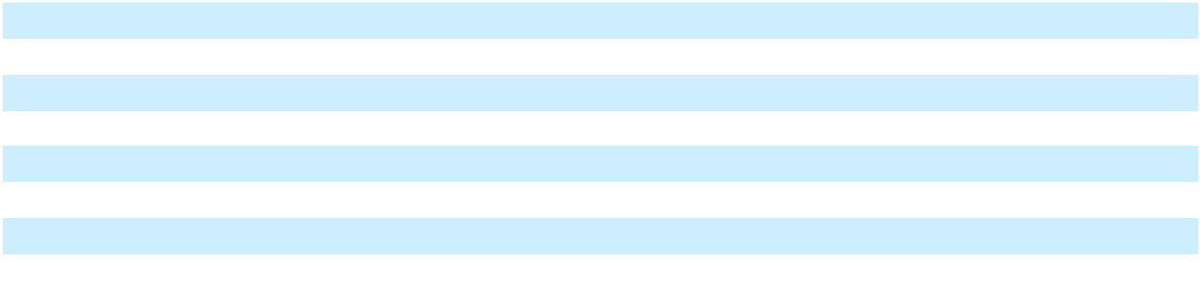

Effective Tax Rate

Upon the adoption of ASU 2023-09, as described in Note 5, the reconciliation of taxes at the federal statutory rate to our provision for (benefit from) income taxes for the year ended December 31, 2025 was as follows:

F-71

Table of Contents

 |  | Year Ended December 31,
 |  | 2025
U.S. Federal Statutory Tax Rate |  | (371,826) | 21.0 %
State and Local Income Taxes, Net of Federal Income Tax Effect |  | 644 | —
Effect of Cross-Border Tax Laws |  | 11,308 | (0.6)
Changes in Valuation Allowance |  | 126,824 | (7.2)
Other
Gain on Disposal of Business |  | 32,460 | (1.8)
Loss from Taxable Liquidation of Subsidiary |  | (69,797) | 3.9
Others |  | 2,146 | (0.1)
Foreign Tax Effects
BERMUDA
Statutory Tax Rate Difference between Bermuda and United States |  | 31,103 | (1.8)
Impairment |  | 85,193 | (4.8)
Other |  | (9) | —
BRAZIL
Nontaxable or Nondeductible Items |  | (25,923) | 1.5
Valuation Allowance |  | 17,853 | (1.0)
Other |  | 33,097 | (1.9)
MEXICO
Nontaxable or Nondeductible items |  | 37,535 | (2.1)
Valuation Allowance |  | 2,736 | -0.2
Other |  | (567) | —
UNITED KINGDOM
Statutory Tax Rate Difference between United Kingdom and United States |  | (25,165) | 1.4
Impairment |  | 155,405 | (8.8)
Other |  | 18,590 | (1.0)
OTHER FOREIGN JURISDICTIONS |  | (1,656) | 0.1
Changes in Unrecognized Tax Benefits |  | 1,399 | (0.1)
Grand Total | $ | 61,350 | (3.5)%
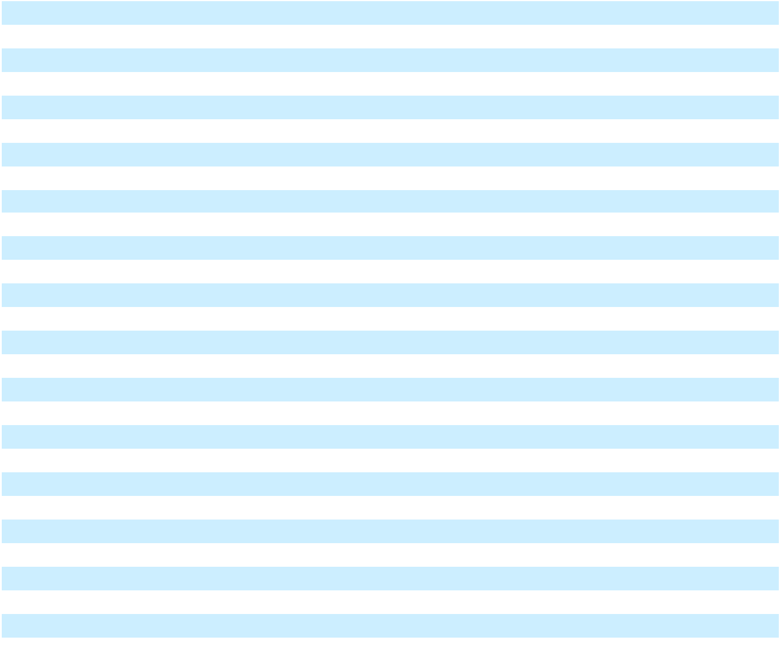

The reconciliation of taxes at the federal statutory rate to our provision for (benefit from) income taxes for the years ended

December 31, 2024 and 2023 in accordance with the guidance prior to the adoption of ASU 2023-09 was as follows:

F-72

Table of Contents

 |  | Year Ended December 31,
 |  | 2024 (As |  | 2023 (As
 |  | Restated) |  | Restated)
Income tax at the statutory rate | 21.0% |  | 21.0%
Foreign tax rate differential | 69.0 |  | (12.5)
US taxation on foreign earnings | (7.4) |  | (0.6)
Impact from foreign operations | 8.7 |  |  | —
Change in valuation allowance | (152.7) |  | 8.6
Effects of share-based compensation | (3.0) |  | 0.3
Withholding taxes |  | — | 0.6
Income tax credits | 9.3 |  | (4.9)
Outside basis differences |  | — | 0.1
Changes in deferred taxes and payable | 13.9 |  |  | —
Other |  | 0.8 |  | 3.3
Effective income tax rate | (40.4%) |  | 15.8%
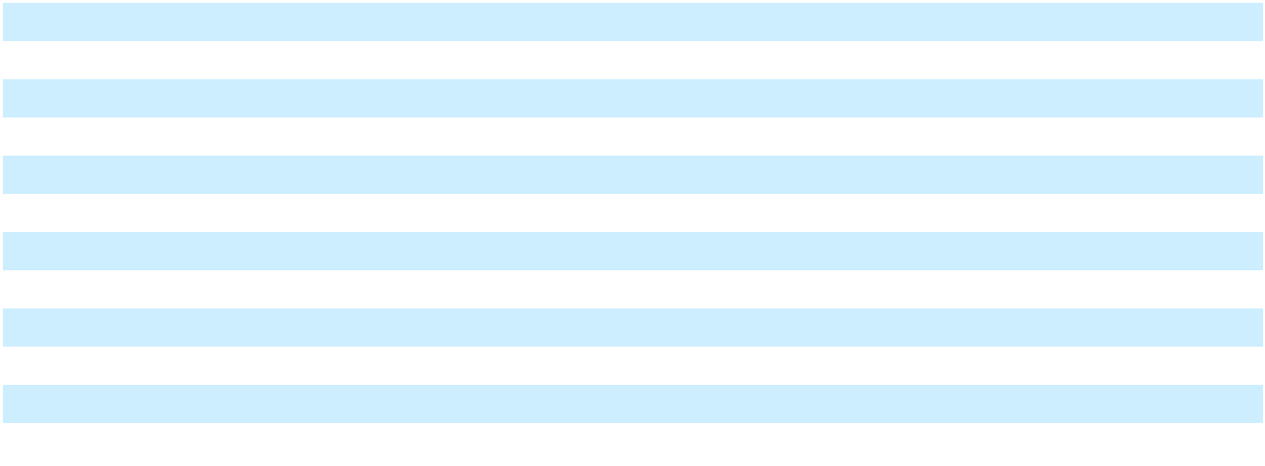

The Company has certain operations in jurisdictions that are not subject to income taxes or are subject to preferential tax rates. The effect of these earnings taxed at zero percent, as well as the impact of such preferential tax rates, are included in the foreign rate differential.

On July 4, 2025, the One Big Beautiful Bill Act (the “Tax Act of 2025”) was enacted. The Tax Act of 2025 includes significant provisions, such as the permanent extension of certain expiring provisions of the Tax Cuts and Jobs Act, modifications to the international tax framework, and the restoration of favorable tax treatment of certain business provisions. The legislation has multiple effective dates, with certain provisions effective in 2025 and others implemented through 2027. The Company has evaluated the provisions of the Tax Act of 2025 that could have an impact on the Company’s provision for the year ended December 31, 2025 related to Section 163(j), and such provisions have no impact to the effective tax rate for the year ended December 31, 2025.

The Organization for Economic Cooperation and Development (OECD) released the Pillar Two model rules to reform international corporate taxation that aim to ensure that applicable multinationals pay a minimum global effective tax rate of 15%. The rules are passed into national legislation based on each country’s approach, and some countries already enacted or substantively enacted the rules. The Company continues to assess the effective tax rate and cash tax impact for Pillar Two in light of legislative changes in multiple countries. During 2025, the Company incurred $8,632 of tax expense related to its Pillar Two obligations as a period cost and included such expenses as part of the consolidated annual effective tax rate.

Upon adoption of ASU 2023-09 as described in Note 5, cash paid for income taxes, net of refunds, during the year ended

December 31, 2025 was as follows:

 | Year Ended December 31,
 |  | 2025
Domestic Federal | $ | 44,172
Domestic State |  | 477
Foreign
Brazil |  | 17,083
Jamaica |  | 11,604
Puerto Rico |  | 32,467
Other |  | 3,288
Total Foreign |  | 64,442
Total | $ | 109,091
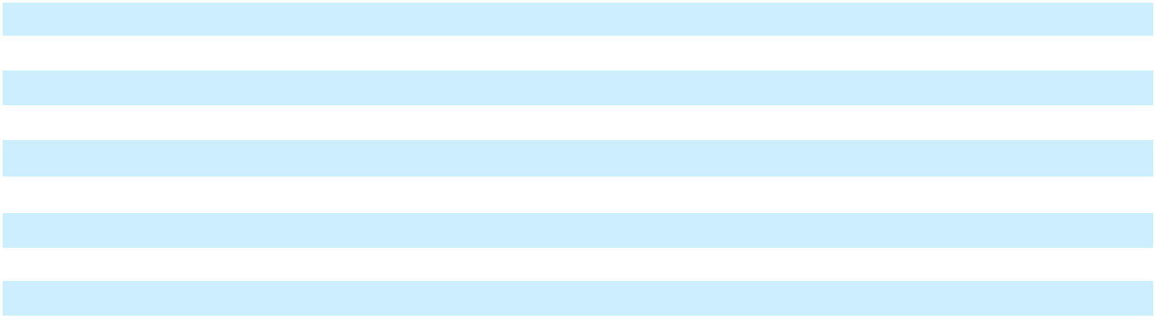

F-73

Table of Contents

Income tax paid were $27,932 and $52,897 for the years ended December 31, 2024 and 2023, respectively.

The tax effect of each type of temporary difference and carryforward that give rise to a significant deferred tax asset or liability as of December 31, 2025 and 2024 are as follows:

 |  | Year Ended December 31,
 |  |  |  |  | 2024 (As
 |  | 2025 |  |  | Restated)
Deferred tax assets:
Accrued interest | $ | — | $ |  | 40,255
IRC Section 163(j) interest carryforward |  | 154,086 |  |  | 27,533
Federal and state net operating loss carryforward |  | 55,485 |  |  | 1,904
Foreign net operating loss carryforward |  | 246,308 |  |  | 253,337
Debt |  | 140,555 |  |  | 264,460
Lease liability |  | 346,578 |  |  | 316,896
Goodwill |  | 38,901 |  |  | 43,004
Other |  | 50,767 |  |  | 78,189
Total deferred tax assets |  | 1,032,680 |  |  | 1,025,578
Valuation allowance |  | (549,493) |  |  | (449,819)
Deferred tax assets, net of valuation allowance |  | 483,187 |  |  | 575,759
Deferred tax liabilities:
Property and equipment |  | (139,492) |  |  | (277,109)
Right-of-use assets |  | (300,996) |  |  | (285,870)
Investments |  | (11,671) |  |  | —
Intangibles |  | (50,156) |  |  | (46,258)
Capitalized costs |  | (40,424) |  |  | (20,514)
Other |  | (16,950) |  |  | (17,522)
Total deferred tax liabilities | $ | (559,689) |  | $ | (647,273)
Net deferred tax liabilities | $ | (76,502) | $ |  | (71,514)
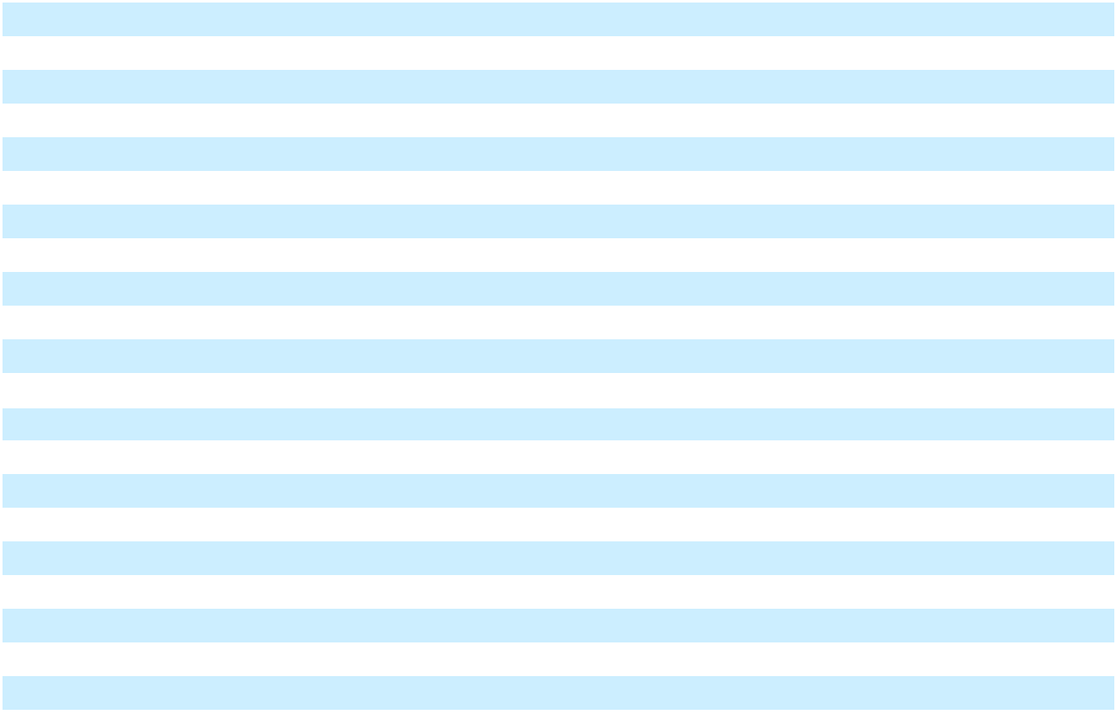

Tax Attributes

United States

As of December 31, 2025, NFE has approximately $261,466 of federal and $4,867 of state net operating loss carry forwards. The federal and state net operating losses are generally allowed to be carried forward indefinitely and can offset up to 80 percent of future taxable income.

Under the provisions of Internal Revenue Code Section 382, certain substantial changes in the Company’s ownership may result in a limitation on the amount of U.S. net operating loss carryforwards that can be utilized annually to offset future taxable income and taxes payable. The Company’s net operating loss carryforwards are subject to an annual limitation of $5,431 under Section 382 of the Internal Revenue Code.

Foreign Jurisdictions

The Company’s foreign subsidiaries file income tax returns in certain foreign jurisdictions. As of December 31, 2025, the Company’s foreign subsidiaries have approximately $983,111 of net operating loss carry forwards, of which $320,558 will expire, if unused between 2028 and 2041, and the remaining $662,553 are allowed to be carried forward indefinitely.

F-74

Table of Contents

Valuation Allowances

The following table summarizes the changes in the Company’s valuation allowance on deferred tax assets for the years ended December 31, 2025 and 2024:

 |  | Year Ended December 31,
 |  |  |  |  | 2024 (As
 |  | 2025 |  |  | Restated)
Balance at the beginning of the period | $ | 449,819 | $ |  | 189,690
Change in valuation allowance |  | 99,674 |  |  | 260,129
Balance at the end of the period | $ | 549,493 | $ |  | 449,819

The change in valuation allowance was mainly due to net operating losses, increase in deferred tax asset related to interest expense disallowance under section 163(j) in the U.S. and increase in net operating losses in foreign jurisdictions for the year ended December 31, 2025.

NFE recorded a valuation allowance against its US federal and state deferred tax assets to reduce the net carrying value to an amount that it believes is more likely than not to be realized. The Company concluded, based on the weight of all available positive and negative evidence, those deferred tax assets are not more likely than not to be realized and accordingly, a valuation allowance has been recorded on this deferred tax asset for the amount not supported by reversing taxable temporary differences. The Company recorded a valuation allowance against foreign deferred tax assets to reduce the net carrying value to an amount that it believes is more likely than not to be realized.

Uncertain Taxes

The following table summarizes the changes in the Company’s unrecognized tax benefits for the years ended December 31, 2025 and 2024:

 |  | Year Ended December 31,
 |  | 2025 |  |  | 2024
Balance at the beginning of the period | $ | — | $ |  | —
Recognized in the income tax provision |  | 15,943 |  |  | —
Balance at the end of the period | $ | 15,943 | $ |  | —

Income Tax Examinations

The Company and its subsidiaries file income tax returns in the U.S. federal and various state and local jurisdictions, as well as various foreign jurisdictions. The U.S. Federal and state income tax returns filed for tax years 2022, 2023 and 2024 are open for examination. The Company is generally open to tax examinations in other foreign jurisdictions for a period of four to six years from the filing of the income tax return.

Undistributed Earnings

The Company has not recorded a deferred tax liability for undistributed earnings for any controlled foreign corporation as of December 31, 2025 and 2024. The Company has unremitted earnings in certain jurisdictions where distributions can be made at no net tax cost. From time to time, the Company may remit these earnings. The Company has the ability and intent to indefinitely reinvest any earnings that cannot be remitted at no net tax cost. It is not practicable to estimate the amount of any additional taxes which may be payable on these undistributed earnings.

Preferential Tax Rates

The Company has subsidiaries incorporated in Bermuda. Under prior Bermuda law before the Bermuda Corporate Income Tax Act 2023, the Company was not required to pay taxes in Bermuda on either income or capital gains. The Company has received an undertaking from the Bermuda government that, in the event of income or capital gain taxes being imposed, it will be exempted from such taxes until 2035. On December 27, 2023, Bermuda enacted the Bermuda Corporate Income

F-75

Table of Contents

Tax Act 2023, which institutes a corporate income tax rate of 15% effective for tax years beginning January 1, 2025. As a result, such tax exemptions will not be valid beyond such subsidiaries’ taxable year ended December 31, 2024, the impact of which has been included in the tax provision and was not material.

Certain of the Company’s Puerto Rican subsidiaries received tax decrees from the Puerto Rico government that affords such subsidiaries a 4% tax rate on qualifying income. The effect of the earnings taxed at a 4% foreign tax rate is included in the foreign rate differential line in the Company’s effective tax rate. For the years ended December 31, 2025 and 2024, the income tax benefits attributable to the tax decrees, before taking into consideration the impact on U.S. taxation and the associated U.S. foreign tax credits, are estimated to be approximately $27,823 ($(0.10) per share of issued and outstanding Class A common stock on a diluted basis) and $142,776 ($(0.65) per share of issued and outstanding Class A common stock on a diluted basis), respectively.

25. Commitments and contingencies

The Company is subject to certain legal and regulatory proceedings, claims and disputes that arise in the ordinary course of business. The Company will recognize a loss contingency when it is probable a liability has been incurred and the amount of the loss can be reasonably estimated. The Company will disclose any loss contingencies that do not meet both conditions if there is a reasonable possibility that a material loss may be incurred. The Company is currently focusing on managing its working capital and liquidity, which has resulted in delays in making payments to certain vendors. While the amounts due to these vendors are recorded on the Consolidated Balance Sheets, potential legal actions against the Company enforcing payments may result in interest, penalties and/or legal expenses, which may materially affect the Company’s financial position, results of operations or cash flows.

With respect to the specific legal proceedings and claims described below, unless otherwise noted, the amount or range of possible losses is not reasonably estimable. There can be no assurance that the settlement, resolution, or other outcome of one or more matters, including the matters set forth below, during any subsequent reporting period will not have a material adverse effect on the Company’s results of operations or cash flows for that period or on the Company’s financial condition.

In 2024, Jamaica Power Service Company Limited (“JPS”) initiated arbitration proceedings claiming damages of approximately $32,900 for use of alternative fuel due to infrastructure changes required by the Port of Montego Bay where the Company’s Montego Bay terminal was located. The Company asserted force majeure under the contract and has made a counterclaim of approximately $7,200. Arbitration proceedings commenced in the first quarter of 2026, and the Company expects this matter to be resolved in 2026. The Company has accrued for the probable loss as of December 31, 2025.

In 2024, the Company’s contract to provide temporary power services ended as a result of FEMA not renewing the funding of the temporary power project in Puerto Rico. The Company determined that a force majeure event occurred under the lease agreement with the owner of a portion of the turbines used in this temporary power project and accordingly terminated the turbine lease agreement pursuant to the force majeure termination provisions. The lessor subsequently initiated arbitration proceedings seeking damages, fees and costs up to $46,200 as a result of the termination of the lease and alleged damages suffered by certain of the leased units during operation and decommissioning. The Company has a counterclaim of approximately $6,500. Arbitration proceedings have commenced in the first quarter of 2026, and the Company expects this matter to be resolved in 2026. The Company has accrued for the probable loss as of December 31, 2025.

In the first quarter of 2025, Alunorte Alumina do Norte do Brasil S.A. (“Alunorte”) initiated arbitration proceedings at the International Chamber of Commerce (“ICC”). Alunorte claims it is owed damages for alleged delays by the Company to supply gas at the Barcarena Facility and is claiming damages up to BRL 375,700 (approximately $68,200 using exchange rates as of December 31, 2025). The Company believes Alunorte’s claims are without merit and not supported by the contract between the parties, and as a result the Company plans to vigorously defend itself in these proceedings. However, due to the inherent difficulty in predicting the outcome of arbitration, the amount of any probable loss is uncertain. The Company has not accrued any probable losses as of December 31, 2025.

PortoCem is a thermal power plant project originally developed by a third party and later acquired by the Company in 2024. Under its prior ownership, the project was designed for a different location and had executed a CUST, a transmission system usage agreement that establishes rights and obligations for grid connection. As part of the acquisition, the Company redesigned the project to be implemented in Barcarena, Pará, where it could be integrated with the Company’s LNG import and power infrastructure. In 2024, PortoCem submitted a request—approximately two years before the applicable

F-76

Table of Contents

milestones—to relocate the originally approved transmission connection point, and the Brazilian power regulator, ANEEL, subsequently approved this relocation. The change produced no impact on the tariff paid by consumers for transmission use.

In 2024, despite having approved the new connection point, ANEEL informed PortoCem that certain obligations tied to the original connection point had not been fulfilled and that a penalty of approximately BRL 610,000 ($110,900 using exchange rates in effect as of December 31, 2025) could be imposed under the CUST. PortoCem appealed, and in November 2024, ANEEL suspended imposition of any penalty, which remains in force and prevents enforcement until the ANEEL Board of Directors issues a final decision. During the fourth quarter of 2025, the matter was scheduled to be examined by ANEEL’s Board of Directors, however, as of the date of the issuance of these financial statements, ANEEL’s Board has not rendered a final decision and the outcome remains uncertain. The Company has not accrued any probable losses as of December 31, 2025.

If the Company were to receive an unfavorable decision, the matter may still be challenged in the Brazilian courts. Finally, the Company believes that if any penalty is ultimately imposed and enforced by the courts, the original third-party developer of the project is required to indemnify the Company for any losses incurred related to the relocation of the project because the relocation request resulting in any penalty was submitted before the closing of the sale of PortoCem to the Company, thus such regulatory request was filed when PortoCem was controlled by its prior owner. These matters are not expected to be resolved in the near term, and as such, the Company’s ability to collect amounts due under the indemnification obligation are subject to the future condition of the prior owner, which is uncertain. There can be no assurance that the prior owner will have sufficient solvency and financial condition to honor an indemnification obligation.

In the third quarter of 2025, a contractor under an Engineering, Procurement and Construction (“EPC”) contract initiated

arbitration proceedings. The contractor claims that it is owed damages for alleged breach of the EPC contract for the

construction of the Barcarena Power Plant by the Company and is claiming damages up to approximately BRL 501,000

($91,000 using exchange rates as of December 31, 2025). The Company has a counterclaim of approximately BRL 400,100

($72,700 using exchange rates as of December 31, 2025). The Company believes the plaintiff’s claims are without merit and not supported by the contract between the parties, and as a result the Company plans to vigorously defend itself in these proceedings. However, due to the inherent difficulty in predicting the outcome of arbitration, the amount of any probable loss is uncertain. The Company has not accrued any probable losses as of December 31, 2025.

Various local communities and organizations in Brazil have made claims against the Company seeking compensation for alleged damages arising out of the Company’s operations in Brazil. The plaintiffs are claiming damages up to BRL 616,300 (approximately $112,000 using exchange rates as of December 31, 2025). The Company believes the plaintiffs’ claims are without merit, and as a result the Company plans to vigorously defend itself in these proceedings. However, due to the inherent difficulty in predicting the outcome of arbitration, the amount of any probable loss is uncertain. The Company has not accrued any probable losses as of December 31, 2025.

On September 17, 2024, plaintiff Mikolaj Bojdol filed a putative class action lawsuit in the U.S. District Court for the Southern District of New York against the Company and certain officers alleging violations of Sections 10(b) and 20(a) of the Securities and Exchange Act of 1934 and certain rules promulgated thereunder relating to statements concerning the Company’s FLNG project in Altamira, Mexico. On November 1, 2024, plaintiff Taylor Anderson filed a similar class action lawsuit also in the U.S. District Court for the Southern District of New York. The cases were consolidated and a lead plaintiff was appointed on December 17, 2024. The lead plaintiff filed an amended complaint on February 18, 2025 asserting claims on behalf of persons and entities that purchased the Company’s securities between September 20, 2022 and August 8, 2024 and seeks compensatory damages, interest, fees, and costs. On February 19, 2026, the Court denied the defendants’ motion to dismiss. While the Company believes the claims are without merit, and plans to vigorously defend itself in these proceedings, a loss is reasonably possible. A liability has not been recognized as of December 31, 2025, since the Company is unable to predict the outcome given the significant uncertainty with regard to whether such matters will proceed to trial, among other uncertainties. Therefore, the Company is not in a position to assess the likely outcome, and therefore unable to estimate of the range of possible loss.

Changes in regulatory or other governmental policies may affect the delivery of LNG to our terminals, including our San Juan terminal, which may have an adverse effect on the Company’s financial position, results of operations or cash flows.

As of December 31, 2025 and 2024, the Company has accrued a liability of $52,421 and $0, respectively. The liability as of December 31, 2025 represents management’s estimate of probable losses for certain legal matters.

F-77

Table of
Table of | Contents
26. Earnings per share (As Restated)
 |  |  |  | Year Ended December 31,
 |  |  |  |  |  |  | 2024 (As |  |  | 2023 (As
 |  |  |  | 2025 |  |  | Restated) |  |  | Restated)
Basic
Numerator:
Net (loss) income |  |  | $ | (1,831,953) | $ |  | (244,537) | $ |  | 548,224
Net (loss) income attributable to non-controlling interests |  |  |  | (11,653) |  |  | (6,652) |  |  | (994)
Convertible preferred stock dividend |  |  |  | (1,304) |  |  | (3,462) |  |  | —
Deemed dividend from the preferred stock exchange |  |  |  | — |  |  | (17,605) |  |  | —
Net (loss) income attributable to Class A common stock |  |  | $ | (1,844,910) | $ |  | (272,256) | $ |  | 547,230
Denominator:
Weighted-average shares - basic |  |  |  | 278,474,487 |  |  | 217,578,487 |  |  | 205,942,837
Net (loss) income per share - basic |  |  | $ | (6.63) | $ |  | (1.25) | $ |  | 2.66
Diluted
Numerator:
Net (loss) income |  |  | $ | (1,831,953) | $ |  | (244,537) | $ |  | 548,224
Net (loss) income attributable to non-controlling interests |  |  |  | (11,653) |  |  | (6,652) |  |  | (994)
Convertible preferred stock dividend |  |  |  | (1,304) |  |  | (3,462) |  |  | —
Deemed dividend from the preferred stock exchange |  |  |  | — |  |  | (17,605) |  |  | —
Adjustments attributable to dilutive securities |  |  |  | — |  |  | (2,418) |  |  | (736)
Net (loss) income attributable to Class A common stock |  |  | $ | (1,844,910) | $ |  | (274,674) | $ |  | 546,494
Denominator:
Weighted-average shares - diluted |  |  |  | 278,474,487 |  |  | 218,622,419 |  |  | 206,481,977
Net (loss) income per share - diluted |  |  | $ | (6.63) | $ |  | (1.26) | $ |  | 2.65
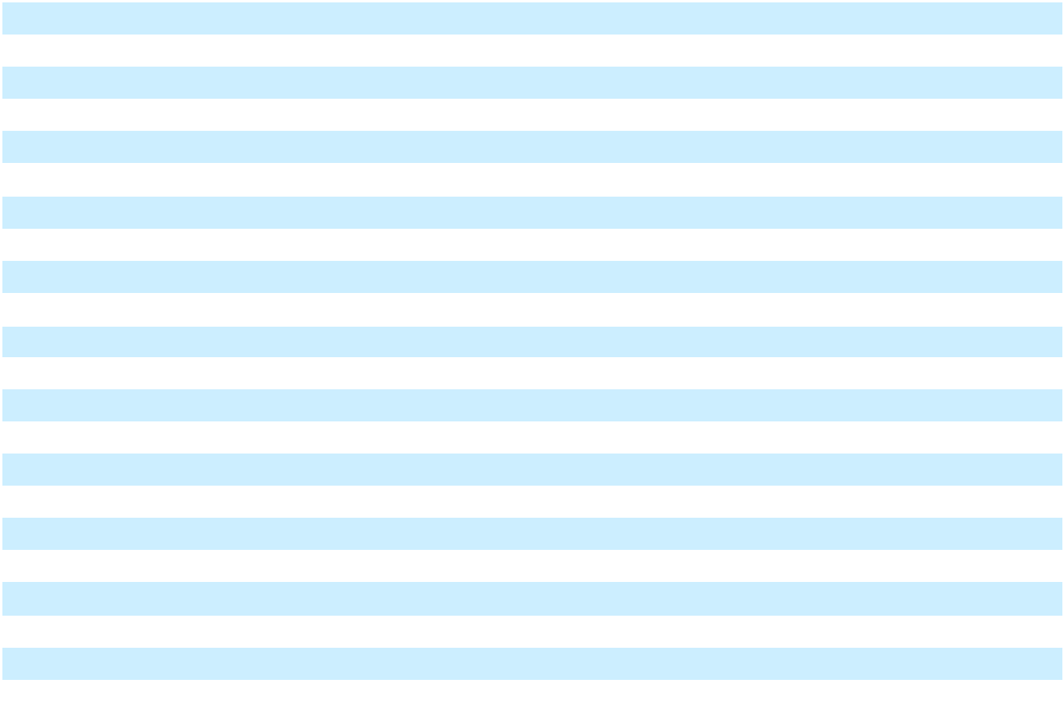

The following table presents potentially dilutive securities excluded from the computation of diluted net (loss) income per share for the years ended December 31, 2025, 2024 and 2023 because its effects would have been anti-dilutive.

 | Year Ended December 31,
 | 2025 |  | 2024 |  |  | 2023
Unvested RSUs | — | 1,579,802 |  |  |  | —
Series B convertible preferred stock⁽¹⁾ | — | 81,746 |  |  |  | —
Equity agreement shares⁽²⁾ | 13,907,346 |  | — |  |  | —

- Represents the number of unconverted Series B convertible preferred shares as of December 31, 2024.

- Represents Class A common stock that would be issued in relation to an agreement to issue shares executed in conjunction with a prior year asset acquisition.

F-78

Table of Contents

27. Stockholders’ equity

Redeemable preferred stock

On October 1, 2024, the Company issued 96,746 shares of the Company’s 4.8% Series B Convertible Preferred Stock, par value $0.01 per share and liquidation preference $1,000 per share (the “Series B Convertible Preferred Stock”), in exchange for all outstanding shares of the Company’s Series A convertible preferred stock.

Conversion to Class A common shares

During the first quarter of 2025, holders of Series B Convertible Preferred Stock submitted conversion notices to convert a total of 45,000 shares of Series B Convertible Preferred Stock, including accrued and unpaid dividends of $107 on these shares, into 4,977,837 Class A common shares at a conversion price of $9.06 per share. The Company issued a total of 6,651,511 Class A common shares to the holders of Series B Convertible Preferred Stock during the three months ended March 31, 2025, which included 1,673,674 shares issued for a conversion notice received in December 2024.

During the third quarter of 2025, the Company notified the holders of Series B Convertible Preferred Stock of a Change Event as a result of downgrades in the credit rating of the Company’s debt, which allowed the holders to require redemption of all outstanding shares by the Company. On August 1, 2025, the Company redeemed a total of 36,746 shares with an updated liquidation preference of $950 per share, including accumulated and unpaid dividends of $756. The conversion price was $4.01, and the Company issued 10,351,348 shares of Class A common stock, which were delivered on August 1, 2025. There are no shares of Series B Convertible Preferred Stock outstanding as of December 31, 2025.

Dividends

The Company paid dividends of $453 and $969 on the Series B Convertible Preferred Stock during the years ended December 31, 2025 and 2024. The Company paid dividends on the Series A Convertible Preferred Stock of $2,493 for the year ended December 31, 2024.

The Company did not declare a dividend on its Class A common stock during the year ended December 31, 2025. The Company declared dividends of $0.10 per share totaling $61,517 during the year ended December 31, 2024, respectively, of which $20,507 remains unpaid. Under certain intercompany agreements entered into in conjunction with the Refinancing Transaction s completed in the fourth quarter of 2024, the Company is no longer permitted to pay dividends to shareholders. The Company also entered into forbearance agreements during the fourth quarter of 2025 and first quarter of 2026 (Note 3); these agreements contains covenants that preclude the Company from making dividend payments.

During the years ended December 31, 2025, 2024, and 2023, the Company paid dividends of $3,019, $12,076, and $12,076 to holders of Golar LNG Partners LP’s (“GMLP”) 8.75% Series A Cumulative Redeemable Preferred Units (“GMLP Preferred Units”), respectively. As these equity interests have been issued by the Company’s consolidated subsidiaries, the value of the GMLP Preferred Units is recognized as non-controlling interest in the consolidated financial statements.

Upon the sale of the vessel Mazo (Refer to Note 17), one of the Company’s non-wholly owned subsidiaries paid a dividend using proceeds from the sale. The dividend of $8,662 paid to the other shareholder in this subsidiary was recognized as a reduction to non-controlling interest during the first quarter of 2024.

Equity issuance

On October 1, 2024, the Company entered into an Underwriting Agreement with several underwriters to issue and sell 46,349,942 shares of the Company’s Class A common stock, at a purchase price to the public of $8.63 per share, less underwriting discounts and commissions, in a registered public offering (the “Equity Offering”). The Company’s Chief Executive Officer, Wesley R. Edens, agreed to purchase 5,793,742 shares at the public offering price per share and on the same terms as the other purchasers in the Equity Offering. The Equity Offering closed on October 2, 2024. The Company received net proceeds of approximately $386,583 after underwriters’ discounts and commissions and the estimated offering expenses payable by the Company.

F-79

Table of Contents

28. Share-based compensation

The Company has granted RSUs to select officers, employees and certain non-employees under the Incentive Plan. The fair value of RSUs on the grant date is estimated based on the closing price of the underlying shares on the grant date. The following table summarizes the RSU activity for the year ended December 31, 2025:

 |  |  |  | Weighted-
 |  |  |  | average
 | Restricted |  |  | grant date
 | Restricted |  |  | fair
 | Stock |  |  | value per
 | Units |  |  | share
Non-vested RSUs as of December 31, 2024 | 1,579,802 | $ |  | 32.60
Granted | 1,417,682 |  |  | 1.10
Vested | (2,212,770) |  |  | 12.42
Forfeited | (511,040) |  |  | 32.66
Non-vested RSUs as of December 31, 2025 | 273,674 | $ |  | 32.66
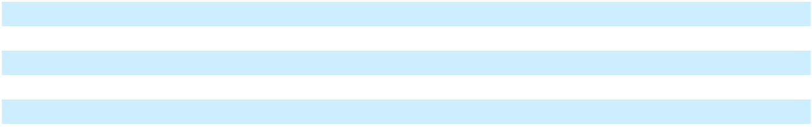

The unvested RSUs as of December 31, 2025 vested in the first quarter of 2026, and there is no significant remaining unrecognized compensation cost as of December 31, 2025.

For the years ended December 31, 2025, 2024, and 2023, the Company recognized compensation costs associated with equity awards in the Consolidated Statements of Operations and Comprehensive (Loss) Income as follows:

 |  | Year Ended December 31,
 |  | 2025 |  |  | 2024 |  |  | 2023
Operations and maintenance | $ | 58 | $ |  | 250 | $ |  | —
Selling, general and administrative |  | 14,488 |  |  | 50,375 |  |  | 1,574
Total share-based compensation expense | $ | 14,546 | $ |  | 50,625 | $ |  | 1,574

During 2024, the Company granted an equity award to certain employees that would settle in shares of a subsidiary owning the Company’s Brazilian operations. In the fourth quarter of 2025, the Company granted a new equity award that fully cancelled and replaced those vested and unvested restricted share units issued during 2024. Vesting of the new award is subject to the Brazilian operations meeting certain development milestones as defined in the agreement. The total expected compensation expense is recognized ratably for each vesting tranche over the respective vesting periods if it is probable that these milestones will be met. Total unrecognized compensation cost of $13,196 under the previous award, along with the incremental compensation cost of $5,406 resulted from the modification, will be recognized over the remaining service period, which is currently expected to conclude in the third quarter of 2027. Included in the table above are compensation expenses of $21,168 and $11,537 for the years ended December 31, 2025 and 2024, respectively, which does not reflect the impact of forfeitures. Unrecognized compensation cost from this equity award was $12,514 as of December 31, 2025.

During the years ended December 31, 2025 and 2024, the Company recognized a reversal of previous compensation expense of $14,025 and $13,584, respectively, due to the forfeiture of awards upon separation with certain employees. The Company recognizes the income tax benefits resulting from vesting of RSUs in the period of vesting, to the extent the compensation expense has been recognized.

29. Related party transactions

Management services

Messrs. Edens, chief executive officer and chairman of the Board of Directors, and Nardone, member of the Board of Directors, are currently employed by Fortress Investment Group LLC (“Fortress”). In the ordinary course of business, Fortress, through affiliated entities, charges the Company for administrative and general expenses incurred pursuant to its Administrative Services Agreement (“Administrative Agreement”). The charges under the Administrative Agreement that are attributable to the Company totaled $802, $6,822 and $5,845 for the years ended December 31, 2025, 2024 and 2023, respectively. Costs associated with the Administrative Agreement are included within Selling, general and administrative in

F-80

Table of Contents

the Consolidated Statements of Operations and Comprehensive (Loss) Income. As of December 31, 2025 and 2024, $738 and $6,755 were due to Fortress, respectively.

In addition to administrative services, Mr. Edens owns an aircraft that the Company charters from a third party operator for

business purposes in the ordinary course of operations. The Company incurred, at aircraft operator rates, charter costs of

$1,837, $2,126 and $2,784 for the years ended December 31, 2025, 2024 and 2023, respectively. As of December 31, 2025

and 2024, $318 and $1,146 was due to this affiliate, respectively.

Fortress affiliated entities

The Company provides certain administrative services to related parties including entities affiliated with Fortress. No costs are incurred for such administrative services by the Company as the Company is fully reimbursed for all costs incurred. The Company has subleased a portion of office space to affiliates of entities managed by Fortress, and for the years ended December 31, 2025, 2024 and 2023, rent and office related expenses of $1,592, $1,080 and $913 were incurred by these affiliates, respectively. As of December 31, 2025 and 2024, $4,263 and $2,637 were due from affiliates, respectively.

Additionally, an entity formerly affiliated with Fortress and currently owned by Messrs. Edens and Nardone provides certain administrative services to the Company, as well as providing office space under a month-to-month non-exclusive license agreement. In May 2024, this affiliate assigned the office lease to the Company, and after this point, the Company no longer incurs rent expense with this affiliate. The Company incurred rent and administrative expenses of approximately $912 and $2,702 for the years ended December 31, 2024 and 2023, respectively. As of December 31, 2025 and 2024, $3,614 was due to Fortress affiliated entities.

Land leases

Prior to the sale of the Company’s Miami Facility in the fourth quarter of 2024, the Company leased land from Florida East Coast Industries, LLC (“FECI”), which is controlled by funds managed by an affiliate of Fortress. The Company recognized expense related to the land lease of $349 and $505 during the years ended December 31, 2024 and 2023, respectively, which was included within Operations and maintenance in the Consolidated Statements of Operations and Comprehensive (Loss) Income. No amounts are due to FECI as of December 31, 2025 and 2024.

In September 2023, the Company entered into a lease agreement to lease land from Jefferson Terminal South LLC, which is an indirect, majority-owned subsidiary of a public company which is managed by an affiliate of Fortress. The Company recognized expense related to the land lease of $731, $731, and $—, during the years ended December 31, 2025, 2024, and 2023, respectively, which was included within Operations and maintenance in the Consolidated Statements of Operations and Comprehensive (Loss) Income. As of December 31, 2025, the right-of-use asset balance is $0 after recognizing an impairment charge during the year (Refer to Note 17), and the lease liability balance is $4,813 on the Consolidated Balance Sheets. As of December 31, 2024, the Company recorded a right-of-use asset of $3,530 and a lease liability of $4,474 on the Consolidated Balance Sheets.

DevTech investment

In 2018, the Company entered into a consulting arrangement with DevTech Environment Limited (“DevTech”) to provide business development services to increase the customer base of the Company. DevTech also contributed cash consideration in exchange for a 10% interest in a consolidated subsidiary. The 10% interest was reflected as non-controlling interest in the Company’s consolidated financial statements.

In March 2025, the Company entered into an agreement to acquire DevTech’s 10% non-controlling interest, and concurrently, terminated the consulting arrangement. A cash payment of $950 was made to DevTech, of which $822 was allocated to the value of the acquired shares of the subsidiary. The Company recognized approximately $0, $537 and $424 in expense within Selling, general and administrative for the years ended December 31, 2025, 2024 and 2023, respectively. As of December 31, 2025 and 2024, $— and $149 were due to DevTech, respectively.

30. Customer concentrations (As Restated)

For the year ended December 31, 2025, revenue from one significant customer constituted approximately 30% of total revenue, or $444,021; no other customers comprised more than 10% of our revenue. For the year ended December 31, 2024, revenue from three significant customers constituted approximately 48% of the total revenue. These three customers

F-81

Table of Contents

each constituted revenues of $433,972, $395,209, and $295,558, respectively. For the year ended December 31, 2023, revenue from two significant customers constituted 47% of the total revenue. These customers each constituted revenues of $755,841 and $371,389, respectively. These customers’ revenues are included in the Company’s Terminals and Infrastructure segment.

During the years ended December 31, 2025, 2024 and 2023, revenue from external customers that were derived from customers located in the United States were $567,802, $1,043,845 and $1,062,487, respectively, and from customers outside of the United States were $936,235, $1,318,322, and $1,352,618, respectively. The Company attributes revenue from customers to the country in which the party to the applicable agreement has its principal place of business.

The table below shows long-lived assets, which are all non-current assets excluding long-term receivables, deposits, investment in equity securities, deferred tax assets, goodwill, and intangible assets, by country, and for those countries with significant long-lived assets:

 |  | December 31, |  |  | December 31,
(in thousands) |  | December 31, |  |  | 2024 (As
(in thousands) |  | 2025 |  |  | Restated)
Long-lived assets
United States | $ | 1,397,828 | $ |  | 1,661,913
Mexico |  | 4,148,176 |  |  | 4,355,753
Brazil |  | 1,944,315 |  |  | 1,225,969
Other foreign countries |  | 1,441,334 |  |  | 2,980,545
Total long-lived assets | $ | 8,931,653 |  | $ | 10,224,180
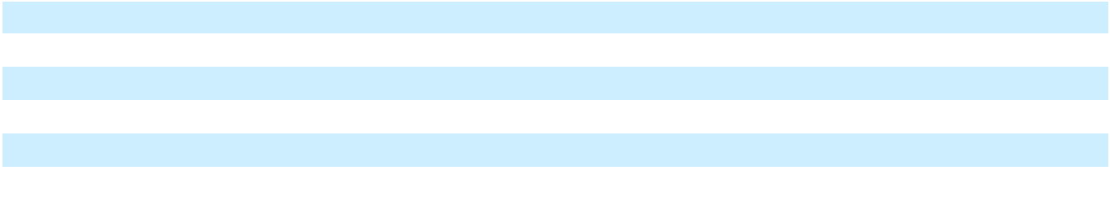

Long-lived assets located in Mexico includes the Company’s FLNG 1 project, which operates in Mexican waters.

31. Segments (As Restated)

As of December 31, 2025, the Company operates in two reportable segments: Terminals and Infrastructure and Ships:

- Terminals and Infrastructure includes the Company’s vertically integrated gas to power solutions, spanning the entire production and delivery chain from natural gas procurement and liquefaction to logistics, shipping, facilities and conversion or development of natural gas-fired power generation. Vessels that are utilized in the Company’s terminal, logistics or sub-charter operations are included in this segment.

- Ships includes vessels chartered under long-term arrangements that were part of a historical financing transaction. We exclude such vessels from this segment and include them in our Terminals and Infrastructure segment once we begin to use the vessels in our own operations. One vessel is currently included in this segment. The Company’s investment in Energos was also included in the Ships segment prior to the disposition of this investment in the first quarter of 2024. The Operating Margin of the Ships segment also included the Company’s effective share of revenue, expenses and operating margin attributable to ownership of the common units of Hilli LLC prior to the disposition of this investment in the first quarter of 2023.

The Company’s CEO, who is the CODM, uses Segment Operating Margin to evaluate the performance of the segments and allocate resources. Segment Operating Margin is defined as the segment’s revenue less cost of sales less operations and maintenance less vessel operating expenses, excluding unrealized gains or losses to financial instruments recognized at fair value. The CODM includes deferred earnings from contracted sales for which a prepayment was received in the segment measure.

The CODM considers Segment Operating Margin to be the appropriate metric to evaluate and compare the ongoing operating performance of the Company’s segments on a consistent basis across reporting periods as it eliminates the effect of items which management does not believe are indicative of each segment’s operating performance.

F-82

Table of Contents

The table below presents segment information for the years ended December 31, 2025, 2024 and 2023:

Year Ended December 31, 2025

(in thousands of $) |  |  | Terminals and |  |  |  |  |  | Total |  | Consolidation
(in thousands of $) |  |  | Infrastructure |  |  | Ships |  |  | Segment |  | and Other⁽⁵⁾ |  |  | Consolidated
Statement of operations:
Total revenues | $ |  | 1,384,693 | $ |  | 119,344 | $ |  | 1,504,037 | $ |  | — | $ |  | 1,504,037
Less⁽¹⁾:
Cost of sales⁽²⁾⁽⁴⁾ |  |  | 918,603 |  |  | — |  |  | 918,603 |  |  | — |  |  | 918,603
Vessel operating expenses |  |  | 4,407 |  |  | 22,187 |  |  | 26,594 |  |  | — |  |  | 26,594
Operations and maintenance |  |  | 218,511 |  |  | — |  |  | 218,511 |  |  | — |  |  | 218,511
Segment Operating Margin |  | $ | 243,172 |  | $ | 97,157 |  | $ | 340,329 |  | $ | — |  | $ | 340,329
Balance sheet:
Total assets | $ |  | 10,467,502 | $ |  | 88,121 | $ |  | 10,555,623 | $ |  | — | $ |  | 10,555,623
Other segmental financial
information:
Capital expenditures⁽³⁾ | $ |  | 990,724 | $ |  | 2,680 | $ |  | 993,404 | $ |  | — | $ |  | 993,404
 |  |  | Year Ended December 31, 2024 (As Restated)
(in thousands of $) |  |  | Terminals and |  |  |  |  |  | Total |  | Consolidation
(in thousands of $) |  |  | Infrastructure |  |  | Ships |  |  | Segment |  | and Other⁽⁵⁾ |  |  | Consolidated
Statement of operations:
Total revenues⁽⁶⁾ | $ |  | 2,041,580 | $ |  | 170,587 | $ |  | 2,212,167 | $ |  | 146,777 | $ |  | 2,358,944
Less⁽¹⁾:
Cost of sales⁽²⁾⁽⁴⁾ |  |  | 1,065,181 |  |  | — |  |  | 1,065,181 |  |  | — |  |  | 1,065,181
Vessel operating expenses |  |  | — |  |  | 33,372 |  |  | 33,372 |  |  | — |  |  | 33,372
Operations and maintenance |  |  | 170,763 |  |  | — |  |  | 170,763 |  |  | — |  |  | 170,763
Deferred earnings from
contracted sales⁽⁶⁾ |  |  | 150,000 |  |  | — |  |  | 150,000 |  |  | (150,000) |  |  | —
Segment Operating Margin |  | $ | 955,636 |  | $ | 137,215 |  | $ | 1,092,851 |  | $ | (3,223) |  | $ | 1,089,628
Balance sheet:
Total assets | $ |  | 12,349,356 | $ |  | 573,869 | $ |  | 12,923,225 | $ |  | — | $ |  | 12,923,225
Other segmental financial
information:
Capital expenditures⁽³⁾ | $ |  | 2,288,994 | $ |  | — | $ |  | 2,288,994 | $ |  | — | $ |  | 2,288,994
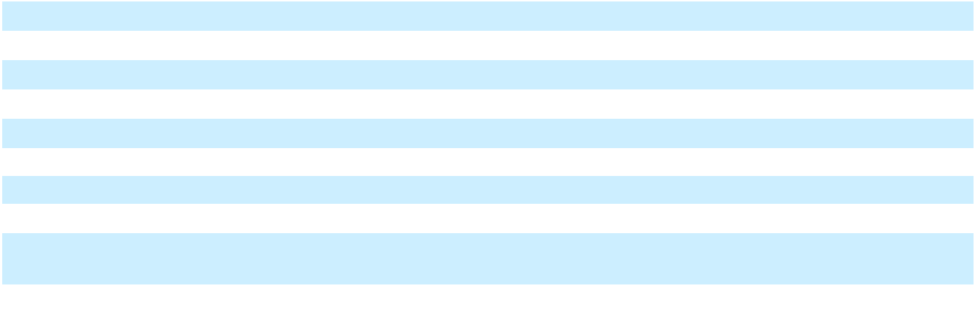
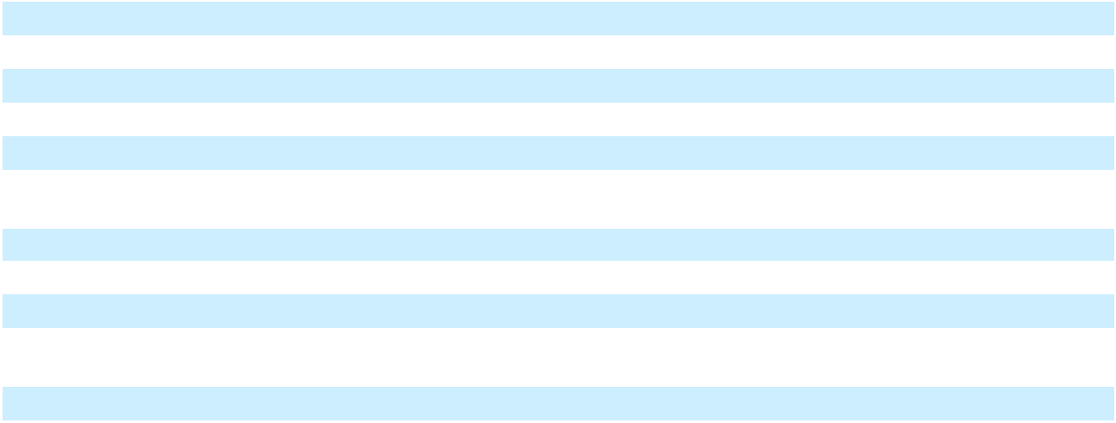

F-83

Table of Contents

Year Ended December 31, 2023 (As Restated)

(in thousands of $) |  |  | Terminals and |  |  |  |  |  | Total |  | Consolidation
(in thousands of $) |  |  | Infrastructure |  |  | Ships |  |  | Segment |  | and Other⁽⁵⁾ |  |  | Consolidated
Statement of operations:
Total revenues⁽⁶⁾ | $ |  | 2,142,894 | $ |  | 293,605 | $ |  | 2,436,499 | $ |  | (45,894) | $ |  | 2,390,605
Less⁽¹⁾:
Cost of sales⁽²⁾⁽⁴⁾ |  |  | 766,598 |  |  | — |  |  | 766,598 |  |  | 112,623 |  |  | 879,221
Vessel operating expenses |  |  | — |  |  | 51,387 |  |  | 51,387 |  |  | (5,948) |  |  | 45,439
Operations and maintenance |  |  | 175,559 |  |  | — |  |  | 175,559 |  |  | — |  |  | 175,559
Segment Operating Margin |  | $ | 1,200,737 |  | $ | 242,218 |  | $ | 1,442,955 |  | $ | (152,569) |  | $ | 1,290,386
Balance sheet:
Total assets | $ |  | 9,677,170 | $ |  | 836,266 | $ |  | 10,513,437 | $ |  | — | $ |  | 10,513,437
Other segmental financial
information:
Capital expenditures⁽³⁾ | $ |  | 3,455,738 | $ |  | 7,568 | $ |  | 3,463,306 | $ |  | — | $ |  | 3,463,306

- The significant expense categories and amounts align with the segment-level information that is regularly provided to the CODM.

- Cost of sales in the Company’s segment measure only includes realized gains and losses on derivative transactions that are an economic hedge of commodity purchases and sales, and a realized gain of $139,089 for the year ended December 31, 2023 was recognized as a reduction to Cost of sales in the segment measure. No realized gains or losses were recognized for the years ended December 31, 2025 and 2024.

The Company recognized unrealized losses of $106,393 on the mark-to-market value of derivative transactions for the year ended December 31, 2023, and these losses reconcile Cost of sales in the segment measure to Cost of sales in the Consolidated Statements of Operations and Comprehensive (Loss) Income. No unrealized gains or losses were recognized for the years ended December 31, 2025 and 2024.

The Company has excluded contract acquisition costs that do not meet the criteria for capitalization from the segment measure. Contract acquisition costs of $6,232 for the year ended December 31, 2023 reconcile Cost of sales in the segment measure to Cost of sales in the Consolidated Statements of Operations and Comprehensive (Loss) Income. The Company did not incur such costs in the years ended December 31, 2025 and 2024.

- Capital expenditures includes amounts capitalized to construction in progress and additions to property, plant and equipment during the period.

- Cost of sales is presented exclusive of costs included in Depreciation and amortization in the Consolidated Statements of Operations and Comprehensive (Loss) Income.

- For the year ended December 31, 2024, Consolidation and Other adjusts for the inclusion of deferred earnings from contracted sales of $150,000 (Note 8) which were recognized during the third and fourth quarters of 2024.

Deferred earnings from contracted sales represent forward sales transactions that were contracted in the second and third quarters of 2024 and prepayment for these sales was received. Revenue has been recognized in the Consolidated Statements of Operations and Comprehensive (Loss) Income during the third and fourth quarters of 2024.

In 2023, the effective share of revenues, expenses and operating margin attributable to the Company’s ownership of the common units of Hilli LLC was included in the segment measure prior to the disposition of these investments. Unrealized mark-to-market gains or losses on derivative instruments and the exclusion of non-capitalizable contract acquisition costs were also removed.

- For the years ended December 31, 2024 and 2023, Consolidation and Other adjusts for $3,223 and $24,500 amortization of intangible assets recognized from acquisition of certain vessels with in-place leases, which was

F-84

Table of Contents

recorded in Vessel charter revenue; such amortization is excluded from Total Segment Operating Margin reviewed by the Company’s CODM.

Consolidated Segment Operating Margin is defined as net (loss) income, adjusted for selling, general and administrative expenses, transaction and integration costs, depreciation and amortization, asset and goodwill impairment expenses, (gain) loss on sale of assets, interest expense, other (income) expense, net, loss on extinguishment of debt, net, and tax (benefit) provision.

The following table reconciles Net income, the most comparable financial statement measure, to Consolidated Segment Operating Margin:

 |  |  | Year Ended December 31,
(in thousands of $) |  |  |  |  |  | 2024 (As |  |  | 2023 (As
(in thousands of $) |  |  | 2025 |  |  | Restated) |  |  | Restated)
Net (loss) income |  |  | (1,831,953) |  |  | (244,537) |  |  | 548,224
Add:
Selling, general and administrative |  |  | 307,442 |  |  | 293,378 |  |  | 203,385
Transaction and integration costs |  |  | 161,756 |  |  | 12,279 |  |  | 6,946
Depreciation and amortization |  |  | 203,508 |  |  | 158,791 |  |  | 161,424
Interest expense |  |  | 777,845 |  |  | 316,337 |  |  | 284,019
(Gain) loss on sale |  |  | (670,938) |  |  | 80,207 |  |  | (27,978)
Other income (expense), net |  |  | (147,593) |  |  | 116,308 |  |  | 10,408
Tax provision |  |  | 61,350 |  |  | 70,308 |  |  | 102,972
Asset impairment expense |  |  | 860,865 |  |  | 16,494 |  |  | 10,958
Goodwill impairment expense |  |  | 598,110 |  |  | — |  |  | —
Loss on extinguishment of debt, net |  |  | 19,937 |  |  | 270,063 |  |  | —
(Income) on equity method investments |  |  | — |  |  | — |  |  | (9,972)
Consolidated Segment Operating Margin |  | $ | 340,329 | $ |  | 1,089,628 | $ |  | 1,290,386
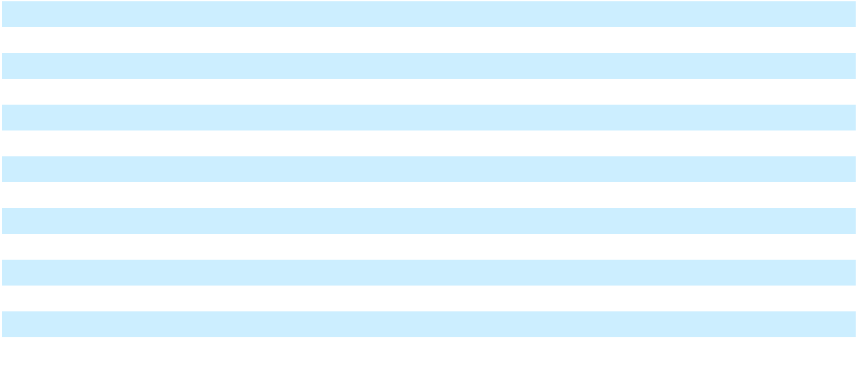

32. Subsequent events

Energos Restructuring Support Agreement

On March 8, 2026, the Company entered into a restructuring support agreement with Energos, which was further amended on March 17, 2026 (“Energos RSA”). The Energos RSA, among other things, reduces the hire rates for Energos Maria and Energos Princess and cancel and terminates the Company’s forward starting charter agreement for Nusantara Regas Satu.

EB-5 Loan Agreement

On March 13, 2026, the Company entered into a term sheet with CanAm Texas Regional Center LP. IV., a Delaware limited partnership in respect of the EB-5 Loan Agreement that contemplates, among other things, the incurrence by the Company of a new unsecured note in the aggregate principal amount of $22,500, with an interest rate of 7.0% per annum, with the option to pay interest in kind, and that matures on December 31, 2029.

Turbine Sale-Leaseback Transaction

On April 1, 2026, the Company, entered into an Asset Purchase Agreement (the “Purchase Agreement”) and Master Lease Agreement (the “Turbine Lease”), pursuant to which the parties agreed to consummate a sale and leaseback transaction with respect to certain turbines. On April 1, 2026, the Company completed the sale of these turbines for a purchase price of

F-85

Table of Contents

$265,883. The Turbine Lease has a 10-year term, which is expected to begin on July 1, 2026. The Company used the net proceeds from the transaction to repay certain indebtedness and provide additional liquidity.

F-86

Table of Contents

33. Restatement of Previously Issued Condensed Consolidated Financial Statements (Unaudited)

In connection with the preparation of the financial statements for the year ended December 31, 2025, the Company identified certain errors in its interest capitalization calculation and determined that adjustments are required to previously issued financial statements for the interim periods ended March 31, June 30, and September 30, 2025. In addition, the Company is restating the previously issued 2025 and 2024 interim financial statements to correct the classification of capital expenditures paid outside of customary payment terms (Note 1), as well as to correct other unrelated errors. Accordingly, the Company has restated its quarterly financial statements for each of the interim periods ended March 31, 2024, June 30, 2024, September 30, 2024, March 31, 2025, June 30, 2025, and September 30, 2025.

The following tables reflect the impact of the restatements to the specific line items presented in our previously financial statements as of and for each of the interim periods ended March 31, 2024, June 30, 2024, September 30, 2024, March 31, 2025, June 30, 2025, and September 30, 2025.

Consolidated Balance Sheets
 |  | As of March 31, 2024 |  |  |  |  |  |  |  |  | As of June 30, 2024 |  |  |  |  |  |  |  |  | As of September 30, 2024
 | As Reported |  |  | Adjustments |  |  | As Restated |  |  | As Reported |  |  | Adjustments |  |  | As Restated |  |  | As Reported |  |  | Adjustments |  |  | As Restated
Assets
Current assets
Cash and cash equivalents | $ | 143,457 | $ |  | — | $ |  | 143,457 | $ |  | 132,960 | $ |  | — | $ |  | 132,960 | $ |  | 90,842 | $ |  | — | $ |  | 90,842
Restricted cash |  | 171,476 |  |  | — |  |  | 171,476 |  |  | 164,888 |  |  | — |  |  | 164,888 |  |  | 145,881 |  |  | — |  |  | 145,881
Receivables, net of allowances |  | 335,313 |  |  | (2,897) |  |  | 332,416 |  |  | 406,779 |  |  | (2,897) |  |  | 403,882 |  |  | 435,883 |  |  | (1,199) |  |  | 434,684
Inventory |  | 186,584 |  |  | — |  |  | 186,584 |  |  | 141,723 |  |  | — |  |  | 141,723 |  |  | 88,095 |  |  | — |  |  | 88,095
Prepaid expenses and other |  | 201,953 |  |  | (757) |  |  | 201,196 |  |  | 277,983 |  |  | (12,501) |  |  | 265,482 |  |  | 273,255 |  |  | (17,501) |  |  | 255,754
current assets, net |  | 201,953 |  |  | (757) |  |  | 201,196 |  |  | 277,983 |  |  | (12,501) |  |  | 265,482 |  |  | 273,255 |  |  | (17,501) |  |  | 255,754
Total current assets |  | 1,038,783 |  |  | (3,654) |  |  | 1,035,129 |  |  | 1,124,333 |  |  | (15,398) |  |  | 1,108,935 |  |  | 1,033,956 |  |  | (18,700) |  |  | 1,015,256
Construction in progress |  | 5,797,511 |  |  | (13,237) |  |  | 5,784,274 |  |  | 6,301,162 |  |  | 4,661 |  |  | 6,305,823 |  |  | 7,051,297 |  |  | 4,492 |  |  | 7,055,789
Property, plant and equipment, |  | 2,175,882 |  |  | — |  |  | 2,175,882 |  |  | 2,144,838 |  |  | 1,628 |  |  | 2,146,466 |  |  | 2,134,987 |  |  | — |  |  | 2,134,987
net |  | 2,175,882 |  |  | — |  |  | 2,175,882 |  |  | 2,144,838 |  |  | 1,628 |  |  | 2,146,466 |  |  | 2,134,987 |  |  | — |  |  | 2,134,987
Right-of-use assets |  | 726,391 |  |  | — |  |  | 726,391 |  |  | 673,424 |  |  | 6,574 |  |  | 679,998 |  |  | 640,978 |  |  | 6,574 |  |  | 647,552
Intangible assets, net |  | 211,854 |  |  | — |  |  | 211,854 |  |  | 207,731 |  |  | — |  |  | 207,731 |  |  | 206,266 |  |  | — |  |  | 206,266
Goodwill |  | 776,760 |  |  | 16,380 |  |  | 793,140 |  |  | 776,760 |  |  | 16,380 |  |  | 793,140 |  |  | 776,760 |  |  | 16,380 |  |  | 793,140
Deferred tax assets, net |  | 27,549 |  |  | — |  |  | 27,549 |  |  | 43,023 |  |  | (17,600) |  |  | 25,423 |  |  | 13,380 |  |  | — |  |  | 13,380
Other non-current assets, net |  | 125,632 |  |  | (1,812) |  |  | 123,820 |  |  | 137,106 |  |  | (1,694) |  |  | 135,412 |  |  | 112,272 |  |  | (2,771) |  |  | 109,501
Total assets | $ | 10,880,362 | $ |  | (2,323) | $ |  | 10,878,039 | $ |  | 11,408,377 | $ |  | (5,449) | $ |  | 11,402,928 | $ |  | 11,969,896 | $ |  | 5,975 | $ |  | 11,975,871
Liabilities
Current liabilities
Current portion of long-term | $ | 291,518 | $ |  | — | $ |  | 291,518 | $ |  | 236,147 | $ |  | — | $ |  | 236,147 | $ |  | 1,145,865 | $ |  | — | $ |  | 1,145,865
debt and short-term borrowings
Accounts payable |  | 524,535 |  |  | (676) |  |  | 523,859 |  |  | 572,746 |  |  | 276 |  |  | 573,022 |  |  | 819,544 |  |  | (3,691) |  |  | 815,853
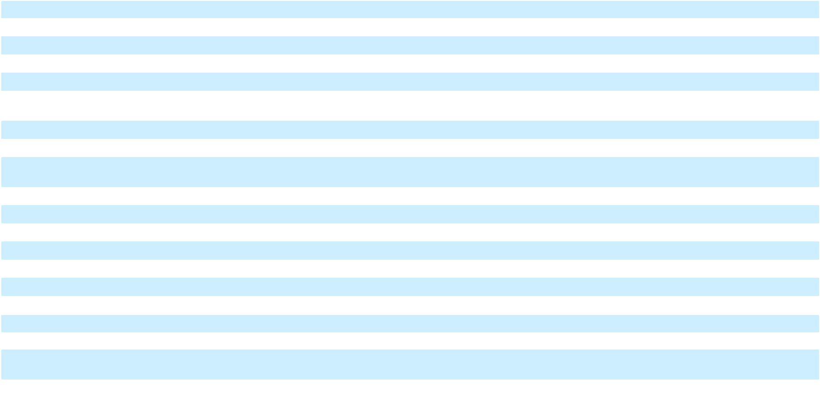

F-87

Table of Contents
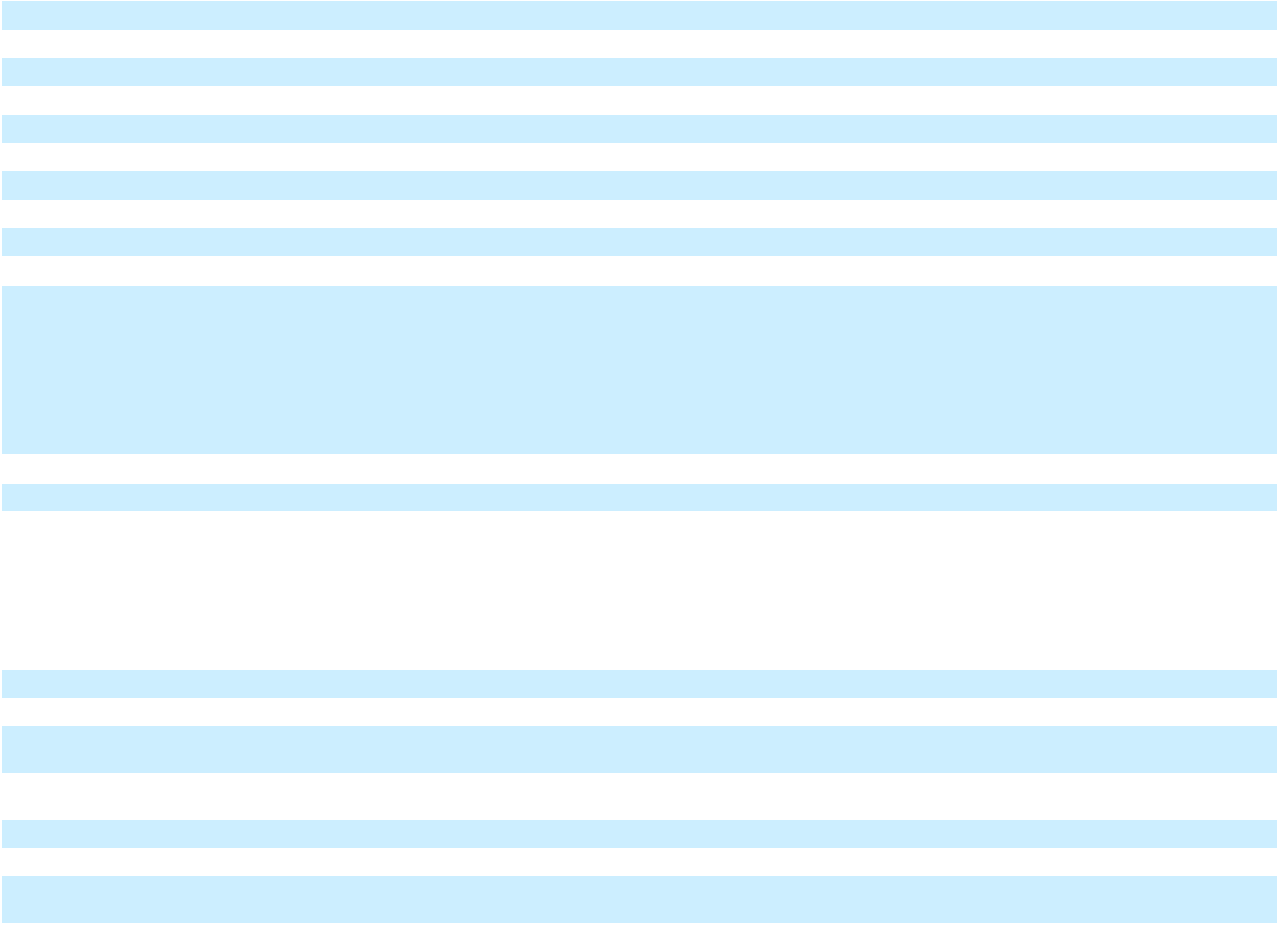

Accrued liabilities | 417,612 |  |  | 5,024 | 422,636 |  | 384,476 |  |  |  | 3,752 | 388,228 |  | 373,882 |  |  |  | 2,534 | 376,416
Current lease liabilities | 147,793 |  |  | — | 147,793 |  | 120,873 |  |  |  | 4,161 | 125,034 |  | 120,949 |  |  |  | 4,161 | 125,110
Other current liabilities | 185,415 |  |  | (17,253) |  | 168,162 |  | 250,558 |  |  | (13,956) |  | 236,602 |  | 248,825 |  |  | (16,043) |  | 232,782
Total current liabilities | 1,566,873 |  |  | (12,905) | 1,553,968 |  | 1,564,800 |  |  |  | (5,767) | 1,559,033 |  | 2,709,065 |  |  |  | (13,039) | 2,696,026
Long-term debt | 6,734,860 |  |  | — | 6,734,860 |  | 7,392,811 |  |  |  | — | 7,392,811 |  | 6,863,123 |  |  |  | 6,623 | 6,869,746
Non-current lease liabilities | 552,619 |  |  | — | 552,619 |  | 521,225 |  |  |  | 2,366 | 523,591 |  | 494,222 |  |  |  | 2,366 | 496,588
Deferred tax liabilities, net | 93,083 |  |  | 15,757 | 108,840 |  | 97,936 |  |  |  | (1,843) | 96,093 |  | 66,226 |  |  |  | 15,757 | 81,983
Other long-term liabilities | 36,645 |  |  | — |  | 36,645 |  | 46,492 |  |  | — |  | 46,492 |  | 50,250 |  |  | (4,419) |  | 45,831
Total liabilities | 8,984,080 |  |  | 2,852 | 8,986,932 |  | 9,623,264 |  |  |  | (5,244) | 9,618,020 |  | 10,182,886 |  |  |  | 7,288 | 10,190,174
Series A convertible preferred
stock, $0.01 par value, 96,746
shares authorized, issued and
outstanding as of March 31, June
30 and September 30, 2024;
aggregate liquidation preference of
$96,746 at March 31, June 30 and | 96,655 |  |  | — | 96,655 |  | 97,845 |  |  |  | — | 97,845 |  | 96,555 |  |  |  | — | 96,555
September 30, 2024 | 96,655 |  |  | — |  |  |  |  |  |  | — |  |  |  |  |  |  | —
Stockholders’ equity
Class A common stock, $0.01 par
value, 750.0 million shares
authorized, 205.0 million issued
and outstanding as of March 31,
2024; 205.1 million issued and
outstanding as of June 30, 2024;
205.1 million issued and
outstanding as of September 30, | 2,050 |  |  | — | 2,050 |  | 2,050 |  |  |  | — | 2,050 |  | 2,050 |  |  |  | — | 2,050
2024 | 2,050 |  |  | — |  |  |  |  |  |  | — |  |  |  |  |  |  | —
Additional paid-in capital | 1,043,652 |  |  | — | 1,043,652 |  | 1,063,426 |  |  |  | — | 1,063,426 |  | 1,085,950 |  |  |  | — | 1,085,950
Retained earnings | 561,422 |  |  | (5,734) | 555,688 |  | 450,871 |  |  |  | (764) | 450,107 |  | 438,502 |  |  |  | (1,872) | 436,630
Accumulated other | 64,179 |  |  | 559 |  | 64,738 |  | 43,653 |  |  | 559 |  | 44,212 |  | 37,141 |  |  | 559 |  | 37,700
comprehensive income | 64,179 |  |  |  |  |  |  |  |  |  |  |  |  |  |  |  |  | 559 |  | 37,700
Total stockholders’ equity | 1,671,303 |  |  | (5,175) | 1,666,128 |  | 1,560,000 |  |  |  | (205) | 1,559,795 |  | 1,563,643 |  |  |  | (1,313) | 1,562,330
attributable to NFE | 1,671,303 |  |  | (5,175) |  |  |  |  |  |  | (205) |  |  |  |  |  |  | (1,313)
Non-controlling interest | 128,324 |  |  | — |  | 128,324 |  | 127,268 |  |  | — |  | 127,268 |  | 126,812 |  |  | — |  | 126,812
Total stockholders’ equity | 1,799,627 |  |  | (5,175) |  | 1,794,452 |  | 1,687,268 |  |  | (205) |  | 1,687,063 |  | 1,690,455 |  |  | (1,313) |  | 1,689,142
Total liabilities and | $10,880,362 |  | $ | (2,323) |  | $10,878,039 |  | $11,408,377 |  | $ | (5,449) |  | $11,402,928 |  | $11,969,896 |  | $ | 5,975 |  | $11,975,871
stockholders’ equity

F-88

Table of Contents

Quarterly Consolidated Statements of Operations and Comprehensive (Loss) Income

 |  | Three Months Ended March 31, 2024 |  |  |  |  |  |  |  |  | Three Months Ended June 30, 2024 |  |  |  |  |  |  |  |  | Three Months Ended September 30, 2024
 | As Reported |  |  | Adjustments |  |  | As Restated |  |  | As Reported |  |  | Adjustments |  |  | As Restated |  |  | As Reported |  |  | Adjustments |  |  | As Restated
Revenues
Operating revenue | $ | 609,504 | $ |  | — | $ |  | 609,504 | $ |  | 291,222 | $ |  | — | $ |  | 291,222 | $ |  | 446,048 | $ |  | — | $ |  | 446,048
Vessel charter revenue |  | 46,655 |  |  | (832) |  |  | 45,823 |  |  | 52,416 |  |  | (832) |  |  | 51,584 |  |  | 59,668 |  |  | (727) |  |  | 58,941
Other revenue |  | 34,162 |  |  | (3,507) |  |  | 30,655 |  |  | 84,368 |  |  | — |  |  | 84,368 |  |  | 61,819 |  |  | 1,697 |  |  | 63,516
Total Revenues |  | 690,321 |  |  | (4,339) |  |  | 685,982 |  |  | 428,006 |  |  | (832) |  |  | 427,174 |  |  | 567,535 |  |  | 970 |  |  | 568,505
Operating expenses
Cost of sales (exclusive of
depreciation and amortization |  | 229,117 |  |  | (1,206) |  |  | 227,911 |  |  | 221,860 |  |  | (47) |  |  | 221,813 |  |  | 325,292 |  |  | — |  |  | 325,292
shown separately below) |  | 229,117 |  |  | (1,206) |  |  | 227,911 |  |  | 221,860 |  |  | (47) |  |  | 221,813 |  |  | 325,292 |  |  | — |  |  | 325,292
Vessel operating expenses |  | 8,396 |  |  | — |  |  | 8,396 |  |  | 8,503 |  |  | — |  |  | 8,503 |  |  | 8,254 |  |  | — |  |  | 8,254
Operations and maintenance |  | 68,548 |  |  | (2,887) |  |  | 65,661 |  |  | 39,292 |  |  | (6,213) |  |  | 33,079 |  |  | 32,062 |  |  | 2,777 |  |  | 34,839
Selling, general and |  | 70,754 |  |  | (2,717) |  |  | 68,037 |  |  | 70,578 |  |  | 3,023 |  |  | 73,601 |  |  | 82,388 |  |  | (1,043) |  |  | 81,345
administrative |  | 70,754 |  |  | (2,717) |  |  | 68,037 |  |  | 70,578 |  |  | 3,023 |  |  | 73,601 |  |  | 82,388 |  |  | (1,043) |  |  | 81,345
Transaction and integration costs |  | 1,371 |  |  | — |  |  | 1,371 |  |  | 1,760 |  |  | — |  |  | 1,760 |  |  | 3,154 |  |  | — |  |  | 3,154
Depreciation and amortization |  | 50,491 |  |  | (832) |  |  | 49,659 |  |  | 37,413 |  |  | (832) |  |  | 36,581 |  |  | 35,364 |  |  | (727) |  |  | 34,637
Asset impairment expense |  | — |  |  | — |  |  | — |  |  | 4,272 |  |  | 11,744 |  |  | 16,016 |  |  | 1,484 |  |  | — |  |  | 1,484
(Gain) loss on sale |  | 77,140 |  |  | 2,645 |  |  | 79,785 |  |  | — |  |  | — |  |  | — |  |  | — |  |  | — |  |  | —
Total operating expenses |  | 505,817 |  |  | (4,997) |  |  | 500,820 |  |  | 383,678 |  |  | 7,675 |  |  | 391,353 |  |  | 487,998 |  |  | 1,007 |  |  | 489,005
Operating (loss) income |  | 184,504 |  |  | 658 |  |  | 185,162 |  |  | 44,328 |  |  | (8,507) |  |  | 35,821 |  |  | 79,537 |  |  | (37) |  |  | 79,500
Interest expense |  | 77,344 |  |  | 7,401 |  |  | 84,745 |  |  | 80,399 |  |  | (17,312) |  |  | 63,087 |  |  | 71,107 |  |  | 795 |  |  | 71,902
Other (income) expense, net |  | 19,112 |  |  | — |  |  | 19,112 |  |  | 47,354 |  |  | — |  |  | 47,354 |  |  | (5,836) |  |  | — |  |  | (5,836)
Loss on extinguishment of debt, |  | 9,754 |  |  | — |  |  | 9,754 |  |  | — |  |  | — |  |  | — |  |  | — |  |  | — |  |  | —
net |  | 9,754 |  |  | — |  |  | 9,754 |  |  | — |  |  | — |  |  | — |  |  | — |  |  | — |  |  | —
(Loss) income before income |  | 78,294 |  |  | (6,743) |  |  | 71,551 |  |  | (83,425) |  |  | 8,805 |  |  | (74,620) |  |  | 14,266 |  |  | (832) |  |  | 13,434
taxes |  | 78,294 |  |  | (6,743) |  |  | 71,551 |  |  | (83,425) |  |  | 8,805 |  |  | (74,620) |  |  | 14,266 |  |  | (832) |  |  | 13,434
Tax provision |  | 21,624 |  |  | (1,661) |  |  | 19,963 |  |  | 3,435 |  |  | 3,835 |  |  | 7,270 |  |  | 2,953 |  |  | 276 |  |  | 3,229
Net (loss) income |  | 56,670 |  |  | (5,082) |  |  | 51,588 |  |  | (86,860) |  |  | 4,970 |  |  | (81,890) |  |  | 11,313 |  |  | (1,108) |  |  | 10,205
Net (loss) income attributable | $ | 53,939 | $ |  | (5,082) | $ |  | 48,858 | $ |  | (90,044) | $ |  | 4,970 | $ |  | (85,075) | $ |  | 8,138 | $ |  | (1,108) | $ |  | 7,030
to common stockholders
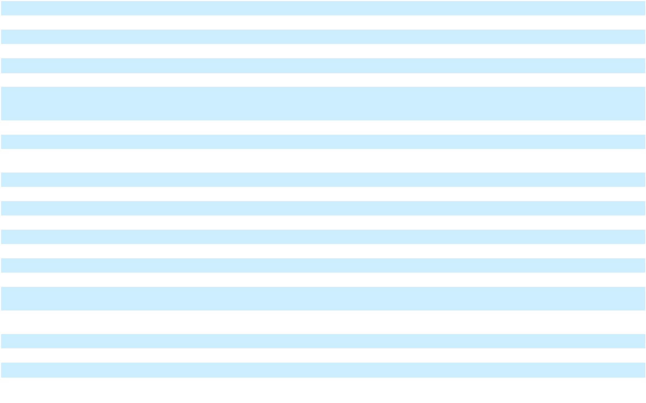

F-89

Table of Contents
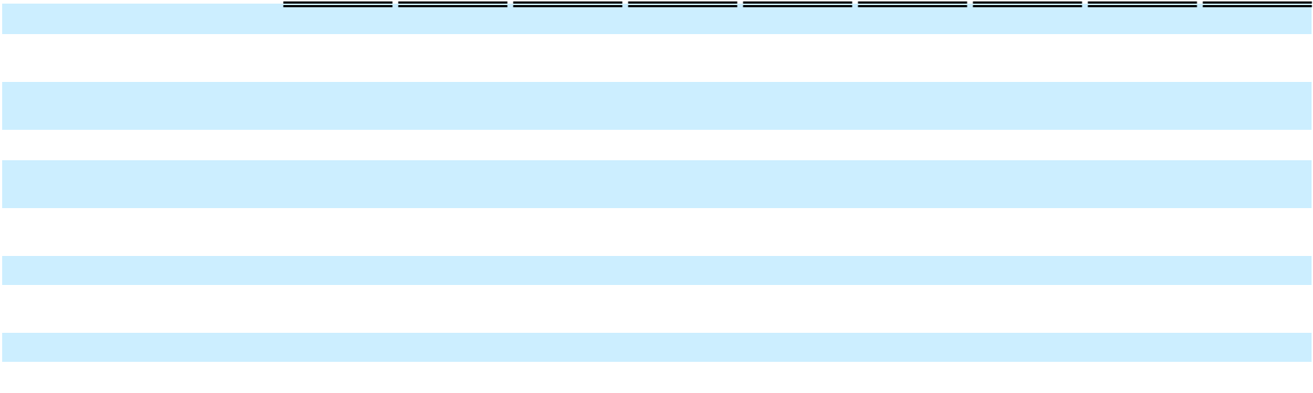

Net (loss) income per share – | $ | 0.26 | $ |  | (0.02) | $ |  | 0.24 | $ |  | (0.44) | $ |  | 0.03 | $ |  | (0.41) | $ |  | 0.04 | $ |  | (0.01) | $ |  | 0.03
basic
Net (loss) income per share –
Net (loss) income per share – | $ | 0.26 | $ |  | (0.03) | $ |  | 0.23 | $ |  | (0.44) | $ |  | 0.02 | $ |  | (0.42) | $ |  | 0.03 | $ |  | — | $ |  | 0.03
diluted
Weighted average number of
Weighted average number of | 205,061,967 |  |  |  | — | 205,061,967 |  |  | 205,070,756 |  |  |  |  | — | 205,070,756 |  |  | 205,071,771 |  |  |  |  | — | 205,071,771
shares outstanding – basic |  |  |  |  | — |  |  |  |  |  |  |  |  | — |  |  |  |  |  |  |  |  | —
Weighted average number of
Weighted average number of | 205,977,720 |  |  |  | — | 205,977,720 |  |  | 205,851,364 |  |  |  |  | — | 205,851,364 |  |  | 208,880,044 |  |  |  |  | — | 208,880,044
shares outstanding – diluted |  |  |  |  | — |  |  |  |  |  |  |  |  | — |  |  |  |  |  |  |  |  | —
Other comprehensive (loss)
income:
Currency translation adjustment |  | (7,708) |  |  | — |  |  | (7,708) |  |  | (20,557) |  |  | — |  |  | (20,557) |  |  | (5,963) |  |  | — |  |  | (5,963)
Comprehensive (loss) income |  | 48,962 |  |  | (5,082) |  |  | 43,880 |  |  | (107,417) |  |  | 4,970 |  |  | (102,447) |  |  | 5,350 |  |  | (1,108) |  |  | 4,242
Comprehensive (income)
attributable to non-controlling |  | (2,230) |  |  | — |  |  | (2,230) |  |  | (1,963) |  |  | — |  |  | (1,963) |  |  | (2,563) |  |  | — |  |  | (2,563)
interest |  | (2,230) |  |  | — |  |  | (2,230) |  |  | (1,963) |  |  | — |  |  | (1,963) |  |  | (2,563) |  |  | — |  |  | (2,563)
Comprehensive (loss) income | $ | 46,732 |  | $ | (5,082) |  | $ | 41,650 |  | $ | (109,380) |  | $ | 4,970 |  | $ | (104,410) |  | $ | 2,787 |  | $ | (1,108) |  | $ | 1,679
attributable to stockholders
 |  |  |  |  |  |  |  |  |  |  | Six Months Ended June 30, 2024 |  |  |  |  |  |  |  |  | Nine Months Ended September 30, 2024
 |  |  |  |  |  |  |  |  |  | As Reported |  |  | Adjustments |  |  | As Restated |  |  | As Reported |  |  | Adjustments |  |  | As Restated
Revenues
Operating revenue |  |  |  |  |  |  |  |  | $ |  | 900,726 | $ |  | — | $ |  | 900,726 | $ 1,346,774 |  |  | $ |  | — | $ 1,346,774
Vessel charter revenue |  |  |  |  |  |  |  |  |  |  | 99,071 |  |  | (1,664) |  |  | 97,407 |  |  | 158,739 |  |  | (2,391) |  |  | 156,348
Other revenue |  |  |  |  |  |  |  |  |  |  | 118,530 |  |  | (3,507) |  |  | 115,023 |  |  | 180,349 |  |  | (1,809) |  |  | 178,540
Total Revenues |  |  |  |  |  |  |  |  |  |  | 1,118,327 |  |  | (5,171) |  |  | 1,113,156 |  |  | 1,685,862 |  |  | (4,200) |  |  | 1,681,662
Operating expenses
Cost of sales (exclusive of depreciation and amortization shown separately |  |  |  |  |  |  |  |  |  |  | 450,977 |  |  | (1,252) |  |  | 449,725 |  |  | 776,269 |  |  | (1,252) |  |  | 775,017
below) |  |  |  |  |  |  |  |  |  |  | 450,977 |  |  | (1,252) |  |  | 449,725 |  |  | 776,269 |  |  | (1,252) |  |  | 775,017
Vessel operating expenses |  |  |  |  |  |  |  |  |  |  | 16,899 |  |  | — |  |  | 16,899 |  |  | 25,153 |  |  | — |  |  | 25,153
Operations and maintenance |  |  |  |  |  |  |  |  |  |  | 107,840 |  |  | (9,101) |  |  | 98,739 |  |  | 139,902 |  |  | (6,323) |  |  | 133,579
Selling, general and administrative |  |  |  |  |  |  |  |  |  |  | 141,332 |  |  | 307 |  |  | 141,639 |  |  | 223,720 |  |  | (736) |  |  | 222,984
Transaction and integration costs |  |  |  |  |  |  |  |  |  |  | 3,131 |  |  | — |  |  | 3,131 |  |  | 6,285 |  |  | — |  |  | 6,285
Depreciation and amortization |  |  |  |  |  |  |  |  |  |  | 87,904 |  |  | (1,664) |  |  | 86,240 |  |  | 123,268 |  |  | (2,391) |  |  | 120,877
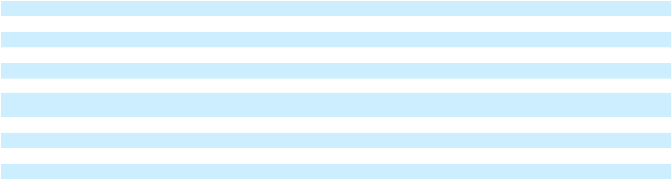

F-90

Table of Contents
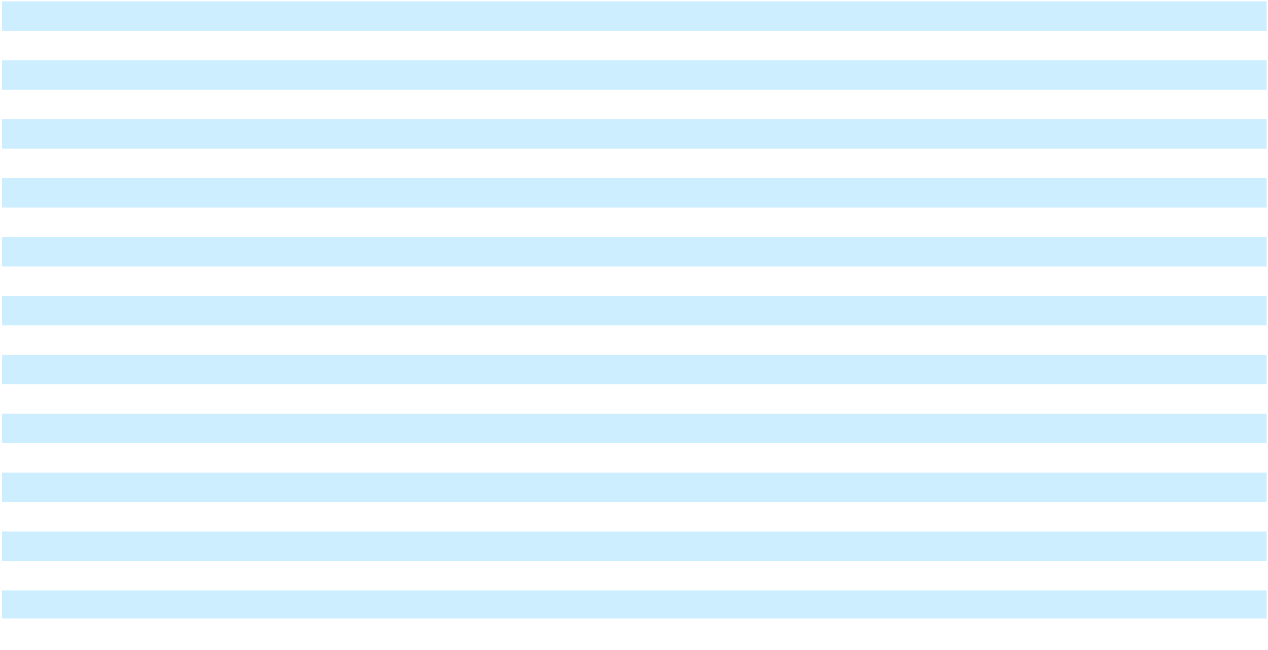

Asset impairment expense |  | 4,272 |  |  | 11,744 |  |  | 16,016 |  |  | 5,756 |  |  | 11,744 |  |  | 17,500
(Gain) loss on sale |  | 77,140 |  |  | 2,645 |  |  | 79,785 |  |  | 77,140 |  |  | 2,645 |  |  | 79,785
Total operating expenses |  | 889,495 |  |  | 2,679 |  |  | 892,174 |  |  | 1,377,493 |  |  | 3,687 |  |  | 1,381,180
Operating income |  | 228,832 |  |  | (7,850) |  |  | 220,982 |  |  | 308,369 |  |  | (7,887) |  |  | 300,482
Interest expense |  | 157,743 |  |  | (9,911) |  |  | 147,832 |  |  | 228,850 |  |  | (9,116) |  |  | 219,734
Other (income) expense, net |  | 66,466 |  |  | — |  |  | 66,466 |  |  | 60,630 |  |  | — |  |  | 60,630
Loss on extinguishment of debt, net |  | 9,754 |  |  | — |  |  | 9,754 |  |  | 9,754 |  |  | — |  |  | 9,754
(Loss) income before income taxes |  | (5,131) |  |  | 2,061 |  |  | (3,070) |  |  | 9,135 |  |  | 1,229 |  |  | 10,364
Tax provision |  | 25,059 |  |  | 2,173 |  |  | 27,232 |  |  | 28,012 |  |  | 2,449 |  |  | 30,461
Net (loss) |  | (30,190) |  |  | (112) |  |  | (30,302) |  |  | (18,877) |  |  | (1,220) |  |  | (20,097)
Net (loss) attributable to common stockholders | $ | (36,105) |  | $ | (112) |  | $ | (36,217) |  | $ | (27,967) |  | $ | (1,220) |  | $ | (29,187)
Net (loss) per share – basic | $ | (0.18) |  | $ | — |  | $ | (0.18) |  | $ | (0.14) |  | $ | — |  | $ | (0.14)
Net (loss) per share – diluted | $ | (0.18) |  | $ | — |  | $ | (0.18) |  | $ | (0.15) |  | $ | (0.01) |  | $ | (0.16)
Weighted average number of shares outstanding – basic | 205,066,362 |  | $ |  | — | 205,066,362 |  |  | 205,068,178 |  |  |  |  | — | 205,068,178
Weighted average number of shares outstanding – diluted | 205,846,970 |  |  |  | — | 205,846,970 |  |  | 206,836,683 |  |  |  |  | — | 206,836,683
Other comprehensive (loss) income:
Currency translation adjustment |  | (28,265) |  |  | — |  |  | (28,265) |  |  | (34,228) |  |  | — |  |  | (34,228)
Comprehensive (loss) |  | (58,455) |  |  | (112) |  |  | (58,567) |  |  | (53,105) |  |  | (1,220) |  |  | (54,325)
Comprehensive (income) attributable to non-controlling interest |  | (4,193) |  |  | — |  |  | (4,193) |  |  | (6,756) |  |  | — |  |  | (6,756)
Comprehensive (loss) attributable to stockholders | $ | (62,648) | $ |  | (112) | $ |  | (62,760) | $ |  | (59,861) | $ |  | (1,220) | $ |  | (61,081)

Consolidated Statements of Changes in Stockholders’ Equity
 |  |  |  |  |  |  | Three Months Ended March 31, 2024
 | Series A convertible |  |  |  |  |  |  |  |  |  |  |  | Accumulated
 |  |  |  |  |  |  |  |  | Additional |  |  |  | other |  | Non- |  | Total
 | preferred stock |  |  |  | Class A common stock |  |  |  | Additional |  |  |  | other |  | Non- |  | Total
 |  |  |  |  |  |  |  |  | paid-in |  | Accumulated |  | comprehensive |  | controlling |  | stockholders’
As Reported | Shares |  | Amount |  | Shares |  | Amount |  | capital |  | deficit |  | (loss) income |  | Interest |  | equity

F-91

Table of Contents

Balance as of December 31, | — |  | — | 205,031,406 |  | 2,050 |  | 1,038,530 |  | 527,986 |  | 71,528 |  | 137,775 |  | 1,777,869
2023 (As Reported) | —
Net income (loss)
Net income (loss) | — |  | — |  | — |  | — |  | — |  | 54,081 |  | — |  | 2,589 |  | 56,670
Other comprehensive income
(loss) | — |  | — |  | — |  | — |  | — |  | — | (7,349) |  | (359) |  | (7,708)
Share-based compensation
expense | — |  | — |  | — |  | — | 5,248 |  |  | — |  | — |  | — | 5,248
Issuance of shares for vested
share-based compensation
awards | — |  | — | 14,126 |  |  | — |  | — |  | — |  | — |  | — |  | —
Shares withheld from
employees related to share-
based compensation, at cost | — |  | — | (3,708) |  |  | — | (126) |  |  | — |  | — |  | — | (126)
Issuance of Series A convertible
preferred stock, net | 96,746 | 96,513 |  |  | — |  | — |  | — |  | — |  | — |  | — |  | —
Dividends | — |  | 142 |  | — |  | — |  | — |  | (20,645) |  | — |  | (11,681) |  | (32,326)
Balance as of March 31, 2024 | 96,746 | 96,655 |  | 205,041,824 |  | 2,050 |  | 1,043,652 |  | 561,422 |  | 64,179 |  | 128,324 |  | 1,799,627
(As Reported)
Adjustments
Balance as of December 31, | — |  | — |  | — |  | — |  | — | (652) |  | 559 |  |  | — | (93)
2023 | — |  | — |  | — |  | — |  | — |  |  |  |  |  | —
Net income (loss) | — |  | — |  | — |  | — |  | — |  | (5,082) |  | — |  | — |  | (5,082)
Total Adjustments | — |  | — |  | — |  | — |  | — | (5,734) |  | 559 |  |  | — | (5,175)
As Restated
Balance as of December 31, | — |  | — |  | 205,031,406 |  | 2,050 |  | 1,038,530 |  | 527,334 |  | 72,087 |  | 137,775 |  | 1,777,776
2023 (As Restated) | —
Net income (loss)
Net income (loss) | — |  | — |  | — |  | — |  | — |  | 48,999 |  | — |  | 2,589 |  | 51,588
Other comprehensive income
(loss) | — |  | — |  | — |  | — |  | — |  | — | (7,349) |  | (359) |  | (7,708)
Share-based compensation
expense | — |  | — |  | — |  | — | 5,248 |  |  | — |  | — |  | — | 5,248
share-based compensation
awards | — |  | — | 14,126 |  |  | — |  | — |  | — |  | — |  | — |  | —
Shares withheld from
employees related to share-
based compensation, at cost | — |  | — | (3,708) |  |  | — | (126) |  |  | — |  | — |  | — | (126)
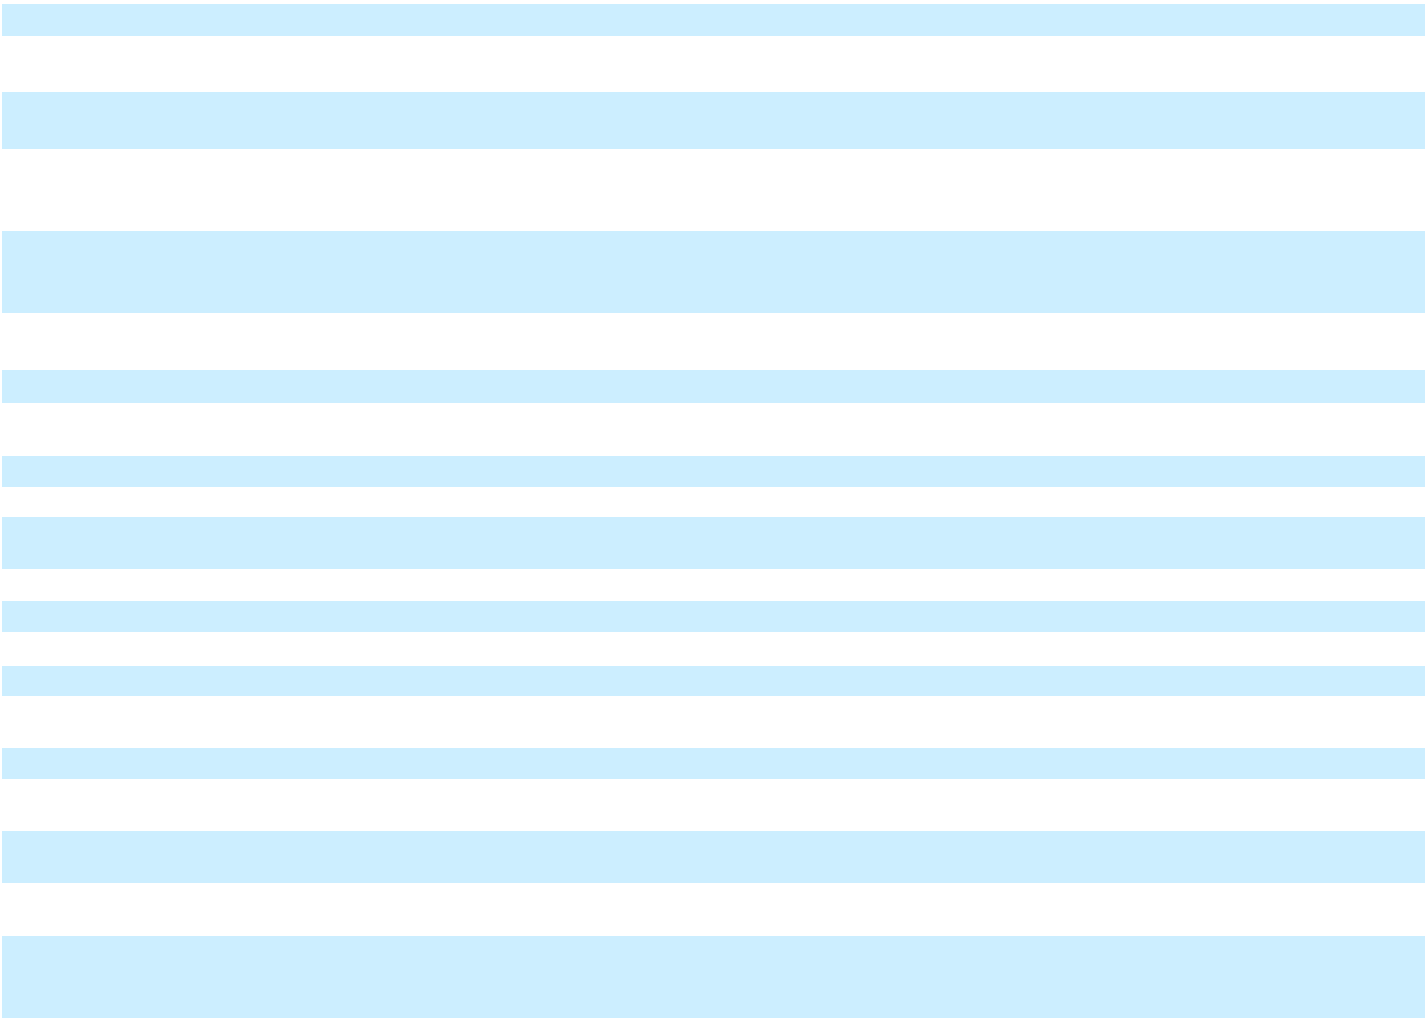

F-92

Table of Contents

Issuance of Series A convertible
preferred stock, net | 96,746 | 96,513 |  |  | — |  | — |  | — |  | — |  | — |  | — |  | —
Dividends | — |  | 142 |  | — |  | — |  | — |  | (20,645) |  | — |  | (11,681) |  | (32,326)
Balance as of March 31, 2024 | 96,746 |  | 96,655 |  | 205,041,824 |  | 2,050 |  | 1,043,652 |  | 555,688 |  | 64,738 |  | 128,324 |  | 1,794,452
(As Restated)
 |  |  |  |  |  |  | Three Months Ended June 30, 2024
 | Series A convertible |  |  |  |  |  |  |  |  |  |  |  | Accumulated
 |  |  |  |  |  |  |  |  | Additional |  |  |  | other |  | Non- |  | Total
 | preferred stock |  |  |  | Class A common stock |  |  |  | Additional |  |  |  | other |  | Non- |  | Total
 |  |  |  |  |  |  |  |  | paid-in |  | Accumulated |  | comprehensive |  | controlling |  | stockholders’
As Reported | Shares |  | Amount |  | Shares |  | Amount |  | capital |  | deficit |  | (loss) income |  | Interest |  | equity
Balance as of March 31, 2024 | 96,746 |  | 96,655 |  | 205,041,824 |  | 2,050 |  | 1,043,652 |  | 561,422 |  | 64,179 |  | 128,324 |  | 1,799,627
(As Reported)
Net income (loss) | — |  | — |  | — |  | — |  | — | (88,854) |  |  | — | 1,994 |  | (86,860)
Other comprehensive income
(loss) | — |  | — |  | — |  | — |  | — |  | — | (20,526) |  | (31) |  | (20,557)
Share-based compensation
expense | — |  | — |  | — |  | — | 20,064 |  |  | — |  | — |  | — | 20,064
Issuance of shares for vested | — |  | — | 34,578 |  |  | — |  | — |  | — |  | — |  | — |  | —
Shares withheld from
employees related to share-
based compensation, at cost | — |  | — | (11,074) |  |  | — | (290) |  |  | — |  | — |  | — | (290)
Dividends | — |  | 1,190 |  |  |  | — |  | — |  | (21,697) |  | — |  | (3,019) |  | (24,716)
Balance as of June 30, 2024 (As | 96,746 | 97,845 |  | 205,065,328 |  | 2,050 |  | 1,063,426 |  | 450,871 |  | 43,653 |  | 127,268 |  | 1,687,268
Reported)
Adjustments
Balance as of March 31, 2024 | — |  | — |  | — |  | — |  | — | (5,734) |  | 559 |  |  | — | (5,175)
Net income (loss) | — |  | — |  | — |  | — |  | — |  | 4,970 |  | — |  | — |  | 4,970
Total Adjustments | — |  | — |  | — |  | — |  | — | (764) |  | 559 |  |  | — | (205)
As Restated
Balance as of March 31, 2024 | 96,746 | 96,655 |  | 205,041,824 |  | 2,050 |  | 1,043,652 |  | 555,688 |  | 64,738 |  | 128,324 |  | 1,794,452
(As Restated)
Net income (loss) | — |  | — |  | — |  | — |  | — | (83,884) |  |  | — | 1,994 |  | (81,890)
Other comprehensive income | — |  | — |  | — |  | — |  | — |  | — | (20,526) |  | (31) |  | (20,557)
(loss) | — |  | — |  | — |  | — |  | —
Share-based compensation | — |  | — |  | — |  | — | 20,064 |  |  | — |  | — |  | — | 20,064
expense | — |  | — |  | — |  | — |  |  |  | — |  | — |  | —
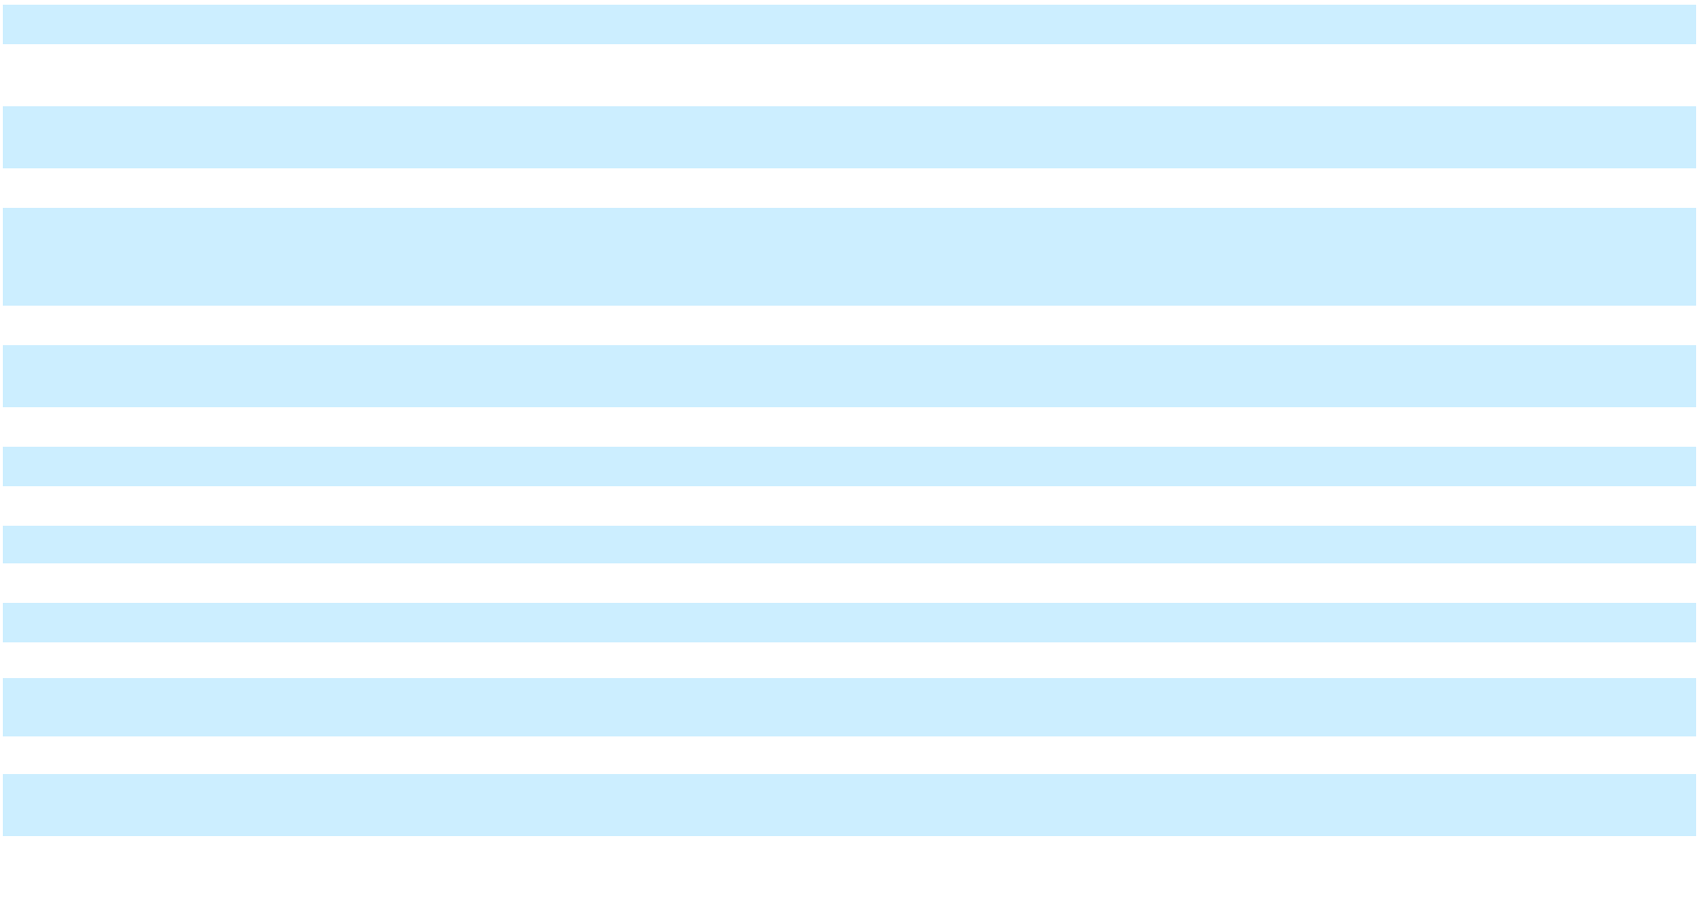

F-93

Table of Contents
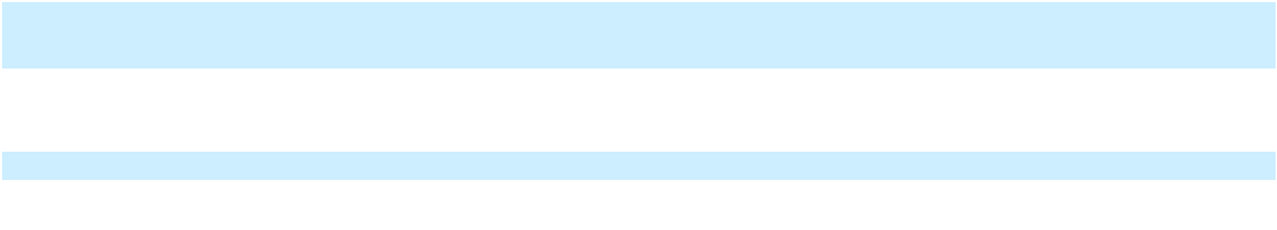

Issuance of shares for vested
share-based compensation | — |  | — | 34,578 |  |  | — |  | — |  | — |  | — |  | — |  | —
awards | — |  | — |  |  |  | — |  | — |  | — |  | — |  | — |  | —
Shares withheld from
employees related to share-
based compensation, at cost | — |  | — | (11,074) |  |  | — | (290) |  |  | — |  | — |  | — | (290)
Dividends | — |  | 1,190 |  | — |  | — |  | — |  | (21,697) |  | — |  | (3,019) |  | (24,716)
Balance as of June 30, 2024 (As | 96,746 |  | 97,845 |  | 205,065,328 |  | 2,050 |  | 1,063,426 |  | 450,107 |  | 44,212 |  | 127,268 |  | 1,687,063
Restated)
 |  |  |  |  |  |  | Three Months Ended September 30, 2024
 | Series A convertible |  |  |  |  |  |  |  |  |  |  |  | Accumulated
 |  |  |  |  |  |  |  |  | Additional |  |  |  | other |  | Non- |  | Total
 | preferred stock |  |  |  | Class A common stock |  |  |  | Additional |  |  |  | other |  | Non- |  | Total
 |  |  |  |  |  |  |  |  | paid-in |  | Accumulated |  | comprehensive |  | controlling |  | stockholders’
As Reported | Shares |  | Amount |  | Shares |  | Amount |  | paid-in |  | Accumulated |  | comprehensive |  | controlling |  | stockholders’
As Reported | Shares |  | Amount |  | Shares |  | Amount |  | capital |  | deficit |  | (loss) income |  | Interest |  | equity
Balance as of June 30, 2024 (As | 96,746 |  | 97,845 |  | 205,065,328 |  | 2,050 |  | 1,063,426 |  | 450,871 |  | 43,653 |  | 127,268 |  | 1,687,268
Reported)
Net income (loss) | — |  | — |  | — |  | — |  | — | 9,299 |  |  | — | 2,014 |  | 11,313
Other comprehensive income | — |  | — |  | — |  | — |  | — |  | — | (6,512) |  | 549 |  | (5,963)
(loss) | — |  | — |  | — |  | — |  | —
Share-based compensation | — |  | — |  | — |  | — | 22,543 |  |  | — |  | — |  | — | 22,543
Issuance of shares for vested
share-based compensation | — |  | — | 5,331 |  |  | — |  | — |  | — |  | — |  | — |  | —
awards | — |  | — |  |  |  | — |  | — |  | — |  | — |  | — |  | —
Shares withheld from
employees related to share- | — |  | — | (1,299) |  |  | — | (19) |  |  | — |  | — |  | — | (19)
based compensation, at cost | — |  | — |  |  |  | — |  |  |  | — |  | — |  | —
Dividends | — |  | (1,290) |  | — |  | — |  | — |  | (21,668) |  | — |  | (3,019) |  | (24,687)
Balance as of September 30, | 96,746 | 96,555 |  | 205,069,360 |  | 2,050 |  | 1,085,950 |  | 438,502 |  | 37,141 |  | 126,812 |  | 1,690,455
2024 (As Reported)
Adjustments
Balance as of June 30, 2024 | — |  | — |  | — |  | — |  | — | (764) |  | 559 |  |  | — | (205)
Net income (loss) | — |  | — |  | — |  | — |  | — |  | (1,108) |  | — |  | — |  | (1,108)
Total Adjustments | — |  | — |  | — |  | — |  | — | (1,872) |  | 559 |  |  | — | (1,313)
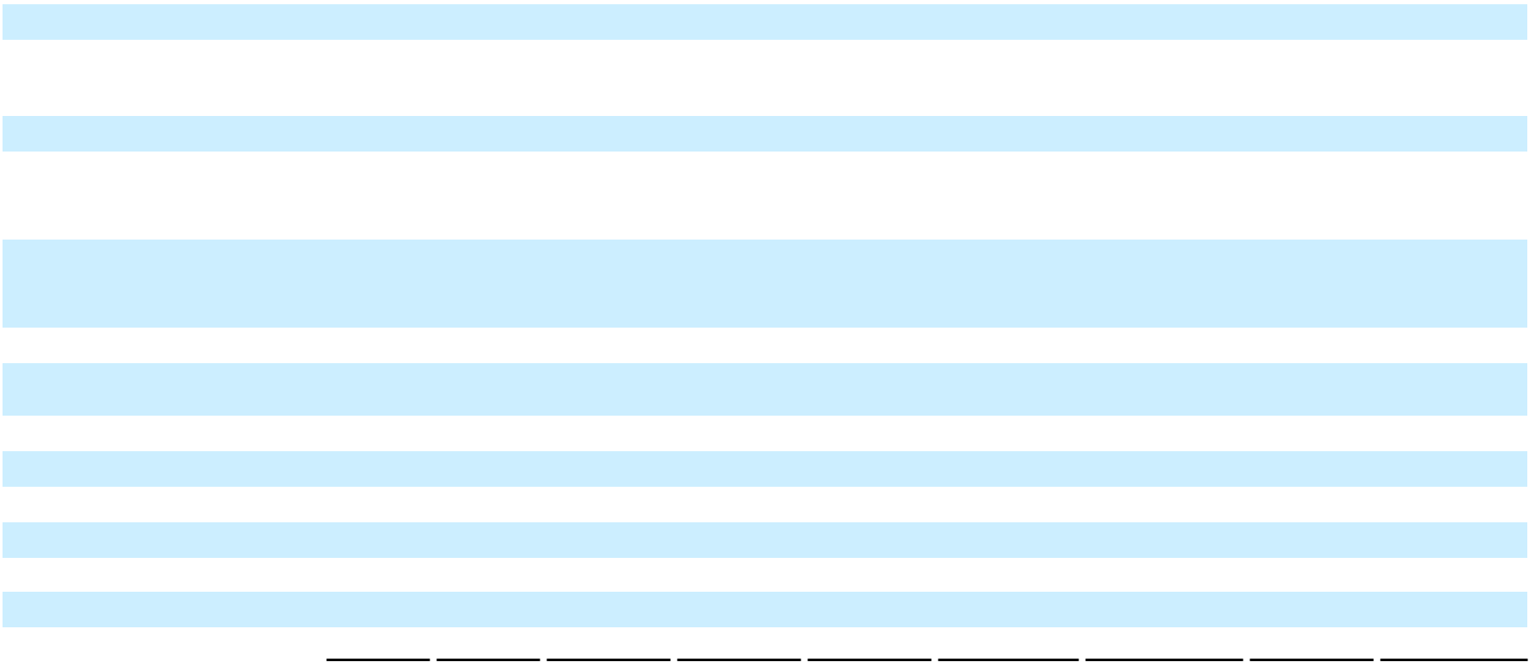

As Restated

F-94

Table of Contents
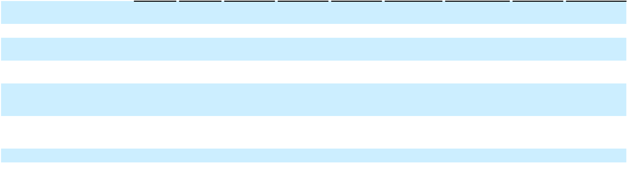

Balance as of June 30, 2024 (As |  |  | 96,746 |  |  |  |  | 97,845 |  |  | 205,065,328 |  |  |  |  |  | 2,050 |  |  | 1,063,426 |  |  |  |  | 450,107 |  |  |  |  | 44,212 |  |  | 127,268 |  |  |  | 1,687,063
Restated) |  |  |  |  |  |  |  | 97,845 |  |  |  |  |  |  |  |  | 2,050 |  |  |  |  |  |  |  | 450,107 |  |  |  |  | 44,212 |  |  | 127,268 |  |  |  | 1,687,063
Net income (loss)
 |  |  |  | — |  |  |  | — |  |  |  | — |  |  |  |  | — |  |  |  | — |  |  |  | 8,191 |  |  |  |  | — |  |  | 2,014 |  |  |  | 10,205
Other comprehensive income |  |  |  | — |  |  |  | — |  |  |  | — |  |  |  |  | — |  |  |  | — |  |  |  | — |  |  |  |  | (6,512) |  |  | 549 |  |  |  | (5,963)
(loss) |  |  |  | — |  |  |  |  |  |  |  |  |  |  |  |  |  |  |  |  |  |  |  |  |  |  |  |  |  | (6,512) |  |  | 549
Share-based compensation |  |  |  | — |  |  |  | — |  |  |  | — |  |  |  |  | — |  |  |  | 22,543 |  |  |  | — |  |  |  |  | — |  |  | — |  |  |  | 22,543
expense |  |  |  | — |  |  |  |  |  |  |  |  |  |  |  |  |  |  |  |  | 22,543 |  |  |  |  |  |  |  |  |  |  |  |  |  |  |  | 22,543
Issuance of shares for vested
share-based compensation |  |  |  | — |  |  |  | — |  |  |  | 5,331 |  |  |  |  | — |  |  |  | — |  |  |  | — |  |  |  |  | — |  |  | — |  |  |  | —
awards |  |  |  | — |  |  |  |  |  |  |  | 5,331
Shares withheld from
employees related to share- |  |  |  | — |  |  |  | — |  |  |  | (1,299) |  |  |  |  | — |  |  |  | (19) |  |  |  | — |  |  |  |  | — |  |  | — |  |  |  | (19)
based compensation, at cost |  |  |  | — |  |  |  |  |  |  |  | (1,299) |  |  |  |  |  |  |  |  | (19)
Dividends |  |  |  | — |  |  |  | (1,290) |  |  |  | — |  |  |  |  | — |  |  |  | — |  |  |  | (21,668) |  |  |  |  | — |  |  | (3,019) |  |  |  | (24,687)
Balance as of September 30, |  |  |  | 96,746 |  |  |  | 96,555 |  |  | 205,069,360 |  |  |  |  |  | 2,050 |  |  | 1,085,950 |  |  |  |  | 436,630 |  |  |  |  | 37,700 |  |  | 126,812 |  |  |  | 1,689,142
2024 (As Restated) |  |  |  | 96,746 |  |  |  | 96,555 |  |  |  |  |  |  |  |  | 2,050 |  |  |  |  |  |  |  | 436,630 |  |  |  |  | 37,700 |  |  | 126,812 |  |  |  | 1,689,142
Restated Consolidated Statements of Cash Flows
 |  |  | Three Months Ended March 31, 2024 |  |  |  |  |  |  |  |  |  |  |  |  |  | Six Months Ended June 30, 2024 |  |  |  |  |  |  |  |  |  |  |  |  | Nine Months Ended September 30, 2024
 |  | As Reported |  |  |  | Adjustments |  |  |  |  |  | As Restated |  |  |  | As Reported |  |  |  | Adjustments |  |  |  |  | As Restated |  |  |  | As Reported |  |  | Adjustments |  |  |  |  | As Restated
Cash flows from operating
activities
Net income (loss) |  | $ | 56,670 |  | $ |  |  | (5,082) |  |  | $ | 51,588 |  |  | $ |  | (30,190) |  |  | $ | (112) |  |  | $ | (30,302) |  |  | $ |  | (18,877) |  | $ | (1,220) |  |  | $ | (20,097)
Adjustments for:
Amortization of deferred
financing costs and debt
guarantee, net |  |  | 4,751 |  |  |  |  | — |  |  |  | 4,751 |  |  |  |  | 13,835 |  |  |  | 1,436 |  |  |  | 15,271 |  |  |  |  | 18,841 |  |  | — |  |  |  | 18,841
Depreciation and |  |  | 50,491 |  |  |  |  | (832) |  |  |  | 49,659 |  |  |  |  | 88,400 |  |  |  | (1,664) |  |  |  | 86,736 |  |  |  |  | 123,981 |  |  | (2,391) |  |  |  | 121,590
amortization |  |  |  |  |  |  |  |  |  |  |  |  |  |  |  |  |  |  |  |  |  |  |  |  |  |  |  |  |  | 123,981 |  |  |  |  |  |  | 121,590
Deferred taxes |  |  | (6,822) |  |  |  |  | — |  |  |  | (6,822) |  |  |  |  | (13,860) |  |  |  |  |  | — |  | (13,860) |  |  |  |  | (14,155) |  |  | — |  |  |  | (14,155)
Share-based compensation |  |  | 5,248 |  |  |  |  | — |  |  |  | 5,248 |  |  |  |  | 25,312 |  |  |  |  |  | — |  | 25,312 |  |  |  |  | 47,855 |  |  | — |  |  |  | 47,855
Asset impairment expense |  |  |  | — |  |  |  | — |  |  |  | — |  |  |  |  | 4,272 |  |  |  | 11,744 |  |  |  | 16,016 |  |  |  |  | 5,756 |  |  | 11,744 |  |  |  | 17,500
Loss on sale of assets |  |  | 77,140 |  |  |  |  | 2,645 |  |  |  | 79,785 |  |  |  |  | 77,140 |  |  |  | 2,645 |  |  |  | 79,785 |  |  |  |  | 77,140 |  |  | 2,645 |  |  |  | 79,785
Loss on extinguishment of |  |  | 9,754 |  |  |  |  | — |  |  |  | 9,754 |  |  |  |  | 9,754 |  |  |  |  |  | — |  | 9,754 |  |  |  |  | 9,754 |  |  | — |  |  |  | 9,754
debt |  |  |  |  |  |  |  |  |  |  |  |  |  |  |  |  |  |  |  |  |  |  | — |  |  |  |  |  |  | 9,754 |  |  |  |  |  |  | 9,754
Earnings recognized from
vessels chartered to third
parties transferred to |  |  | (23,952) |  |  |  |  | — |  |  |  | (23,952) |  |  |  |  | (51,674) |  |  |  |  |  | — |  | (51,674) |  |  |  |  | (72,539) |  |  | — |  |  |  | (72,539)
Energos |  |  |  |  |  |  |  |  |  |  |  |  |  |  |  |  |  |  |  |  |  |  | — |  |  |  |  |  |  |  |  |  |  |  |  |  | (72,539)
Other |  |  | 26,756 |  |  |  |  | 833 |  |  |  | 27,589 |  |  |  |  | 22,930 |  |  |  | 1,607 |  |  |  | 24,537 |  |  |  |  | 50,026 |  |  | 2,344 |  |  |  | 52,370
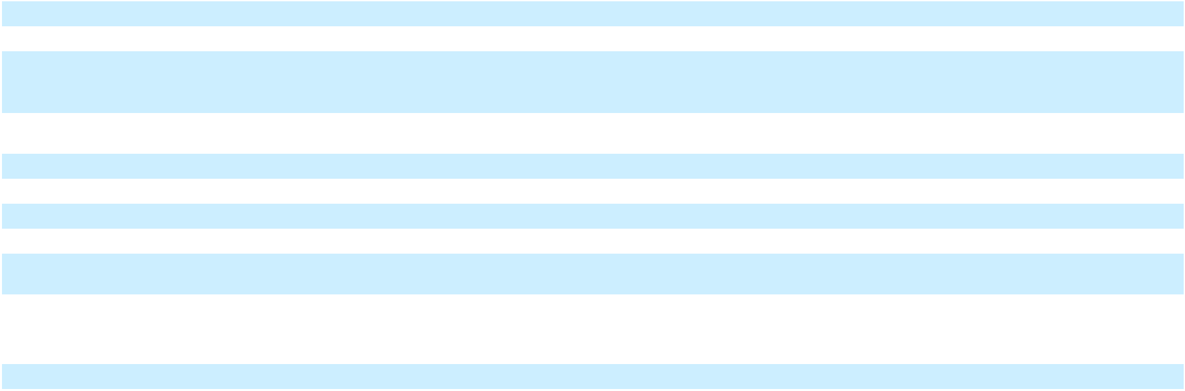

F-95

Table of Contents

Changes in operating assets
and liabilities:
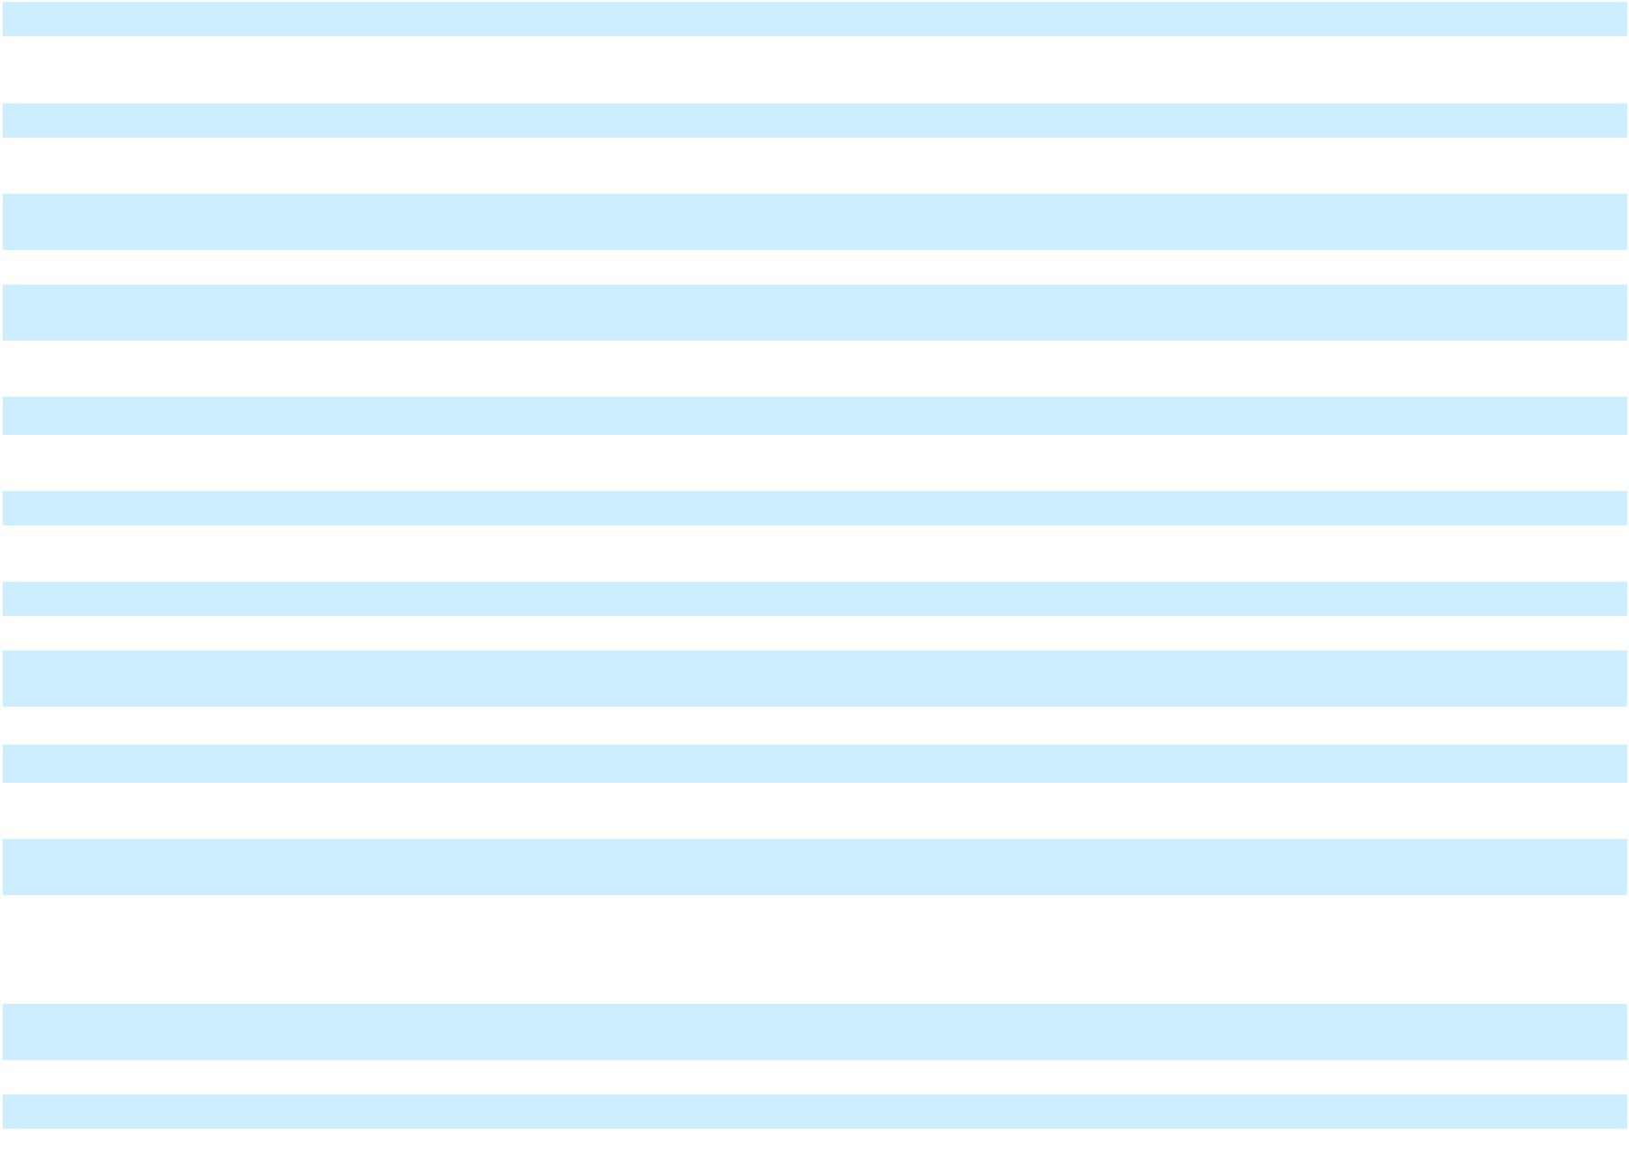

(Increase) in receivables | (8,656) | 3,507 |  | (5,149) |  | (114,030) |  | 3,507 |  | (110,523) |  | (95,928) |  | 1,809 |  | (94,119)
(Increase) decrease in | (85,539) | 2,500 |  | (83,039) |  | (62,815) |  | 2,500 |  | (60,315) |  | 23,132 |  | 2,500 |  | 25,632
inventories
(Increase) in other assets | (19,394) | 1,191 |  | (18,203) |  | (91,251) |  | 1,073 |  | (90,178) |  | (53,989) |  | 7,150 |  | (46,839)
Decrease in right-of-use | 57,190 |  | — | 57,190 |  | 111,561 |  |  | — | 111,561 |  | 145,371 |  |  | — | 145,371
assets | 57,190 |  | — |  |  |  |  |  | — |  |  |  |  |  | —
Increase in accounts payable/ | 63,208 | (9,328) |  | 53,880 |  | 255,337 |  | (9,648) |  | 245,689 |  | 30,168 |  | (14,833) |  | 15,335
accrued liabilities
(Decrease) in lease liabilities | (62,090) |  | — | (62,090) |  | (126,311) |  |  | — | (126,311) |  | (150,251) |  |  | — | (150,251)
(Decrease) increase in other | (74,705) |  | (2,494) |  | (77,199) |  | 44,558 |  | 803 |  | 45,361 |  | 19,915 |  | 921 |  | 20,836
liabilities
Net cash provided by | 70,050 | (7,060) |  | 62,990 |  | 162,968 |  | 13,891 |  | 176,859 |  | 146,200 |  | 10,669 |  | 156,869
operating activities
Cash flows from investing
activities
Capital expenditures | (683,449) | 162,524 |  | (520,925) |  | (1,346,385) |  | 218,421 |  | (1,127,964) |  | (1,781,278) |  | 306,263 |  | (1,475,015)
Sale of equity method | 136,365 |  | — | 136,365 |  | 136,365 |  |  | — | 136,365 |  | 136,365 |  |  | — | 136,365
investment | 136,365 |  | — |  |  |  |  |  | — |  |  |  |  |  | —
Asset sales | 328,999 |  | — | 328,999 |  | 328,999 |  |  | — | 328,999 |  | 328,999 |  |  | — | 328,999
Other investing activities | (1,695) |  | — |  | (1,695) |  | (1,694) |  | — |  | (1,694) |  | 7,360 |  | — |  | 7,360
Net cash used in investing | (219,780) | 162,524 |  | (57,256) |  | (882,715) |  | 218,421 |  | (664,294) |  | (1,308,554) |  | 306,263 |  | (1,002,291)
activities
Cash flows from financing
activities
Proceeds from borrowings of | 2,164,687 |  | — | 2,164,687 |  | 3,037,127 |  |  | — | 3,037,127 |  | 3,594,229 |  |  | — | 3,594,229
debt | 2,164,687 |  | — |  |  |  |  |  | — |  |  |  |  |  | —
Payments made for capital
expenditures paid beyond
customary vendor payment | — | (155,464) |  | (155,464) |  |  | — | (232,312) |  | (232,312) |  |  | — | (316,932) |  | (316,932)
terms | — |  |  |  |  |  | — |  |  |  |  |  | —
Payment of deferred | (25,781) |  | — | (25,781) |  | (37,983) |  |  | — | (37,983) |  | (76,759) |  |  | — | (76,759)
financing costs | (25,781) |  | — |  |  |  |  |  | — |  |  |  |  |  | —
Repayment of debt | (1,944,044) |  | — | (1,944,044) |  | (2,202,722) |  |  | — | (2,202,722) |  | (2,342,847) |  |  | — | (2,342,847)
Payment of dividends | (32,326) |  | — | (32,326) |  | (55,710) |  |  | — | (55,710) |  | (61,322) |  |  | — | (61,322)
Other financing activities | (4,919) |  | — |  | (4,919) |  | (5,033) |  | — |  | (5,033) |  | (12,424) |  | — |  | (12,424)

F-96

Table of Contents
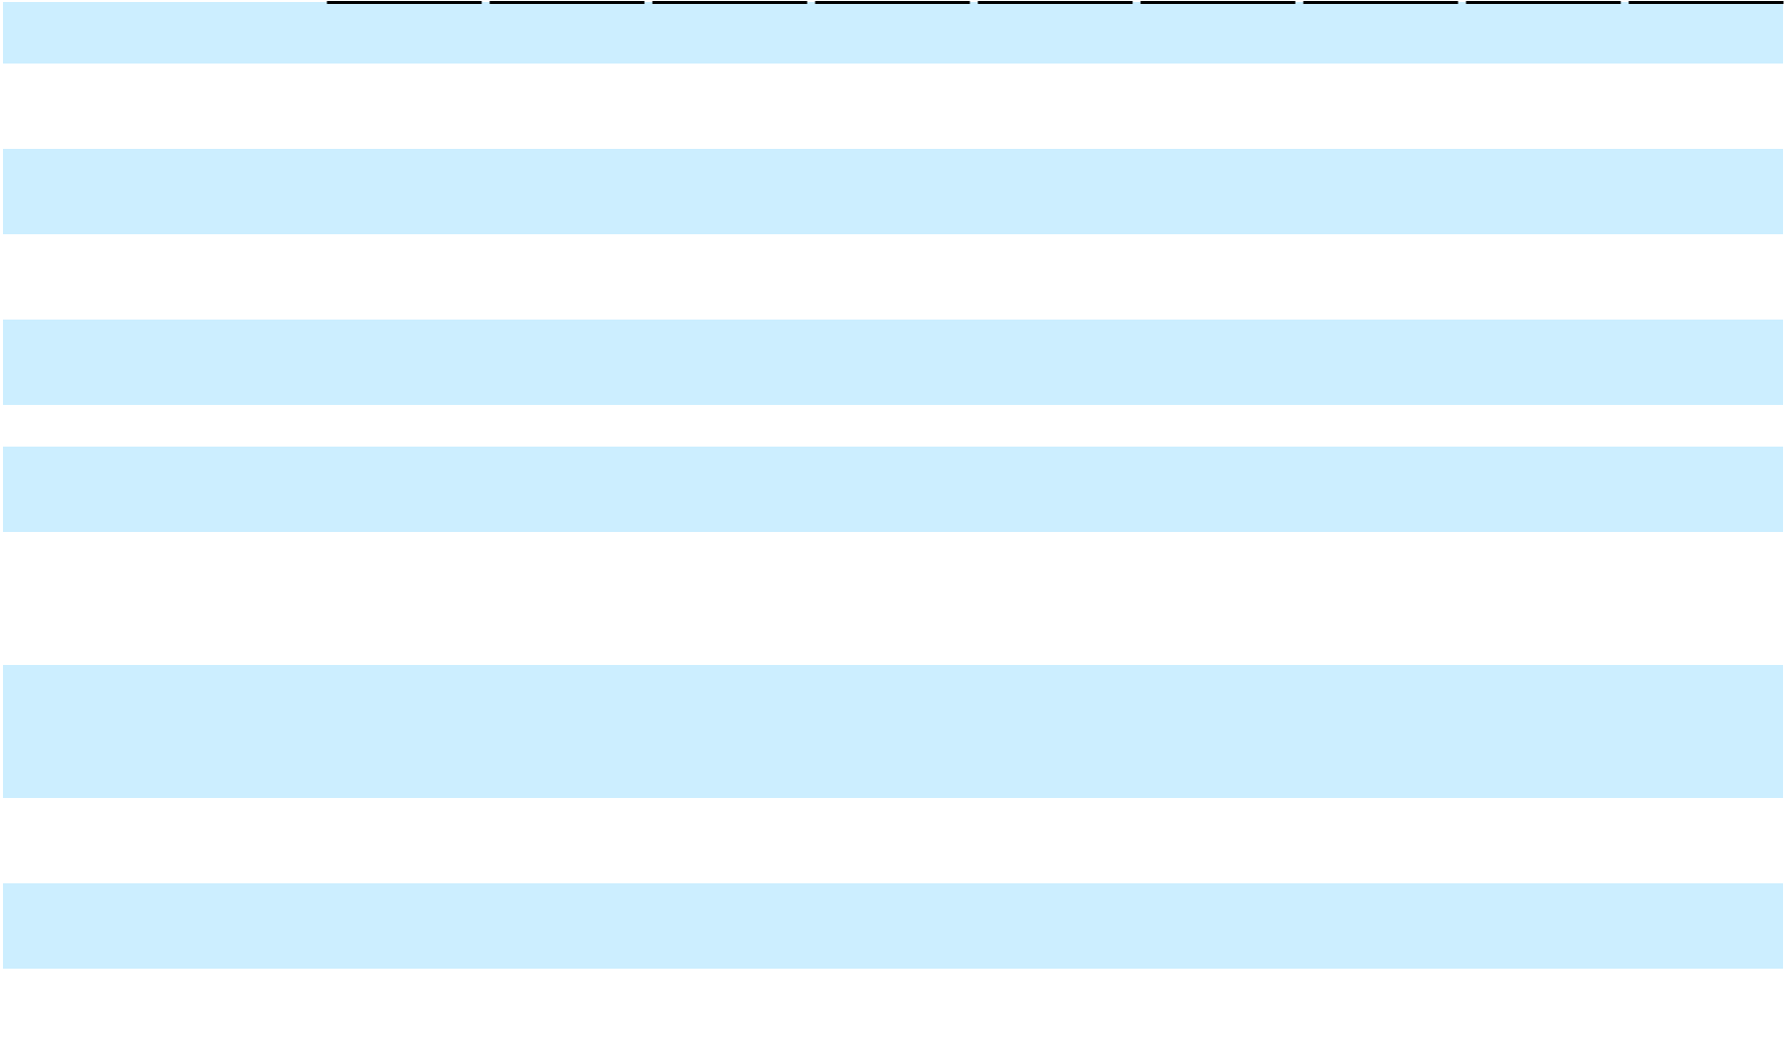

Net cash provided by |  | 157,617 |  |  | (155,464) |  |  | 2,153 |  |  | 735,679 |  |  | (232,312) |  |  | 503,367 |  |  | 1,100,877 |  |  | (316,932) |  |  | 783,945
financing activities |  | 157,617 |  |  | (155,464) |  |  | 2,153 |  |  | 735,679 |  |  | (232,312) |  |  | 503,367 |  |  | 1,100,877 |  |  | (316,932) |  |  | 783,945
Impact of changes in foreign
exchange rates on cash and |  | (3,768) |  |  | — |  |  | (3,768) |  |  | (28,898) |  |  | — |  |  | (28,898) |  |  | (12,614) |  |  | — |  |  | (12,614)
cash equivalents |  | (3,768) |  |  | — |  |  | (3,768) |  |  | (28,898) |  |  | — |  |  | (28,898) |  |  | (12,614) |  |  | — |  |  | (12,614)
Net increase (decrease) in
cash, cash equivalents and |  | 4,119 |  |  | — |  |  | 4,119 |  |  | (12,966) |  |  | — |  |  | (12,966) |  |  | (74,091) |  |  | — |  |  | (74,091)
restricted cash |  | 4,119 |  |  | — |  |  | 4,119 |  |  | (12,966) |  |  | — |  |  | (12,966) |  |  | (74,091) |  |  | — |  |  | (74,091)
Cash, cash equivalents and
restricted cash – beginning of |  | 310,814 |  |  | — |  |  | 310,814 |  |  | 310,814 |  |  | — |  |  | 310,814 |  |  | 310,814 |  |  | — |  |  | 310,814
period |  | 310,814 |  |  | — |  |  | 310,814 |  |  | 310,814 |  |  | — |  |  | 310,814 |  |  | 310,814 |  |  | — |  |  | 310,814
Cash, cash equivalents and
restricted cash – end of | $ | 314,933 | $ |  | — | $ |  | 314,933 | $ |  | 297,848 | $ |  | — | $ |  | 297,848 | $ |  | 236,723 | $ |  | — | $ |  | 236,723
period
Supplemental disclosure of
non-cash investing and
financing activities:
Changes in accounts payable
and accrued liabilities
associated with construction in
progress and property, plant | $ | (117,304) | $ |  | (256) | $ |  | (117,560) | $ |  | (162,056) | $ |  | (256) | $ |  | (162,312) | $ |  | 134,069 | $ |  | (256) | $ |  | 133,813
and equipment additions
Accounts payable and accrued
liabilities associated with
construction in progress and
property, plant and equipment |  | 623,318 |  |  | — |  |  | 623,318 |  |  | 609,009 |  |  | — |  |  | 609,009 |  |  | 877,210 |  |  | — |  |  | 877,210
additions |  | 623,318 |  |  | — |  |  | 623,318 |  |  | 609,009 |  |  | — |  |  | 609,009 |  |  | 877,210 |  |  | — |  |  | 877,210
Principal payments on
financing obligation to Energos |  | (2,912) |  |  | — |  |  | (2,912) |  |  | (6,445) |  |  | — |  |  | (6,445) |  |  | (6,108) |  |  | — |  |  | (6,108)
by third party charters |  | (2,912) |  |  | — |  |  | (2,912) |  |  | (6,445) |  |  | — |  |  | (6,445) |  |  | (6,108) |  |  | — |  |  | (6,108)
Fair value of contingent
payments in the Lins |  | — |  |  | — |  |  | — |  |  | — |  |  | — |  |  | — |  |  | 8,080 |  |  | — |  |  | 8,080
Acquisition |  | — |  |  | — |  |  | — |  |  | — |  |  | — |  |  | — |  |  | 8,080 |  |  | — |  |  | 8,080
Class A convertible preferred
stock issued and debt assumed |  | (125,198) |  |  | — |  |  | (125,198) |  |  | (125,195) |  |  | — |  |  | (125,195) |  |  | (125,198) |  |  | — |  |  | (125,198)
in the PortoCem Acquisition |  | (125,198) |  |  | — |  |  | (125,198) |  |  | (125,195) |  |  | — |  |  | (125,195) |  |  | (125,198) |  |  | — |  |  | (125,198)

Restated Condensed Consolidated Balance Sheets (Unaudited)
 | As of March 31, 2025 |  |  |  |  |  | As of June 30, 2025 |  |  |  |  |  | As of September 30, 2025
 | As Reported Adjustments As Restated |  |  |  |  |  | As Reported Adjustments As Restated |  |  |  |  |  | As Reported Adjustments As Restated
Assets

F-97

Table of Contents


Current assets
Cash and cash equivalents | $ | 447,862 | $ |  | — | $ |  | 447,862 | $ |  | 551,109 | $ |  | — | $ |  | 551,109 | $ |  | 145,237 | $ |  | — | $ |  | 145,237
Restricted cash |  | 379,537 |  |  | — |  |  | 379,537 |  |  | 270,298 |  |  | — |  |  | 270,298 |  |  | 244,104 |  |  | — |  |  | 244,104
Receivables, net of allowances |  | 273,136 |  |  | (1,199) |  |  | 271,937 |  |  | 269,405 |  |  | 694 |  |  | 270,099 |  |  | 419,761 |  |  | 3,499 |  |  | 423,260
Inventory |  | 66,695 |  |  | — |  |  | 66,695 |  |  | 74,000 |  |  | — |  |  | 74,000 |  |  | 109,279 |  |  | (647) |  |  | 108,632
Assets held for sale - current |  | 104,553 |  |  | — |  |  | 104,553 |  |  | — |  |  | — |  |  | — |  |  | — |  |  | — |  |  | —
Prepaid expenses and other |  | 201,925 |  |  | 2,774 |  |  | 204,699 |  |  | 317,687 |  |  | 8,209 |  |  | 325,896 |  |  | 415,421 |  |  | 12,030 |  |  | 427,451
Total current assets |  | 1,473,708 |  |  | 1,575 |  |  | 1,475,283 |  |  | 1,482,499 |  |  | 8,903 |  |  | 1,491,402 |  |  | 1,333,802 |  |  | 14,882 |  |  | 1,348,684
Construction in progress |  | 3,901,113 |  |  | 32,390 |  |  | 3,933,503 |  |  | 4,072,291 |  |  | 55,888 |  |  | 4,128,179 |  |  | 4,222,750 |  |  | 75,086 |  |  | 4,297,836
Property, plant and equipment, |  | 5,545,980 |  |  | 4,170 |  |  | 5,550,150 |  |  | 5,539,901 |  |  | (3,101) |  |  | 5,536,800 |  |  | 5,543,873 |  |  | (1,640) |  |  | 5,542,233
net |  | 5,545,980 |  |  | 4,170 |  |  | 5,550,150 |  |  | 5,539,901 |  |  | (3,101) |  |  | 5,536,800 |  |  | 5,543,873 |  |  | (1,640) |  |  | 5,542,233
Right-of-use assets |  | 465,939 |  |  | — |  |  | 465,939 |  |  | 437,548 |  |  | — |  |  | 437,548 |  |  | 418,383 |  |  | — |  |  | 418,383
Intangible assets, net |  | 188,118 |  |  | — |  |  | 188,118 |  |  | 194,752 |  |  | — |  |  | 194,752 |  |  | 195,821 |  |  | — |  |  | 195,821
Goodwill |  | 594,256 |  |  | 14,408 |  |  | 608,664 |  |  | 15,938 |  |  | — |  |  | 15,938 |  |  | 15,938 |  |  | — |  |  | 15,938
Deferred tax assets, net |  | 6,848 |  |  | 626 |  |  | 7,474 |  |  | 155 |  |  | 626 |  |  | 781 |  |  | 6,559 |  |  | 626 |  |  | 7,185
Assets held for sale - non- |  | 633,654 |  |  | 1,972 |  |  | 635,626 |  |  | — |  |  | — |  |  | — |  |  | — |  |  | — |  |  | —
Other non-current assets, net |  | 218,464 |  |  | (830) |  |  | 217,634 |  |  | 214,246 |  |  | 125 |  |  | 214,371 |  |  | 168,481 |  |  | 330 |  |  | 168,811
Total assets | $ | 13,028,080 | $ |  | 54,311 | $ |  | 13,082,391 | $ |  | 11,957,330 | $ |  | 62,441 | $ |  | 12,019,771 | $ |  | 11,905,607 | $ |  | 89,284 | $ |  | 11,994,891
Liabilities
Current liabilities
Current portion of long-term | $ | 260,848 | $ |  | — | $ |  | 260,848 | $ |  | 1,181,559 | $ |  | — | $ |  | 1,181,559 | $ |  | 6,579,321 | $ |  | — | $ |  | 6,579,321
debt and short-term borrowings
Accounts payable |  | 655,073 |  |  | 2,707 |  |  | 657,780 |  |  | 578,835 |  |  | 934 |  |  | 579,769 |  |  | 632,777 |  |  | 2,440 |  |  | 635,217
Accrued liabilities |  | 268,083 |  |  | 19,873 |  |  | 287,956 |  |  | 253,043 |  |  | 29,966 |  |  | 283,009 |  |  | 488,905 |  |  | 22,089 |  |  | 510,994
Current lease liabilities |  | 82,442 |  |  | (5,200) |  |  | 77,242 |  |  | 79,060 |  |  | (5,200) |  |  | 73,860 |  |  | 63,700 |  |  | — |  |  | 63,700
Liabilities held for sale - |  | 35,894 |  |  | — |  |  | 35,894 |  |  | — |  |  | — |  |  | — |  |  | — |  |  | — |  |  | —
Other current liabilities |  | 171,342 |  |  | 879 |  |  | 172,221 |  |  | 108,807 |  |  | (443) |  |  | 108,364 |  |  | 189,057 |  |  | (2,718) |  |  | 186,339
Total current liabilities |  | 1,473,682 |  |  | 18,259 |  |  | 1,491,941 |  |  | 2,201,304 |  |  | 25,257 |  |  | 2,226,561 |  |  | 7,953,760 |  |  | 21,811 |  |  | 7,975,571
Long-term debt |  | 8,931,506 |  |  | 5,492 |  |  | 8,936,998 |  |  | 7,805,260 |  |  | 4,951 |  |  | 7,810,211 |  |  | 2,335,994 |  |  | 4,001 |  |  | 2,339,995
Non-current lease liabilities |  | 355,050 |  |  | — |  |  | 355,050 |  |  | 341,509 |  |  | — |  |  | 341,509 |  |  | 328,071 |  |  | — |  |  | 328,071
Deferred tax liabilities, net |  | 51,359 |  |  | 1,792 |  |  | 53,151 |  |  | 61,770 |  |  | 908 |  |  | 62,678 |  |  | 53,227 |  |  | 6,117 |  |  | 59,344
Liabilities held for sale - non- |  | 135,398 |  |  | — |  |  | 135,398 |  |  | — |  |  | — |  |  | — |  |  | — |  |  | — |  |  | —

F-98

Table of Contents

Other long-term liabilities | 168,851 |  |  | 5,208 |  | 174,059 |  | 154,139 |  |  | 1,815 |  | 155,954 |  | 110,471 |  |  | (2,510) |  | 107,961
Total liabilities | 11,115,846 |  |  | 30,751 | 11,146,597 |  | 10,563,982 |  |  |  | 32,931 | 10,596,913 |  | 10,781,523 |  |  |  | 29,419 | 10,810,942
Series B convertible preferred
stock, $0.01 par value, 36,746,
36,746 and — shares
authorized, issued and
outstanding as of March 31,
June 30 and September 30,
2025; aggregate liquidation
preference of $36,746, $36,746
and $— at March 31, June 30
and September 30, 2025 | 40,708 |  |  | — | 40,708 |  | 41,154 |  |  |  | — | 41,154 |  |  | — |  |  | — |  | —
Stockholders’ equity
Class A common stock, $0.01
par value, 750.0 million shares
authorized, 273.8 million issued
and outstanding as of March 31,
2025; 274.2 million issued and
outstanding as of June 30, 2025;
284.6 million issued and
outstanding as of September 30, | 2,738 |  |  | — | 2,738 |  | 2,742 |  |  |  | — | 2,742 |  | 2,846 |  |  |  | — | 2,846
2025 | 2,738 |  |  | — |  |  |  |  |  |  | — |  |  |  |  |  |  | —
Additional paid-in capital | 1,722,829 |  |  | — | 1,722,829 |  | 1,725,985 |  |  |  | — | 1,725,985 |  | 1,772,580 |  |  |  | — | 1,772,580
(Accumulated deficit) | (3,766) |  |  | 19,145 | 15,379 |  | (558,397) |  |  |  | 29,510 | (528,887) |  | (858,057) |  |  |  | 59,865 | (798,192)
Accumulated other | 26,671 |  |  | 4,415 |  | 31,086 |  | 59,426 |  |  | — |  | 59,426 |  | 78,025 |  |  | — |  | 78,025
comprehensive income | 26,671 |  |  |  |  |  |  |  |  |  |  |  |  |  |  |  |  | — |  | 78,025
Total stockholders’ equity | 1,748,472 |  |  | 23,560 | 1,772,032 |  | 1,229,756 |  |  |  | 29,510 | 1,259,266 |  | 995,394 |  |  |  | 59,865 | 1,055,259
attributable to NFE | 1,748,472 |  |  | 23,560 |  |  |  |  |  |  | 29,510 |  |  |  |  |  |  | 59,865
Non-controlling interest | 123,054 |  |  | — |  | 123,054 |  | 122,438 |  |  | — |  | 122,438 |  | 128,690 |  |  | — |  | 128,690
Total stockholders’ equity | 1,871,526 |  |  | 23,560 |  | 1,895,086 |  | 1,352,194 |  |  | 29,510 |  | 1,381,704 |  | 1,124,084 |  |  | 59,865 |  | 1,183,949
Total liabilities and | $13,028,080 |  | $ | 54,311 |  | $13,082,391 |  | $11,957,330 |  | $ | 62,441 |  | $12,019,771 |  | $11,905,607 |  | $ | 89,284 |  | $11,994,891
stockholders’ equity
Restated Quarterly Condensed Consolidated Statements of Operations and Comprehensive (Loss) Income (Unaudited)
 | Three Months Ended March 31, 2025 |  |  |  |  |  |  | Three Months Ended June 30, 2025 |  |  |  |  |  |  | Three Months Ended September 30,
 |  |  |  |  |  |  |  |  |  |  |  |  |  |  |  |  |  | 2025
 | As Reported |  | Adjustments |  |  | As Restated |  | As Reported |  | Adjustments |  |  | As Restated |  | As Reported |  | Adjustments |  |  | As Restated
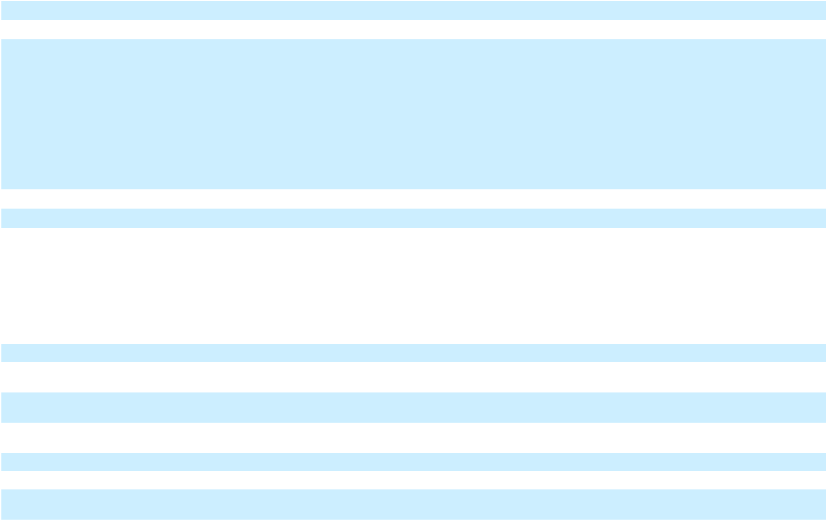

F-99

Table of Contents

Revenues
Operating revenue | $ | 384,881 | $ |  | — | $ |  | 384,881 | $ |  | 227,204 | $ |  | 884 | $ |  | 228,088 | $ |  | 240,318 | $ |  | — | $ |  | 240,318
Vessel charter revenue |  | 45,436 |  |  | — |  |  | 45,436 |  |  | 46,739 |  |  | — |  |  | 46,739 |  |  | 61,048 |  |  | — |  |  | 61,048
Contract novation revenue |  | — |  |  | 1,746 |  |  | 1,746 |  |  | — |  |  | 1,693 |  |  | 1,693 |  |  | — |  |  | 1,570 |  |  | 1,570
Other revenue |  | 40,219 |  |  | — |  |  | 40,219 |  |  | 27,749 |  |  | (169) |  |  | 27,580 |  |  | 26,001 |  |  | 2,974 |  |  | 28,975
Total Revenues |  | 470,536 |  |  | 1,746 |  |  | 472,282 |  |  | 301,692 |  |  | 2,408 |  |  | 304,100 |  |  | 327,367 |  |  | 4,544 |  |  | 331,911
Operating expenses
Cost of sales (exclusive of
depreciation and amortization |  | 302,377 |  |  | — |  |  | 302,377 |  |  | 208,852 |  |  | (690) |  |  | 208,162 |  |  | 196,908 |  |  | — |  |  | 196,908
shown separately below) |  | 302,377 |  |  | — |  |  | 302,377 |  |  | 208,852 |  |  | (690) |  |  | 208,162 |  |  | 196,908 |  |  | — |  |  | 196,908
Vessel operating expenses |  | 7,176 |  |  | — |  |  | 7,176 |  |  | 8,056 |  |  | 12 |  |  | 8,068 |  |  | 7,297 |  |  | — |  |  | 7,297
Operations and maintenance |  | 54,957 |  |  | (17) |  |  | 54,940 |  |  | 59,817 |  |  | (2,414) |  |  | 57,403 |  |  | 58,520 |  |  | (1,219) |  |  | 57,301
Selling, general and |  | 59,271 |  |  | (7,451) |  |  | 51,820 |  |  | 57,256 |  |  | (697) |  |  | 56,559 |  |  | 86,050 |  |  | 417 |  |  | 86,467
administrative |  | 59,271 |  |  | (7,451) |  |  | 51,820 |  |  | 57,256 |  |  | (697) |  |  | 56,559 |  |  | 86,050 |  |  | 417 |  |  | 86,467
Transaction and integration costs |  | 11,931 |  |  | — |  |  | 11,931 |  |  | 75,384 |  |  | (30) |  |  | 75,354 |  |  | 19,649 |  |  | 30 |  |  | 19,679
Depreciation and amortization |  | 53,057 |  |  | 3,254 |  |  | 56,311 |  |  | 52,870 |  |  | — |  |  | 52,870 |  |  | 50,474 |  |  | (1,144) |  |  | 49,330
Goodwill impairment expense |  | — |  |  | — |  |  | — |  |  | 582,172 |  |  | — |  |  | 582,172 |  |  | — |  |  | — |  |  | —
Asset impairment expense |  | 246 |  |  | — |  |  | 246 |  |  | 117,312 |  |  | 5,571 |  |  | 122,883 |  |  | 10,353 |  |  | (5,571) |  |  | 4,782
(Gain) loss on sale |  | — |  |  | — |  |  | — |  |  | (472,699) |  |  | 1,705 |  |  | (470,994) |  |  | 1,705 |  |  | (1,705) |  |  | —
Total operating expenses |  | 489,015 |  |  | (4,214) |  |  | 484,801 |  |  | 689,020 |  |  | 3,457 |  |  | 692,477 |  |  | 430,956 |  |  | (9,192) |  |  | 421,764
Operating (loss) |  | (18,479) |  |  | 5,960 |  |  | (12,519) |  |  | (387,328) |  |  | (1,049) |  |  | (388,377) |  |  | (103,589) |  |  | 13,736 |  |  | (89,853)
Interest expense |  | 213,694 |  |  | (13,385) |  |  | 200,309 |  |  | 206,408 |  |  | (20,019) |  |  | 186,389 |  |  | 210,562 |  |  | (12,344) |  |  | 198,218
Other (income) expense, net |  | (63,937) |  |  | — |  |  | (63,937) |  |  | (56,262) |  |  | (2,762) |  |  | (59,024) |  |  | (29,042) |  |  | (1,524) |  |  | (30,566)
Loss on extinguishment of debt, |  | 467 |  |  | — |  |  | 467 |  |  | 20,320 |  |  | — |  |  | 20,320 |  |  | — |  |  | — |  |  | —
net |  | 467 |  |  | — |  |  | 467 |  |  | 20,320 |  |  | — |  |  | 20,320 |  |  | — |  |  | — |  |  | —
(Loss) before income taxes |  | (168,703) |  |  | 19,345 |  |  | (149,358) |  |  | (557,794) |  |  | 21,732 |  |  | (536,062) |  |  | (285,109) |  |  | 27,604 |  |  | (257,505)
Tax provision |  | 28,670 |  |  | (2,602) |  |  | 26,068 |  |  | (967) |  |  | 11,367 |  |  | 10,400 |  |  | 8,247 |  |  | (2,751) |  |  | 5,496
Net (loss) |  | (197,373) |  |  | 21,947 |  |  | (175,426) |  |  | (556,827) |  |  | 10,365 |  |  | (546,462) |  |  | (293,356) |  |  | 30,355 |  |  | (263,001)
Net (loss) attributable to | $ | (200,129) |  | $ | 21,947 |  | $ | (178,182) |  | $ | (555,077) |  | $ | 10,365 |  | $ | (544,712) |  | $ | (299,970) |  | $ | 30,355 |  | $ | (269,615)
common stockholders
Net (loss) per share – basic | $ | (0.73) | $ |  | 0.08 | $ |  | (0.65) | $ |  | (2.02) | $ |  | 0.03 | $ |  | (1.99) | $ |  | (1.07) | $ |  | 0.11 | $ |  | (0.96)
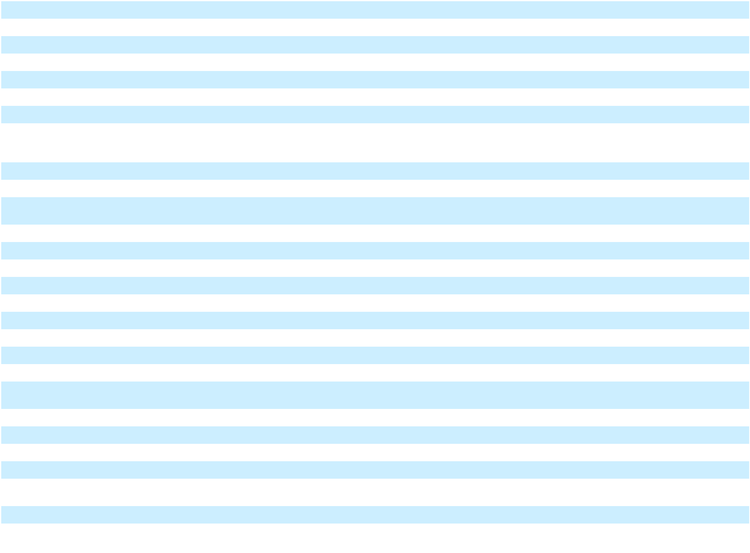

F-100

Table of Contents
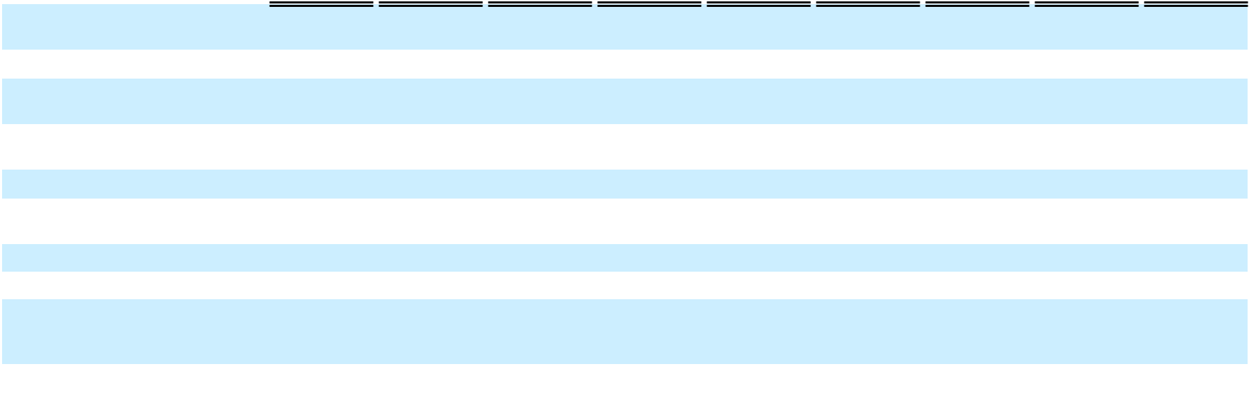

Net (loss) per share – diluted | $ | (0.73) | $ |  | 0.08 | $ |  | (0.65) | $ |  | (2.02) | $ |  | 0.03 | $ |  | (1.99) | $ |  | (1.07) | $ |  | 0.11 | $ |  | (0.96)
Weighted average number of
Weighted average number of | 273,609,766 |  |  |  | — | 273,609,766 |  |  | 274,371,636 |  |  |  |  | — | 274,371,636 |  |  | 281,121,646 |  |  |  |  | — | 281,121,646
shares outstanding – basic |  |  |  |  | — |  |  |  |  |  |  |  |  | — |  |  |  |  |  |  |  |  | —
Weighted average number of
Weighted average number of | 273,609,766 |  |  |  | — | 273,609,766 |  |  | 274,371,636 |  |  |  |  | — | 274,371,636 |  |  | 281,121,646 |  |  |  |  | — | 281,121,646
shares outstanding – diluted |  |  |  |  | — |  |  |  |  |  |  |  |  | — |  |  |  |  |  |  |  |  | —
Other comprehensive (loss)
income:
Currency translation adjustment |  | 24,253 |  |  | — |  |  | 24,253 |  |  | 34,335 |  |  | (4,415) |  |  | 29,920 |  |  | 18,547 |  |  | — |  |  | 18,547
Comprehensive (loss) |  | (173,120) |  |  | 21,947 |  |  | (151,173) |  |  | (522,492) |  |  | 5,950 |  |  | (516,542) |  |  | (274,809) |  |  | 30,355 |  |  | (244,454)
Comprehensive (income)
attributable to non-controlling |  | (2,879) |  |  | — |  |  | (2,879) |  |  | 616 |  |  | — |  |  | 616 |  |  | (6,252) |  |  | — |  |  | (6,252)
interest |  | (2,879) |  |  | — |  |  | (2,879) |  |  | 616 |  |  | — |  |  | 616 |  |  | (6,252) |  |  | — |  |  | (6,252)
Comprehensive (loss) | $ | (175,999) | $ |  | 21,947 | $ |  | (154,052) | $ |  | (521,876) | $ |  | 5,950 | $ |  | (515,926) | $ |  | (281,061) | $ |  | 30,355 | $ |  | (250,706)
attributable to stockholders

Year to Date Condensed Consolidated Statements of Operations and Comprehensive (Loss) Income (Unaudited)

 | Six Months Ended June 30, 2025 |  |  |  |  |  |  | Nine Months Ended September 30,
 |  |  |  |  |  |  |  |  |  |  | 2025
 | As Reported |  | Adjustments |  |  | As Restated |  | As Reported |  | Adjustments |  |  | As Restated
Revenues
Operating revenue | $ 612,085 | $ |  | 884 | $ 612,969 |  | $ 852,403 |  | $ |  | 884 | $ 853,287
Vessel charter revenue | 92,175 |  |  | — | 92,175 |  | 153,223 |  |  |  | — | 153,223
Contract novation revenue | — |  |  | 3,439 | 3,439 |  |  | — |  |  | 5,009 | 5,009
Other revenue | 67,968 |  |  | (169) |  | 67,799 |  | 93,969 |  |  | 2,805 |  | 96,774
Total Revenues | 772,228 |  |  | 4,154 | 776,382 |  | 1,099,595 |  |  |  | 8,698 | 1,108,293
Operating expenses
Cost of sales (exclusive of depreciation and amortization shown separately | 511,229 |  |  | (690) | 510,539 |  | 708,137 |  |  |  | (690) | 707,447
below) | 511,229 |  |  | (690) |  |  |  |  |  |  | (690)
Vessel operating expenses | 15,232 |  |  | 12 | 15,244 |  | 22,529 |  |  |  | 12 | 22,541
Operations and maintenance | 114,774 |  |  | (2,431) | 112,343 |  | 173,294 |  |  |  | (3,650) | 169,644
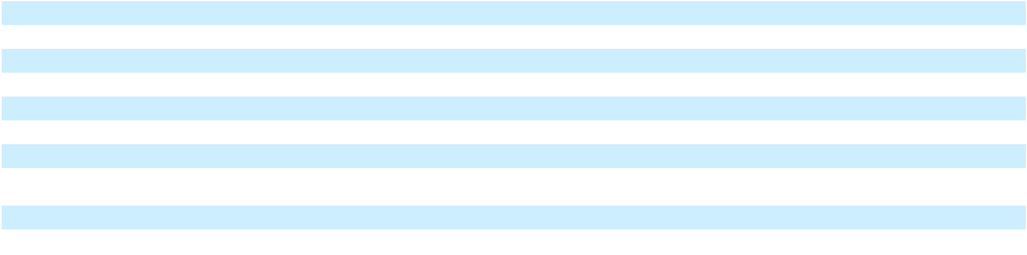

F-101

Table of Contents
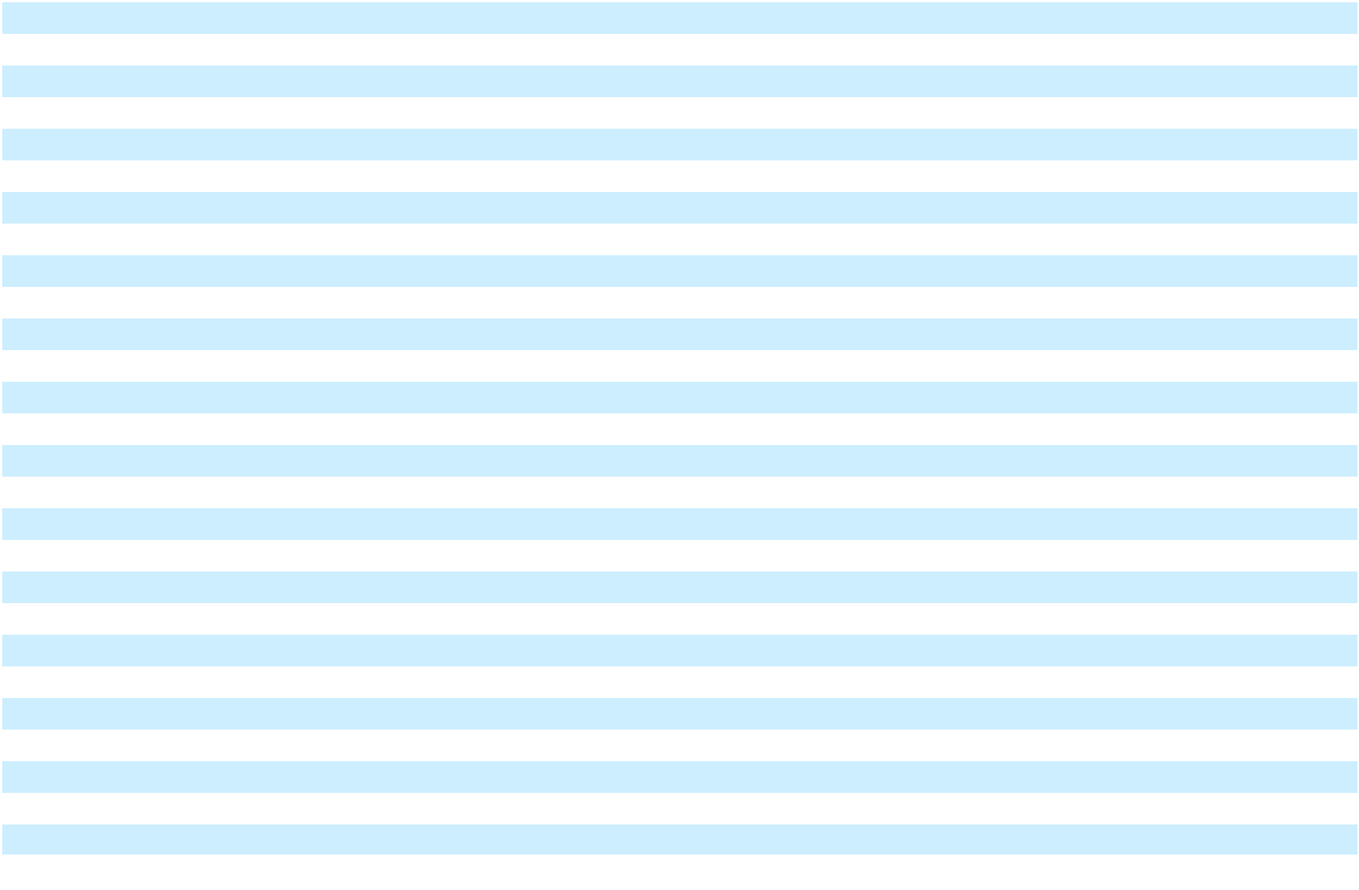

Selling, general and administrative |  | 116,527 |  |  | (8,148) |  |  | 108,379 |  |  | 202,577 |  |  | (7,731) |  |  | 194,846
Transaction and integration costs |  | 87,315 |  |  | (30) |  |  | 87,285 |  |  | 106,964 |  |  | — |  |  | 106,964
Depreciation and amortization |  | 105,927 |  |  | 3,254 |  |  | 109,181 |  |  | 156,401 |  |  | 2,110 |  |  | 158,511
Goodwill impairment expense |  | 582,172 |  |  | — |  |  | 582,172 |  |  | 582,172 |  |  | — |  |  | 582,172
Asset impairment expense |  | 117,558 |  |  | 5,571 |  |  | 123,129 |  |  | 127,911 |  |  | — |  |  | 127,911
(Gain) loss on sale |  | (472,699) |  |  | 1,705 |  |  | (470,994) |  |  | (470,994) |  |  | — |  |  | (470,994)
Total operating expenses |  | 1,178,035 |  |  | (757) |  |  | 1,177,278 |  |  | 1,608,991 |  |  | (9,949) |  |  | 1,599,042
Operating (loss) |  | (405,807) |  |  | 4,911 |  |  | (400,896) |  |  | (509,396) |  |  | 18,647 |  |  | (490,749)
Interest expense |  | 420,102 |  |  | (33,404) |  |  | 386,698 |  |  | 630,664 |  |  | (45,748) |  |  | 584,916
Other (income) expense, net |  | (120,199) |  |  | (2,762) |  |  | (122,961) |  |  | (149,241) |  |  | (4,286) |  |  | (153,527)
Loss on extinguishment of debt, net |  | 20,787 |  |  | — |  |  | 20,787 |  |  | 20,787 |  |  | — |  |  | 20,787
(Loss) before income taxes |  | (726,497) |  |  | 41,077 |  |  | (685,420) |  |  | (1,011,606) |  |  | 68,681 |  |  | (942,925)
Tax provision |  | 27,703 |  |  | 8,765 |  |  | 36,468 |  |  | 35,950 |  |  | 6,014 |  |  | 41,964
Net (loss) |  | (754,200) |  |  | 32,312 |  |  | (721,888) |  |  | (1,047,556) |  |  | 62,667 |  |  | (984,889)
Net (loss) attributable to common stockholders | $ | (755,206) |  | $ | 32,312 |  | $ | (722,894) |  | $ (1,055,176) |  |  | $ | 62,667 |  | $ | (992,509)
Net (loss) per share – basic | $ | (2.76) |  | $ | 0.12 |  | $ | (2.64) |  | $ | (3.82) |  | $ | 0.23 |  | $ | (3.59)
Net (loss) per share – diluted | $ | (2.76) |  | $ | 0.12 |  | $ | (2.64) |  | $ | (3.82) |  | $ | 0.23 |  | $ | (3.59)
Weighted average number of shares outstanding – basic | 273,996,219 |  |  |  | — | 273,996,219 |  |  | 276,381,199 |  |  |  |  | — | 276,381,199
Weighted average number of shares outstanding – diluted | 273,996,219 |  |  |  | — | 273,996,219 |  |  | 276,381,199 |  |  |  |  | — | 276,381,199
Other comprehensive (loss) income:
Currency translation adjustment |  | 58,588 |  |  | (4,415) |  |  | 54,173 |  |  | 77,135 |  |  | (4,415) |  |  | 72,720
Comprehensive (loss) |  | (695,612) |  |  | 27,897 |  |  | (667,715) |  |  | (970,421) |  |  | 58,252 |  |  | (912,169)
Comprehensive (income) attributable to non-controlling interest |  | (2,263) |  |  | — |  |  | (2,263) |  |  | (8,515) |  |  | — |  |  | (8,515)
Comprehensive (loss) attributable to stockholders | $ | (697,875) | $ |  | 27,897 | $ |  | (669,978) | $ |  | (978,936) | $ |  | 58,252 | $ |  | (920,684)

Condensed Consolidated Statements of Changes in Stockholders’ Equity (Unaudited)

Three Months Ended March 31, 2025

F-102

Table of Contents

As Reported

Balance as of Balance as of
December 31, 2024 (As Reported)

Net income (loss)

Other comprehensive income (loss)

Share-based compensation expense

Class A stock issued, net of issuance costs

Acquisition of non-controlling interest

Issuance of shares for vested share-based compensation awards

Shares withheld from employees related to share-based compensation, at cost

Issuance of preferred stock and deemed dividend

Conversion of Series B convertible preferred stock

Dividends

Balance as of Balance as of March 31, 2025 (As Reported)

Series B convertible |  |  |  |  |  |  |  |  |  |  |  | Accumulated
 |  |  |  |  |  |  |  | Additional |  |  |  | other |  | Non- |  | Total
preferred stock |  |  |  | Class A common stock |  |  |  | Additional |  |  |  | other |  | Non- |  | Total
 |  |  |  |  |  |  |  | paid-in |  | Accumulated |  | comprehensive |  | controlling |  | stockholders’
Shares |  | Amount |  | Shares |  | Amount |  | capital |  | deficit |  | (loss) income |  | Interest |  | equity
96,746 |  | 90,570 |  | 266,459,093 |  | 2,664 |  | 1,674,312 |  | 196,363 |  | 3,089 |  | 122,660 |  | 1,999,088
— |  | — |  | — |  | — |  | — |  | (199,581) |  | — |  | 2,208 |  | (197,373)
— |  | — |  | — |  | — |  | — |  | — | 23,582 |  | 671 |  | 24,253
— |  | — |  | — |  | — | (229) |  |  | — |  | — |  | — | (229)
— |  | — | 661,207 |  | 7 |  | 363 |  |  | — |  | — |  | — | 370
— |  | — |  | — |  | — | (1,356) |  |  | — |  | — | 534 |  | (822)
— |  | — | 31,814 |  |  | — |  | — |  | — |  | — |  | — |  | —
— |  | — | (13,086) |  |  | — | (159) |  |  | — |  | — |  | — | (159)
— |  | — |  | — |  | — |  | — |  | — |  | — |  | — |  | —
(60,000) | (49,969) |  | 6,651,511 |  | 67 |  | 49,898 |  |  | — |  | — |  | — | 49,965
— |  | 107 |  | — |  | — |  | — |  | (548) |  | — |  | (3,019) |  | (3,567)
36,746 | 40,708 |  | 273,790,539 |  | 2,738 |  | 1,722,829 |  | (3,766) |  | 26,671 |  | 123,054 |  | 1,871,526
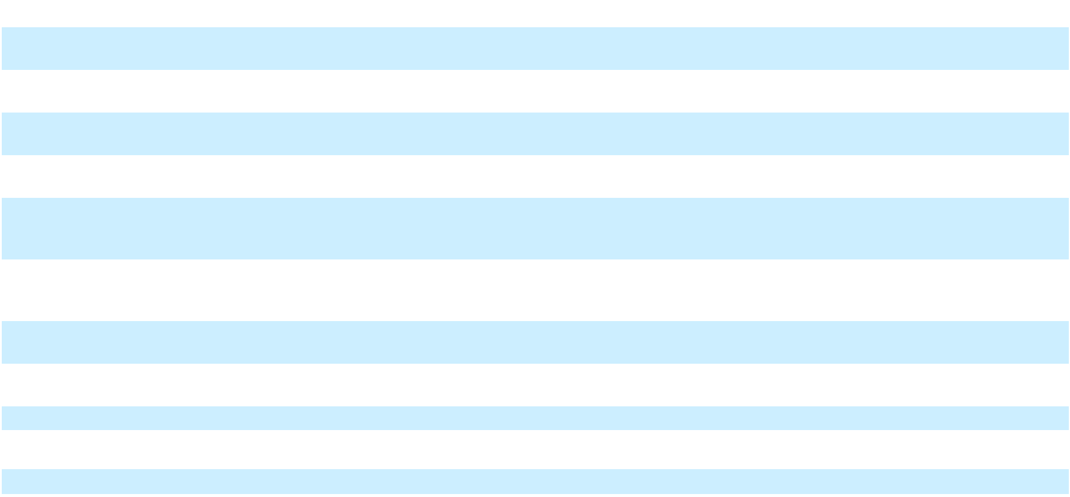

Adjustments
Balance as of December 31, | — |  | — |  | — |  | — |  | — | (2,802) |  | 4,415 |  |  | — | 1,613
2024 | — |  | — |  | — |  | — |  | — |  |  |  |  |  | —
Net income (loss) | — |  | — |  | — |  | — |  | — |  | 21,947 |  | — |  | — |  | 21,947
Total Adjustments | — |  | — |  | — |  | — |  | — | 19,145 |  | 4,415 |  |  | — | 23,560

As Restated

F-103

Table of Contents

Balance as of Balance as of
December 31, 2024 (As | 96,746 | 90,570 |  | 266,459,093 |  | 2,664 |  | 1,674,312 |  | 193,561 |  | 7,504 |  | 122,660 |  | 2,000,701
Restated)
Net income (loss)
Net income (loss) | — |  | — |  | — |  | — |  | — |  | (177,634) |  | — |  | 2,208 |  | (175,426)
Other comprehensive income | — |  | — |  | — |  | — |  | — |  | — | 23,582 |  | 671 |  | 24,253
(loss) | — |  | — |  | — |  | — |  | —
Share-based compensation | — |  | — |  | — |  | — | (229) |  |  | — |  | — |  | — | (229)
expense | — |  | — |  | — |  | — |  |  |  | — |  | — |  | —
Class A stock issued, net of | — |  | — | 661,207 |  | 7 |  | 363 |  |  | — |  | — |  | — | 370
issuance costs | — |  |  |  |  |  |  |  |  |  | — |  | — |  | —
Acquisition of non-controlling | — |  | — |  | — |  | — | (1,356) |  |  | — |  | — | 534 |  | (822)
interest | — |  | — |  | — |  | — |  |  |  | — |  | —
Issuance of shares for vested
share-based compensation | — |  | — | 31,814 |  |  | — |  | — |  | — |  | — |  | — |  | —
awards | — |  | — |  |  |  | — |  | — |  | — |  | — |  | — |  | —
Shares withheld from
employees related to share- | — |  | — | (13,086) |  |  | — | (159) |  |  | — |  | — |  | — | (159)
based compensation, at cost | — |  | — |  |  |  | — |  |  |  | — |  | — |  | —
Issuance of preferred stock and | — |  | — |  | — |  | — |  | — |  | — |  | — |  | — |  | —
deemed dividend | — |  | — |  | — |  | — |  | — |  | — |  | — |  | — |  | —
Conversion of Series B | (60,000) | (49,969) |  | 6,651,511 |  | 67 |  | 49,898 |  |  | — |  | — |  | — | 49,965
convertible preferred stock |  |  |  |  |  |  |  |  |  |  | — |  | — |  | —
Dividends | — |  | 107 |  | — |  | — |  | — |  | (548) |  | — |  | (3,019) |  | (3,567)
Balance as of Balance as of | 36,746 |  | 40,708 |  | 273,790,539 |  | 2,738 |  | 1,722,829 |  | 15,379 |  | 31,086 |  | 123,054 |  | 1,895,086
March 31, 2025 (As Restated)
 |  |  |  |  |  |  | Three Months Ended June 30, 2025
 | Series B convertible |  |  |  |  |  |  |  |  |  |  |  | Accumulated
 |  |  |  |  |  |  |  |  | Additional |  |  |  | other |  | Non- |  | Total
 | preferred stock |  |  |  | Class A common stock |  |  |  | Additional |  |  |  | other |  | Non- |  | Total
 |  |  |  |  |  |  |  |  | paid-in |  | Accumulated |  | comprehensive |  | controlling |  | stockholders’
As Reported | Shares |  | Amount |  | Shares |  | Amount |  | capital |  | deficit |  | (loss) income |  | Interest |  | equity
Balance as of March 31, 2025 | 36,746 |  | 40,708 |  | 273,790,539 |  | 2,738 |  | 1,722,829 |  | (3,766) |  | 26,671 |  | 123,054 |  | 1,871,526
(As Reported)
Net income (loss)
Net income (loss) | — |  | — |  | — |  | — |  | — |  | (554,631) |  | — |  | (2,196) |  | (556,827)
Other comprehensive income
(loss) | — |  | — |  | — |  | — |  | — |  | — | 32,755 |  | 1,580 |  | 34,335
Share-based compensation
expense | — |  | — |  | — |  | — | 5,250 |  |  | — |  | — |  | — | 5,250
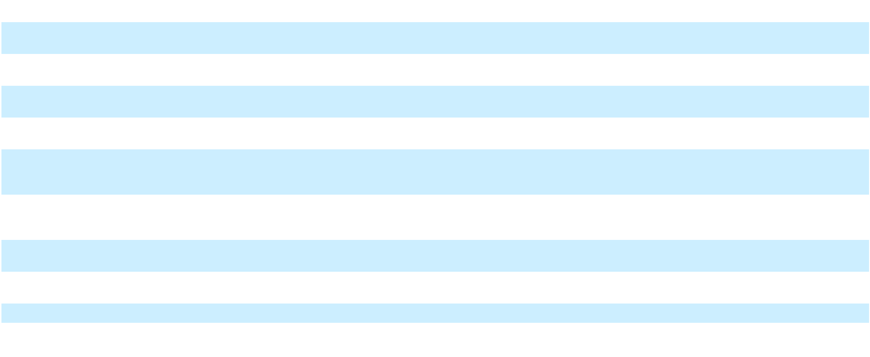
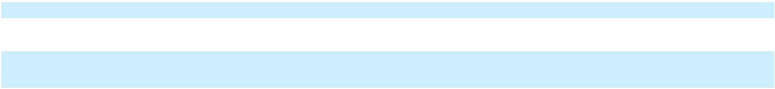

F-104

Table of Contents

Issuance of shares for vested share-based compensation awards

Shares withheld from employees related to share-based compensation, at cost

Dividends

Balance as of June 30, 2025 (As Reported)

Adjustments

Balance as of March 31, 2025 Net income (loss)

Other comprehensive income (loss)

Total Adjustments

As Restated

Balance as of March 31, 2025
(As Restated)

Net income (loss)

Other comprehensive income (loss)

Share-based compensation expense

Issuance of shares for vested share-based compensation awards

Shares withheld from employees related to share-based compensation, at cost

Dividends

Balance as of June 30, 2025 (As Restated)

— |  | — | 720,642 |  | 7 |  |  | — |  | — |  | — |  | — | 7
— |  | — | (309,718) |  | (3) |  | (1,648) |  |  | — |  | — |  | — | (1,651)
— | 446 |  |  | — |  | — | (446) |  |  | — |  | — |  | — |  | (446)
36,746 | 41,154 |  | 274,201,463 |  | 2,742 |  | 1,725,985 |  | (558,397) |  | 59,426 |  | 122,438 |  | 1,352,194
— |  | — |  | — |  | — |  | — | 19,145 |  | 4,415 |  |  | — | 23,560
— |  | — |  | — |  | — |  | — | 10,365 |  |  | — |  | — | 10,365
— |  | — |  | — |  | — |  | — |  | — | (4,415) |  |  | — |  | (4,415)
— |  | — |  | — |  | — |  | — | 29,510 |  |  | — |  | — | 29,510
36,746 |  | 40,708 |  | 273,790,539 |  | 2,738 |  | 1,722,829 |  | 15,379 |  | 31,086 |  | 123,054 |  | 1,895,086
— |  | — |  | — |  | — |  | — |  | (544,266) |  | — |  | (2,196) |  | (546,462)
— |  | — |  | — |  | — |  | — |  | — | 28,340 |  | 1,580 |  | 29,920
— |  | — |  | — |  | — | 5,250 |  |  | — |  | — |  | — | 5,250
— |  | — | 720,642 |  | 7 |  |  | — |  | — |  | — |  | — | 7
— |  | — | (309,718) |  | (3) |  | (1,648) |  |  | — |  | — |  | — | (1,651)
— |  | 446 |  | — |  | — |  | (446) |  | — |  | — |  | — |  | (446)
36,746 | 41,154 |  | 274,201,463 |  | 2,742 |  | 1,725,985 |  | (528,887) |  | 59,426 |  | 122,438 |  | 1,381,704
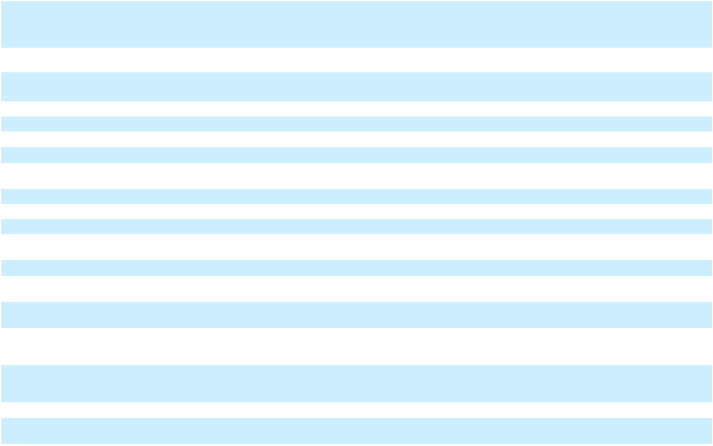

Three Months Ended September 30, 2025

F-105

Table of Contents

 | Series B convertible |  |  |  |  |  |  |  |  |  |  |  | Accumulated
 |  |  |  |  |  |  |  |  | Additional |  |  |  | other |  | Non- |  | Total
 | preferred stock |  |  |  | Class A common stock |  |  |  | Additional |  |  |  | other |  | Non- |  | Total
 |  |  |  |  |  |  |  |  | paid-in |  | Accumulated |  | comprehensive |  | controlling |  | stockholders’
As Reported | Shares |  | Amount |  | Shares |  | Amount |  | capital |  | deficit |  | (loss) income |  | Interest |  | equity
Balance as of June 30, 2025 (As | 36,746 |  | 41,154 |  | 274,201,463 |  | 2,742 |  | 1,725,985 |  | (558,397) |  | 59,426 |  | 122,438 |  | 1,352,194
Reported)
Net income (loss)
Net income (loss) | — |  | — |  | — |  | — |  | — |  | (299,660) |  | — |  | 6,304 |  | (293,356)
Other comprehensive income
(loss) | — |  | — |  | — |  | — |  | — |  | — | 18,599 |  | (52) |  | 18,547
Share-based compensation
expense | — |  | — |  | — |  | — | 5,544 |  |  | — |  | — |  | — | 5,544
Conversion of Series B
convertible preferred stock | (36,746) | (41,464) |  | 10,351,348 |  | 104 |  | 41,361 |  |  | — |  | — |  | — | 41,465
Dividends | — |  | 310 |  | — |  | — |  | (310) |  | — |  | — |  | — |  | (310)
Balance as of September 30, | — |  | — | 284,552,811 |  | 2,846 |  | 1,772,580 |  | (858,057) |  | 78,025 |  | 128,690 |  | 1,124,084
2025 (As Reported) | —
Adjustments
Balance as of June 30, 2025 | — |  | — |  | — |  | — |  | — | 29,510 |  |  | — |  | — | 29,510
Net income (loss) | — |  | — |  | — |  | — |  | — | 30,355 |  |  | — |  | — | 30,355
Other comprehensive income | — |  | — |  | — |  | — |  | — |  | — |  | — |  | — |  | —
Total Adjustments | — |  | — |  | — |  | — |  | — | 59,865 |  |  | — |  | — | 59,865
As Restated
Balance as of June 30, 2025 (As | 36,746 |  | 41,154 |  | 274,201,463 |  | 2,742 |  | 1,725,985 |  | (528,887) |  | 59,426 |  | 122,438 |  | 1,381,704
Restated)
Net income (loss)
Net income (loss) | — |  | — |  | — |  | — |  | — |  | (269,305) |  | — |  | 6,304 |  | (263,001)
Other comprehensive income | — |  | — |  | — |  | — |  | — |  | — | 18,599 |  | (52) |  | 18,547
Share-based compensation | — |  | — |  | — |  | — | 5,544 |  |  | — |  | — |  | — | 5,544
Conversion of Series B | (36,746) | (41,464) |  | 10,351,348 |  | 104 |  | 41,361 |  |  | — |  | — |  | — | 41,465
convertible preferred stock |  |  |  |  |  |  |  |  |  |  | — |  | — |  | —
Dividends | — |  | 310 |  | — |  | — |  | (310) |  | — |  | — |  | — |  | (310)
Balance as of September 30, | — |  | — | 284,552,811 |  | 2,846 |  | 1,772,580 |  | (798,192) |  | 78,025 |  | 128,690 |  | 1,183,949
2025 (As Restated) | —
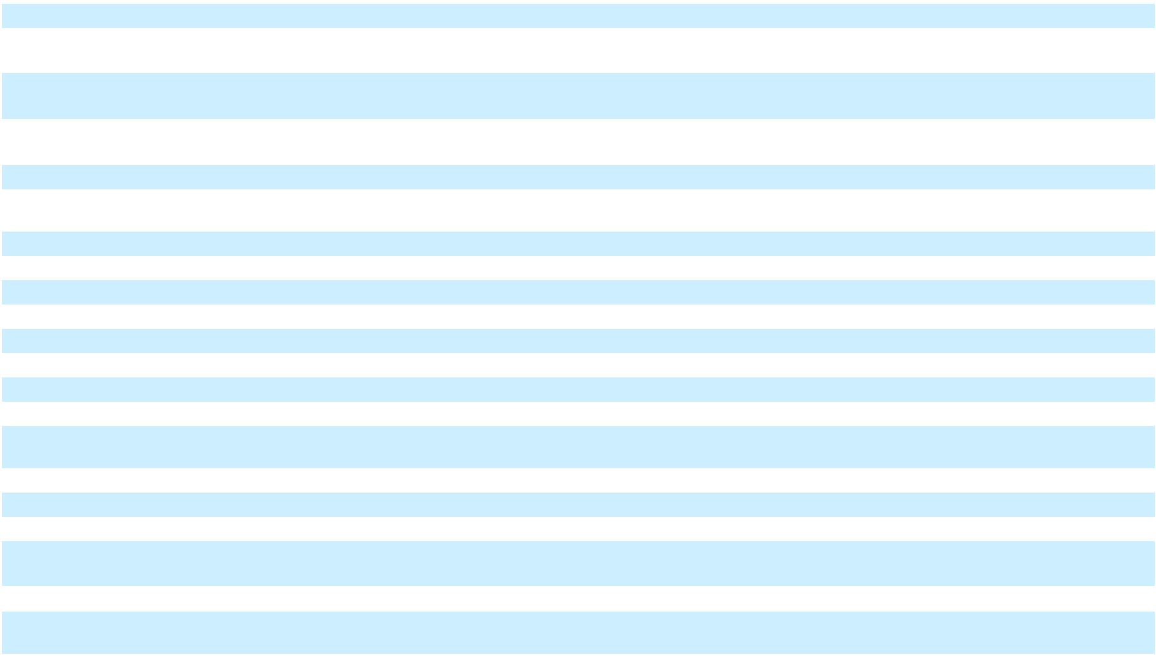

F-106

Table of
Table of | Contents
Restated Consolidated Cash Flow Statements
 |  |  |  | Three Months Ended March 31, 2025 |  |  |  |  |  |  | Six Months Ended June 30, 2025 |  |  |  |  |  |  | Nine Months Ended September 30, 2025
 |  |  | As Reported |  |  | Adjustments |  |  | As Restated |  | As Reported |  | Adjustments |  |  | As Restated |  | As Reported |  | Adjustments |  |  | As Restated
Cash flows from
operating
activities
Net loss |  |  | $ | (197,373) | $ |  | 21,947 | $ (175,426) |  | $ (754,200) |  | $ |  | 32,312 | $ (721,888) |  | $ (1,047,556) |  | $ |  | 62,667 | $ |  | (984,889)
Adjustments for:
Amortization of
deferred financing
costs and debt |  |  |  | 23,841 |  |  | 7,383 | 31,224 |  | 36,231 |  |  |  | 6,842 | 43,073 |  | 47,452 |  |  |  | 8,027 |  |  | 55,479
guarantee, net |  |  |  | 23,841 |  |  | 7,383 |  |  |  |  |  |  | 6,842 |  |  |  |  |  |  | 8,027 |  |  | 55,479
Depreciation and |  |  |  | 63,353 |  |  | 3,254 | 66,607 |  | 124,531 |  |  |  | 3,254 | 127,785 |  | 183,377 |  |  |  | 2,110 |  |  | 185,487
amortization |  |  |  | 63,353 |  |  | 3,254 |  |  |  |  |  |  | 3,254 |  |  |  |  |  |  | 2,110 |  |  | 185,487
Deferred taxes |  |  |  | (4,740) |  |  | 152 | (4,588) |  | 590 |  |  |  | 11,232 | 11,822 |  | (15,495) |  |  |  | 13,342 |  |  | (2,153)
Share-based |  |  |  | — |  |  | — |  | — | 5,021 |  |  |  | — | 5,021 |  | 10,565 |  |  |  | — |  |  | 10,565
compensation |  |  |  | — |  |  | — |  | — |  |  |  |  | — |  |  |  |  |  |  | — |  |  | 10,565
Goodwill |  |  |  | — |  |  | — |  | — | 582,172 |  |  |  | — | 582,172 |  | 582,172 |  |  |  | — |  |  | 582,172
impairment expense |  |  |  | — |  |  | — |  | — |  |  |  |  | — |  |  |  |  |  |  | — |  |  | 582,172
Asset impairment |  |  |  | 246 |  |  | — | 246 |  | 117,558 |  |  |  | 5,571 | 123,129 |  | 127,911 |  |  |  | — |  |  | 127,911
expense |  |  |  | 246 |  |  | — |  |  |  |  |  |  | 5,571 |  |  |  |  |  |  | — |  |  | 127,911
(Gain) on sale of |  |  |  | — |  |  | — |  | — | (472,699) |  |  |  | 1,705 | (470,994) |  | (470,994) |  |  |  | — |  |  | (470,994)
assets |  |  |  | — |  |  | — |  | — |  |  |  |  | 1,705 |  |  |  |  |  |  | — |  |  | (470,994)
Loss on
extinguishment of |  |  |  | 467 |  |  | — | 467 |  | 20,787 |  |  |  | — | 20,787 |  | 20,787 |  |  |  | — |  |  | 20,787
debt |  |  |  | 467 |  |  | — |  |  |  |  |  |  | — |  |  |  |  |  |  | — |  |  | 20,787
(Earnings)
recognized from
vessels chartered to
third parties
transferred to |  |  |  | (13,082) |  |  | — | (13,082) |  | (23,329) |  |  |  | — | (23,329) |  | (24,856) |  |  |  | — |  |  | (24,856)
Energos |  |  |  | (13,082) |  |  | — |  |  |  |  |  |  | — |  |  |  |  |  |  | — |  |  | (24,856)
Other |  |  |  | (31,189) |  |  | (3,718) | (34,907) |  | (10,703) |  |  |  | (3,719) | (14,422) |  | (659) |  |  |  | (3,720) |  |  | (4,379)
Changes in operating
assets and liabilities:
(Increase) in |  |  |  | (7,001) |  |  | (1,174) | (8,175) |  | (14,951) |  |  |  | (1,366) | (16,317) |  | (164,452) |  |  |  | (4,172) |  |  | (168,624)
receivables |  |  |  | (7,001) |  |  | (1,174) |  |  |  |  |  |  | (1,366) |  |  |  |  |  |  | (4,172) |  |  | (168,624)
Decrease (increase) |  |  |  | 7,622 |  |  | — | 7,622 |  | 6,112 |  |  |  | — | 6,112 |  | (27,653) |  |  |  | 647 |  |  | (27,006)
in inventories |  |  |  | 7,622 |  |  | — |  |  |  |  |  |  | — |  |  |  |  |  |  | 647 |  |  | (27,006)
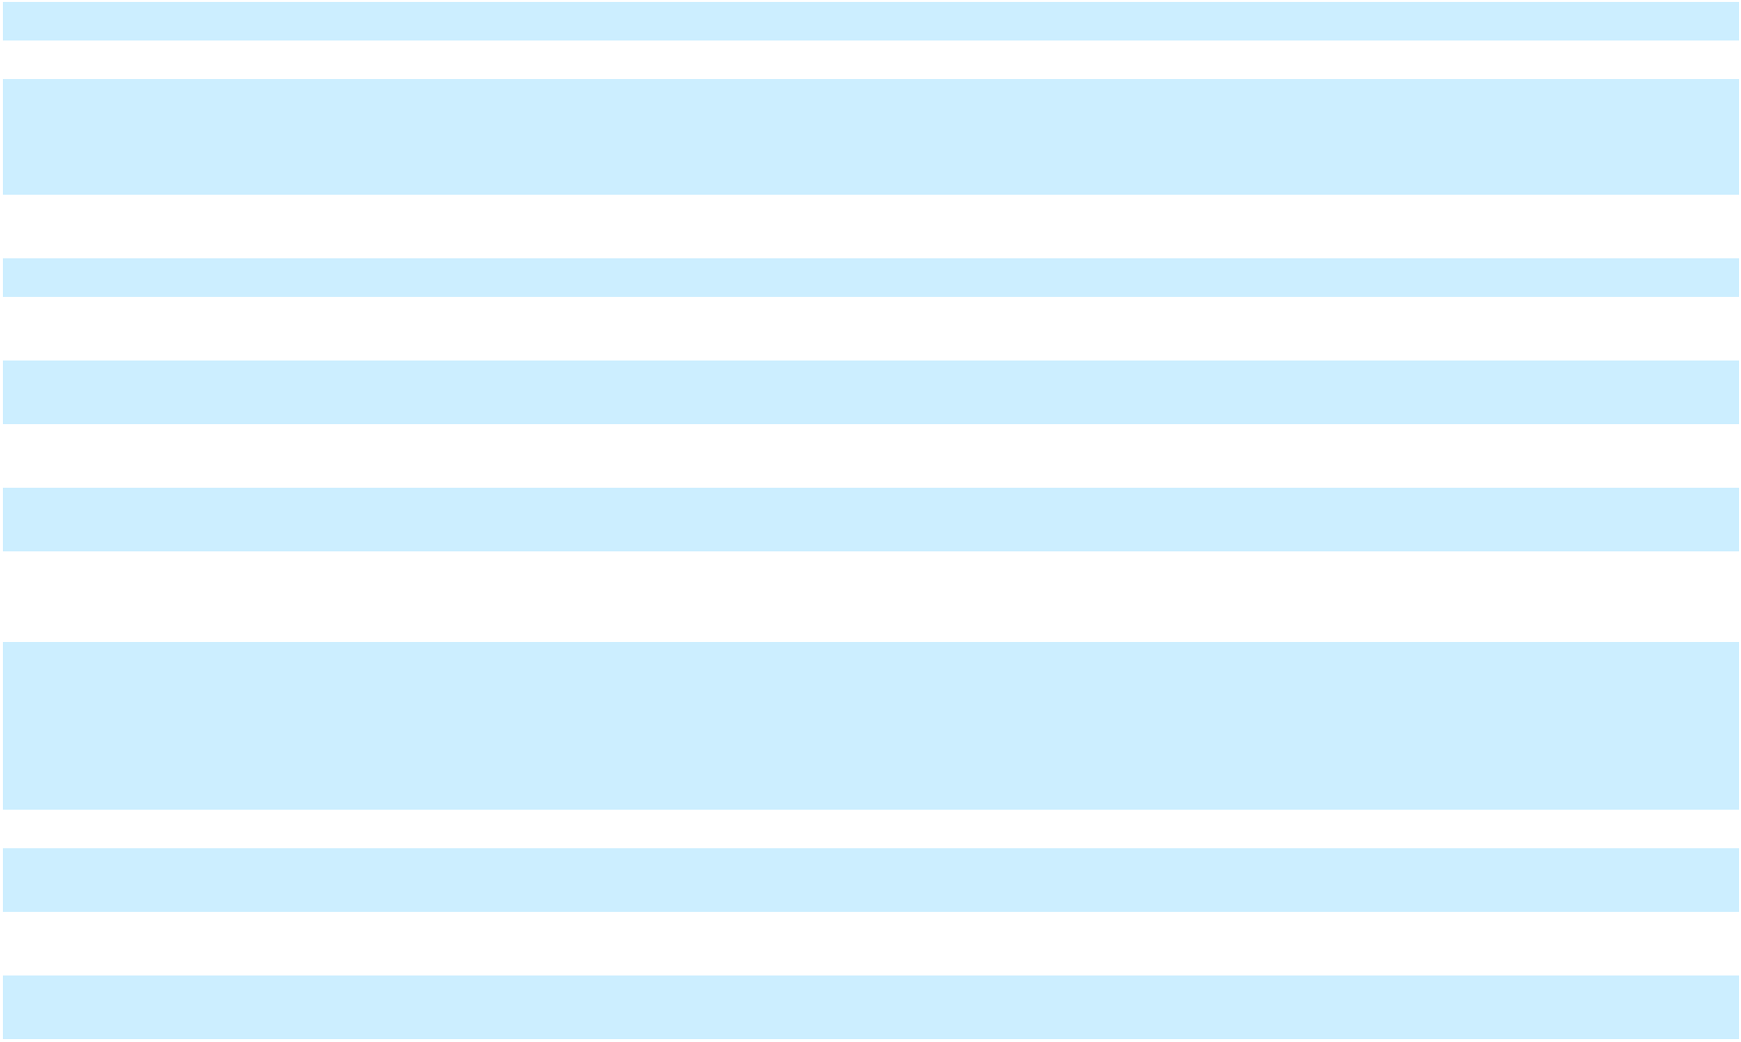

F-107

Table of Contents

(Increase) in other |  | (1,074) | 2,466 |  | 1,392 |  | (31,961) |  | (5,409) |  | (37,370) |  | (81,184) |  | (7,950) |  | (89,134)
assets
Decrease in right-of- |  | 30,848 |  | — | 30,848 |  | 32,772 |  |  | — | 32,772 |  | 51,738 |  |  | — | 51,738
use assets |  | 30,848 |  | — |  |  |  |  |  | — |  |  |  |  |  | —
Increase in accounts
payable/accrued |  | 130,433 | (3,470) |  | 126,963 |  | 98,782 |  | 2,971 |  | 101,753 |  | 326,521 |  | 4,483 |  | 331,004
liabilities
(Decrease) in
amounts due to |  |  |  | — |  | — |  | — |  | — |  | — |  | — |  | — |  | —
affiliates |  |  |  | — |  | — |  | — |  | — |  | — |  | — |  | — |  | —
(Decrease) in lease |  | (42,888) |  | — | (42,888) |  | (39,857) |  |  | — | (39,857) |  | (67,816) |  |  | — | (67,816)
liabilities |  | (42,888) |  | — |  |  |  |  |  | — |  |  |  |  |  | —
Increase (decrease) |  | 8,832 | (2,372) |  | 6,460 |  | (61,012) |  | (5,428) |  | (66,440) |  | (25,045) |  | (7,468) |  | (32,513)
in other liabilities
Net cash (used in)
provided by
operating | $ | (31,705) | 24,468 |  | (7,237) |  | (384,156) |  | 47,965 |  | (336,191) |  | (575,187) |  | 67,966 |  | (507,221)
activities
Cash flows from
investing activities
Capital expenditures |  | (340,470) | 85,373 |  | (255,097) |  | (652,798) |  | 151,068 |  | (501,730) |  | (758,457) |  | 166,252 |  | (592,205)
Sale of Jamaica |  | — |  | — |  | — | 949,456 |  |  | — | 949,456 |  | 949,456 |  |  | — | 949,456
Business |  | — |  | — |  | — |  |  |  | — |  |  |  |  |  | —
Other investing |  | 4,555 |  | — | 4,555 |  | 4,791 |  |  | — | 4,791 |  | 4,654 |  |  | — | 4,654
activities |  | 4,555 |  | — |  |  |  |  |  | — |  |  |  |  |  | —
Net cash used in
(provided by) |  | (335,915) | 85,373 |  | (250,542) |  | 301,449 |  | 151,068 |  | 452,517 |  | 195,653 |  | 166,252 |  | 361,905
investing activities
Cash flows from
financing activities
Proceeds from |  | 901,733 |  | — | 901,733 |  | 1,316,864 |  |  | — | 1,316,864 |  | 1,375,495 |  |  | — | 1,375,495
borrowings of debt |  | 901,733 |  | — |  |  |  |  |  | — |  |  |  |  |  | —
Payments made for
capital expenditures
paid beyond
customary vendor |  | — | (109,841) |  | (109,841) |  |  | — | (199,033) |  | (199,033) |  |  | — | (234,218) |  | (234,218)
payment terms |  | — |  |  |  |  |  | — |  |  |  |  |  | —
Payment of deferred |  | (26,093) |  | — | (26,093) |  | (27,774) |  |  | — | (27,774) |  | (27,781) |  |  | — | (27,781)
financing costs |  | (26,093) |  | — |  |  |  |  |  | — |  |  |  |  |  | —
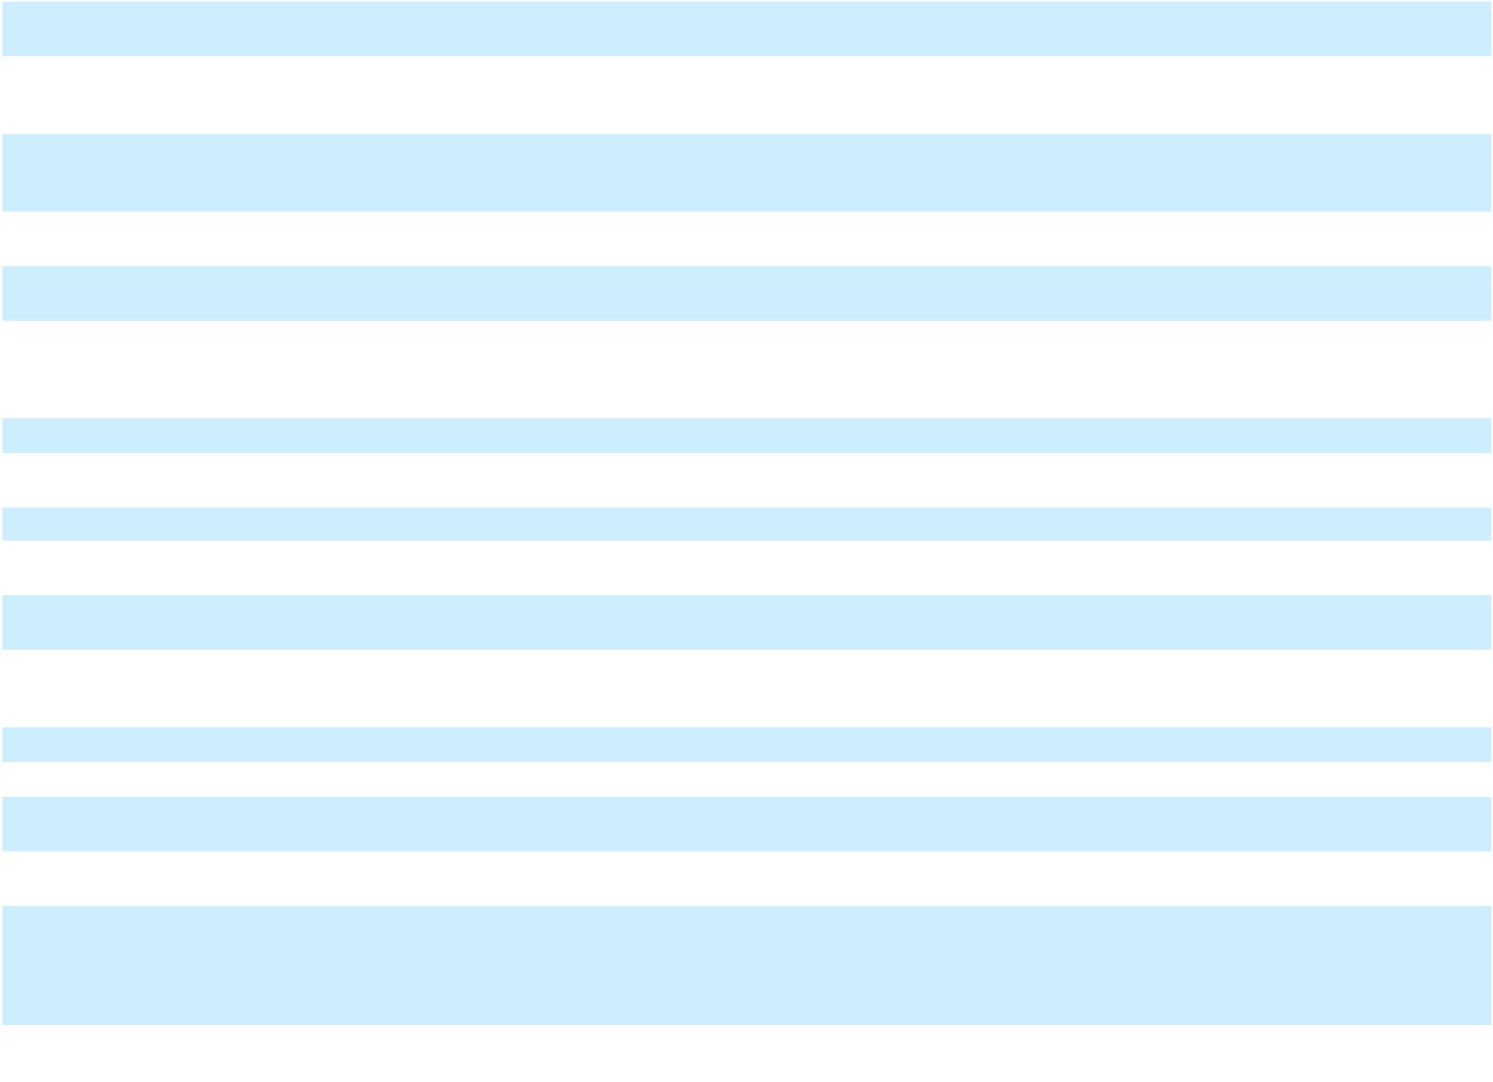

F-108

Table of Contents
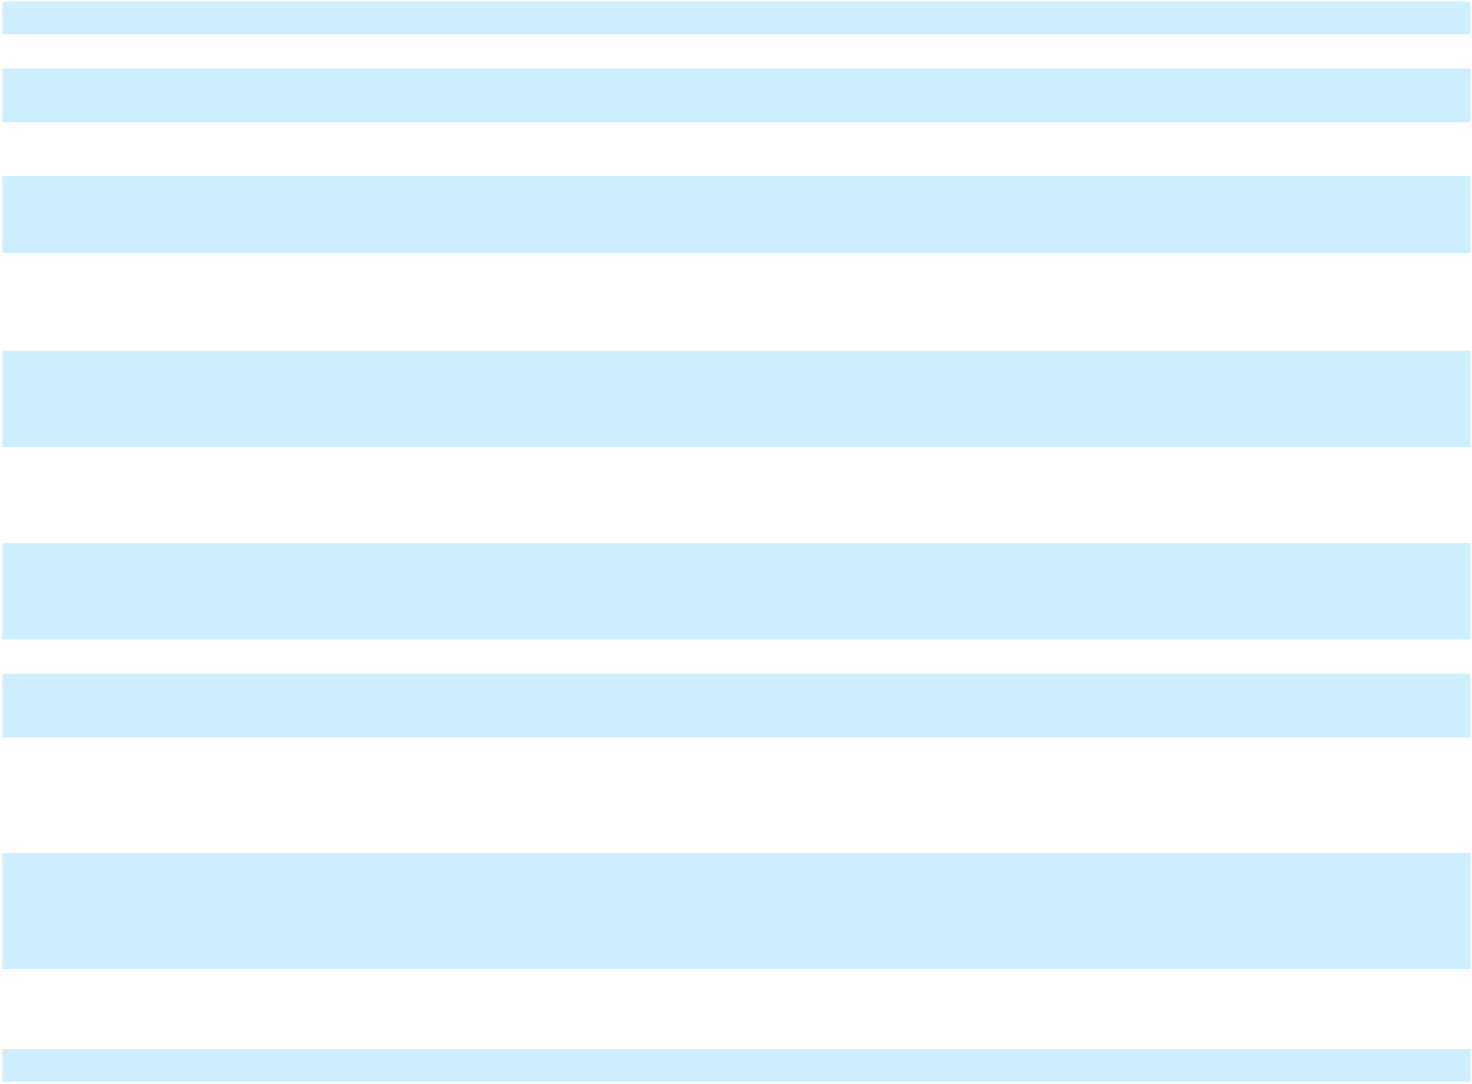

Repayment of debt |  | (664,062) |  |  | — |  |  | (664,062) |  |  | (1,390,187) |  |  | — |  |  | (1,390,187) |  |  | (1,592,321) |  |  | — |  |  | (1,592,321)
Payment of |  | (3,460) |  |  | — |  |  | (3,460) |  |  | (3,014) |  |  | — |  |  | (3,014) |  |  | (3,019) |  |  | — |  |  | (3,019)
dividends |  | (3,460) |  |  | — |  |  | (3,460) |  |  | (3,014) |  |  | — |  |  | (3,014) |  |  | (3,019) |  |  | — |  |  | (3,019)
Other financing |  | (3,662) |  |  | — |  |  | (3,662) |  |  | (6,317) |  |  | — |  |  | (6,317) |  |  | (6,644) |  |  | — |  |  | (6,644)
activities |  | (3,662) |  |  | — |  |  | (3,662) |  |  | (6,317) |  |  | — |  |  | (6,317) |  |  | (6,644) |  |  | — |  |  | (6,644)
Net cash provided
by (used in) |  | 204,456 |  |  | (109,841) |  |  | 94,615 |  |  | (110,428) |  |  | (199,033) |  |  | (309,461) |  |  | (254,270) |  |  | (234,218) |  |  | (488,488)
financing activities |  | 204,456 |  |  | (109,841) |  |  | 94,615 |  |  | (110,428) |  |  | (199,033) |  |  | (309,461) |  |  | (254,270) |  |  | (234,218) |  |  | (488,488)
Impact of changes in
foreign exchange
rates on cash and cash |  | 34,332 |  |  | — |  |  | 34,332 |  |  | 48,965 |  |  | — |  |  | 48,965 |  |  | 57,568 |  |  | — |  |  | 57,568
equivalents |  | 34,332 |  |  | — |  |  | 34,332 |  |  | 48,965 |  |  | — |  |  | 48,965 |  |  | 57,568 |  |  | — |  |  | 57,568
Net (decrease)
increase in cash,
cash equivalents and |  | (128,832) |  |  | — |  |  | (128,832) |  |  | (144,170) |  |  | — |  |  | (144,170) |  |  | (576,236) |  |  | — |  |  | (576,236)
restricted cash |  | (128,832) |  |  | — |  |  | (128,832) |  |  | (144,170) |  |  | — |  |  | (144,170) |  |  | (576,236) |  |  | — |  |  | (576,236)
Cash, cash
equivalents and
restricted cash – |  | 965,577 |  |  | — |  |  | 965,577 |  |  | 965,577 |  |  | — |  |  | 965,577 |  |  | 965,577 |  |  | — |  |  | 965,577
beginning of period |  | 965,577 |  |  | — |  |  | 965,577 |  |  | 965,577 |  |  | — |  |  | 965,577 |  |  | 965,577 |  |  | — |  |  | 965,577
Cash, cash
equivalents and
restricted cash – end | $ | 836,745 | $ |  | — | $ |  | 836,745 | $ |  | 821,407 | $ |  | — | $ |  | 821,407 | $ |  | 389,341 | $ |  | — | $ |  | 389,341
of period
Supplemental disclosure
of non-cash investing and
financing activities:
Changes in accounts
payable and accrued
liabilities associated with
construction in progress
and property, plant and | $ | (62,874) | $ |  | (25,058) | $ |  | (87,932) |  |  | (161,057) | $ |  | (25,058) | $ |  | (186,115) |  |  | (163,921) | $ |  | (31,061) | $ |  | (194,982)
equipment additions
Accounts payable and
accrued liabilities
associated with
construction in progress
and property, plant and |  | 366,358 |  |  | 6,003 |  |  | 372,361 |  |  | 266,191 |  |  | 6,003 |  |  | 272,194 |  |  | 295,174 |  |  | — |  |  | 295,174
equipment additions |  | 366,358 |  |  | 6,003 |  |  | 372,361 |  |  | 266,191 |  |  | 6,003 |  |  | 272,194 |  |  | 295,174 |  |  | — |  |  | 295,174
Principal payments on
financing obligation to
Energos by third party |  | (9,871) |  |  | — |  |  | (9,871) |  |  | (17,027) |  |  | — |  |  | (17,027) |  |  | (16,567) |  |  | — |  |  | (16,567)
charters |  | (9,871) |  |  | — |  |  | (9,871) |  |  | (17,027) |  |  | — |  |  | (17,027) |  |  | (16,567) |  |  | — |  |  | (16,567)
Proceeds held in escrow |  | — |  |  | — |  |  | — |  |  | 98,635 |  |  | — |  |  | 98,635 |  |  | 98,635 |  |  | — |  |  | 98,635

F-109

Table of
Table of | Contents
 |  |  | Schedule II
 |  |  |  | Balance at
 |  |  | Beginning of |  |  |  |  |  |  | Balance at
Description |  |  |  | Year |  | Additions⁽¹⁾ |  | Deductions | End of Year
Year ended December 31, 2025
Allowance for expected credit losses |  |  | $ | 16,490 | $ | 14,044 | $ | (12,437) | $ | 18,097
Year ended December 31, 2024 - As Restated
Allowance for expected credit losses |  |  |  | 1,484 |  | 15,184 |  | (178) |  | 16,490
Year ended December 31, 2023
Allowance for expected credit losses |  |  |  | 1,526 |  | — |  | (42) |  | 1,484
Notes:
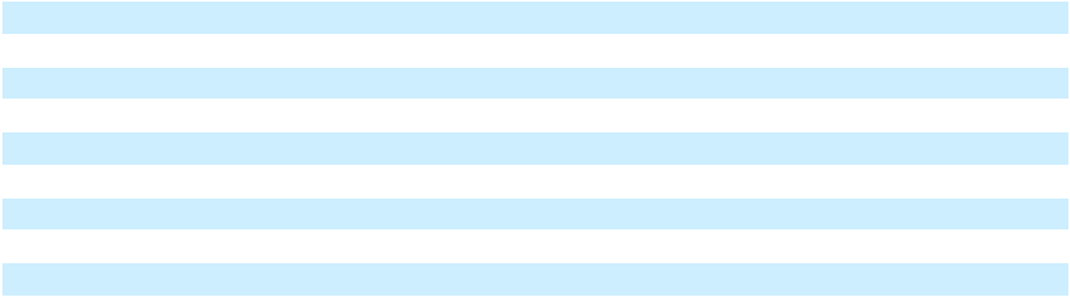

- Amount expensed is included within Selling, general and administrative.

F-110

